Thought process on FINAL HOMETASK
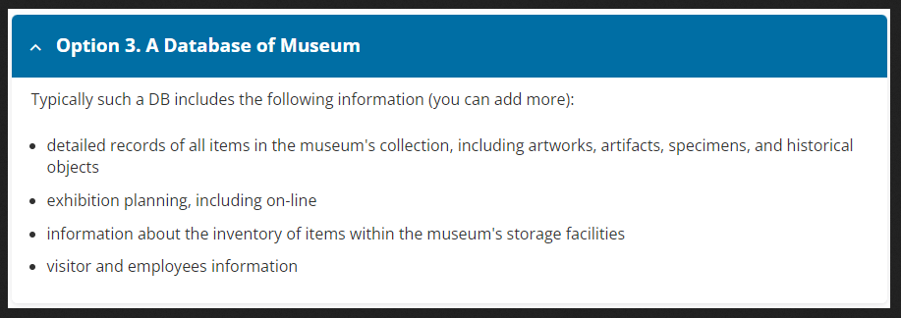

Option 3. A Database of Museum
Typically such a DB includes the following information (you can add more):
detailed records of all items in the museum's collection, including artworks, artifacts, specimens, and historical objects
exhibition planning, including on-line
information about the inventory of items within the museum's storage facilities
visitor and employees information

- Create logical models for your selected domain. Save these models as PNG files.
  - The model should be in 3rd normal form (3NF)
  - Your model should include at least 6 tables (relations)
  - Your model should include at least one many-to-many relationship
  - All relationships should be graphically indicated on the diagram
  - Сheck that the visualization of relationship matches the logic
  - The correct data types should be specified
  - Keys and other constraints should be specified
  - The names of the tables and columns should be clear (adhere to the coding standards)

Brainstorm what could be in the logical model:
1. artists
artist_id (PK)
first_name (varchar, not null)
last_name (varchar)
birth_date (date)
death_date (date)
country (varchar)

2. collection_items
item_id (PK)
accession_number (varchar, unique, not null)
title (varchar)
description (text)
creation_date (varchar)
item_type (varchar, not null) -- artwork, artifact, specimen, etc.
material (varchar)
dimensions (varchar)
provenance (text)
acquisition_date (date)
acquisition_method (varchar)
value_estimate (numeric(12,2))
is_on_display (boolean, default false)

3. items_artists
item_id (FK → collection_items.item_id)
artist_id (FK → artists.artist_id)
role (varchar) -- creator, co-creator, workshop, etc.
primary_creator (boolean)
PRIMARY KEY (item_id, artist_id)

4. exhibitions
exhibition_id (PK)
title (varchar, not null)
description (text)
start_date (date)
end_date (date)
is_online (boolean, default false)
location (varchar)

5. exhibition_items
exhibition_id (FK → exhibitions.exhibition_id)
item_id (FK → collection_items.item_id)
display_order (integer)
placement_notes (text)
PRIMARY KEY (exhibition_id, item_id)

6. storage_locations
location_id (PK)
room (varchar)
shelf (varchar)
box (varchar)
climate_control (varchar)
notes (text)

7. inventory
inventory_id (PK)
item_id (FK → collection_items.item_id)
location_id (FK → storage_locations.location_id)
quantity (integer, default 1, check quantity >= 0)
condition (varchar)
last_checked (date)
status (varchar) -- in_storage, on_display, on_loan, deaccessioned

8. employees
employee_id (PK)
first_name (varchar, not null)
last_name (varchar, not null)
role (varchar)
email (varchar, unique)
phone (varchar)
hire_date (date)
notes (text)

9. visitors
visitor_id (PK)
first_name (varchar)
last_name (varchar)
email (varchar)
visit_date (timestamp)
ticket_type (varchar)
comments (text)

10. exhibition_managers
exhibition_id (FK → exhibitions.exhibition_id) employee_id (FK → employees.employee_id) role (varchar) PRIMARY KEY (exhibition_id, employee_id)

Removing unnecessary attributes, making new Bridge-Relations, changing names
1. artists
artist_id (PK)
first_name (varchar, not null)
last_name (varchar)
birth_date (date)
death_date (date)
country (varchar)

2. item_types
item_type_id (PK)
type_name (varchar, not null, unique)
type_description (text)

3. collection_items
item_id (PK)
accession_number (varchar, unique, not null)
title (varchar)
description (text)
creation_date (varchar)
item_type_id (FK → item_types.item_type_id)
material (varchar)
dimensions (varchar)
provenance (text)
acquisition_date (date)
acquisition_method (varchar)
value_estimate (numeric(12,2))
is_on_display (boolean, default false)

4. items_artists
item_id (FK → collection_items.item_id)
artist_id (FK → artists.artist_id)
PRIMARY KEY (item_id, artist_id)

5. exhibitions
exhibition_id (PK)
title (varchar, not null)
description (text)
start_date (date)
end_date (date)
is_online (boolean, default false)

6. exhibition_items
exhibition_id (FK → exhibitions.exhibition_id)
item_id (FK → collection_items.item_id)
display_order (integer)
PRIMARY KEY (exhibition_id, item_id)

7. storage_locations
location_id (PK)
room (varchar)
shelf (varchar)
box (varchar)
notes (text)

8. item_statuses
status_id (PK)
status_name (varchar, unique, not null) -- in_storage, on_display, on_loan, deaccessioned, etc.

9. inventory
inventory_id (PK)
item_id (FK → collection_items.item_id)
location_id (FK → storage_locations.location_id, NULL allowed)
quantity (integer, default 1, check quantity >= 0)
condition (varchar)
last_checked (date)
status_id (FK → item_statuses.status_id)

10. employees
employee_id (PK)
first_name (varchar, not null)
last_name (varchar, not null)
role (varchar)
email (varchar, unique)
phone (varchar)

11. visitors
visitor_id (PK)
first_name (varchar)
last_name (varchar)
visit_date (timestamp)

12. exhibition_managers
exhibition_id (FK → exhibitions.exhibition_id) employee_id (FK → employees.employee_id) role (varchar) PRIMARY KEY (exhibition_id, employee_id)

Making valid namings, removing some more attributes, , putting tables in order from informational to bridge
1. Artist
PK_Artist_ID (PK)
Artist_First_Name (varchar, not null)
Artist_Last_Name (varchar)
Artist_Birth_Date (date)
Artist_Death_Date (date)
Artist_Country (varchar)

2. Type
PK_Type_ID (PK)
Type_Name (varchar, unique, not null)
Type_Description (text)

3. Role
PK_Role_ID (PK)
Role_Name (varchar, unique, not null)

4. Storage
PK_Storage_ID (PK)
Storage_Room (varchar)
Storage_Shelf (varchar)
Storage_Box (varchar)
Storage_Notes (text)

5. Status
PK_Status_ID (PK)
Status_Name (varchar, unique, not null)

6. Exhibition
PK_Exhibition_ID (PK)
Exhibition_Title (varchar, not null)
Exhibition_Description (text)
Exhibition_Start_Date (date)
Exhibition_End_Date (date)
Exhibition_Is_Online (boolean default false)

7. Employee
PK_Employee_ID (PK)
Employee_First_Name (varchar, not null)
Employee_Last_Name (varchar, not null)
Employee_Email (varchar, unique)
Employee_Phone (varchar)

8. Visitor
PK_Visitor_ID (PK)
Visitor_First_Name (varchar)
Visitor_Last_Name (varchar)

Visit
PK_Visit_ID (PK)
FK_Visit_Visitor_ID (FK → Visitor.Visitor_ID)
Visit_Date (timestamp, not null)

9. Item
PK_Item_ID (PK)
Item_Title (varchar)
Item_Description (text)
Item_Creation_Date (varchar) -- varchar for cases like “18th century”, “ca. 1890”
FK_Type_ID (FK → Type.Type_ID)
Item_Provenance (text)
Item_Acquisition_Date (date)
Item_Value_Estimate (numeric(12,2))
Item_Is_On_Display (boolean default false)

10. Inventory
PK_Inventory_ID (PK)
FK_Inventory_Item_ID (FK → Item.Item_ID)
FK_Inventory_Storage_ID (FK → Storage.Storage_ID) NULLABLE –For case when on display
Inventory_Quantity (integer default 1) -- CHECK (Inventory_Quantity >= 0)
Inventory_Condition (varchar)
Inventory_Last_Checked (date)
FK_Inventory_Status_ID (FK → Status.Status_ID)

11. Item_Artist
PK_FK_Item_Artist_Item_ID (FK → Item.Item_ID)
PK_FK_Item_Artist_Artist_ID (FK → Artist.Artist_ID)

12. Exhibition_Item
PK_FK_Exhibition_Item_Exhibition_ID (FK → Exhibition.Exhibition_ID)
PK_FK_Exhibition_Item_Item_ID (FK → Item.Item_ID)

13. Exhibition_Employee
PK_FK_Exhibition_Employee_Exhibition_ID (FK → Exhibition.Exhibition_ID)
PK_FK_Exhibition_Employee_Employee_ID (FK → Employee.Employee_ID)
FK_Exhibition_Employee_Role_ID (FK → Role.Role_ID)

