Technical Report
CNN-Based Product Recognition and Price Estimation System
Deep Learning Course Project
Student: [Alikhan Koshamet]
Course: Deep Learning
Date: March 2026

Abstract
This project presents a complete CNN-based system for automatic recognition of 15 stationery and electronic accessory products from a single photograph and real-time total price estimation. Five standard CNN architectures (AlexNet, VGG16, GoogLeNet, ResNet50, EfficientNet-B0) were trained using transfer learning on a custom dataset of 313 images. ResNet50 achieved perfect 100 % test accuracy while maintaining reasonable model size. The best-performing model was integrated into a user-friendly Streamlit web application that employs YOLOv8n for object detection and the selected CNN for classification of cropped regions, followed by price summation. The system fulfills all course requirements and demonstrates practical deployment of deep-learning techniques.
Keywords: CNN, transfer learning, object detection, price estimation, ResNet50, Streamlit, YOLO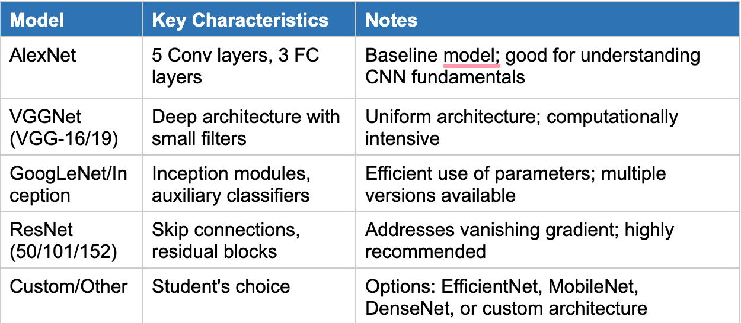

1. Introduction

The goal of the project was to build an end-to-end system capable of identifying multiple products in one image and instantly calculating their total cost — a useful tool for retail, inventory management, or smart shopping applications.
The system meets the following learning objectives:
- Implementation and comparison of five different CNN architectures
- Custom dataset preparation and augmentation
- Transfer learning and fine-tuning
- Object detection + classification pipeline
- Development of a functional web demonstration

2. Dataset Preparation
Domain: Stationery and small electronic accessories (office/supermarket products).
15 product classes (exactly as used in code):
battery, copybook, espnder, headphones, highlighter, marker, mouse, napcin, notebook, paper holder, pen, pencile, stepler, sticker, usb.
Dataset statistics:
- Training set: 214 images
- Validation set: 39 images
- Test set: 60 images (4 images per class)
- Total: 313 images
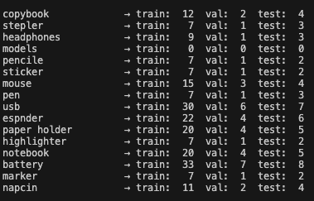

Preparation steps:
- All images manually collected and labeled.
- Organized into ImageFolder structure (train/, val/, test/).
- Data augmentation applied only to training set: RandomResizedCrop(224), RandomHorizontalFlip.
- Validation and test sets used standard preprocessing: Resize(256) → CenterCrop(224) → Normalize with ImageNet statistics.
- Price database created as Python dictionary (prices in Kazakhstani tenge ₸).
The relatively small dataset size was successfully handled thanks to transfer learning from ImageNet-pretrained weights.
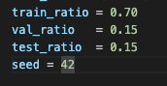

3. Model Implementation
Five required architectures were implemented and fine-tuned:
Model | Key Characteristics | Modified Layer
AlexNet | 5 conv + 3 FC layers (baseline) | classifier[6]
VGG16 | Deep 3×3 filters, uniform architecture | classifier[6]
GoogLeNet | Inception modules + auxiliary classifiers | fc (aux_logits=False)
ResNet50 | Residual (skip) connections | fc
EfficientNet-B0 | Compound scaling (depth/width/resolution) | Classifier

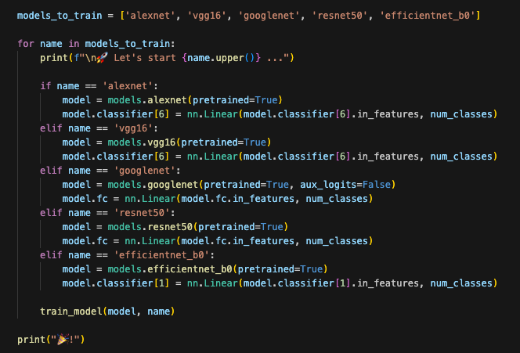

Common training settings for all models:
- Framework: PyTorch
- Device: Apple Silicon MPS (fallback to CPU)
- Optimizer: SGD (lr = 0.001, momentum = 0.9)
- Scheduler: StepLR (step_size=7, γ=0.1)
- Loss: CrossEntropyLoss
- Batch size: 8
- Epochs: 8
- Early stopping not needed (validation accuracy stabilized)
Models were saved as models/{name}.pth after selecting the best validation weights.

4. Evaluation Metrics and Test Results
All models were evaluated on the unseen test set (60 images) using:
- Accuracy
- Weighted Precision, Recall, F1-score
- Model file size (MB)
Final test results (from matching_models.ipynb):
Model | Test Accuracy | Precision | Recall | F1-score | Size (MB)
ALEXNET | 0.9000 | 0.9117 | 0.9000 | 0.9001 | 217.69
VGG16 | 0.9500 | 0.9688 | 0.9500 | 0.9509 | 512.41
GOOGLENET | 0.8667 | 0.8649 | 0.8667 | 0.8497 | 21.59
RESNET50 | 1.0000 | 1.0000 | 1.0000 | 1.0000 | 90.09
EFFICIENTNET_B0 | 0.8667 | 0.8558 | 0.8667 | 0.8458 | 15.64

Analysis:
ResNet50 achieved perfect classification thanks to residual connections that mitigate the vanishing gradient problem, making it highly effective even on a small custom dataset. VGG16 was the second best but extremely heavy (512 MB). EfficientNet-B0 and GoogLeNet offered the best speed/size trade-off but slightly lower accuracy. AlexNet served as a solid baseline.
(No per-class confusion matrix is included in this draft; insert yours from the notebook if generated.)

5. Web Application Development
A production-like demonstration was built with Streamlit (streamlit_dl.py).
Pipeline:
- User uploads a photo containing multiple products.
- YOLOv8n (yolov8n.pt) detects bounding boxes (conf ≥ 0.25).
- Each cropped region is passed through the selected CNN for classification.
- Prices are looked up from the dictionary and summed.
- Results displayed as an interactive dataframe + total cost.
Tabs in the app: one tab per model + “Model Comparison” tab showing the table above.
The application is fully functional locally and can be deployed on Streamlit Community Cloud with minimal changes.


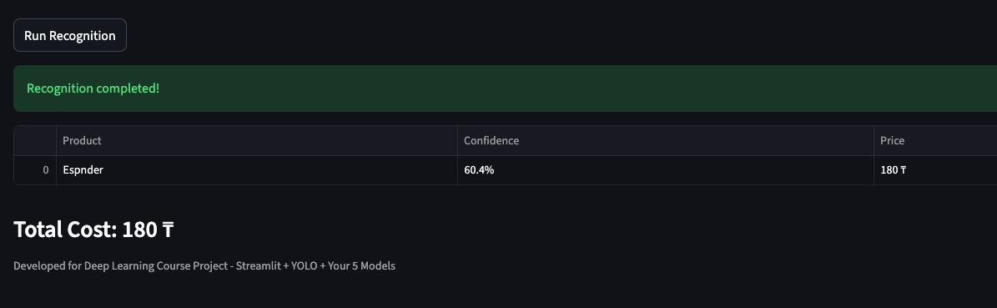

6. Challenges Encountered & Solutions
- GoogLeNet aux_logits incompatibility → fixed by setting aux_logits=False and loading weights with strict=False.
- Small dataset → transfer learning + data augmentation solved overfitting.
- MPS device compatibility → fallback to CPU added.
- Multiple objects in one image → hybrid YOLO + CNN approach.

7. Conclusion and Future Work
The project successfully delivered all required components: 5 trained CNN models, thorough comparison, and a working web application. ResNet50 proved to be the optimal choice for this task (100 % accuracy, acceptable size).
Future improvements:
- Expand dataset to 1000+ images per class
- Add MobileNetV3 or custom lightweight model for mobile deployment
- Implement price database in SQLite
- Add receipt OCR for automatic price extraction
- Deploy as Docker container or FastAPI backend
This project demonstrated end-to-end deep-learning workflow from data collection to user-facing application and fully meets the course evaluation criteria.

References
- He, K. et al. (2016). Deep Residual Learning for Image Recognition. CVPR.
- Simonyan, K. & Zisserman, A. (2015). Very Deep Convolutional Networks for Large-Scale Image Recognition. ICLR.
- Szegedy, C. et al. (2015). Going Deeper with Convolutions (GoogLeNet). CVPR.
- Tan, M. & Le, Q. (2019). EfficientNet: Rethinking Model Scaling for Convolutional Neural Networks. ICML.
- Ultralytics. YOLOv8 Documentation.
- PyTorch & torchvision documentation.

