Assignment #3
Responsive Web Design
Media Queries + Bootstrap Grid
Student: Yerbol Alikhan
Group: SE-2517

Objective
The goal of this assignment is to practice responsive web design using CSS Media Queries and the Bootstrap 12-column Grid system. The pages adapt to mobile, tablet, and desktop screen sizes.

Part 1 - Task 0. Responsive Typography
I created a simple page with headings and paragraphs. CSS media queries change the font sizes at different breakpoints. Mobile uses smaller text, tablet uses medium text, and desktop uses larger text.
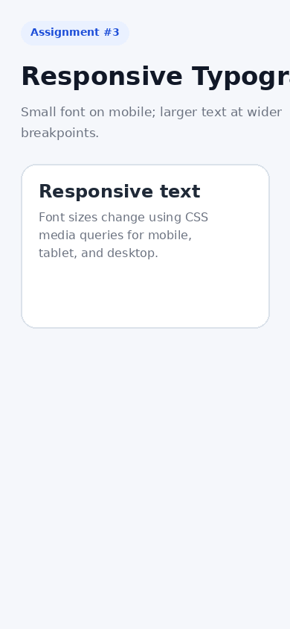
Figure 1. Task 0 - mobile view.
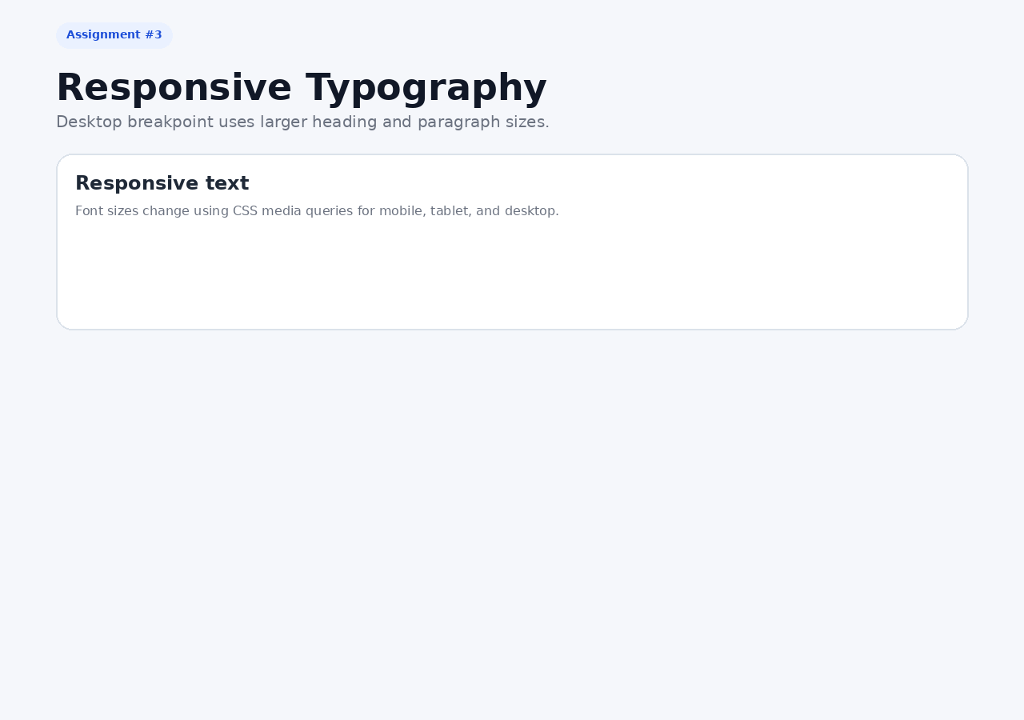
Figure 2. Task 0 - desktop view.

Part 1 - Task 1. Responsive Layout with Media Queries
I created three content boxes using CSS Grid and custom media queries only. On mobile the boxes are stacked vertically, on tablet two boxes fit in the first row, and on desktop all three boxes are displayed side by side.
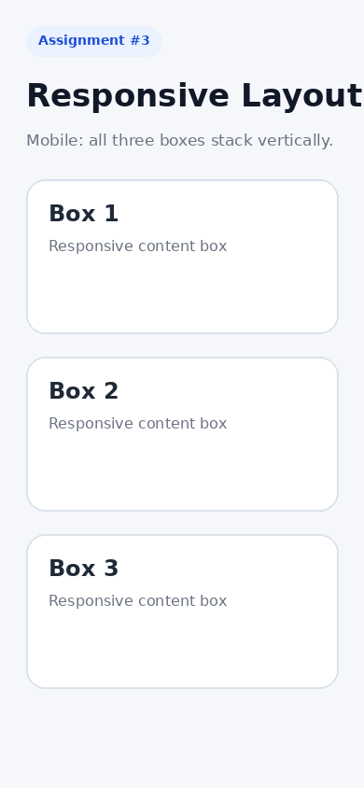
Figure 3. Task 1 - mobile view.
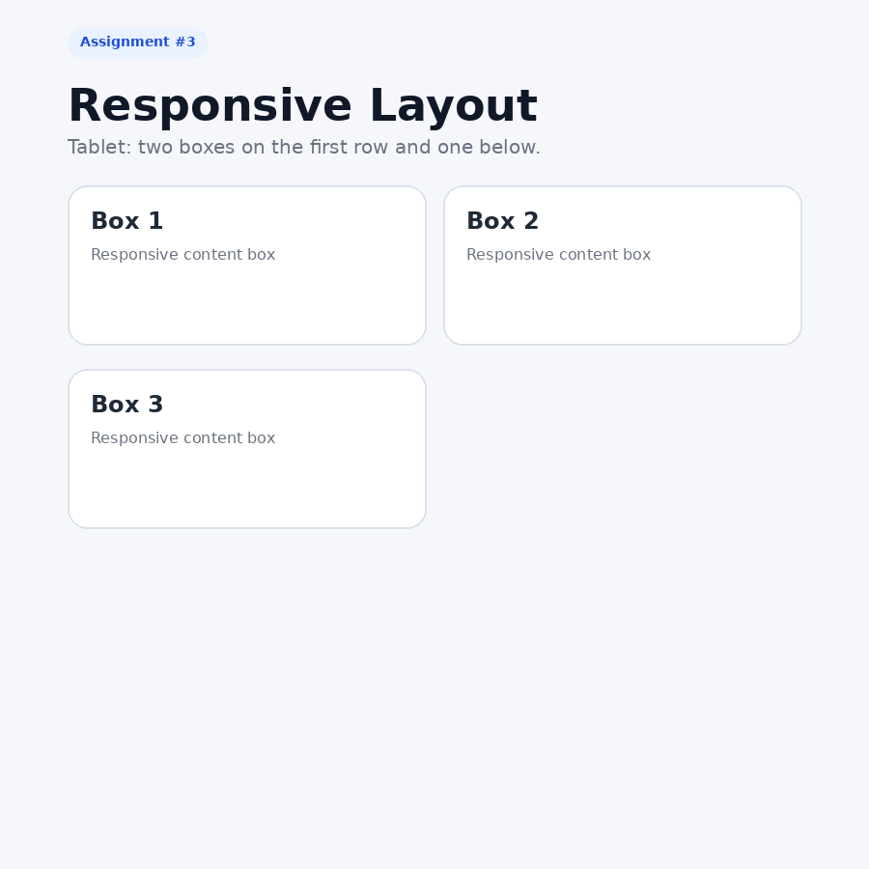
Figure 4. Task 1 - tablet view.
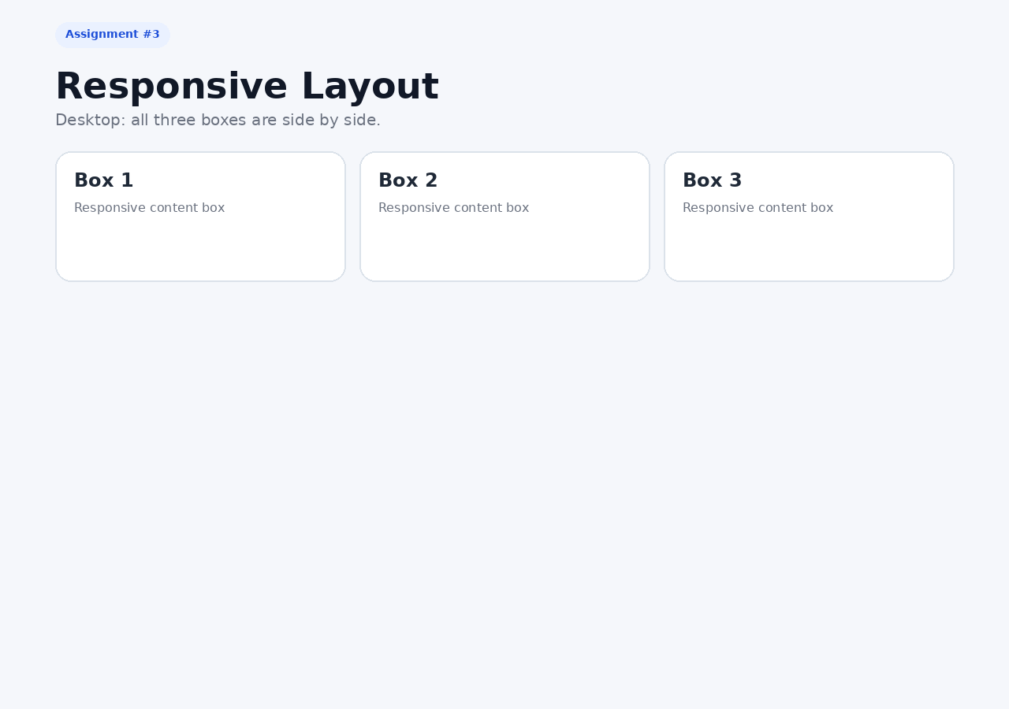
Figure 5. Task 1 - desktop view.

Part 2 - Task 2. Bootstrap Responsive Columns
I used Bootstrap's 12-column grid. Every column uses the classes col-12 col-md-6 col-lg-4. Therefore, each item takes the full width on mobile, half width on tablet, and one third on desktop.
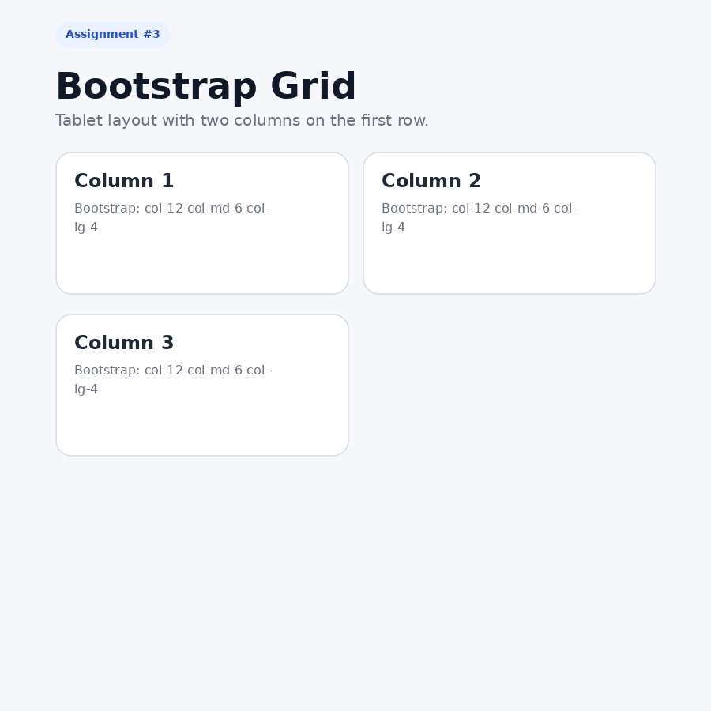
Figure 6. Task 2 - tablet Bootstrap grid.

Part 2 - Task 3. Bootstrap Navigation Bar
I created a Bootstrap navbar with the brand/logo on the left and navigation links on the right. The navbar uses navbar-expand-lg, so it collapses into a hamburger menu on smaller screens.
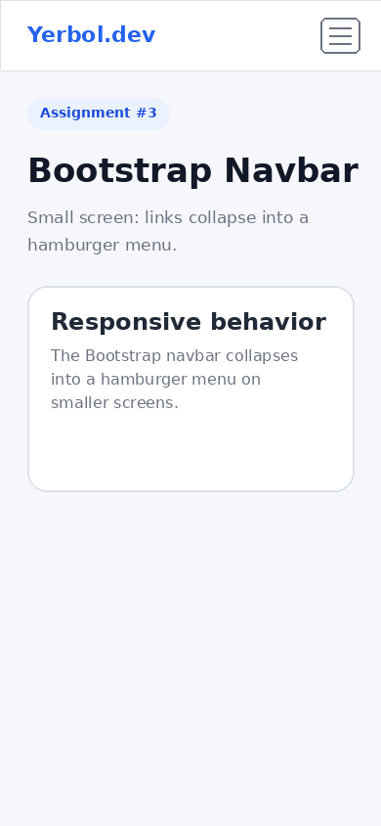
Figure 7. Task 3 - mobile navbar.
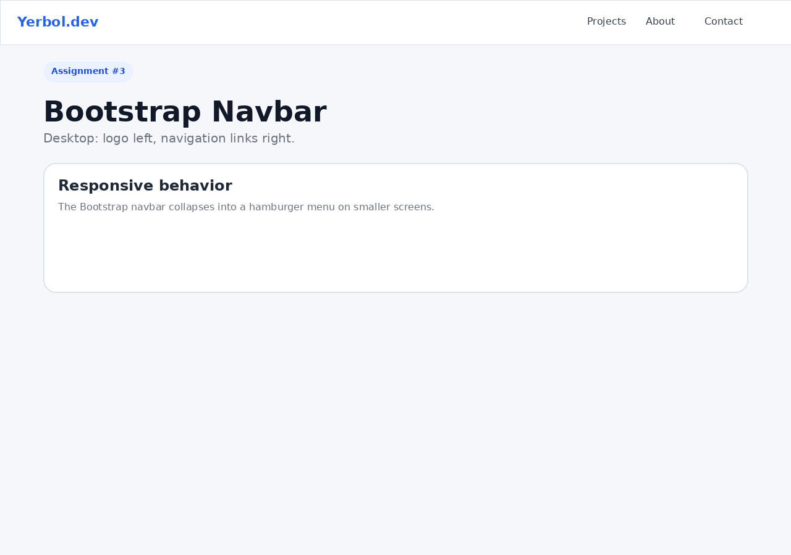
Figure 8. Task 3 - desktop navbar.

Part 3 - Task 4. Responsive Portfolio Page
The final project combines Bootstrap Grid and custom media queries. It includes a Bootstrap navbar, a projects section arranged with responsive cards, a personal-information sidebar, and a footer. Custom media queries also adjust typography, spacing, and visibility.
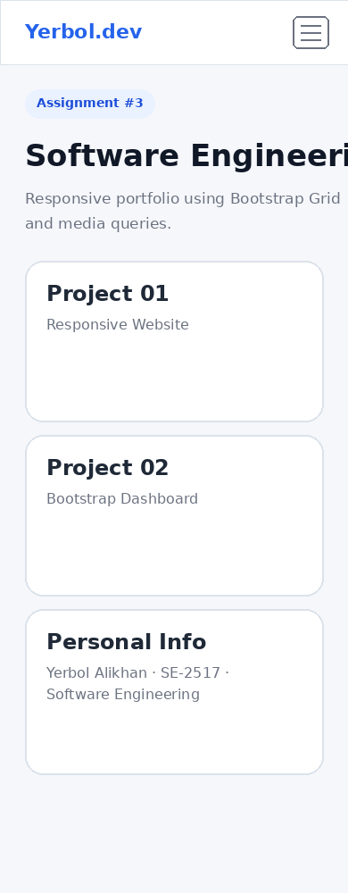
Figure 9. Task 4 - mobile portfolio.
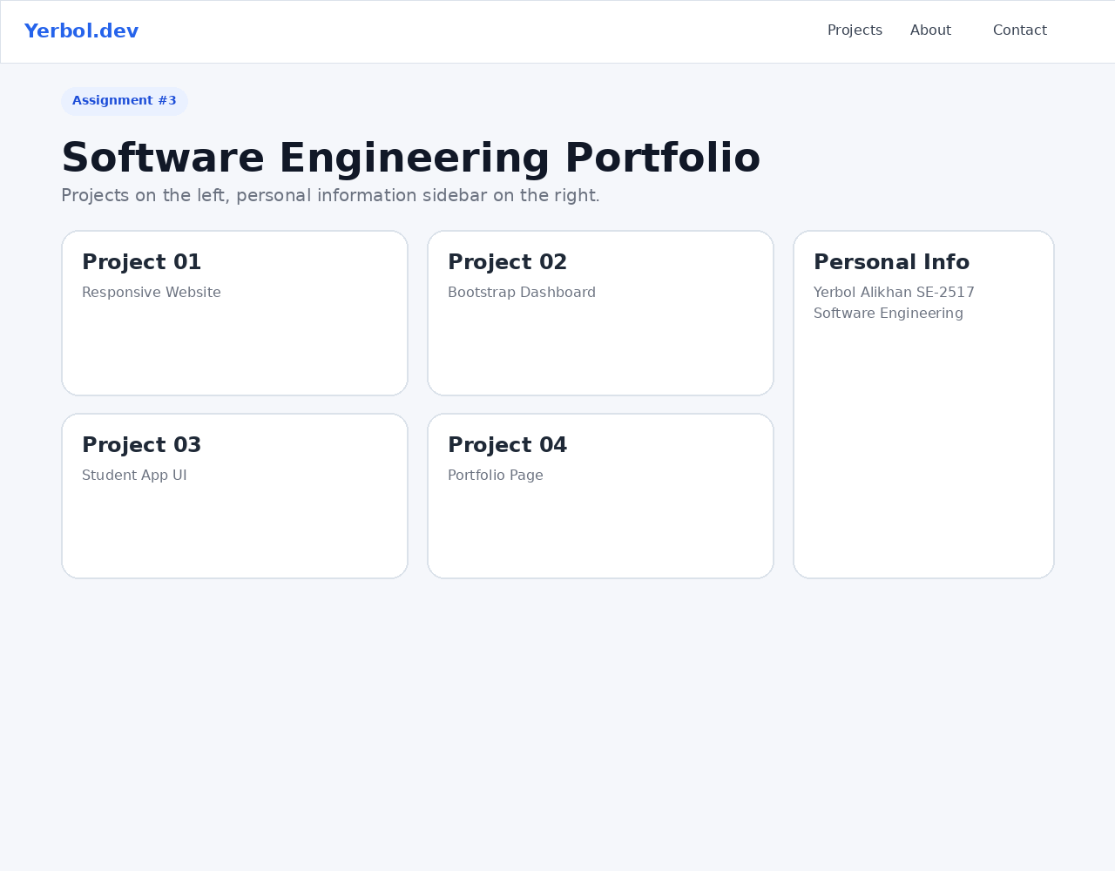
Figure 10. Task 4 - desktop portfolio.

Summary
During this assignment, I created responsive pages using two approaches. First, I used pure CSS media queries to change typography and layout depending on the screen width. Second, I used Bootstrap's responsive grid and navbar components. In the final portfolio page, I combined both approaches. I tested the layouts for mobile, tablet, and desktop sizes and kept the code separated into clear HTML and CSS files.

Project Structure
- index.html - start page with links to all tasks
- task0.html - responsive typography
- task1.html - responsive layout using CSS media queries
- task2.html - Bootstrap responsive columns
- task3.html - Bootstrap navigation bar
- task4.html - final responsive portfolio
- css/ - custom CSS files
- screenshots/ - screenshots used in this report

