Week 1 — Azure Functions Fundamentals
Summary Document
Effa & Maham | Supervisor: Dr. A. Khawaja | SProj 2026-27-DCW

1. Serverless Computing & Azure Functions' Position
The cloud providers have three models, IaaS, PaaS and FaaS, and they have been categorised based on the facilities provided by the cloud provider and how much of it has to be operated and handled by the user. Generally, cloud providers provide physical server, virtualisation and networking.
Virtualisation is the software layer that sits on top of the physical server. The hypervisor slices the physical server's resources (CPU, RAM, storage) into multiple complete, isolated virtual machines (VMs), each functioning as a separate computer.
In IaaS, the operating system, runtime environment configuration, app-code and function logic has to be handled by the user, and the server is up 24/7, always running. An example of this in Azure is the VM (Virtual Machine).
In PaaS, the operating system and the runtime configuration is also handled by the provider, whereas the app-code and application logic has to be handled by the user. An example is the Web App.
In FaaS, you only have to concern yourself with the function logic pieces of code executed due to a specific trigger, which are not running 24/7 all the time. They are executed on demand, when needed.
The control and handling is shifted to the provider as we move from IaaS to PaaS and then to FaaS. Azure Functions belong to the FaaS model, for which you are only responsible for the function logic, with execution done on the basis of triggers and carried out on-demand so there are no servers running 24/7.

Cold Starts
Cold starts happen in FaaS / Azure Functions because a function only executes on demand and scales down to zero when not needed, it is initiated by a trigger and is not running 24/7 waiting for a request. So when a request is actually made, the platform has to spin up a worker for the function, load the language runtime, and load your code before it can execute. This startup delay is known as a cold start.
It is important to note that the delay comes from preparing the function's own execution environment the worker, the language runtime, and the code not from the underlying physical server, virtualisation, or networking, which are always running. In PaaS and IaaS, the application is already running 24/7 and loaded in memory, so requests are served immediately without this startup penalty.

2. Core Concepts Deep Dive

Execution Model — Lifecycle of a Single Invocation
A function is part of the FaaS model, which means it is not running 24/7. Therefore a function needs a way to be started, and this is done by a trigger. A trigger is what starts the function in response to an event. When a real-time event occurs that matches a function's trigger, the runtime selects that function for execution. Azure then looks for a warm worker (host) to run it; if no warm instance exists, a new host is spun up and the runtime and your code are loaded — this is the cold start. Next, the input bindings resolve and the incoming data is passed to the function as parameters (bindings define the flow of data in and out of the function). The function's code then executes, and any results are pushed out through the output bindings to the destination service. For an HTTP trigger, a response is returned to the caller; for other triggers, the function simply completes. The host then stays warm for a period before going idle again.

Triggers vs Bindings
A trigger is what starts the function, because functions are part of the FaaS model — they are not running 24/7, so there needs to be some way to start them, and that is done by the trigger. Every function has exactly one trigger; a function with no trigger can never be executed. There are different types of triggers, such as the HTTP trigger (an HTTP request made to a specific URL), the timer trigger (started after a set duration, e.g. every five minutes), and the queue trigger (runs when a new message is added to a queue).
The flow of data into and out of the function is made possible by bindings. There is no need to figure out the connections between other components on the cloud platform and the Azure function, as this is handled by bindings automatically. When data flows into the function that is an input binding; when data flows out that is an output binding. There are two kinds of binding: declarative binding, where the connection is set up simply by declaring it upfront and Azure wires it automatically; and imperative binding, where the connection is established in code at runtime between the function and the other component.

The function.json Schema & Programming Models
The function.json is a configuration file for each function that contains the triggers, bindings, and details for that function. Importantly, it configures only the wiring (the trigger and bindings) — the actual function logic always lives in the code file. In Python v1, the function.json file was separate from the code; however in v2 there is no longer any separate configuration file, the triggers and bindings have become part of the code itself, declared using decorators. In the .NET models, bindings are declared in code using attributes (the C# equivalent of decorators). The in-process model runs the function code in the same process as the Functions host, whereas the isolated model runs it in a completely separate process — which makes the code independent of the host's .NET version, and is the model Microsoft now recommends.
A function is a separate unit of code written for a specific piece of functionality, while a Function App is the shared container that holds one or more functions. The Function App is the unit of deployment and management: functions inside it share the same configuration, runtime, and scaling.

3. Environment Setup & First Function
For the hands-on portion, the local development environment was set up on macOS using Azure Functions Core Tools (v4) as the local runtime, Azurite as the local storage emulator, and Visual Studio Code with the Azure Functions extension as the editor. An HTTP-triggered function was then created using the Python v2 programming model and run locally before being deployed to Azure.

The HTTP-Triggered Function
This was the code written for making an HTTP request. The trigger type was HTTP, as required in Task 3. The route decorator was used to specify the name in the URL after the base code for the Azure Function App was generated. It can be tested by using the Browse option of the Function App, which has a base URL of https://week1-az-effa-2026.azurewebsites.net, while we can add /api/http_trigger?name=ali for a specific HTTP function to be executed as part of the Function App.
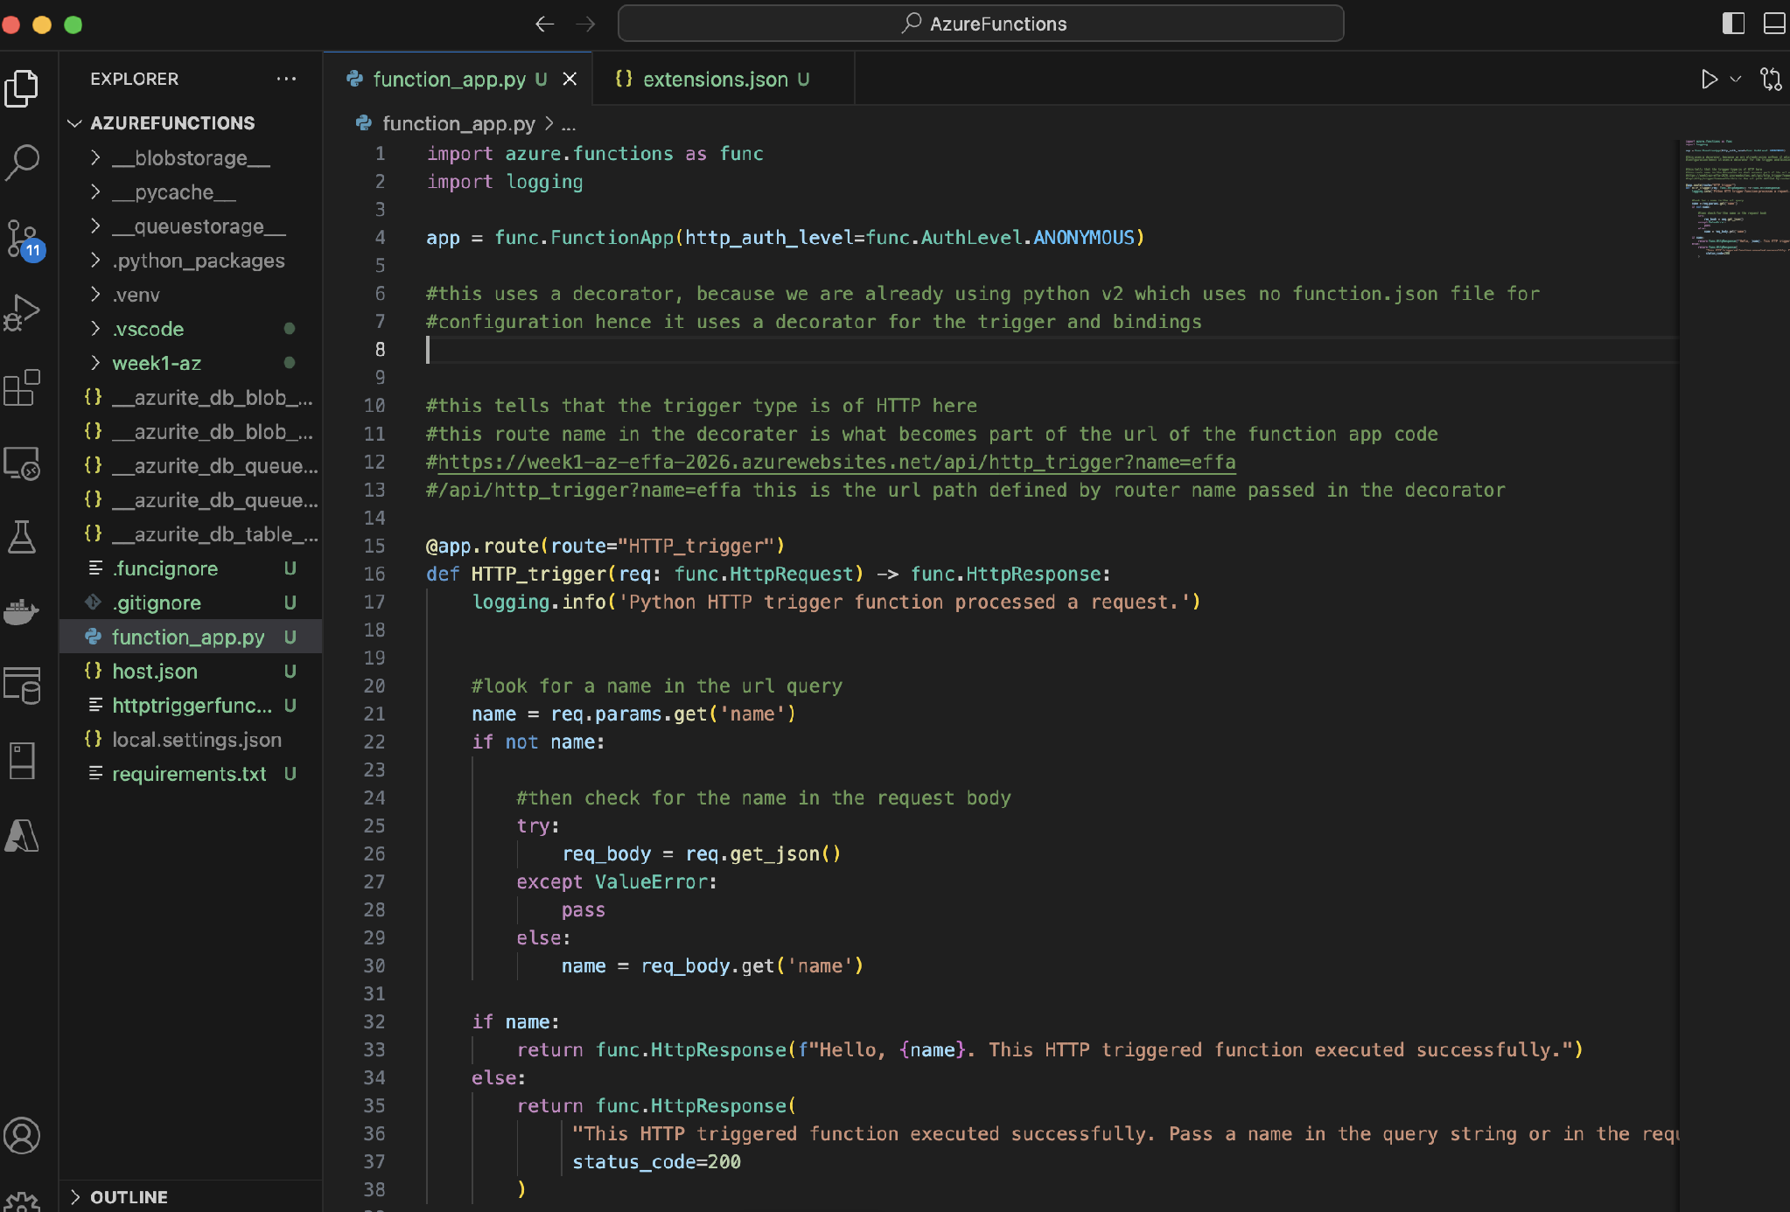
function_app.py — the HTTP-triggered function (Python v2), with the @app.route decorator declaring the trigger and defining the URL path.

Deploying to Azure

The local project was pushed to Azure using the command func azure functionapp publish week1-az-effa-2026. This packages the local project, uploads it, and performs a remote build (via Oryx) that installs the Python dependencies in the cloud, then activates the function so it can be reached at a public URL.
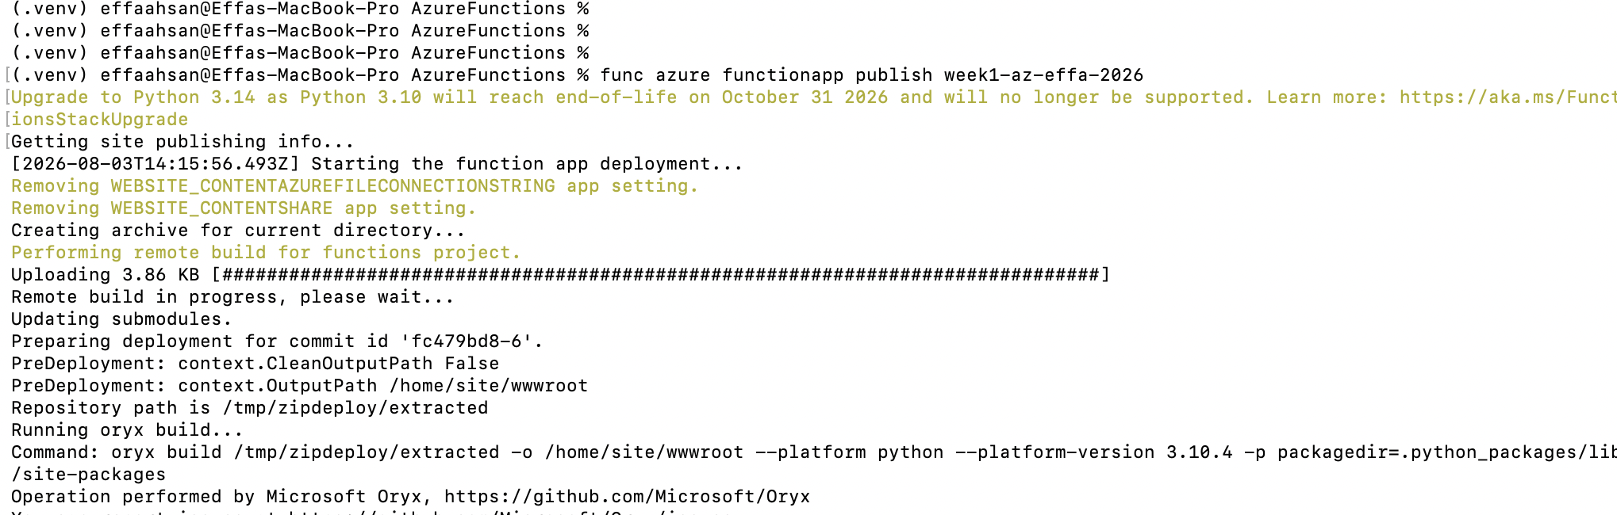
Deploying the function to Azure with 'func azure functionapp publish' — the local code being uploaded and remote-built on the Azure portal.
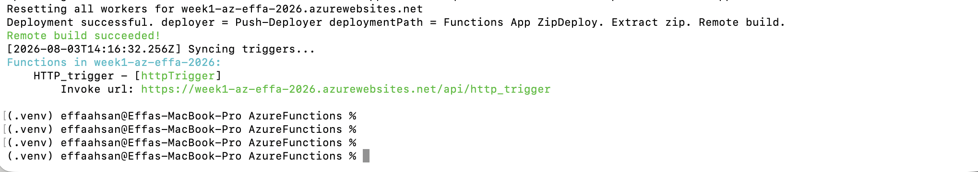
Deployment successful — the remote build succeeded and the function is now live at its public Invoke URL.

4. Trigger & Binding Catalogue
The following catalogue documents the key Azure Functions trigger types. For each, it records when to use it and its key configuration parameters. Every function has exactly one trigger, which is what starts it in response to an event.
Trigger | When to use it | Key configuration parameters
HTTP | Use when the function should run in response to an HTTP request made to a specific URL — for example, a web API or a function you can call from a browser. | route (URL path, set in the @app.route decorator), authorization level (ANONYMOUS / FUNCTION / ADMIN), allowed HTTP methods (GET, POST).
Timer | Use when the function should run automatically after a set duration or on a schedule — for example, every five minutes or every night at a fixed time. | schedule, written as a CRON expression (e.g. 0 */5 * * * * = every 5 minutes).
Blob Storage | Use when the function should run every time a file (blob) is uploaded to a storage container — for example, resizing an image whenever a photo is added. | path (the container/folder to watch) and connection (the storage account connection string).
Queue Storage | Use for simple, low-cost background jobs: the function runs when a new message arrives in a basic queue and waits its turn to be processed. Good when advanced features are not needed. | queue name (which queue to watch) and connection (storage account connection string).
Service Bus | Use for enterprise / critical business workflows that need guaranteed first-in-first-out ordering, one-to-many broadcasting (topics), or strong reliability — a more powerful version of a queue. | queue name OR topic name + subscription name, and connection (the Service Bus connection string).
Event Grid | Use to react in near-real-time to events happening across Azure (e.g. a resource being created). It pushes events instantly with no waiting queue, and can notify many subscribed functions at once. | event subscription wiring (which event types / source the function subscribes to); the function declares an Event Grid trigger.
Cosmos DB | Use when the function should run every time the data in a Cosmos DB (NoSQL) database changes — for example, when a new document is inserted or an existing one is updated. | database name, container name, connection, and a lease container (tracks how far the change feed has been read). Reacts to inserts/updates via the change feed.

When we wrote the code in function_app.py locally on our desktop before deploying it to the Azure platform, we connected it to Azurite (the local emulator for Azure Storage). This timer-trigger function runs on its schedule (every 5 minutes) and prints out a success message that it ran. Unlike the HTTP trigger, the timer trigger needs storage because it has to track its schedule state — its last and next run times — which can be seen in the ScheduleStatus in the output below.
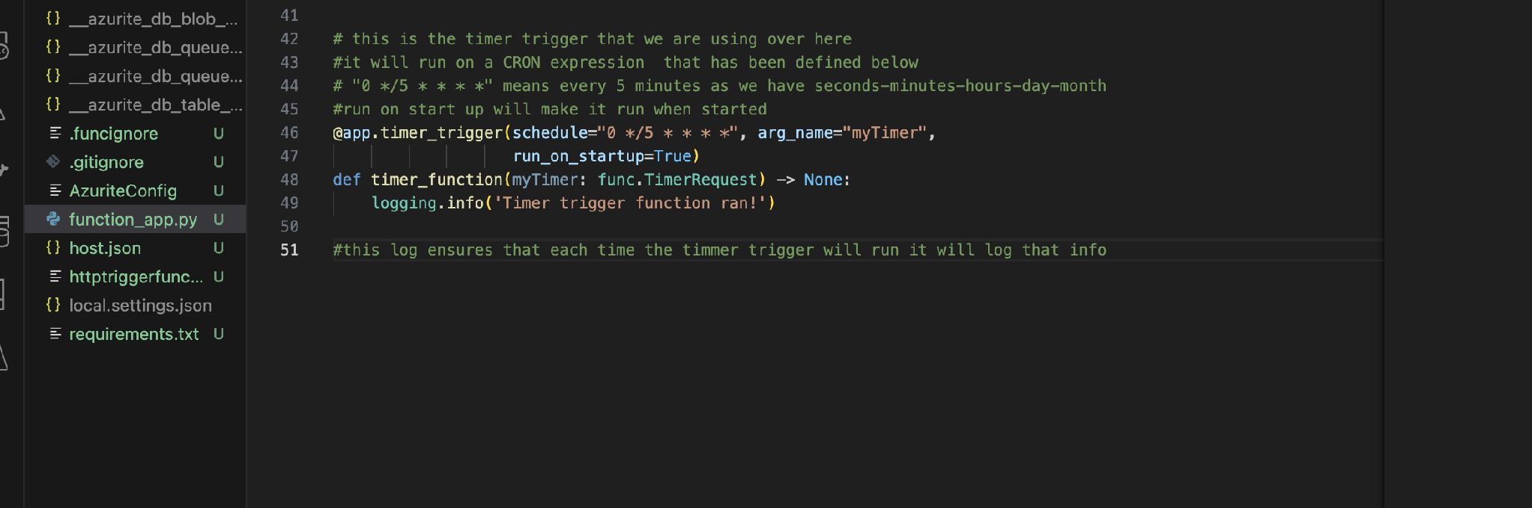
The code written for the timer function. A CRON expression sets the interval to every 5 minutes, and run_on_startup=True ensures the timer runs at least once on startup.
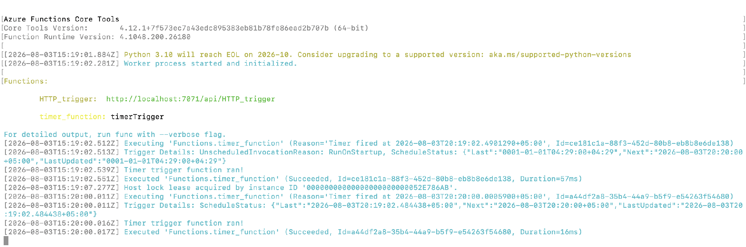
The timer trigger running locally against Azurite — firing on its own (first via run_on_startup, then on schedule) and logging 'Timer trigger function ran!' each time.

Implementing a Queue Trigger
The queue trigger fires when a new message arrives at the queue we created, named effaqueue, which triggers the function. This is a different activation style from the timer: the timer fires on a schedule (time-driven), while the queue fires only when a message is placed in the queue (event-driven). One gotcha observed during testing: Azure Functions expects queue messages to be Base64-encoded by default, so a plain-text message failed with a non-UTF8 error until it was Base64-encoded before being sent.
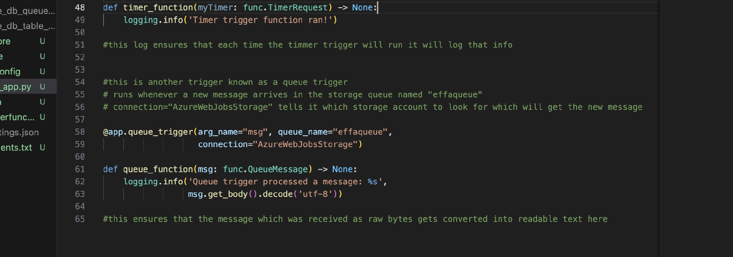
The code for the queue trigger — it watches the queue named 'effaqueue' and logs the message contents whenever one arrives.
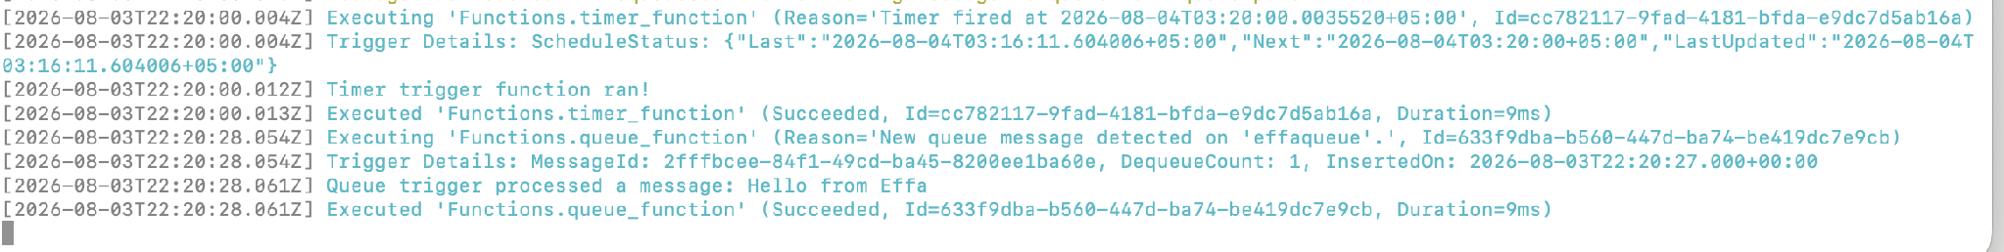
The queue trigger firing successfully — 'Queue trigger processed a message: Hello from Effa' (Succeeded). Note the timer fires by schedule while the queue fires on a message arriving.

Building a Data Pipeline (Queue Trigger → Blob Output)
The final part of Task 4 combines a trigger and an output binding into a simple data pipeline: this shows that the message was received by the queue, which acts as the trigger, and then an output binding writes the message out as a file to blob storage. In other words, data flows through the function — in from the queue, out to a blob — which is triggers and bindings working together to move data from one source to another.
The data pipeline running — the function received the message from the queue and wrote it to a blob (Succeeded).

All Triggers Deployed to Azure
Finally, all the functions were deployed to Azure with a single publish command (they all live in one Function App). The portal confirms all four functions are live and enabled in the cloud, across three different trigger types — HTTP, Queue, and Timer. The timer function now runs automatically in the cloud every five minutes without any local process.
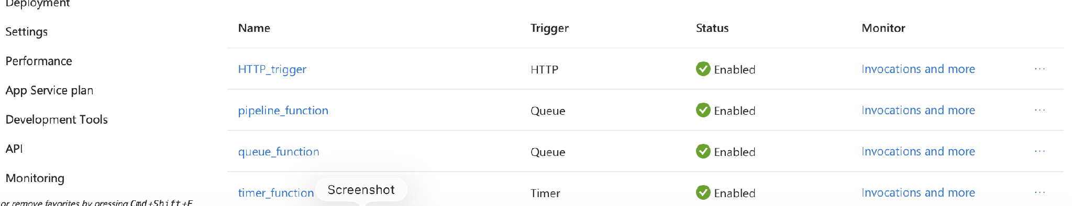
All four functions deployed and enabled in the Azure portal: HTTP_trigger (HTTP), pipeline_function and queue_function (Queue), and timer_function (Timer).

