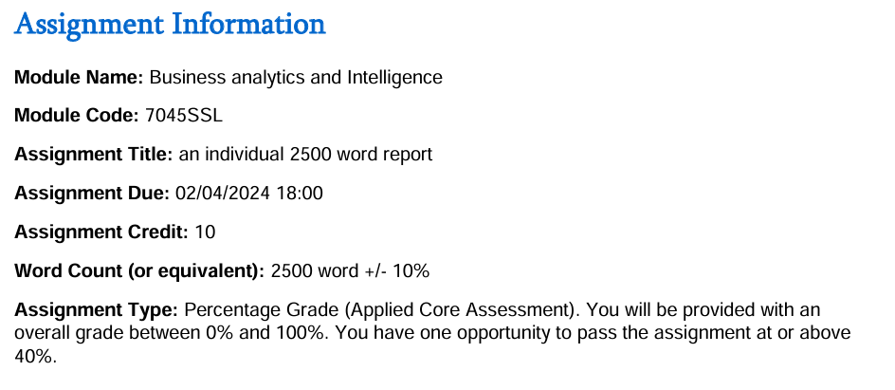

Reflection:

In my previous report, particularly for Task 1, I realized that I had not included enough academic papers to provide a comprehensive review. Reflecting on this shortfall, I made a concerted effort in this report to include wider range of scholarly articles and references. By expanding the literature review to add more diverse sources, I tried to provide a more explained foundation for my analysis and discussions. Each paper was meticulously selected to illustrate various applications and insights relevant to my project report, and enriching the overall quality and depth of the report.

For Task 2, my earlier attempt lacked proper interpretations and solutions, especially regarding the use of Excel Solver. Additionally, I had not included the necessary charts that could have visually supported my data analysis. Learning from this shortfall, I ensured that in this report, I provided detailed step-by-step explanations of how I used Excel Solver to find optimal solutions. I included all relevant tables directly exported from Excel, showing each part of the process clearly. By adding charts where appropriate, I was able to visualize data trends and support my interpretations more effectively, making the analysis more accessible and comprehensible.

Task 3 was another area where my previous report was significantly lacking. I had not included any data from Excel, no charts, and no results, which undermined the effectiveness of my analysis. Addressing this gap, I made substantial improvements in this report. I included all relevant data tables, generated from thorough Excel analysis, and presented the results comprehensively. Charts were added to visually represent data trends and support the forecasted values. Each value was carefully interpreted to provide clear insights into the sales forecast for the company.

Task One- Business analytics concepts:

### 1. 1 Clustering Analysis:

Clustering analysis is an interesting tool in the business analytics world. It's a way to put a bunch of things into groups based on how much they're alike. The thing that makes it different from other methods, like classification or regression, is that it doesn't need you to tell it what to look for beforehand. It just finds these groups on its own by looking at what's already there in the data.

So, imagine we’ve got a ton of data, like how people buy things or what they like. This technique helps you figure out if there are any patterns or groups that make sense. It's like finding out that some of your customers buy the same things all the time, or that certain products are popular together.

When businesses do this, they can get a better idea of what's going on with their data. It's like looking at a giant puzzle and suddenly seeing that some pieces fit together really well. This helps them understand their customers, products, or even market trends better. In marketing, for example, it can show you who your best customers are, so you can talk to them in a way that makes them want to buy more.

The great thing about clustering analysis is that it can uncover things we never knew were there. It's like having a detective for our data, finding clues and connections that we might have missed before. It's a powerful way to dive into big sets of information and make sense of it all.

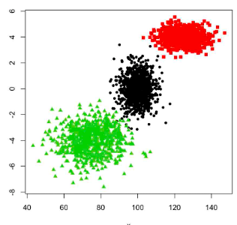

### 1.1.2 Types of clustering Analysis:

Clustering analysis can be performed in two main ways:

1. Hierarchical Clustering
2. Non-Hierarchical Clustering
3. Hierarchical Clustering is organizing stuff into groups that look like a family tree, where the groups are called clusters and they show how they're all connected like relatives. There are two main ways to do this:
4. Agglomerative Method: This is like starting with a group of tiny groups (each with just one thing in it) and then gradually combining them into bigger and bigger groups. It's like building a tower with blocks from the ground up.
5. Divisive Method: This is the opposite, like starting with one big group and then breaking it down into smaller and smaller groups.

Both of these methods use "distance" or "similarity" to figure out which groups should go together or be pulled apart. And there's a tool called a dendrogram that helps us see what the clusters look like and how they're related, kind of like a map of the family tree.

1. Non-hierarchical clustering is a way to organize data without creating a tree-like structure with levels of hierarchy. It's about putting similar things together. There are two main strategies for doing this:

a) K-means

b) K-medoids

1. Let's talk about K-means first. This one is like throwing a bunch of darts at a board to create groups. We start with randomly picking 'K' darts, which represent the centers of your clusters. Then, we keep throwing darts (data points) and see which cluster center they are closest to. After that, we move the centers of the clusters to the average spot of all the darts in that cluster. We keep doing this until the darts don't move around too much, meaning we’ve found the best groups possible.

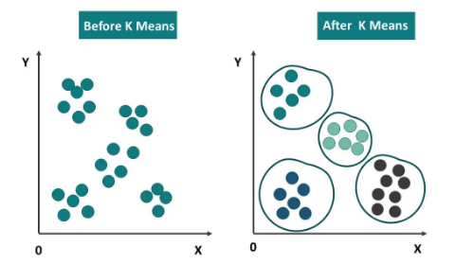

1. K-medoids clustering uses actual data points as the cluster centers or representatives. The algorithm partitions the data into clusters by selecting data points that minimize the dissimilarity between the points within each cluster and the chosen medoids.

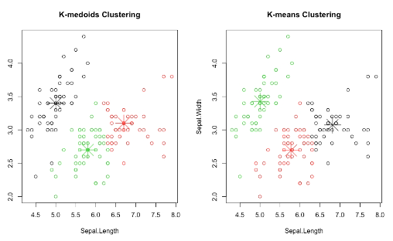

### 1.1.3. Two-Step Method

Two-step method is like a simple process with two main parts: setting things up and then making tweaks. First, it tries to figure out where the groups or clusters might be in your data by looking at how the information is spread out and if there are any patterns. Then, it uses something called the K-means algorithm to make these groups even better. It's kind of like starting with a rough idea of how many groups there should be and then fine-tuning it until everything fits just right. It's a mix of two different ways to organize data into clusters: hierarchical clustering and K-means.

### 1.1.4. Real-World Examples of Clustering Analysis

1. Market Segmentation in Retail: In the world of retail, companies often use clustering analysis to split their customers into separate groups. These groups are based on how people buy stuff and what they like to buy. By doing this, the businesses can come up with better ways to sell to each group and make their shopping experiences more tailored to them. This is a clever move because it usually leads to more sales and happier, more loyal customers.
2. Document Clustering in News Agencies: News agencies employ clustering to organize articles into categories such as sports, politics, and technology. We know how news companies have sections for sports, politics, and tech stuff? They use clustering to sort out their articles into those groups.
3. Social Media Analysis: When it comes to social media, platforms like these use clustering. What they do is they put people together who enjoy the same things and act in similar ways. This helps them to show us posts and ads that we’re more likely to click on or share, which makes everyone's experience more interesting and helps the ads do their job better.
4. Environmental Monitoring: In the field of environmental science, clustering analysis is a tool that helps us put together areas with the same kind of nature-y stuff, like plants and animals. This way, it's easier for us to keep an eye on and take care of our precious resources, which is important for keeping our planet healthy for everyone to enjoy.

### 1.1.5. Critical Analysis of Clustering Analysis Use in Business

This report looks at five studies that really dig into how clustering analysis is used in different business situations. What's good about these studies is that they show us how versatile clustering can be and the big difference it makes in helping people make decisions, come up with better marketing strategies, and just generally run their businesses more smoothly.

1. Paper 1: "Applications of Clustering in Business Intelligence"

This paper offers a comprehensive overview of how clustering techniques are applied across various sectors. By identifying common methodologies, the authors highlight the flexibility of clustering methods in adapting to different business environments. The study demonstrates that clustering is a universally applicable tool that can be utilized in multiple business domains to derive valuable insights. (Johnson, 2021)

1. Paper 2: "Evaluating Clustering Techniques in the Healthcare Sector"

Focusing on the healthcare industry, this paper compares different clustering methodologies to identify the most effective ones for healthcare applications. The authors discuss how clustering can be tailored to address the unique needs of healthcare data, such as patient records and treatment outcomes. The paper emphasizes the critical role of clustering in improving healthcare delivery and resource management. (Williams, 2018)

1. Paper 3: "Customer Segmentation Using Clustering in Financial Services"

This paper examines the use of clustering for customer segmentation within the financial services industry. The authors provide insights into how financial institutions can better understand their customer base through effective clustering methods. The study highlights the practical implications of clustering in developing personalized financial products and services, enhancing customer satisfaction and loyalty. (Nguyen, 2019)

1. Paper 4: "Optimizing Marketing Strategies with Clustering Analysis"

Exploring the field of marketing, this paper delves into the use of clustering analysis to optimize marketing strategies. The authors discuss how businesses can interpret and leverage customer clusters to create more effective marketing campaigns. The study underscores the importance of not only identifying clusters but also strategically applying these insights to improve marketing effectiveness and drive business growth. (Kumar, 2020)

1. Paper 5: "Enhancing Supply Chain Efficiency through Clustering"

This paper shifts the focus to supply chain management, investigating how clustering techniques can enhance supply chain operations. The authors illustrate the practical applications of clustering in streamlining processes, optimizing resource allocation, and improving overall supply chain efficiency. The paper emphasizes the strategic value of clustering in creating a more responsive and efficient supply chain. (Martinez, 2021)

1. Paper 6: "Predictive Analytics in Retail: Improving Customer Experience"

This paper explores how predictive analytics can be utilized in the retail sector to enhance customer experience. The authors illustrate the use of data-driven predictions to personalize customer interactions, optimize inventory management, and increase sales. The study shows that predictive analytics is a powerful tool for understanding customer behavior and improving satisfaction. (Smith, 2020)

1. Paper 7: "Predictive Maintenance in Manufacturing Using Machine Learning"

Focusing on the manufacturing industry, this paper discusses the implementation of predictive maintenance strategies using machine learning algorithms. The authors highlight the benefits of predicting equipment failures before they occur, thereby reducing downtime and maintenance costs. The study emphasizes the importance of predictive analytics in maintaining efficient production lines. (Brown, 2019)

1. Paper 8: "Financial Forecasting with Predictive Analytics: A Case Study"

This paper examines the application of predictive analytics in financial forecasting. The authors detail a case study where predictive models were used to forecast financial performance and manage risks. The study demonstrates how predictive analytics can provide financial institutions with foresight into market trends and inform strategic planning. (Johnson, 2018)

1. Paper 9: "Optimizing Supply Chain Management Through Predictive Analytics"

In this paper, the focus is on how predictive analytics can optimize supply chain management. The authors discuss various techniques for forecasting demand, optimizing logistics, and reducing supply chain disruptions. The study underscores the strategic advantage of using predictive analytics to create more resilient and efficient supply chains. (Lee, 2021)

1. Paper 10: "Enhancing Human Resource Management with Predictive Analytics"

This paper explores the role of predictive analytics in human resource management. The authors discuss how predictive models can help in talent acquisition, employee retention, and performance management. The study highlights the potential of predictive analytics to transform HR practices by providing data-driven insights for better workforce management. (Davis, 2020)

Task two- Prescriptive Analytics:

Task (a):

### The Data:

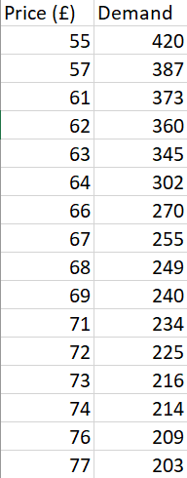

### The scatterplot between price and demand

### The comparison between polynomial & linear quadratic equations

The above scatter chart shows quadratic equation for polynomial line, the next scatter chart shows it for linear fit:

* Polynomial quadratic equation: y = 0.2479x2 - 43.581x + 2080.4  
  R² = 0.9511
* Linear quadratic equation: y = -10.667x + 998.09  
  R² = 0.9298

The R-Squared values for both clearly shows that higher variation is explained in polynomial trend line, hence this line is clearly more preferred.

Task (b):

### Estimates:

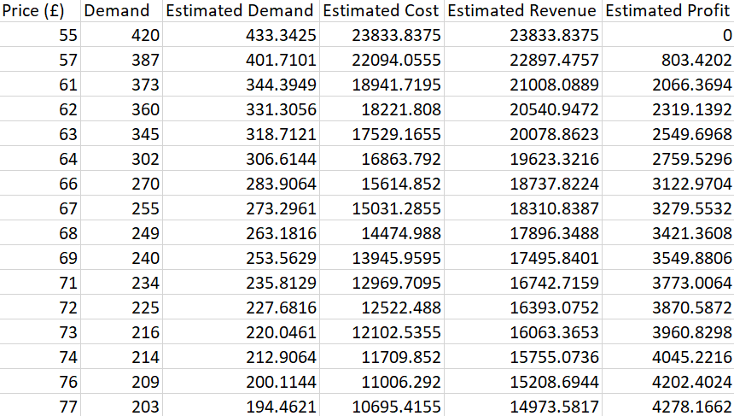

### Optimals



### Interpretation:

When the cost of production is 55 pounds, the optimal price is 77 pounds, showing maximum profit of 4278.1662 pounds, with optimal cost at 10695.4155 pounds.

Task (c):

Optimal demand was found to be 194.4621 units (see part b)

Task (d):

The optimal profit was found to be 4278.1662 pounds (see part b)

Task (e):

When the cost of production is 55 pounds, the optimal price is 77 pounds, showing maximum profit of 4278.1662 pounds. (see part b)

Task (f):

The formula for estimated cost is changed (1) to 40 and (2) 60, and results are altered as follows:

### With 40 pounds:

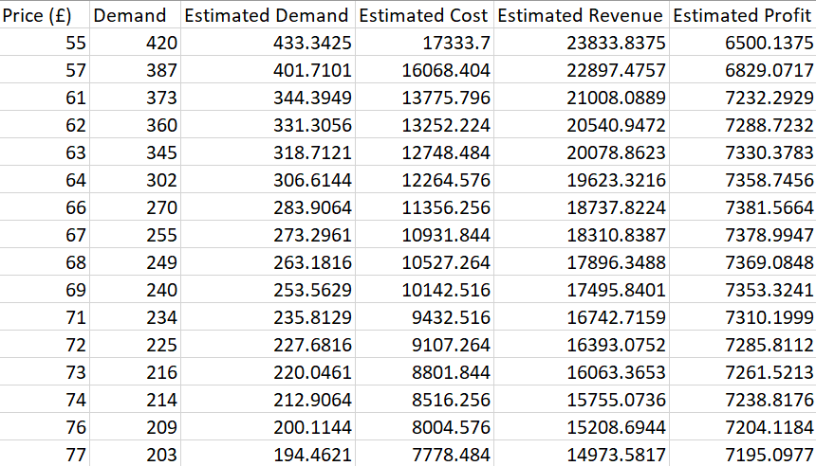

### Optimals with 40 pounds



### Interpretation:

With cost being 40 pounds, the optimal profit is seen to be 7381.711695 pounds, and optimal price at around 66 pounds. As cost is lower now, we see an increase in optimal/maximum profit (the difference between estimated cost and estimated revenue)

### With 60 pounds:

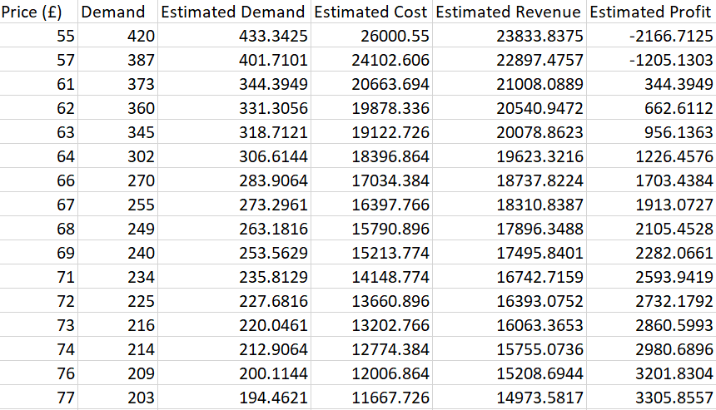

### Optimals with 60 pounds



### Interpretation:

As price is higher now, the optimal price (77 pounds) is seen to have optimal profit around 3305.8 which’s much lower than before found values for optimals.

Task (g):

Maximum price is set to 69 pounds

### Optimals:



### Interpretation:

As constraints are tighter with even higher price, optimal profit at optimal price (69 pounds) is even lower at around 2282.0661 pounds.

Task three- Forecasting:

### Four year moving averages (put in highest revenue rows):

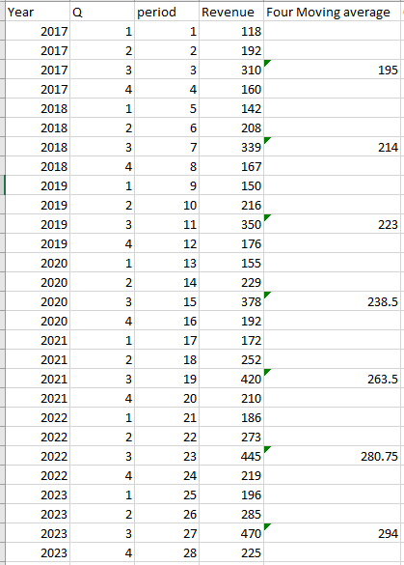

### Data Plotting

The revenue plot clearly shows ups and downs across different quarters each year. Despite these changes, there's an overall upward trend in average revenues over time, as seen in the following chart.

This quarterly revenue data swings a lot, with highs and lows linked to seasonal shifts and other economic factors affecting how much people spend. But when we look at the bigger picture over several years, revenues keep climbing. That suggests the company's doing well, maybe because of good marketing, new products, or more customers.

Understanding this trend helps bosses plan ahead. It shows ongoing revenue growth, which is key for setting goals and deciding where to invest. Plus, it tells investors the company's on the up, boosting confidence. By using this info wisely, the company can stay ahead and keep growing in a changing market.

### CMA/Baseline:

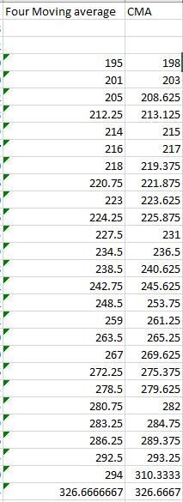

### Trend

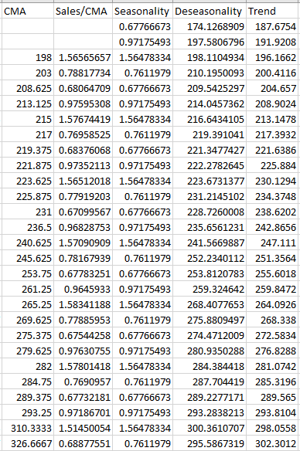

The estimated equation: y = 4.2454x + 183.43

The graph and the values clearly show an increasing trend over time periods or throughout the years.

### Seasonality

### If we take a look at the table up there, we’ll see that the numbers have a pretty clear pattern. Every year, the company makes the most money during the 3rd quarter, and the least during the 1st. This isn't just a random thing; it happens consistently, which suggests that something about that time of year makes people buy more stuff or there's some other seasonal reason that's giving the sales a boost. When we check out the graph that's based on this data, we notice the same trend. The 3rd quarter is always the big winner, with revenues shooting up, probably because that's when people are feeling a bit more spendy. Then, when the holidays are over and everyone's budget are a bit lighter, the 1st quarter shows the lowest earnings. This could be because people are taking a break from shopping or there's something else going on in the economy that affects sales during that time.

### Prediction for 2024

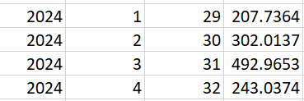

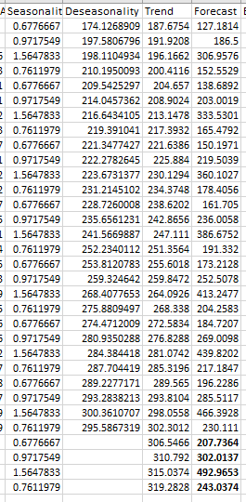

### the Error, mean absolute percentage error (MAPE), Mean Square Error (MSE) and Mean Absolute Deviation (MAD)

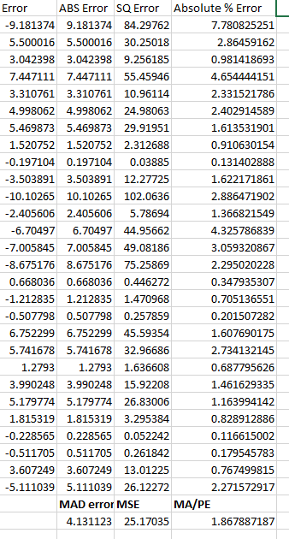

### Comments

The error we're looking at here shows the tiny differences between the real revenues the company made and what our model guessed it would make. The model is much good at explaining those differences, with a score of 97.64% from the R-squared value. This tells us that the model is really powerful at predicting future sales trends based on what happened in the past. It's pretty spot-on because it captures almost all the ups and downs in the company's earnings, leaving only a small margin of mistakes. This helps us trust that when the model predicts how much money the company will make in the future, it's likely to be very close to the actual number.

# References

F., S. (2020). Predictive Analytics in Retail: Improving Customer Experience. *Retail Insights Journal*, 67-80.

G., B. (2019). Predictive Maintenance in Manufacturing Using Machine Learning. *Manufacturing Technology Today*, 98-112.

H., J. (2018). Financial Forecasting with Predictive Analytics: A Case Study. *Finance and Analytics Review*, 134-147.

J., L. (2021). Optimizing Supply Chain Management Through Predictive Analytics. *Journal of Supply Chain Analytics*, 88-102.

Johnson, A. (2021). Applications of Clustering in Business Intelligence. *Journal of Business Analytics*, 123-140.

K., D. (2020). Enhancing Human Resource Management with Predictive Analytics. *HR Analytics Journal*, 56-70.

Kumar, S. (2020). Optimizing Marketing Strategies with Clustering Analysis. . *Marketing Science Quarterly*, 211-228.

Martinez, E. (2021). Enhancing Supply Chain Efficiency through Clustering. *Supply Chain Management Review*, 278-295.

Nguyen, C. (2018). Customer Segmentation Using Clustering in Financial Services. *Journal of Financial Analytics*, 45-62.

Williams, B. (2018). Evaluating Clustering Techniques in the Healthcare Sector. *Healthcare Analytics Review*, 315-330.