DATABASE REPORT

**Group Members:**

Talha Shahzad 21i-0540

Ali Khizar 21i-0514

**TASK 1:**

**PART 1**

**Entities:**

* Stadiums
* Players
* Teams
* Managers
* Goals
* Matches

**Relations:**

* One team consists of many players
* One team can be manages by one manager
* A player can goal many goals
* Many matches can be played in a stadium
* A match can have many teams

**PART 2**

**Fully Functional Dependencies:**

**Stadium:**

Id -> {name,city,country,capacity}

**Teams:**

Team_id->{team_name,country,home_stadium_id}

**Players:**

It is not fully functional because there exist a partial dependency due to team_id.

**Manager:**

Id->{first_name,last_name,DOB,team_id}

**Matches:**

This is not a fully functional because there exists a composite key.

**Goals:**

It is not a fully functional dependency because there exist composite key and redundant values.

**Partial Dependencies:**

**Stadium:**

There is no other key than primary key. Hence, there do not exists any partial dependency.

**Teams:**

There is no partial dependency present in this table.

**Players:**

Team_id->{jersey_number,height,weight,foot}

So it is partially functional.

**Manager:**

No partial dependency present in this table.

**Matches:**

Stadium_id->{ht_score,at_score,pso,attendance}

Hence it became a partial dependency.

**Goals:**

It is a partial dependency because

Pid->{duration,assist}

Match_id->{goal_desc}

**PART 3**

**Normal forms:**

**Stadium:** This table is in 3NF. Since there is no redundancy, no composite key, no partial dependency and in last no transition dependency so it is in 3NF. So no normalization required.

**Teams:** This table is also in 3NF. Because there do not exist redundancy. No multi valued attribute or composite keys. There exists no partial dependency. No transition dependency. Hence no normalization required.

**Managers:** This table is also in 3NF. . Since there is no redundancy, no composite key, no partial dependency and in last no transition dependency. Hence normalization is not required.

**Players:** This table is in 1NF. There exists a composite key and hence a partial dependency so we have to make it in 2NF.

Such that {player_id,match_id}->jersey_number

So for that reason we have to make a new table.

**Matches:**

This table is also in 1NF form. There exist a composite key or a partial dependency such that

{Match_id,stadium_id}->{home_team_score,away_team_score,penalty_shoot_out}

So we have to make it in 2NF by breaking the table based on partial dependency.

**Goals:**

The table is in 1NF form. But there exist a transitive dependency in goal_id, player_id and assist_player_id.

So we have to break the table to remove it and make it in 3NF.

**QUERIES SCREENSHOT:**

**1.**

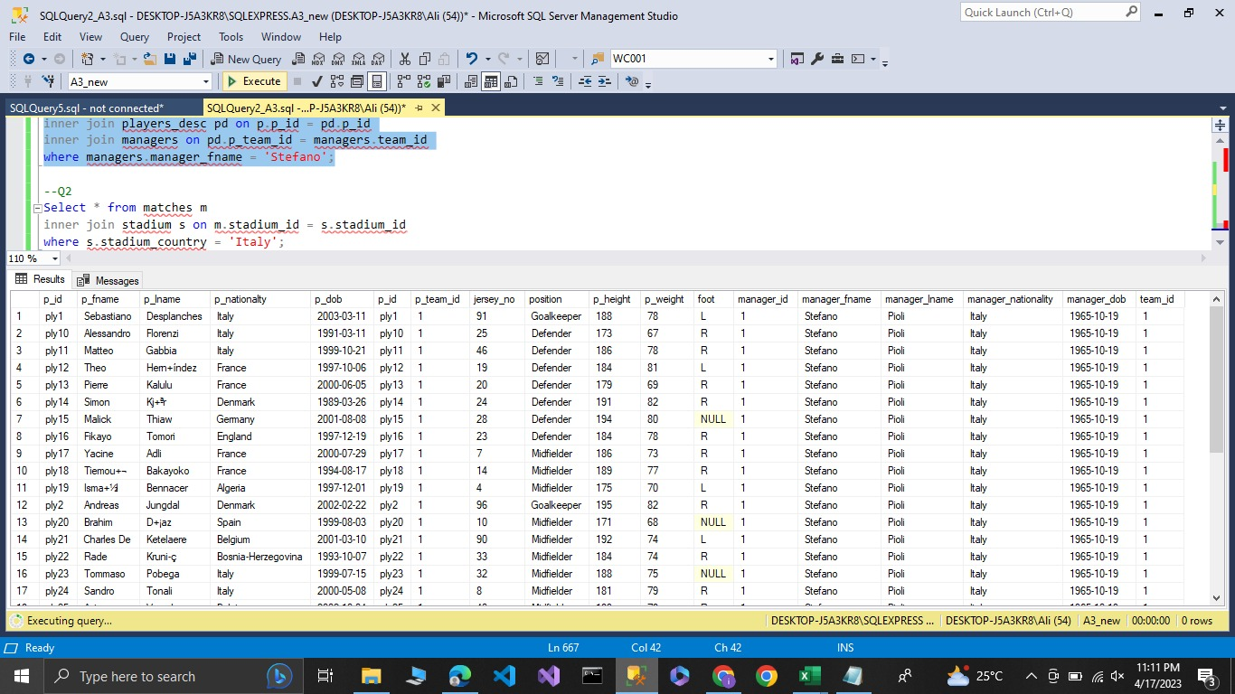

**2.**

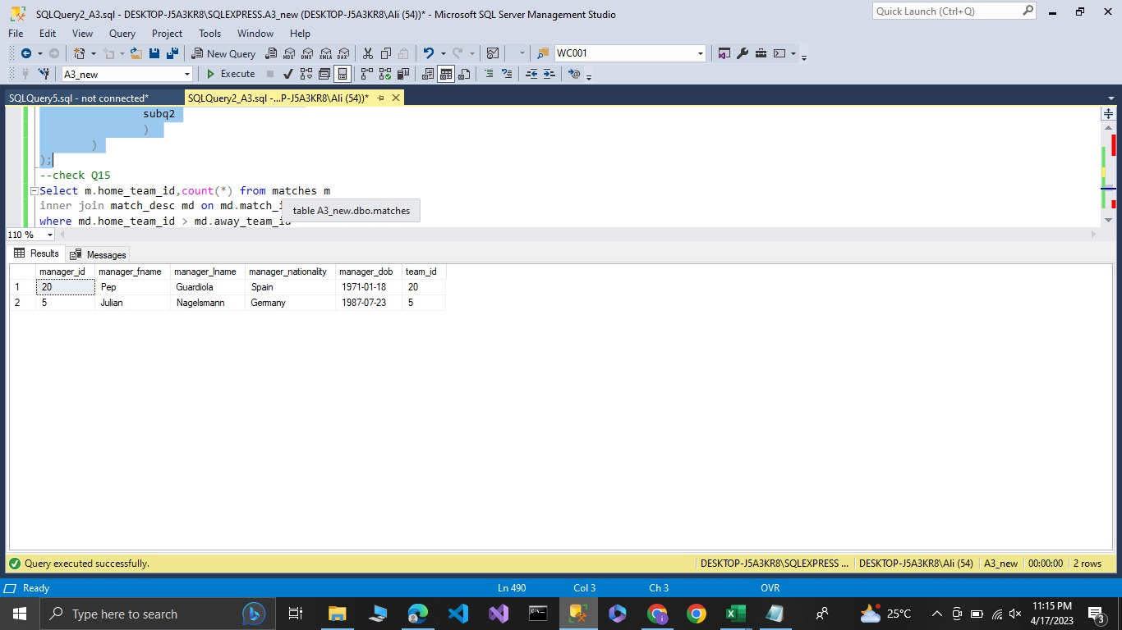

**3.**

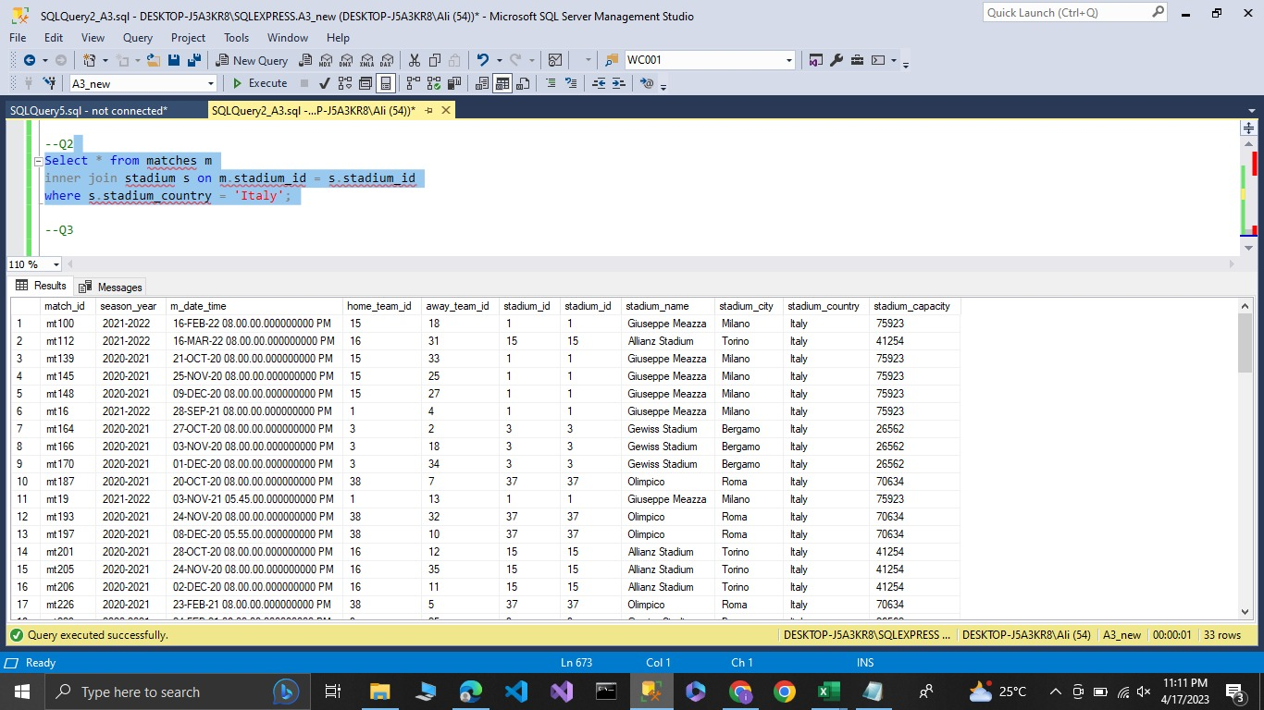

**4.**

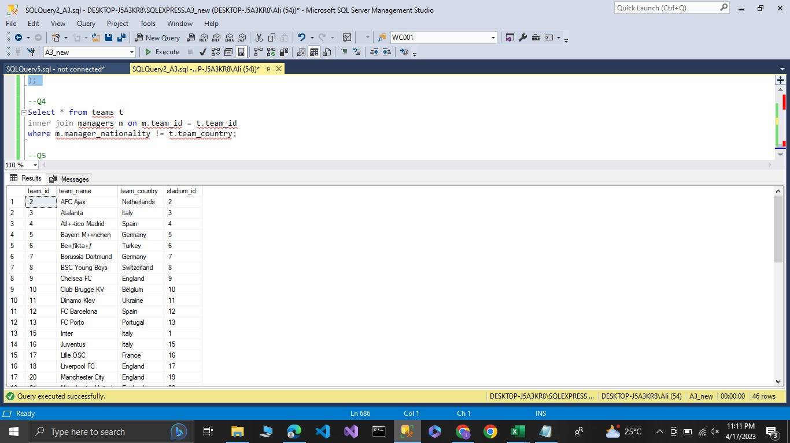

**5.**

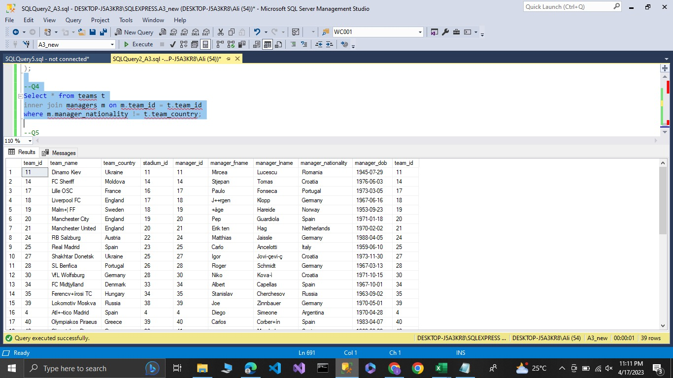

**6.**

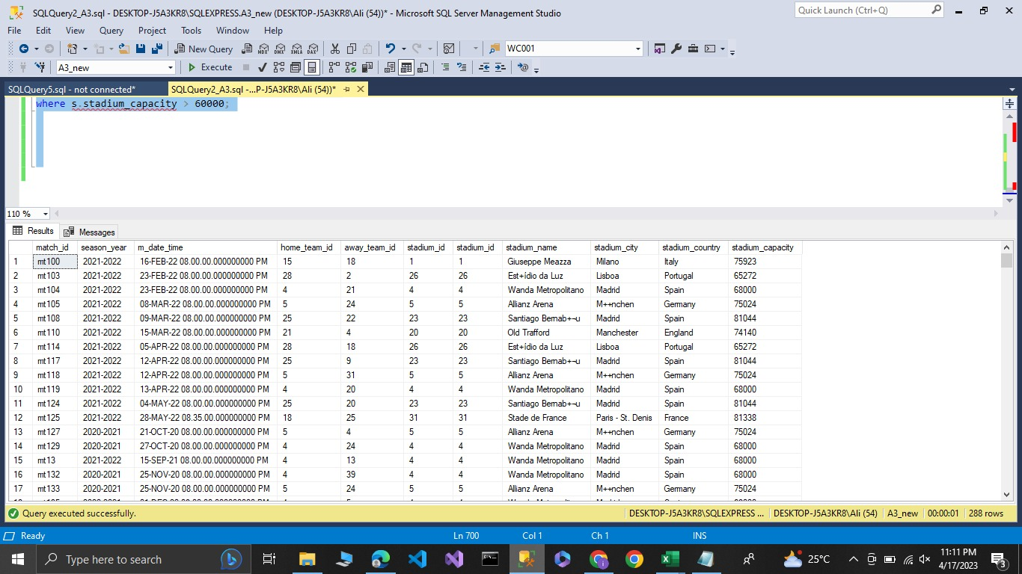

**7.**

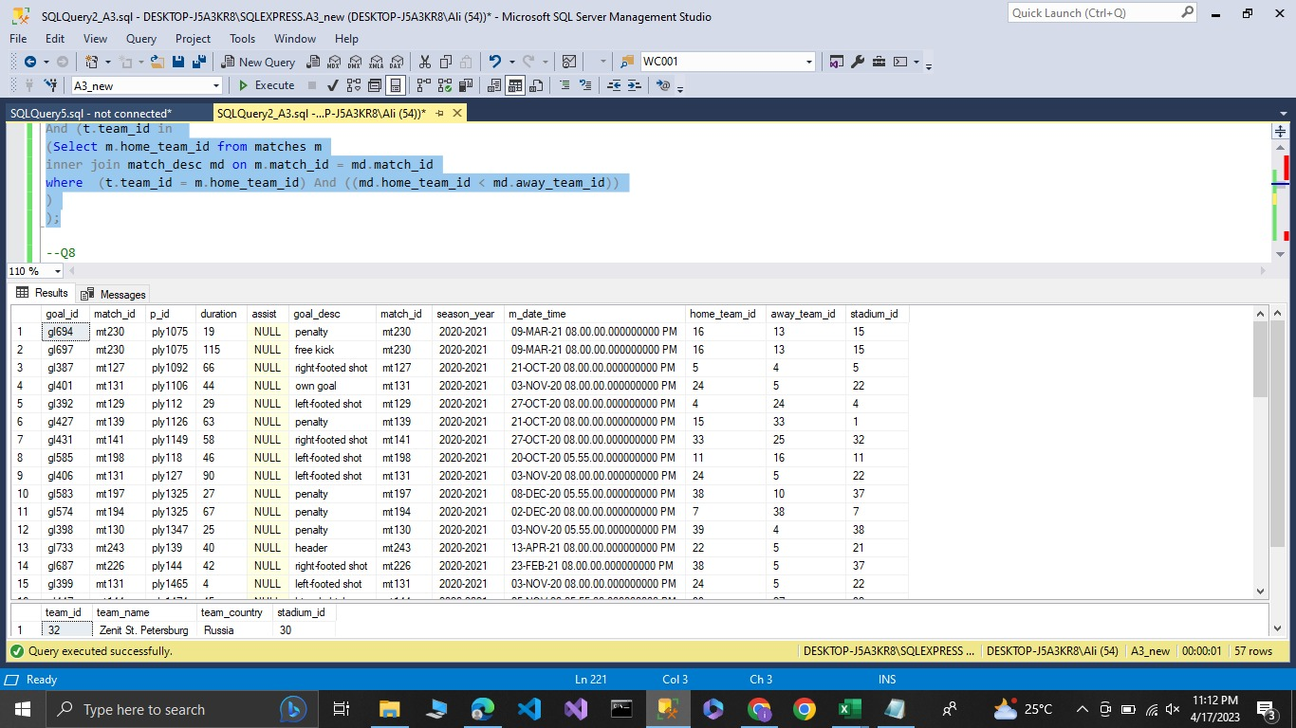

**8.**

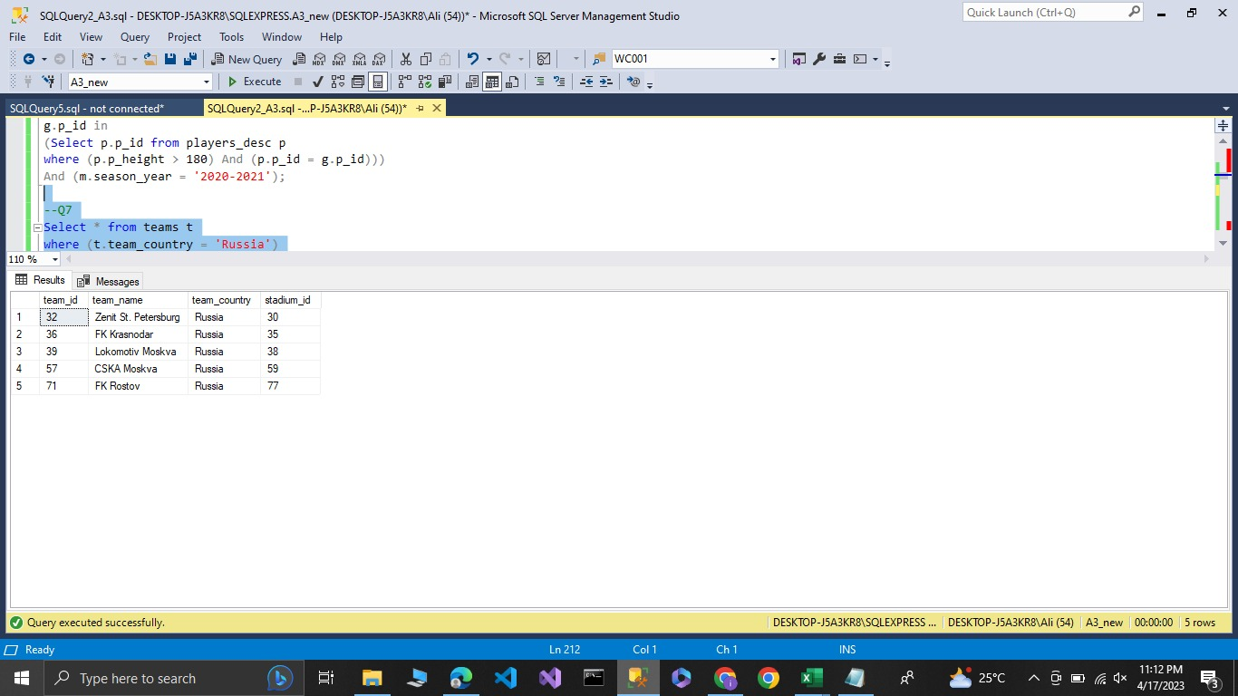

**9.**

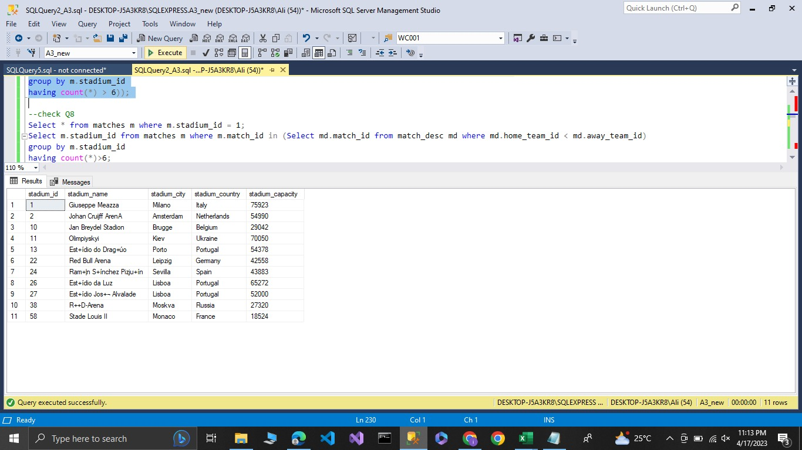

**10.**

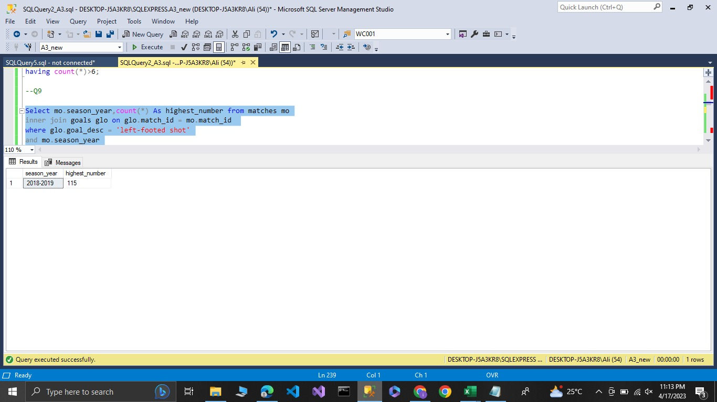

**11.**

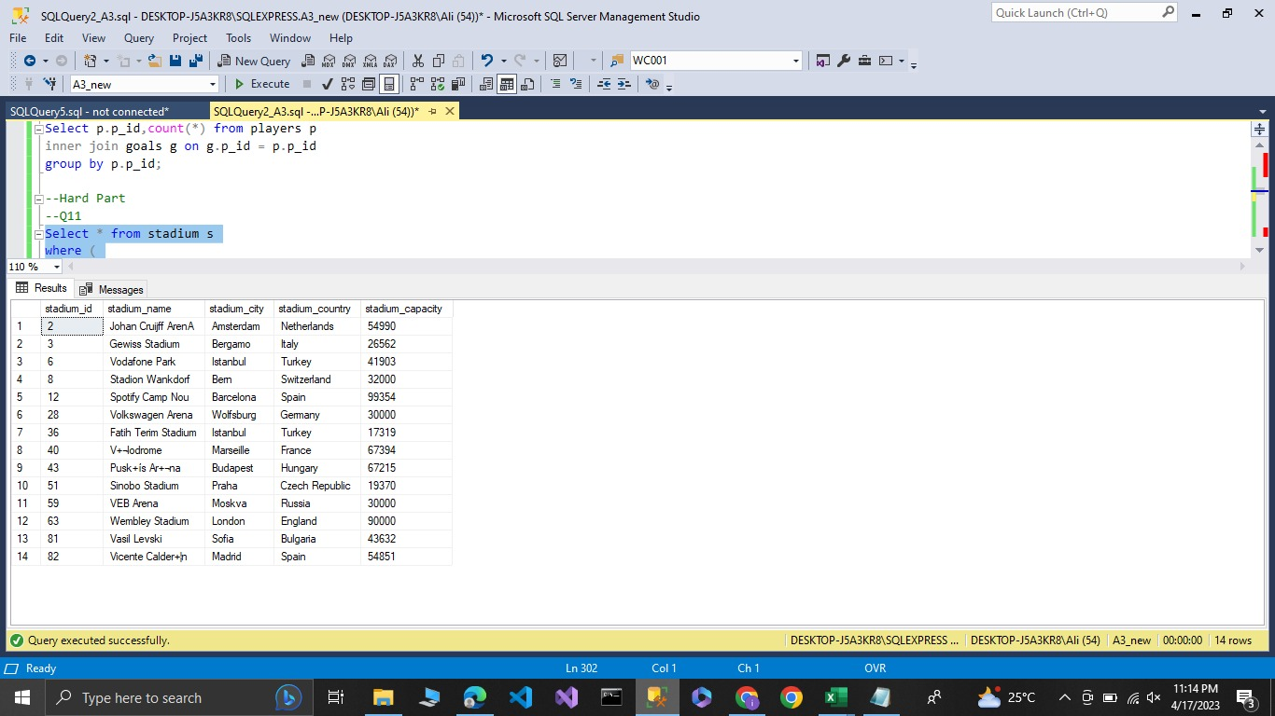

**12.**

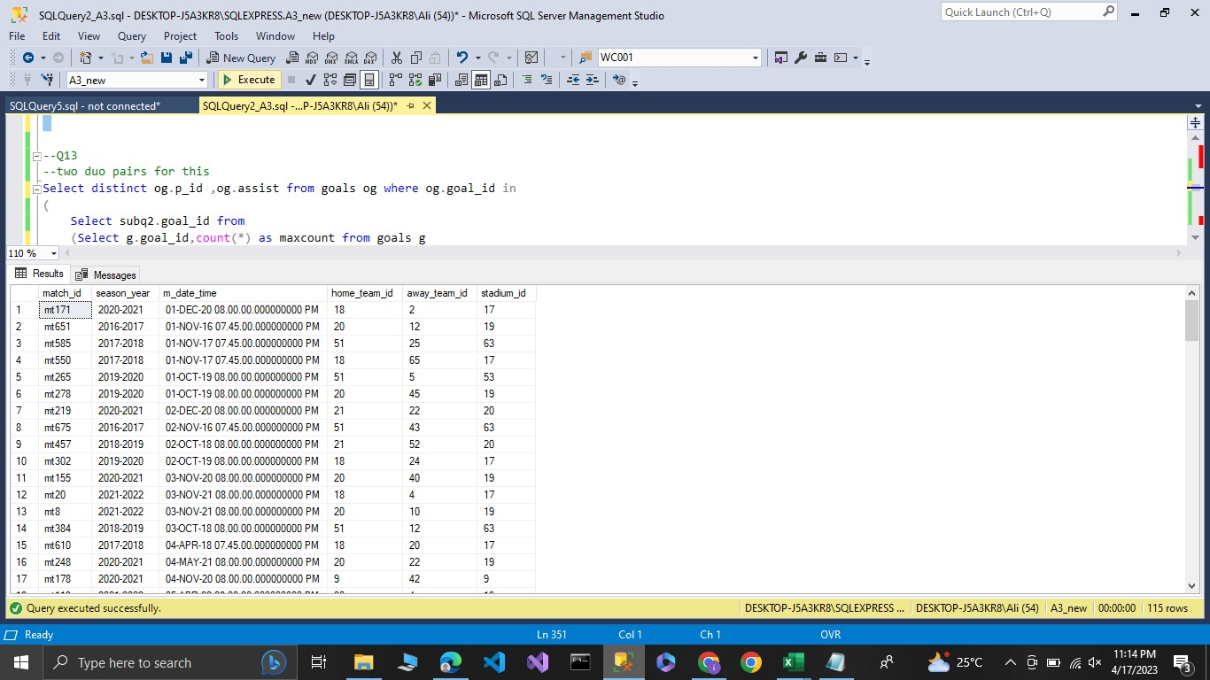

**13.**

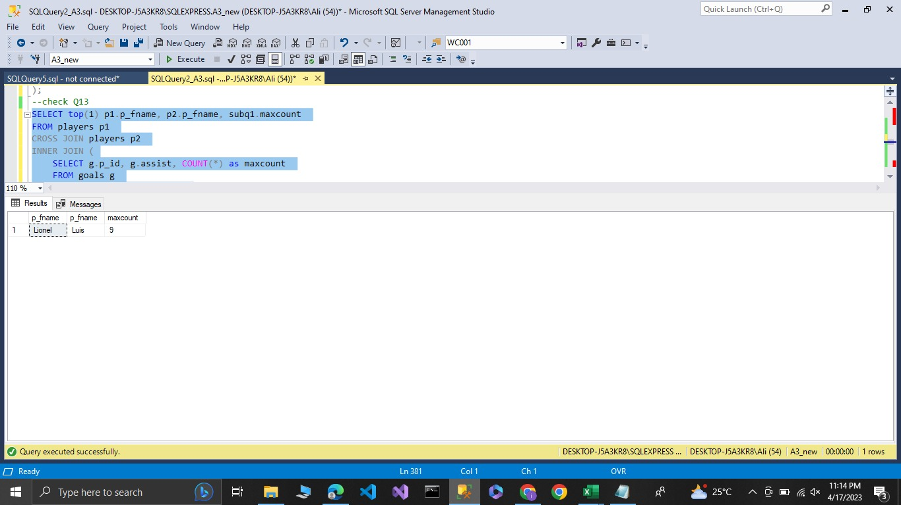

**14.**

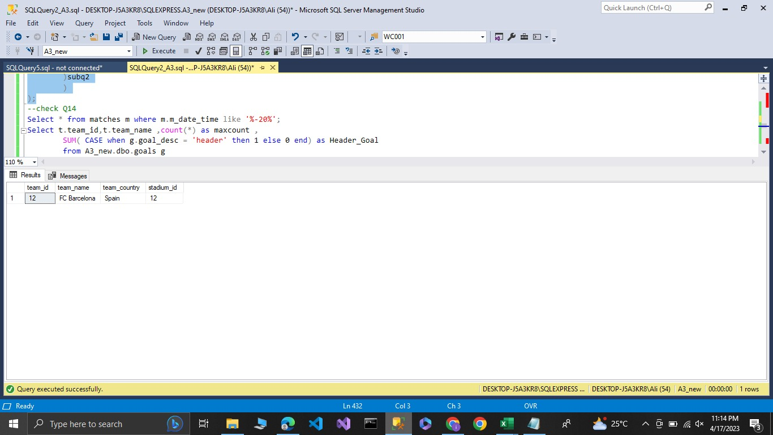

**15.**

