Alix Casey LAB3 PART2

1. **What is the G score? What is the Z score? What is the p-value? What does this tell you? Paste your results image below.**

g-score: 0.000042

z-score: 3.463102

p-value: 0.000534

There is no clustering. It is not significant

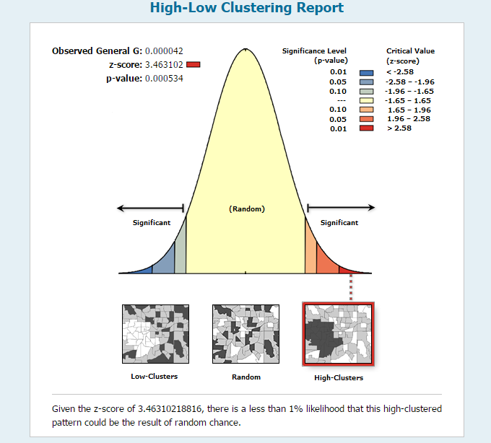

1. **What are the results of Spatial Autocorrelation (Global Moran’s I)? What does this tell you about clustering of housing values? Paste your results image below.**

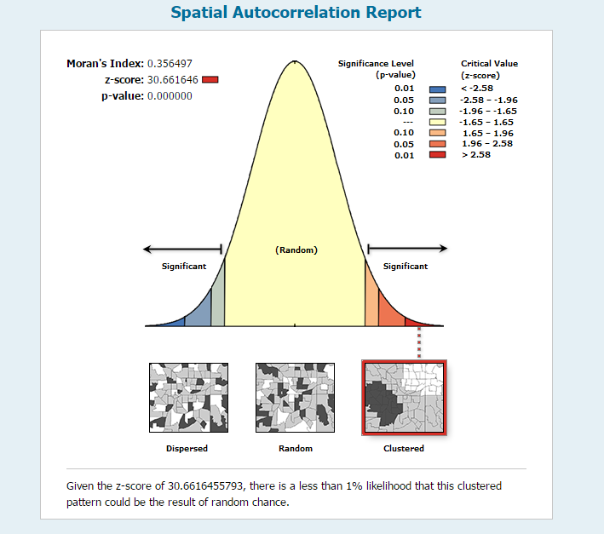

1. **Are there any clusters present? Where? Describe them – are they HH or LL or other. Paste your map image below.**

1. **Are there significant clusters? Describe them. Do these represent HH or LL significant clusters? Paste your map image below.**
2. **Is there spatial autocorrelation of points based on the number of cholera deaths (you can see this number in the Count column in Cholera_Deaths)? Try a few different measures of global autocorrelation - ANN, Moran’s I, Ripley’s K. Report your results below. Was the correlation in any of the measures significant? Paste the image from the html report for Moran’s I below.**

1. **Create a map that shows the points displayed by graduated symbols (see the Symbology tab and go under Quantities) and display Value of “Counts”. What classification scheme are you using? How many classes? Why? Does this display help you identify where the most deaths occurred? If so, where would you see the clustering of deaths is highest? Paste an image of your map below.**
2. **Create a Local Moran’s I. This will create a new layer. Where did you find the highest clusters in this new layer? Past an image of your map below.**
3. **Document the settings you choose for making your two interpolations.**
4. **Explain how the interpolation methods in your two maps work and why you choose those settings.**
5. **Paste the maps below. Discuss the differences between the two maps and explain the differences in terms of how the interpolation methods you choose work. Use examples from your maps.**
6. **Document the settings you chose for classifying the two interpolations. Explain why you choose these settings (why choose standard deviation, Natural Breaks, etc.).**
7. **Insert the two layer images below. Explain differences in the maps in terms of classification decisions. Where are differences? Why?**
8. **Choose your favorite interpolation layer. Put the pumps and death points (proportional symbology) on top of your new raster layers. You can move the layers in the table of contents. Paste the map below.**
9. **Based on your analysis, what pump (each pump has a unique FID) would you shut off?**