LAB3 Alix Casey

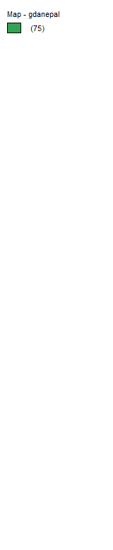

1. **Add a base map to your map window. Right-click on the map and save a copy of the image to your clipboard. Paste the image into your working document. It should look something like this.**

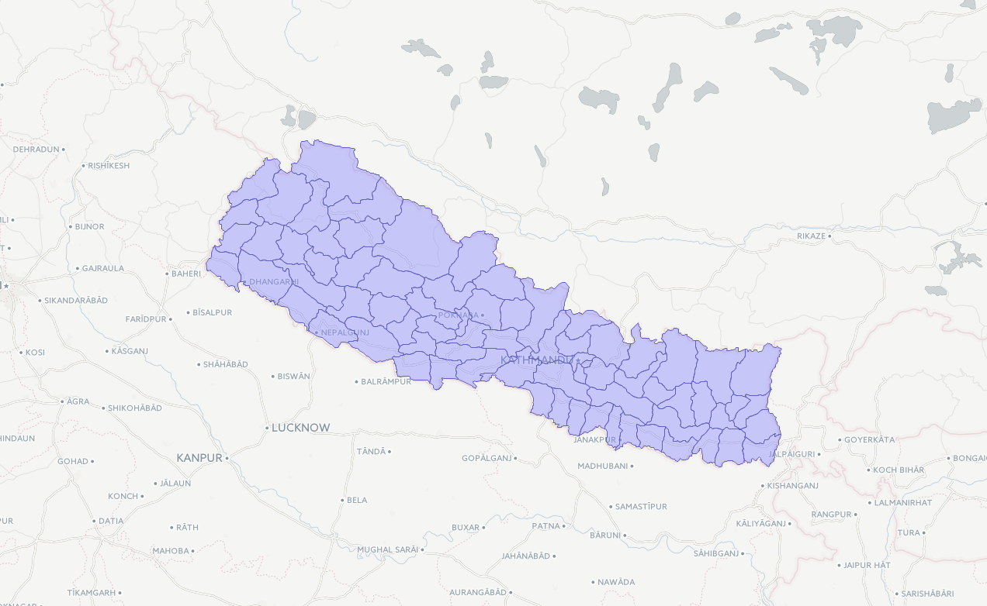

1. **Paste images of the two maps below. Describe the two maps. Which general areas in the maps have higher rates of ALF and CPR? Do the spatial distributions appear to be similar? What does this suggest?**

The higher values for both ALF and CPR are mostly in the center and right end of the map. It is possible that there is a correlation between the adult literacy rate and contraceptive prevalence rate.

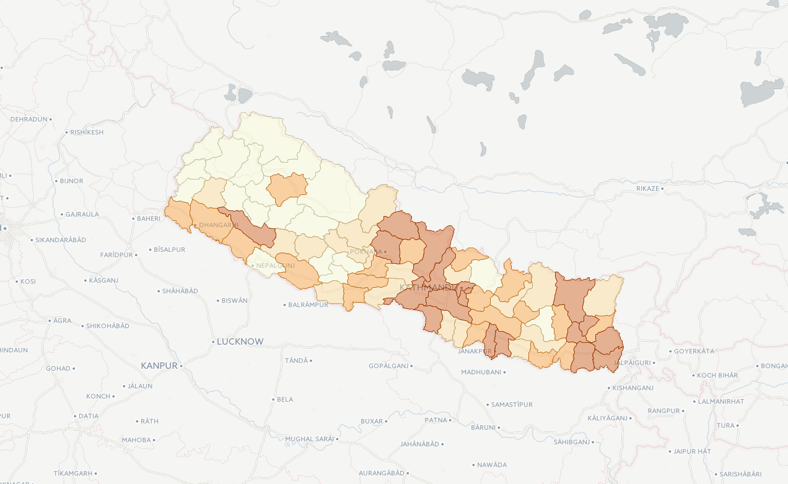

CPR

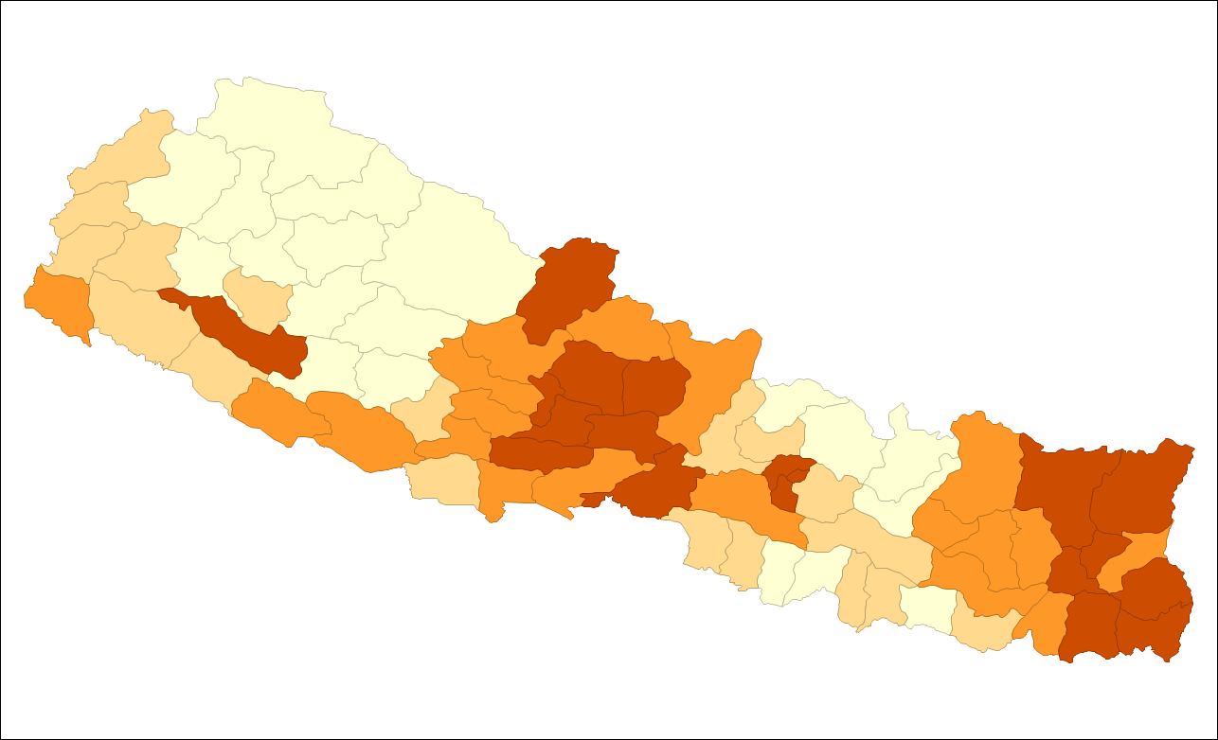

ALF

1. **Paste the histogram here. Describe the histogram distribution of adult female literacy in Nepal. Using your eyes, is the distribution parametric? Is it positively or negatively skewed? Using the statistics read out, what is the mean rate of female literacy in Nepal?**

It is nonparametric because it is not a normal distribution. It is positively skewed. The mean rate of female literacy is 18.7276.

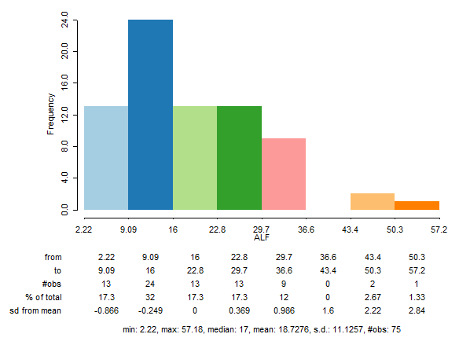

1. **Paste the standard deviation map here. What is the mean contraceptive rate for Nepal? What do the dark blue and dark red colors indicate on the standard deviation map?**

Mean = 19.0053. The blue represents locations -2.79 to 8.11 SDs away from the mean. The dark red represents any location >40.8 SDs away from the mean.

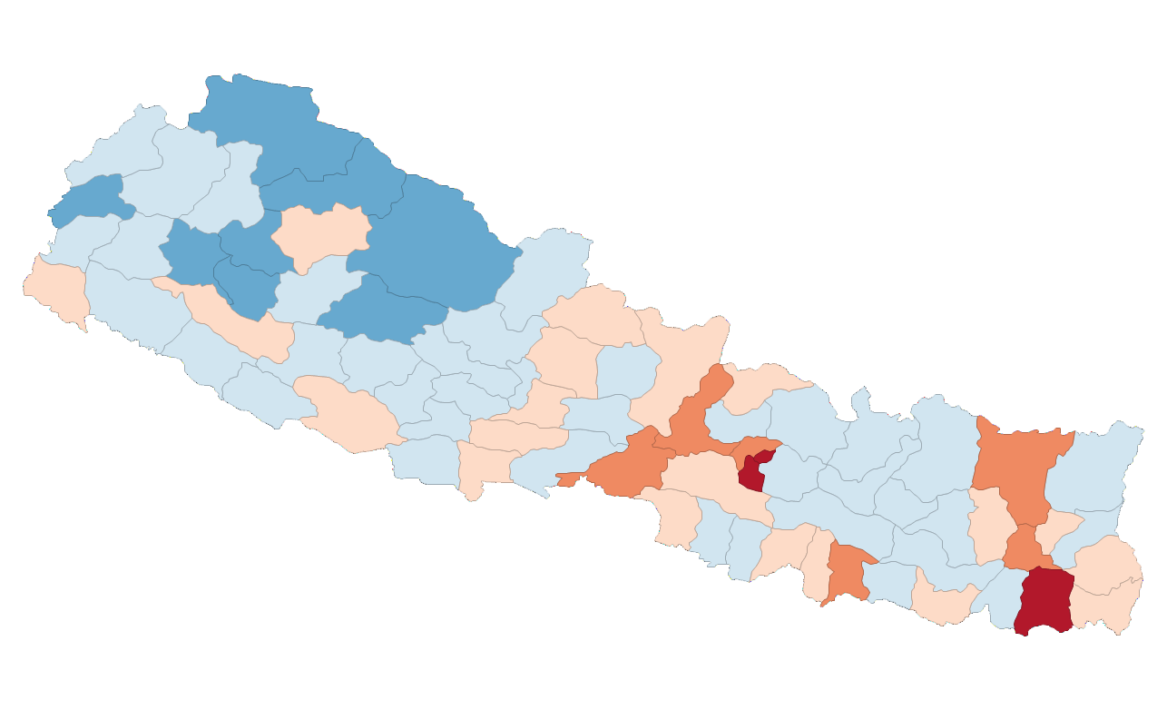

**5. Paste the scatterplot here. What does the scatterplot tell you/ suggest about the relation between CPR and ALF?**

There could be correlation between the two data sets. They are also both not normally distributed.

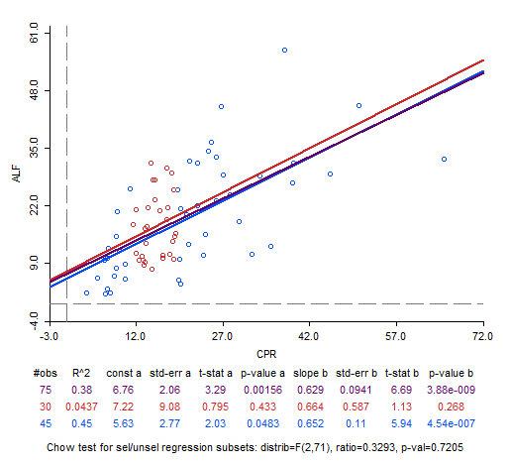

1. **In your own words, define the following terms and answer the questions.**
2. **Centroid:** center area of a geographic unit.
3. **Weight Matrix:** adds structure to the data to determine the amount of the similarity between location and values.
4. **What are the two broad types of matrices?** Contiguity: shared borders. Distance
5. **Are Queen and Rook contiguity or distance based?** Contiguity.
6. **Spatial Autocorrelation:** comparing the correlation between a variable and itself in space.
7. **What is the difference between global and local spatial autocorrelation measures?** Global captures the complete clustering in a dataset. Local shows cluster and spatial outliers that have a local location.
8. **What test is used for global spatial autocorrelation?** Local Moran statistic
9. **What test is used for local spatial autocorrelation?** Global Moran’s I.
10. **Briefly describe the purpose of creating a weight file.**

Computation of spatial autocorrelation statistics.



1. **Paste the Queen’s histogram and Rook’s histogram here. How many districts had 8 or more neighbors based on the Queen’s contiguity matrix? How many had 8 or more neighbors in the Rook’s contiguity matrix? What were the names of the different districts for both Queens and Rook’s that had 8 neighbors?**

4 districts had 8 or more neighbours in the Queen’s contiguity matrix. 3 districts had 8 or more neighbours in the Rook’s contiguity matrix. The names of the districts are Jajarkot, Surkhet, Myagdi, Salyan, Tanahu, Kathmandu, Kavrepalanchok, Dhankuta, Singhuli, Udayapur.

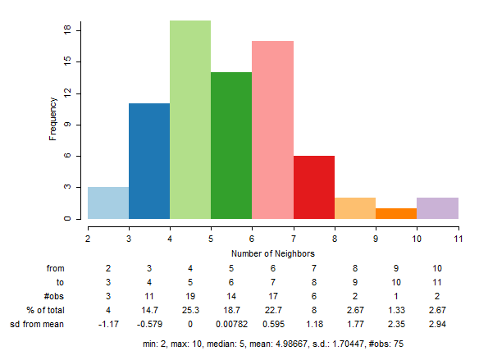

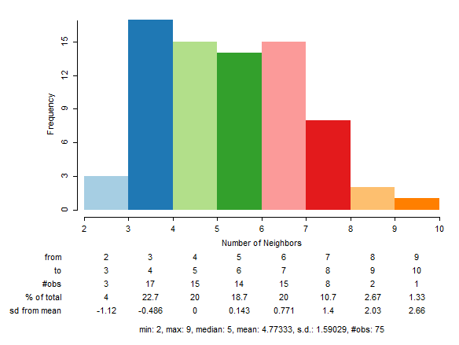

1. **Explain the difference in weight files above by explaining what the Queen’s contiguity approach to neighbor selection is and how it differs from Rook’s contiguity. Draw an example of the contiguity differences in a Queen’s Weight Matrix and a Rook’s Weight Matrix (you might use any graphics program or you can insert shapes here).**

The queen’s matrix defines a location’s neighbours by determining those who share a border or vortex. A rook’s matrix determines a location’s neighbours by determining only those who share a border, but not a vortex. This can explain the difference in the spread of the histogram.

1. **Paste the Global Moran’s I image here. Label the 4 quadrants of a basic Moran’s I graph. Label each quadrant correctly using the x-y terms as high-high (HH), high-low (HL),  low-low (LL), or low-high (LH). Draw a line that shows a negative correlation going through the quadrants.**

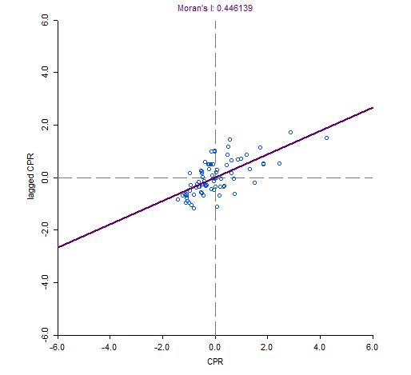

Negative Correlation

Low-high (LH)

High-high (HH)

Low-low (LL)

High-low (HL)

1. **Paste the image here. While the previous data showed you a p-value based on a normal distribution, this one shows you a pseudo p-value based on permutations.**

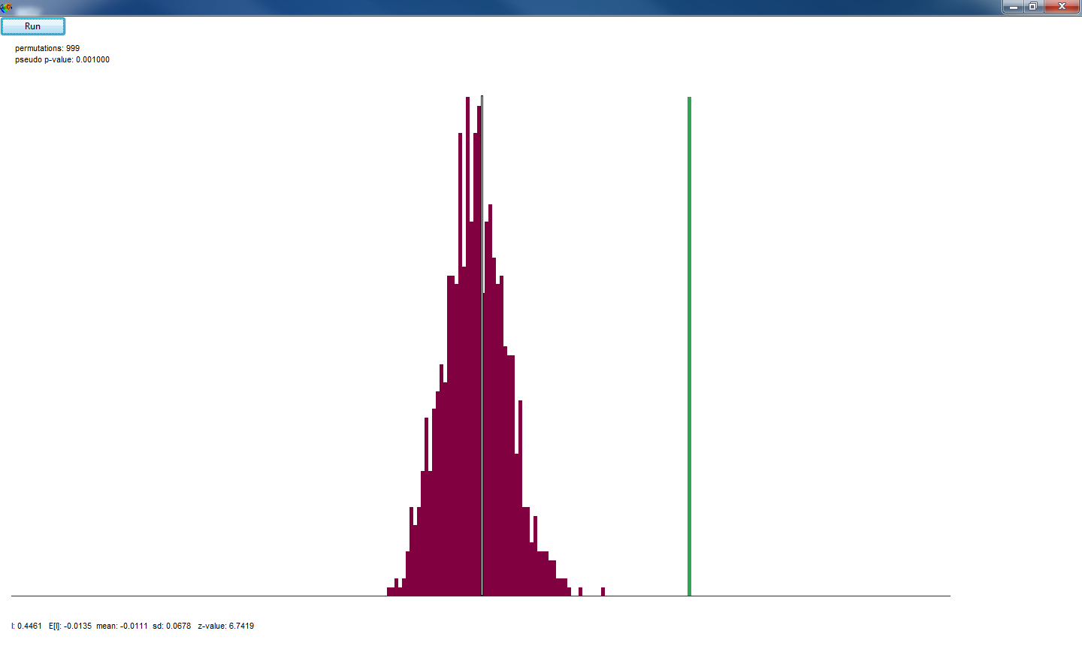

* 1. **What are your null and alternative hypotheses?**

Null: There is no significant clustering for this data set. Alternative: there is significant negative or positive clustering for this data set.

* 1. **Is the rate of contraceptive use in Nepal spatially clustered? If so, report the Global Moran’s I and the pseudo p-value.**

Pseudo p-value: 0.001000. Moran’s 1: 0.446139

* 1. **Interpret your results in plain English.**

The pseudo value is lower than 0.05, so we can reject the null. This means that there is a significant negative or positive clustering of the data.

1. **Paste the map significance and cluster map here. Where are the clusters of high contraception use in Nepal? What is the name of the development region in which many of these districts are found? Interpret your results in terms of significance.**

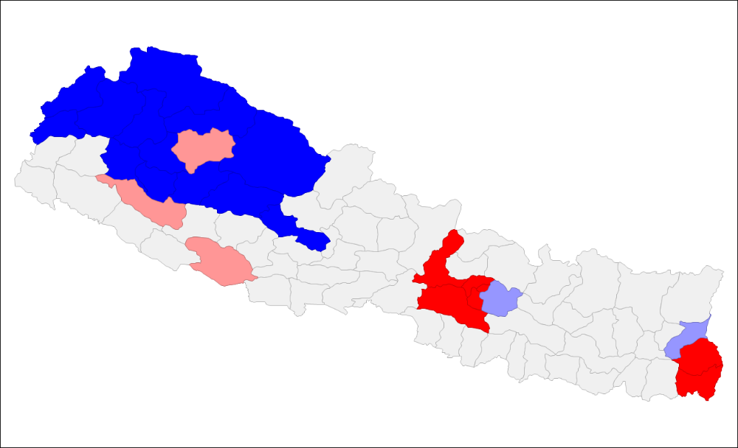East and central Nepal has high clusters.

There are less significant clusters than there are cluster with no significance.

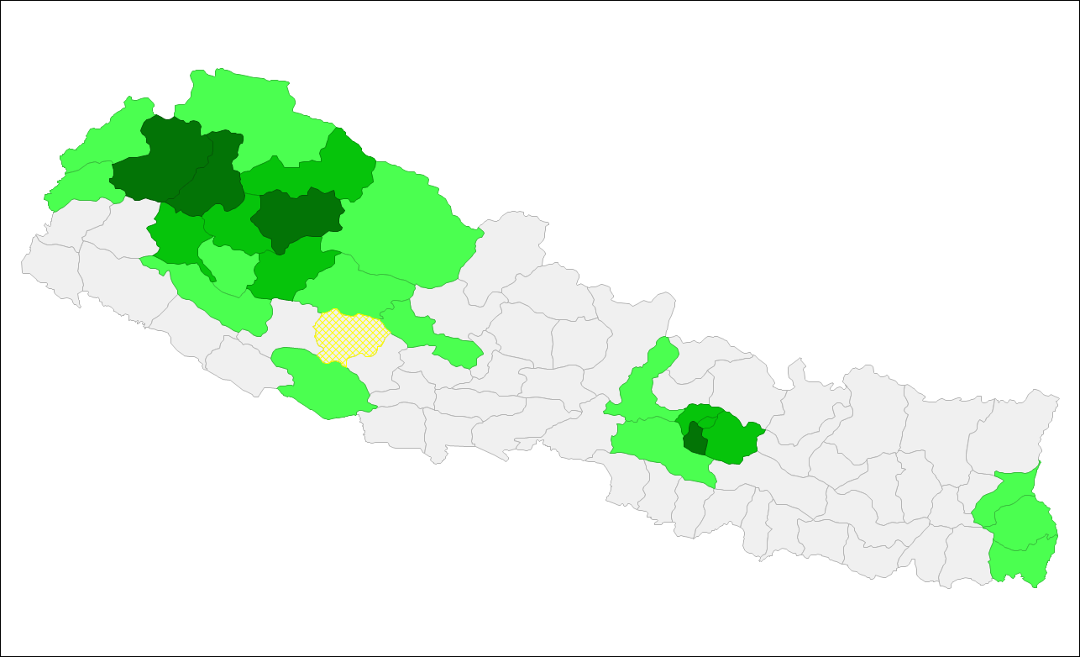

1. **Where are the significant clusters of low contraception use? What is the name of the development region in which many of these districts are found? Interpret your results in terms of significance.**

In the west and central areas of Nepal. Midwest, Far west, and central. There are far more regions that do not have significant results.

1. **Why do you think these high and low clusters are found in these areas? Hint: Try mapping population density (DEN) and/or googling a map of Nepal to learn more about its demographics. Paste maps if they help in your explanation.**

The low clusters match the areas with low population density, while the high cluster significance occurs where there is a high population density.

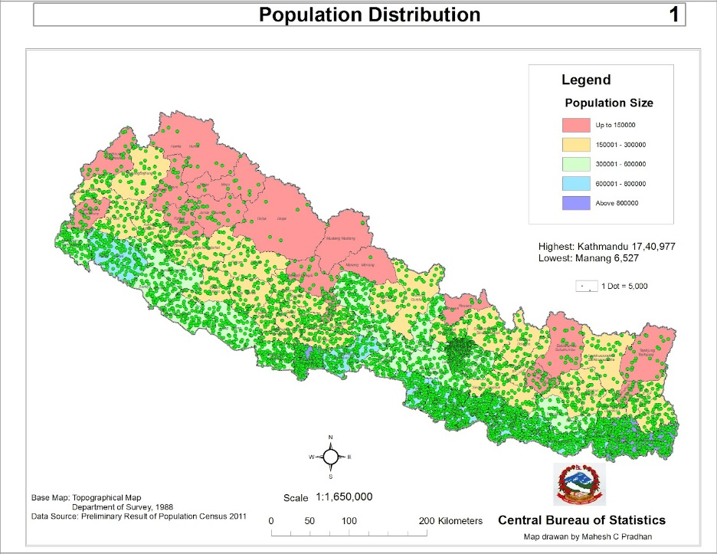

1. **Paste the significance and cluster map for K-Nearest Neighbors here. How do the LISA Significance Map, LISA Cluster Map, and Scatterplot for this K-Nearest Neighbors weight file differ from the maps you made using the Queen’s Weight File? Report numbers for Moran’s I. Describe the maps. Explain why there is a difference.**

There are different regions that have significant clustering. Moran’s I: 0.350051.

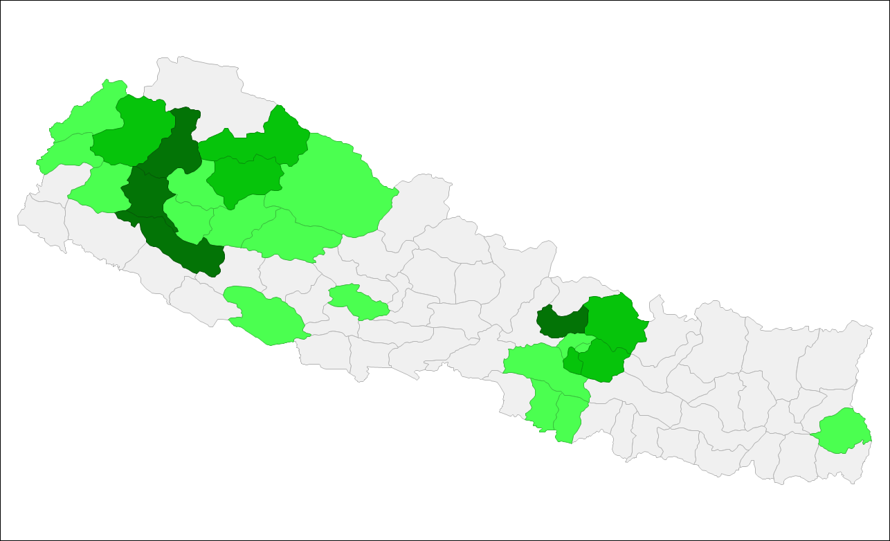

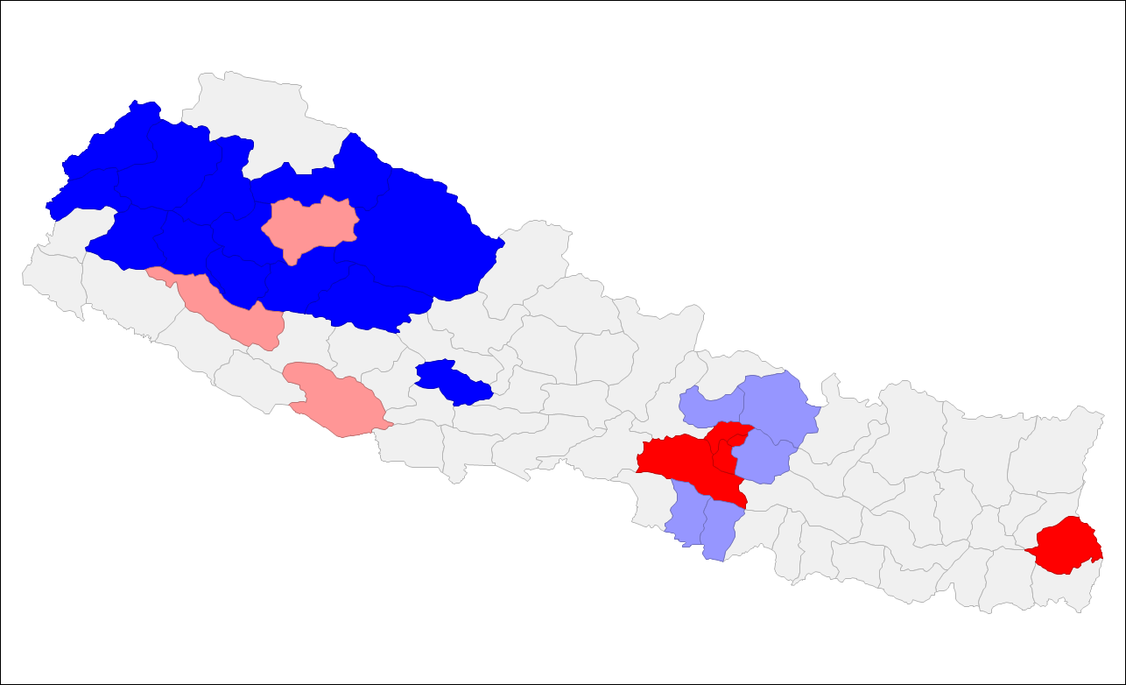

1. **Paste the scatterplot here. What is the bivariate scatterplot showing us in terms of the relation between the two variables? Is it significant?**
2. **Paste the cluster and significance map here. Where are there significant relations in the maps?**
3. **Paste the resulting maps here. Describe each of the maps in the series of Local G maps you just produced. What are they showing?  Where are there significant relations in the maps?**
4. **Paste the cartogram here. Describe what is happening in this map.**
5. **What are the mandatory files in a shapefile? List each and describe what it does. What is the purpose of the .prj file?**