Generic Claims Management System Review
Prompt:
Generic Claims Management System
Requirement is to use Microsoft Entra authentication. Firstly implementing Org-based RBAC before above requirements. Review screenshots and code, identify bugs, fixes, and whether Department/Designation backend relationship is correct.

Roles
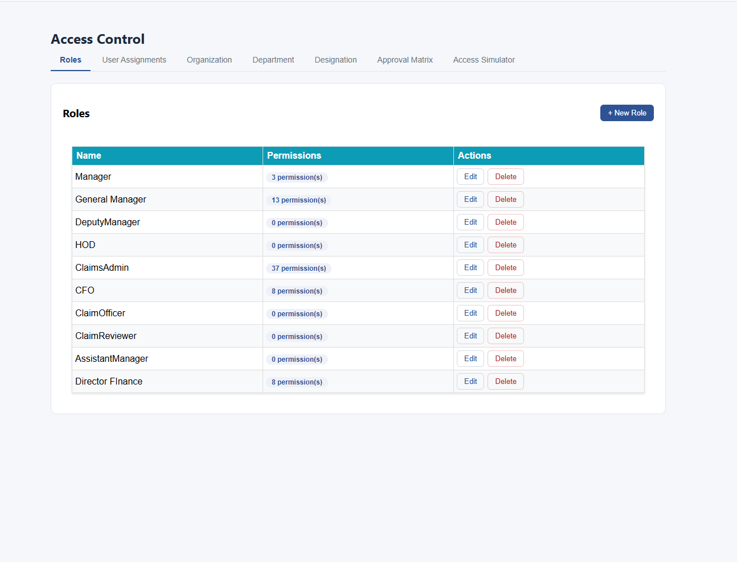

Edit Role
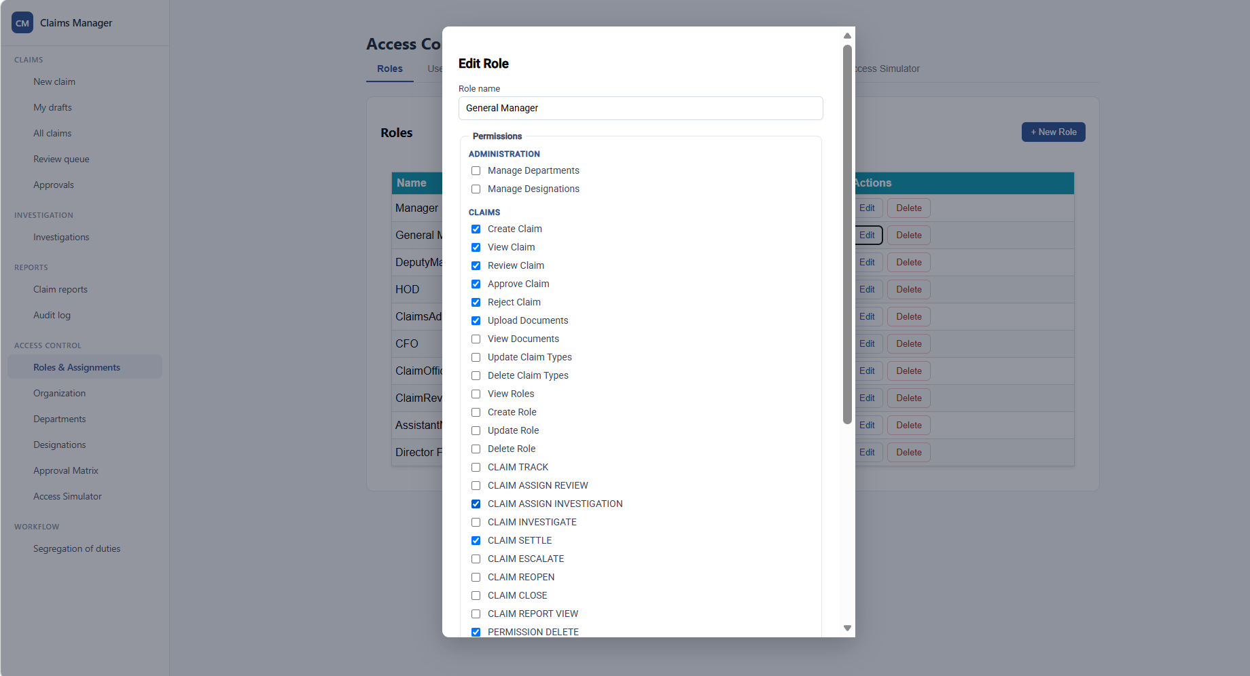

User Assignments
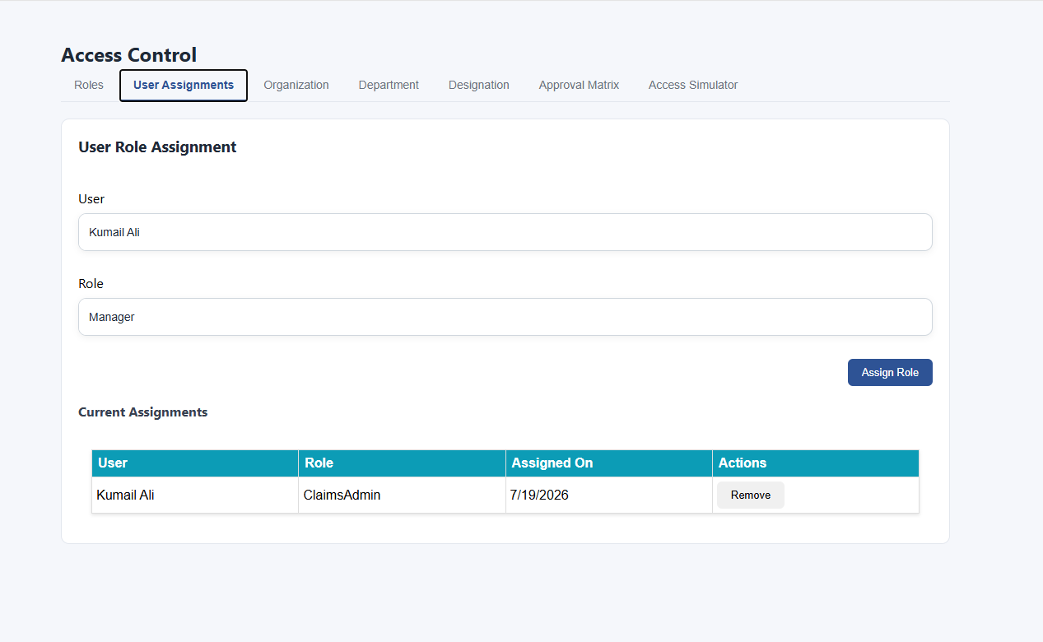

Employee Hirerchy
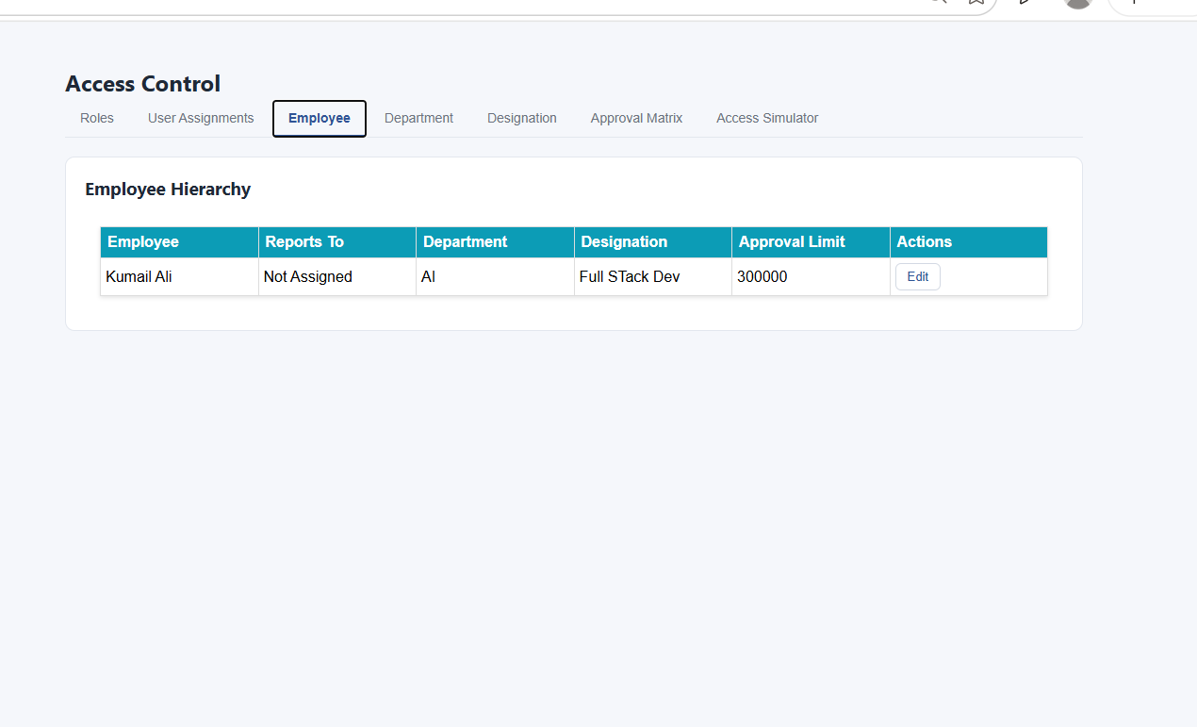

Department
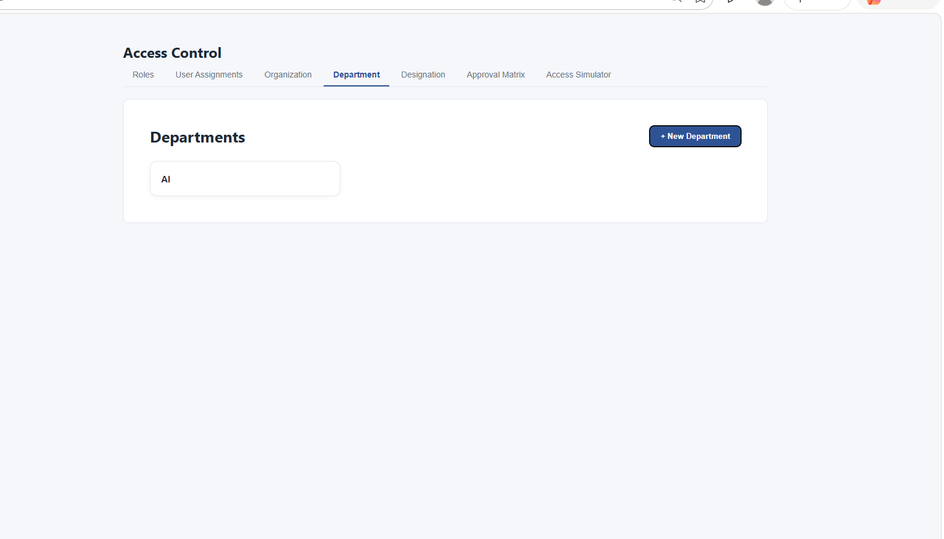

Designation
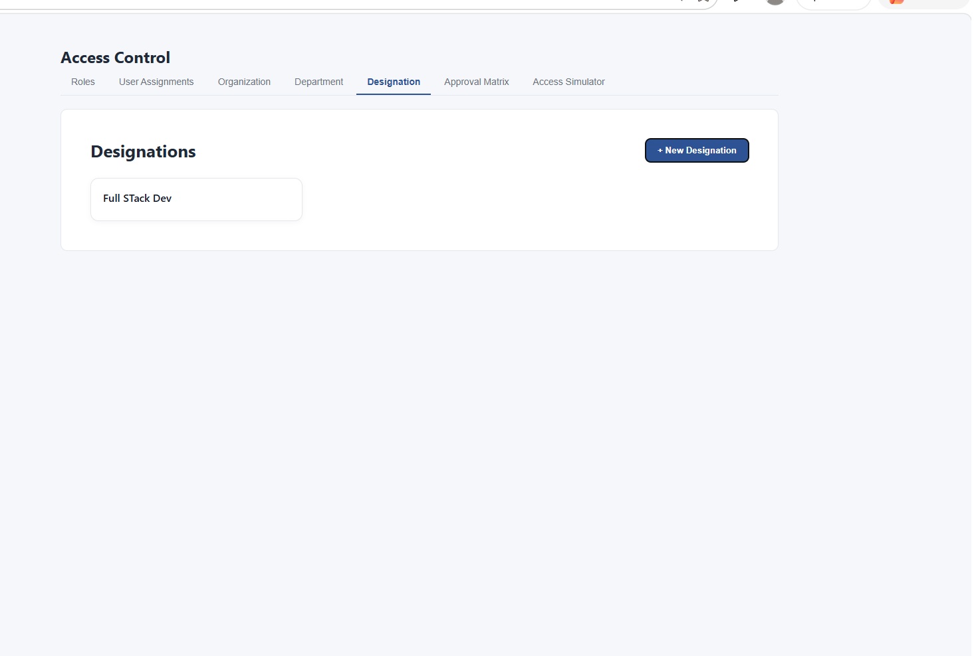

Approval Matrix
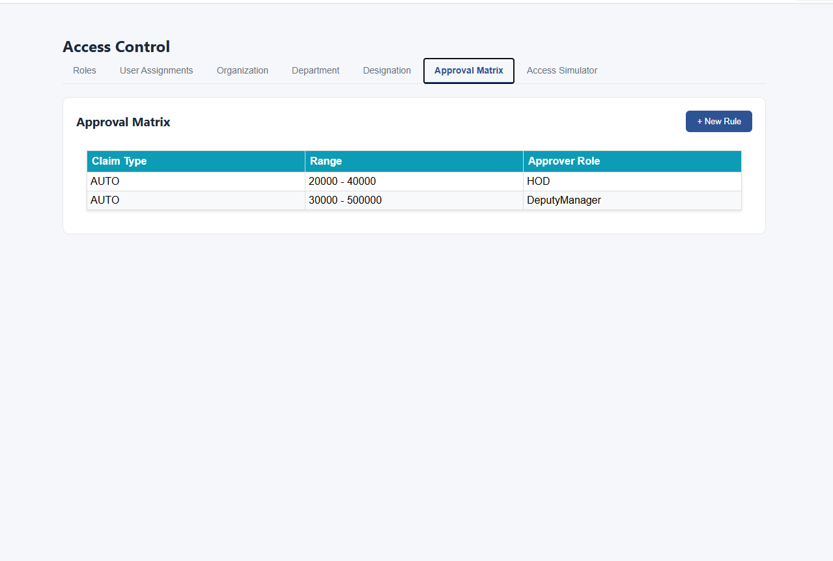

New Approval Rule
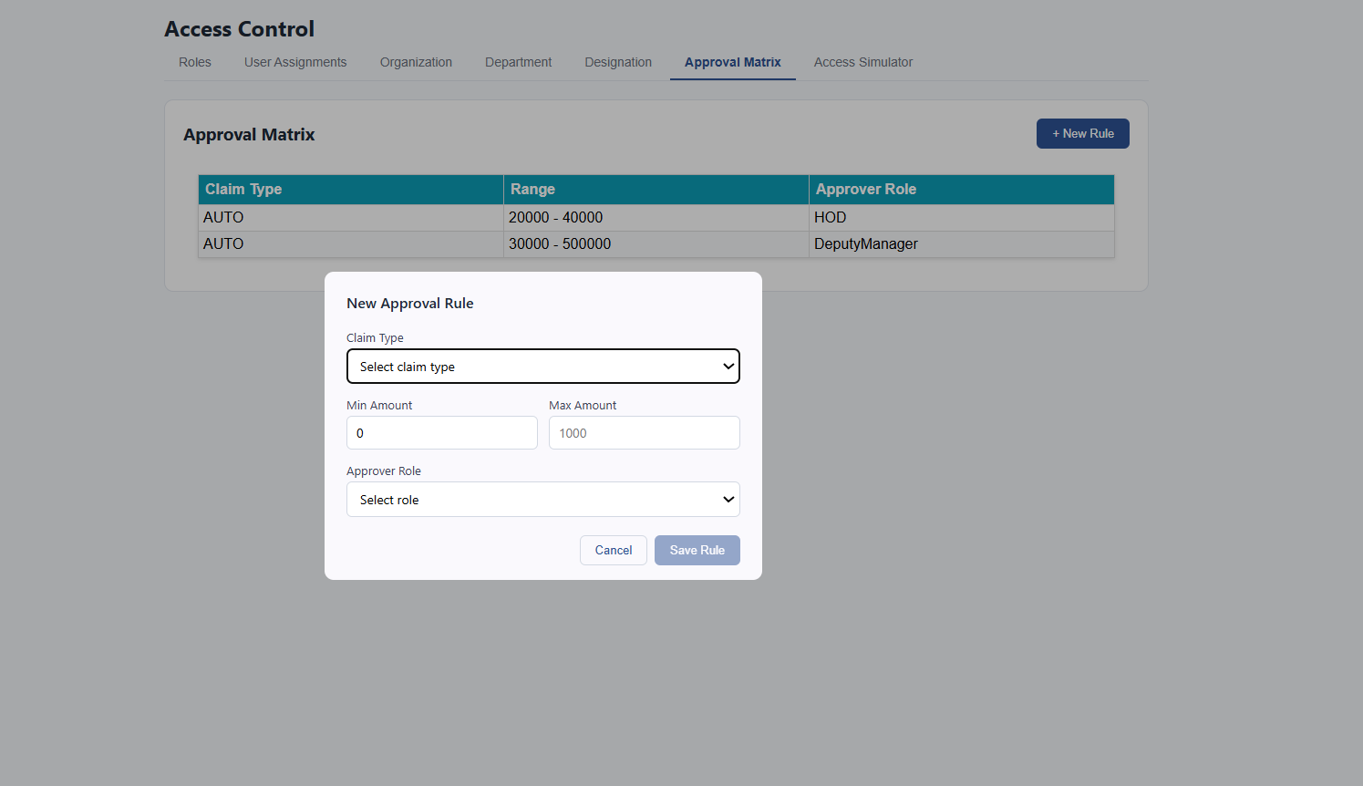

Access Simulator
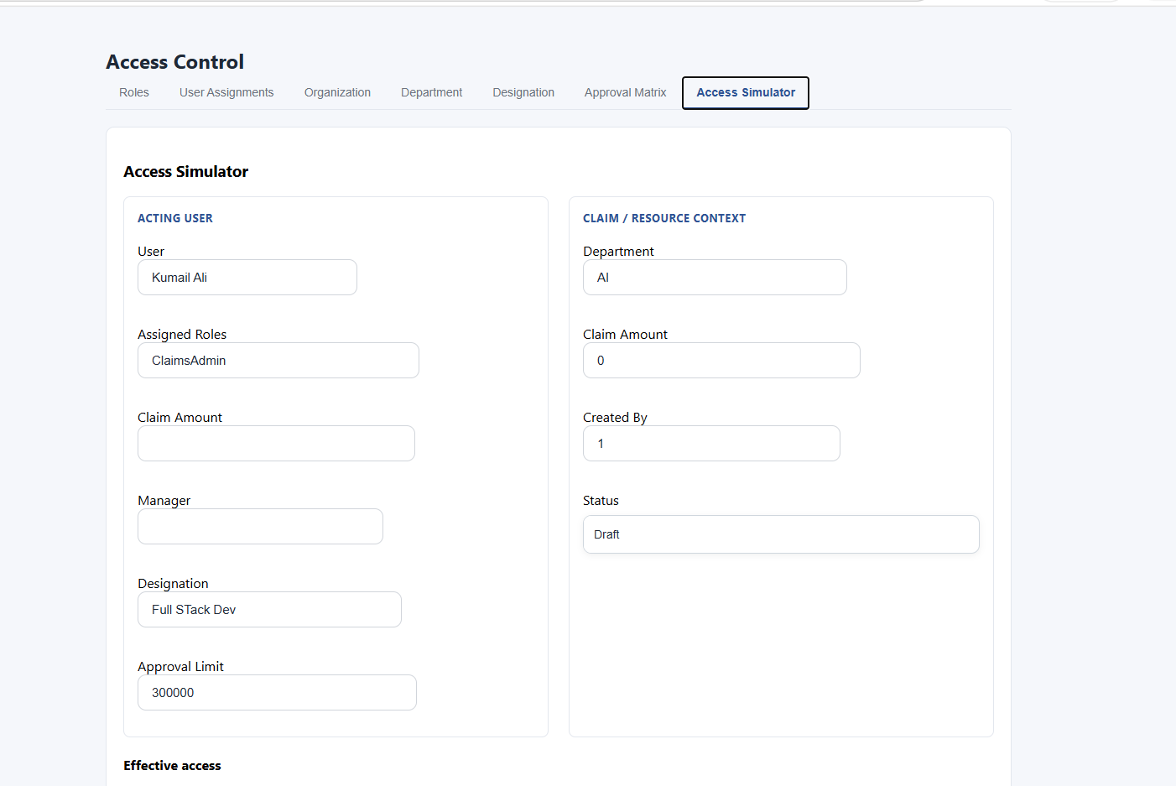

New Claim Details
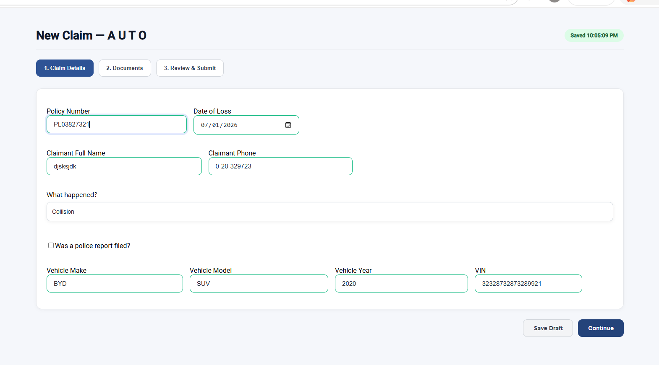

Documents
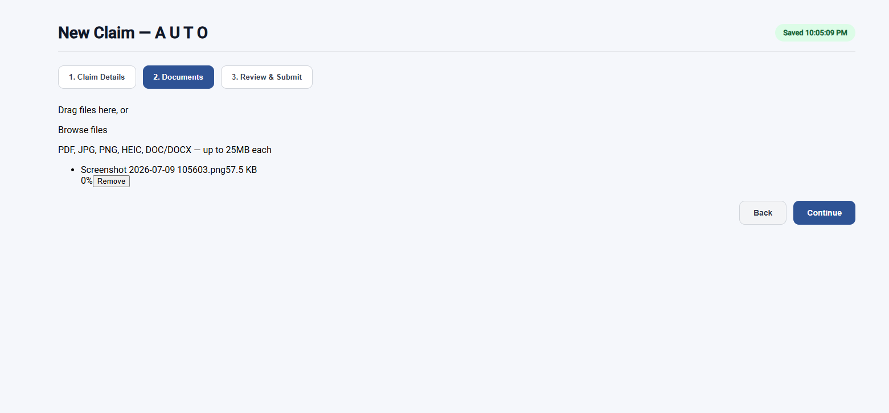

Review & Submit
