Data definition language (DDL)

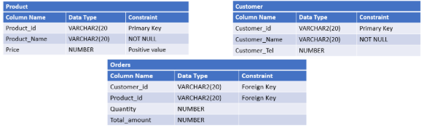

1/

* CREATE TABLE Customer (Customer_Id varchar(20), Customer_Name varchar(20) NOT NULL, Customer_Tel Number ,Primary key (Customer_Id));
* CREATE TABLE PRODUCT(Product_id varchar(20), Product_Name varchar(20) NOT NULL, Price NUMBER CHECK(price>0), Primary key (Product_Id ));
* CREATE TABLE ORDERS (FOREIGN KEY(Customer_Id) references Customer(Customer_Id), FOREIGN KEY(Product_Id ) references Product(Product_Id ),Quantity NUMBER,Total_amount NUMBER);

2/

ALTER TABLE Product ADD Category VARCHAR(20)

ALTER TABLE ORDERS ADD OrderDate date DEFAULT  SYSDATE()