Data Manipulation language (DML)

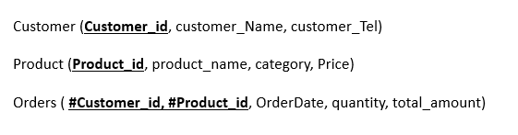

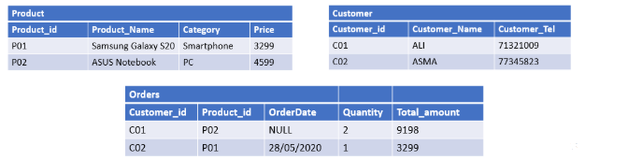

INSERT INTO Customer VALUES (‘CO1’,’ALI’, 71321009),

INSERT INTO Customer VALUES (‘CO2’,’ASMA’, 77345823),

INSERT INTO Product VALUES (‘P01’, ‘Samsung Galaxy S20’,’Smartphone’, 3299),

INSERT INTO Product VALUES (‘P02’, ‘ASUS Notebook’, ’PC’, 4599),

INSERT INTO Orders VALUES (‘CO1’, ‘P02’, NULL, 2, 9198),

INSERT INTO Orders VALUES (‘CO2’, ‘P01’, 28/05/2020, 1, 3299),