Project 2: Shipment Program

Student # 40630493
Author: Yousef Linares
Professor: Piyush Jangam
March/ 18 /2021
PROJECT 2 – Package and Shipment Classes

Sample output

1.

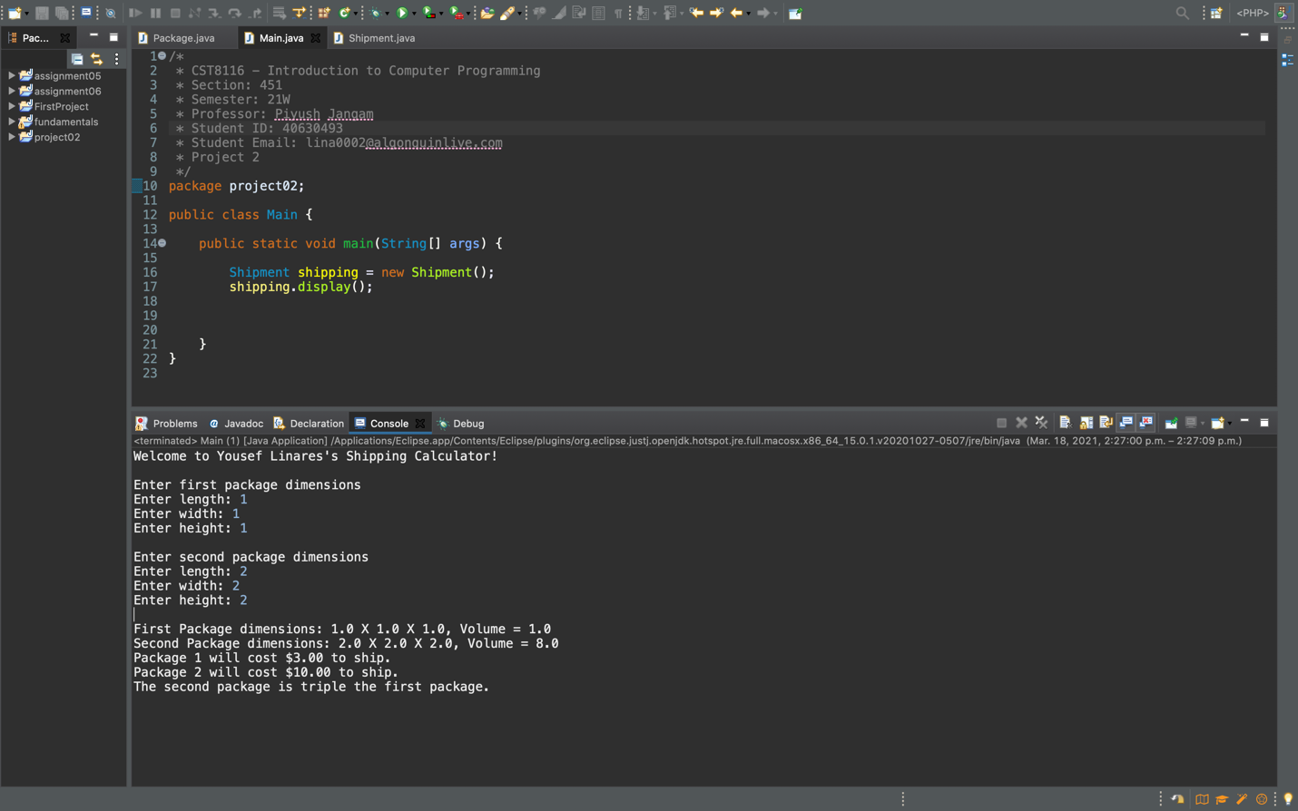

2.

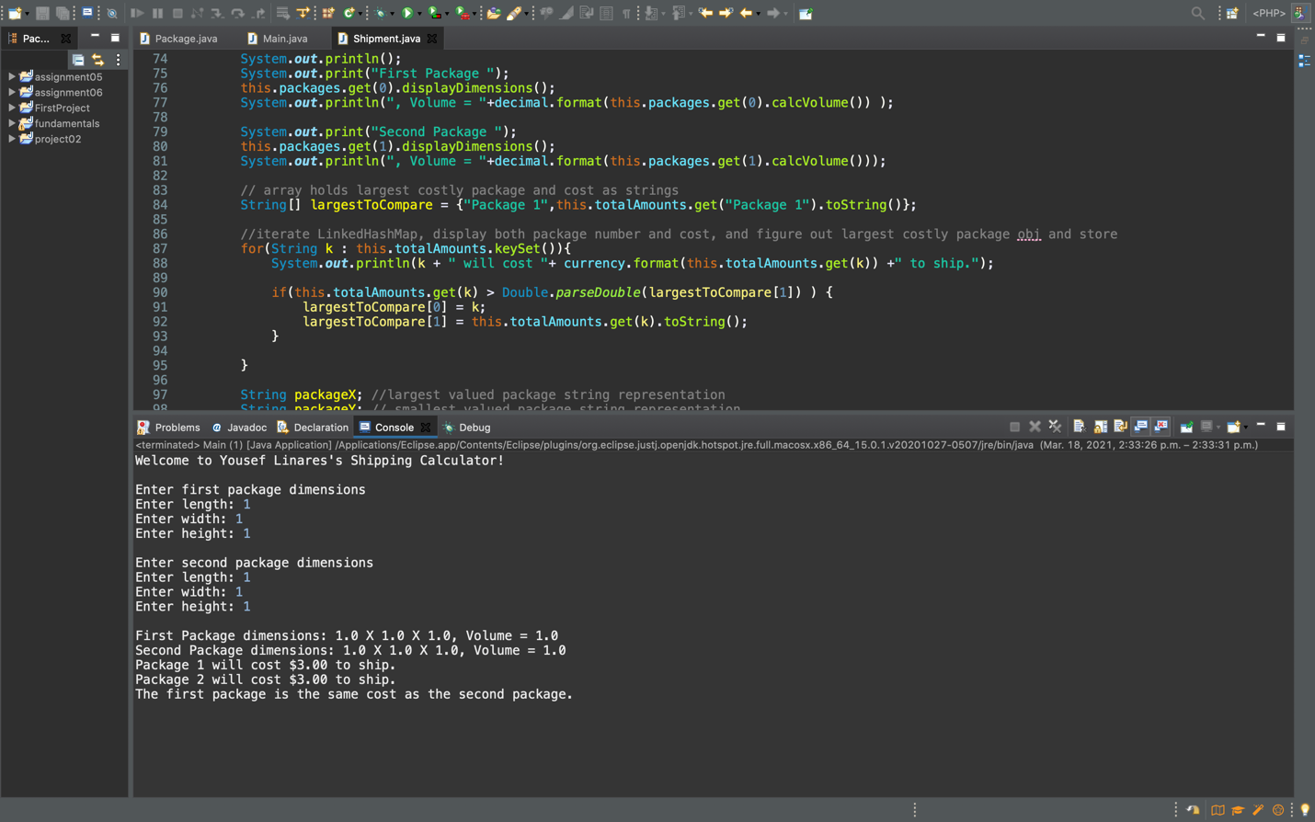

3.

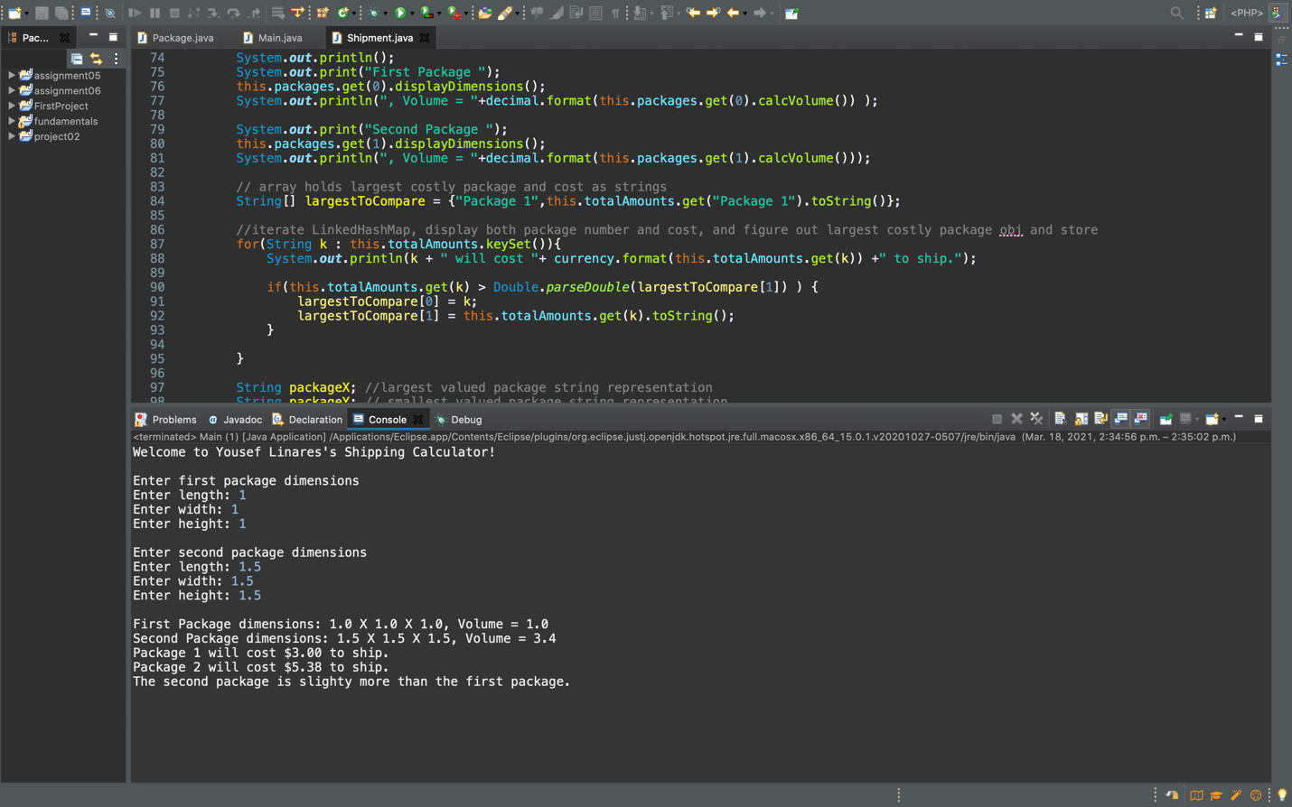

Works Cited

(Java™ Platform, Standard Edition 8 API Specification, 2021)https://docs.oracle.com/javase/8/docs/api/overview-summary.html

