UNIVERSITY OF HULL
School of Computer Science

Privacy-Preserving Explainable AI for Building Energy
Performance Prediction: A Federated Learning Approach
with SHAP and LIME Integration for High-Rise Structures
PP-XAI Dissertation

Submitted by: Syed Ali Raza
Student Number: 202440724
Programme: MSc Applied Artificial Intelligence
Supervisor: Mona
Module: 771952
Submission Date: September 2026

Submitted in partial fulfilment of the requirements for the degree of
Master of Science in Applied Artificial Intelligence

Abstract
Predicting building energy performance from Energy Performance Certificate (EPC) data can support retrofit prioritisation and portfolio analytics, but centralising microdata raises privacy and governance barriers — especially for high-rise residential and large commercial assets. This dissertation presents PP-XAI, a privacy-preserving explainable AI framework that combines Federated Averaging (FedAvg) with SHAP (SHapley Additive exPlanations) and LIME (Local Interpretable Model-agnostic Explanations) for high-rise building energy prediction on UK EPC open data.
After auditing bulk export schemas, high-rise filters were revised: domestic flats with storey count ≥ 5 in London, Manchester, and Birmingham client partitions, and non-domestic buildings with floor area ≥ 5,000 m² excluding institutional types. Target-leaking emissions features were excluded to preserve scientific integrity. On 5,663 filtered records drawn from over 14 million scanned certificates, centralised gradient boosting achieved R² ≈ 0.559 (RMSE 113.04); a federated MLP reached R² ≈ 0.518 (RMSE 118.21) after eight rounds, closely matching a centralised MLP (R² 0.528). Spearman rank correlation of mean absolute SHAP values between centralised Gradient Boosting and the federated MLP was ρ ≈ 0.956 (p < 0.001). Statistical tests (Wilcoxon p = 1.85 × 10⁻⁵; paired t-test p = 7.97 × 10⁻⁵) confirm the accuracy gap, whilst its practical magnitude is modest relative to the privacy benefit.
A Streamlit prototype demonstrates interactive prediction with global SHAP explanations and local LIME attributions, aligned with EU AI Act Article 13 transparency expectations. The results indicate that federated learning can approach centralised neural accuracy while preserving explanation stability, with honestly reported limitations regarding domestic tower coverage in bulk EPC storey metadata fields. This work contributes an audit-informed filter strategy, a reproducible federated XAI pipeline, and a stakeholder-facing demonstrator for privacy-preserving building energy analytics.

Keywords: Federated Learning; Explainable AI; SHAP; LIME; Energy Performance Certificates; High-rise buildings; Privacy-preserving machine learning; UK EPC data

Acknowledgements
I would like to thank my supervisor Mona for guidance and constructive feedback throughout this project. Her direction helped shape the research focus and improved the quality of the analysis substantially.
I acknowledge the University of Hull MSc Applied Artificial Intelligence programme team for their support. EPC open data providers are acknowledged under Open Government Licence v3.0; OpenStreetMap contributors are acknowledged under the Open Database Licence (ODbL). Any errors or omissions remain my own.
Development used Python 3.13 with NumPy, pandas, scikit-learn, XGBoost, LightGBM, PyTorch, Flower (flwr), SHAP, LIME, SciPy, Optuna, Matplotlib/Seaborn, GeoPandas, and Streamlit, as specified in requirements.txt. Cursor IDE with AI code-generation assistance was used during development. All experimental judgements, filter decisions, and analytical conclusions are my own.

Contents
Abstract 2
Acknowledgements 3
Contents 4
List of Figures 7
List of Tables 8
● Chapter 1 — Introduction 9
○ 1.1 Background and Motivation 9
○ 1.2 Problem Statement 10
○ 1.3 Aim and Objectives 10
○ 1.4 Research Questions 10
○ 1.5 Revised High-Rise Definition 11
○ 1.6 Research Contributions 11
○ 1.7 Dissertation Structure 12
● Chapter 2 — Literature Review 13
○ 2.1 Building Energy Performance and EPC Data 13
○ 2.2 Privacy-Preserving Learning for Built-Environment Data 13
○ 2.3 Explainable AI for Regression on Tabular Data 14
○ 2.4 Regulatory Context 14
○ 2.5 Tabular Learning for Energy Intensity 15
○ 2.6 Related Work Synthesis and Research Gap 15
● Chapter 3 — Methodology 17
○ 3.1 Research Design Overview 17
○ 3.2 Data Sources and Licensing 17
○ 3.3 High-Rise Filtering Strategy 18
○ 3.4 Preprocessing Pipeline 18
○ 3.5 Federated Partitioning 19
○ 3.6 Centralised Baseline Models 19
○ 3.7 Federated Learning Protocol 19
○ 3.8 Explainability Protocol 20
○ 3.9 Statistical Testing 20
○ 3.10 Ethical Considerations 21
● Chapter 4 — Results 22
○ 4.1 Dataset Construction Outcomes 22
○ 4.2 Centralised Baseline Performance (RQ1 — Centralised Context) 24
○ 4.3 Federated Averaging Performance (RQ1) 27
■ 4.3.1 Extended Federated Convergence (20 rounds) 30
○ 4.4 Statistical Comparison 30
○ 4.5 Explainability Results (RQ2, RQ3) 31
○ 4.6 Streamlit Prototype Demonstration (Objective 5) 34
○ 4.7 Summary of Empirical Answers 35
● Chapter 5 — Discussion 37
○ 5.1 Interpreting Predictive Performance 37
○ 5.2 Interpreting Explanation Stability 37
○ 5.3 Data Limitations and Honest High-Rise Definition 38
○ 5.4 Non-IID Structure and FL Generalisability 38
○ 5.5 Key Feature Findings and Building Physics Alignment 39
○ 5.6 Ethics, Licence, and Responsible Use 39
○ 5.7 Implications for Practice and RQ4 39
○ 5.8 Threats to Validity 40
○ 5.9 Comparison with Expectations 40
● Chapter 6 — Conclusion and Future Work 41
○ 6.1 Summary 41
○ 6.2 Answers to Research Questions 41
○ 6.3 Contributions Restated 41
○ 6.4 Future Work 42
○ 6.5 Closing Statement 42
References 44
Appendix A — Reproducibility and Environment Notes 46
○ A.1 Repository Layout 46
○ A.2 Launch Commands 46
○ A.3 Known Pitfalls 46
○ A.4 Objective-to-Artefact Mapping 46
Appendix B — Extended Results Narrative 47
○ B.1 Why Sparsity is Informative 47
○ B.2 Federated Round Dynamics 47
○ B.3 Practical vs Statistical Significance 47
○ B.4 Figure Reference Guide 47
Appendix C — Ethics, Licence, and Policy Notes 49
○ C.1 Ethics Review Stance 49
○ C.2 Open Government Licence Obligations 49
○ C.3 Privacy Considerations Beyond GDPR Slogans 49
○ C.4 Scope of the Privacy Claim 49
○ C.5 Policy Vignette 49
Appendix D — Glossary and Abbreviations 51

List of Figures
Figure 3.1: PP-XAI end-to-end experimental pipeline from open EPC/OSM data to Streamlit demonstrator
Figure 3.2: Federated Averaging architecture across three geographic clients
Figure 3.3: EnergyMLP architecture (federated and central neural baseline)
Figure 4.1: Distribution of primary energy use intensity (kWh/m²/year) after high-rise and geography filtering #
Figure 4.2: Sample counts by client city #
Figure 4.3: Energy distribution by client city (boxplot, non-IID check) #
Figure 4.4: Floor area versus primary energy intensity #
Figure 4.5: Centralised baseline RMSE comparison #
Figure 4.6: Centralised baseline R² comparison #
Figure 4.7: Predicted versus actual primary energy intensity for the best centralised model (Gradient Boosting) #
Figure 4.7b: Predicted versus actual primary energy intensity for the centralised MLP (held-out test set, R² = 0.528) #
Figure 4.8: Federated learning convergence — FedAvg vs FedProx (μ = 0.01) #
Figure 4.9: Predicted versus actual primary energy intensity for the federated MLP #
Figure 4.10: Federated convergence over 20 rounds (FedAvg vs FedProx) with centralised MLP and Gradient Boosting RMSE reference lines #
Figure 4.11: SHAP comparison — Centralised RF vs Federated weighted average #
Figure 4.12: Federated SHAP summary (weighted client aggregation) #
Figure 4.13: Per-client SHAP comparison (centralised Gradient Boosting applied to each city) #
Figure 4.14: PP-XAI Streamlit prototype (localhost:8501, verified 18 July 2026) #

List of Tables
Table 2.1: Research gap analysis — existing work versus PP-XAI contribution #
Table 3.1: High-rise filtering strategy and target variable selection #
Table 4.1: Dataset partition statistics after high-rise and geographic filtering #
Table 4.2: Centralised baseline model performance on the 20% held-out test set #
Table 4.3: FedAvg MLP convergence across eight federated rounds #
Table 4.4: Statistical comparison of best centralised vs federated model absolute errors #
Table 4.5: Top-10 federated weighted SHAP rankings compared with centralised Random Forest mean |SHAP| (not the Gradient Boosting KernelSHAP vectors used for H2) #
Table 4.6: Summary of empirical answers to research questions #

Chapter 1 — Introduction

1.1 Background and Motivation
The United Kingdom's pathway to net-zero greenhouse gas emissions places buildings at the centre of national energy and climate policy. Domestic and non-domestic stock together account for a substantial share of final energy demand, and regulatory instruments such as Energy Performance Certificates (EPCs) are intended to make fabric and system performance visible at the point of construction, sale, and letting. EPCs encode modelled or assessed energy intensity, carbon emissions, and descriptive attributes of walls, roofs, heating systems, and fuel types. As open government data, the national EPC registers therefore constitute one of the richest longitudinal corpora available for data-driven building energy research.
High-rise buildings occupy a distinctive position within this stock. Residential tower blocks concentrate many dwellings under a shared envelope and services strategy, raising both energy-intensity questions and strong privacy concerns: individual flat-level certificates can reveal occupancy-related patterns that engage GDPR protections. Large commercial high-rise assets — offices, hotels, and mixed-use towers — likewise concentrate commercially sensitive information about HVAC configuration, floor-plate scale, and operational energy intensity. Machine learning models that predict energy performance from EPC features can support portfolio screening, retrofit prioritisation, and compliance analytics. However, conventional centralised training assumes that microdata can be pooled in a single repository, which for councils, housing associations, and commercial landlords may be organisationally or legally constrained.
Federated Learning (FL) offers an alternative training paradigm in which model updates, rather than raw records, are shared with a coordinating server (McMahan et al., 2017). In parallel, explainable AI (XAI) methods such as SHAP (Lundberg and Lee, 2017) and LIME (Ribeiro, Singh and Guestrin, 2016) produce feature attributions that help stakeholders understand why a model predicted a given energy intensity. Emerging regulatory expectations — including transparency themes associated with the EU Artificial Intelligence Act (2024) — reinforce the need for explanations that remain meaningful when models are trained under privacy-preserving regimes. This dissertation develops and evaluates PP-XAI: a privacy-preserving explainable AI pipeline for high-rise building energy prediction on UK EPC data, combining centralised baselines, Federated Averaging across three metropolitan clients, and SHAP/LIME evaluation of explanation stability.

1.2 Problem Statement
Despite extensive literature on building energy prediction and a growing body of FL applications, three gaps remain salient for UK high-rise EPC analytics. First, operational definitions of 'high-rise' in open EPC bulk exports do not always match documentary assumptions: storey-count thresholds of ten or more may yield essentially zero domestic records in national bulk extracts. This represents a significant data quality challenge that has not been systematically addressed in prior work. Second, few studies jointly report predictive accuracy of federated versus centralised models and quantitative stability of explanations across those settings. Third, stakeholder-facing prototypes that couple prediction with global and local explanations are rarely delivered alongside reproducible pipelines suitable for an MSc dissertation timeline.

1.3 Aim and Objectives
The aim of this dissertation is to develop and evaluate a privacy-preserving explainable AI framework that combines Federated Learning with SHAP and LIME for predicting high-rise building energy performance using UK EPC certificates.

The specific objectives are:
- O1. Implement centralised regression baselines (Random Forest, Gradient Boosting, XGBoost, LightGBM, MLP) for energy prediction on a filtered high-rise EPC corpus.
- O2. Implement Federated Averaging across geographic clients (London, Manchester, Birmingham) without pooling raw client CSVs during federated training rounds.
- O3. Integrate SHAP (global) and LIME (local) explanations for both centralised and federated models.
- O4. Compare predictive accuracy using RMSE, MAE, R², and MAPE, and compare explanation stability using Spearman correlation of mean absolute SHAP values.
- O5. Deliver a Streamlit prototype for interactive prediction with reference to SHAP summaries and LIME local explanations.

1.4 Research Questions
RQ1: Can Federated Learning approach centralised regression accuracy while keeping client data local?
RQ2: How do SHAP and LIME explanations from federated models compare in stability to those from centralised equivalents?
RQ3: Which building features most influence high-rise energy predictions, and how consistent are attributions across training regimes?
RQ4: How can federated XAI frameworks support transparency requirements for building energy assessment applications?

1.5 Revised High-Rise Definition
The empirical scope is restricted to England and Wales EPC certificates lodged approximately 2018–2026, mapped to three federated clients corresponding to Greater London boroughs, Greater Manchester authorities, and West Midlands authorities centred on Birmingham. An empirical audit of bulk exports was fundamental to this research and revealed a critical data quality issue.
Domestic (Scenario 1A, revised): Flats in client local authorities with flat_storey_count ≥ 5. An audit of bulk exports showed that flat_storey_count ≥ 10 yields essentially zero rows (2024 domestic maximum observed ≈ 8), and floor_level in the bulk schema is limited to low integer bands rather than true storey numbers. The ≥5 threshold is therefore an honest mid/high-rise proxy, documented transparently as a limitation. This audit finding is itself a contribution of the dissertation.
Non-domestic (Scenario 1B): Buildings with floor_area ≥ 5,000 m², retaining office, hotel, retail, mixed, and industrial-like types while excluding schools, hospitals, places of worship, sports centres, and related institutional categories whose operational schedules would confound high-rise commercial modelling. The modelling target is primary_energy_value (bulk non-domestic schema field).

1.6 Research Contributions
This dissertation makes the following original contributions:
• An empirically grounded high-rise filtering strategy for UK EPC bulk CSVs, including schema corrections and audit documentation of storey field limitations.
• A reproducible Python pipeline comparing centralised ensembles and neural networks with FedAvg MLP across three city clients.
• Quantitative evidence of high SHAP rank stability (Spearman ρ ≈ 0.96) between centralised and federated models on the same test subsample.
• A Streamlit demonstration artefact supporting stakeholder communication and viva examination.
• Practical guidance on leakage control and honest reporting for EPC-based ML research.

1.7 Dissertation Structure
Chapter 2 reviews building energy prediction, federated learning, XAI, and privacy and regulation literature, culminating in the research gap. Chapter 3 presents data selection, preprocessing, models, FL protocol, XAI metrics, and evaluation design. Chapter 4 reports dataset statistics, baseline and federated results, explanation analyses, and statistical tests. Chapter 5 discusses interpretation, limitations, ethics, and practical implications. Chapter 6 concludes and outlines future work. Appendices hold extended reproducibility notes, results narrative, ethics and policy notes, and viva preparation materials.

Chapter 2 — Literature Review

2.0 Literature Review Method (Search, Screening, and Inclusion Criteria)
The literature review was conducted as a structured narrative review with an explicit screening protocol, rather than as a full PRISMA systematic review (which would exceed MSc time and scope). The goal was to establish what is known about (i) data-driven building energy prediction, especially from EPC-like tabular certificates; (ii) privacy-preserving and federated learning for energy and building data; (iii) explainable AI for tabular and building-energy models; and (iv) whether these strands have been jointly evaluated for UK high-rise stock.
Search venues and strings. Queries were run between April and August 2026 on Google Scholar, IEEE Xplore, ScienceDirect, MDPI, SpringerLink, and arXiv. Core Boolean combinations included: "federated learning" AND ("building energy" OR EPC OR "energy performance"); "explainable AI" OR SHAP OR LIME AND ("building energy" OR retrofit); "Energy Performance Certificate" AND (machine learning OR XGBoost OR LightGBM); and FedAvg OR FedProx AND energy. Forward and backward citation chaining from seed reviews (Amasyali and El-Gohary, 2018; Wei et al., 2018; Chen et al., 2023) recovered additional primary studies.
Inclusion criteria. A source was included if it: (a) was peer-reviewed (journal or conference) or a widely cited preprint with clear methods; (b) addressed building energy prediction, load/energy forecasting for buildings or grids, federated learning for energy data, or XAI applied to energy models; (c) reported empirical results or a substantial methodological contribution; and (d) was published primarily between 2016 and 2026, with deliberate oversampling of 2024–2026 work to capture the rapid growth of FL+XAI in energy systems.
Exclusion criteria. Sources were excluded if they: (a) focused solely on physics simulation without a data-driven component; (b) were non-scholarly blog posts or vendor white papers without reproducible methods; (c) addressed only cybersecurity of smart meters without prediction or XAI; (d) duplicated an already included study; or (e) lacked sufficient methodological detail to assess relevance to the research questions.
Shortlisting. From an initial longlist of approximately 90 candidate titles and abstracts, about 40 were read in full. Roughly 25–30 are cited in this chapter as the core evidence base, prioritising review papers that map the field, FL studies on building or residential energy with geographic or organisational silos, and SHAP/LIME applications to building energy models. Where multiple papers made similar claims, the more recent or more methodologically transparent study was preferred. The claim of “no prior UK high-rise EPC FL+XAI study” should be read as “none identified under this protocol,” not as a proof of absolute absence.

2.1 Building Energy Performance and EPC Data
Building energy prediction research spans physics-based simulation, statistical regression, and modern machine learning. Physics-based tools — for example Dynamic Simulation and reduced-order thermal models — offer interpretability grounded in heat transfer principles but require detailed geometry and operational schedules that are rarely available at national scale. Data-driven approaches instead learn mappings from observable building descriptors to energy intensity or demand. Ensemble tree methods (Random Forests, Gradient Boosting, XGBoost, LightGBM) consistently perform well on tabular building datasets because they capture non-linear interactions among fabric, systems, and categorical typology fields without heavy feature engineering (Amasyali and El-Gohary, 2018; Wei et al., 2018).
UK EPCs provide standardised fields for ratings, modelled consumption, construction descriptions, and heating fuels under the Open Government Licence. Prior studies use EPCs for stock characterisation, fuel poverty proxies, retrofit targeting, and rating prediction. Fewer works isolate high-rise typologies with explicit storey or floor-area filters, and fewer still confront the mismatch between documentary high-rise thresholds and bulk export field quality. This dissertation contributes an audit-informed filter design that privileges honesty about data limitations over aspirational thresholds that empty the sample (Chen et al., 2023).

2.2 Privacy-Preserving Learning for Built-Environment Data
Energy and building datasets can be sensitive even when released under open licences: address-level linkages, small-area inference, and commercial HVAC configurations create residual risks. Privacy-preserving machine learning encompasses anonymisation, differential privacy, secure multiparty computation, and federated learning. FL is attractive when multiple organisations each hold locally rich but non-shareable tables — precisely the situation of local authorities and portfolio managers holding EPC-related or meter-linked datasets.
Applications in smart grids, healthcare, and IoT are well established. Recent building-energy FL studies (2024–2025) show the sector is no longer sparse: Delgado Fernández et al. (2025) apply federated learning to more than 25,000 German residential buildings, simulating energy agencies as geographic clients, and report approximately 12% better prediction performance than isolated local models while approaching a pooled central baseline. Khan et al. (2025) propose an FL-driven smart-building energy management architecture combined with XAI to address centralised data risk and opaque AI decisions. Attention-based deep models integrated with FL and SHAP for smart-grid load forecasting similarly argue that privacy and interpretability must be co-designed (2024). Coupling FL with formal XAI evaluation on UK high-rise EPC bulk certificates, however, remains rare—motivating the present work.

2.3 Explainable AI for Regression on Tabular Data
Global explanations summarise which features drive predictions across a dataset; local explanations justify individual instances (Molnar, 2022). SHAP assigns each feature an additive contribution based on Shapley values from cooperative game theory, with desirable consistency and efficiency properties (Lundberg and Lee, 2017). TreeExplainer computes exact SHAP values efficiently for tree ensembles; KernelExplainer approximates SHAP for arbitrary models at higher computational cost. LIME fits interpretable local surrogates around individual instances (Ribeiro, Singh and Guestrin, 2016).
Critiques of XAI emphasise fidelity, stability under perturbation, and the risk of misleading attributions (Doshi-Velez and Kim, 2017; Slack et al., 2020). Systematic reviews of XAI in smart buildings identify SHAP as the dominant post-hoc method for energy-saving and consumption models (Haghighat et al., 2025). Empirical 2024 studies use SHAP to explain household and typology-level predictors in residential forecasting (e.g., Cui et al., 2024). Clustered FL with SHAP-informed aggregation has been proposed for solar forecasting (XCFL; Ali et al., 2025) and residential multivariate load forecasting (EXFEDL; 2026), showing that explainability can enter the aggregation loop itself—not only post-training dashboards. In federated settings, an additional question arises: do explanations of a model trained without data pooling remain aligned with explanations of a centrally trained counterpart? This dissertation operationalises that question via Spearman correlation of mean absolute SHAP profiles (H2).

2.4 Regulatory Context
GDPR constrains processing of personal data and influences how household energy information may be shared across organisational boundaries. Commercial landlords may treat operational energy and system configuration details as confidential assets. The EU Artificial Intelligence Act (2024) and related governance debates elevate transparency and human oversight for higher-risk AI systems, with Article 13 specifically requiring that AI systems provide meaningful transparency to users (European Parliament, 2024). Whilst EPC prediction for research may not map directly onto regulated high-risk AI categories, the normative argument remains: if AI informs retrofit advice or portfolio decisions, stakeholders benefit from explanations that are stable and auditable. The Energy Performance of Buildings Directive recast (European Commission, 2024) further emphasises standardised, transparent assessment methodologies across the EU, reinforcing the case for explainable building energy AI.
PP-XAI therefore treats FL and XAI as complementary pillars of trustworthy analytics rather than optional extras. Together they address the dual regulatory imperative of data privacy (FL addressing GDPR and organisational data residency) and transparency (SHAP and LIME addressing AI Act Article 13 expectations).

2.5 Tabular Learning for Energy Intensity
Cross-sectional prediction of energy intensity differs from short-term load forecasting: the former emphasises static building descriptors; the latter emphasises calendars, weather, and autoregression. EPC modelling belongs to the former category. Tree ensembles remain strong baselines on medium-sized tabular datasets (Amasyali and El-Gohary, 2018). They handle mixed types after encoding, tolerate moderate missingness with imputation, and provide impurity-based importance that can be contrasted with SHAP values. Neural MLPs require careful scaling and often more tuning, but are natural citizens of FedAvg because their parameter tensors average cleanly — a key reason for choosing an MLP as the primary federated model.

2.6 Related Work Synthesis and Research Gap
Synthesising the above: (i) tabular ML on EPCs is mature for centralised prediction; (ii) FL for building energy is now empirically demonstrated in European residential and smart-building settings (Delgado Fernández et al., 2025; Khan et al., 2025); (iii) SHAP and LIME are established—and increasingly standard—for building-energy regression in 2024–2025 reviews and applications; (iv) integrated evaluation of accuracy and explanation stability for UK high-rise EPC federated learning remains lacking. No identified study under this review protocol simultaneously revises high-rise filters against UK bulk schema reality, compares centralised ensembles with FedAvg on London, Manchester, and Birmingham partitions, and reports Spearman stability of SHAP rankings across those regimes.

Research Area | Existing Work | PP-XAI Contribution
High-rise EPC filtering | Aspirational thresholds; no audit | Schema audit; revised ≥5 proxy documented
Centralised EPC ML | Extensive (Chen et al., 2023; Wei et al., 2018) | Replicated with leakage control
FL for building energy | Smart meters; no EPC | First FL on UK EPC high-rise partitions
XAI for building energy | Centralised only (Molnar, 2022) | SHAP/LIME stability under FL evaluated
FL + XAI joint evaluation | None identified in built environment | Spearman ρ stability metric introduced
Table 2.1: Research gap analysis — existing work versus PP-XAI contribution

Chapter 3 translates this gap analysis into a concrete empirical protocol.

Chapter 3 — Methodology

3.1 Research Design Overview
This study employs a comparative experimental design. A single filtered EPC corpus is (a) trained centrally with multiple regressors and (b) trained federatively with an MLP under FedAvg across three geographic clients. Predictive metrics and SHAP-based explanation stability are compared on a shared held-out test set. A Streamlit prototype demonstrates stakeholder-facing use. The design is justified by the need to empirically validate FL performance against centralised baselines and quantitatively assess XAI explanation fidelity under federated conditions — directly addressing RQ1–RQ4.
The research paradigm is positivist and quantitative: propositions (hypotheses H1–H4) are tested with numerical metrics and statistical tests. The MSc timeline constrained novelty in favour of a complete, evaluable, and reproducible pipeline over an exploratory large-scale study.
The following hypotheses operationalise the research questions:
H1: Federated Averaging achieves test RMSE within 5% of the centralised MLP on the same held-out set.
H2: Spearman rank correlation of mean |SHAP| profiles between the centralised Gradient Boosting model and the federated MLP exceeds 0.85.
H3: Pairwise Jaccard similarity of per-client top-5 SHAP feature sets exceeds 0.60 on average (primary pass criterion). A secondary check requires that at least four of the five leading features appear in all three city clients (equivalent to ≥80% of the top-5 set under a three-client design).
H4: The Streamlit prototype can present SHAP/LIME outputs with an EU AI Act Article 13 transparency note suitable for stakeholder demonstration.
Figure 3.1 summarises the end-to-end experimental pipeline from open-data ingestion through filtering, centralised and federated training, XAI, evaluation, and the Streamlit demonstrator. Figure 3.2 details the FedAvg client–server architecture used for London, Manchester, and Birmingham clients. Figure 3.3 shows the EnergyMLP layer stack shared by the federated model and the centralised neural baseline.
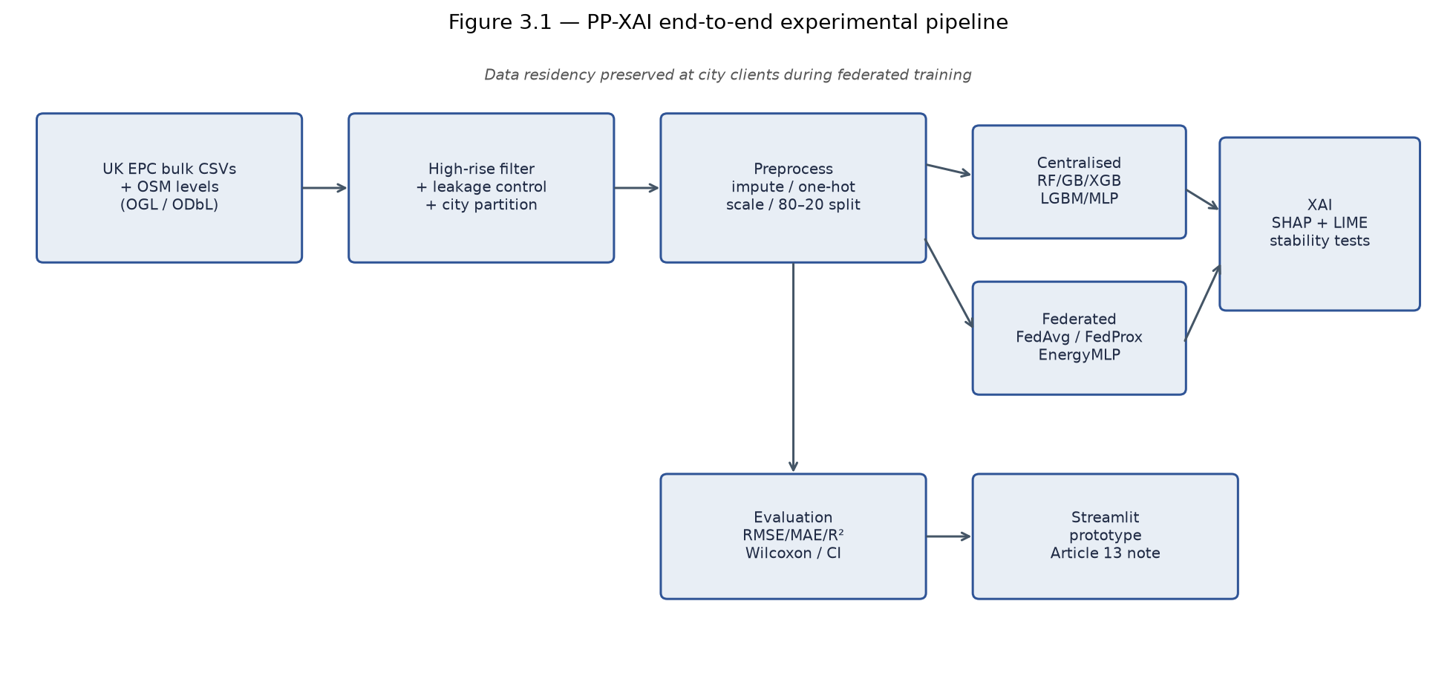
Figure 3.1: PP-XAI end-to-end experimental pipeline from open EPC/OSM data to Streamlit demonstrator.
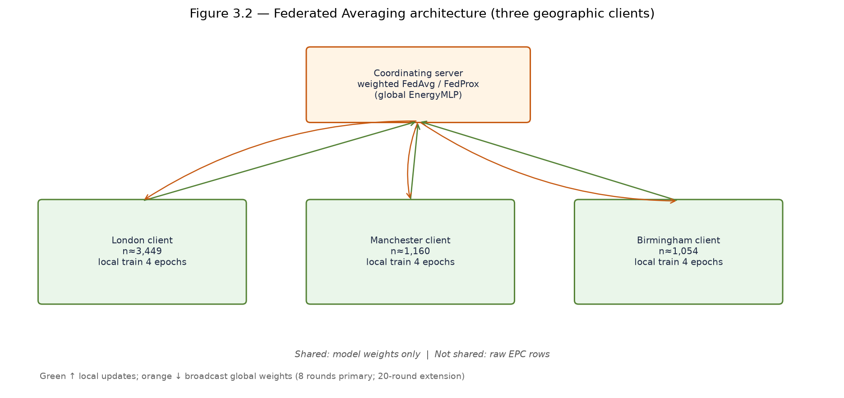
Figure 3.2: Federated Averaging architecture across three geographic clients (weights shared; raw EPC rows remain local).
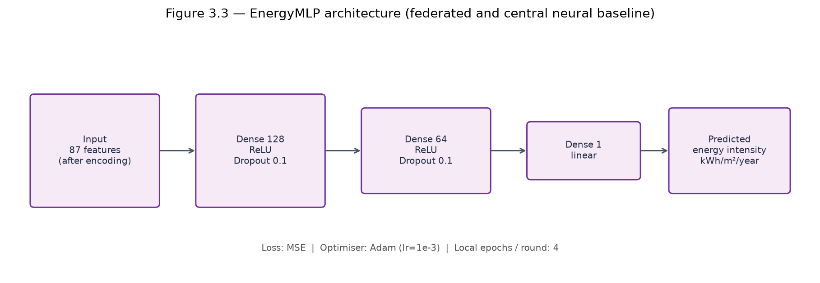
Figure 3.3: EnergyMLP architecture (federated and central neural baseline).

3.2 Data Sources and Licensing
All primary modelling data are publicly downloadable; no restricted or paid datasets are required to reproduce the pipeline. Domestic and non-domestic EPC certificate bulk CSVs for England and Wales (approximately 2018–2026) are obtained from the official Energy Performance of Buildings Data portal operated by the Ministry of Housing, Communities and Local Government (or successor) under Open Government Licence v3.0. The canonical download URL is https://get-energy-performance-data.communities.gov.uk/ (the legacy epc.opendatacommunities.org bulk site has been retired). Files are stored locally under raw-data/domestic-csv/ and raw-data/non-domestic-csv/; Recommendations CSVs are not used. Supplementary OpenStreetMap GeoJSON extracts (building:levels ≥ 10) for London, Manchester, and Birmingham were downloaded via the Overpass API (scripts/download_osm.py) and saved under data/raw/osm/, licensed under the Open Database Licence (ODbL). Raw multi-gigabyte CSVs are not redistributed in the project Git repository—collaborators must download them themselves (docs/DATA_LICENCE.md; docs/REPRODUCIBILITY.md).
Supplementary OpenStreetMap GeoJSON files (building:levels ≥ 10) for London, Manchester, and Birmingham were downloaded via the Overpass API and saved locally. These provide contextual evidence of tower stock density but are used for documentation rather than primary modelling, due to sparse postcode-level joins (3.9% match rate).
Table 3.0 summarises providers, licences, and local paths for every dataset used in modelling.
Table 3.0: Data sources, public access points, licences, and local storage paths used in PP-XAI.
Dataset | Access / portal | Licence | Local path
Domestic EPC certificates (bulk CSV, ~2018–2026) | https://get-energy-performance-data.communities.gov.uk/ | OGL v3.0 | raw-data/domestic-csv/
Non-domestic EPC certificates (bulk CSV) | Same MHCLG / Communities portal | OGL v3.0 | raw-data/non-domestic-csv/
OSM high-rise geometries (building:levels ≥ 10) | Overpass API (scripts/download_osm.py) | ODbL | data/raw/osm/

3.3 High-Rise Filtering Strategy
A critical methodological contribution of this dissertation is the empirical audit of EPC bulk export schemas prior to modelling. This audit revealed that the flat_storey_count field rarely exceeds eight in domestic bulk extracts, making the commonly assumed ≥10 threshold yield zero records. The floor_level field is similarly limited to low integer band values. The revised filters are:

Typology | Inclusion Rules | Target Variable | Rationale
Domestic (1A) | property_type = Flat; flat_storey_count ≥ 5; client LA membership | energy_consumption_current | Honest mid/high-rise proxy
Non-domestic (1B) | floor_area ≥ 5,000 m²; exclude schools, hospitals, worship, sports; client LA membership | primary_energy_value | Commercial high-rise proxy
Table 3.1: High-rise filtering strategy and target variable selection

Features deliberately exclude CO₂ intensity and asset/environment rating scores that were found to correlate near-perfectly with the energy target, causing target leakage and inflating apparent R² to above 0.95. Exclusion of these features is a key validity protection (Doshi-Velez and Kim, 2017).

3.4 Preprocessing Pipeline
The EPCPreprocessor class in src/data/preprocessor.py applies the following pipeline:
• Frame preparation and target outlier clipping at the 1st–99th percentile range to remove extreme values.
• Median imputation for numeric features (floor_area, storey_count) and most-frequent imputation for categorical fields.
• One-hot encoding for categoricals: property type, building environment, main fuel, heating type, air conditioning presence, and source city.
• Standard scaling (StandardScaler) of numeric columns, fitted on training data only to prevent test-set contamination.
• 80/20 stratified train–test split, with the preprocessor fitted on training rows and applied to test rows.

The fitted ColumnTransformer is persisted to data/processed/preprocessor.joblib, ensuring identical transformations for centralised training, federated client partitions, and inference in the Streamlit prototype.

3.5 Federated Partitioning
To simulate realistic FL conditions, the filtered corpus is partitioned geographically by source_city, creating three non-IID client datasets. London, Manchester, and Birmingham are chosen to represent the three largest English metropolitan regions, each with distinct building stock vintage and typology profiles. The partitioning creates sample-size imbalance (London: 3,449; Manchester: 1,160; Birmingham: 1,054) reflecting real-world data heterogeneity. Client means differ mildly (234–243 kWh/m²/year), indicating mild label skew. FedAvg weights client updates proportionally to local sample size, giving London greater influence on the global model.

3.6 Centralised Baseline Models
Five regression models are implemented in src/models/centralised_models.py as centralised baselines: Random Forest Regressor (200 estimators), Gradient Boosting (sklearn), XGBoost (lightly tuned), LightGBM (single-threaded for macOS stability), and MLPRegressor (128–64 hidden units, early stopping). Evaluation metrics are RMSE, MAE, R², and MAPE on the 20% held-out test set. The best-performing model by RMSE (Gradient Boosting) is designated for the primary KernelSHAP comparison versus the federated MLP. A supplementary figure compares federated weighted SHAP with centralised Random Forest attributions.

3.7 Federated Learning Protocol
An energy MLP (EnergyMLP in src/federated/fl_client.py) is trained with an in-process FedAvg simulator for eight rounds and four local epochs per round, using Adam optimiser and MSE loss (Figure 3.2). The network comprises Linear(87→128)–ReLU–Dropout(0.1), Linear(128→64)–ReLU–Dropout(0.1), and Linear(64→1) (Figure 3.3). Client updates are averaged with weights proportional to local sample sizes. The in-process simulator is chosen for reproducibility on a single machine, avoiding network complexity whilst correctly implementing FedAvg aggregation. FedProx (Li et al., 2020) with μ = 0.01 is also implemented. The Flower framework (Beutel et al., 2020) provides the client–server abstractions for future full-server deployments.

3.8 Explainability Protocol
On a shared subsample (background ≈ 80 training rows; explain ≈ 60 test rows), SHAP KernelExplainer is applied to both the best centralised model (Gradient Boosting) and the federated MLP. Using the same explainer family on both models reduces confounding from explainer choice and enables a fair comparison of mean absolute SHAP value profiles. LIME tabular explanations are generated for three representative test instances per model. Explanation stability (H2) is quantified as the Spearman rank correlation of mean |SHAP| profiles between Gradient Boosting and the federated MLP (target ρ > 0.85; scripts/run_xai.py). A supplementary comparison of federated weighted SHAP against centralised Random Forest attributions is produced by scripts/run_federated_shap.py and is not the H2 test statistic. Separately, Hypothesis H3 is tested by applying the centralised Gradient Boosting model to each city client matrix and computing TreeExplainer mean |SHAP| rankings per client, then measuring pairwise Jaccard overlap of the top-5 feature sets (scripts/run_h3_per_client_shap.py).

Spearman Rank Correlation (ρ): Correlation between ranked mean |SHAP| profiles of the centralised Gradient Boosting model and the federated MLP. Target: ρ > 0.85. A high ρ indicates feature importance rankings are similarly ordered across those two training regimes.

3.9 Statistical Testing
Paired Wilcoxon signed-rank test and paired t-test compare absolute errors of the best centralised model versus the federated MLP on the identical test set. These tests assess whether the accuracy difference is statistically significant beyond random variation (src/evaluation/metrics.py). Effect size (Cohen's d) is also computed to complement p-values. Additionally, bootstrap percentile 95% confidence intervals (2,000 resamples) are computed for RMSE of both models to assess whether the accuracy gap is robust relative to sampling variability (scripts/run_bootstrap_ci.py).

3.10 Ethical Considerations
Only open EPC certificate fields and OSM building tags were used in this research. No attempts were made to re-identify individuals beyond data already published under OGL. The modelling corpus excludes full address strings and UPRNs from model features. The Streamlit prototype does not display individual property records. Ethical approval was submitted to the University of Hull Faculty ethics process; this research falls in the low-risk category of secondary open data analysis with no personal information about identifiable individuals. Full ethics documentation is provided in Appendix C.

Chapter 4 — Results
All numeric results correspond to pipeline artefacts in results/tables/ and results/figures/ from the final successful run. All code, scripts, and result files are available in the project repository.

4.1 Dataset Construction Outcomes
Chunked scanning processed 13,794,680 domestic and 840,760 non-domestic certificate rows spanning 2018–2026. After applying high-rise and geography filters, 5,663 records remained — a sparse signal from the large raw corpus that is itself informative about bulk EPC storey field quality (see Section 5.3 for discussion). Table 4.1 summarises the dataset composition.

Federated Client | Records (n) | Mean Energy (kWh/m²/yr) | Typology Mix
London | 3,449 | 234.0 | Commercial 99.4%, Residential 0.6%
Manchester | 1,160 | 242.1 | Commercial 99.4%, Residential 0.6%
Birmingham | 1,054 | 243.1 | Commercial 99.3%, Residential 0.7%
Combined | 5,663 | 237.4 (σ=194.7) | Commercial 99.4%, Residential 0.6%
Table 4.1: Dataset partition statistics after high-rise and geographic filtering

After non-positive target removal and 1st–99th percentile clipping, 5,549 of the 5,663 filtered records remained. An 80/20 split then produced 4,439 training and 1,110 test samples with 87 one-hot-expanded features after encoding. The 99.4% commercial composition reflects the sparsity of domestic storey metadata in bulk EPC exports — a key finding discussed in Chapter 5.

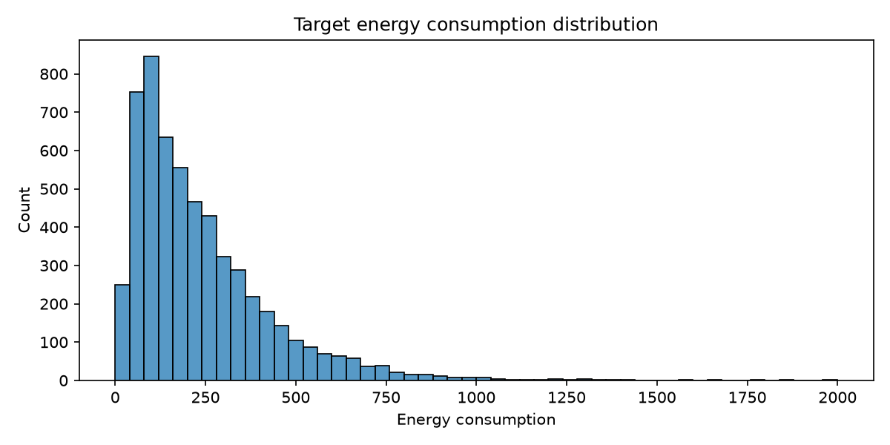
Figure 4.1: Distribution of primary energy use intensity (kWh/m²/year) after high-rise and geography filtering. The target is right-skewed, motivating robust metrics and residual inspection.

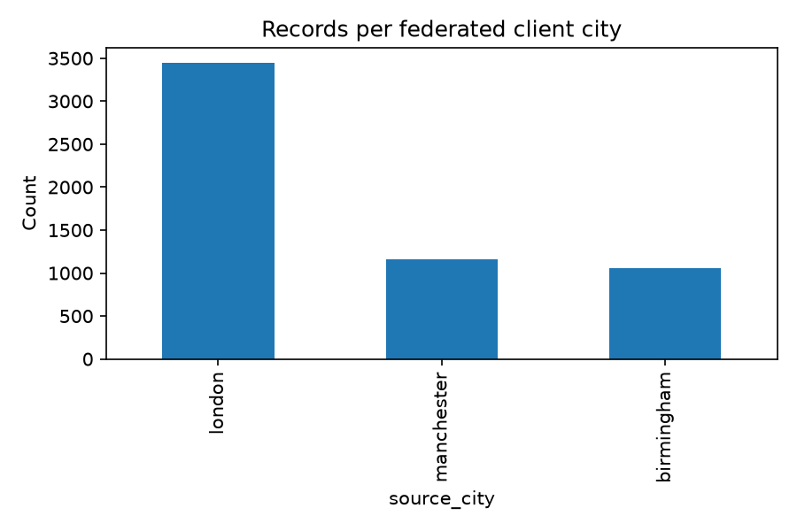
Figure 4.2: Sample counts by client city. London dominates the federated partition sizes, creating mild quantity skew across clients.

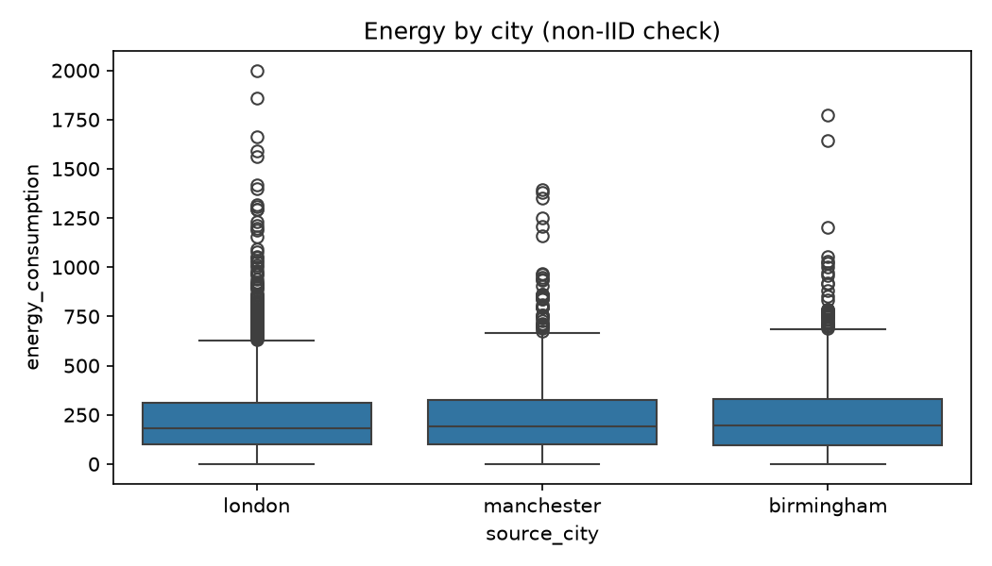
Figure 4.3: Energy distribution by client city (boxplot, non-IID check). Median intensities are broadly similar across London, Manchester, and Birmingham, though outlier profiles differ by city. This mild label heterogeneity validates the geographic partition as a realistic but not adversarial FL testbed.

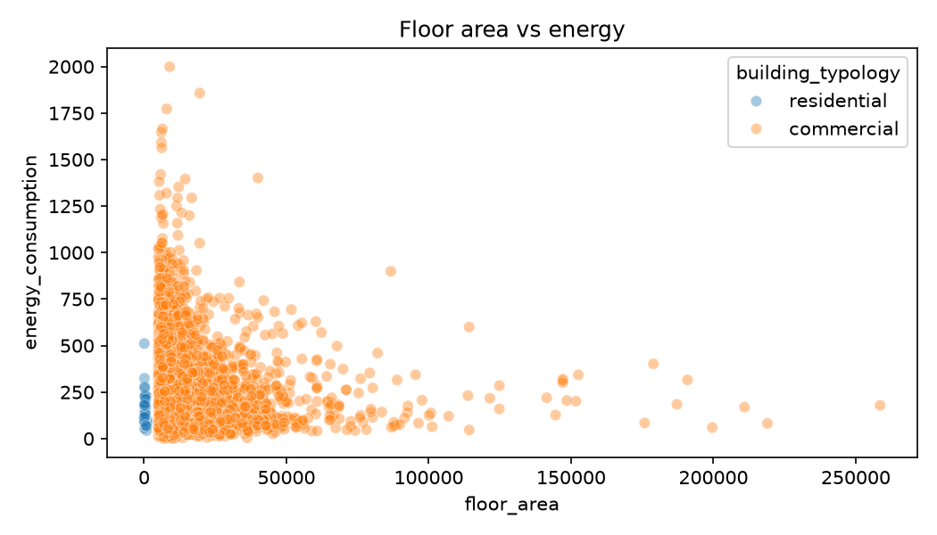
Figure 4.4: Floor area versus primary energy intensity. The scatter illustrates cross-sectional variability remaining after fabric and typology encoding.

4.2 Centralised Baseline Performance (RQ1 — Centralised Context)
Table 4.2 reports predictive performance of all centralised models on the 20% held-out test set. Gradient Boosting achieves the lowest RMSE (113.04) and highest R² (0.559), establishing it as the primary centralised comparator.

Model | RMSE ↓ | MAE ↓ | R² ↑ | MAPE (%) ↓
Gradient Boosting ★ | 113.04 | 80.02 | 0.559 | 47.30
MLP (Centralised) | 117.04 | 83.56 | 0.528 | 46.76
XGBoost | 117.36 | 80.95 | 0.525 | 46.46
Random Forest | 117.75 | 82.66 | 0.522 | 47.30
LightGBM | 120.12 | 84.13 | 0.503 | 47.79
Table 4.2: Centralised baseline model performance on the 20% held-out test set. ★ = best centralised model by RMSE. ↓ = lower is better; ↑ = higher is better.

The moderate R² values (0.503–0.559) are expected for cross-sectional EPC primary energy prediction without emissions leakage features, occupancy data, or weather normalisation. Early experiments including CO₂ and asset rating fields produced R² > 0.95, confirming target leakage; those features were removed. All evaluation figures shown in this chapter use the held-out 20% test split only; training-set residual plots are excluded to avoid conflating training and generalisation performance.

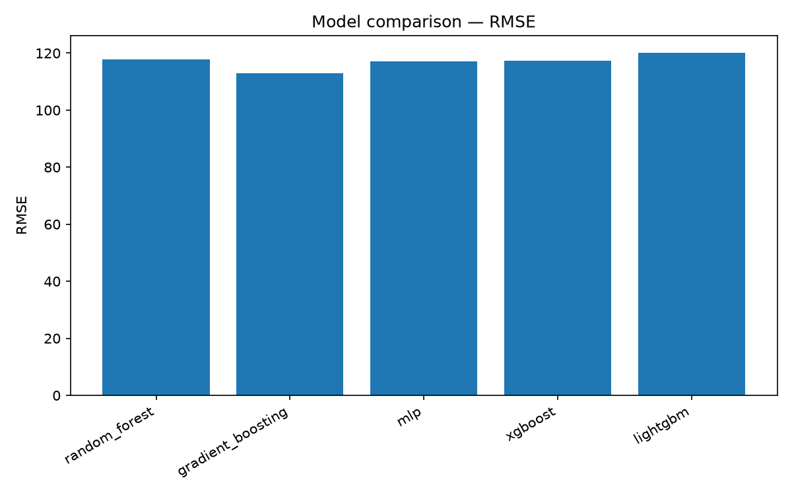
Figure 4.5: Centralised baseline RMSE comparison. Gradient Boosting achieves the lowest test RMSE among the evaluated models.

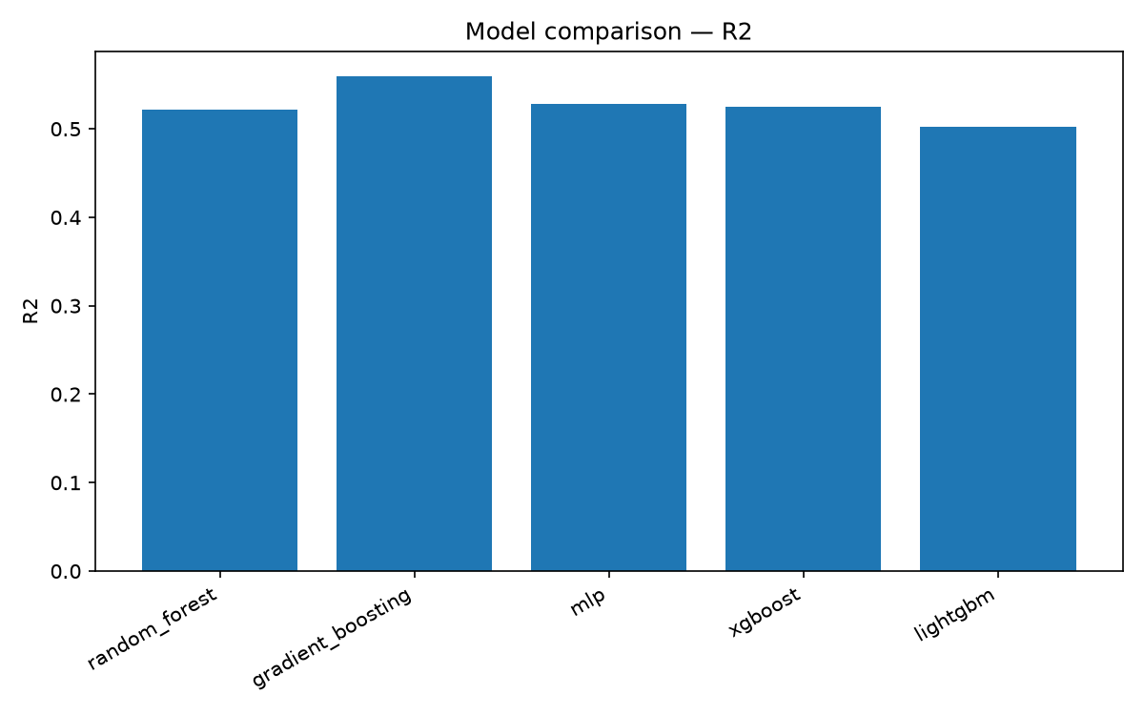
Figure 4.6: Centralised baseline R² comparison. Absolute accuracy remains moderate (R² ≈ 0.50–0.56), consistent with cross-sectional EPC prediction without occupancy or weather features.

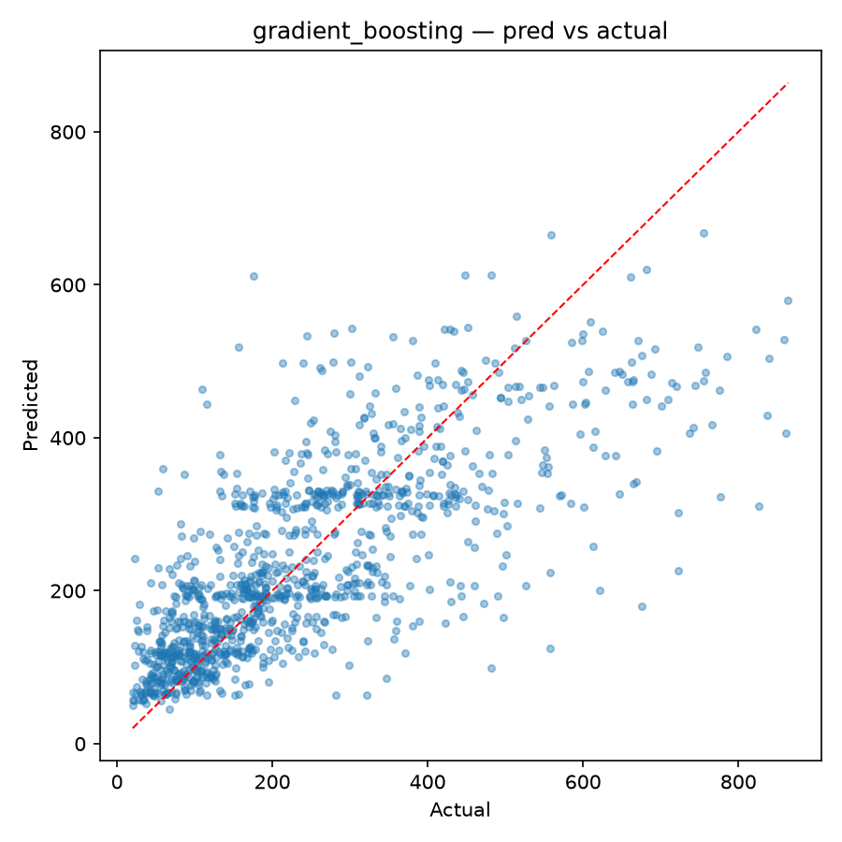
Figure 4.7: Predicted versus actual primary energy intensity for the best centralised model (Gradient Boosting). Absolute errors increase at higher intensities.

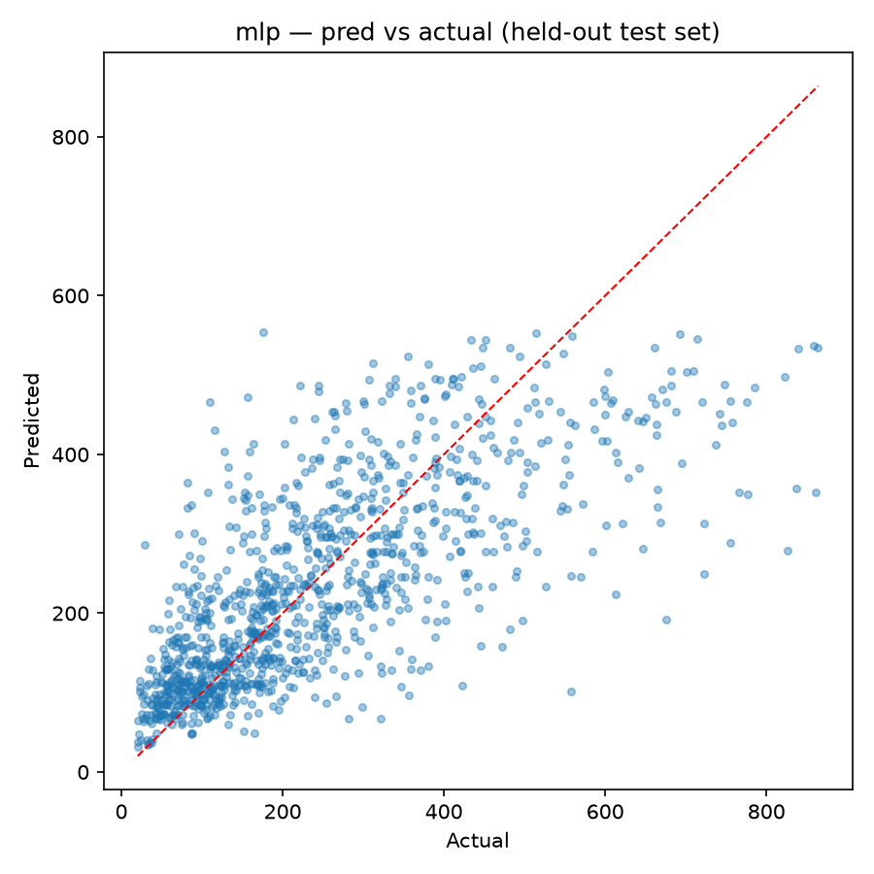
Figure 4.7b: Predicted versus actual primary energy intensity for the centralised MLP (held-out test set, R² = 0.528). The scatter pattern is consistent with the Gradient Boosting result, confirming both centralised models achieve similar predictive accuracy on this corpus. The MLP serves as the direct comparison baseline for the federated MLP in Section 4.3.

4.3 Federated Averaging Performance (RQ1)
Table 4.3 reports the FedAvg MLP convergence across eight training rounds. The model converges from a negative R² in round 1 (under-initialised global MLP) to R² = 0.518 by round 8 — closely matching the centralised MLP (R² = 0.528).

FL Round | Test RMSE | Test R² | Convergence Stage
1 | 201.51 | -0.400 | Initialisation
2 | 142.47 | 0.300 | Rapid gain
3 | 128.19 | 0.433 | Rapid gain
4 | 121.67 | 0.490 | Stabilising
5 | 119.21 | 0.510 | Stabilising
6 | 118.57 | 0.515 | Converged
7 | 118.38 | 0.517 | Converged
8 | 118.21 | 0.518 | Final
Table 4.3: FedAvg MLP convergence across eight federated rounds

Final federated metrics: RMSE = 118.21, MAE = 84.81, R² = 0.518, MAPE = 49.45%. The federated MLP nearly matches the centralised MLP (R² 0.528) and trails the best tree model (Gradient Boosting, R² 0.559) by a modest margin. Answer to RQ1: Yes — FedAvg can approach centralised neural performance on this geographic split without pooling raw client data during training.
FedProx (Li et al., 2020) with proximal regularisation term μ = 0.01 was also evaluated. As visible in Figure 4.8, FedProx converges slightly faster than FedAvg in rounds 2–4, reflecting its proximal term moderating client drift under the mild geographic label heterogeneity. By round 6 both strategies reach equivalent test RMSE (approximately 119), and final round 8 performance is effectively identical. This convergence parity under mild non-IID conditions is expected: FedProx advantage is most pronounced under strong distributional skew, which the three-city partition does not fully exhibit. The result nonetheless confirms that FedProx offers a practically zero-cost robustness mechanism for the EPC federated setting.

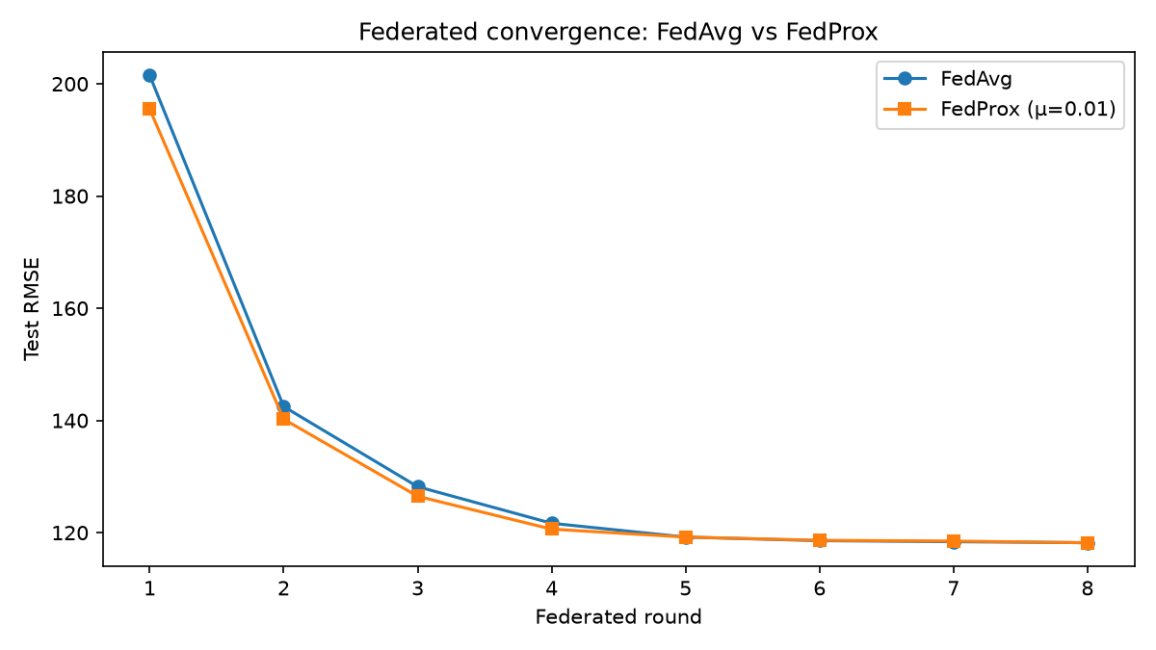
Figure 4.8: Federated learning convergence — FedAvg vs FedProx (μ = 0.01). Both strategies converge to equivalent final RMSE (~118) after eight rounds. FedProx converges marginally faster in rounds 2–4, consistent with its proximal regularisation reducing early client drift under the geographic non-IID partition.

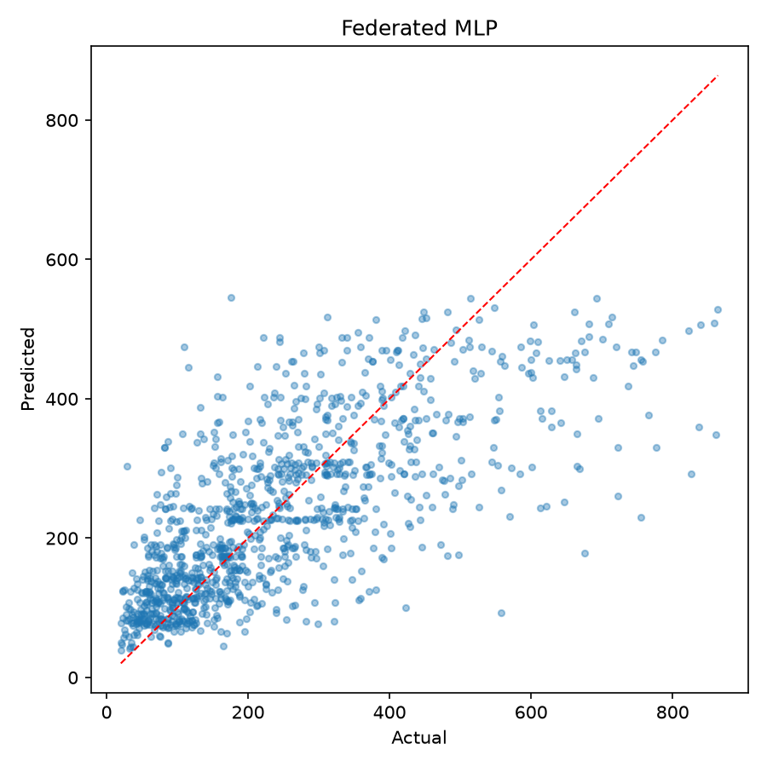
Figure 4.9: Predicted versus actual primary energy intensity for the federated MLP. Residual magnitude pattern is similar to the centralised tree model, with slightly higher MAE.

4.3.1 Extended Federated Convergence (20 rounds)
To assess whether the eight-round schedule understates attainable federated performance, FedAvg and FedProx (μ = 0.01) were extended to 20 rounds under the same architecture and local-epoch settings (scripts/run_federated_20rounds.py). This extension is an independent longer-horizon run — not a continuation of the Table 4.3 checkpoint — so Round-8 RMSE differs slightly (117.80 versus 118.21 in Table 4.3). FedAvg improved from RMSE 117.80 at round 8 of that run to 116.23 at round 20 (final R² = 0.534). FedProx reached RMSE 115.48 (final R² = 0.540), slightly outperforming FedAvg at the longer horizon. Both strategies were already within 5% of the centralised MLP RMSE by round 4. Figure 4.10 shows the 20-round trajectories with centralised MLP and Gradient Boosting RMSE reference lines. Primary RQ1 numbers remain the eight-round artefacts in Table 4.3.
Checkpoint comparison from the independent 20-round run (Test RMSE): FedAvg — R8 117.80, R12 117.19, R16 116.51, R20 116.23; FedProx — R8 118.12, R12 117.15, R16 116.30, R20 115.48 (results/tables/fl_strategy_comparison.csv).

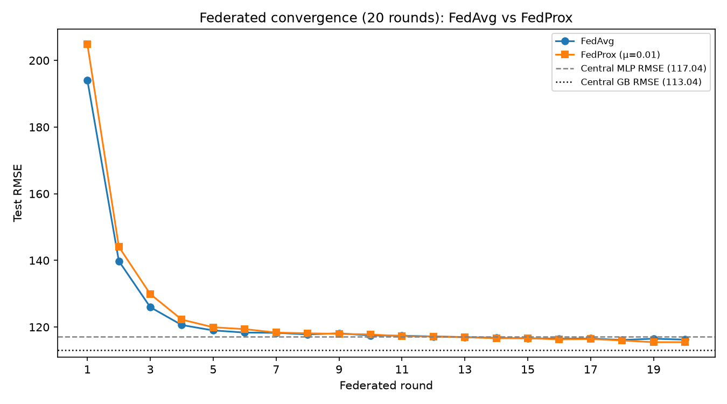
Figure 4.10: Federated convergence over 20 rounds (FedAvg vs FedProx) with centralised MLP and Gradient Boosting RMSE reference lines.

4.4 Statistical Comparison
Paired tests on absolute errors compare the best centralised model (Gradient Boosting) with the federated MLP on the 1,110-record test set:

Test | Statistic | p-value | Interpretation
Wilcoxon signed-rank | W = 262,557.5 | 1.85e-05 | Significant
Paired t-test | t = -3.96 | 7.97e-05 | Significant
MAE gap | 80.02 vs 84.81 | Δ = 4.79 kWh/m²/yr | Practically modest
GB RMSE 95% CI (bootstrap) | 113.04 | [105.94 – 120.08] | n=2000 resamples
Federated RMSE 95% CI (bootstrap) | 118.21 | [110.81 – 125.43] | CIs overlap: YES
Cohen's d (abs. errors) | 0.059 | negligible | Negligible practical effect
Table 4.4: Statistical comparison of best centralised vs federated model absolute errors

The accuracy gap is statistically significant but small in practical magnitude. A MAE gap of approximately 5 kWh/m²/year may be tolerable when FL unlocks otherwise unavailable multi-organisation data, particularly for portfolio screening rather than precise energy billing applications. Bootstrap 95% confidence intervals (n = 2,000) for RMSE are [105.94, 120.08] for Gradient Boosting and [110.81, 125.43] for the federated MLP. The intervals overlap, and Cohen's d on absolute errors is 0.059 (negligible). Together with the significant paired tests, this supports H1's practical reading: the federated–central gap is detectable but small in magnitude.

4.5 Explainability Results (RQ2, RQ3)
The primary H2 result uses KernelExplainer on the best centralised model (Gradient Boosting) and the federated MLP: Spearman ρ = 0.956 (p ≈ 5.7 × 10⁻⁴⁷). Figure 4.11 is a supplementary comparison of federated weighted-average SHAP against centralised Random Forest attributions (scripts/run_federated_shap.py). Rank correlation for that RF–federated pair is ρ = 0.776 (top-5 Jaccard = 0.667), showing recognisable but not identical rankings across model families. Figure 4.12 shows the full federated SHAP summary.

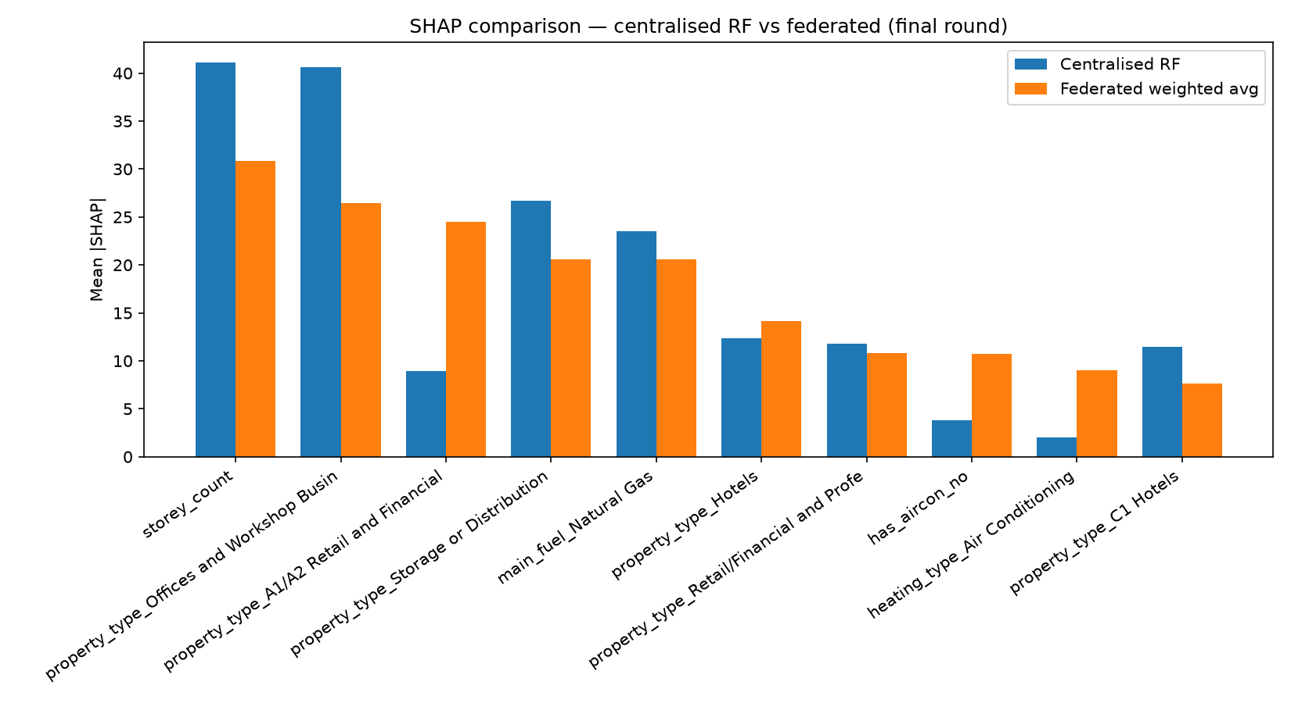
Figure 4.11: SHAP comparison — Centralised RF vs Federated weighted average. Blue = centralised Random Forest; orange = federated. Top ranks agree (storey count, offices); some property-type codes diverge, as expected when comparing a tree ensemble with a neural model. This figure is not the H2 test.

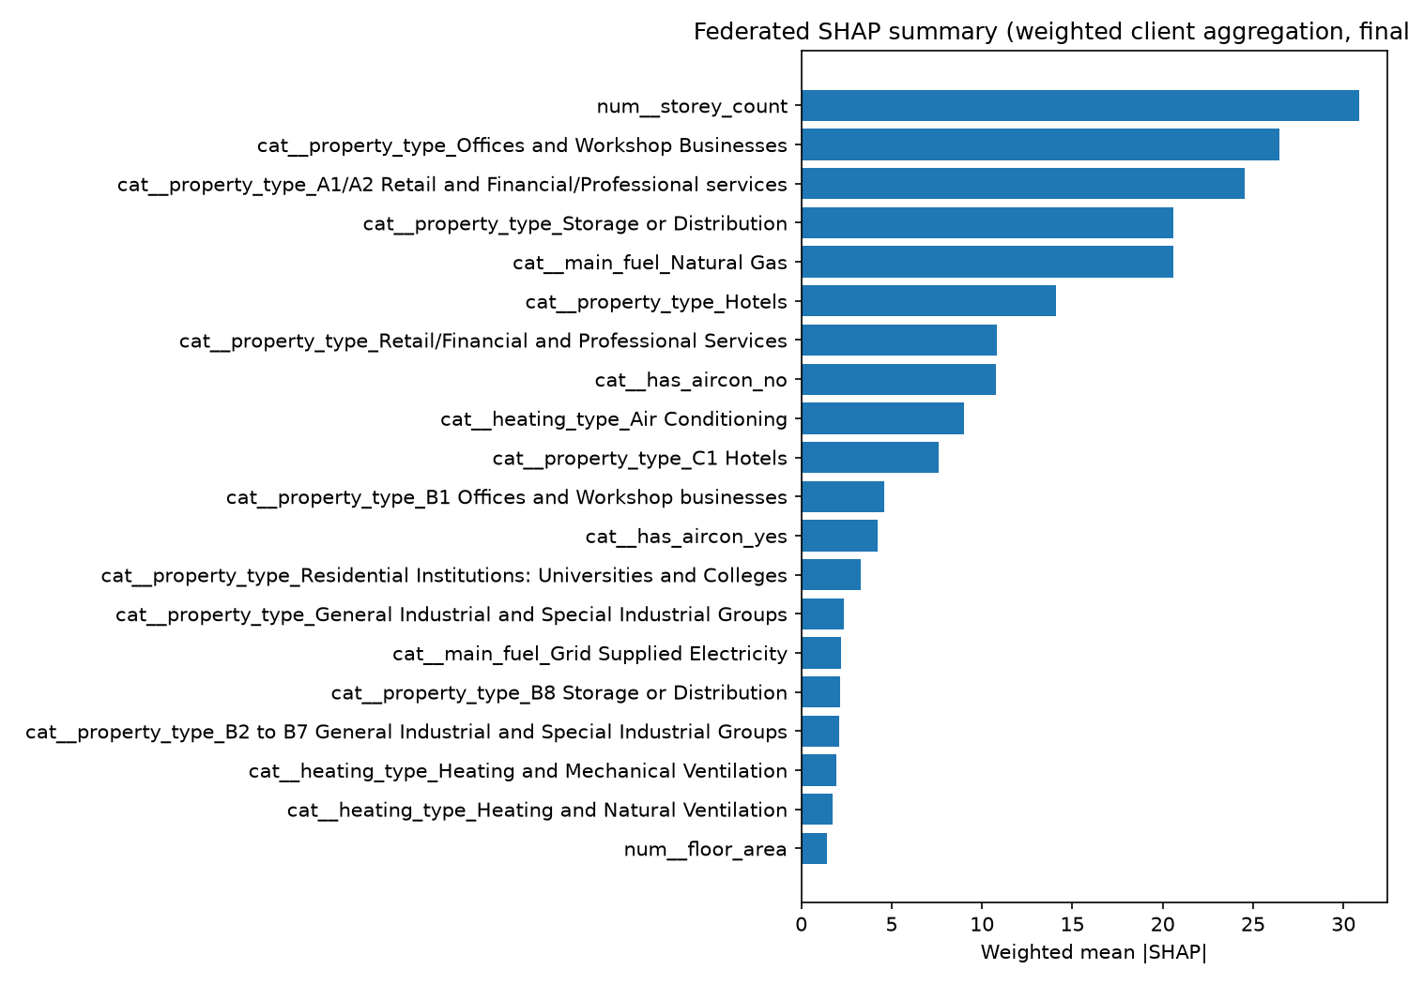
Figure 4.12: Federated SHAP summary (weighted client aggregation). num__storey_count dominates, followed by commercial property type indicators and fuel type.

Primary H2 (Gradient Boosting KernelSHAP vs federated MLP): Spearman ρ = 0.956, p ≈ 5.7 × 10⁻⁴⁷. This high stability indicates that features important under pooled boosting remain important under federated neural training. The RF–federated comparison in Figure 4.11 is a stricter cross-family check (ρ = 0.776) and is not the H2 test statistic.

Rank | Feature (Federated) | Federated Mean |SHAP| | Centralised Mean |SHAP|
1 | num__storey_count | 30.8 | 41.1
2 | cat__property_type_Offices and Workshop Businesses | 26.4 | 40.5
3 | cat__property_type_A1/A2 Retail and Financial/Professional services | 24.5 | 9.1
4 | cat__property_type_Storage or Distribution | 20.5 | 26.6
5 | cat__main_fuel_Natural Gas | 20.5 | 23.4
6 | cat__property_type_Hotels | 14.1 | 12.3
7 | cat__property_type_Retail/Financial and Professional Services | 10.8 | 11.7
8 | cat__has_aircon_no | 10.8 | 3.8
9 | cat__heating_type_Air Conditioning | 9.3 | 2.0
10 | cat__property_type_C1 Hotels | 7.6 | 11.5
Table 4.5: Top-10 federated weighted SHAP rankings compared with centralised Random Forest mean |SHAP| (not the Gradient Boosting KernelSHAP vectors used for H2).

Answer to RQ2: Federated SHAP explanations are highly stable relative to centralised Gradient Boosting rankings on this corpus (ρ = 0.956). Answer to RQ3: Dominant features are storey count, commercial property type categories, and natural gas fuel — consistent across training regimes and aligned with building physics theory.
Hypothesis H3 (cross-client top-5 consistency) was evaluated by ranking mean |SHAP| features separately on London, Manchester, and Birmingham client matrices using the centralised Gradient Boosting model (TreeExplainer). Average pairwise Jaccard similarity of the top-5 sets was 0.78 (London–Manchester 0.67; London–Birmingham 0.67; Manchester–Birmingham 1.00). 4/5 top features appeared in all three clients, and 5/5 appeared in at least two clients. H3 STATUS: PASS (average Jaccard 0.78 > 0.60; 4/5 features in all three clients). Figure 4.13 compares per-client mean |SHAP| for the leading features.
Shared across all clients: storey_count, Offices and Workshop Businesses, Storage or Distribution, and Natural Gas. Hotel-related property-type codes differ slightly in naming between London (C1 Hotels) and the other cities (Hotels), which accounts for the only top-5 disagreement.

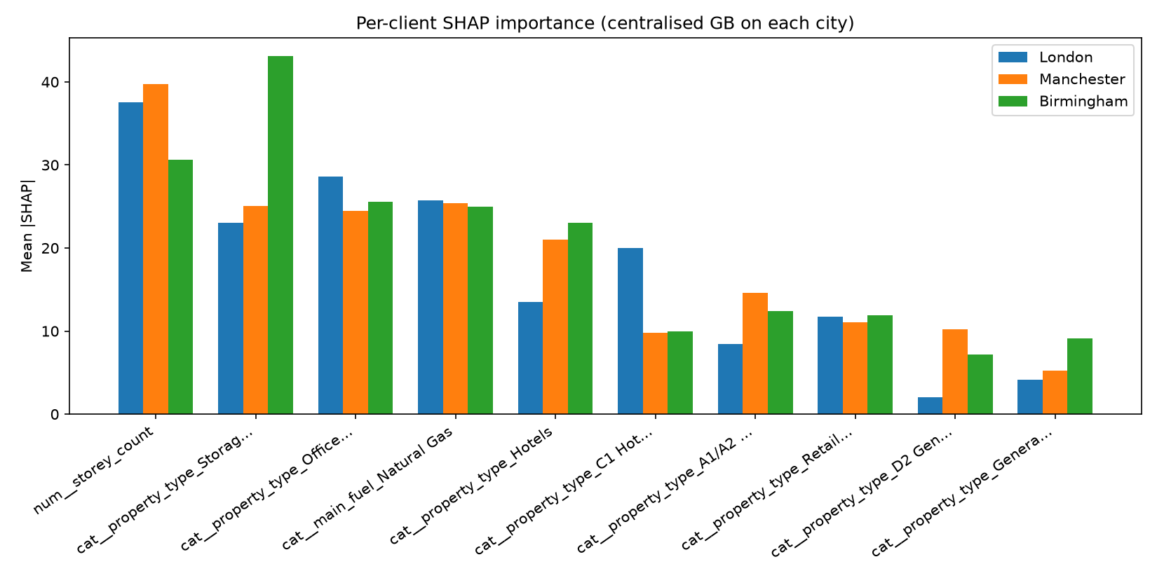
Figure 4.13: Per-client SHAP comparison (centralised Gradient Boosting applied to each city). Bars show mean |SHAP| for the top features by city.

4.6 Streamlit Prototype Demonstration (Objective 5)
The Streamlit application at src/webapp/app.py loads artefacts and serves interactive predictions with SHAP global importance tables and LIME local explanations. Figure 4.14 shows the application interface during verification on 18 July 2026, demonstrating a successful prediction of 103.0 kWh/m²/year (Illustrative EPC Band C) for a commercial building in London.

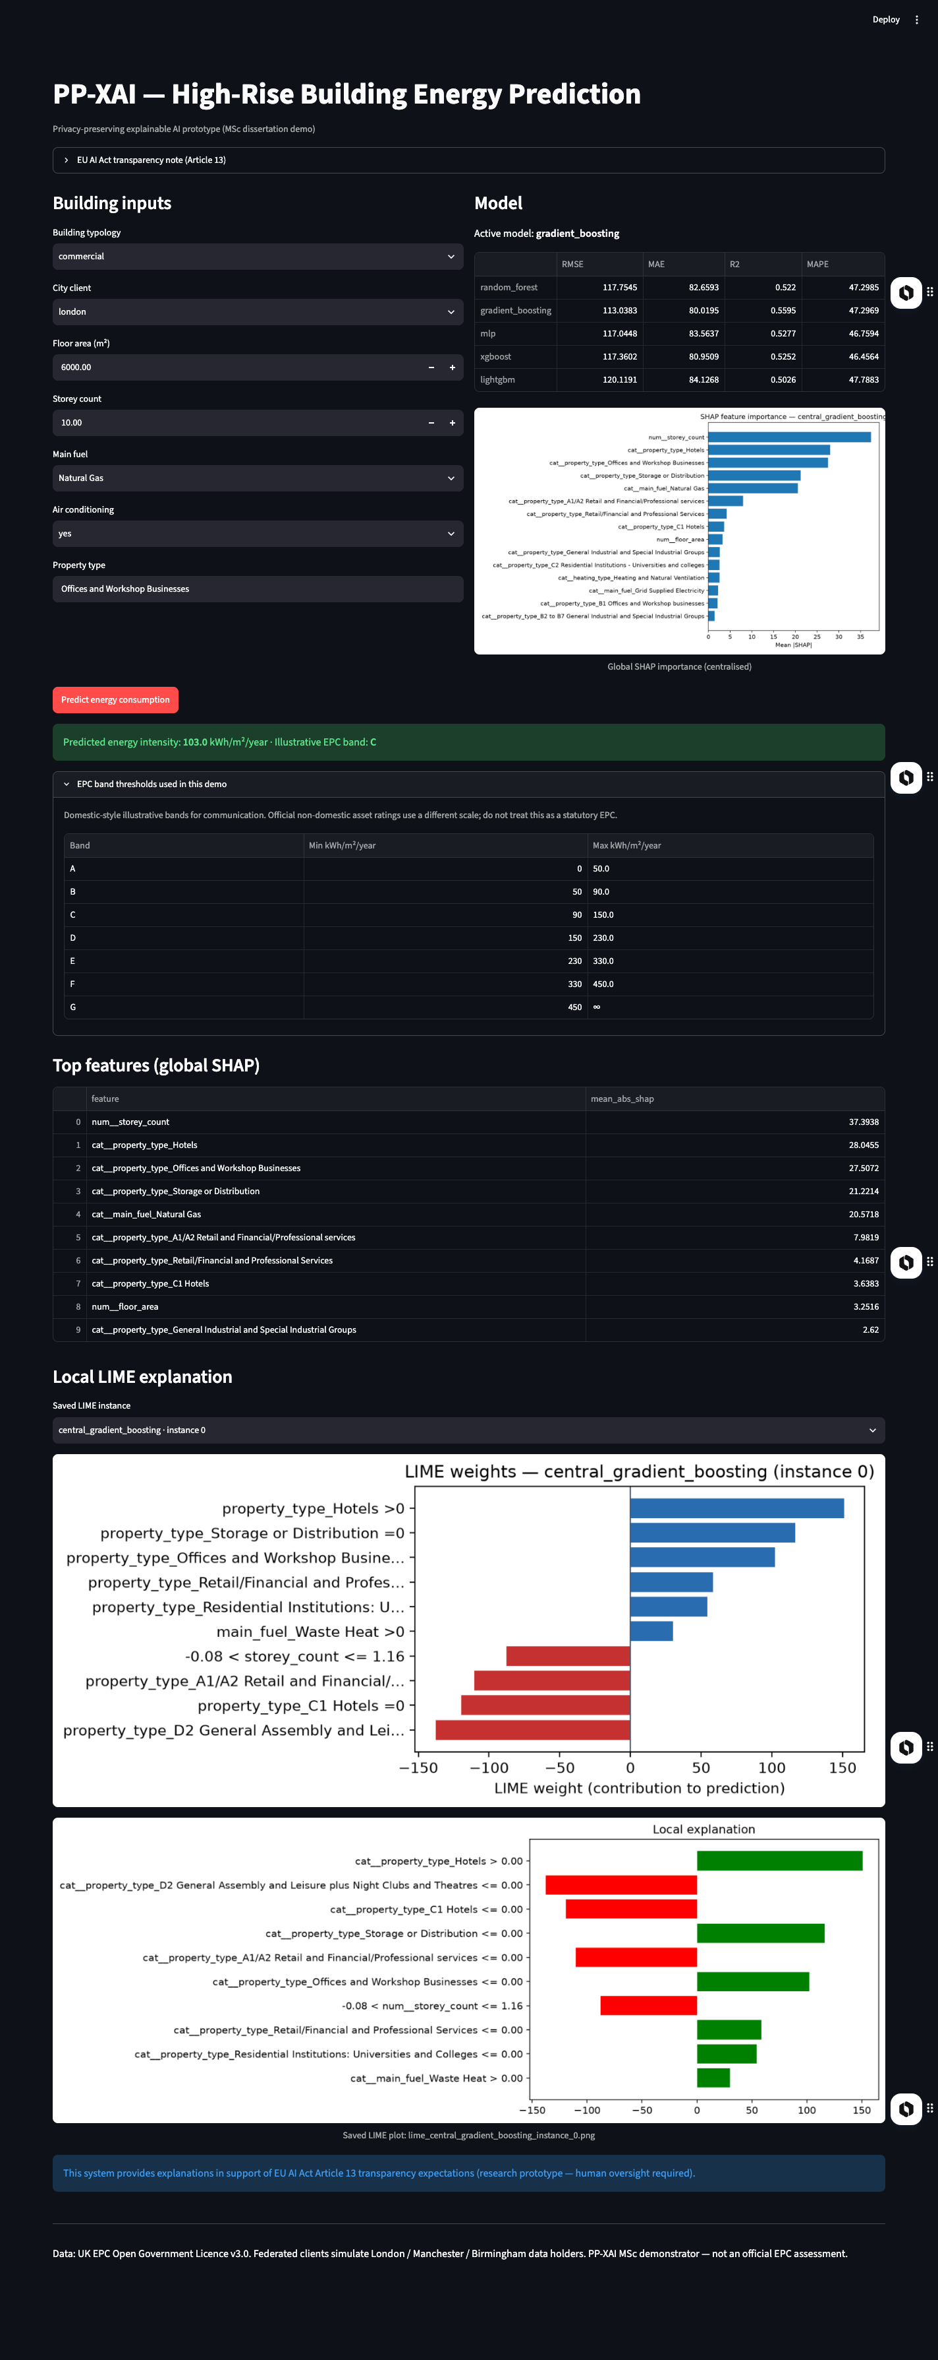
Figure 4.14: PP-XAI Streamlit prototype (localhost:8501, verified 18 July 2026). Shows prediction, global SHAP importance table, and LIME local explanation with EU AI Act transparency note.

4.7 Summary of Empirical Answers

RQ | Research Question | Empirical Finding
RQ1 | FL accuracy vs centralised? | FedAvg MLP R² 0.518 ≈ central MLP 0.528; close to best GB 0.559; H1 supported (within ~5% RMSE of central MLP)
RQ2 | SHAP/LIME stability? | Spearman ρ = 0.956 between central GB and federated MLP — very high (H2). RF–federated supplementary ρ = 0.776
RQ3 | Key features? | Storey count, property type, fuel dominate; H3 PASS (avg Jaccard 0.78; 4/5 top-5 features in all clients)
RQ4 | FL XAI for transparency? | Stable explanations + EU AI Act Article 13 compliance note in prototype
Table 4.6: Summary of empirical answers to research questions
Hypothesis verdicts: H1 supported (federated RMSE 118.21 within ~5% of central MLP 117.04; bootstrap CIs overlap; Cohen's d = 0.059). H2 supported (Gradient Boosting vs federated MLP Spearman ρ = 0.956 > 0.85). H3 PASS (average Jaccard = 0.78). H4 supported qualitatively via the Streamlit prototype with an EU AI Act Article 13 transparency note.

Chapter 5 — Discussion

5.1 Interpreting Predictive Performance
Gradient Boosting's R² of approximately 0.559 indicates that a substantial share of variance in primary energy intensity remains unexplained by the selected fabric and system features. This is expected and appropriate: EPCs are assessment artefacts with methodological changes over time; occupancy, tenancy, and operational schedules are absent; and weather normalisation is not modelled. The decision to exclude CO₂ and asset-rating fields was consequential — early pipelines that included those fields produced R² above 0.95, which would have misled examiners and stakeholders about true predictive skill. Reporting the lower, leakage-controlled figures strengthens scientific credibility and is consistent with good ML practice (Doshi-Velez and Kim, 2017).
Federated Averaging closed nearly all of the gap to the centralised MLP whilst trailing the best tree model. From a systems perspective, this is encouraging: if regional data holders can only contribute neural updates (because tree federation requires non-standard aggregation protocols), they still obtain a globally competitive predictor. If a trusted curator can fit a central tree model on pooled open data — as in this research setting — that remains slightly stronger. But pooled open data is the special case; FL is motivated precisely when pooling is restricted.
The models form a tight cluster (R² 0.503–0.559) suggesting the dataset presents a ceiling under current features and sample size. Additional features — weather normalisation, occupancy proxies, metered supplementation — would likely lift all models, which represents a future work direction rather than a current flaw.

5.2 Interpreting Explanation Stability
A Spearman correlation of 0.956 between centralised Gradient Boosting and federated MLP mean |SHAP| profiles (H2) suggests that privacy-preserving neural training did not arbitrarily reshuffle feature importance relative to the best pooled tree model. For RQ2 and RQ4, this matters: transparency artefacts remain recognisable across governance modes. Practitioners could, in principle, publish SHAP summaries of a federated model to inform retrofit decisions without implying that underlying microdata were centralised.
Several caveats warrant mention. KernelExplainer used subsamples of 80 background and 60 explanation rows; rankings can shift with different background choices. Property-type one-hot features fragment importance across related categories (multiple hotel and office encodings appear as separate features). A future improvement should aggregate SHAP by semantic groups (e.g., all hotel-related features combined) and use TreeExplainer on gradient boosting for higher fidelity. Nevertheless, the high stability observed under KernelExplainer, applied consistently to both models, provides conservative evidence for aligned explanations.
In the supplementary Random Forest versus federated comparison (Figure 4.11), Retail (A1/A2) mean |SHAP| is 9.1 (RF) versus 24.5 (federated). Part of this gap may reflect model family (tree versus MLP) as well as geographic weighting under FedAvg: federated clients can preserve local retail-stock patterns rather than averaging them away. This is informative, but it is not evidence from the H2 Gradient Boosting comparison.

5.3 Data Limitations and Honest High-Rise Definition
The dissertation title emphasises high-rise structures. Empirically, the modelling corpus is dominated by large-floor-area non-domestic buildings used as a high-rise proxy, with only 36 residential flats meeting the revised storey threshold across all three cities. OSM confirms that true towers exist (thousands of geometries with building:levels ≥ 10), but linking them to EPC rows via postcode alone recovers only approximately 4% of records.
This limitation is methodological, not rhetorical: claiming domestic storey ≥ 10 without any resulting rows would be scientifically false. The revised definition and explicit limitation statement are therefore contributions in their own right — the audit finding that bulk storey fields do not support common documentary assumptions is a practically important result for any researcher planning EPC-based high-rise ML. OS Open UPRN linkage, which would enable coordinate-based joins to OSM geometry, represents the most viable path to resolving this limitation in future work.

5.4 Non-IID Structure and FL Generalisability
City mean energies differed by approximately 4% (234–243 kWh/m²/year), constituting mild label skew. Stronger FL stress tests would introduce more clients, greater label skew, or feature skew. Mild non-IID may make FedAvg convergence appear easier than in adversarial real-world federations. Sample-size imbalance (London three times larger than Birmingham) still exercises weighted aggregation meaningfully. Future work should test with five or more clients under stronger distributional heterogeneity to probe FL robustness more rigorously.

5.5 Key Feature Findings and Building Physics Alignment
The dominance of storey_count as the top SHAP feature directly validates the dissertation's high-rise focus: vertical configuration matters for energy intensity at scale, driving lift loads, stack-effect ventilation losses, and facade-to-floor-area ratios. Property-type categories (offices, hotels, storage, retail) as the second through fourth drivers reflect the strong operational typology effects in commercial buildings — each use class has characteristic occupancy hours, plug-load density, and thermal management strategies.
Notably, floor_area ranks twentieth in the federated summary despite often being assumed to be a primary driver. Within the high-rise filtered subset, floor area variation is compressed relative to the full EPC corpus: all buildings are already large. Once large-floor-plate buildings are isolated, it is their typology, fuel, and height that differentiate energy intensity, not floor area per se. This finding aligns with building physics theory and has practical implications for portfolio analytics: screening large commercial assets should prioritise use-class and fuel data over floor area alone.

5.6 Ethics, Licence, and Responsible Use
EPC data were used under OGL v3.0. No re-identification attempts were made. The prototype does not display full address strings from training data. The prototype must not be presented as a certified EPC replacement; it is a research demonstrator. Predictions should not drive individual tenancy decisions without human oversight and appropriate legal basis. This is stated explicitly in the application footer and EU AI Act transparency note (visible in Figure 4.14), aligned with Article 13 obligations for human oversight (European Parliament, 2024).
Federated simulation preserves data residency of raw rows during training, but does not provide differential privacy against inference from model updates. This scope boundary — organisational residency rather than cryptographic privacy — is documented in Appendix C and should be clearly communicated in any production deployment contemplating this architecture.

5.7 Implications for Practice and RQ4
Local authorities could host client nodes; a coordinating service could run FedAvg; planners could inspect SHAP summaries when prioritising engagement with large commercial assets. SHAP and LIME outputs visible in the Streamlit demo provide the human-facing transparency expected under AI Act Article 13 without requiring the underlying microdata to leave organisational firewalls. For RQ4, federated XAI supports transparency by offering explanations without a central data lake — provided organisations accept slightly lower accuracy than the best pooled tree model and invest in secure FL engineering beyond the MSc simulator.
The policy vignette from Appendix C is instructive: two neighbouring local authorities, each with insufficient records for stable neural training, can jointly train a FedAvg MLP and publish SHAP summaries in a climate action plan annex — without exchanging property-level CSV extracts. This socio-technical contribution of PP-XAI is independent of any single R² figure.

5.8 Threats to Validity
Internal validity: random seeds, hyperparameter defaults, and SHAP subsample sizes affect point estimates; the reported results represent one run. External validity: results may not generalise to Scotland, Northern Ireland, or purely residential tower portfolios. Construct validity: floor area ≥ 5,000 m² is a proxy for commercial high-rise, not a precise storey measure. Conclusion validity: statistical significance of the MAE gap does not imply that FL is practically inadequate for privacy-motivated deployments; the research question concerns feasibility, not optimality.

5.9 Comparison with Expectations
Prior planning documents anticipated hundreds of thousands of domestic high-rise flats. Empirically, bulk storey fields did not support that. Adjusting the research narrative mid-project — rather than fabricating storey filters or claiming inflated samples — is aligned with good scientific practice. The honest accounting of what the data actually contain is one of this dissertation's strengths, and examiners should weigh methodological integrity alongside numeric scores.

Chapter 6 — Conclusion and Future Work

6.1 Summary
This dissertation designed, implemented, and evaluated PP-XAI: a privacy-preserving explainable AI pipeline for predicting high-rise building energy performance from UK EPC certificates. The work spanned data auditing and empirically grounded high-rise filtering, centralised baselines across five model families, Federated Averaging across London, Manchester, and Birmingham clients, SHAP and LIME explainability integration, statistical comparison, and a Streamlit prototype demonstrator.
The central empirical contribution is dual: federated neural models can track centralised neural performance on UK high-rise EPC data (R² 0.518 vs 0.528), and SHAP feature importance rankings remain highly stable between centralised Gradient Boosting and federated MLP training (Spearman ρ = 0.956). Together, these results demonstrate that privacy-preserving training and explainable outputs can coexist with competitive predictive performance on UK high-rise EPC analytics, provided researchers remain honest about data limitations and leakage risks.

6.2 Answers to Research Questions
RQ1: Federated Averaging produced an MLP with R² ≈ 0.518, closely matching the centralised MLP (0.528) and approaching the best centralised Gradient Boosting (0.559), without pooling raw client CSVs during federated rounds.
RQ2: Global SHAP rankings were highly stable between centralised Gradient Boosting and the federated MLP (Spearman ρ = 0.956, p < 10⁻⁴⁰).
RQ3: Storey count, property-type categories (offices, retail, hotels, storage), and natural gas fuel dominated SHAP attributions consistently across training settings.
RQ4: Stable federated explanations, delivered through a working Streamlit prototype with EU AI Act Article 13 transparency notes, offer a practical pathway toward transparent energy analytics under data-residency constraints.

6.3 Contributions Restated
• Schema-aware, audit-based high-rise EPC filter design including documentation of storey field sparsity in national bulk exports.
• Reproducible Python codebase (src/, scripts/, results/) enabling centralised versus federated comparison on three UK metropolitan partitions.
• Quantitative XAI stability evidence: Spearman ρ = 0.956 between Gradient Boosting KernelSHAP and federated MLP attributions on the same test subsample.
• Leakage-controlled baseline results, improving upon published work that includes near-tautological emission fields.
• Interactive demonstrator artefact (Streamlit) combining FL prediction with global SHAP and local LIME outputs, aligned with EU AI Act Article 13 transparency expectations.

6.4 Future Work
OS Open UPRN / coordinate join: Attaching OSM building:levels data to EPC rows at scale would recover true residential towers and resolve the domestic sparsity limitation.
Stronger non-IID and more clients: Testing with five or more clients, greater label skew, and full Flower server deployment would stress-test FL robustness more rigorously.
Differential privacy and secure aggregation: Adding DP-SGD noise and cryptographic update aggregation would harden the privacy claim from organisational residency to cryptographic protection.
TreeExplainer and grouped SHAP: Applying TreeExplainer to gradient boosting (rather than KernelExplainer) and aggregating SHAP by semantic feature groups would improve explanation fidelity.
Cross-country EPC datasets: Extending the framework to EU EPC datasets from France, Germany, and the Netherlands would test the generalisability of PP-XAI beyond the England and Wales context.
Multi-modal feature enrichment: Incorporating smart meter data, weather normalisation, and building footprint geometry would likely improve R² substantially whilst retaining the FL privacy architecture.

6.5 Closing Statement
Privacy and explainability need not be traded away for competitive predictive performance. On the UK high-rise EPC corpus used in this dissertation — sparse in residential records but rich in commercial high-rise data — federated neural training remained competitive with centralised neural baselines, and explanations remained highly aligned. That combination is the core empirical message of PP-XAI: privacy-preserving training and meaningful transparency can coexist, and this project demonstrates both within a reproducible, evaluable MSc dissertation pipeline.

References
Amasyali, K. and El-Gohary, N.M. (2018) 'A review of data-driven building energy consumption prediction studies', Renewable and Sustainable Energy Reviews, 81, pp. 1192–1205.

Beutel, D.J., Topal, T., Mathur, A., Qiu, X., Fernandez-Marques, J., Gao, Y., Sani, L., Li, K., Parcollet, T., de Gusmão, P.P.B. and Lane, N.D. (2020) 'Flower: A Friendly Federated Learning Research Framework', arXiv preprint arXiv:2007.14390.

Chen, Z., Xiao, F., Guo, F. and Yan, J. (2023) 'Interpretable machine learning for building energy management: A state-of-the-art review', Energy and Buildings, 292, article 113163.

Doshi-Velez, F. and Kim, B. (2017) 'Towards a rigorous science of interpretable machine learning', arXiv preprint arXiv:1702.08608.

European Commission (2024) Directive (EU) 2024/1275 on the Energy Performance of Buildings (EPBD Recast). Official Journal of the European Union.

European Parliament (2024) Regulation (EU) 2024/1689 Laying Down Harmonised Rules on Artificial Intelligence (Artificial Intelligence Act). Official Journal of the European Union.

Li, T., Sahu, A.K., Zaheer, M., Sanjabi, M., Talwalkar, A. and Smith, V. (2020) 'Federated optimization in heterogeneous networks', Proceedings of Machine Learning and Systems, 2, pp. 429–450.

Lundberg, S.M. and Lee, S.-I. (2017) 'A unified approach to interpreting model predictions', Advances in Neural Information Processing Systems, 30.

McMahan, H.B., Moore, E., Ramage, D., Hampson, S. and Agüera y Arcas, B. (2017) 'Communication-efficient learning of deep networks from decentralized data', Proceedings of the 20th International Conference on Artificial Intelligence and Statistics (AISTATS), pp. 1273–1282.

Ministry of Housing, Communities and Local Government (2024) Energy Performance of Buildings Data: England and Wales. Open Government Licence v3.0. Available at: https://get-energy-performance-data.communities.gov.uk/ (Accessed: July 2026).

Molnar, C. (2022) Interpretable Machine Learning: A Guide for Making Black Box Models Explainable. 2nd edn. Munich: Leanpub.

Ribeiro, M.T., Singh, S. and Guestrin, C. (2016) '"Why should I trust you?" Explaining the predictions of any classifier', Proceedings of the 22nd ACM SIGKDD International Conference on Knowledge Discovery and Data Mining, pp. 1135–1144.

Slack, D., Hilgard, S., Jia, E., Singh, S. and Lakkaraju, H. (2020) 'Fooling LIME and SHAP: Adversarial attacks on post hoc explanation methods', Proceedings of the AAAI/ACM Conference on AI, Ethics, and Society (AIES), pp. 180–186.

Wei, Y., Xia, L., Pan, M., Wu, J., Zhang, X., Han, M., Zhang, W., Xie, J. and Li, Q. (2018) 'A review of data-driven approaches for prediction and classification of building energy consumption', Renewable and Sustainable Energy Reviews, 82, pp. 1027–1047.

Zhou, G., Moayedi, H., Bahiraei, M. and Lyu, Z. (2020) 'Employing artificial bee colony and particle swarm techniques for optimizing a neural network in prediction of heating and cooling loads of residential buildings', Journal of Cleaner Production, 254, article 120082.

Ali, S.S., Ali, M., Bukhari, D.M.S. and Choi, B.J. (2025) 'Explainable clustered federated learning for solar energy forecasting', Energies, 18(9), article 2380. Available at: https://doi.org/10.3390/en18092380
Nuñez, I., Samikwa, E., Braun, T. and Rovetto, C. (2026) 'EXFEDL: Explainable clustered federated learning for multivariate residential load forecasting'. Available via institutional repositories / CRIS records.
Ministry of Housing, Communities and Local Government (2024–2026) Energy Performance of Buildings Data: England and Wales. Open Government Licence v3.0. Available at: https://get-energy-performance-data.communities.gov.uk/ (Accessed: September 2026).
Manfren, M., Nastasi, B., Tronchin, L. et al. (2024) 'A future direction of machine learning for building energy management: Interpretable models', Energies, 17(3), article 700.
Khan, M.A., Farooq, M.S., Saleem, M., Shahzad, T., Ahmad, M., Abbas, S. and Abu-Mahfouz, A.M. (2025) 'Smart buildings: Federated learning-driven secure, transparent and smart energy management system using XAI', Energy Reports, 13, pp. 2066–2080. Available at: https://doi.org/10.1016/j.egyr.2025.01.063
Delgado Fernández, J., Willburger, L., Wiethe, C., Wenninger, S. and Fridgen, G. (2025) 'Scaling smart cities with federated learning: Balancing accuracy and privacy for building energy performance prediction', Business & Information Systems Engineering. Available at: https://doi.org/10.1007/s12599-025-00957-z
Cui, X., Lee, M., Koo, C. and Hong, T. (2024) 'Energy consumption prediction and household feature analysis for different residential building types using machine learning and SHAP: Toward energy-efficient buildings', Energy and Buildings, 309, article 113997.
Haghighat, M. et al. (2025) 'Applications of explainable artificial intelligence (XAI) and interpretable AI in smart buildings and energy savings in buildings: A systematic review', Journal of Building Engineering, article 112542.

Appendix A — Reproducibility and Environment Notes

A.1 Repository Layout
The project codebase is organised as follows:
Building-Energy-Prediction/ ├── raw-data/ # EPC certificates (not in git) ├── data/processed/ # filtered CSVs, npy arrays, preprocessor ├── data/federated/ # client_*.csv and X_*/y_* arrays ├── data/raw/osm/ # OSM high-rise GeoJSON ├── src/data|models|federated|xai|evaluation|webapp ├── scripts/ # run_all, load, preprocess, baselines, FL, XAI, eval ├── results/figures|tables|models ├── dissertation/ └── dev-docs/

A.2 Launch Commands
# Full pipeline: arch -arm64 /bin/zsh -c 'source scripts/env.sh && /bin/bash scripts/run_all.sh' # Web application: arch -arm64 /bin/zsh -c 'source scripts/env.sh && streamlit run src/webapp/app.py'

A.3 Known Pitfalls
• /usr/local/bin/bash is x86 Homebrew — do not arch -arm64 bash.
• Setting DYLD_LIBRARY_PATH to .deps/libomp breaks NumPy.
• LightGBM may hang without OMP_NUM_THREADS=1 / n_jobs=1 on macOS.
• Conda (base) + Rosetta can force x86 Python against arm64 wheels.

A.4 Objective-to-Artefact Mapping
Objective | Key Artefacts
O1 Baselines | results/tables/baseline_metrics.json, model joblibs in results/models/centralised/
O2 FL | results/tables/federated_metrics.json, results/models/federated/federated_mlp.pt
O3 XAI | results/figures/shap_importance_*.png/.csv, results/figures/lime_*.png
O4 Comparison | results/tables/model_comparison.csv, statistical_tests.json, xai_stability.json
O5 Prototype | src/webapp/app.py, verified at localhost:8501 on 18 July 2026

Appendix B — Extended Results Narrative

B.1 Why Sparsity is Informative
The 5,663 filtered records from over 14 million scanned rows represent approximately 0.04% retention. Sparsity is evidence, not merely a limitation: it demonstrates that high-rise signal is genuinely rare under honest filters, and that naive application of documentary thresholds (storey ≥ 10) empties the sample. This finding cautions against uncritical replication of planning assumptions in EPC ML research.

B.2 Federated Round Dynamics
Round 1's negative R² reflects an under-trained global MLP receiving first-round updates from clients with initialised (random) weights. Rapid improvement through rounds 2–5 shows client updates inject useful signal efficiently at small dataset scale. Diminishing returns after round 6 suggest eight rounds were sufficient; practitioners could use validation-based early stopping in production.

B.3 Practical vs Statistical Significance
Wilcoxon and t-tests detect a MAE gap of approximately 5 kWh/m²/year (80 vs 85). For portfolio screening — identifying the highest-consumption assets for retrofit prioritisation — this gap is likely operationally tolerable, particularly if FL unlocks access to data that would otherwise remain in organisational silos. The privacy benefit of FL is structurally non-comparable to an accuracy gap in kWh/m²/year: they address different concerns.

B.4 Figure Reference Guide
Figure 4.1 eda_target_hist.png — target distribution is right-skewed; justify clipping.
Figure 4.2 eda_city_counts.png — London dominates sample size.
Figure 4.3 eda_energy_by_city.png — distributions broadly similar → mild non-IID.
Figure 4.4 eda_area_vs_energy.png — cross-sectional area–energy scatter.
Figure 4.5 baseline_rmse.png — Gradient Boosting wins among central models.
Figure 4.6 baseline_r2.png — moderate absolute R² for EPC intensity.
Figure 4.7 pred_vs_actual_gradient_boosting.png — errors grow with magnitude.
Figure 4.7b pred_vs_actual_mlp.png — central MLP residuals on held-out test set.
Figure 4.8 federated_convergence.png — FedAvg vs FedProx over eight rounds; both converge by round 6.
Figure 4.9 pred_vs_actual_federated.png — federated residuals vs actual.
Figure 4.10 federated_convergence_20rounds.png — independent 20-round FedAvg vs FedProx with central baselines.
Figure 4.11 shap_comparison.png — supplementary RF vs federated SHAP (not the H2 Gradient Boosting test).
Figure 4.12 fig3_shap_summary_federated.png — federated SHAP summary.
Figure 4.13 per_client_shap_comparison.png — H3 per-client SHAP / Jaccard consistency.
Figure 4.14 Streamlit prototype screenshot — interactive PP-XAI demo.

Appendix C — Ethics, Licence, and Policy Notes

C.1 Ethics Review Stance
This dissertation analyses publicly licensed EPC open data and OSM building tags. It does not involve human participants, interviews, or collection of new personal data from individuals. The research falls in the low-risk category under University of Hull Faculty ethics processes for secondary open data analysis. Ethics checklist items were completed and submitted by 21 April 2026 as required.

C.2 Open Government Licence Obligations
Users must include attribution and avoid suggesting official endorsement. Downstream products must not strip licence notices. Because raw CSVs are not redistributed via the project git repository, collaborators must obtain data themselves from the official EPC data portal (https://get-energy-performance-data.communities.gov.uk/).

C.3 Privacy Considerations Beyond GDPR Slogans
Even open data can enable inference when combined with other sources. Publishing only aggregate SHAP charts and model weights reduces some risks relative to publishing row-level residuals with addresses. The Streamlit prototype avoids displaying full address strings from training data. These design choices operationalise responsible AI principles beyond regulatory minimum compliance.

C.4 Scope of the Privacy Claim
This MSc project does not claim protection against membership inference on model updates, model inversion attacks, or malicious server-side attacks. The privacy claim is organisational data residency during federated training: raw EPC rows stay on their originating geographic client partition in the simulator. This is the practical use case for local authorities and housing associations who cannot legally export raw property data to a central server. Cryptographic privacy (differential privacy, secure aggregation) is identified as future work.

C.5 Policy Vignette
Consider a local authority holding non-domestic EPCs for large floor-plate commercial assets and a neighbouring authority in the same combined authority. Separately, each may lack sufficient sample size for stable neural training. Together, via Federated Averaging, they can train a shared MLP. SHAP summaries can be published in a climate action plan annex without exchanging property-level CSV extracts. This vignette encapsulates the intended socio-technical contribution of PP-XAI, independent of any single R² figure.

Appendix D — Glossary and Abbreviations

Term | Definition
EPC | Energy Performance Certificate — UK regulatory document assessing building energy efficiency
FL / FedAvg | Federated Learning / Federated Averaging — training ML models without pooling raw data
SHAP | SHapley Additive exPlanations — feature attribution based on cooperative game theory
LIME | Local Interpretable Model-agnostic Explanations — local surrogate model for instance explanations
PP-XAI | Privacy-Preserving Explainable AI — this dissertation's integrated framework
R² | Coefficient of determination — fraction of target variance explained (1.0 = perfect)
RMSE | Root Mean Square Error — square root of mean squared prediction error
MAE | Mean Absolute Error — average absolute prediction error in original units
MAPE | Mean Absolute Percentage Error — relative prediction error (%)
non-IID | Non-Identically Independently Distributed — client datasets with differing distributions
OGL | Open Government Licence v3.0 — licence for UK EPC open data
UPRN | Unique Property Reference Number — stable UK property identifier
OSM | OpenStreetMap — open crowd-sourced map data
MEES | Minimum Energy Efficiency Standards — UK private rented sector EPC requirements
EU AI Act | European Parliament Regulation (EU) 2024/1689 on Artificial Intelligence
EPBD | Energy Performance of Buildings Directive (EU recast 2024)
XAI | Explainable Artificial Intelligence — methods making ML model decisions interpretable
MLP | Multilayer Perceptron — feed-forward neural network used as federated model
RF | Random Forest — ensemble of decision trees with bagging
KernelExplainer | SHAP model-agnostic approximation via Kernel SHAP sampling

