GLR Pipeline Automation
Guideline Loss Report — Claims Portal
Project Technical Documentation

Version 1.0 | Prepared June 2026
Full-Stack Web Application for Insurance Claims Automation

1. What is GLR?
GLR stands for Guideline Loss Report.

In the insurance and property restoration industries, when damage occurs to a home or business (such as water leaks, wind damage, or fires), a field inspector, claims adjuster, or service provider must document the situation. They compile a detailed physical report — often a PDF containing photos, descriptions, and equipment readings — and must then manually transcribe this information into a standardized Microsoft Word template (the Guideline Loss Report) to submit to the insurance carrier (e.g., USAA, State Farm) for estimate approval.

Doing this transcription manually is slow, repetitive, and prone to typing errors. The GLR Claims Portal automates this entire step.

2. What the Project Does
The GLR Claims Portal is a full-stack web application that allows users to:
- Upload a Microsoft Word document (.docx) containing empty placeholders (e.g., [INSURED_NAME], {{DATE_LOSS}}).
- Upload one or more PDF photo reports, site inspection documents, or contractor logs containing raw text and images.
- Automatically Extract & Cross-Reference information from the PDFs using Large Language Models (LLMs) to match the placeholders in the Word template.
- Review & Edit the extracted information in a neat, responsive tabbed interface to correct any discrepancies.
- Download a perfectly formatted Word document where the placeholders have been replaced with the verified data, preserving all original fonts and styles.

3. Core Features
- Dynamic Template Scanning: Instead of using fixed fields, the application scans the uploaded Word file dynamically on-the-fly to find bracketed ([...]) or double-curly ({{...}}) placeholders.
- Hybrid PDF Text Extraction: Uses high-speed text extraction from digital PDFs, with an automatic page-by-page fallback to Tesseract OCR (Optical Character Recognition) for scanned PDFs or image-only pages.
- Tri-Provider LLM Integration: Supports direct API connections to Google Gemini (free-tier/beta models), Groq (low-latency open-source models like Llama), and OpenRouter (for general models like GPT-3.5/4, Claude, or DeepSeek).
- Keyless User Mode: If the server administrator pre-configures the API keys in the backend .env file, end-users do not have to enter any API keys to use the portal.
- Interactive Data Verification: Automatically categorizes placeholders into logical tabs ("Loss & Claims", "Insured & Property", "Mortgage & Vendor") and shows live field completion badges.
- Preserved Styling (Run Merging): Solves Microsoft Word's default behavior of splitting paragraph texts into separate styled fragments ("runs") by performing paragraph-level replacements and safely merging runs, preventing broken template formatting.
- Sleek Light Theme & Fully Responsive: Stretched, mobile-friendly interface using modern design practices: soft gradients, custom stepper progress bars, radar sweep scanning animations, and drop-zones.

4. Technical Architecture & Tech Stack
The project is built on a decoupled full-stack architecture consisting of a Next.js frontend and a FastAPI backend.

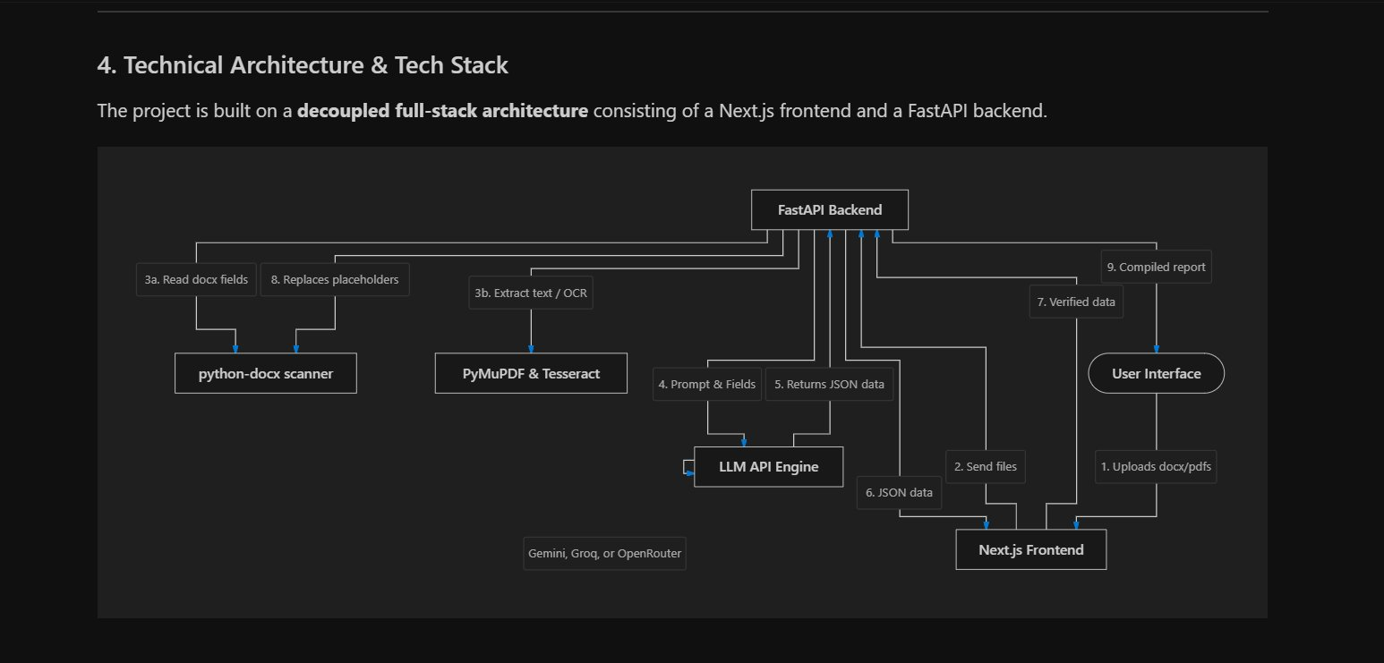
Figure 1: GLR Pipeline — Full-Stack Architecture Diagram

Frontend (User Interface)
- Next.js (App Router, React, TypeScript): Serves as the foundation for the interactive user experience, ensuring type-safe client-side routing and state management.
- Lucide React: Provides uniform modern line icons across the application.
- Vanilla CSS (globals.css): Defines color tokens (Light Slate base with deep Indigo and violet accents), smooth transitions, glassmorphic card borders, drop-zones, and a pulsing radar scanning effect. No Tailwind was used — keeping markup clean and styling fully controlled.

Backend (API Server)
- FastAPI (Python): A high-performance, asynchronous web framework used to build RESTful endpoints.
- python-docx: A library used to read paragraphs/tables in Microsoft Word files, scan for placeholders, and programmatically insert values.
- PyMuPDF (fitz): A fast PDF library used to extract digital text from uploaded PDF reports.
- Pytesseract (OCR): Integrates Google's Tesseract-OCR engine to read text from scanned documents or photos inside PDF reports.
- Pillow (PIL): Used to manage page images when rendering them for the OCR engine.
- Requests: Executes REST calls to LLM APIs with timeout controls and custom headers.
- python-dotenv: Loads preset API keys from the server's environment.

5. APIs Used & Their Role

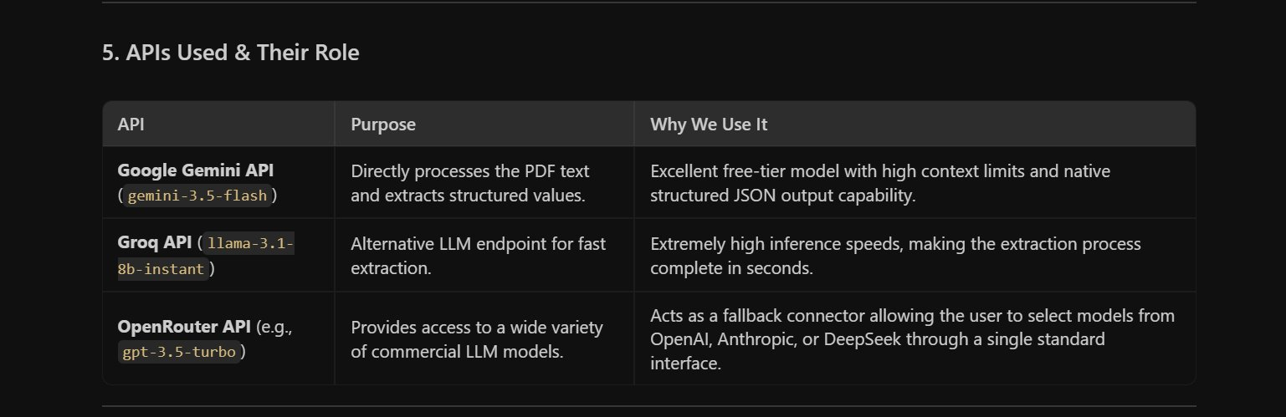
Figure 2: APIs Used & Their Role

API | Purpose | Why We Use It
Google Gemini API gemini-3.5-flash | Directly processes the PDF text and extracts structured values. | Excellent free-tier model with high context limits and native structured JSON output capability.
Groq API llama-3.1-8b-instant | Alternative LLM endpoint for fast extraction. | Extremely high inference speeds, making the extraction process complete in seconds.
OpenRouter API e.g., gpt-3.5-turbo | Provides access to a wide variety of commercial LLM models. | Acts as a fallback connector allowing the user to select models from OpenAI, Anthropic, or DeepSeek through a single standard interface.

6. Detailed Step-by-Step Working Process
Step 1: File Upload (Frontend)
The user opens the portal, drags and drops a Word template (.docx), and selects one or multiple PDF reports. The user expands the Settings accordion to select an LLM provider. If they have custom API keys, they can input them; otherwise, the portal uses the server's pre-configured keys.
Step 2: Template Scanning (Backend — /api/extract-placeholders)
The frontend uploads the Word document to the backend. The backend runs extract_placeholders_from_docx, traversing both body paragraphs and tables. It looks for terms wrapped in brackets [FIELD_NAME] or double curlies {{FIELD_NAME}} and compiles a list of unique keys.
Step 3: Document Reading (Backend — /api/extract-pdf-text)
The frontend uploads the PDF reports to the backend. The backend runs extract_text_from_pdf to load pages. For text-based PDFs, it extracts the characters directly. If a page has no digital characters, it converts the page to an RGB image and uses Pytesseract to perform OCR. The extracted text from all PDFs is concatenated.
Step 4: AI Extraction (Backend — /api/extract-data)
The backend formats a structured system prompt, providing the concatenated text and the list of target placeholders. It instructs the selected LLM to map the raw text into a key-value JSON object containing the exact placeholder names. The LLM parses the document and returns a structured JSON payload. Missing values are mapped to empty strings ("").
Step 5: Review & Editing (Frontend)
The frontend transitions to Step 3 (Verify Data) and displays a loading radar. Once it receives the LLM response, it sorts the keys dynamically into tabs: keys containing LOSS, DATE, TOL, or CLAIM go to "Loss & Claims"; keys containing INSURED, NAME, STREET, CITY, STATE, or ZIP go to "Insured & Property"; all other keys go to "Mortgage & Vendor". The user reviews the filled textboxes and modifies values as needed.
Step 6: Generating & Downloading (Backend — /api/fill-template)
The user clicks Generate Report. The frontend uploads the original Word template along with the edited key-value JSON. The backend's fill_docx_template replaces occurrences of the placeholders, resolving Microsoft Word's run-splitting issue by consolidating runs per paragraph. The compiled report is streamed back to the user, and background tasks automatically clean up all temporary files on the server storage.

7. Future Add-ons (Potential Enhancements)
The following enhancements are planned or considered for future development:

- Multimodal Visual Analysis: Sending PDF images directly to vision-capable models (like Gemini 1.5/2.0 Pro) to analyze damaged areas, sketch maps, or estimate tables directly from photos.
- Smart Synonym Dictionary: An automated mapping dictionary that links slightly different placeholders (e.g., [INSURED] vs [INSURED_NAME]) to the same extracted concept.
- Integrated PDF Side-by-Side Viewer: Allowing users to view their uploaded PDF reports on the screen next to the verification fields for fast cross-checking.
- Direct PDF Export: Exporting the compiled report as a secure PDF document alongside the Microsoft Word document.
- Database Claim Logs: Storing a history of completed claims, letting adjusters retrieve past client reports, search records, or inspect historical data trends.

