

# Jashore University Of Science and Technology

**Department of Computer Science and Engineering**

## Course Title: Image Processing Laboratory Course Code: CSE 4106

**Submitted To**

**Dr. Md. Nasim Adnan**

Assistant Professor

Department of Computer Science & Engineering. Jashore University of Science & Technology.

# Submitted By

Md. Abdul Alim (150110)

Dept. Of Computer Science & Engineering Jashore University of Science & Technology.

Remarks

## Date of submission: 30-06-21

**Problem:**

Write a Python program that will isolate the purple zone from the whole image (see the attached file).

**Used Technology:**

1. **Python 3.8:** Python 3.8 is the latest major release of the Python programming language, and it contains many new features and optimizations.
2. **NumPy:** NumPy is the most important Python package for scientific computing. A powerful N-dimensional array object is included in this package. (Broadcasting) functions that are complex.NumPy is a Python library that adds support for massive, multi-dimensional arrays and matrices, as well as a vast set of high-level mathematical functions to manipulate them.
3. **OpenCV:** OpenCV (Open Source Computer Vision Library) is a machine learning and computer vision software library that is free to use. More than 2500 optimized algorithms are included in the library, which contains a comprehensive mix of both classic and cutting-edge computer vision and machine learning techniques. Most of the time, OpenCV automatically locates memory and allocates memory for output function arguments.
4. **Notepad++:** Notepad++ is a free (as in “free speech” and also as in “free beer”) source code editor and Notepad replacement that supports several languages.
5. **Operating System (Windows 10):** Windows 10 is a major release of the Windows NT operating system developed by Microsoft.
6. **PyCharm:** PyCharm is a Python Integrated Development Environment (IDE) that includes a wide range of necessary tools for Python developers, all of which are tightly integrated to create a pleasant environment for productive Python, web, and data science development.
7. **GitHub:** is a service that hosts Git repositories, but it also has its own set of services. GitHub is a Web-based graphical interface for Git, which is a command line application. For each project, it also provides access control and numerous collaborative capabilities, such as wikis and rudimentary task management tools.
8. **Virtual environment:** A virtual environment is a tool that helps to keep dependencies required by different projects separate by creating isolated python virtual environments for them.

**Methodology:**

* Run Pycharm software.
* Create a project named “Isolate_the_purple_zone.py”.
* Import numpy and opencv library.
* Read the image using **imread()** function.
* Using **fastNlMeansDenoisingColored**() function for remove noise.
* Calculate the height weight and channels by using “shape” method.
* Use the **cvtColor()** method of the cv2 module which takes the original image and the COLOR_BGR2GRAY attribute as an argument return black and white image.
* Find the threshold. In the **threshold()** method, the last argument defines the style of the threshold
* Find the image contours. Use the **findContours()** method which takes the image (we passed threshold here) and some attributes.
* Sort the contours by using **sorted()** method and using a for loop calculate contours only greater than 100.
* Generate the mask using **zeros()** method of NumPy.
* Draw contours by using **drawContours()** method of OpenCV.
* Apply the **bitwise_and()** method of OpenCV and assign into a new variable as new_img.
* create zeros mask 2 pixels larger in each dimension for using in **floodFill()** method of OpenCV.
* Do floodfill for white background by using **floodFill()** method of OpenCV.
* Display the Oeriginal image by using **imshow()** method of OpenCV.
* Display the Isolated shape with background removed image by using **imshow()** method of OpenCV.
* Using the **waitKey()** display untill manually stop as the parameter of the method is 0.
* Save the file and run the program.

**Source Code:******

**Input and Output:**

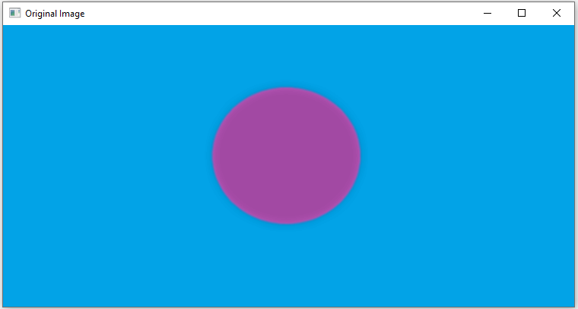

Fig: Input Image

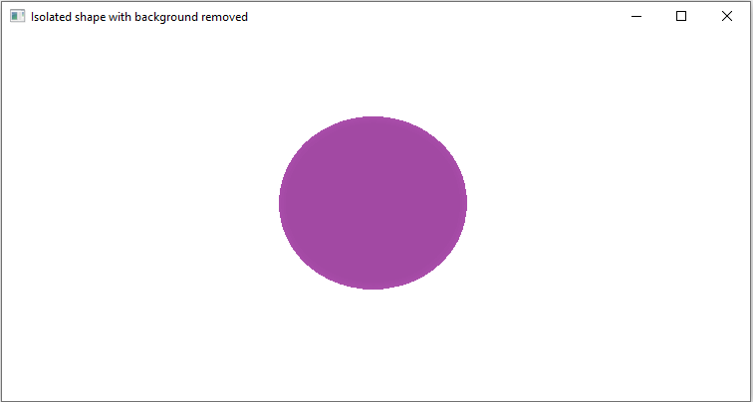

Fig: Output Image

**References:**

*https://github.com/alimabdul420/image_processing*

[*https://www.python.org/downloads/release/python-380/*](https://www.python.org/downloads/release/python-380/)

*https://pypi.org/project/numpy/*

*https://likegeeks.com/python-image-processing/*

[*https://www.geeksforgeeks.org/opencv-python-tutorial/*](https://www.geeksforgeeks.org/opencv-python-tutorial/)