As noted, the vast majority of the new construction is occurring in metro Atlanta’s intown submarket, primarily within the Downtown and Midtown Atlanta submarkets. In addition to projects currently under construction, there are a significant number of multifamily developments planned for the Atlanta market. Planned projects are summarized with the submarket analysis.
Completion Trends
The following graph summarizes completions over the past several years.

HISTORICAL COMPLETIONS: ATLANTA METRO APARTMENT MARKET


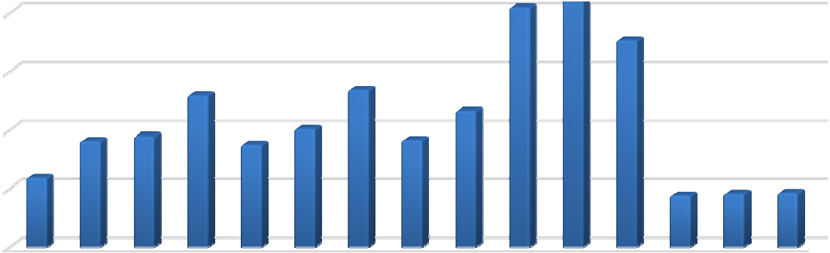
30,000
25,761
20,444
17,645
12,932
13,431
11,622
10,057
9,034
9,454
8,711
9,131
5,876
4,371 4,539 4,607

25,000

20,000

15,000

10,000

5,000

0
2014 2015 2016 2017 2018 2019 2020 2021 2022 2023 2024* 2025* 2026* 2027* 2028*

* Future Projected Data according to Axiometrics
Source: Axiometrics, 2nd Quarter 2024

Occupancy Trends
The following chart illustrates metropolitan Atlanta apartment occupancy over the past decade, as well as future projections for the next five year period.

HISTORICAL OCCUPANCY: ATLANTA METRO APARTMENT MARKET

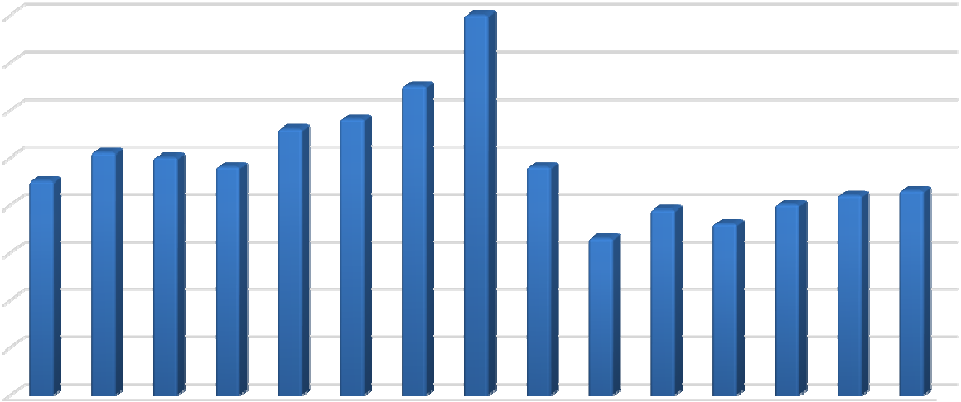
97.0%
97.0%
95.5%
94.6%
94.8%
94.1%
94.0%
93.8%
93.8%
93.5%
93.2%
93.3%
92.9%
93.0%
92.6%
92.3%

96.0%

95.0%

94.0%

93.0%

92.0%

91.0%

90.0%

89.0%
2014 2015 2016 2017 2018 2019 2020 2021 2022 2023 2024* 2025* 2026* 2027* 2028*

* Future Projected Data according to Axiometrics
Source: Axiometrics, 2nd Quarter 2024

Rental Rate Trends
The following table illustrates historical market trends within the Atlanta metropolitan area.

HISTORICAL EFFECTIVE RENT: ATLANTA METRO APARTMENT MARKET

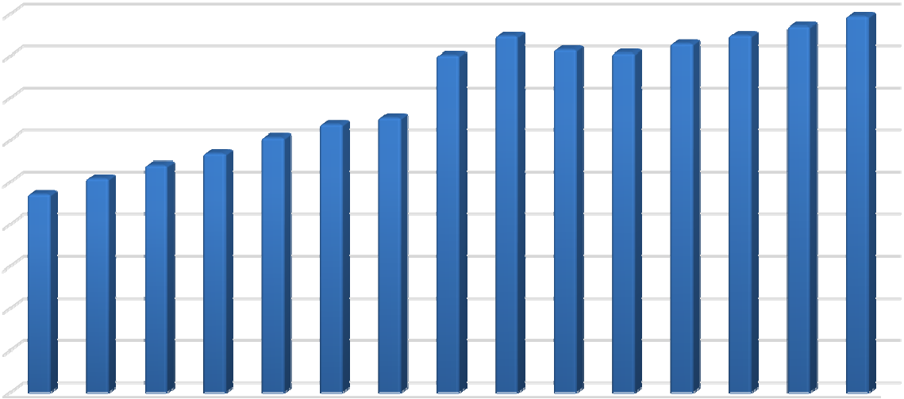
$1,800
$1,787
$1,695
$1,740
$1,602
$1,628
$1,612
$1,657
$1,697
$1,273
$1,305
$1,211
$1,134
$1,079
$1,015
$942

$1,600

$1,400

$1,200

$1,000

$800

$600

$400

$200

$0
2014 2015 2016 2017 2018 2019 2020 2021 2022 2023 2024* 2025* 2026* 2027* 2028*

* Future Projected Data according to Axiometrics
Source: Axiometrics, 2nd Quarter 2024

Absorption Trends
The following graph illustrates metro Atlanta apartment absorption trends.

HISTORICAL NET ABSORPTION: ATLANTA METRO APARTMENT MARKET

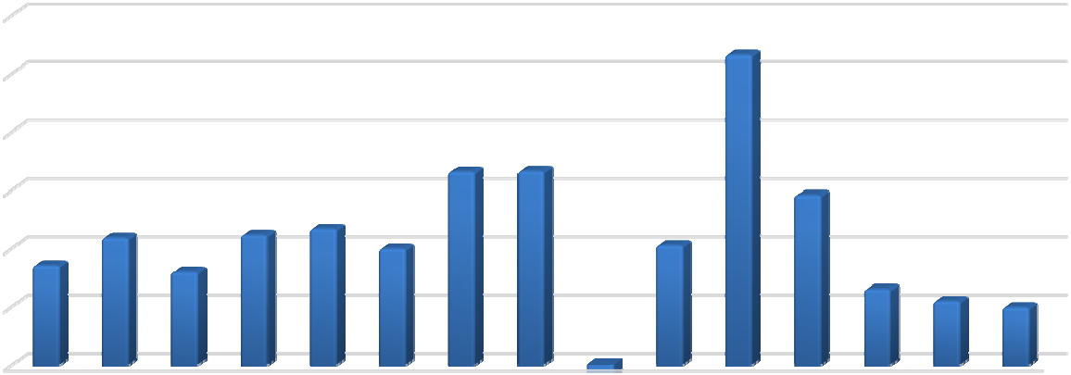
30,000
26,593
16,577 16,635
14,567
10,898
11,150
11,689
9,941
10,234
8,521
7,974
6,499
5,456
4,916
2014 2015 2016 2017 2018 2019 2020 2021 2022 2023 2024* 2025* 2026* 2027* 2028*

-6,409

25,000

20,000

15,000

10,000

5,000

0

-5,000

-10,000

* Future Projected Data according to Axiometrics
Source: Axiometrics, 2nd Quarter 2024

Demand Generators
Demand for multi-family communities is primarily correlated to population and employment shifts. More recently, changes in capital markets, particularly the home mortgage market, have had an additional impact on demand. The primary indicator of apartment demand is changes in job growth, as the addition of new jobs ultimately provides the catalyst for new apartments.

EMPLOYMENT
The following table summarizes employment trends in the Atlanta metropolitan area.

AVERAGE ANNUAL UNEMPLOYMENT RATE
 | MSA | State | US
2013 | 7.7% | 8.1% | 7.4
2014 | 6.8% | 7.1% | 6.2
2015 | 5.8% | 6.1% | 5.3
2016 | 5.2% | 5.5% | 4.9
2017 | 4.6% | 4.8% | 4.4
2018 | 3.8% | 4.0% | 3.9
2019 | 3.4% | 3.5% | 3.7
2020 | 6.8% | 6.6% | 8.1
2021 | 3.9% | 3.8% | 5.4
2022 | 3.0% | 3.1% | 3.6
2023 | 3.1% | 3.2% | 3.4
June 2024 (preliminary) | 3.9% | 3.2% | 4.1
Source: US Bureau of Labor Statistics

POPULATION GROWTH
Metro Atlanta remains one of the fastest growing areas in the country, with over 1.9 million people added from 2000 to 2023. The following table illustrates the Atlanta MSA’s population change by county. As illustrated, the Atlanta MSA is expected to gain over 390,000 people over the next five years.

ATLANTA MSA - POPULATION BY COUNTY
 | Percentage |  |  |  | Annual  Growth | 2028 | Annual  Growth
County | of MSA | 2000 | 2010 | 2023 | 2010-2023 | Projected | 2022-2028
Barrow | 1.4% | 46,144 | 69,367 | 89,106 | 28.5% | 98,539 | 10.6%
Bartow | 1.8% | 76,019 | 100,157 | 112,844 | 12.7% | 121,851 | 8.0%
Butts | 0.4% | 19,460 | 23,655 | 25,971 | 9.8% | 26,792 | 3.2%
Carroll | 2.0% | 87,268 | 110,527 | 122,939 | 11.2% | 127,356 | 3.6%
Cherokee | 4.5% | 141,919 | 214,346 | 283,868 | 32.4% | 311,255 | 9.6%
Clayton | 4.9% | 236,517 | 259,424 | 306,865 | 18.3% | 329,841 | 7.5%
Cobb | 12.3% | 607,751 | 688,078 | 773,279 | 12.4% | 813,585 | 5.2%
Coweta | 2.5% | 89,215 | 127,317 | 154,479 | 21.3% | 167,362 | 8.3%
Dawson | 0.5% | 15,999 | 22,330 | 30,081 | 34.7% | 34,991 | 16.3%
DeKalb | 12.2% | 665,865 | 691,893 | 767,066 | 10.9% | 784,832 | 2.3%
Douglas | 2.4% | 92,329 | 132,403 | 152,690 | 15.3% | 167,076 | 9.4%
Fayette | 1.9% | 91,263 | 106,567 | 121,098 | 13.6% | 125,342 | 3.5%
Forsyth | 4.3% | 98,391 | 175,511 | 267,349 | 52.3% | 293,795 | 9.9%
Fulton | 17.4% | 816,006 | 920,581 | 1,094,703 | 18.9% | 1,161,801 | 6.1%
Gwinnett | 15.7% | 588,448 | 805,321 | 986,973 | 22.6% | 1,043,737 | 5.8%
Haralson | 0.5% | 25,690 | 28,780 | 30,667 | 6.6% | 31,183 | 1.7%
Heard | 0.2% | 11,012 | 11,834 | 11,676 | -1.3% | 12,087 | 3.5%
Henry | 4.0% | 119,403 | 203,922 | 251,216 | 23.2% | 268,998 | 7.1%
Jasper | 0.2% | 11,426 | 13,900 | 15,581 | 12.1% | 16,758 | 7.6%
Lamar | 0.3% | 15,912 | 18,317 | 19,369 | 5.7% | 19,968 | 3.1%
Meriwether | 0.3% | 22,534 | 21,992 | 20,610 | -6.3% | 20,544 | -0.3%
Morgan | 0.3% | 15,457 | 17,868 | 20,865 | 16.8% | 21,420 | 2.7%
Newton | 1.9% | 62,001 | 99,958 | 118,840 | 18.9% | 129,641 | 9.1%
Paulding | 2.9% | 81,523 | 142,324 | 179,937 | 26.4% | 197,758 | 9.9%
Pickens | 0.6% | 22,983 | 29,431 | 35,153 | 19.4% | 39,114 | 11.3%
Pike | 0.3% | 13,688 | 17,869 | 20,196 | 13.0% | 21,696 | 7.4%
Rockdale | 1.5% | 70,111 | 85,215 | 95,173 | 11.7% | 99,056 | 4.1%
Spalding | 1.1% | 58,417 | 64,073 | 68,749 | 7.3% | 72,495 | 5.4%
Walton | 1.6% | 60,687 | 83,768 | 102,341 | 22.2% | 112,636 | 10.1%
Total MSA | 100% | 4,263,438 | 5,286,728 | 6,279,684 | 18.8% | 6,671,509 | 6.2%
Source: CBRE Location Analytics & Mapping

ADDITIONAL FACTORS IMPACTING DEMAND
During the last cycle, the apartment market was negatively impacted by exceptionally low interest rates and lenient credit requirements for first-time homebuyers. However, due to the recent mortgage meltdown and increase in foreclosures, many homeowners have once again become renters.

WEST ATLANTA SUBMARKET
The subject property is within the West Atlanta submarket as defined by Axiometrics. The following map depicts the boundaries for the submarket.
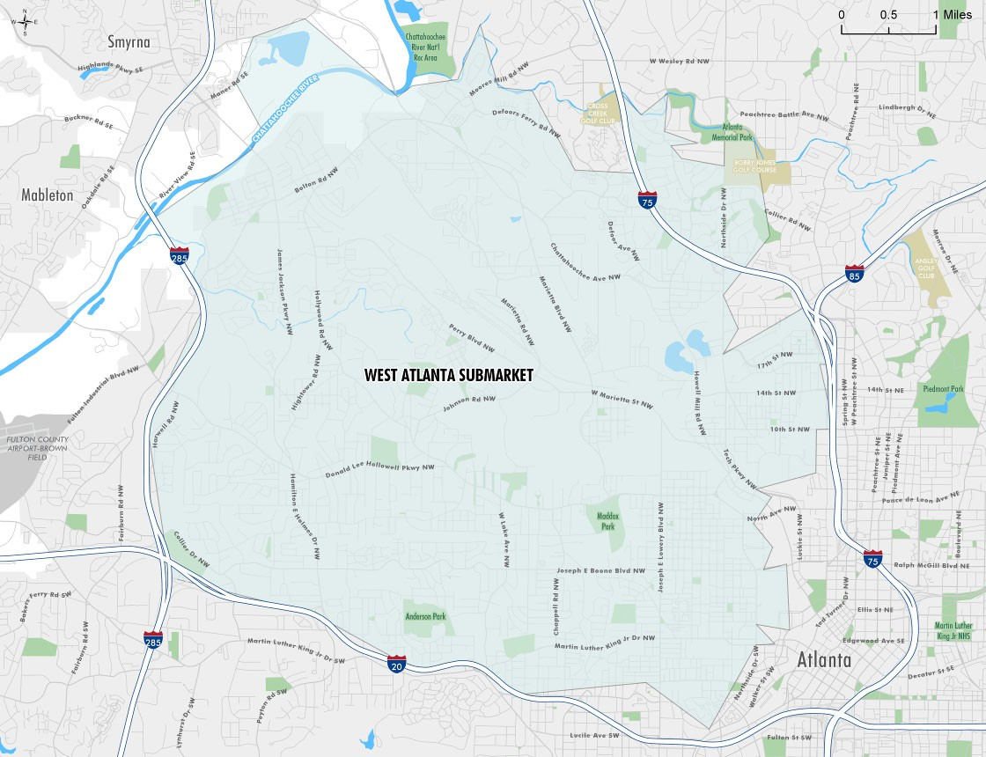
The following table depicts the overall annual market characteristics for the submarket for the past 10 years, with five years of future projections estimated by Axiometrics.

WEST ATLANTA APARTMENT SUBMARKET
Year Ending | Inventory  (Units) | Completions  (Units) | Occupied  Stock (Units) | Occupancy | Effective Rent  ($/Unit/Mo.) | Effective Rent  Change | Net Absorption  (Units)
2014 | 16,531 | 1,025 | 15,458 | 93.5% | $1,295 | 7.08% | 1,311
2015 | 17,229 | 698 | 16,132 | 93.6% | $1,395 | 6.45% | 672
2016 | 17,820 | 915 | 16,526 | 92.7% | $1,347 | 4.63% | 396
2017 | 18,952 | 1,132 | 17,720 | 93.5% | $1,387 | 1.09% | 1,193
2018 | 19,137 | 185 | 17,968 | 93.9% | $1,442 | 1.55% | 249
2019 | 19,245 | 108 | 18,171 | 94.4% | $1,508 | 3.23% | 203
2020 | 21,025 | 1,780 | 19,816 | 94.3% | $1,415 | -4.36% | 1,646
2021 | 21,590 | 565 | 20,690 | 95.8% | $1,761 | 9.70% | 874
2022 | 21,904 | 314 | 20,298 | 92.7% | $1,861 | 11.27% | -391
2023 | 22,877 | 973 | 21,040 | 92.0% | $1,774 | -2.78% | 741
2024 Q1 | 23,190 | 313 | 21,453 | 92.5% | $1,758 | -1.20% | 414
2024 Q2 | 23,701 | 511 | 21,727 | 91.7% | $1,754 | -0.27% | 273
2024 Q3* | 23,879 | 178 | 21,897 | 91.7% | $1,756 | 0.11% | 163
2024 Q4* | 24,126 | 247 | 22,148 | 91.8% | $1,733 | -1.31% | 251
2025* | 26,298 | 2,172 | 23,984 | 91.2% | $1,759 | 0.73% | 1,842
2026* | 26,535 | 237 | 24,386 | 91.9% | $1,779 | 0.65% | 393
2027* | 26,746 | 211 | 24,633 | 92.1% | $1,795 | 0.83% | 246
2028* | 26,983 | 237 | 24,878 | 92.2% | $1,822 | 1.23% | 245
*Future Projected Data according to |  | Axiometrics
Source: Axiometrics, 2nd Quarter 2024

Completion Trends
The following graph summarizes completions over the past several years occurring within the subject’s submarket compared to the overall market.

COMPLETIONS: WEST ATLANTA APARTMENT SUBMARKET VS. MARKET

30,000

25,761


25,000
20,444
17,645
12,932
13,431
11,622
9,034
9,454
10,057
8,711
9,131
5,876
4,371 4,539 4,607
2,172
1,025
698
915
1,132
1,780
185
973 1,249
108
565 314
237 211 237

20,000

15,000

10,000

5,000

0
2014 2015 2016 2017 2018 2019 2020 2021 2022 2023 2024* 2025* 2026* 2027* 2028*
Market Submarket

* Future Projected Data according to Axiometrics
Source: Axiometrics, 2nd Quarter 2024

Occupancy Trends
The following chart illustrates apartment occupancy within the West Atlanta submarket over the past decade, as well as future projections for the next five year period.

OCCUPANCY: WEST ATLANTA APARTMENT SUBMARKET VS. MARKET

98.0%




97.0%
95.8%
94.4%
94.3%
93.9%
93.5%
93.6%
93.5%
92.7%
92.7%
97.0% 92.0%
92.1%
92.2%
91.8%
91.9%
95.5%
91.2%
94.6%
94.8%
94.1% 94.0%
93.5%
93.8%
93.8%
92.9%
93.0%
93.2% 93.3%
92.3%
92.6%

96.0%

95.0%

94.0%

93.0%

92.0%

91.0%

90.0%

89.0%

88.0%
2014 2015 2016 2017 2018 2019 2020 2021 2022 2023 2024* 2025* 2026* 2027* 2028*
Market Submarket
* Future Projected Data according to Axiometrics
Source: Axiometrics, 2nd Quarter 2024

Rental Rate Trends
The following table illustrates historical market trends within the West Atlanta submarket area versus the overall market.

EFFECTIVE RENT: WEST ATLANTA APARTMENT SUBMARKET VS. MARKET




$2,000
$1,761
$1,774
$1,733
$1,759
$1,779
$1,795
$1,822
$1,508
$1,395
$1,442
$1,387
$1,415
$1,295
$1,347
$1,602
$1,695
$1,740
$1,787
$1,628
$1,612
$1,657
$1,697
$1,211
$1,273 $1,305
$1,079
$1,134
$942
$1,015

$1,800
$1,861

$1,600

$1,400

$1,200

$1,000

$800

$600

$400

$200

$0
2014 2015 2016 2017 2018 2019 2020 2021 2022 2023 2024* 2025* 2026* 2027* 2028*
Market Submarket

* Future Projected Data according to Axiometrics
Source: Axiometrics, 2nd Quarter 2024

Absorption Trends
The following graph illustrates the West Atlanta submarket apartment absorption trends.

NET ABSORPTION: WEST ATLANTA APARTMENT SUBMARKET VS. MARKET

30,000
26,593

25,000
16,577 16,635
14,567
10,898
11,150
11,689
9,941
10,234
8,521
7,974
6,499
5,456
4,916
1,311
672
396
1,193
1,646
249
203
874
1,842
741
1,101
-391
393 246 245
2014 2015 2016 2017 2018 2019 2020 2021 2022 2023 2024* 2025* 2026* 2027* 2028*

20,000

15,000

10,000

5,000

0

-5,000
-6,409
-10,000
Market Submarket
* Future Projected Data according to Axiometrics
Source: Axiometrics, 2nd Quarter 2024

New Construction
Apartment projects currently under construction within metro Atlanta were previously identified. We have identified the following projects under construction within the West Atlanta submarket.

ATLANTA METRO APARTMENT MARKET - PROJECTS UNDER CONSTRUCTION

County

Pipeline

Begin Lease

First Movein

Submarket | Proj Name | Address | City | Zip | Name | Level | Parking Type | Units Status | Start Date Date Date
West Atlanta | 1299 Northside Drive Northwest | 1299 Northside Dr NW | Atlanta | 30318 | Fulton | 5 | Above Ground Structure | 321 | 1/1/2024 5/1/2025 7/1/2025
West Atlanta | AMLI Atlantic Station | 240 20th St | Atlanta | 30363 | Fulton | 12 | Above Ground Structure | 360 | 10/1/2022 2/1/2025 4/1/2025
West Atlanta | UrbA ATL | 480 17th St NW | Atlanta | 30363 | Fulton | 5 | Above Ground Structure | 321 | 6/1/2023 2/1/2025 4/1/2025
West Atlanta | BRYKS Upper Westside | 2200 Marietta Blvd | Atlanta | 30318 | Fulton | 7 | Above Ground Structure | 576 | 12/1/2022 10/1/2024 12/1/2024
West Atlanta | Stella at Star Metals | 11th St NW & Howell Mill Rd NW | Atlanta | 30318 | Fulton | 21 | Above Ground Structure | 327 | 3/1/2023 1/1/2025 2/1/2025
West Atlanta | Modera Westside Trail | 576 Northside Dr | Atlanta | 30318 | Fulton | 8 | Above Ground Structure | 373 | 7/1/2023 8/1/2025 10/1/2025
West Atlanta | 400 Bishop Street Northwest | 400 Bishop St NW | Atlanta | 30318 | Fulton | 11 | Above Ground Structure | 278 | 9/1/2022 12/1/2024 2/1/2025
West Atlanta | The Howell | 1850 Howell Mill Rd NW | Atlanta | 30318 | Fulton | 7 | Above Ground Structure | 212 | 6/1/2022 5/1/2024 5/2/2024
West Atlanta | The Vue II at the Quarter | 2078 Bolton Dr NW | Atlanta | 30318 | Fulton | 5 | Individual | 154 | 6/1/2022 12/1/2023 1/1/2024
West Atlanta | The Collective Upper Westside | 2000 James Jackson Pkwy | Atlanta | 30318 | Fulton | 4 | Above Ground Structure | 191 | 5/1/2022 3/1/2024 4/1/2024
West Atlanta | NOVEL West Midtown I | 1330 Fairmont Ave NW | Atlanta | 30318 | Fulton | 5 | Above Ground Structure | 340 | 5/1/2021 4/1/2023 5/1/2023
West Atlanta | The Goat Farm | 1200 Foster St NW | Atlanta | 30318 | Fulton | 5 | Above Ground Structure | 210 | 6/1/2022 1/1/2024 3/1/2024
West Atlanta | Vibe at Echo Street West | 750 Echo St NW | Atlanta | 30318 | Fulton | 5 | Above Ground Structure | 292 | 9/1/2020 3/1/2023 4/1/2023
West Atlanta | Westbound at the Works | 202A Chattahoochee Row NW | Atlanta | 30318 | Fulton | 5 | Above Ground Structure | 306 | 12/1/2021 7/1/2023 10/1/2023
West Atlanta | Populus Westside | 1315 Northwest Dr | Atlanta | 30318 | Fulton | 3 | Individual | 285 | 10/1/2021 5/1/2023 6/1/2023
Source: Axiometrics
Proposed Apartments
The following table summarizes additional projects that are planned or proposed for this submarket.

ATLANTA METRO APARTMENT MARKET - PROJECTS PROPOSED

County

Pipeline

Begin Lease

First Movein

Submarket | Proj Name | Address | City | Zip | Name | Level | Parking Type | Units Status Start Date Date Date
West Atlanta | Cypress Grove | 1005 Gun Club Rd NW & 988 Cato St NW | Atlanta | 30318 | Fulton |  | Individual
West Atlanta | Parkview | Walnut St NW & Thurmond St NW | Atlanta | 30314 | Fulton | 3 | Individual | 73
West Atlanta | Howell Mill Road & 11th Street Northwest | Howell Mill Rd & 11th St NW | Atlanta | 30318 | Fulton | 11 | Above Ground Structure | 395
West Atlanta | NOVEL West Midtown II | 1095 & 1121 Huff Rd | Atlanta | 30318 | Fulton | 7 | Above Ground Structure | 250
West Atlanta | 2285 Alvin Drive Northwest | 2285 Alvin Dr NW | Atlanta | 30318 | Fulton |  | Individual | 21
West Atlanta | 1335 Donald Lee Hollowell Parkway Northwest1335 Donald Lee Hollowell Pkwy NW |  | Atlanta | 30318 | Fulton |  | Above Ground Structure | 495
West Atlanta | The Works Future Phases 1301 Chattahoochee Ave NW |  | Atlanta | 30318 | Fulton |  | Above Ground Structure
West Atlanta | 1355 & 1359 Ellsworth Industrial Boulevard 1355 & 1359 Ellsworth Industrial Blvd |  | Atlanta | 30318 | Fulton |  | Above Ground Structure | 665
West Atlanta | 559 10th Street Northwest 559 10th St NW |  | Atlanta | 30318 | Fulton | 4 | Individual | 34
West Atlanta | 965-975 Howell Mill Road Northwest 965-975 Howell Mill Rd NW |  | Atlanta | 30318 | Fulton | 16 | Subterranean | 312
West Atlanta | 981 Howell Mill Road Northwest 981 Howell Mill Rd NW |  | Atlanta | 30318 | Fulton |  | Above Ground Structure | 500
West Atlanta | QTS Atlanta Development Herndon St NW & W Marietta St NW |  | Atlanta | 30318 | Fulton | 5 | Above Ground Structure | 400
West Atlanta | Star Metals Urban Park 690 11th St NW |  | Atlanta | 30318 | Fulton |  | Above Ground Structure | 400
West Atlanta | Vance on 14th 250 14th St NW |  | Atlanta | 30318 | Fulton | 22 | Above Ground Structure | 245
West Atlanta | Quarry Yards II 1060 Donald Lee Hollowell Pkwy NW |  | Atlanta | 30318 | Fulton | 5 | Above Ground Structure
West Atlanta | Quarry Yards I 1060 Donald Lee Hollowell Pkwy NW |  | Atlanta | 30318 | Fulton | 5 | Above Ground Structure | 350
Source: Axiometrics
Conclusion
The West Atlanta submarket represents an area with a diversity of land uses, but the area is generally considered a bedroom community for metropolitan Atlanta. Although it contains a substantial amount of commercial development, much of this is industrial, flex space and local/neighborhood/regional retail which lacks employee density. The submarket offers good access to the metro Atlanta employment centers of Downtown, Midtown, and Cumberland/Galleria via I-20 and I-285. As the population of metro Atlanta continues to increase, the West Atlanta submarket is expected to continue to see strong operating characteristics.

BARRIERS TO ENTRY
Vacant land is available throughout the metropolitan area. Within the subject submarket, which is a more mature area of Atlanta, there are a limited number of vacant sites for development as well as suitable sites that could benefit from redevelopment. Availability of suitable sites is not a constraint to development. The city attitude toward development is perceived as challenging at times, but as evinced by continuing development in the area, is navigable. Therefore, no significant barriers to entry were noted.

Student Housing Market Analysis

FALL 2023 TRENDS (MOST RECENT AVAILABLE)
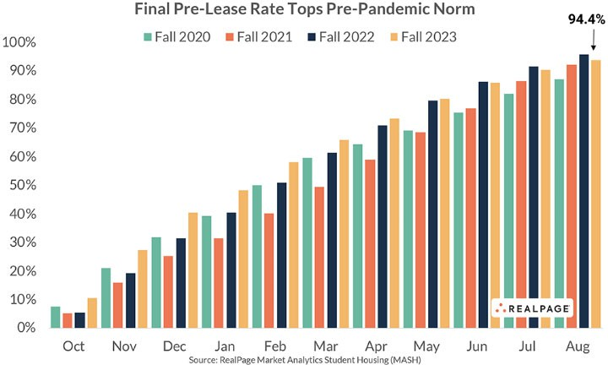
The final 2023 pre-lease occupancy falls just short of the Fall 2022 record of 95.7%. As of August 2023, 94.4% of beds at the core 175 universities have been leased for the Fall 2023 school year according to RealPage Market Analytics. This data is for the core 175 universities tracked by RealPage Market Analytics.

The final Fall 2023 September occupancy saw a slight increase in occupancy to 95.0% across the core 175 universities. As illustrated in the chart below, it is common for final occupancy to be higher than the final pre-lease occupancy due to students filling beds right as they move back to campus.

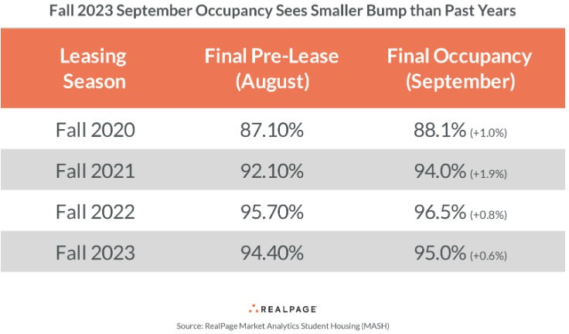
According to RealPage Market Analytics, student housing properties within a half mile of campus reported the strongest pre-lease occupancy of 94.6%. Properties within one half mile to one mile of campus reported a pre-lease occupancy at 93.1% and properties greater than one mile from campus reported pre-lease occupancies at 94.5%.
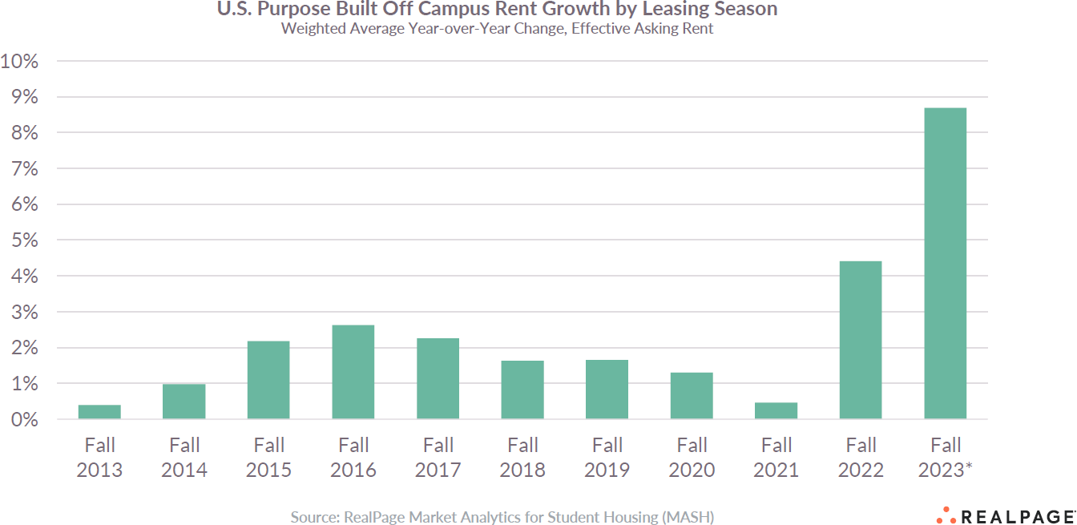

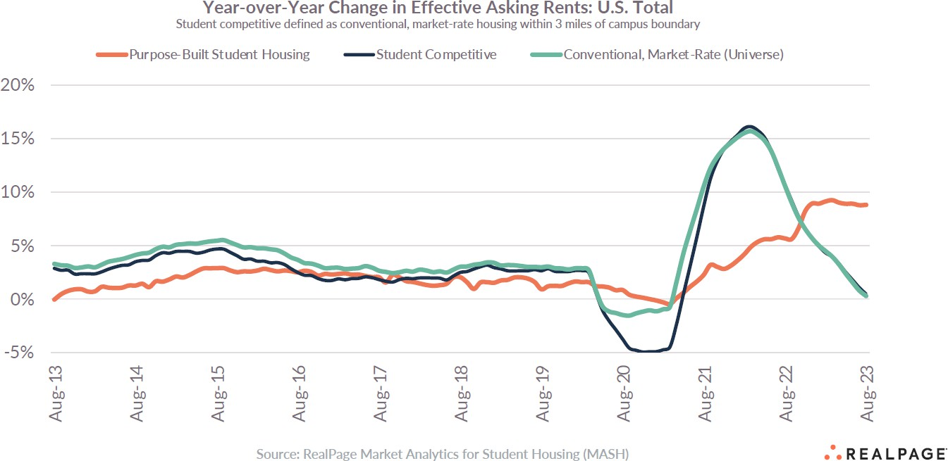
Per RealPage Market Analytics, the final annual effective rent change as of August 2023 reached 9.3% which is an all-time high. The prior year as of August 2022 had the previous record with an increase of 5.9%. Properties within a half mile of campus experienced the strongest rent growth of 9.7%, followed by 9.3% for properties greater than one mile form campus and 8.1% growth was reported at properties within a half mile to one mile of campus.
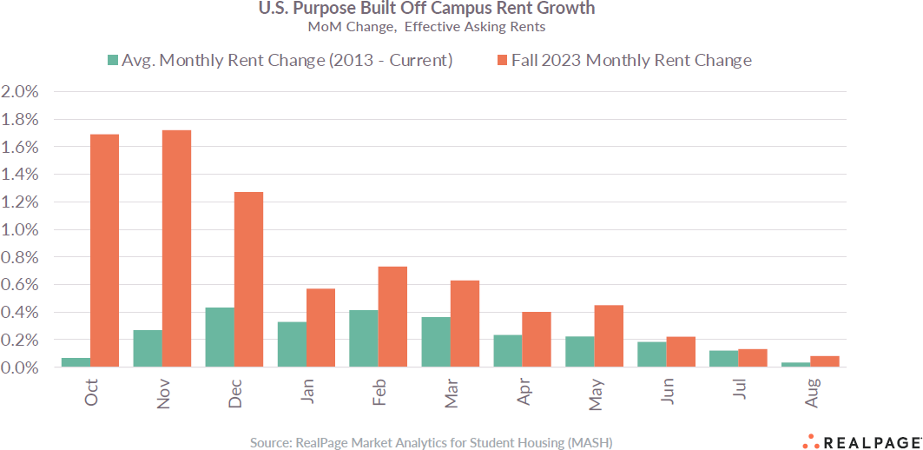
The 2023/2024 academic year experienced record rent growth. The 2023-2024 rent growth surge was primarily due to the strong start of the academic year. However, the late lease-up months (June through August) had trends looking similar to the average monthly rent change of

2013-current. In addition, to strong rental rate growth, the student housing sector has seen reduced concessions being offered.
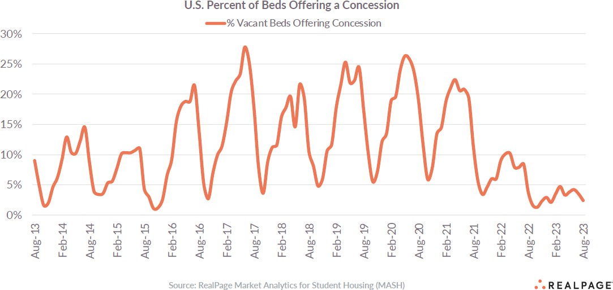
The investment-grade universities are maintaining a general hold on their enrollment bases. The total enrollment base of the U.S. is contracting which suggest selecting key investment-grade universities will become increasingly important in the next few years.
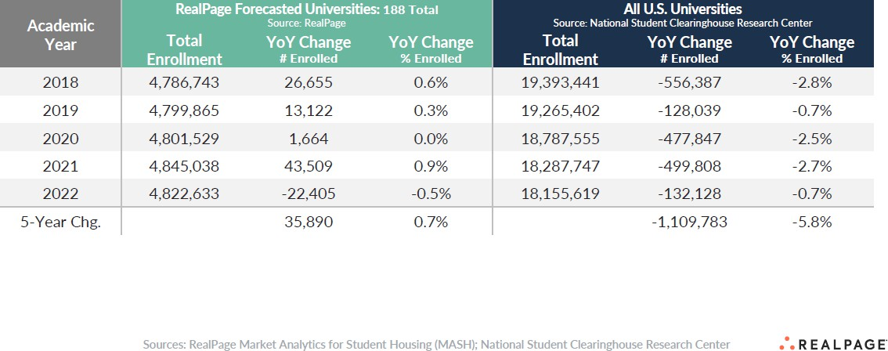
As shown in the following chart the Power 5 schools experienced an average increase in enrollment of 0.6% between Fall 2022 and Fall 2021. All other schools experienced a decline in enrollment between -0.4% to -0.5%.

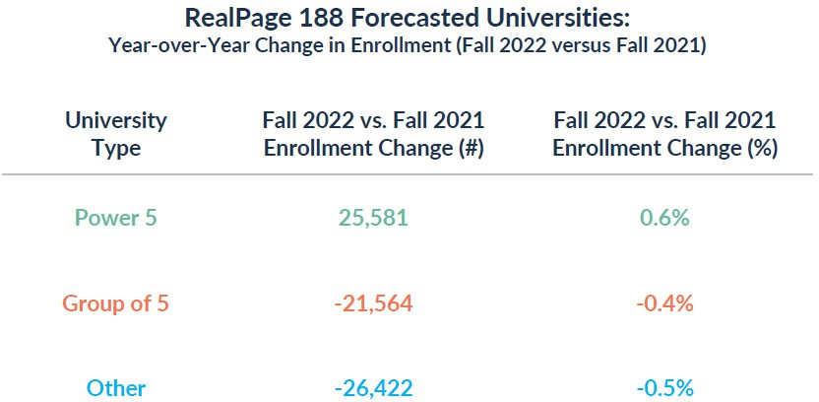
The Power 5 is made up of schools that are in the Atlantic Coast Conference (ACC), Big Ten Conference (Big Ten), Big 12 Conference (Big 12), Pacific-12 Conference (Pac-12), and the Southeastern Conference (SEC). The Group of 5 consists of schools from The American Conference, Conference USA (C-USA), Mid-American Conference (MAC), Mountain West Conference (MW), and the Sun Belt Conference.
Conclsuion
In conclusion, the national student housing supply appears to be at a new equilibrium, which should help performance at some oversupplied schools recover as demand catches back up. Enrollment growth headwinds are emerging at a high-level, but the local campus-level drivers show it’s far more nuanced than a headline figure would suggest. Many student housing market participants anticpate the Fall 2024 occupancy could be higher than Fall 2023 occupancy despite the new additional supply that is projected to come on-line in time for the Fall 2024 move-in season. A primary factor of the lower bed deliveries is the curent high interest rate environment for new construciton lending.

STUDENT HOUSING INDUSTRY
Overview
Over the past decade, the student housing industry has experienced significant growth, fueled in large part by the demographic trends supporting it. The adjacent chart illustrates the U.S. population growth projections according to the National Multi-Housing Council (NHMC). The students currently attending college are Generation Z.

The following chart details the generations currently enrolled in college along with the generations that came before them:

The Silent Generation | 1928-1945 (78-95 years old)
Baby Boomers | Born 1946 – 1964 (59-77 years old)
Generation X | Born 1965 – 1980 (43-58 years old)
Millennials (Generation Y/Echo Boomers) | Born 1981- 1996 (27-42 years old)
Post-Millennials (Generation Z) | Born 1997 – Present (0–26 years old)
This “Post-Millennials” (Generation Z) segment of the population represents nearly sixty-nine million people, nearly one-fifth of the U.S. population. University enrollments across the nation experienced marked growth following the “Millennials” population segment’s move to attend college in 1999 and 2000. In addition, more students in these cohort groups (Millennials and Post-Millennials) are choosing to stay in college to pursue additional or advanced degrees and many individuals are returning to college for retraining and or higher degrees.
Along with this growth, many universities have outgrown their existing on-campus housing facilities. At the same time, many on-campus housing facilities have become functionally obsolete, offering small, shared bedrooms, common bathrooms and few amenities. As the student populations have grown, specialized student housing developers have stepped in and built off-campus housing alternatives with many offering leasing by-the-bedroom formats, luxury amenities specifically tailored to student needs, roommate matching and individual leases backed by parental guarantees in garden, mid-rise, high-rise, and cottage-style apartment communities, offering new and appealing property types to student renters. Today, these communities are purpose-built specifically to meet the demands of today’s students, in many cases offering private bedrooms and bathrooms, wireless high-speed internet access throughout the property, computer labs, tanning beds, theater rooms, large resort style swimming pools and hot tubs, and many more new and appealing common area amenities.
Student housing is one of the only cyclical marketing assets in commercial real estate. This is due to the timing created by the typical nine or ten-month University calendar. Student properties follow a very cyclical leasing season that hinges on the start of the fall academic school year. The tenant turnover window (called The Turn) for student properties is extremely short, typically two weeks in total just before the fall move-in date. After the fall semester move-in season is completed, it is very unlikely that a property will sign additional leases for the next twelve months, unless a student starts in January for the spring semester. Occasionally some projects will offer short term leases, including spring semester leases with a premium monthly up-charge if offered at all by the management company. These properties will see some minor fluctuation in

occupancy at the end of the calendar year. The softest student markets offer nine or ten-month leases and see a dramatic drop off in occupancy during summer months. The vast majority of student operators nationwide only offer twelve-month lease terms in order to avoid the economic losses that come with short term (nine or ten-month-academic year) leasing.
Strong markets will usually begin their leasing season for the following school year during the early winter months, sometimes signing leases ten to eleven months in advance of lease commencement. Many student housing leasing seasons begin around February and can last through the end of the University calendar year in May. The softest markets will often continue leasing all the way through the summer or until the start of the school year, particularly for students accepted during the summer months or those that wait until classes begin.
Student housing sales typically occur year-round; however, the ideal student housing sales time frame is from early summer to the end of each calendar year. Assuming an asset shows enough leasing velocity by early summer, investors will underwrite the property while taking into account the upcoming fall rent roll. This gives current ownership the potential benefit of higher pricing based on improved rent growth for the upcoming school year. This assumes the buyer will close on the transaction after the start of the school year. This enables the student buyer to accurately forecast the income for the upcoming months through the end of the student lease term in late summer. Once school has started, most investors will underwrite based only on the income that is in place for the remainder of the academic school year.
Some of the key differences between traditional multi-family apartments and student housing assets include the following items. Historically, student housing capitalization rates have been 50 to 100 basis points above a similar conventional multi-family asset in the same market area. However, it should be noted that some college towns with smaller populations do not have a large Class A conventional apartment asset pool other than the dedicated student assets. Recently, the spread between traditional multi-family apartment assets and student housing assets has significantly decreased due to the recent compression in student housing cap rates.
Lease terms are typically twelve months, with occasional six or nine-month leases in softer markets or in older properties with occupancy concerns. One of the primary attractions for renters is connected with the parental guarantees, which allow the student/parents to be responsible solely for their student’s rent and not the delinquent rent of roommates. Fully furnished units and roommate matching are common and partial or all-inclusive utility packages are seen in many markets. In some markets with older university dorm product, developers have built modern student dorm projects better suited to the current needs of university students with larger and more private accommodations, on-site cafeterias and modern amenities. All leases typically end and begin on the same day or week for each tenant and this is tied to the start of the university calendar each year.
Location of these student apartments in relation to the university and access to a local bus system or other public transportation is a critical factor for the success of the student apartment. One

location measurement for student housing is called a walk score measurement. Walk scores measure the walkability of any address. The subject has a walk score of 95 which is considered a “Walker’s Paradise” location. The following list described the walk scores range and their description:
- 90-100 is classified as a “Walkers Paradise” and is described as “daily errands not requiring a car”;
- 70-89 is classified as “Very Walkable” and is described as “most errands can be accomplished on foot”;
- 50-69 is considered “Somewhat Walkable” and is described as “some errands can be accomplished on foot”;
- 25-49 is considered “Car Dependent” and is described as “most errands require a car”;
- 0-24 is considered “Car-Dependent” and is described as “almost all errands require a car”.
The supply and quality of on-campus housing is also an important factor for success, along with the residency requirements of the individual university, potential for these policies to change and any new construction planned by the university.
Some additional important factors for success are the current and projected growth in university enrollment, the percentage of commuter students living at their parent’s home along with the degree of current and planned off-campus student housing competition. The level of barriers to entry for new product are also of vital concern for any student housing developer or owner.
From 2000 to 2010, the industry experienced a high degree of consolidation, with several public REITs forming and acquiring large portfolios of student housing. Similarly, the capital markets focused more on the student segment with both investment and development of this product type increasing. By-the-bed student housing saw its early peak in investment and development from 2005-2007, fueled in part by the ease of access to construction and acquisition financing.
Student housing market participants cite that there is a healthy and growing amount of investment capital earmarked for student housing investment. In the past three years there has been significant growth from international investors in the student housing market.
Supply
Although the vast majority of apartment properties located in close proximity to the university campus are leased by the student population and oriented toward student occupancy, very few fill the criteria to be “student housing”. The specific qualifications for our definition of student housing include design considerations, exclusive student tenancy, lease basis of individual beds or bedrooms (rather than units) and an above-average amenity level. The properties fulfilling these criteria in the local market include the subject and all or most of those properties identified in the competitive rent comparable set.

Today’s student renters grow up in their family home with their own bedroom and many times their own bathroom. Due to this current trend, parents and students visiting on campus housing are often disappointed to find older buildings made from dated materials with little to no privacy. These aging facilities with deferred maintenance and limited amenities do not meet the demands of the current student renters. Although some universities have begun to renovate or replace their housing facilities, they often cannot meet the immediate needs of today's college students. Funding these renovations or replacements has been an obstacle for many universities due to the recent decreases in state and federal backing of universities. Because on campus housing is suffering from aged facilities and deferred maintenance, on-campus occupancy rates have declined in many markets and students eligible to live off-campus are seeking more modern and private alternative living arrangements.
Local apartment properties that are over ten years of age generally have few on-site amenities and lack conveniences that are typical in new properties driven by current student demand trends. New market properties are being built to include business centers, elaborate fitness facilities, controlled access, security systems, entertainment and social space, individual or group study areas and high-speed internet access. Student housing incorporates some or all of these amenities plus most offer private bathrooms with each bedroom. In both the short and long term, newer, higher quality complexes will increase market share to the detriment of the older properties, especially those properties that lack timely maintenance and suitable management. In many subject neighborhoods, the majority of conventional multi-family housing is over twenty years old. These older properties have few on-site amenities and lack modern conveniences that are becoming standard in the new purpose-built student product.
With rising costs and aging facilities, on campus housing has lost most upper-class students to off campus apartment communities. These communities offer the amenities that today's students demand, including high-speed computer connections, elaborate fitness rooms, no required meal plan, and private bedrooms and bathrooms in many cases. In addition, many off-campus conventional apartment communities have also aged, creating the demand for a product designed with today’s student in mind.
The student housing industry had approximately 30,000 new purpose-built student housing beds added in 2022, which marked the lowest level since 2008/2009 period. Illustrated below is the nine-year historical and projected Fall 2023 student housing new bed deliveries. This chart indicates that the Fall 2023 deliveries will have slightly below pre-pandemic historical levels.

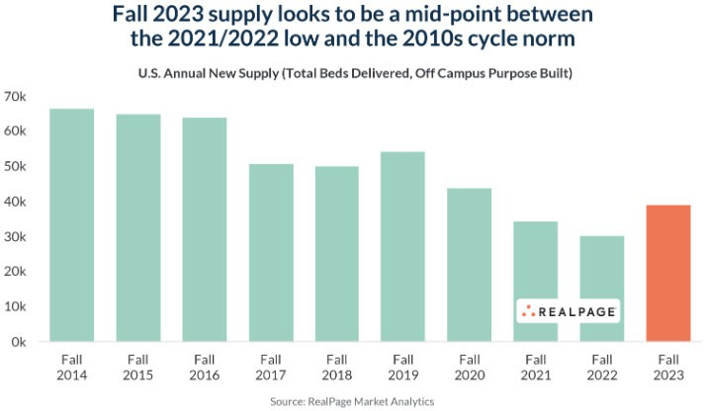
Demand
During the past twenty years, multi-family developers identified a niche in providing new, high quality housing for college students. They concluded that the existing housing stock serving many major colleges and universities was inadequate, old and overpriced. Several factors were identified which contributed to this situation:
- The student housing market was largely ignored by private developers prior to 2000;
- The tightening budgets of many U.S. colleges and universities, and the on-campus availability of university owned land, does not allow for the expansion of student housing;
- The current generation’s parents and grandparents are providing students with sufficient funding to support more comfortable living arrangement than previous generations.
In the few instances where a private development group recognized this opportunity, the results have been very successful. Because most campuses have not seen new construction in the past five to ten years, the absorption and retention rate of these properties is significantly higher than traditional university related apartment projects. The project and unit amenities of these projects are designed to promote effective time management while providing the necessary tools to compete in the college environment, while also providing recreational activities on the housing site. These tools include high-speed wireless internet access throughout a facility, direct access to university or private shuttle buses, individual bedrooms/bathrooms for each student, and a comfortable and safe living environment. These unit types are typically two, three or four-bedroom units which lease on a per bedroom/student basis with individual leases to each student/tenant.

Few students prefer dormitory housing. Dorms do not offer the privacy or amenities found in modern student apartment communities. Most of the dorms have communal restrooms and baths; many do not have individual in-room sinks; and some dorms do not have air conditioning. On a cost basis, the dorms are significantly or slightly less expensive to rent than most student apartments in our survey of private student housing. One of the cost advantages of dorm residence is a per-semester lease term. Market student properties require a twelve-month lease, which typically begins in mid-August or the first of September. Also, dorm rent typically includes utilities, which are generally not fully included in off-campus student properties.
According to most university housing directors, price constraints are not a factor for most students. Students and their parents are willing and able to pay more than dorm cost for rent and utilities – typically 40% to 50% more to live off campus. Students indicate in surveys a desire for fewer rules and less supervision as seen in the on-campus options. A recent survey of college freshmen reported 93% didn’t share a bedroom while living at home – shared bedrooms having been more commonplace in previous generations, when these university’s dorms were constructed. General perceptions among freshmen are that dormitories lack cleanliness and privacy.
Enrollment Trends
The following information was obtained from research obtained from The National Center for Educational Statistics. Total enrollment increased 19% from 2002 to 2016 (16.6 to 19.8 million), a period of 14 year or an average of 1.4% per year. Total enrollment is projected to increase 3% from 2016 to 2027 (19.8 to 20.5 million) over an 11-year period or an average of 0.3% per year. Degree-granting institutions are postsecondary institutions that provide study beyond secondary school and offer programs terminating in an associate’s, baccalaureate, or higher degree and participate in federal financial aid programs. Enrollment is expected to increase slightly in both public and private degree-granting postsecondary institutions.
Currently, on average, the largest universities in the country are only able to house approximately 20% of their undergraduate student body in on-campus housing according to Axiometrics data. The remaining 80% of undergraduate and graduate students are left to find off-campus housing options.
The following chart from Real Page, Inc. – Axiometrics a leading provider of Student Housing data illustrates the supply and demand metrics in the student housing sector from 2001 to a projected year of 2024. It should be noted that supply (new construction/beds) peaked in 2017 and 2018, and supply exceeded demand overall for four years in a row nationally.

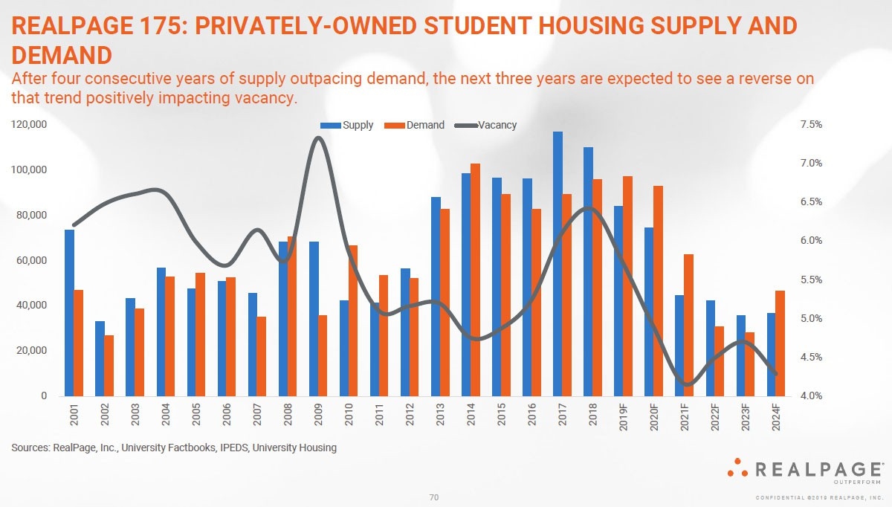

OFF-CAMPUS HOUSING SUPPLY
Off-campus dedicated Student Housing and Student Competitive property supply is summarized below.
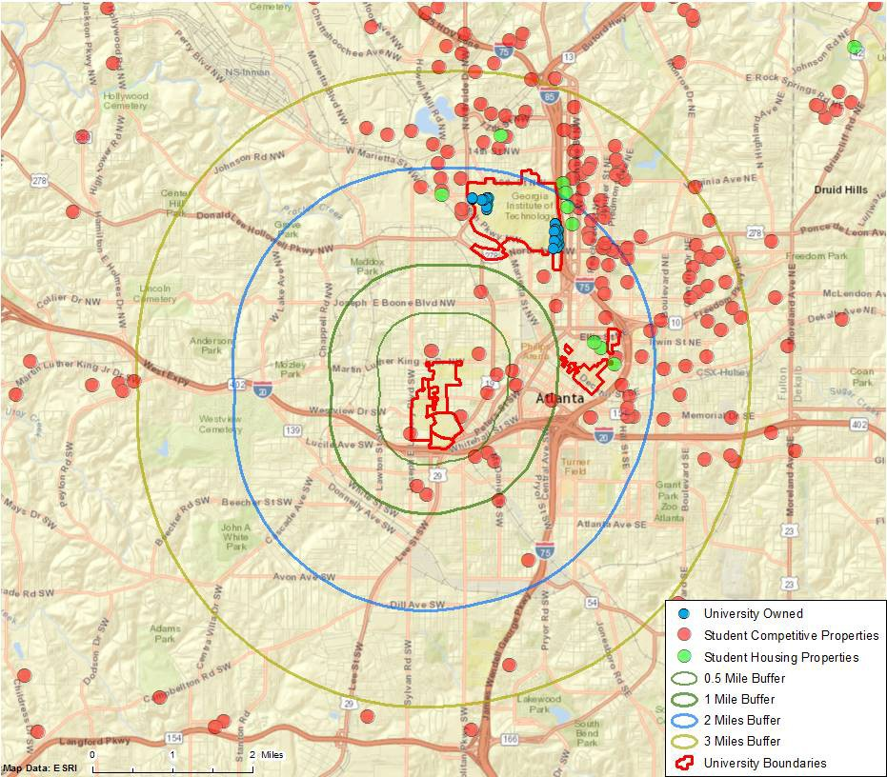
Georgia’s HOPE Scholarship
The Georgia’s HOPE (Helping Outstanding Pupils Educationally) scholarship program is funded by the Georgia Lottery and began in 1993. To date, the program has helped over 1.5 million students, with over $6.4 billion in awards. Given the immense popularity and limited funding of the program, the HOPE scholarship has been divided into separate scholarships based on the student’s merit. The Zell Miller Scholarship program is designed for students seeking a college degree and is generally eligible to students that achieve a 3.7 grade point average (GPA) in high school, maintain a 3.3 GPA in college, and a achieve minimum SAT/ACT score. This funding assists with tuition, but no longer helps with books or fees. HOPE Grant is designed for students,

regardless of GPA or graduation date, who desire a technical certification or diploma. These programs are targeted towards Georgia residents.
In many cases, the scholarship allows families to reallocate available resources to providing students with a higher standard of living, including off-campus housing, automobiles, and computers. High quality apartment properties, such as the subject, clearly benefit from the scholarship program.

DEMOGRAPHIC ANALYSIS
Demand for residential properties is a direct function of demographic characteristics analyzed on the following pages.
Housing, Population and Household Formation
The following table illustrates the population and household changes for the subject neighborhood with primary focus on the 1-, 3- and 5-mile radius.

POPULATION AND HOUSEHOLD PROJECTIONS

1 Mile Radius |  | 3 Mile Radius | 5 Mile Radius
Population
2029 Total Population | 21,911 | 197,562 | 386,932
2024 Total Population | 20,669 | 184,251 | 367,304
2010 Total Population | 17,698 | 138,466 | 296,355
2000 Total Population | 21,889 | 139,006 | 305,479
Annual Growth 2024 - 2029 | 1.17% | 1.40% | 1.05%
Annual Growth 2010 - 2024 | 3.96% | 7.40% | 5.51%
Annual Growth 2000 - 2010 | -2.10% | -0.04% | -0.30%
Households
2029 Total Households | 7,880 | 99,342 | 188,477
2024 Total Households | 7,020 | 89,172 | 173,454
2010 Total Households | 5,671 | 58,651 | 129,448
2000 Total Households | 6,727 | 52,581 | 122,173
Annual Growth 2024 - 2029 | 2.34% | 2.18% | 1.68%
Annual Growth 2010 - 2024 | 5.48% | 11.04% | 7.59%
Annual Growth 2000 - 2010 | -1.69% | 1.10% | 0.58%
Source: ESRI
As shown, the subject’s neighborhood is experiencing strong positiv movement in both population and households.
Income Distributions
Household income available for expenditure on housing and other consumer items is a primary factor in determining the price/rent level of housing demand in a market area. In the case of this study, projections of household income, particularly for renters, identifies in gross terms the market from which the subject submarket draws. The following table illustrates estimated household income distribution for the subject neighborhood.

HOUSEHOLD INCOME DISTRIBUTION

1 Mile Radius |  | 3 Mile Radius | 5 Mile Radius
Households by Income Distribution (2024)
<$15,000 | 24.52% | 14.70% | 13.36%
$15,000 - $24,999 | 10.20% | 5.60% | 5.61%
$25,000 - $34,999 | 8.55% | 5.60% | 5.50%
$35,000 - $49,999 | 12.82% | 8.04% | 7.64%
$50,000 - $74,999 | 15.46% | 13.67% | 13.27%
$75,000 - $99,999 | 9.69% | 11.22% | 10.82%
$100,000 - $149,999 | 11.61% | 17.09% | 16.11%
$150,000 - $199,999 | 3.13% | 10.27% | 10.36%
$200,000+ | 3.89% | 13.80% | 17.32%
Source: ESRI
The following table illustrates the median and average household income levels for the subject neighborhood.

HOUSEHOLD INCOME LEVELS
1 Mile Radius |  | 3 Mile Radius | 5 Mile Radius
Income
2024 Median Household Income | $41,653 | $79,286 | $84,135
2024 Average Household Income | $63,923 | $115,842 | $128,419
2024 Per Capita Income | $25,377 | $56,652 | $61,217
Source: ESRI
An analysis of the income data indicates that the submarket is generally comprised of middle-to-upper-income economic cohort groups, which include the target groups to which the subject is oriented.
Employment
An employment breakdown typically indicates the working-class characteristics for a given market area. The specific employment population within the indicated radii of the subject is as follows:

EMPLOYMENT BY INDUSTRY

Occupation (2024)
1 Mile Radius 3 Mile Radius 5 Mile Radius

Agric/Forestry/Fishing/Hunting | 0.00% | 0.08% | 0.12%
Construction | 2.94% | 2.17% | 2.97%
Manufacturing | 5.04% | 5.21% | 5.48%
Wholesale Trade | 0.98% | 1.98% | 2.14%
Retail Trade | 8.68% | 7.54% | 7.45%
Transportation/Warehousing | 9.54% | 7.26% | 6.82%
Information | 3.59% | 4.64% | 4.29%
Finance/Insurance | 3.11% | 4.85% | 5.55%
Prof/Scientific/Tech Services | 11.13% | 21.32% | 19.93%
Mgmt of Companies/Enterprises | 0.37% | 0.16% | 0.17%
Admin/Support/Waste Mgmt Srvcs | 7.22% | 4.21% | 4.67%
Educational Services | 13.88% | 11.37% | 10.58%
Health Care/Social Assistance | 6.24% | 10.11% | 10.16%
Arts/Entertainment/Recreation | 5.71% | 2.93% | 3.00%
Accommodation/Food Services | 12.64% | 7.19% | 7.30%
Other Services (excl Publ Adm) | 5.65% | 4.14% | 4.38%
Public Administration | 3.27% | 4.84% | 4.99%
Source: ESRI
The previous table illustrates the employment character of the submarket, indicating a predominantly middle-income employment profile, with the majority of the population holding education, professional, and food service related jobs.
Outlook
Based on this analysis, the immediate area surrounding the subject is projected to experience modest growth relative to households and population into the near future. Given the area demographics, it appears that demand for both comparable surrounding area apartment units and the subject will continue to be favorable.

COMPETITIVE PROPERTIES
Comparable properties were surveyed in order to identify the current occupancy within the competitive market. The comparable data is summarized in the following table:

SUMMARY OF COMPARABLE MULTIFAMILY RENTALS
Comp. No. | Name | Location | Distance from Subject | Occupancy
1 | CAU Suites | 128 Mildred Street SW, Atlanta, GA | 0.3 Miles | 86%
2 | Camden Vantage | 180 Jackson Street NE, Atlanta, GA | 2.0 Miles | 93%
3 | Heritage Commons | 15 James P Brawley Drive, Atlanta, GA | 0.2 Miles | 85%
4 | Gammon Theological Seminary | 653 Beckwith Street SW., Atlanta, GA | 0.2 Miles | 85%
5 | 200 Edgewood | 200 Edgewood Avenue, Atlanta, GA | 1.6 Miles | 90%
6 | One12 Courtland | 112 Courtland Street, NE, Atlanta, GA | 1.4 Miles | 96%
Subject | Turner Theological Seminary | 702 Martin Luther King Jr Drive SW, Atlanta, Georgia |  | 88%
Compiled by CBRE
It should be noted that there was limited data for on-campus dormitory style housings. As such, we have analyzed off-campus student housing properties servicing other universities (Georgia Institute of Technology, Georgia State University, etc.), however, considering these to be generally newer and higher quality properties, have also analyzed conventional market rate multifamily properties of somewhat similar buildout and quality as the subject. Comparable 4 is considered to be most similar to the subject as it located on the same ITC campus and operates as a seminary school with similar student housing unit mixes.
As illustrated, the comparable properties surveyed reported occupancy levels ranging from 85% to 96%; indicating an average occupancy level of 91%. Given the lack of historical occupancy data, we have leaned on the market comparables with primary emphasis awarded to comparable 4. Therefore, our estimated stabilized occupancy rate for the subject is 88%.

SUBJECT ANALYSIS
Occupancy
Based on the foregoing analysis, CBRE, Inc.’s conclusion of stabilized occupancy for the subject is illustrated in the following table. This estimate considers both the physical and economic factors of the market.

OCCUPANCY CONCLUSIONS

Atlanta Market Average | 92.3%
West Atlanta Submarket Average | 92.4%
Rent Comparables | 91.0%
Subject's Master Leased Occupancy | 88.0%
Subject's Stabilized Occupancy | 88.0%
Compiled by CBRE
Our concluded stabilized occupancy is generally supported by the occupancy levels indicated by the stabilized rent comparables. As such, we believe our conclusion is consistent with how a typical buyer would analyze the subject property and we believe our estimate is appropriate.
Given that the subject is older than most of the competing student housing properties and lacks in amenities, as well as structured as a dormitory with limited in-unit kitchens, and mostly communal showers, a conclusion towards the low end of the range is warranted and supported by current operations.

CONCLUSION
The area apartment market, in particular the student housing market and the majority of the comparable properties, vary based on numerous factors such as amenity offering, proximity to campus, unit mixes, etc. As enrollment growth at the university continues, we expect the area’s purpose-built student housing developments to experience continued, steady demand.

Highest and Best Use
In appraisal practice, the concept of highest and best use represents the premise upon which value is based. The four criteria the highest and best use must meet are:
- legally permissible;
- physically possible;
- financially feasible; and
- maximally productive.
The highest and best use analysis of the subject is discussed below.

AS VACANT
Legal Permissibility
The legally permissible uses were discussed in the Site Analysis and Zoning Sections.
Physical Possibility
The subject is adequately served by utilities, and has an adequate shape and size, sufficient access, etc., to be a separately developable site. There are no known physical reasons why the subject site would not support any legally probable development (i.e. it appears adequate for development). Existing structures on similar sites provides additional evidence for the physical possibility of development.
Financial Feasibility
The determination of financial feasibility is dependent primarily on the relationship of supply and demand for the legally probable land uses versus the cost to create the uses. As discussed in the Market Analysis section of this report, the subject apartment market is stabilized. Development of new apartment properties has occurred in the past few years. These factors indicate that it would be financially feasible to complete a new apartment project if the site acquisition cost was low enough to provide an adequate developer’s profit.
Maximum Productivity - Conclusion
The final test of highest and best use of the site as if vacant is that the use be maximally productive, yielding the highest return to the land.
Based on the information presented above and upon information contained in the market and neighborhood analysis, we conclude that the highest and best use of the subject as if vacant would be the development of a multifamily property serving the surrounding educational institutions.

AS IMPROVED
Legal Permissibility
The site has been improved with a multifamily development that is a legal, conforming use.

Physical Possibility
The layout and positioning of the improvements are considered functional for multifamily use. While it would be physically possible for a wide variety of uses, based on the legal restrictions and the design of the improvements, the continued use of the property for multifamily users would be the most functional use.
Financial Feasibility
The financial feasibility of an multifamily property is based on the amount of rent which can be generated, less operating expenses required to generate that income; if a residual amount existing, then the land is being put to a productive use. Based upon the income capitalization approach conclusion, the subject is producing a positive net cash flow and continued utilization of the improvements for multifamily purposes is considered financially feasible. Further, the value of the improvements detailed clearly exceeds the underlying land value.
Maximum Productivity - Conclusion
The maximum profitable use of the subject as improved should conform to neighborhood trends and be consistent with existing land uses. Although several uses may generate sufficient revenue to satisfy the required rate of return on investment and provide a return on the land, the single use that produces the highest price or value is typically the highest and best use. As shown in the applicable valuation sections, improvements that are similar to the subject have been acquired or continue to be used by apartment owners/tenants. None of the comparable properties have been acquired for conversion to an alternative use. These comparables would indicate that the maximally productive use of the property is consistent with the existing use, as an apartment property. The most likely buyer for the subject property is as follows:
- Investor-Regional
Based on the foregoing, the highest and best use of the property, as improved, is consistent with the existing use, as a multifamily development.

Insurable Replacement Cost
Insurable Replacement Cost is defined as follows:
- the value of an asset or asset group that is covered by an insurance policy; can be estimated by deducting costs of non-insurable items (e.g., land value) from market value.
- The estimated cost, at current prices as of the effective date of valuation, of a substitute for the building being valued, using modern materials and current standards, design, and layout for insurance coverage purposes guaranteeing that damaged property is replaced with new property (i.e., depreciation is not deducted). ⁶
CBRE, Inc. has followed traditional appraisal standards to develop a reasonable calculation based upon industry practices and industry-accepted publications such as the Marshall Valuation Service. The methodology employed is a derivation of the cost approach and is not reliable for Insurable Replacement Cost estimates. Actual construction costs and related estimates can vary greatly from this estimate.
The Insurable Replacement Cost estimate presented herein is intended to reflect the value of the destructible portions of the subject, based on the replacement of physical items that are subject to loss from hazards (excluding indestructible items such as basement excavation, foundation, site work, land value and indirect costs). In the case of the subject, this estimate is based upon the base building costs (direct costs) as obtained via the Marshall Valuation Service cost guide, with appropriate deductions.
This analysis should not be relied upon to determine proper insurance coverage as only consultants considered experts in cost estimation and insurance underwriting are qualified to provide an Insurable Replacement Cost. It is provided to aid the client/reader/user as part of their overall decision making process and no representations or warranties are made by CBRE, Inc. regarding the accuracy of this estimate. It is strongly recommended that other sources be utilized to develop any estimate of Insurable Replacement Cost.

6 Appraisal Institute, The Dictionary of Real Estate Appraisal, 6th ed. (Chicago: Appraisal Institute, 2015), 119.

INSURABLE REPLACEMENT COST

Primary Building Type: Effective Age: Condition:
Exterior Wall: Number of Stories:
Apartment (Student) 20 YRS
Average Brick
4
Height per Story: 10'
Number of Buildings: 1
Gross Building Area: 24,800 SF
Net Rentable Area: 19,825 SF
Average Floor Area: 6,200 SF

MVS Sec/Page | 11/14
Quality/Bldg. Class | Avg.- Good/D
Building Component | Dormitory
Component Sq. Ft. | 24,800 SF
Base Square Foot Cost | $165.00
Square Foot Refinements
Heating and Cooling | $0.00
Sprinklers | $2.00
Subtotal | $167.00
Height and Size Refinements
Number of Stories Multiplier | 1.000
Height per Story Multiplier | 1.000
Floor Area Multiplier | 1.000
Subtotal | $167.00

Cost Multipliers
Current Cost Multiplier 0.97
Local Multiplier 0.94
Final Square Foot Cost $152.27
Base Component Cost $3,776,311

Base Building Cost (via Marshall Valuation Service cost data) $3,776,311

Insurable Exclusions 10.0% of Total Building Cost ($377,631)

Indicated Insurable Replacement Cost $3,398,680
Rounded $3,400,000

Compiled by CBRE

Sales Comparison Approach
The following map and table summarize the comparable data used in the valuation of the subject. A detailed description of each transaction is included in the addenda.
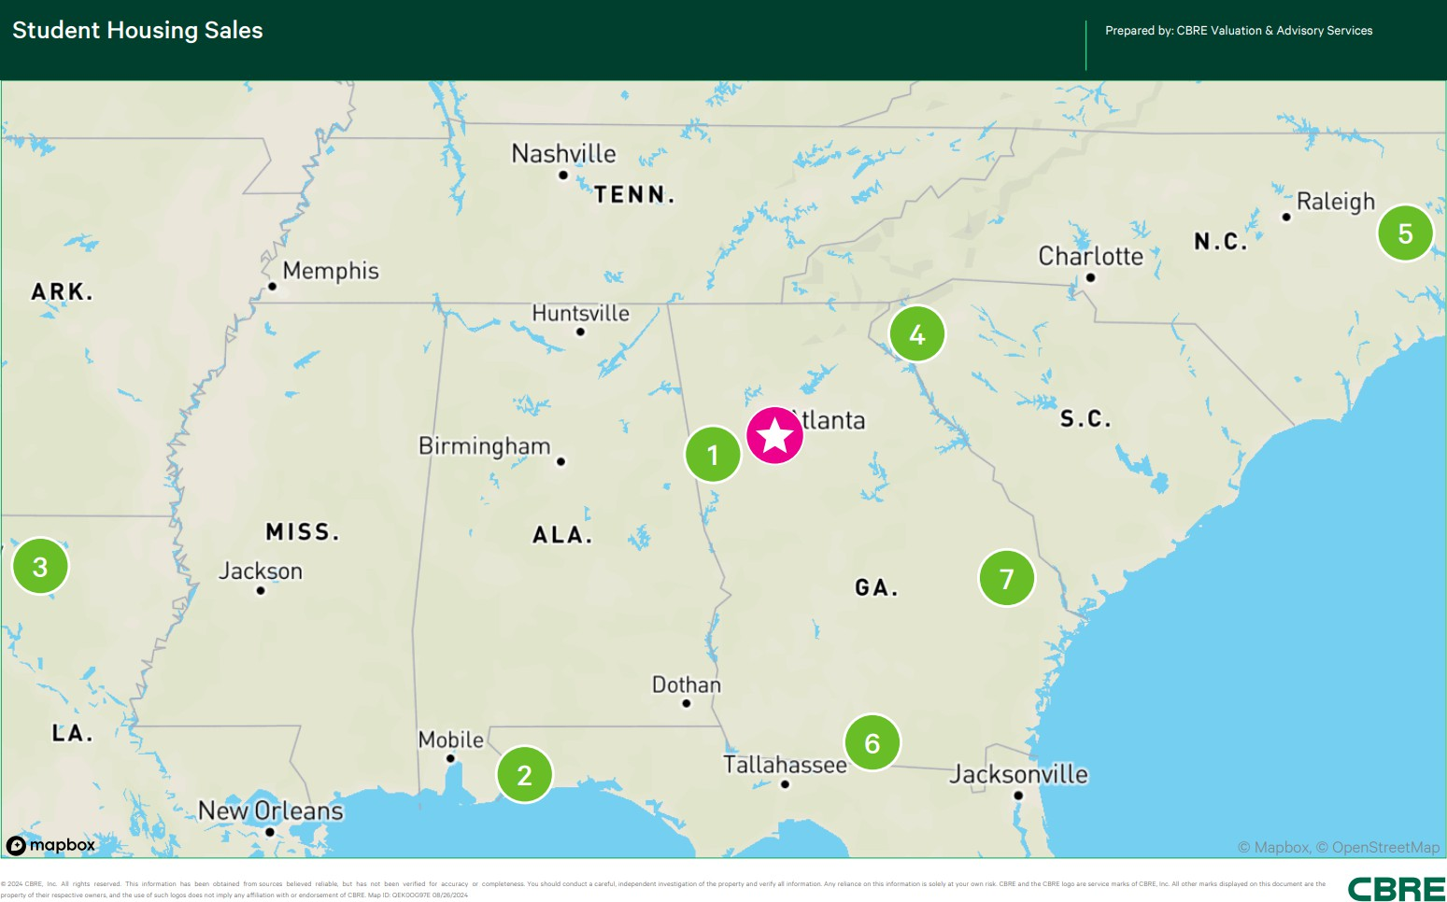

SUMMARY OF COMPARABLE STUDENT HOUSING SALES
No. | Property Name | Transaction Type Date | Interest Transferred | YOC /  Reno'd | Property Subtype | No. Units | Avg. Unit Size | No. Beds | Actual Sale Price | Adjusted Sale Price ¹ | Price Per Bed | Occ. | NOI Per Bed | OAR
1 | The Cottages UWG, 324 Brumbelow Rd  Carrollton, GA 30117 | Sale Dec-23 | Leased Fee | 2013 | Multi-unit Student | 26 | 1,454 | 118 | $5,900,000 | $5,900,000 | $50,000 | 99% | $3,190 | 6.38%
2 | The Next,  10080 Hillview Drive  Pensacola, FL 32514 | Sale Nov-23 | Leased Fee | 2016 | Multi-unit Student | 165 | 1,170 | 551 | $35,750,000 | $35,750,000 | $64,882 | 92% | $4,503 | 6.94%
3 | CEV Ruston,  1812 W Alabama Ave Ruston, LA 71270 | Sale Dec-22 | Leased Fee | 2008 | Multi-unit Student | 120 | 1,197 | 432 | $14,150,000 | $15,003,000 | $34,729 | 71% | $2,570 | 7.40%
4 | The Enclave at Clemson,  423 Lindsay Road & 1146 Old Central Road Clemson, SC 29630 | Sale Aug-22 | Leased Fee | 1998 | Multi-unit Student | 146 | 1,012 | 382 | $24,749,000 | $24,749,000 | $64,788 | 100% | $3,142 | 4.85%
5 | Residences at Greenville, | Sale May-22 | Leased Fee | 2006 / | Multi-unit | 144 | 1,200 | 432 | $11,020,630 | $11,020,630 | $25,511 | 64% | $1,737 | 6.81%
 | 3800 Bostic Drive  Greenville, NC 27834 |  |  | 2007 | Student
6 | Remerton Mill Apartments, 1853 W Gordon St Valdosta, GA 31601 | Sale Mar-22 | Leased Fee | 2019 | Multi-unit Student | 194 | 1,023 | 378 | $17,200,000 | $17,200,000 | $45,503 | 96% | $2,794 | 6.14%
7 | The Hudson,  831 South Main Street Statesboro, GA 30458 | Sale Jan-22 | Leased Fee | 2012 | Multi-unit Student | 300 | 1,034 | 780 | $41,700,000 | $41,700,000 | $53,462 | 99% | $3,069 | 5.74%
Subj. | Turner Theological Seminary, | --- --- | --- | 1894 / | Multi-unit | 56 | 354 | 88 | --- | --- | --- | 88% | $3,718 | ---
Pro  Forma | 702 Martin Luther King Jr Drive SW  Atlanta, GA 30314 |  |  | 2024 | Student

1 Adjusted sale price for cash equivalency, lease-up and/or deferred maintenance (where applicable) Compiled by CBRE

Given the lack of local sales, we have relied upon regional sales from our research of comparable improved sales. Student properties are unique among apartment properties and the sale of true student (not conventional) properties represent the best comparables for the subject.

These sales were chosen based upon date of sale, type of construction, and amenities offered. The sales utilized represent the best data available for comparison with the subject property. In our discussion with market participants, they also concurred that regional sales represent the best comparables for the subject.
Given the subject’s smaller unit sizes and dormitory-style layouts, significant adjustments are warranted for the comparables for both quality and unit mix/average unit size.

STUDENT HOUSING ADJUSTMENT BASIS
The adjustments for a student housing and/or lease by the bed/bedroom property are complex because of the unique physical characteristics of this product type. The following factors are considered in the selection of adjustments for this product type.
- The age/quality/condition adjustment is similar to the adjustment process as seen in traditional apartment projects.
- The location factor has several components to be considered in this product type. First, is the fact that a wider geographic range of improved sales is usually required for true student apartment sales. The second location factor is the consideration of market conditions in the comparable region, with special attention to the level of competition in the area and the probability of new entrants in the area. The third factor is the enrollment trends and enrollment growth possibilities projected in the comparable market area. The final factor involves the proximity of the comparable to the University and the proximity to bus stops and the level of bus service available to the nearby campus.
- The level of amenities is seen as a strong absorption and retention factor for this type of properties which are typically 100% occupied by University students. Most modern student housing projects have extensive swimming pools and spas, recreation rooms, study rooms, computer rooms, basketball/tennis courts, and BBQ grills. Most of the student properties built in the past five years have all or most of these project amenities.
The last adjustment deals with the bed count per unit factor which is related to the economic difference seen due to the unit mix level in a particular apartment project. A typical student complex will have a variety of unit types, however some have only one or two-unit types. This is a very important factor to consider since the rent level in one-bedroom units can vary significantly on a per bed basis. For example, a project may have an approximate rent level for one-bedrooms of $500 to $550 per bed, two-bedroom units at $450 to $500 per bed, three-bedrooms at $400 to $450 per bed, and four-bedrooms at $350 to $400 per bed. This rent differential is essentially a price for privacy and is at a higher cost for each level of unit privacy,
i.e. as a bed count gets smaller in a unit the price per bed increases substantially.

DISCUSSION/ANALYSIS OF IMPROVED SALES
Improved Sale One
This comparable represents the sale of a 26-unit, 118-bed student-housing apartment property that was built in 2013. The property is located on Brumbelow Road in Carrollton, Georgia. The property features four- and six-bedroom floorplans, with an average unit size of 1,431 square feet. The units are fully furnished. Unit amenities include full size washer and dryers and stainless steel kitchen appliances. The sale occurred in December 2023 for $5,900,000, which equates to $226,923 per unit or $50,000/bed. The sale reflected a 6.38% cap rate. The details of the transaction were verified with the PSA.
Improved Sale Two
This comparable represents a 165 unit, 551 bedroom off campus student housing property with two-, three- and four-bedroom floor plans built in 2016. The property is a luxury student apartment with a comprehensive amenity package within a walkable distance to UWF's campus. Property amenities include a fitness center, zero entry luxury pool with expansive sun deck, game room, courtyard area, clubhouse with leasing offices, tanning salon, business center, air condition hallways and elevators. The unit amenities include a dishwasher, disposal, Formica countertops, stainless steel and faux stainless steel appliances, attached microwave, oven/range, refrigerator, faux wood vinyl plank floors in the kitchen and living room, closets in the bedrooms, washer/dryer, 9-foot ceilings and ceiling fans with light kits in all rooms. Leasing is done on a per bed basis and all units are furnished. Each bedroom is furnished with a bed frame with mattress, desk, chair and dresser. Each living room is furnished with two couches, an end table, lamp, coffee table, TV and TV stand. The property includes 76 garage parking spaces that are tucked underneath a portion of the building. The listing broker indicated that the deal was arms-length and the property was in good overall condition at the time of the sale. The property sold in November 2023 for $35,750,000 or $64,882 per bed. Based upon data provided by the listing broker and inclusive of reserves, the resulting cap rate equates to 6.94%.
Improved Sale Three
The property is a 120-unit, 432-bed student housing property located at 1812 W Alabama Avenue in Ruston, Louisiana. The property is marketed toward the approximately 11,000 students attending Louisiana Tech University. Enrollment has declined by about 12% over the past 5-years. The property was 70.6% occupied at the time of sale. The property has a 3.60 bed per unit ratio. The property is under contract for $14,150,000 or $117,917 price per unit and $32,755 price per bed. The buyer has a capital improvement budget of $505,596 which includes new granite countertops and stainless-steel appliances in 78 units. In addition, the capital improvement budget will be used to restore all downed units (5 flooded units, 11 downed units needing appliances or furniture and 3 units being used as storage). The capital improvements are scheduled to be completed in May 2023 according to the buyer. The capital adjustment reflects the lease-up cost to achieve a stabilized occupancy. The effective purchase price is $15,003,000

or $34,729 per bed. Based on the buyer's pro forma, this transaction reveals an overall capitalization rate of 7.40%.
Improved Sale Four
This comparable represents the sale of a 146-unit / 403-bed garden-style student oriented apartment property that was built in 1998. The property is located in Central, SC and services Clemson University. Property amenities include a pool, clubhouse, dog park, and fitness center. Units include a balcony, washer and dryer and plank vinyl throughout. The property offers two-and three- bedroom units. The property sold in August 2022 for $24,749,000, which equates to
$169,5114 per unit and $61,412 per bed. The sale reflected a 4.85% capitalization rate based on buyer's year 1 pro forma and adjusting for SC tax law.
Improved Sale Five
This comparable is a 144-unit/432-bed student-purpose property located at 3800 Bostic Drive in Greenville, North Carolina. The improvements were constructed in 2005 and offer two-, three-, and four-bedroom units with an average unit size of 1,200 square feet. The property is one of two in a portfolio sale that totaled $51,000,000 and sold at a reported cap rate of 6.81% on May 4, 2022. According to public record, this comparable had an allocated purchase price of
$11,020,630, or $25,510 per bed. Several unsuccessful attempts were made to confirm the data with the listing broker. According to CoStar data, the property was approximately 35.8% vacant on May 4, 2022.
Improved Sale Six
Remerton Mills Apartments, 194-unit/378-bed student housing community located at 1853 West Gordon Street in Valdosta, Georgia sold on March 31st, 2022 for $17,200,000, or $45,502 per bed. This class A multifamily building, delivered in 2019, features a unit mix of one-to-three-bedroom fully-furnished units ranging from 785 to 1,345 square feet. The percent leased was reported as 95.6% as of April 2022. This is an up-leg of a 1031 exchange for the buyer who declined to disclose the down-leg of the exchange. The buyer also stated he purchased land and LLC as part of the transaction however the information was not corroborated with both parties. The seller’s representative reported a $1,056,32 net operating income yielding a 5.56% capitalization rate.
Improved Sale Seven
This comparable represents the sale of a 300-unit, 780-bed, student housing apartment property located on South Main Street in Statesboro, Georgia near the Georgia Southern campus. The property was built in 2012 and offers studio-, one-, two-, three-, and four-bedroom floor plans, with an average unit size of 1,034 square feet. The apartment units are rented on a furnished basis with a package that includes living room furniture (couch, chair, coffee table, entertainment center, and barstools), bedroom furniture (a mattress and bed frame, chest of drawers, nightstand and desk with chair), and washer/dryer machines. The project amenities include a

clubhouse with on-site management, swimming pool, business center, coffee bar, game room, fitness center, grill areas, tanning bed, sand volleyball court, car care center, and gated entrances. The property sold for $41,700,000, or $53,462 per bed on January 24, 2022. The sale price implies a cap rate of 5.74% based on T-3 income and T-12 expenses, adjusted for taxes at 80% of purchase price and reserves of $125 per unit. The property was 98.7% occupied at the time of contract.

SUMMARY OF ADJUSTMENTS
Based on our comparative analysis, the following chart summarizes the adjustments warranted to each comparable.
Subj. Pro Forma
7
6
5
4
3
2
1
Comparable Number
Name  Location | The Cottages UWG  Carrollton, GA | The Next  Pensacola, FL | CEV Ruston  Ruston, LA | The Enclave at Clemson  Clemson, SC | Residences at Greenville  Greenville, NC | Remerton Mill Apartments  Valdosta, GA | The Hudson  Statesboro, GA | Turner Theological Seminary  Atlanta, GA
Transaction Type | Sale | Sale | Sale | Sale | Sale | Sale | Sale | ---
Transaction Date | Dec-23 | Nov-23 | Dec-22 | Aug-22 | May-22 | Mar-22 | Jan-22 | ---
Interest Transferred | Leased Fee | Leased Fee | Leased Fee | Leased Fee | Leased Fee | Leased Fee | Leased Fee | ---
Year Built/Renovated | 2013 | 2016 | 2008 | 1998 | 2006 / 2007 | 2019 | 2012 | 1894 / 2024

STUDENT HOUSING SALES ADJUSTMENT GRID

 | Property Subtype  No. Units | Multi-unit Student  26 | Multi-unit Student  165 | Multi-unit Student  120 | Multi-unit Student  146 | Multi-unit Student  144 | Multi-unit Student  194 | Multi-unit Student  300 | Multi-unit Student  56
 | Avg. Unit Size | 1,454 | 1,170 | 1,197 | 1,012 | 1,200 | 1,023 | 1,034 | 354
 | Beds Per Unit | 4.54 | 3.34 | 3.6 | 2.62 | 3 | 1.95 | 2.6 | 1.57
 | No. Beds | 118 | 551 | 432 | 382 | 432 | 378 | 780 | 88
 | Actual Sale Price | $5,900,000 | $35,750,000 | $14,150,000 | $24,749,000 | $11,020,630 | $17,200,000 | $41,700,000 | ---
 | Adjusted Sale Price ¹ | $5,900,000 | $35,750,000 | $15,003,000 | $24,749,000 | $11,020,630 | $17,200,000 | $41,700,000 | ---
 | Price Per Unit ¹ | $226,923 | $216,667 | $125,025 | $169,514 | $76,532 | $88,660 | $139,000 | ---
 | Price Per Bed | $50,000 | $64,882 | $34,729 | $64,788 | $25,511 | $45,503 | $53,462 | ---
 | Occupancy | 99% | 92% | 71% | 100% | 64% | 96% | 99% | 88%
 | NOI Per Unit | $14,467 | $15,037 | $9,250 | $8,221 | $5,215 | $5,445 | $7,985 | $5,842
 | NOI Per Bed | $3,190 | $4,503 | $2,570 | $3,142 | $1,737 | $2,794 | $3,069 | $3,718
 | OAR | 6.38% | 6.94% | 7.40% | 4.85% | 6.81% | 6.14% | 5.74% | ---
 | Adj. Price Per Bed | $50,000 | $64,882 | $34,729 | $64,788 | $25,511 | $45,503 | $53,462
 | Property Rights Conveyed | 0% | 0% | 0% | 0% | 0% | 0% | 0%
 | Financing Terms ¹ | 0% | 0% | 0% | 0% | 0% | 0% | 0%
 | Conditions of Sale | 0% | 0% | 0% | 0% | 0% | 0% | 0%
 | Market Conditions (Time) | 0% | 0% | -5% | -5% | -5% | -5% | 0%
 | Subtotal - Price Per Bed | $50,000 | $64,882 | $32,993 | $61,549 | $24,235 | $43,228 | $53,462
 | Location | 15% | 5% | 5% | 15% | 15% | 15% | 10%
 | Project Size | 0% | -5% | -5% | -5% | -5% | -10% | -15%
 | Age/Condition | -5% | -10% | -5% | 0% | -5% | -10% | -5%
 | Quality of Construction | -15% | -15% | -15% | -15% | -15% | -15% | -15%
 | No. Beds/Density | 20% | 15% | 15% | 15% | 15% | 0% | 15%
 | Unit Mix | -10% | -10% | -10% | -10% | -10% | -10% | -10%
 | Project Amenities | 5% | 5% | 5% | 5% | 5% | 5% | 5%
 | Occupancy | 0% | 0% | 0% | 0% | 0% | 0% | 0%
 | Total Other Adjustments | 10% | -15% | -10% | 5% | 0% | -25% | -15%
 | Indicated Value Per Bed | $55,000 | $55,150 | $29,693 | $64,626 | $24,235 | $32,421 | $45,442
 | Absolute Adjustment | 70% | 65% | 65% | 70% | 75% | 70% | 75%
¹ Adjusted for cash equivalency, lease-up and/or deferred maintenance (where applicable) Compiled by CBRE

SALE PRICE PER SQUARE FOOT ANALYSIS
Property Rights Conveyed – We note that no adjustments for property rights was deemed necessary.
Financing Terms – We note that no adjustments for financing terms was deemed necessary.

Conditions of Sale – We note that no adjustments for conditions of sale was deemed necessary.
Market Conditions (Time) – Comparables Three through Seven warranted downward adjustments for their superior market conditions and interest rate environment at the time of sale.
Location – All of the comparables warranted upward adjustments to reflect their inferior locations with respect to their multi-family submarkets. Adjustments were also made based on their distance from the college campuses that they are marketed towards.
Project Size – Comparables Two through Seven warranted downward adjustments to reflect their larger project size as student housing properties with more units/beds sell for less on a per bed basis due to economies of scale.
Age/Condition – Comparables One, Two, Three, Five, Six, and Seven warranted downward adjustments to reflect their superior age/condition.
Quality of Construction – All of the comparables warranted downward adjustments to reflect their superior quality of construction.
No Beds/Density – All of the comparables excluding Comparable Six, warranted upward adjustments to reflect their higher number of beds per unit, which is seen as inferior in the student housing market.
Unit Mix – All of the comparables warranted downward adjustments to reflect their superior unit mixes.
Project Amenities – All of the comparables warranted slightly upward adjustments for their project amenities as the subject’s on-campus location permits easy access to the amenities provided by the surrounding universities that are free to students as well as closer proximity to courses and shuttle services.
Occupancy – We note that no adjustments for occupancy was deemed necessary.

SALE PRICE PER BED ANALYSIS
As shown, the comparable sales indicate an adjusted value per bed range of $24,235 to
$64,626, with an adjusted average of $43,795 per bed. Based on the preceding discussions of each comparable and the foregoing adjustment analysis, we have not placed primary emphasis on any single sale. We have considered a price per bed indication within the adjusted range of the comparables to be reasonable for the subject. As previously noted, given the subject’s location on-campus and partial use as a seminary school with smaller unit sizes and dormitory-style layouts, the necessary adjustments were applied.

SALES COMPARISON APPROACH CONCLUSION
The following table presents the estimated value for the subject as indicated by the sales comparison approach.

SALES COMPARISON APPROACH

Total Beds X Value Per Bed = Value
88 | X | $40,000 | = | $3,520,000
88 | X | $45,000 | = | $3,960,000
VALUE CONCLUSION
As Stabilized Market Value |  |  |  | $3,800,000
Rounded |  |  |  | $3,800,000
Rent Loss During Remaining Master Lease Term |  |  |  | ($329,000)
Indicated Value As Is |  |  |  | 3,471,000
Rounded |  |  |  | $3,475,000
Value Per Bed |  |  |  | $39,489
Compiled by CBRE

Income Capitalization Approach
The following map and table summarize the primary comparable data used in the valuation of the subject. A detailed description of each transaction is included in the addenda.
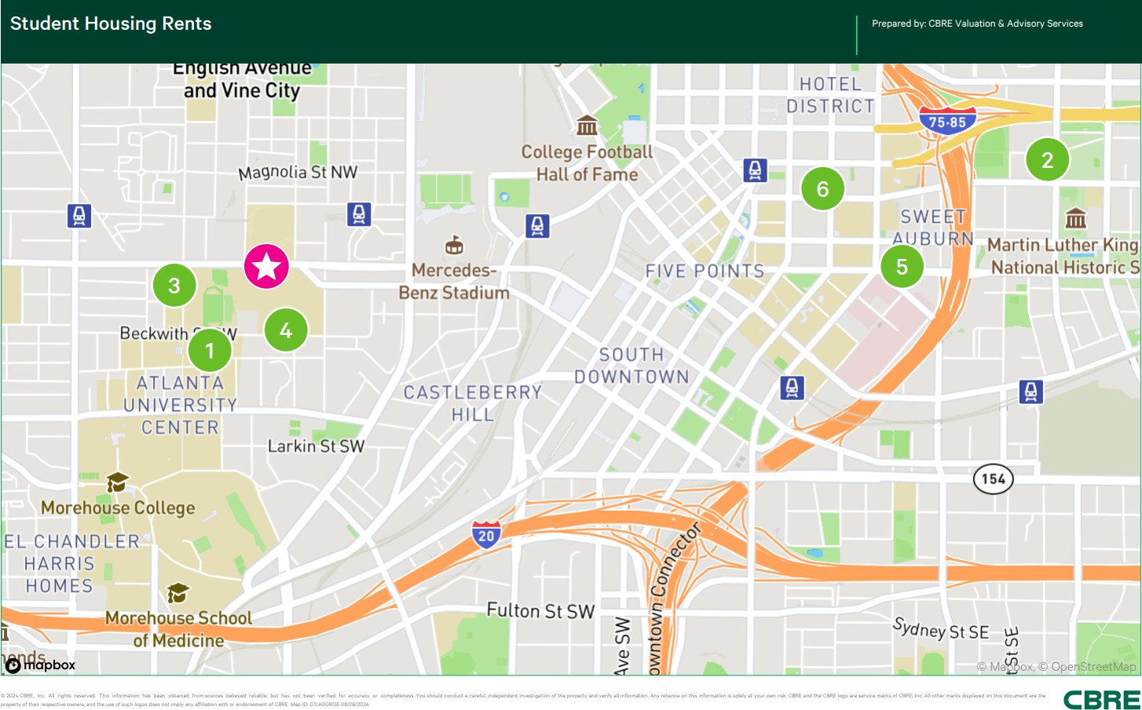

SUMMARY OF COMPARABLE STUDENT HOUSING RENTALS
No. | Property Name | Location | YOC /  Reno'd | Property Subtype | Occ. | No. Units | Distance from Subj | No. Beds
1 | CAU Suites | 128 Mildred Street SW | 2005 | Multi-unit Student | 86% | 159 | 0.3 Miles | 598
 |  | Atlanta, GA 30314
2 | Camden Vantage | 180 Jackson Street NE | 2009 | Multi-unit Mid / High Rise | 93% | 592 | 2.0 Miles | 803
 |  | Atlanta, GA 30312
3 | Heritage Commons | 15 James P Brawley Drive | 2001 | Multi-unit Student | 85% | 128 | 0.2 Miles | 455
 |  | Atlanta, GA 30314
4 | Gammon Theological Seminary | 653 Beckwith Street SW. | 1989 | Multi-unit Student | 85% | 80 | 0.2 Miles | 110
 |  | Atlanta, GA 30314
5 | 200 Edgewood | 200 Edgewood Avenue | 2016 | Multi-unit Student | 90% | 144 | 1.6 Miles | 254
 |  | Atlanta, GA 30303
6 | One12 Courtland | 112 Courtland Street, NE | 2014 | Multi-unit Student | 96% | 254 | 1.4 Miles | 717
 |  | Atlanta, GA 30303
Subj. | Turner Theological Seminary | 702 Martin Luther King Jr Drive SW, | 1894 / | Multi-unit Student | 100% | 56 | --- | 88
 |  | Atlanta, Georgia | 2024
Compiled by CBRE

The rentals utilized represent the best data available for comparison with the subject.
It should be noted that there was limited data for on-campus dormitory style housings. As such, we have analyzed off-campus student housing properties servicing other universities (Georgia

Institute of Technology, Georgia State University, etc.), however, considering these to be generally newer and higher quality properties, have also analyzed conventional market rate multifamily properties of somewhat similar buildout and quality as the subject.
Rent Comparable One
This comparable represents a 159-unit, 598-bed on-campus student-housing property located at
128 Mildred Street SW in Atlanta, Georgia. The property consists of 2 four-story apartment buildings. The improvements were constructed in 2005 and are situated on a 2.08-acre site. The improvements were quoted to be 86% occupied going into the 2024 fall semester. The building currently exclusively serves Clark Atlanta University and is renting its units to students on a per-bed basis. The subject improvements consist of dormitory buildings mostly comprised of dorm rooms (with no kitchen) and study rooms on each floor. The ground floors include a lounge area, laundry room and offices. One of the buildings contains a fitness center. All bedrooms are furnished with a bed, dresser, nightstand, and desk.
Rent Comparable Two
This comparable represents a 592-unit mid-rise apartment property, located along Jackson Street in Midtown Atlanta. The property, identified as Camden Vantage, was developed in 2009 and is currently 100% occupied. The comparable offers studio, one-, and two-bedroom floor plans, with an average unit size of 901 square feet. Interiors feature gray cabinets and white quartz countertops, white subway tile backsplashes, USB outlets, walk-in closets, hardwood-style flooring and full-size washers and dryers. There is a one-time parking fee of $100. Storage units are available for lease at $65 - $75 per month. Management employs a RUBS for reimbursement of water and sewer. Resident pays $35 per month for valet trash and $2 per month for pest control. No concessions are currently being offered. Reserved parking is available for $50 per month.
Rent Comparable Three
This comparable is a 128-unit, 455-bed multi-family garden style student-oriented property located at 15 James P Brawley Drive in Atlanta, Georgia. The property consists of 1 four-story residential building and 1 two-story parking garage. The improvements were constructed in 2001 and are situated on a 3.76-acre site. The improvements were 85.1% leased as of the survey and considered stabilized. The subject is student-oriented housing servicing Clark Atlanta University renting on a per-bed basis. All bedrooms are furnished with a bed, dresser, nightstand, and desk. Each unit is furnished with a couch, coffee table, kitchen table, and chairs.
Rent Comparable Four
The comparable represents a seminary school/dormitory property known as the Gammon Theological Seminary located at 653 Beckwith Street SW. in downtown west Atlanta, Georgia. The improvements are situated on the Interdenominational Theological Center campus that is in collaboration with the Atlanta University Center Consortium, which offers graduate level and PhD's to students studying theology. The building is three stories and features classrooms, a

chapel, common areas, etc., on the first floor and the top two floors offer a mix of residential units for on-campus living students. The residential portion features 80 rental units/110-beds. The unit mix is comprised of single-dorms and shared dorms with communal restrooms/showers, and efficiency unit suites with private bathrooms. The units are all furnished. The units are rented on a semester basis or annual basis. Based on the quoted annual amount, the quoted monthly rate on a per bed basis for single-dorms is $917 per bed, while the shared dorms is quoted at
$750 per bed, and the efficiency units are quoted at $1,083 per bed. A representative of the seminary quoted the building to be approximately 85% leased for the 2024 fall semester.
Rent Comparable Five
This comparable is a 144-unit, 254-bedroom off-campus student housing property located in the northwest corner of Edgewood Avenue and Jesse Hill Junior Drive. The property is identified as 200 Edgewood. It is located within walking distance to Georgia State University, and tends to draw most of its demand from the university's undergraduates. The property is located on the downtown streetcar line and is also in close proximity to Grady/Children’s Hospital. The property offers studio, 1, and 2 bedroom floor plans. Leases are signed by the room. Community amenities include a gym, study lounges, and meeting rooms, as well as a clubroom and coffee bar. Additionally, the property features ground-floor retail. All units are leased on a fully furnished basis and feature fully-equipped kitchens with granite countertops. Utilities included in rent are water/sewer, cable, and trash removal. Electricity is sub-metered for usage with the tenant responsible for usage. Garages are available for rent at an additional monthly charge of
$150. Deck parking is $125 per month for reserved. The property is not currently offering any concessions. The property is currently 7% pre-leased for the fall 2024 school year.
Rent Comparable Six
This property is a 254-unit, 717-bed off-campus student housing property that represents the adaptive reuse conversion of a former Ramada Inn converted that was constructed in 1964 and renovated in 2013 and expanded in 2014. The property sits on a 1.47-acre site, is located within walking distance to Georgia State University, and tends to draw most of its demand from their undergraduates. Currently, the property is 96% occupied. The property offers one-, two-, three-, and four-bedroom floor plans. Leases are signed by the bedroom. Amenities include a rooftop pool overlooking Downtown, a clubhouse equipped with large screen TV’s, and a fully equipped fitness center. Utilities included in the rent are water, sewer, trash, cable, electricity, and internet; however, there is a one-time utility setup fee of $60 for each calendar year. Units are fully furnished. Monthly garage parking is $90 per month. No concessions are currently being offered. The property is currently 72% pre-leased for the fall 2024 school year.

SUBJECT RENTAL INFORMATION
The following table shows the subject’s unit mix and rental rates.

SUBJECT RENTAL INFORMATION
 | No. of | No. of | Unit | Bed | Avg. Quoted | Rent | Avg. In-Place | Rent
Type | Units | Beds | Size (SF) | Occ. | $/Bed | Per SF | $/Bed | Per SF
1BR/1BA - Apartment Suite | 5 | 5 | 650 | 100% | $1,267 | $1.95 | $1,267 | $1.95
1BR/1BA - Efficiency Unit | 19 | 19 | 325 | 100% | $917 | $2.82 | $917 | $2.82
2BR/1BA - Dorm | 32 | 64 | 325 | 100% | $600 | $3.69 | $600 | $3.69
Compiled by CBRE

The subject project is an on-campus student apartment leased by the bed/bedroom facility with quoted rates as fully-furnished.
- The lease rates above have been converted from a semester and/or annual total to a monthly rent, pro-rated over 12 months, per bedroom.
- The rental rates depicted are inclusive of electric, water and sewer costs, and internet.

MARKET RENT ESTIMATE
In order to estimate the market rates for the various floor plans, the subject unit types have been compared with similar units in the comparable projects.
One-Bedroom Units

SUMMARY OF COMPARABLE RENTALS
ONE BEDROOM UNITS
Comparable | Plan Type Size (SF) | Rental Rates  $/Mo. | $/Bed
Subject (Avg. Quoted) | 1BR/1BA - Efficiency Unit 325 SF | $917 | $917
Subject (Concluded) | 1BR/1BA - Efficiency Unit 325 SF | $917 | $917
CAU Suites | 1BD/1BA 450 SF | $925 | $925
Heritage Commons | 1BD/1BA 600 SF | $931 | $931
Gammon Theological Seminary | 1BR/1BA - Dorm 300 SF | $1,014 | $1,014
Gammon Theological Seminary | 1BR/1BA - Apartment Suite 350 SF | $1,054 | $1,054
Subject (Avg. Quoted) | 1BR/1BA - Apartment Suite 650 SF | $1,267 | $1,267
Subject (Concluded) | 1BR/1BA - Apartment Suite 650 SF | $1,267 | $1,267
One12 Courtland | 1BR/1BA 533 SF | $1,410 | $1,410
Camden Vantage | 1BR/1BA 843 SF | $1,439 | $1,439
Camden Vantage | 1BR/1BA 831 SF | $1,469 - $1,549 | $1,509
Camden Vantage | 1BR/1BA 884 SF | $1,509 | $1,509
Camden Vantage | 1BR/1BA 756 SF | $1,589 | $1,589
Camden Vantage | 1BR/1BA 845 SF | $1,599 | $1,599
200 Edgewood | 1BR/1BA (A1) 540 SF | $1,625 | $1,625
200 Edgewood | 1BR/1BA (A2) 586 SF | $1,645 | $1,645
Compiled by CBRE
The rent comparables range in size from 300 SF to 884 SF, with an average unit size of 627 SF. The rent comparables' rent per month ranges from $925 to $1,645, with an average rent of

$1,354. The rent comparables' rent per bed per month ranges from $925 to $1,645, with an average rent of $1,354.
We note that the subject is generally in inferior condition and quality as compared to the competitive set. The efficiency unit is at the low end of the range as it is only 325 square feet and only features a small kitchenette and being more of a dormitory-style unit. The other 1BR/1BA Apartment Suite is within the lower-middle portion of the range mostly due to its location within a dormitory and its smaller size. Additionally, the subject units are generally smaller than the competing product. As such, a conclusion at the low end of the comps is reasonable. Comparable No. 4 (Gammon Theological Seminary) is most similar to the subject as it is on the same campus and offers similar style unit mixes.
Two-Bedroom Units

SUMMARY OF COMPARABLE RENTALS
TWO BEDROOM UNITS
Comparable | Plan Type Size (SF) | Rental Rates  $/Mo. | $/Bed
Subject (Avg. Quoted) | 2BR/1BA - Dorm 325 SF | $1,200 | $600
Gammon Theological Seminary | 2BR/1BA - Dorm 350 SF | $866 | $433
Subject (Concluded) | 2BR/1BA - Dorm 325 SF | $1,200 | $600
CAU Suites | 2BD/1BA 450 SF | $1,240 | $620
Camden Vantage | 2BR/2BA 1,046 SF | $1,549 | $775
Camden Vantage | 2BR/2BA 1,149 SF | $1,729 | $865
Camden Vantage | 2BR/2BA 1,152 SF | $1,799 | $900
Heritage Commons | 2BD/2BA 600 SF | $1,862 | $931
One12 Courtland | 2BR/1BA 614 SF | $1,890 | $945
Camden Vantage | 2BR/2BA 1,277 SF | $1,919 | $960
One12 Courtland | 2BR/2BA 852 SF | $2,110 | $1,055
200 Edgewood | 2BR/2BA (B1) 812 SF | $2,198 | $1,099
200 Edgewood | 2BR/2BA (B2) 834 SF | $2,198 | $1,099
Compiled by CBRE
The rent comparables range in size from 350 SF to 1,277 SF, with an average unit size of 831 SF. The rent comparables' rent per month ranges from $866 to $2,198, with an average rent of
$1,760. The rent comparables' rent per bed per month ranges from $433 to $1,099, with an average rent of $880.
We note that the subject is an on-campus dormitory with minimal amenities, while the majority of the comparables (excluding Comparable 4) represent conventional student housing projects that offer larger units with private bathrooms along with more amenities.
Spellman College Dorm Rates
As previously discussed, the subject is a dormitory that is currently part of the Spellman College on-campus living residences. In order to provide a more accurate depiction of market rates for dormitory style student housing such as the subject, we have provided a list of Spellman College’s quoted rates for their on-campus and affiliated off-campus student units.

QUOTED DORMITORY RENT COMPARABLES
Spellman College Dorm | Unit Mix | No. | Monthly Rent | Annual Total
Options | Description | Beds | $/Bed
Spellman Campus Living | 2BR/Shared Bath | 2 | $719 | $17,253
The Mix | 2BR/Shared Bath | 2 | $662 | $15,886
Westmar | 2BR/Shared Bath | 2 | $490 | $11,750
Gammon Hall (Seminary) | 2BR/Shared Bath | 2 | $507 | $12,166
Gammon Hall (Seminary) | 1BR/1BA - Efficiency | 1 | $1,054 | $12,650
Subject (Turner Seminary) | 2BR/Shared Bath | 2 | $600 | $14,400
Subject (Turner Seminary) | 1BR/1BA - Efficiency | 1 | $917 | $11,004
Subject (Turner Seminary) | 1BR/1BA - Suite | 1 | $1,267 | $15,204
Compiled by CBRE
The quoted rates range from $490 to $719 on a per bed basis for two-bedroom shared dorms, while the efficiency units range from $917 to $1,054. As shown, the subject’s quoted rates are more in-line with the other competing dorms offered at Spellman College. Therefore, we have concluded the quoted rates to be at market.

MARKET RENT CONCLUSIONS
The following chart shows the market rent conclusions for the subject:

RENT CONCLUSIONS

No. No. Unit Monthly Rent Annual Rent Annual
Units | Beds | Unit Type | Size (SF) | Total SF | $/Bed | $/SF | PRI | $/Bed | $/SF | Total
5 | 5 | 1BR/1BA - Apartmen | 650 | 3,250 | $1,267 | $1.95 | $6,335 | $15,204 | $23.39 | $76,020
19 | 19 | 1BR/1BA - Efficiency | 325 | 6,175 | $917 | $2.82 | $17,423 | $11,004 | $33.86 | $209,076
32 | 64 | 2BR/1BA - Dorm | 325 | 10,400 | $600 | $1.85 | $38,400 | $7,200 | $44.31 | $460,800
56 | 88 |  | 354 | 19,825 | $706 | $3.14 | $62,158 | $8,476 | $37.62 | $745,896
Compiled by CBRE

In the market rent conclusions above, all units are at market rate.

POTENTIAL RENTAL INCOME CONCLUSION
Within this analysis, potential rental income is estimated based upon our estimate of pro forma income for the 12 months. We have included deductions for loss-to-lease, concessions, vacancy and credit loss, as necessary, to account for any expected losses in potential rental income. Our methodology is consistent with buyers in the market, who are typically analyzing acquisitions based on income levels they expect to achieve over the next twelve months. However, we note that buyers are currently placing significant emphasis on income levels being achieved in the most recent months in preparing their year one pro formas, with buyers’ future-looking estimates generally being slightly above actual income levels in place. Further, buyers are typically adjusting any expenses to reasonable levels that are typically seen in the market, as needed.

OPERATING HISTORY
Although requested, we were not provided with any historical operating information from prior years as well as a budget.

LOSS TO LEASE
Loss-to-lease results when there are leases in-place at the property which are below the current quoted and/or market lease rates. This occurs as quoted rental rates are increased to levels above previous levels. In addition, loss-to-lease occurs if management allows existing tenants to renew for less than the full market rate, in order for the landlord to forego the cost of painting, redecorating and leasing a unit. As a student housing property, the subject leasing cycle typically runs August 17th through July 31st, after which all units are released at market. As previously stated, the subject’s asking and actual rents are in line with the comparables effective rents; therefore, we have not included a loss-to-lease deduction within our analysis.

RENT CONCESSIONS

 | CONCESSIONS
Year |  | Total | % of PGI
CBRE Estimate |  | $0 | 0.00%
Compiled by CBRE
Rent concessions exist in the market as a result of the current imbalance of supply and demand. Typically, rent concessions are moderate when pricing is reasonable, and market based in student housing apartments.

VACANCY
The subject’s estimated stabilized occupancy rate was previously discussed in the market analysis. The subject’s vacancy is detailed as follows:

 | VACANCY
Year |  | Total | % of ARI
CBRE Estimate |  | ($89,508) | 12.0%
Compiled by CBRE
As previously discussed, we have estimated the subject’s pro forma stabilized occupancy level in line with the prevailing market data and comparable data. The rent comparables range from 85% to 96%. Our estimate is considered reasonable given the relatively strong growth of the AUC colleges.

CREDIT LOSS
The credit loss estimate is an allowance for nonpayment of rent or other income. The subject’s credit loss is detailed as follows:

CREDIT LOSS

Year Total % of ARI

CBRE Estimate ($7,459) 1.00%
Compiled by CBRE

Similar quality conventional property typically garners a credit loss of 1.0% to 3.0% of PGI. However, student housing properties are typically on the lower end of the range. This is largely attributed to the use of parental guarantees and/or student aid, which pays for room & board fees upfront, ultimately minimizing credit loss. In our analysis, we concluded to 1.00%, which is within the typical range and considered reasonable given the subject’s quality, location, and typical tenant base.

OTHER INCOME
Other income is supplemental to that derived from leasing of the improvements. This includes categories such as forfeited deposits, vending machines, late charges, etc. The subject’s income is detailed as follows:

OTHER INCOME

Year Total $/Bed/Yr

CBRE Estimate $0 $0
Compiled by CBRE

We have not included any additional income associated with the property as no additional income was reported and it is an on-campus dormitory that offers no other sources of revenue.

RUBS INCOME
The RUBS program (Ratio Utility Billing System) is a system in which a portion of the utility expense is shared by tenants and reimbursed to the landlord on a pro rata basis. The subject’s RUBS income, if applicable, is detailed as follows:

RUBS/UTILITY INCOME

Year Total $/Bed/Yr

CBRE Estimate $0 $0
Compiled by CBRE

All utilities are included in the rent. As such, we did not include a RUBS/utility income.

EFFECTIVE GROSS INCOME
The subject’s effective gross income is detailed as follows:

EFFECTIVE GROSS INCOME

Year Total $/Bed/Yr

CBRE Estimate $648,930 $7,374
Compiled by CBRE

As illustrated, our effective gross income estimate is a reflection of our market-based vacancy estimate and in-place rental rates.
Our methodology is consistent with that used by most buyers in the market, who are typically forecasting future-looking income to be very close to, or slightly above, actual income in-place. Given this, we believe that our pro forma estimate, which reflects future 12-month projections, is appropriate. In addition, our estimates are considered to be reasonable and well supported by comparable area properties.

OPERATING EXPENSE ANALYSIS
Expense Comparables
The following chart summarizes expenses obtained from recognized industry publications and/or comparable properties.

EXPENSE COMPARABLES
Comparable Number 1 2 | 3 |  | 4 |  | Subject
Location Southeast Southeast | Southeast |  | Southeast |  | Atlanta, GA
No. Beds 421 600 or more | 141 |  | 389 |  | 88
Vintage 2000's 2000's  Type Student Student | 1980's  Student |  | 1990's  Garden |  | 1894 / 2024  Student
Period 03/2022 T-12 08/2022 T-12 | 09/2023 T-12 |  | 12/2023 T-12 |  | Pro Forma
Revenues $/Bed $/Bed | $/Bed |  | $/Bed |  | $/Bed
Effective Gross Income $8,080 $7,536 | $6,920 |  | $8,057 |  | $7,374
Expenses
Real Estate Taxes $426 $1,129 | $564 |  | $959 |  | $573
Property Insurance 160 324 | 246 |  | 179 |  | 250
Utilities 475 1,287 | 591 |  | 571 |  | 950
Administrative & General 154 214 | 250 |  | 181 |  | 200
Repairs & Maintenance 212 238 | 514 |  | 393 |  | 400
Landscaping & Security 62 36 | 103 |  | 54 |  | 75
Management Fee 201 157 | 278 |  | 281 |  | 258
Payroll 718 618 | 674 |  | 781 |  | 700
Non-Revenue Units 23 0 | 45 |  | 46 |  | -
Advertising & Promotion 228 83 | 101 |  | 162 |  | 100
Replacement Reserves $150 $150 | $150 |  | $150 |  | 150
Total Operating Expenses $2,809 $4,236 | $3,515 |  | $3,757 |  | $3,656
Operating Expenses Excluding Taxes 2,383 3,107 | 2,952 |  | 2,798 |  | 3,083
Operating Expense Ratio 34.8% 56.2% | 50.8% |  | 46.6% |  | 49.6%
Management Fee % of EGI) 2.49% 2.08% | 4.02% |  | 3.49% |  | 3.5%
² The median total differs from the sum of the individual amounts.
Compiled by CBRE

A discussion of each expense category is presented on the following pages.
Real Estate Taxes
The comparable data and projections for the subject are summarized as follows:

REAL ESTATE TAXES

Year Total $/Bed/Yr
Expense Comparable 1 | --- | $426
Expense Comparable 2 | --- | $1,129
Expense Comparable 3 | --- | $564
Expense Comparable 4 | --- | $959
CBRE Estimate | $50,439 | $573
Compiled by CBRE
As previously discussed, with support from our analysis of tax comparables, we have included the subject's property tax liability based on a tax value above the actual current tax value. Please refer to the Tax and Assessment Data portion of the report for additional details. As noted, the subject does not currently incur a real estate tax expense as a result of its tax-exempt status as a “non-profit institution”.
Property Insurance
Property insurance expenses typically include fire and extended coverage and owner’s liability coverage. The comparable data and projections for the subject are summarized as follows:

PROPERTY INSURANCE

Year Total $/Bed/Yr
Expense Comparable 1 | --- | $160
Expense Comparable 2 | --- | $324
Expense Comparable 3 | --- | $246
Expense Comparable 4 | --- | $179
CBRE Estimate | $22,000 | $250
Compiled by CBRE
We have concluded $250 per bed for the subject's property insurance, which is within the range of the expense comparables. Given the lack of historicals, we concluded within the range of the comps.
Utilities
Utility expenses include electricity, natural gas, water, sewer, trash, and cable/internet. The comparable data and projections for the subject are summarized as follows:

 | UTILITIES
Year |  | Total | $/Bed/Yr
Expense Comparable 1 |  | --- | $475
Expense Comparable 2 |  | --- | $1,287
Expense Comparable 3 |  | --- | $591
Expense Comparable 4 |  | --- | $571
CBRE Estimate |  | $83,600 | $950
Compiled by CBRE
We have concluded $950 expense comparables. | per bed for the subject's | utilities, which is within | the range of the
Administrative & General
Administrative expenses typically include legal costs, accounting, items which are not provided by off-site management, telephone, supplies, furniture, and temporary help. The comparable data and projections for the subject are summarized as follows:

ADMINISTRATIVE & GENERAL

Year Total $/Bed/Yr
Expense Comparable 1 | --- | $154
Expense Comparable 2 | --- | $214
Expense Comparable 3 | --- | $250
Expense Comparable 4 | --- | $181
CBRE Estimate | $17,600 | $200
Compiled by CBRE
We have concluded $200 per bed for the subject's administrative & general, which is within the range of the expense comparables. Given the lack of historicals, we concluded within the range of the comps.
Repairs & Maintenance
Repairs and maintenance expenses typically include all outside maintenance service contracts and the cost of maintenance and repairs supplies. The comparable data and projections for the subject are summarized as follows:

REPAIRS & MAINTENANCE

Year Total $/Bed/Yr
Expense Comparable 1 | --- | $212
Expense Comparable 2 | --- | $238
Expense Comparable 3 | --- | $514
Expense Comparable 4 | --- | $393
CBRE Estimate | $35,200 | $400
Compiled by CBRE

We have concluded $400 per bed for the subject's repairs & maintenance, which is within the range of the expense comparables. Given the lack of historicals, we concluded within the range of the comps
Landscaping & Security
Landscaping and security expenses typically include all outside landscaping and grounds maintenance service contracts and the cost of landscaping supplies, as well as security services. The comparable data and projections for the subject are summarized as follows:

LANDSCAPING & SECURITY

Year Total $/Bed/Yr
Expense Comparable 1 | --- | $62
Expense Comparable 2 | --- | $36
Expense Comparable 3 | --- | $103
Expense Comparable 4 | --- | $54
CBRE Estimate | $6,600 | $75
Compiled by CBRE
We have concluded $75 per bed for the subject's landscaping & security, which is within the range of the expense comparables. Given the lack of historicals, we concluded within the range of the comps.
Management Fee
Management expenses are typically negotiated as a percentage of collected revenues (i.e., effective gross income). The comparable data and projections for the subject are summarized as follows:

MANAGEMENT FEE

Year Total % of EGI
Expense Comparable 1 | --- | 2.5%
Expense Comparable 2 | --- | 2.1%
Expense Comparable 3 | --- | 4.0%
Expense Comparable 4 | --- | 3.5%
CBRE Estimate | $22,713 | 3.5%
Compiled by CBRE
Given the subject's rent levels and the subject’s bottom floor operations as a seminary school, we believe a management fee at the higher level of the range is reasonable at 3.5%.
Payroll
Payroll expenses typically include all payroll and payroll related items for all directly employed administrative and maintenance personnel. Not included are the salaries or fees for off-site management firm personnel and services. The comparable data and projections for the subject are summarized as follows:

PAYROLL

Year Total $/Bed/Yr

Expense Comparable 1 --- $718
Expense Comparable 2 --- $618
Expense Comparable 3 --- $674
Expense Comparable 4 --- $781
CBRE Estimate $61,600 $700

Compiled by CBRE
We have concluded $700 per bed for the subject's payroll, which is within the range of the expense comparables. Given the lack of historicals, we concluded within the range of the comps.
Non-Revenue Units
Non-revenue units represent otherwise rentable units which are not available for lease due to their use for other purposes such as employee occupied units and/or model units. The lost revenue, which would have been generated by these units if leased, is deducted as an operating expense. The comparable data and projections for the subject are summarized as follows:

NON-REVENUE UNITS

Year Total $/Bed/Yr
Expense Comparable 1 | --- | $23
Expense Comparable 2 | --- | $0
Expense Comparable 3 | --- | $45
Expense Comparable 4 | --- | $46
CBRE Estimate | $0 | $0
Compiled by CBRE
Non-Revenue Units can include model units, units for security officers, and discounts for Student Resident Assistants (RAs). We have found that this expense normally approximates one bed per every 100 beds at a market rate property. Based on conversations with on-site management, the subject features no RA or employee units. Within our analysis, we have not included an expense for non-revenue units, consistent with current operations.
Advertising & Promotion
This expense category accounts for placement of advertising, commissions, signage, brochures, and newsletters. The comparable data and projections for the subject are summarized as follows:

