ADVERTISING & PROMOTION

Year Total $/Bed/Yr
Expense Comparable 1 | --- | $228
Expense Comparable 2 | --- | $83
Expense Comparable 3 | --- | $101
Expense Comparable 4 | --- | $162
CBRE Estimate | $8,800 | $100
Compiled by CBRE
We have concluded $100 per bed for the subject's advertising & promotion, which is within the range of the expense comparables. Given the limited reliability of the historicals, we concluded within the range of the comps.
Reserves for Replacement
Reserves for replacement have been estimated based on discussions with knowledgeable market participants who indicate a range from $100 to $200 per bed for comparable properties. Based on the subject’s age, condition and average unit size, we have included reserves for replacement at $150 per bed.

OPERATING EXPENSE CONCLUSION
The subject’s expense excluding taxes is detailed as follows:

TOTAL OPERATING EXPENSES

Year | Total | $/Bed/Yr
Expense Comparable 1 | --- | $2,809
Expense Comparable 2 | --- | $4,236
Expense Comparable 3 | --- | $3,515
Expense Comparable 4 | --- | $3,757
CBRE Estimate | $321,752 | $3,656
Compiled by CBRE
We have concluded $3,656 per bed for the subject's total operating expenses, which is within the range of the expense comparables. As noted, we were not provided with historical operating statements. As such, we have placed primary reliance on the expense comparables in estimating how a typical market participant would analyze the subject. Our expenses are supported on a line-by-line basis and appear reasonable.

NET OPERATING INCOME CONCLUSION
The comparable data and projections for the subject are summarized as follows:

NET OPERATING INCOME

Year Total $/Bed/Yr

CBRE Estimate $327,178 $3,718
Compiled by CBRE

Our methodology is consistent with buyers in the market, who are considering income levels they expect to achieve going forward. We note that buyers are currently placing significant emphasis on income levels being achieved in the most recent months in preparing their year one pro formas, with buyers’ forecasted income generally being very close to the actual income levels in place. Further, buyers are typically adjusting any expenses to reasonable levels that are typically seen in the market, including replacement reserves and adjusting expenses to more reasonable levels, as needed. Overall, we believe our net operating income conclusion to be appropriate and in-line with how a typical buyer/investor would underwrite the subject property.

DIRECT CAPITALIZATION
Direct capitalization is a method used to convert a single year’s estimated stabilized net operating income into a value indication. The following subsections represent different techniques for deriving an overall capitalization rate.
Comparable Sales
The overall capitalization rates (OARs) confirmed for the comparable sales analyzed in the sales comparison approach are as follows:

COMPARABLE CAPITALIZATION RATES
Sale | Name | Sale  Date | Sale Price  $/Bed | Occupancy | Buyer's Primary Analysis | OAR
1 | The Cottages UWG | Dec-23 | $50,000 | 99% | Pro Forma (Stabilized) | 6.38%
2 | The Next | Nov-23 | $64,882 | 92% | Pro Forma (Stabilized) | 6.94%
3 | CEV Ruston | Dec-22 | $34,729 | 71% | Pro Forma (Stabilized) | 7.40%
4 | The Enclave at Clemson | Aug-22 | $64,788 | 100% | Pro Forma (Stabilized) | 4.85%
5 | Residences at Greenville | May-22 | $25,511 | 64% | Other (see comments) | 6.81%
6 | Remerton Mill Apartments | Mar-22 | $45,503 | 96% | Trailing Actuals | 6.14%
7 | The Hudson | Jan-22 | $53,462 | 99% | Trailing Actuals | 5.74%
Indicate | d OAR: |  |  | 87% |  | 4.85%-7.40%
Compiled by CBRE

The overall capitalization rates for these sales were derived based upon the actual or pro-forma income characteristics of the property. We note that the rates above are reflective of off-campus student housing with vastly superior unit mixes, while the subject is an on-campus seminary school with dormitory units that have minimal amenities. Additionally, given the subject’s unique design and use, specific zoning, and location on campus, this further limits the buyer pool. In conclusion, we estimate that these factors would impact the subject’s cap rate by an additional spread of 150 to 300 basis points as compared to traditional multi-family student-oriented housing.

Published Investor Surveys
The results of the most recent investor surveys are summarized in the following chart.

OVERALL CAPITALIZATION RATES
Investment Type | OAR | Range | Average
RealtyRates.com - Apartments (2nd Qtr. 2024)  Apartments | 5.21% | - 12.08% | 8.37%
Garden/Suburban TH | 5.21% | - 11.07% | 7.71%
Hi-Rise/Urban TH | 5.66% | - 12.08% | 8.48%
Student Housing | 5.39% | - 11.62% | 8.62%
PwC Apartment (2nd Qtr. 2024)
National Data | 4.00% | - 7.50% | 5.44%

Indicated OAR: 5.39% - 11.62%
Compiled by CBRE

Market Participants
The results of recent interviews with knowledgeable real estate professionals are summarized in the following table.

OVERALL CAPITALIZATION RATES
Respondent | OAR | Income | Date of Survey
Confidential | 8.00% - 9.00% | Stabilized Pro Forma | Aug-24
Indicated OAR: |  |  | 8.00% - 9.00%
Compiled by CBRE
In deriving an appropriate overall capitalization rate for the subject, market participants were interviewed and consulted in gathering applicable information. The professionals are active in the local market and have been directly involved with transactions involving properties similar to the subject. These market participants were interviewed with respect to prevailing overall capitalization rates within the subject's market segment.
The participants were specifically interviewed in regard to recent events and prevailing market conditions and the impacts of current inflationary pressures, higher cost of capital (considering interest rates as well as risk spreads), and the recent geopolitical events. The participants indicated a general agreement on several points:
- the overall long-term outlook for multifamily real estate in the southeast remains positive;
- the full effect of the above factors may not yet be reflected in recent transactional data;
- based on ongoing negotiations of under contract and currently listed properties; capitalization rates in the southeast markets have increased 100 to 150 bps since March/April 2022.

Band of Investment
The band of the investment technique has been utilized as a crosscheck to the foregoing techniques. The Mortgage Interest Rate and the Equity Dividend Rate (EDR) are based upon current market yields for similar investments. The analysis is shown in the following table.

BAND OF INVESTMENT
Mortgage Interest Rate  Mortgage Term (Amortization Period) Mortgage Ratio (Loan-to-Value) | 6.50%  30 Years  70%
Mortgage Constant (monthly payments) | 0.07585
Equity Dividend Rate (EDR) | 11.00%
Mortgage Requirement | 70% | x | 0.07585 | = | 0.05310
Equity Requirement | 30% | x | 0.11000 | = | 0.03300
 | 100% |  |  |  | 0.08610
Indicated OAR: |  |  |  |  | 8.60%
Compiled by CBRE
Capitalization Rate Conclusion
The following chart summarizes the OAR conclusions.

OVERALL CAPITALIZATION RATE - CONCLUSION

Source | Indicated OAR
Comparable Sales | 4.85%-7.40%
Published Surveys | 5.39% - 11.62%
Market Participants | 8.00% - 9.00%
Band of Investment | 8.60%
CBRE Estimate | 8.50%
Compiled by CBRE
In conclusion, we placed primary weight on the sales comparables and conversations with market participants. investor surveys, and band of investment technique have been used as a test of reasonableness.
We have also considered recent events and prevailing market conditions with respect to capitalization rates. This includes a combination of inflationary pressures and higher cost of capital (considering interest rates as well as risk spreads). While the overall long-term outlook for commercial real estate remains positive, the full effect of these factors may not yet be reflected in transactional data. Overall, we view uncertainty and the higher cost of capital to have an upward influence on capitalization rates which is considered with respect to our conclusion herein.
Additionally, we note that our cap rate is reflective of the relatively limited buyer pool for the subject’s market and asset type. Given the average enrollment figures of Spellman College of around 3,100 students and the current leasehold agreement, a cap rate towards the upper end of the range is deemed appropriate. Additionally, the subject’s dormitory-style units and layout

would not be considered functional for typical market student housing operations and would demand a higher cap rate.
Lease-Up Discount
Given that typical buyer would not renew the existing master lease to Spellman College, our analysis is based on the stabilized value at the end of the term of the master lease. Therefore, an adjustment for lease-up to achieve stabilization following the end the lease would be warranted.
However, college semesters are divided by the fall semester from August to December and the spring semester from January to May, with the fall semester being the official start of the new school year. Given this characteristic, on-campus student housing properties are typically fully stabilized by the beginning of the next semester. Therefore, we would assume the subject to have achieved its stabilized rate as of the date of the expiration of the master lease. Thus, no deductions for lease-up costs are necessary.
Value of Remaining Master Lease Term
Based on the provided lease agreement. The subject’s dorm units are master leased to Spellman College for a 1-year term with two 1-year renewal options. Per the lease agreement, the lease was signed April 25, 2024, and commenced August 1, 2024, with a majority of lease expirations occurring on May 31, 2025, and a single unit expiring on July 31, 2025. The total rent amount for the year term is a sum of $640,220. The first half of the lease amount is due to be paid no later than July 1, 2024, while the second installment will be due no later than January 1, 2025. In our assumption that the typical buyer would not renew the master lease agreement. The subject’s master lease agreement is summarized in the following table:

REMAINING MASTER LEASE TERM

Tenant Term Lease Start Date
Lease Commencement Date
Lease Expiration Date
Annual Lease
Amount
Remaining Rent

Spellman College 1-Year 4/25/2024 9/1/2024 5/31/2025* $640,220 $320,110

Compiled by CBRE

Our analysis of the subject reflects t property as stabilized at the prevailing market rates. Within our analysis, we have included a rent loss deduction based on the spread between the market based effective gross income and the remaining total rent payment for the master lease. Our calculation of the estimated rent loss is presented in the chart below.

 | RENT LOSS ANALYSIS
Remaining Master Lease Term |  | 12 Months
Pro Forma EGI |  | $648,930
Remaining Master Lease Rent |  | $320,110
Indicated Rent Loss |  | $328,820
Rounded |  | $329,000
Compiled by CBRE

DIRECT CAPITALIZATION SUMMARY
A summary of the direct capitalization is illustrated in the following chart.

DIRECT CAPITALIZATION SUMMARY
Income | $/Bed/Yr | Total
Potential Rental Income | $8,476 | $745,896
Loss to Lease 0.00% | 0 | -
Concessions 0.00% | 0 | -
Adjusted Rental Income | $8,476 | $745,896
Vacancy 12.00% | (1,017) | (89,508)
Credit Loss 1.00% | (85) | (7,459)
Net Rental Income | $7,374 | $648,930
Other Income | 0 | -
RUBS/Utility Income | 0 | -
Effective Gross Income | $7,374 | $648,930
Expenses
Real Estate Taxes | $573 | $50,439
Property Insurance | 250 | 22,000
Utilities | 950 | 83,600
Administrative & General | 200 | 17,600
Repairs & Maintenance | 400 | 35,200
Landscaping & Security | 75 | 6,600
Management Fee 3.50% | 258 | 22,713
Payroll | 700 | 61,600
Non-Revenue Units | 0 | -
Advertising & Promotion | 100 | 8,800
Replacement Reserves | 150 | 13,200
Total Operating Expenses | $3,656 | $321,752
Operating Expenses Excluding Taxes | $3,083 | $271,313
Operating Expense Ratio |  | 49.58%
Net Operating Income | $3,718 | $327,178
OAR | ÷ | 8.50%
Indicated Stabilized Value May 31, 2025 |  | $3,849,150
Rounded |  | $3,850,000
Rent Loss During Remaining Master Lease Term |  | ($329,000)
Indicated Value As Is August 9, 2024 |  | $3,520,150
Rounded |  | $3,525,000
Value Per Bed |  | $40,057
Compiled by CBRE

Reconciliation of Value
The value indications from the approaches to value are summarized as follows:

SUMMARY OF VALUE CONCLUSIONS

Appraisal Premise As of Date
Sales Comparison Approach
Income
Approach Reconciled Value

As Is August 9, 2024 $3,475,000 $3,525,000 $3,525,000
Compiled by CBRE

In the sales comparison approach, the subject is compared to similar properties that have been sold recently or for which listing prices or offers are known. The sales used in this analysis are considered somewhat comparable to the subject, and the required adjustments were based on reasonable and well-supported rationale. In addition, market participants are currently analyzing purchase prices on investment properties as they relate to available substitutes in the market. Therefore, the sales comparison approach is considered to provide a reliable value indication but has been given secondary emphasis in the final value reconciliation.
The income capitalization approach is applicable to the subject since it is an income producing property leased in the open market. Market participants are primarily analyzing properties based on their income generating capability. Therefore, the income capitalization approach is considered a reasonable and substantiated value indicator and has been given primary emphasis in the final value estimate.
Based on the foregoing, the market value of the subject has been concluded as follows:

MARKET VALUE CONCLUSION

Appraisal Premise | Interest Appraised | Date of Value | Value Conclusion
As Is | Leased Fee Interest | August 9, 2024 | $3,525,000
Compiled by CBRE

Assumptions and Limiting Conditions
- CBRE, Inc. through its appraiser (collectively, “CBRE”) has inspected through reasonable observation the subject property. However, it is not possible or reasonably practicable to personally inspect conditions beneath the soil and the entire interior and exterior of the improvements on the subject property. Therefore, no representation is made as to such matters.
- The report, including its conclusions and any portion of such report (the “Report”), is as of the date set forth in the letter of transmittal and based upon the information, market, economic, and property conditions and projected levels of operation existing as of such date. The dollar amount of any conclusion as to value in the Report is based upon the purchasing power of the U.S. Dollar on such date. The Report is subject to change as a result of fluctuations in any of the foregoing. CBRE has no obligation to revise the Report to reflect any such fluctuations or other events or conditions which occur subsequent to such date.
- Unless otherwise expressly noted in the Report, CBRE has assumed that:
  - Title to the subject property is clear and marketable and that there are no recorded or unrecorded matters or exceptions to title that would adversely affect marketability or value. CBRE has not examined title records (including without limitation liens, encumbrances, easements, deed restrictions, and other conditions that may affect the title or use of the subject property) and makes no representations regarding title or its limitations on the use of the subject property. Insurance against financial loss that may arise out of defects in title should be sought from a qualified title insurance company.
  - Existing improvements on the subject property conform to applicable local, state, and federal building codes and ordinances, are structurally sound and seismically safe, and have been built and repaired in a workmanlike manner according to standard practices; all building systems (mechanical/electrical, HVAC, elevator, plumbing, etc.) are in good working order with no major deferred maintenance or repair required; and the roof and exterior are in good condition and free from intrusion by the elements. CBRE has not retained independent structural, mechanical, electrical, or civil engineers in connection with this appraisal and, therefore, makes no representations relative to the condition of improvements. CBRE appraisers are not engineers and are not qualified to judge matters of an engineering nature, and furthermore structural problems or building system problems may not be visible. It is expressly assumed that any purchaser would, as a precondition to closing a sale, obtain a satisfactory engineering report relative to the structural integrity of the property and the integrity of building systems.
  - Any proposed improvements, on or off-site, as well as any alterations or repairs considered will be completed in a workmanlike manner according to standard practices.
  - Hazardous materials are not present on the subject property. CBRE is not qualified to detect such substances. The presence of substances such as asbestos, urea formaldehyde foam insulation, contaminated groundwater, mold, or other potentially hazardous materials may affect the value of the property.
  - No mineral deposit or subsurface rights of value exist with respect to the subject property, whether gas, liquid, or solid, and no air or development rights of value may be transferred. CBRE has not considered any rights associated with extraction or exploration of any resources, unless otherwise expressly noted in the Report.
  - There are no contemplated public initiatives, governmental development controls, rent controls, or changes in the present zoning ordinances or regulations governing use, density, or shape that would significantly affect the value of the subject property.
  - All required licenses, certificates of occupancy, consents, or other legislative or administrative authority from any local, state, or national government or private entity or organization have been or can be readily obtained or renewed for any use on which the Report is based.
  - The subject property is managed and operated in a prudent and competent manner, neither inefficiently, nor super-efficiently.
  - The subject property and its use, management, and operation are in full compliance with all applicable federal, state, and local regulations, laws, and restrictions, including without limitation environmental laws, seismic hazards, flight patterns, decibel levels/noise envelopes, fire hazards, hillside ordinances, density, allowable uses, building codes, permits, and licenses.
  - The subject property is in full compliance with the Americans with Disabilities Act (ADA). CBRE is not qualified to assess the subject property’s compliance with the ADA, notwithstanding any discussion of possible readily achievable barrier removal construction items in the Report.

  - All information regarding the areas and dimensions of the subject property furnished to CBRE are correct, and no encroachments exist. CBRE has neither undertaken any survey of the boundaries of the subject property, nor reviewed or confirmed the accuracy of any legal description of the subject property.
Unless otherwise expressly noted in the Report, no issues regarding the foregoing were brought to CBRE’s attention, and CBRE has no knowledge of any such facts affecting the subject property. If any information inconsistent with any of the foregoing assumptions is discovered, such information could have a substantial negative impact on the Report and any conclusions stated therein. Accordingly, if any such information is subsequently made known to CBRE, CBRE reserves the right to amend the Report, which may include the conclusions of the Report. CBRE assumes no responsibility for any conditions regarding the foregoing, or for any expertise or knowledge required to discover them. Any user of the Report is urged to retain an expert in the applicable field(s) for information regarding such conditions.
- CBRE has assumed that all documents, data and information furnished by or on behalf of the client, property owner or owner’s representative are accurate and correct, unless otherwise expressly noted in the Report. Such data and information include, without limitation, numerical street addresses, lot and block numbers, Assessor’s Parcel Numbers, land dimensions, square footage area of the land, dimensions of the improvements, gross building areas, net rentable areas, usable areas, unit count, room count, rent schedules, income data, historical operating expenses, budgets, and related data. Any error in any of the above could have a substantial impact on the Report and any conclusions stated therein. Accordingly, if any such errors are subsequently made known to CBRE, CBRE reserves the right to amend the Report, which may include the conclusions of the Report. The client and intended user should carefully review all assumptions, data, relevant calculations, and conclusions of the Report and should immediately notify CBRE of any questions or errors within 30 days after the date of delivery of the Report.
- CBRE assumes no responsibility (including any obligation to procure the same) for any documents, data or information not provided to CBRE, including, without limitation, any termite inspection, survey or occupancy permit.
- All furnishings, equipment and business operations have been disregarded with only real property being considered in the Report, except as otherwise expressly stated and typically considered part of real property.
- Any cash flows included in the analysis are forecasts of estimated future operating characteristics based upon the information and assumptions contained within the Report. Any projections of income, expenses and economic conditions utilized in the Report, including such cash flows, should be considered as only estimates of the expectations of future income and expenses as of the date of the Report and not predictions of the future. This Report has been prepared in good faith, based on CBRE's current anecdotal and evidence-based views of the commercial real estate market. Although CBRE believes its views reflect market conditions on the date of this Report, they are subject to significant uncertainties and contingencies, many of which are beyond CBRE's control. In addition, many of CBRE's views are opinion and/or projections based on CBRE's subjective analyses of current market circumstances. Actual results are affected by a number of factors outside the control of CBRE, including without limitation fluctuating economic, market, and property conditions. Actual results may ultimately differ from these projections, and CBRE does not warrant any such projections. Further, other firms may have different opinions, projections and analyses, and actual market conditions in the future may cause CBRE's current views to later change or be incorrect. CBRE has no obligation to update its views herein if its opinions, projections, analyses or market circumstances later change.
- The Report contains professional opinions and is expressly not intended to serve as any warranty, assurance or guarantee of any particular value of the subject property. Other appraisers may reach different conclusions as to the value of the subject property. Furthermore, market value is highly related to exposure time, promotion effort, terms, motivation, and conclusions surrounding the offering of the subject property. The Report is for the sole purpose of providing the intended user with CBRE’s independent professional opinion of the value of the subject property as of the date of the Report. Accordingly, CBRE shall not be liable for any losses that arise from any investment or lending decisions based upon the Report that the client, intended user, or any buyer, seller, investor, or lending institution may undertake related to the subject property, and CBRE has not been compensated to assume any of these risks. Nothing contained in the Report shall be construed as any direct or indirect recommendation of CBRE to buy, sell, hold, or finance the subject property.
- No opinion is expressed on matters which may require legal expertise or specialized investigation or knowledge including, but not limited to, environmental, social, and governance principles (“ESG”), beyond that customarily employed by real estate appraisers. Any user of the Report is advised to retain experts in areas that fall outside the scope of the real estate appraisal profession for such matters.

- CBRE assumes no responsibility for any costs or consequences arising due to the need, or the lack of need, for flood hazard insurance. An agent for the Federal Flood Insurance Program should be contacted to determine the actual need for Flood Hazard Insurance.
- Acceptance or use of the Report constitutes full acceptance of these Assumptions and Limiting Conditions and any special assumptions set forth in the Report. It is the responsibility of the user of the Report to read in full, comprehend and thus become aware of all such assumptions and limiting conditions. CBRE assumes no responsibility for any situation arising out of the user’s failure to become familiar with and understand the same.
- The Report applies to the property as a whole only, and any pro ration or division of the title into fractional interests will invalidate such conclusions, unless the Report expressly assumes such pro ration or division of interests.
- The allocations of the total value estimate in the Report between land and improvements apply only to the existing use of the subject property. The allocations of values for each of the land and improvements are not intended to be used with any other property or appraisal and are not valid for any such use.
- The maps, plats, sketches, graphs, photographs, and exhibits included in this Report are for illustration purposes only and shall be utilized only to assist in visualizing matters discussed in the Report. No such items shall be removed, reproduced, or used apart from the Report.
- The Report shall not be duplicated or provided to any unintended users in whole or in part without the written consent of CBRE, which consent CBRE may withhold in its sole discretion. Exempt from this restriction is duplication for the internal use of the intended user and its attorneys, accountants, or advisors for the sole benefit of the intended user. Also exempt from this restriction is transmission of the Report pursuant to any requirement of any court, governmental authority, or regulatory agency having jurisdiction over the intended user, provided that the Report and its contents shall not be published, in whole or in part, in any public document without the written consent of CBRE, which consent CBRE may withhold in its sole discretion. Finally, the Report shall not be made available to the public or otherwise used in any offering of the property or any security, as defined by applicable law. Any unintended user who may possess the Report is advised that it shall not rely upon the Report or its conclusions and that it should rely on its own appraisers, advisors and other consultants for any decision in connection with the subject property. CBRE shall have no liability or responsibility to any such unintended user.

ADDENDA

Addendum A

IMPROVED SALE DATA SHEETS

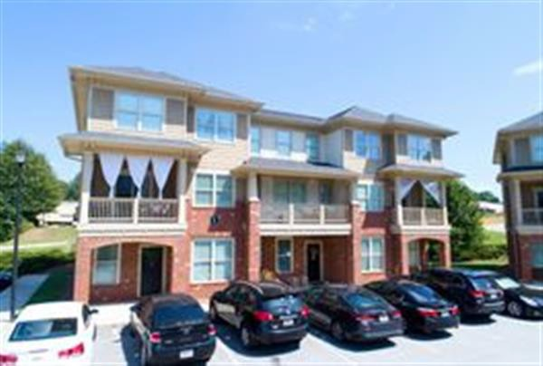
Property Name The Cottages UWG
Address 324 Brumbelow Rd Carrollton, GA 30117 United States
Government Tax Agency Carroll Govt./Tax ID Multiple Unit Mix Detail
Rate Timeframe Monthly
Unit Type No. % Size (sf) Rent Rent / sf 4BR/4.5BA 19 73% 1,400 $2,500 $1.79
6BR/6.5BA 7 27% 1,600 $3,540 $2.21
Totals/Avg 26 $2,780 $1.91

Improvements

Land Area | 4.160 ac | Status | Existing
Gross Building Area (GBA) | 37,800 sf | Year Built | 2013
Total # of Units | 26 Unit | Year Renovated | N/A
Average Unit Size | 1,454 sf | Condition | Good
Floor Count | 3 | Exterior Finish | Vinyl Siding
Property Features On-Site Management, Pitched Roofs, Surface Parking Project Amenities Courtyard, Study Rooms
Unit Amenities Carpeted Flooring, Ceiling Fans, Dishwasher, Hardwood Flooring, Laminate Countertops, Microwave Oven, Private
Patios / Balconies, Range / Oven, Refrigerator, Stainless Steel Appliances, Washer / Dryer

Sale Summary

Recorded Buyer  True Buyer | Carricarte Family  N/A | Marketing Time  Buyer Type | N/A  N/A
Recorded Seller | Soho on Brumbelow / McKinney Builders | Seller Type | N/A
True Seller | James Beveridge | Primary Verification | PSA
Interest Transferred | Leased Fee | Type | Sale
Current Use | Student | Date | 12/29/2023
Proposed Use | N/A | Sale Price | $5,900,000
Listing Broker | Kurt McGarry | Financing | N/A
Selling Broker | Bradley M. Thompson 404-697-7700 | Cash Equivalent | $5,900,000
Doc # | 6212,398 | Capital Adjustment | $0
 |  | Adjusted Price | $5,900,000
Transaction Summary plus Five-Year CBRE View History Transaction Date Transaction Type Buyer Seller Price Cash Equivalent

Units of Comparison
Static Analysis Method | Pro Forma (Stabilized) | Eff Gross Inc Mult (EGIM) | 7.21
Buyer's Primary Analysis | Static Capitalization Analysis | Op Exp Ratio (OER) | 66.24%
Net Initial Yield/Cap. Rate | 6.38% | Adjusted Price / sf | $156.08
Projected IRR | N/A | Adjusted Price / Unit | $226,923
Actual Occupancy at Sale | 99%
Financial
Revenue Type | Pro Forma Stabilized
Period Ending | N/A
Source | Appraiser
Price | $5,900,000
Potential Gross Income | $860,928
Economic Occupancy | 95%
Economic Loss | $43,046
Effective Gross Income | $817,882
Expenses | $541,745
Net Operating Income | $376,137
NOI / sf | $9.95
NOI / Unit | $14,467
EGIM | 7.21
OER | 66.24%
Net Initial Yield/Cap. Rate | 6.38%
Map & Comments
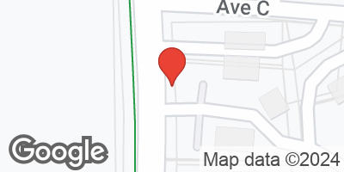
This comparable represents the sale of a 26-unit, 118-bed student-housing apartment property that was built in 2013. The property is located on Brumbelow Road in Carrollton, Georgia. The property features four- and six-bedroom floorplans, with an average unit size of 1,431 square feet. The units are fully furnished. Unit amenities include full size washer and dryers and stainless steel kitchen appliances. The sale occurred in December 2023 for $5,900,000, which equates to $226,923 per unit or $50,000/bed. The sale reflected a 6.38% cap rate. The details of the transaction were verified with the PSA.

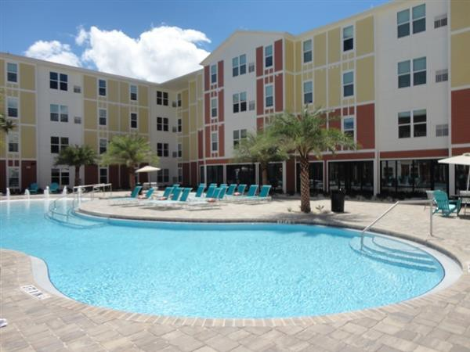
Property Name The Next
Address 10080 Hillview Drive Pensacola, FL 32514 United States
Government Tax Agency Escambia Govt./Tax ID 044423900 Unit Mix Detail
Rate Timeframe  Unit Type | Monthly  No. | % | Size (sf) | Rent | Rent / sf
2BR/2BA | 54 | 33% | 892 | $1,690 | $1.89
3BR/3BA | 1 | 1% | 1,079 | $2,181 | $2.02
4BR/4BA | 110 | 67% | 1,307 | $2,988 | $2.29
Totals/Avg | 165 |  |  | $2,558 | $2.19

Improvements

Land Area | 4.741 ac | Status | Existing
Net Rentable Area (NRA) | 193,017 sf | Year Built | 2016
Total # of Units | 165 Unit | Year Renovated | N/A
Average Unit Size | 1,170 sf | Condition | Good
Floor Count | 3 | Exterior Finish | Stucco
Property Features Attached Garages, Gated / Controlled Access, On-Site Management, Pitched Roofs Project Amenities Business Center, Clubhouse, Cyber Cafe, Fitness Center, Pool
Unit Amenities Dishwasher, Refrigerator, Vaulted / Cathedral Ceilings, Washer / Dryer, Washer / Dryer Connections

Sale Summary
Recorded Buyer WFI UWF II, LLC Marketing Time N/A
True Buyer N/A Buyer Type N/A
Recorded Seller USL Pensacola I, LLC Seller Type N/A
True Seller N/A Primary Verification Jaclyn Fitts - CBRE National Student Housing
Interest Transferred Leased Fee
Type Date Sale Price Financing
Cash Equivalent Capital Adjustment
Adjusted Price
Sale
11/9/2023
$35,750,000
Cash to Seller
$35,750,000
$0
$35,750,000

Current Use Student Housing
Proposed Use Student Housing
Listing Broker Jaclyn Fitts - CBRE National Student Housing Selling Broker N/A
Doc # Book 9067, Page 75

Transaction Summary plus Five-Year CBRE View History Transaction Date Transaction Type Buyer Seller Price Cash Equivalent

Units of Comparison
Static Analysis Method | Pro Forma (Stabilized) | Eff Gross Inc Mult (EGIM) | N/A
Buyer's Primary Analysis | Price and Capitalization Analyses | Op Exp Ratio (OER) | N/A
Net Initial Yield/Cap. Rate | 6.94% | Adjusted Price / sf | $185.22
Projected IRR | N/A | Adjusted Price / Unit | $216,667
Actual Occupancy at Sale | 92%
Financial
Revenue Type | Pro Forma Stabilized
Period Ending N/A
Source Broker
Price $35,750,000
Potential Gross Income N/A
Economic Occupancy N/A
Economic Loss N/A
Effective Gross Income N/A
Expenses N/A
Net Operating Income $2,481,050 NOI / sf $12.85
NOI / Unit $15,037
EGIM N/A
OER N/A
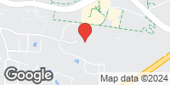
Net Initial Yield/Cap. Rate 6.94%
Map & Comments
This comparable represents a 165 unit, 551 bedroom off campus student housing property with two-, three- and four-bedroom floor plans built in 2016. The property is a luxury student apartment with a comprehensive amenity package within a walkable distance to UWF's campus. Property amenities include a fitness center, zero entry luxury pool with expansive sun deck, game room, courtyard area, clubhouse with leasing offices, tanning salon, business center, air condition hallways and elevators. The unit amenities include a dishwasher, disposal, Formica countertops, stainless steel and faux stainless steel appliances, attached microwave, oven/range, refrigerator, faux wood vinyl plank floors in the kitchen and living room, closets in the bedrooms, washer/dryer, 9-foot ceilings and ceiling fans with light kits in all rooms. Leasing is done on a per bed basis and all units are furnished. Each bedroom is furnished with a bed frame with mattress, desk, chair and dresser. Each living room is furnished with two couches, an end table, lamp, coffee table, TV and TV stand. The property includes 76 garage parking spaces that are tucked underneath a portion of the building. The listing broker indicated that the deal was arms-length and the property was in good overall condition at the time of the sale. The property sold in November 2023 for $35,750,000 or $64,882 per bed. Based upon data provided by the listing broker and inclusive of reserves, the resulting cap rate equates to 6.94%.

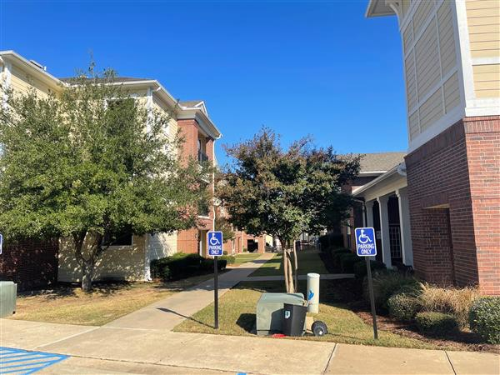
Property Name CEV Ruston
Address 1812 W Alabama Ave Ruston, LA 71270 United States
Government Tax Agency Lincoln Govt./Tax ID 22183005025

Unit Mix Detail
Rate Timeframe Monthly
Unit Type No. % Size (sf) Rent Rent / sf 2BR/2BA 24 20% 976 $1,390 $1.42
4BR/2BA 96 80% 1,252 $1,860 $1.49
Totals/Avg 120 $1,766 $1.48

Improvements

Land Area | 9.920 ac | Status | Existing
Net Rentable Area (NRA) | 143,616 sf | Year Built | 2008
Total # of Units | 120 Unit | Year Renovated | N/A
Average Unit Size | 1,197 sf | Condition | Average
Floor Count | 3 | Exterior Finish | Brick Veneer
Property Features Exterior Stairwells, Fire Sprinklered, Individual Split Systems, On-Site Management, Pitched Roofs, Surface Parking Project Amenities Billiards, Business Center, Clubhouse, Cyber Cafe, Fitness Center, Game Room, Pool
Unit Amenities 9-Foot Ceilings, Carpeted Flooring, Dishwasher, Furnished Units, Garbage Disposal, Laminate Countertops,
Microwave Oven, Range / Oven, Refrigerator with Icemaker, Vinyl Flooring, Washer / Dryer, White / Beige Appliances

Sale Summary
Recorded Buyer BMC Ruston, LLC Marketing Time 1 Month(s)
True Buyer BMC Ruston, LLC Buyer Type Private Investor
Recorded Seller CEV Ruston, L.P. Seller Type Private Investor
True Seller CEV Ruston, L.P. Primary Verification PSA
Interest Transferred Leased Fee
Type Date Sale Price Financing
Cash Equivalent Capital Adjustment
Adjusted Price
Sale
12/16/2022
$14,150,000
Market Rate Financing
$14,150,000
$853,000
$15,003,000

Current Use Student Housing
Proposed Use Student Housing
Listing Broker N/A
Selling Broker N/A
Doc # 207733

Transaction Summary plus Five-Year CBRE View History Transaction Date Transaction Type Buyer Seller Price Cash Equivalent

Units of Comparison
Static Analysis Method | Pro Forma (Stabilized) | Eff Gross Inc Mult (EGIM) | 6.05
Buyer's Primary Analysis | Static Capitalization Analysis | Op Exp Ratio (OER) | 55.23%
Net Initial Yield/Cap. Rate | 7.40% | Adjusted Price / sf | $104.47
Projected IRR | N/A | Adjusted Price / Unit | $125,025
Actual Occupancy at Sale | 71%
Financial
Revenue Type | Pro Forma Stabilized
Period Ending 9/2/2024
Source Appraiser
Price $15,003,000
Potential Gross Income $2,543,040
Economic Occupancy 90% Economic Loss $254,304
Effective Gross Income $2,479,274
Expenses $1,369,299
Net Operating Income $1,109,975 NOI / sf $7.73
NOI / Unit $9,250
EGIM 6.05
OER 55.23%
Net Initial Yield/Cap. Rate 7.40%
Map & Comments
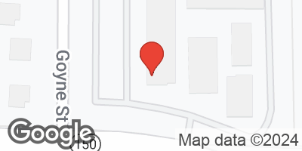
The property is a 120-unit, 432-bed student housing property located at 1812 W Alabama Avenue in Ruston, Louisiana. The property is marketed toward the approximately 11,000 students attending Louisiana Tech University. Enrollment has declined by about 12% over the past 5-years. The property was 70.6% occupied at the time of sale. The property has a 3.60 bed per unit ratio. The property is under contract for $14,150,000 or $117,917 price per unit and $32,755 price per bed. The buyer has a capital improvement budget of $505,596 which includes new granite countertops and stainless-steel appliances in 78 units. In addition, the capital improvement budget will be used to restore all downed units (5 flooded units, 11 downed units needing appliances or furniture and 3 units being used as storage). The capital improvements are scheduled to be completed in May 2023 according to the buyer. The capital adjustment reflects the lease-up cost to achieve a stabilized occupancy. The effective purchase price is
$15,003,000 or $34,729 per bed. Based on the buyer's pro forma, this transaction reveals an overall capitalization rate of 7.40%.

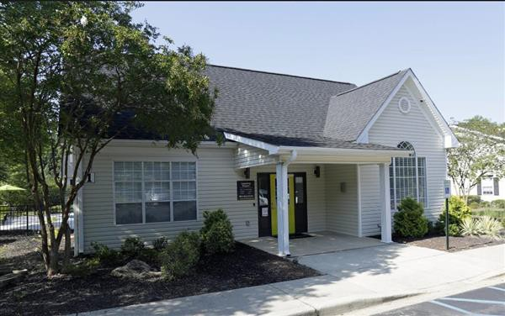
Property Name The Enclave at Clemson
Address 423 Lindsay Road & 1146 Old Central Road Clemson, SC 29630
United States
Government Tax Agency Pickens Govt./Tax ID Multiple Unit Mix Detail
Rate Timeframe  Unit Type | Monthly  No. | % | Size (sf) | Rent | Rent / sf
2BR/1BA Designer - IT | 12 | 8% | 805 | $1,120 | $1.39
2BR/1BA Designer - OC  2BR/1BA Premium - IT | 15  16 | 10%  11% | 805  805 | $1,100  $1,070 | $1.37  $1.33
2BR/1BA Premium - OC  3BR/2BA Designer - IT | 13  17 | 9%  12% | 805  1,141 | $1,050  $1,320 | $1.30  $1.16
3BR/2BA Designer - OC  3BR/2BA Premium - IT | 23  25 | 16%  17% | 1,141  1,141 | $1,290  $1,245 | $1.13  $1.09
3BR/2BA Premium - | 25 | 17% | 1,141 | $1,215 | $1.06
OC
Totals/Avg | 146 | $1,194 |  |  | $1.18
Improvements
Land Area | 32.227 ac |  |  |  | Status | Existing
Net Rentable Area (NRA) | 147,770 sf |  |  |  | Year Built | 1998
Total # of Units | 146 Unit |  |  |  | Year Renovated | N/A
Average Unit Size | 1,012 sf |  |  |  | Condition | Average
Floor Count | 4 |  |  |  | Exterior Finish | Vinyl Siding
Property Features | Surface Parking
Project Amenities | Clubhouse, Dog Park / Run, Fitness Center, Pool
Unit Amenities Dishwasher, Microwave Oven, Plank Flooring, Range / Oven, Refrigerator

Sale Summary

Recorded Buyer  True Buyer | PEP-Clemson I, LLC and PEP-Clemson II, LLC  Pierce Educational Properties | Marketing Time  Buyer Type | N/A  N/A
Recorded Seller | Centerlane-Burkely Clemson LLC | Seller Type | N/A
True Seller | Burkely Communities | Primary Verification | N/A
Interest Transferred | Leased Fee | Type | Sale
Current Use | Student Housing | Date | 8/26/2022
Proposed Use | N/A | Sale Price | $24,749,000
Listing Broker | N/A | Financing | Market Rate Financing
Selling Broker | Teddy Laatherman with JLL | Cash Equivalent | $24,749,000
Doc # | 2444-278 | Capital Adjustment | $0
 |  | Adjusted Price | $24,749,000
Transaction Summary plus Five-Year CBRE View History Transaction Date Transaction Type Buyer Seller Price Cash Equivalent

Units of Comparison
Static Analysis Method | Pro Forma (Stabilized) | Eff Gross Inc Mult (EGIM) | N/A
Buyer's Primary Analysis | Static Capitalization Analysis | Op Exp Ratio (OER) | N/A
Net Initial Yield/Cap. Rate | 4.85% | Adjusted Price / sf | $167.48
Projected IRR | N/A | Adjusted Price / Unit | $169,514
Actual Occupancy at Sale | 100%
Financial
Revenue Type | Pro Forma Stabilized
Period Ending | N/A
Source | N/A
Price | $24,749,000
Potential Gross Income | N/A
Economic Occupancy | N/A
Economic Loss | N/A
Effective Gross Income | N/A
Expenses | N/A
Net Operating Income | $1,200,327
NOI / sf | $8.12
NOI / Unit | $8,221
EGIM | N/A
OER | N/A
Net Initial Yield/Cap. Rate | 4.85%
Map & Comments
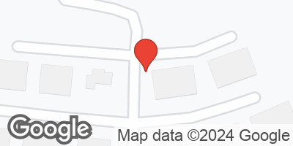
This comparable represents the sale of a 146-unit / 403-bed garden-style student oriented apartment property that was built in 1998. The property is located in Central, SC and services Clemson University. Property amenities include a pool, clubhouse, dog park, and fitness center. Units include a balcony, washer and dryer and plank vinyl throughout. The property offers two- and three- bedroom units. The property sold in August 2022 for $24,749,000, which equates to $169,5114 per unit and $61,412 per bed. The sale reflected a 4.85% capitalization rate based on buyer's year 1 pro forma and adjusting for SC tax law.

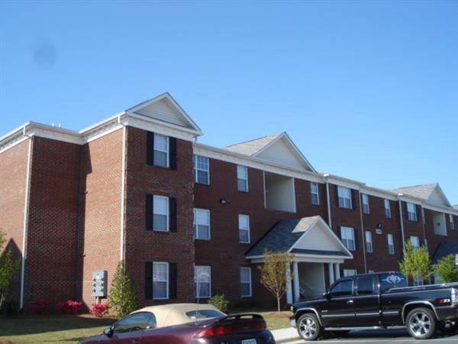
Property Name Residences at Greenville
Address 3800 Bostic Drive Greenville, NC 27834 United States
Government Tax Agency Pitt
Govt./Tax ID 064354 & 072914

Unit Mix Detail

Rate Timeframe  Unit Type | Monthly  No. | % | Size (sf) | Rent | Rent / sf
2BD/2BA | 40 | 28% | 980 | N/A | N/A
3BD/3BA | 64 | 44% | 1,188 | N/A | N/A
4BD/4BA | 40 | 28% | 1,440 | N/A | N/A
Totals/Avg | 144 |  |  | $0 | $0.00

Improvements

Land Area | 40.380 ac | Status | Existing
Net Rentable Area (NRA) | 172,832 sf | Year Built | 2006
Total # of Units | 144 Unit | Year Renovated | 2007
Average Unit Size | 1,200 sf | Condition | Average
Floor Count | 3 | Exterior Finish | Brick Veneer
Property Features | Surface Parking

Project Amenities Basketball Court, Billiards, Clubhouse, Dog Park / Run, Fitness Center, Pool
Unit Amenities Black Appliances, Dishwasher, Furnished Units, Microwave Oven, Range / Oven, Refrigerator, Washer / Dryer

Sale Summary
Captain Quart APTS LLC c/o Arbor Realty
Recorded Buyer Trust, Inc. Marketing Time N/A
True Buyer N/A Buyer Type N/A

Recorded Seller Captains United LLC c/o Arbor Realty Trust,
Inc.
True Seller FM Capital, Gottlieb Family Partnership, and AMAC Holdings
Interest Transferred Leased Fee
Current Use Student Housing
Proposed Use N/A
Listing Broker Steven Vegh (Westwood Realty Associates)
Selling Broker N/A
Doc # 4280-598
Seller Type N/A
Primary Verification CoStar - Reached out to Listing Broker
(No Response)
Type Date Sale Price Financing
Cash Equivalent Capital Adjustment
Adjusted Price
Sale
5/4/2022
$11,020,630
Other(See Comments)
$11,020,630
$0
$11,020,630

Transaction Summary plus Five-Year CBRE View History Transaction Date Transaction Type Buyer Seller Price Cash Equivalent
Price/unit and /sf

05/2022 | Sale | Captain Quart APTS LLC c/o Arbor Realty Trust,  Inc. | Captains United LLC c/o Arbor Realty Trust, Inc. | $11,020,630 | $76,532 / $63.76

Units of Comparison
Static Analysis Method | Other (see comments) | Eff Gross Inc Mult (EGIM) | N/A
Buyer's Primary Analysis | Static and Yield Capitalization Analyses | Op Exp Ratio (OER) | N/A
Net Initial Yield/Cap. Rate | 6.81% | Adjusted Price / sf | $63.76
Projected IRR | N/A | Adjusted Price / Unit | $76,532
Actual Occupancy at Sale | 64%
Financial
Revenue Type | Other See Comments
Period Ending | N/A
Source | N/A
Price | $11,020,630
Potential Gross Income | N/A
Economic Occupancy | N/A
Economic Loss | N/A
Effective Gross Income | N/A
Expenses | N/A
Net Operating Income | $751,031
NOI / sf | $4.35
NOI / Unit | $5,215
EGIM | N/A
OER | N/A
Net Initial Yield/Cap. Rate | 6.81%
Map & Comments
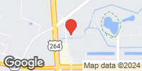
This comparable is a 144-unit/432-bed student-purpose property located at 3800 Bostic Drive in Greenville, North Carolina. The improvements were constructed in 2005 and offer two-, three-, and four-bedroom units with an average unit size of 1,200 square feet. The property is one of two in a portfolio sale that totaled $51,000,000 and sold at a reported cap rate of 6.81% on May 4, 2022.
According to public record, this comparable had an allocated purchase price of $11,020,630, or $25,510 per bed. Several unsuccessful attempts were made to confirm the data with the listing broker. According to CoStar data, the property was approximately 35.8% vacant on May 4, 2022.

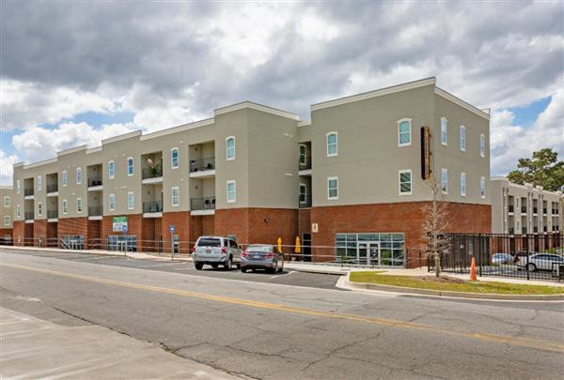
Property Name Remerton Mill Apartments
Address 1853 W Gordon St Valdosta, GA 31601 United States
Government Tax Agency Lowndes Govt./Tax ID N/A Unit Mix Detail
Rate Timeframe  Unit Type | Monthly  No. | % | Size (sf) | Rent | Rent / sf
2BR/2BA | 64 | 33% | 785 | N/A | N/A
1BR/1BA | 24 | 12% | 884 | N/A | N/A
1BR/1BA | 16 | 8% | 1,000 | N/A | N/A
2BR/2BA | 60 | 31% | 1,178 | N/A | N/A
3BR/3BA | 30 | 15% | 1,345 | N/A | N/A
Totals/Avg | 194 |  |  | $0 | $0.00

Improvements

Land Area | 5.450 ac | Status | Existing
Net Rentable Area (NRA) | 198,486 sf | Year Built | 2019
Total # of Units | 194 Unit | Year Renovated | N/A
Average Unit Size | 1,023 sf | Condition | Good
Floor Count | 3 | Exterior Finish | Brick Veneer
Property Features | Flat Roofs, On-Site Management, Surface Parking

Project Amenities Barbeque Area, Clubhouse, Cyber Cafe, Dog Park / Run, Fitness Center, Pool
Unit Amenities Black Appliances, Ceiling Fans, Dishwasher, Furnished Units, Garbage Disposal, Granite Countertops, Microwave Oven, Private Patios / Balconies, Range / Oven, Refrigerator, Vinyl Flooring, Washer / Dryer

Sale Summary
Recorded Buyer Recycle Realty LLC Marketing Time N/A
True Buyer TMC Property Holdings Buyer Type N/A
Recorded Seller RM Apartments LLC Seller Type N/A
True Seller Mandeep Singh Primary Verification John Brigel - Marcus & Millichap
Interest Transferred Leased Fee
Type Date Sale Price Financing
Cash Equivalent Capital Adjustment
Adjusted Price
Sale
3/31/2022
$17,200,000
Market Rate Financing
$17,200,000
$0
$17,200,000

Current Use Student Housing
Proposed Use N/A
Listing Broker John Brigel - Marcus & Millichap
Selling Broker N/A
Doc # 092-2022-001370

Transaction Summary plus Five-Year CBRE View History Transaction Date Transaction Type Buyer Seller Price Cash Equivalent
Price/unit and /sf

03/2022 | Sale | Recycle Realty LLC | RM Apartments LLC | $17,200,000 | $88,660 / $86.66

Units of Comparison
Static Analysis Method Trailing Actuals Eff Gross Inc Mult (EGIM) N/A Buyer's Primary Analysis Static and Yield Capitalization Analyses Op Exp Ratio (OER) N/A Net Initial Yield/Cap. Rate 6.14% Adjusted Price / sf $86.66
Projected IRR N/A Adjusted Price / Unit $88,660 Actual Occupancy at Sale 96%
Financial

Revenue Type | Trailing Actuals | Other See Comments
Period Ending | N/A | N/A
Source | N/A | Other(See Comments)
Price | $17,200,000 | $17,200,000
Potential Gross Income | N/A | N/A
Economic Occupancy | N/A | N/A
Economic Loss | N/A | N/A
Effective Gross Income | N/A | N/A
Expenses | N/A | N/A
Net Operating Income | $1,056,320 | $956,320
NOI / sf | $5.32 | $4.82
NOI / Unit | $5,445 | $4,929
EGIM | N/A | N/A
OER | N/A | N/A
Net Initial Yield/Cap. Rate | 6.14% | 5.56%
Map & Comments

Remerton Mills Apartments, 194-unit/378-bed student housing community located at 1853 West Gordon Street in Valdosta, Georgia sold on March 31st, 2022 for $17,200,000, or $45,502 per bed. This class A multifamily building, delivered in 2019, features a unit mix of one-to-three-bedroom fully-furnished units ranging from 785 to 1,345 square feet. The percent leased was reported as 95.6% as of April 2022. This is an up-leg of a 1031 exchange for the buyer who declined to disclose the down-leg of the exchange.
The buyer also stated he purchased land and LLC as part of the transaction however the information was not corroborated with both parties. The seller's representative reported a $1,056,32 net operating income yielding a 5.56% capitalization rate.

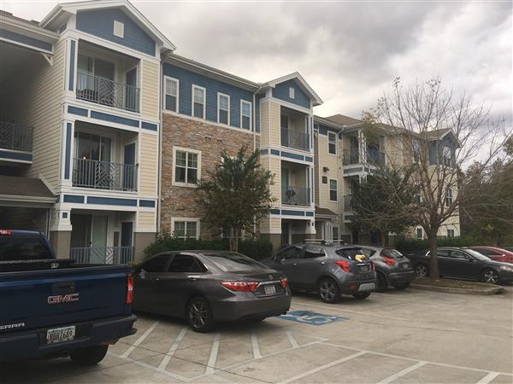
Property Name The Hudson
Address 831 South Main Street Statesboro, GA 30458 United States
Government Tax Agency N/A
Govt./Tax ID MS42000011 002

Unit Mix Detail

Rate Timeframe  Unit Type | Monthly  No. | % | Size (sf) | Rent | Rent / sf
Studio | 36 | 12% | 556 | $904 | $1.63
1BR/1BA | 60 | 20% | 620 | $934 | $1.51
2BR/2BA | 36 | 12% | 876 | $1,258 | $1.44
3BR/3BA | 60 | 20% | 1,182 | $1,587 | $1.34
4BR/4BA | 108 | 36% | 1,393 | $1,956 | $1.40
Totals/Avg | 300 |  |  | $1,468 | $1.42

Improvements

Land Area | 39.630 ac | Status | Existing
Net Rentable Area (NRA) | 310,116 sf | Year Built | 2012
Total # of Units | 300 Unit | Year Renovated | N/A
Average Unit Size | 1,034 sf | Condition | Good
Floor Count | 3 | Exterior Finish | Vinyl Siding
Property Features Gated / Controlled Access, Individual Split Systems, On-Site Management, Pitched Roofs, Surface Parking
Project Amenities Barbeque Area, Basketball Court, Business Center, Car Wash Facility, Clubhouse, Cyber Cafe, Dog Park / Run, Fitness Center, Game Room, Pool, Tanning Bed, Theater, Volleyball Court
Unit Amenities Black Appliances, Carpeted Flooring, Ceiling Fans, Dishwasher, Furnished Units, Garbage Disposal, Laminate Countertops, Microwave Oven, Plank Flooring, Private Patios / Balconies, Range / Oven, Refrigerator, Washer / Dryer

Sale Summary
Recorded Buyer Confidential Marketing Time N/A
True Buyer Confidential Buyer Type Corporation Recorded Seller Vesper Forum at Statesboro, LLC Seller Type Corporation
True Seller Vesper Forum at Statesboro, LLC Primary Verification Appraised for the sale
Interest Transferred Leased Fee
Type Date Sale Price Financing
Cash Equivalent Capital Adjustment
Adjusted Price
Sale
1/24/2022
$41,700,000
Cash to Seller
$41,700,000
$0
$41,700,000

Current Use Student Housing
Proposed Use Student Housing
Listing Broker N/A
Selling Broker N/A
Doc # N/A

Transaction Summary plus Five-Year CBRE View History Transaction Date Transaction Type Buyer Seller Price Cash Equivalent
Price/unit and /sf

01/2022 | Sale | Confidential | Vesper Forum at  Statesboro, LLC | $41,700,000 | $139,000 / $134.47

Units of Comparison
Static Analysis Method | Trailing Actuals | Eff Gross Inc Mult (EGIM) | 8.13
Buyer's Primary Analysis | Static Capitalization Analysis | Op Exp Ratio (OER) | 53.32%
Net Initial Yield/Cap. Rate | 5.74% | Adjusted Price / sf | $134.47
Projected IRR | N/A | Adjusted Price / Unit | $139,000
Actual Occupancy at Sale | 99%
Financial
Revenue Type | Trailing Actuals
Period Ending 9/30/2021
Source Owner/User
Price $41,700,000
Potential Gross Income $5,202,720
Economic Occupancy N/A
Economic Loss N/A
Effective Gross Income $5,131,141
Expenses $2,735,715
Net Operating Income $2,395,426 NOI / sf $7.72
NOI / Unit $7,985
EGIM 8.13
OER 53.32%
Net Initial Yield/Cap. Rate 5.74%
Map & Comments
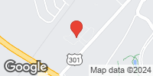
This comparable represents the sale of a 300-unit, 780-bed, student housing apartment property located on South Main Street in Statesboro, Georgia near the Georgia Southern campus. The property was built in 2012 and offers studio-, one-, two-, three-, and four-bedroom floor plans, with an average unit size of 1,034 square feet. The apartment units are rented on a furnished basis with a package that includes living room furniture (couch, chair, coffee table, entertainment center, and barstools), bedroom furniture (a mattress and bed frame, chest of drawers, nightstand and desk with chair), and washer/dryer machines. The project amenities include a clubhouse with on-site management, swimming pool, business center, coffee bar, game room, fitness center, grill areas, tanning bed, sand volleyball court, car care center, and gated entrances. The property sold for $41,700,000, or $53,462 per bed on January 24, 2022. The sale price implies a cap rate of 5.74% based on T-3 income and T-12 expenses, adjusted for taxes at 80% of purchase price and reserves of $125 per unit. The property was 98.7% occupied at the time of contract.

Addenda

Addendum B

RENT COMPARABLE DATA SHEETS

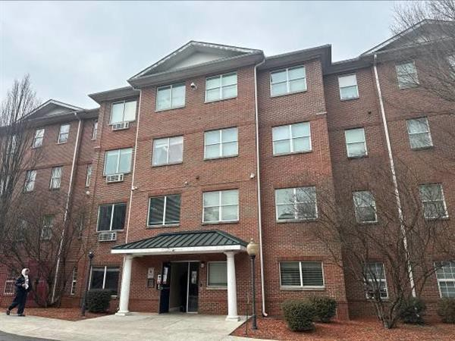
Property Name CAU Suites
Address 128 Mildred Street SW Atlanta, GA 30314 United States
Government Tax Agency Fulton Govt./Tax ID Multiple Unit Mix Detail
Rate Timeframe  Unit Type | Monthly  No. | % | Size (sf) | Rent | Rent / sf
1BD/1BA | 2 | 1% | 450 | $925 | $2.06
2BD/1BA | 16 | 10% | 450 | $1,240 | $2.76
4BD/1BA | 14 | 9% | 600 | $576 | $0.96
4BD/1BA | 127 | 80% | 600 | $576 | $0.96
Totals/Avg | 159 |  |  | $647 | $1.11

Improvements

Land Area | 2.080 ac | Status | Existing
Net Rentable Area (NRA) | 92,700 sf | Year Built | 2005
Total # of Units | 159 Unit | Year Renovated | N/A
Average Unit Size | 583 sf | Condition | Average
Floor Count | 4 | Exterior Finish | Brick
Property Features | Elevators
Project Amenities | Fitness Center, Study Rooms
Unit Amenities | Vinyl Flooring
Rental Survey
Occupancy | 86% | Utilities Included in Rent | All included
Lease Term | 6 - 12 Mo(s). | Rent Premiums | N/A
Tenant Profile | Student Housing | Concessions | None
Survey Date | 08/2024 | Owner | N/A
Survey Notes | N/A | Management | N/A

Map & Comments
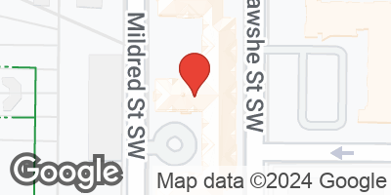
This comparable represents a 159-unit, 598-bed on-campus student-housing property located at 128 Mildred Street SW in Atlanta, Georgia. The property consists of 2 four-story apartment buildings. The improvements were constructed in 2005 and are situated on a 2.08-acre site. The improvements were quoted to be 86% occupied going into the 2024 fall semester. The building currently exclusively serves Clark Atlanta University and is renting its units to students on a per-bed basis. The subject improvements consist of dormitory buildings mostly comprised of dorm rooms (with no kitchen) and study rooms on each floor. The ground floors include a lounge area, laundry room and offices. One of the buildings contains a fitness center. All bedrooms are furnished with a bed, dresser, nightstand, and desk.

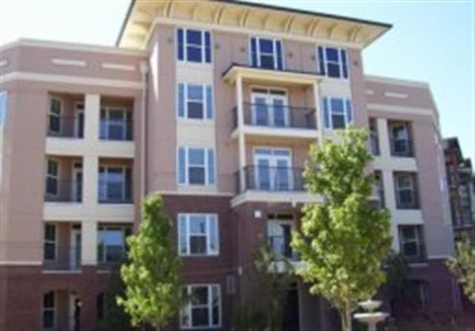
Property Name Camden Vantage
Address 180 Jackson Street NE Atlanta, GA 30312 United States
Government Tax Agency Fulton
Govt./Tax ID 14 -0046-0007-102-4

Unit Mix Detail

Rate Timeframe  Unit Type | Monthly  No. | % | Size (sf) | Rent | Rent / sf
Studio | 107 | 18% | 656 | $1,299 | $1.98
1BR/1BA | 116 | 20% | 756 | $1,589 | $2.10
1BR/1BA | 71 | 12% | 831 | $1,469-$1,549 | $1.82
1BR/1BA | 47 | 8% | 843 | $1,439 | $1.71
1BR/1BA | 20 | 3% | 845 | $1,599 | $1.89
1BR/1BA | 20 | 3% | 884 | $1,509 | $1.71
2BR/2BA | 49 | 8% | 1,046 | $1,549 | $1.48
2BR/2BA | 65 | 11% | 1,149 | $1,729 | $1.50
2BR/2BA | 60 | 10% | 1,152 | $1,799 | $1.56
2BR/2BA | 37 | 6% | 1,277 | $1,919 | $1.50
Totals/Avg | 592 |  |  | $1,567 | $1.74
Improvements
Land Area | 9.600 ac |  | Status |  |  | Existing
Net Rentable Area (NRA) | 533,398 sf |  | Year Built |  |  | 2009
Total # of Units | 592 Unit |  | Year Renovated |  |  | N/A
Average Unit Size | 901 sf |  | Condition |  |  | Good
Floor Count | 5 |  | Exterior Finish |  |  | Brick Veneer
Property Features Flat Roofs, Gated / Controlled Access, Structured Parking, Surface Parking
Project Amenities Business Center, Clubhouse, Courtyard, Cyber Cafe, Dog Park / Run, Fitness Center, Outdoor Fireplace, Pool, Roof Deck / Terrace
Unit Amenities Black Appliances, Carpeted Flooring, Ceiling Fans, Dishwasher, Garbage Disposal, Gourmet Kitchen, Microwave Oven, Private Patios / Balconies, Quartz Countertops, Range / Oven, Refrigerator, Stainless Steel Appliances, Tile Backsplash, Tub / Shower Combo, Vinyl Flooring, Washer / Dryer, Washer / Dryer Connections

Rental Survey

Occupancy | 93% | Utilities Included in Rent | None
Lease Term | 12 Mo(s). | Rent Premiums | Storage - $65-$75
Tenant Profile | Middle Income Groups | Concessions | None
Survey Date | 08/2024 | Owner | N/A
Survey Notes | 2023 Appraised Value = $54,862,200 | Management | Camden Properties

Map & Comments
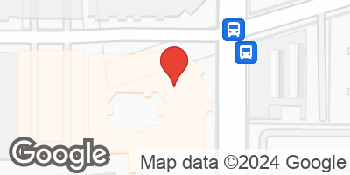
This comparable represents a 592-unit mid-rise apartment property, located along Jackson Street in Midtown Atlanta. The property, identified as Camden Vantage, was developed in 2009 and is currently 100% occupied. The comparable offers studio, one-, and two-bedroom floor plans, with an average unit size of 901 square feet. Interiors feature gray cabinets and white quartz countertops, white subway tile backsplashes, USB outlets, walk-in closets, hardwood-style flooring and full-size washers and dryers.
There is a one-time parking fee of $100. Storage units are available for lease at $65 - $75 per month. Management employs a RUBS for reimbursement of water and sewer. Resident pays $35 per month for valet trash and $2 per month for pest control. No concessions are currently being offered. Reserved parking is available for $50 per month.

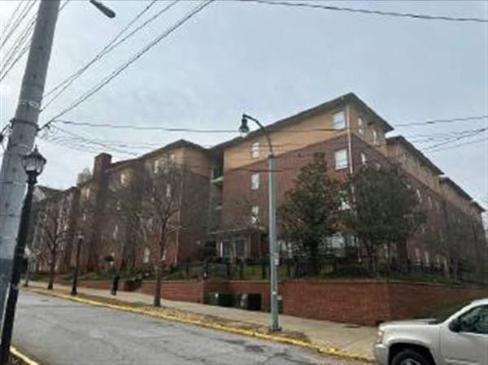
Property Name Heritage Commons
Address 15 James P Brawley Drive Atlanta, GA 30314 United States
Government Tax Agency Fulton Govt./Tax ID Multiple Unit Mix Detail
Rate Timeframe  Unit Type | Monthly  No. | % | Size (sf) | Rent | Rent / sf
1BD/1BA | 1 | 1% | 600 | $931 | $1.55
2BD/2BA | 27 | 21% | 600 | $1,862 | $3.10
4BD/2BA | 100 | 78% | 900 | $2,883 | $3.20
Totals/Avg | 128 |  |  | $2,652 | $3.18

Improvements

Land Area | 3.760 ac | Status | Existing
Net Rentable Area (NRA) | 106,800 sf | Year Built | 2001
Total # of Units | 128 Unit | Year Renovated | N/A
Average Unit Size | 834 sf | Condition | Average
Floor Count | 4 | Exterior Finish | Brick
Property Features | N/A

Project Amenities Barbeque Area, Courtyard, Fitness Center
Unit Amenities Dishwasher, Laminate Countertops, Microwave Oven, Range / Oven, Refrigerator, Vinyl Flooring, White / Beige Appliances

Rental Survey

Occupancy | 85% | Utilities Included in Rent | Electric, W/S, Internet
Lease Term | 12 Mo(s). | Rent Premiums | None
Tenant Profile | Students | Concessions | None
Survey Date | 08/2024 | Owner | N/A
Survey Notes | N/A | Management | N/A

Map & Comments
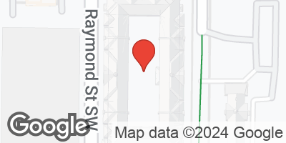
This comparable is a 128-unit, 455-bed multi-family garden style student-oriented property located at 15 James P Brawley Drive in Atlanta, Georgia. The property consists of 1 four-story residential building and 1 two-story parking garage. The improvements were constructed in 2001 and are situated on a 3.76-acre site. The improvements were 85.1% leased as of the survey and considered stabilized. The subject is student-oriented housing servicing Clark Atlanta University renting on a per-bed basis. All bedrooms are furnished with a bed, dresser, nightstand, and desk. Each unit is furnished with a couch, coffee table, kitchen table, and chairs.

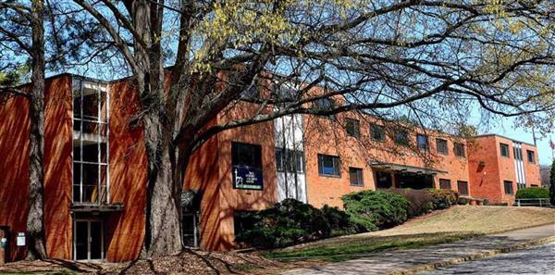
Property Name Gammon Theological Seminary
Address 653 Beckwith Street SW. Atlanta, GA 30314 United States
Government Tax Agency Fulton Govt./Tax ID 14 0109 LL0101

Unit Mix Detail

Rate Timeframe  Unit Type | Monthly  No. | % | Size (sf) | Rent | Rent / sf
1BR/1BA - Dorm | 30 | 38% | 300 | $1,014 | $3.38
1BR/1BA - Apartment | 20 | 25% | 350 | $1,054 | $3.01
Suite  2BR/1BA - Dorm | 30 | 38% | 350 | $866 | $2.47
Totals/Avg | 80 |  |  | $969 | $2.92

Improvements

Land Area | 0.484 ac | Status | Existing
Net Rentable Area (NRA) | N/A | Year Built | 1989
Total # of Units | 80 Unit | Year Renovated | N/A
Average Unit Size | 331 sf | Condition | Average
Floor Count | 3 | Exterior Finish | Brick
Property Features | N/A
Project Amenities | N/A
Unit Amenities | N/A
Rental Survey
Occupancy | 85% | Utilities Included in Rent | All Expenses Included
Lease Term | 6 - 12 Mo(s). | Rent Premiums | N/A
Tenant Profile | Student Housing | Concessions | None
Survey Date | 08/2024 | Owner | N/A
Survey Notes | N/A | Management | N/A

Map & Comments
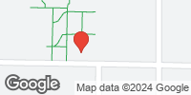
The comparable represents a seminary school/dormitory property known as the Gammon Theological Seminary located at 653 Beckwith Street SW. in downtown west Atlanta, Georgia. The improvements are situated on the Interdenominational Theological Center campus that is in collaboration with the Atlanta University Center Consortium, which offers graduate level and PhD's to students studying theology. The building is three stories and features classrooms, a chapel, common areas, etc., on the first floor and the top two floors offer a mix of residential units for on-campus living students. The residential portion features 80 rental units/110-beds. The unit mix is comprised of single-dorms and shared dorms with communal restrooms/showers, and efficiency unit suites with private bathrooms. The units are all furnished. The units are rented on a semester basis or annual basis. A representative of the seminary quoted the building to be approximately 85% leased for the 2024 fall semester.

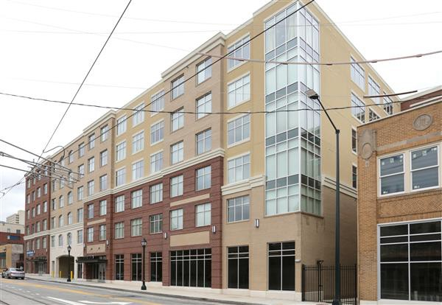
Property Name 200 Edgewood
Address 200 Edgewood Avenue Atlanta, GA 30303 United States
Government Tax Agency Fulton
Govt./Tax ID 14 005100120864

Unit Mix Detail

Rate Timeframe  Unit Type | Monthly  No. | % | Size (sf) | Rent | Rent / sf
Studio (S1) | 4 | 3% | 418 | $1,499 | $3.59
Studio (S2) | 5 | 3% | 421 | $1,499 | $3.56
1BR/1BA (A1) | 20 | 14% | 540 | $1,625 | $3.01
1BR/1BA (A2) | 5 | 3% | 586 | $1,645 | $2.81
2BR/2BA (B1) | 75 | 52% | 812 | $2,198 | $2.71
2BR/2BA (B2) | 35 | 24% | 834 | $2,198 | $2.64
Totals/Avg | 144 |  |  | $2,056 | $2.75

Improvements

Land Area | 1.214 ac | Status | Existing
Gross Building Area (GBA) | 204,115 sf | Year Built | 2016
Total # of Units | 144 Unit | Year Renovated | N/A
Average Unit Size | 747 sf | Condition | Average
Floor Count | 6 | Exterior Finish | Masonry
Property Features Elevators, Flat Roofs, Gated / Controlled Access, Ground-level Retail, Individual Split Systems, On-Site Management, Structured Parking
Project Amenities Business Center, Clubhouse, Courtyard, Fitness Center, Study Rooms
Unit Amenities 10-Foot Ceilings, Black Appliances, Ceiling Fans, Dishwasher, Double-Pane Windows, Furnished Units, Gourmet Kitchen, Granite Countertops, Microwave Oven, Range / Oven, Refrigerator, Tub / Shower Combo, Vinyl Flooring, Washer / Dryer, Washer / Dryer Connections

Rental Survey

Occupancy Lease Term  Tenant Profile | 90%  12 Mo(s).  Students | Utilities Included in Rent Rent Premiums  Concessions | Water, Sewer, Gas & Trash Removal None  See Comments
Survey Date | 08/2024 | Owner | SQ Georgia State I, LLC
Survey Notes | N/A | Management | Caliber Living

Map & Comments
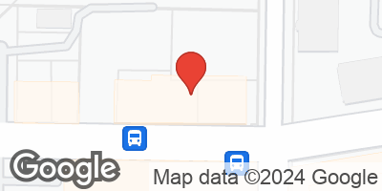
This comparable is a 144-unit, 254-bedroom off-campus student housing property located in the northwest corner of Edgewood Avenue and Jesse Hill Junior Drive. The property is identified as 200 Edgewood. It is located within walking distance to Georgia State University, and tends to draw most of its demand from the university's undergraduates. The property is located on the downtown streetcar line and is also in close proximity to Grady/Children's Hospital. The property offers studio, 1, and 2 bedroom floor plans. Leases are signed by the room. Community amenities include a gym, study lounges, and meeting rooms, as well as a clubroom and coffee bar. Additionally, the property features ground-floor retail. All units are leased on a fully furnished basis and feature fully-equipped kitchens with granite countertops. Utilities included in rent are water/sewer, cable, and trash removal. Electricity is sub-metered for usage with the tenant responsible for usage. Garages are available for rent at an additional monthly charge of $150. Deck parking is $125 per month for reserved. The property is not currently offering any concessions. The property is currently 7% pre-leased for the fall 2024 school year.

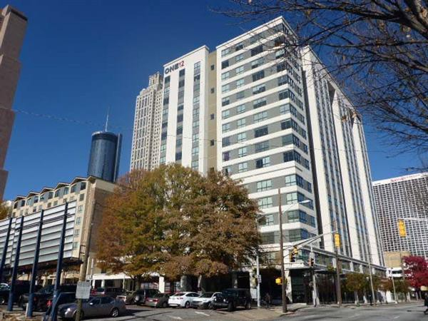
Property Name One12 Courtland
Address 112 Courtland Street, NE Atlanta, GA 30303 United States
Government Tax Agency Fulton
Govt./Tax ID 14 005100080118

Unit Mix Detail

Rate Timeframe  Unit Type | Monthly  No. | % | Size (sf) | Rent | Rent / sf
1BR/1BA | 55 | 22% | 533 | $1,410 | $2.65
2BR/1BA | 13 | 5% | 614 | $1,890 | $3.08
2BR/2BA | 49 | 19% | 852 | $2,110 | $2.48
4BR/2BA | 28 | 11% | 1,050 | $3,600 | $3.43
3BR/3BA | 10 | 4% | 1,208 | $2,850 | $2.36
4BR/4BA | 99 | 39% | 1,476 | $3,956 | $2.68
Totals/Avg | 254 |  |  | $2,860 | $2.72

Improvements

Land Area | 1.470 ac | Status | Existing
Net Rentable Area (NRA) | 269,506 sf | Year Built | 2014
Total # of Units | 254 Unit | Year Renovated | N/A
Average Unit Size | 1,061 sf | Condition | Good
Floor Count | 16 | Exterior Finish | Composite
Property Features | On-Site Management, Structured Parking

Project Amenities Barbeque Area, Business Center, Clubhouse, Concierge, Cyber Cafe, Fitness Center, Tanning Bed, Theater
Unit Amenities Dishwasher, Garbage Disposal, Gourmet Kitchen, Granite Countertops, Microwave Oven, Range / Oven, Refrigerator, Washer / Dryer

Rental Survey
Water, Sewer, Trash, Cable, Electricity,
Occupancy 96% Utilities Included in Rent Internet
Lease Term 12 Mo(s). Rent Premiums $15 for Floors 15-16
Tenant Profile Students Concessions None
Survey Date 08/2024 Owner N/A
Survey Notes Property Contact: 404-584-2464 Management Asset Campus Housing

Map & Comments

This property is a 254-unit, 717-bed off-campus student housing property that represents the adaptive reuse conversion of a former Ramada Inn converted that was constructed in 1964 and renovated in 2013 and expanded in 2014. The property sits on a 1.47-acre site, is located within walking distance to Georgia State University, and tends to draw most of its demand from their undergraduates. Currently, the property is 96% occupied. The property offers one-, two-, three-, and four-bedroom floor plans.
Leases are signed by the bedroom. Amenities include a rooftop pool overlooking Downtown, a clubhouse equipped with large screen TV's, and a fully equipped fitness center. Utilities included in the rent are water, sewer, trash, cable, electricity, and internet; however, there is a one-time utility setup fee of $60 for each calendar year. Units are fully furnished. Monthly garage parking is $90 per month. No concessions are currently being offered. The property is currently 72% pre-leased for the fall 2024 school year.

Addenda

Addendum C

CLIENT CONTRACT INFORMATION


Pinnacle Bank, A Tennessee Bank 150 3rd Avenue S Nashville, TN 37201
336−905−8980
COMMERCIAL ENGAGEMENT FORM
BRANCH: Atlanta Riverwood Office − #6105
File Information
File ID: 240801008 Due Date: 8/26/2024
Loan Number: 20241255355

Account Manager:
Appraiser Information
Loan Type: Commercial Loan − Primary Appraiser: Barwig, Nicholas
Form: Appraisal Report
Appraisal Fee: $3250.00 Interest Valued:

Real Estate
Valued:
Effective Date of
Valuation:

Bid Instruction: Market Value As Is and Insurable Values Required, All three approaches must be considered, a minimum of two approaches required, with justification as to why any one approach is not used, Quantitative not qualitative adjustments "If awarded, it is expected for an appraiser associated with your firm and local to the subject to complete the report. If you will not be signing the appraisal as the engaged appraiser, PLEASE PROVIDE THE NAME OF THE LEAD SIGNING APPRAISER WITHIN THE BID COMMENTS"
Branch Information
Branch: Pinnacle Bank, A Tennessee Bank Borrower: Turner Theological Seminary Corporat
Address: 150 3rd Avenue S Co−Borrower:
Nashville, TN 37201
Subject Property
Address: 702 Martin Luther King Jr Dr SW Intended Use: Other (Please Specify): Line of Credit for operational expenses
Atlanta, GA 30314
County: Fulton Map: Map Link
Land Size: Excess Land: Unknown
Property Type: Other − Describe in Property Description:
Description: Seminary School. 1st Floor is owner occupied.
Current Use: Partially Leased/Owner Occupied Occupancy: Owner−Occupied
Legal: See attached legal description. I could not find a tax card on the county's website.

Review Type:
Property Contact Information
Contact Person: Dr. Ammie Davis Work Phone: (404) 527−0080
Cell Phone: Home Phone: (404) 527−0080
Contact Email: aldavis@itc.edu
Contact Notes: Dr, Ammie Davis, President−Dean

Additional Notes:
Date | From | Message
8/22/2024 6:33  AM | System, (Internal) | This is a reminder that this appraisal assignment is due today. Please upload the completed appraisal by the end of the business day. Please notify us if there are going to be any delays. Please note: If you have updated the status of this order, please disregard this notice. Thank you for your cooperation.
8/22/2024 8:12  AM | Johenning, Barbara | Thank you Nick for the update. We will await your further message this afternoon.
8/22/2024 12:18  PM | Johenning, Barbara | Nick − would you please expand your message regarding the changes to the assignment? We need a little more information in order to request an extension. What were the documents you received and how did it impact the analysis/valuation? We also need this information because we have had instances in the past where the borrower tells the appraiser something which is different or not covered within the request by the lender. Our lender must approve any additions in collateral, alternate or additional values, et al − we need to be sure the borrower is not dictating any of that.  Thank you.

8/22/2024 4:12  PM | Johenning, Barbara | Hi Trey − I was out of the office this afternoon and am just seeing your message. It sounds like you have it under control; I think we just didn't understand what the original message meant − we have to be careful of our borrowers making requests  − they don't do it on purpose; but they don't always understand what the lender requires. We will request an extension from the lender given the delay in the data; thank you for expanding on that − Once we get approval, we will generate a new  engagement letter and make it available to you for inclusion in the appraisal report. Thanks.
8/26/2024 1:28  PM | Tunstall, Beth | Nick/Trey: Good afternoon! Please provide us with the revised delivery date for this request as we need to update ValuTrac and provide the ETA to the line. Thank you so much.

Effective Date of Valuation
 | Retrospective | As Is | Prospective at Completion | Prospective at Stabilized Occupancy | Liquidation Value | Insurable Value
Effective Date(s) of Appraisal: | [ ] | [X] | [ ] | [ ] | [ ] | [X]
Property Interest Leased Fee (all or part): | [ ] | [X] | [ ] | [ ] | [ ] | [X]
Property Interest Fee Simple (not leased): | [ ] | [ ] | [ ] | [ ] | [ ] | [ ]
Property Interest Leasehold (borrower is tenant): | [ ] | [ ] | [ ] | [ ] | [ ] | [ ]
Going Concern Value: | [ ] | [ ] | [ ] | [ ] | [ ] | [ ]
Property Condition (vacant land/improved): |  | Improved |  |  |  | Improved
If Leased Fee approx % leased (excludes owner):
If Leased Fee approx no of tenants (excludes owner):
If Leased Fee approx remaining lease term(s) over 5 years: | [ ] | [ ] | [ ] | [ ] | [ ] | [ ]
If Leased Fee approx remaining lease term(s) under 5 years: | [ ] | [ ] | [ ] | [ ] | [ ] | [ ]

Other information believed germane to the appraisal bid:
Seminary School. 1st Floor is owner occupied.
Note: This appraisal order is not transferrable to another appraiser. If the appraiser named on this appraisal request is unable to complete this assignment please contact Pinnacle Bank, A Tennessee Bank at 336−905−8980. All appraisers are approved on an individual basis, if this assignment is completed by another appraiser Pinnacle Bank, A Tennessee Bank will not be liable for any appraisal related appraisal fee.

This letter will serve as your authorization to issue your appraisal report to Pinnacle Bank estimating the market value of the above−referenced property as defined by the Uniform Standards of professional Appraisal Practice.

For legal purposes, All appraisals should be addressed as follows:

Pinnacle Bank, A Tennessee Bank 150 3rd Avenue S
Nashville, TN 37201
PH: (336) 905 8980

The appraisal report and invoice should be uploaded separately in PDF format into the ValuTrac system. If problems occur during upload, the report and invoice may also be emailed to appraisaldepartment@pnfp.com.

Please include a copy of this engagement letter, a copy of your state certification and reference the Project Number in the report.

Confidentiality: The undersigned authority is your confidential client. You are to take all reasonable steps to ensure that you and your organization divulge no information concerning your appraisal report to any person other than the undersigned. Written approval from the Bank is required to release confidential information, including assignment results or any information, or documents, made available in the ValuTrac appraisal system to a third party. Your acceptance of the appraisal assignment will confirm that we own the appraisal reports that you provide, and that we will be under no restrictions regarding their redistribution to other interested parties of our choice.

IF MULTIPLE PARCELS ARE INVOLVED, PLEASE INDICATE ALL STREET ADDRESSES IN THIS REPORT.

Purpose of the Appraisal
The purpose of the appraisal is to set forth an informed and independent opinion of the Market Value of the Property.

Definition of Market Value
For purposes of the appraisal, you must utilize the definition of market value required under the Bank Requirements below.

Intended Use
The report is intended to be used by Pinnacle Bank, A Tennessee Bank as an aid in underwriting a loan, classification of a loan and/or the disposition of loan collateral, which may constitute a federally related real estate transaction for purposes of applicable regulations. Pinnacle Bank, A Tennessee Bank may, without your prior authorization or a notice to you, provide your report or elements of it to other parties for their use, including without limitation in lending related activities.

Uniform Standard
The appraisal assignment must be in accordance with the Uniform Standards of Professional Appraisal Practice (USPAP); with the appraisal requirements of Title XI of the Federal Financial Institutions Reform, Recovery, and Enforcement Act of 1989 (FIRREA), revised June 7, 1994, and amendments thereto; and the Interagency Appraisal and Evaluation Guidelines and the following Bank Requirements.

Competency
The report should include an affirmative statement that the appraiser is competent to complete this report in accordance with the competency provision in the USPAP.

Insurable Value
In addition to the market values requested in the engagement letter, the report shall also include the insurable value of the improvements located on the subject property. If any structure on the subject property is found to be located within a Special Flood Hazard Area, then the insurable value for those structures must be itemized out per structure.

Scope of Work of Appraisal:
The property to be appraised is collateral for a federally related transaction. We request that you provide the opinions of value as reflected on page one of this order.

Possible value options are as follows:
− "As Is" Market Value should be included in ALL reports (Considering the Cost, Sales and Income Approaches to Value as appropriate)
− Prospective Market Value at Completion, including Discounted Cash Flow Analysis, if appropriate
− Prospective Market Value at Stabilization, including Discounted Cash Flow Analysis, if appropriate
− If it is determined excess land exists, a value for the excess land must be determined separately.
− In assignments where the subject is a going concern (an operating business enterprise that is expected to continue), non−realty components must be identified and the final value allocated among the real property, personal property, and business interest.

The scope of the service should also include a report with discounted cash flow analyses assumptions and projections, as appropriate. Should you find reporting requirements different than indicated here, please contact the undersigned for clarification or direction. We acknowledge it is the appraiser's responsibility to determine and perform a scope of work sufficient to produce credible assignment results. The amount of information and analysis presented in the report should be based on the appraisal product type and the complexity of the appraisal issues addressed.

Bank Requirements:

- The appraisal performed will conform to the Uniform Standards of Professional Appraisal Practice (USPAP) adopted by the Appraisal Standards Board of the Appraisal Foundation.

- For purposes of the appraisal, market value shall be defined as the most probable price which a property should bring in a competitive and open market under all conditions requisite to a fair sale, the buyer and seller each acting prudently and knowledgeably, and assuming the price is not affected by undue stimulants. Implicit in this definition is the consummation of a sale as of a specific date and the passing of the title from seller to buyer under conditions whereby:

- Buyer and seller are typically motivated;
- Both parties are well informed or well advised, and acting in what they consider their best interest;
- A reasonable time is allowed for exposure in the open market;
- Payment is made in terms of cash in US dollars or in terms of financial arrangements comparable thereto; and
- The price represents the normal consideration for the property sold unaffected by special or creative financing or sales commissions granted by anyone associated with the sale.

- All appraisal reports must (a) be written and presented in a narrative format, chosen by the appraiser, or in forms that satisfy all the requirements of this section; (b) be sufficiently descriptive to enable the reader to ascertain an opinion of "market value" and the rationale for the value opinion; (c) regardless of the format selected, the appraisal must be readily understood by a third party and must reflect the complexity to the real estate appraised.

- This appraisal report must analyze and report in reasonable detail any prior sales of the subject property that occurred within the previous 36 months.

- The appraisal report must analyze and report data on current revenues, expenses and vacancies for the property if it is and will continue to be income producing; (Appraisal values should be predicated upon current vacancies for the subject property if the property is income−producing).

- The appraisal report must analyze and report data on current revenues, expenses and vacancies for the property if it is and will continue to be income producing; (Appraisal values should be predicated upon current vacancies for the subject property if the property is income−producing).

- The appraiser will analyze and report reasonable marketing period along with an estimated exposure time for the subject property; (An appraiser's opinion of market value will depend in part on the appraiser's estimate of how long a given piece of property will remain for sale).

- The appraisal report must analyze and report on current market conditions and trends that will affect projected income of the absorption period, to the extent they affect the value of the subject property. An appraiser should inform the reader of any market trends regardless of whether the trend reflects rising or declining values. Such trends might include for example increasing vacancy rates, greater use of rent concessions, or declining sales prices.

- The appraisal report must analyze and report appropriate deductions and discounts (Discounted Cash Flow valuation) for any proposed construction, or any completed properties that are partially leased or leased at other than market rents as of the date of the appraisal, or any tract developments (a project of five units or more is constructed or is to be constructed as a single development) with unsold units. For any transaction, the subject property must always be valued in its "as is" condition as of the date of the valuation.

- The appraisal report must contain sufficient supporting documentation with all pertinent information so the appraiser's logic, reasoning, judgment, and analysis in arriving at a conclusion allows the reader to understand the reasonableness of the market value reported. The appraisal report should not reference documents that are not readily available to the reader. Reasonable steps should be taken to verify third party studies, whether accepted or rejected, that are used to support any assumption or conclusion.

- Appraisal reports shall include a legal description of the real estate being appraised, in addition to the description required by USPAP.

- The appraisal report must identify and separately value any personal property, fixtures, or intangible items that are not real property but are included in the appraisal, and discuss the impact of their inclusion or exclusion on the opinion of market value; (the separate assessment may include those items that are attached to or located on the real property if the items affect market value).

- Each appraisal report must follow a reasonable valuation method that addresses the direct sales comparison, income and cost approaches to market value, reconciles those approaches, and explains the reconciliation of each approach not used.

- The appraisal report must contain a highest and best use analysis considering the four following criteria: legally permissible, physically possible, financially feasible and maximum productivity.

- If information required or deemed pertinent to the completion of an appraisal is unavailable, the fact shall be disclosed and explained in the appraisal report.

- In all analysis involving fractional interests or estates, where the combined value of all is not reported, must establish with market evidence whether the agreement creating the estates or fractional interest reflects market rates and terms and, whether the final value estimate of such fractional interests or estates included non−realty components, the value assigned to them must be specifically disclosed in the appraisal report.

- All appraisals, where there is a clear indication that the subject property is encumbered by a lease instrument or legal limitation upon its operation (i.e.: occupancy of the property by tenants or the property is subject to rent control statutes), must report the impact of such limitation upon the value of the estate being appraised.

- All appraisal reports must identify property rights being appraised and fully describe all salient features of the property.

- The appraiser must search the FEMA flood maps for the subject property. The appraisal report should contain a copy of the FEMA flood map and reference the map number, date and zone the subject property is located. In designated flood hazard areas, a photo should be included for each structure within this area. This includes small utility buildings considered personal property. Also if multiple structures join, comments should be included to indicate whether there is common access between the adjoining structures.

- The appraisal transmittal letter shall communicate and identify the existence of any suspected environmental hazards, in addition to the routine observations(s) included in the site and/or improvement description and analysis.

- The appraisal report must consider and analyze any agreement of current sale, option or listing on the subject property. Also must consider easements, restrictions, encumbrances, leases, reservations, covenants, contracts, declarations, special assessments, ordinances or other items of a similar nature.

- The appraisal report should reflect that land is appraised as though vacant and available for development to its highest and best use and that the appraisal of improvements is based on their actual contribution to the site.

- The appraiser must collect, verify, analyze and reconcile such comparable cost, rental, operating expense, capitalization or rate of discount data as is available. The data and verification sources should also be disclosed. This includes discussions with Market Participant Interviews such as buyers, sellers, property managers, real estate brokers, etc. Report and analyze the most pertinent comments and how they impact the subject's value.

- Photographs and location maps of the subject and all comparable sales and rentals are required. Land sales photographs are optional, except in the case of vacant land appraisals, in which they are required. Interior photos should be included in all reports that require interior inspections.

- Comparable Listings are to be included in addition to closed sales and executed leases. The listings should be considered, with the most relevant analyzed and included in the analysis.

- At a minimum the property inspection should include a representative sample of interior spaces. If the appraiser observes any suspected environmental hazards, the appraiser must notify the Bank immediately and document the suspected hazard in the report.

- The appraisal report shall not contain any wording that limits the appraisers professional liability to the bank. If comments are present, the Bank reserves the right to accept/reject the appraisal and will not be responsible for any expenses incurred by the assignment if wording is included that limits your professional liability to the Bank.

Notice
Your acceptance of the appraisal assignment constitutes an acceptance of the terms contained herein.

Pinnacle Bank, A Tennessee Bank reviews all appraisals either in house or by an independent third party. The appraiser must be prepared to discuss their analyses and conclusions, and provide additional written support, clarification, and/or a corrected appraisal report if requested. If revisions are requested, a revised report should be uploaded to ValuTrac within one business day.

Time is of the essence and it is imperative the appraisal report be delivered on time. Unless arrangements by separate written communication have been made to the contrary, late delivery of an appraisal report will result in liquidated damages at the rate of 2% of the appraisal fee per calendar day for the first 7 days and 5% per calendar day* thereafter, between the due date the date on which the appraisal report is received by the Reviewer. If delivery of the report is 30 days past due, the appraisal engagement is cancelable by Pinnacle Bank, A Tennessee Bank and your right to all fees associated with the assignment are forfeited. Invoices are processed when the report is reviewed and accepted by Pinnacle Bank, A Tennessee Bank.
*A Calendar Day is defined as a single day of the week (Sunday, Monday, Tuesday, Wednesday, Thursday, Friday, or Saturday). There is no exemption of a late fee for holidays or weekends.

Should you have an inquiry on the order or status of a payment, please send such questions to AppraisalDepartment@PNFP.com and include the ValuTrac File Id#.

Sincerely,
Pinnacle Appraisal Department

FORM−SPECIFIC INSTRUCTIONS:

Addenda

Addendum D

QUALIFICATIONS


99
Turner Theological Seminary, Atlanta, Georgia



PROFILES

Pro Affiliations / Accreditations
‒ Certified General Appraiser in AL, GA, SC, TN
‒ Candidate for Designation, Appraisal Institute

Education
‒ Clemson University BS, Economics


VALUATION & ADVISORY SERVICES
Milton C. Bowling, III
Vice President, Atlanta, Georgia
T +1 404 812 5140
M +1 678 316 5880
E milton.bowling@cbre.com

Professional Experience
Milton (Trey) Bowling is a Senior Appraiser in CBRE Valuation & Advisory Services’ Atlanta office. He has over 10 years of real estate appraisal and consulting experience, and has valued over $10 billion of commercial real estate over his career. Mr. Bowling started his real estate career with CBRE in 2012 as a valuation associate. Mr. Bowling’s valuations have been performed for commercial banks, law firms, REITs, life insurance companies, pension funds and individual investors.
Mr. Bowling has a high level of appraisal experience across all asset classes ranging from small privately owned properties to institutional grade assets. Property types include, but are not limited to, apartments including conventional, LIHTC and HUD projects, student housing, condominiums, mixed-use projects, shopping centers and other retail, all classes of office space, vacant land, residential and commercial subdivisions, industrial, places of worship, and other special use properties. Currently, Mr. Bowling has a primary focus on mobile home communities, RV parks/campgrounds, multi-family, and short-term rental properties (Airbnb).
Mr. Bowling is currently is currently a Certified General Appraiser in Alabama, Georgia, South Carolina, and Tennessee.

1 ©2023 CBRE, INC.


MILTON CRANSTON BOWLING III
# 351102
Status ACTIVE
END OF RENEWAL 09/30/2024
CERTIFIED GENERAL REAL PROPERTY APPRAISER

THIS LICENSE EXPIRES IF YOU FAIL TO PAY RENEWAL FEES OR IF YOU FAIL TO COMPLETE ANY REQUIRED EDUCATION IN A TIMELY MANNER.
State of Georgia
Real Estate Commission
Suite 1000 - International Tower 229 Peachtree Street, N.E. Atlanta, GA 30303-1605
LYNN DEMPSEY
Real Estate Commissioner
1530321506754010
MILTON CRANSTON BOWLING III
# 351102
Status ACTIVE
END OF RENEWAL 09/30/2024
CERTIFIED GENERAL REAL PROPERTY APPRAISER

THIS LICENSE EXPIRES IF YOU FAIL TO PAY RENEWAL FEES OR IF YOU FAIL TO COMPLETE ANY REQUIRED EDUCATION IN A TIMELY MANNER.
State of Georgia
Real Estate Commission
Suite 1000 - International Tower 229 Peachtree Street, N.E. Atlanta, GA 30303-1605
LYNN DEMPSEY
Real Estate Commissioner
1530321506754010
BOWLING, MILTON CRANSTON 5200 PEACHTREE RD 2108
CHAMBLEE, GA 30341
STATE OF GEORGIA
REAL ESTATE APPRAISERS BOARD
MILTON CRANSTON BOWLING III 351102
IS AUTHORIZED TO TRANSACT BUSINESS IN GEORGIA AS A
CERTIFIED GENERAL REAL PROPERTY APPRAISER
THE PRIVILEGE AND RESPONSIBILITIES OF THIS APPRAISER CLASSIFICATION SHALL CONTINUE IN EFFECT AS LONG AS THE APPRAISER PAYS REQUIRED APPRAISER FEES AND COMPLIES WITH ALL OTHER REQUIREMENTS OF THE OFFICIA CODE OF GEORGIA ANNOTATED, CHAPTER 43-39-A. THE APPRAISER IS SOLELY RESPONSIBLE FOR THE PAYMENT OF ALL FEES ON A TIMELY BASIS.
D. SCOTT MURPHY JEANMARIE HOLMES
Chairperson KEITH STONE
WILLIAM A. MURRAY
JEFF A. LAWSON
Vice Chairperson
1530321506754010





Report Version 8 Generated on 9/6/2023 at 3:23:48 PM

PROFILES



Clients Represented
‒ Atlantic Capital Bank
‒ Ameris Bank
‒ First Horizon Bank
‒ Synovus Bank
‒ The Piedmont Bank

Pro Affiliations / Accreditations
‒ MAI, Designated Member of the Appraisal Institute

Education
‒ Bachelor degree in Real Estate from the Terry College of Business at the University of Georgia
VALUATION & ADVISORY SERVICES
Marie ll<izler, MAI
Director, Atlanta, GA
T +1 404 812 5029
E marie.ikizler@cbre.com

Professional Experience
Marie Ikizler currently holds the position of Director in the Atlanta office of CBRE, where she is responsible for the supervision and training of over 30 professionals across the Southeast U.S. division. Ms. Ikizler has been active in the commercial real estate field since 2007, engaging in the analysis and valuation of assets on a local and regional basis and serving a broad range of clients including owners, developers, commercial and investment banks, insurance companies and REITs.
Her primary areas of expertise include hospitality (full, select and limited service hotels), retail (shopping centers, power centers, single tenant, restaurants, retail strip centers, mall assets), industrial (distribution, warehouse, flex), office (condos, medical, general), multifamily and specialty use properties (car wash, auto dealerships, golf courses). Ms. Ikizler also has experience providing expert witness court testimony.
Ms. Ikizler is also an active member of the Atlanta chapter of the Appraisal Institute where she serves as a board member.

Achievements
Ms. Ikizler currently holds Certified General Appraiser licenses in Alabama, Georgia, Tennessee, South Carolina and North Carolina.

1 ©2022 CBRE, INC.


MARIE S IKIZLER
# 326728
Status ACTIVE
END OF RENEWAL 07/31/2025
CERTIFIED GENERAL REAL PROPERTY APPRAISER

THIS LICENSE EXPIRES IF YOU FAIL TO PAY RENEWAL FEES OR IF YOU FAIL TO COMPLETE ANY REQUIRED EDUCATION IN A TIMELY MANNER.
State of Georgia
Real Estate Commission
Suite 1000 - International Tower 229 Peachtree Street, N.E. Atlanta, GA 30303-1605
LYNN DEMPSEY
Real Estate Commissioner
1434540341625231
MARIE S IKIZLER
# 326728
Status ACTIVE
END OF RENEWAL 07/31/2025
CERTIFIED GENERAL REAL PROPERTY APPRAISER

THIS LICENSE EXPIRES IF YOU FAIL TO PAY RENEWAL FEES OR IF YOU FAIL TO COMPLETE ANY REQUIRED EDUCATION IN A TIMELY MANNER.
State of Georgia
Real Estate Commission
Suite 1000 - International Tower 229 Peachtree Street, N.E. Atlanta, GA 30303-1605
LYNN DEMPSEY
Real Estate Commissioner
1434540341625231
IKIZLER, MARIE S 2344 AVA PLACE
DECATUR, GA 30033
STATE OF GEORGIA
REAL ESTATE APPRAISERS BOARD
MARIE S IKIZLER 326728
IS AUTHORIZED TO TRANSACT BUSINESS IN GEORGIA AS A
CERTIFIED GENERAL REAL PROPERTY APPRAISER
THE PRIVILEGE AND RESPONSIBILITIES OF THIS APPRAISER CLASSIFICATION SHALL CONTINUE IN EFFECT AS LONG AS THE APPRAISER PAYS REQUIRED APPRAISER FEES AND COMPLIES WITH ALL OTHER REQUIREMENTS OF THE OFFICIAL CODE OF GEORGIA ANNOTATED, CHAPTER 43-39-A. THE APPRAISER IS SOLELY RESPONSIBLE FOR THE PAYMENT OF ALL FEES ON A TIMELY BASIS.
D. SCOTT MURPHY JEANMARIE HOLMES
Chairperson KEITH STONE
WILLIAM A. MURRAY
JEFF A. LAWSON
Vice Chairperson
1434540341625231





Report Version 8 Generated on 7/17/2024 at 9:16:33 AM

PROFILES



Clients Represented
‒ ALDI
‒ Blackstone
‒ DART
‒ Eastdil Secured
‒ KKR
‒ Prologis
‒ VEREIT
‒ Q10 Capital
‒ Walker & Dunlop
‒ Whole Foods Market
‒ Financial Institutions, Lifecos, Investors, Developers, Law Firms

Pro Affiliations / Accreditations
‒ MAI, Appraisal Institute
‒ MRICS, Royal Institution of Chartered Surveyors
‒ ASA, Accredited Senior Appraiser
‒ NAIOP, Future Leader
‒ NAIOP SoCal
‒ NAIOP San Diego

Education
‒ University of Georgia
BBA, Real Estate, Summa Cum Laude
VALUATION & ADVISORY SERVICES
Nick Barwig, MAI, MRICS, ASA

Executive Managing Director, Head of Southern California

T +1 213 613 3402
C +1 770 722 8922
E nick.barwig@cbre.com

Professional Experience
Nick Barwig is Executive Managing Director and Head of Southern California for Valuation & Advisory Services (VAS) where he manages CBRE VAS offices spanning Greater Los Angeles, Inland Empire, Orange County and San Diego. Mr. Barwig oversees all aspects of SoCal VAS operations, including Valuation/Appraisal, Assessment & Consulting Services, and Property & Transaction Tax. As a member of the VAS U.S. Executive Team, he is involved in the development and execution of the strategic growth plan for the U.S. VAS platform, comprised of 800+ professionals and 90 offices.
Mr. Barwig serves a diverse set of clients including accounting firms, developers, commercial and investment banks, Fortune 500 companies, insurance companies, law firms, pension funds, and REITs.
Prior to joining CBRE, Mr. Barwig held a broad range of commercial real estate roles where he was involved in acquisitions, capital markets, development, leasing, and valuation/advisory at firms including Ernst & Young, Colliers International and Majestic Realty.
Mr. Barwig was a quarterback on the 2005 Georgia Tech football team and earned ACC Athletic Academic Honors. He went on to attend the University of Georgia where he majored in Real Estate and graduated #1 in his class from the Terry College of Business.

©2024 CBRE, INC.


NICHOLAS A BARWIG
# 340263
Status ACTIVE
END OF RENEWAL 11/30/2024
CERTIFIED GENERAL REAL PROPERTY APPRAISER

THIS LICENSE EXPIRES IF YOU FAIL TO PAY RENEWAL FEES OR IF YOU FAIL TO COMPLETE ANY REQUIRED EDUCATION IN A TIMELY MANNER.
State of Georgia
Real Estate Commission
Suite 1000 - International Tower 229 Peachtree Street, N.E. Atlanta, GA 30303-1605
LYNN DEMPSEY
Real Estate Commissioner
1506000526431210
NICHOLAS A BARWIG
# 340263
Status ACTIVE
END OF RENEWAL 11/30/2024
CERTIFIED GENERAL REAL PROPERTY APPRAISER

THIS LICENSE EXPIRES IF YOU FAIL TO PAY RENEWAL FEES OR IF YOU FAIL TO COMPLETE ANY REQUIRED EDUCATION IN A TIMELY MANNER.
State of Georgia
Real Estate Commission
Suite 1000 - International Tower 229 Peachtree Street, N.E. Atlanta, GA 30303-1605
LYNN DEMPSEY
Real Estate Commissioner
1506000526431210
BARWIG, NICHOLAS A CBRE
3550 LENOX ROAD, SUITE 2300
ATLANTA, GA 30326
STATE OF GEORGIA
REAL ESTATE APPRAISERS BOARD
NICHOLAS A BARWIG 340263
IS AUTHORIZED TO TRANSACT BUSINESS IN GEORGIA AS A
CERTIFIED GENERAL REAL PROPERTY APPRAISER
THE PRIVILEGE AND RESPONSIBILITIES OF THIS APPRAISER CLASSIFICATION SHALL CONTINUE IN EFFECT AS LONG AS THE APPRAISER PAYS REQUIRED APPRAISER FEES AND COMPLIES WITH ALL OTHER REQUIREMENTS OF THE OFFICIA CODE OF GEORGIA ANNOTATED, CHAPTER 43-39-A. THE APPRAISER IS SOLELY RESPONSIBLE FOR THE PAYMENT OF ALL FEES ON A TIMELY BASIS.
D. SCOTT MURPHY JEANMARIE HOLMES
Chairperson KEITH STONE
WILLIAM A. MURRAY
JEFF A. LAWSON
Vice Chairperson
1506000526431210





Report Version 8 Generated on 10/23/2023 at 2:51:51 PM

Delivering more than just a number
At CBRE, we offer more than expert appraisal services, we consult and advise to help you see the full picture of a property or portfolio.

Valuation & Appraisal
Understand all aspects of value
- Lending & Debt Valuations
- Portfolio Valuations
- Institutional Fund Valuations
- Litigation Support & Testimony
- Right-of-Way & Eminent Domain
- Evaluations/Alternative Valuations

Assessment & Consulting
Understand all aspects of value
- Property Condition Assessments
- Environmental Site Assessments
- Land Surveying
- Seismic Risk Analysis
- Radon, Asbestos, Indoor Air Quality
- Zoning Reports & Compliance

Property & Transaction Tax
Understand all aspects of value
- Assessment Reviews & Appeals
- Real Estate Transaction Tax
- Property Tax Payment Services
- Pre-Acquisition Due Diligence
- Pre-Construction Due Diligence
- Budgeting & Accruals

cbre.com/appraisal
cbre.com/assessment
cbre.com/propertytax

Quality You Can Count On
Reliable valuations depend on accurate insights. Our quality and risk management (QRM) framework ensures the highest-quality reports and analyses, giving you confidence in our calculations.

Upfront conflict and qualification checks
Experience You Can Trust
CBRE is the global leader in commercial real estate services, with more than 100 years of industry experience. We provide unmatched market coverage and sector expertise across every dimension of our Valuation & Advisory Services, delivering insights you can’t get anywhere else
90+
U.S. Valuation Offices
80K+
U.S. Yearly Assignments
600k+
Global Yearly Assignments
200+
Global Valuation Offices
Industry-leading people, data and technologies
Embedded risk detection and leadership reviews
Landmark training, practice guidelines and governance
Dedicated, global team of QRM experts

