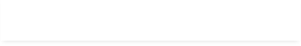


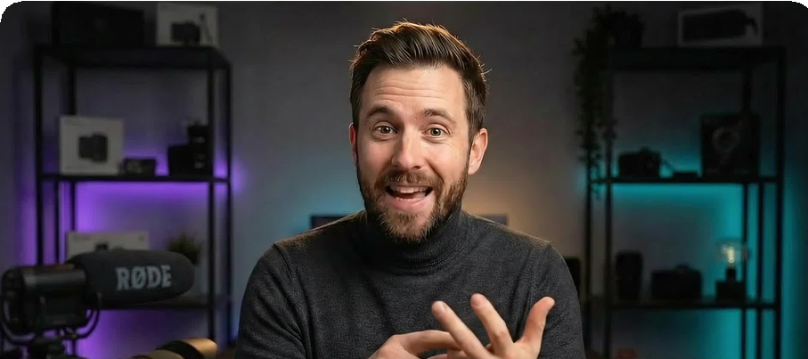
CHRISTMAS MEGA SALE: SAVE UPTO 83% $49 $15/month
22h 43m 6s Upgrade Now

Tools
Discover and use 3000+ powerful AI tools to enhance your workflow

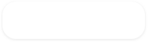





Stable Diffusion
Mid













Advanced motion and expression control

TRY KLING 2.6 MOTION CONTROL

Search by model, task, provide

Request a tool

Categories:

All New

Text Image

Video Document








Audio

Filter by Workflow

Sign in to create and manage folders

Trending

Chat With AI
Engage in conversations with any AI model on any topic.
chat streaming

Trending











Chat Arena
Chat with multiple AI models side by side for comparative insights.
chat streaming

Trending

AI Prompt Library
Explore an expert-crafted collection of AI prompts for various tasks.
prompt library

Trending

Learn with Galaxy.ai
Master Galaxy.ai with our










comprehensive video tutorials.

learn tutorial

Trending

Custom GPTs
Use and create custom AI agents
(GPTs) that combine instructions, extr…

chat training

Trending

YouTube Summarizer
Generate concise summaries of YouTube videos using AI.
video to text

Trending












AI Photo Studio
Train your own image model (LoRA). Upload just a few images of the same…
image to image training

Trending

AI Travel Photo Generator
Create stunning AI-generated travel photos of yourself at famous location…
image to image training

Trending

AI Headshot Generator









Create professional AI-generated headshots for various purposes.
image to image training

Trending

AI Image Generator
Produce stunning AI-generated images and artwork to visualize your ideas.
text to image image to image

Trending

AI Kissing Video Generator
Join the viral kissing trend and create personalized kiss videos.
image to video






Trending
AI Image Editor (Chat)
Just describe your edits, and watch your image transform instantly.
text to image
image to image

