01_frame_001370.PNG", "question": {"text": "Examine the image closely and generate a caption for this image and describe in detail which waste materials are present . There may be broady 4 major categories of waste which includes soft plastic, hard plastic, cardboard and metal. You need to examine closely this image and generate a caption for this image based on various waste items included in these categories? For example if there is cardboard, soft plastic bag, hard plastic and metal is present in the image you should generate a caption including all these and if in the image some of these waste categories are missing then you should not write about them"},

"caption": "The image shows a variety of waste materials on the floor, including cardboard, soft plastic, hard plastic, and metal. The cardboard is in various shapes and sizes, and the soft plastic is wrapped in plastic bags. The hard plastic is also wrapped in plastic bags, and the metal waste includes a bottle cap and a piece of wire."}

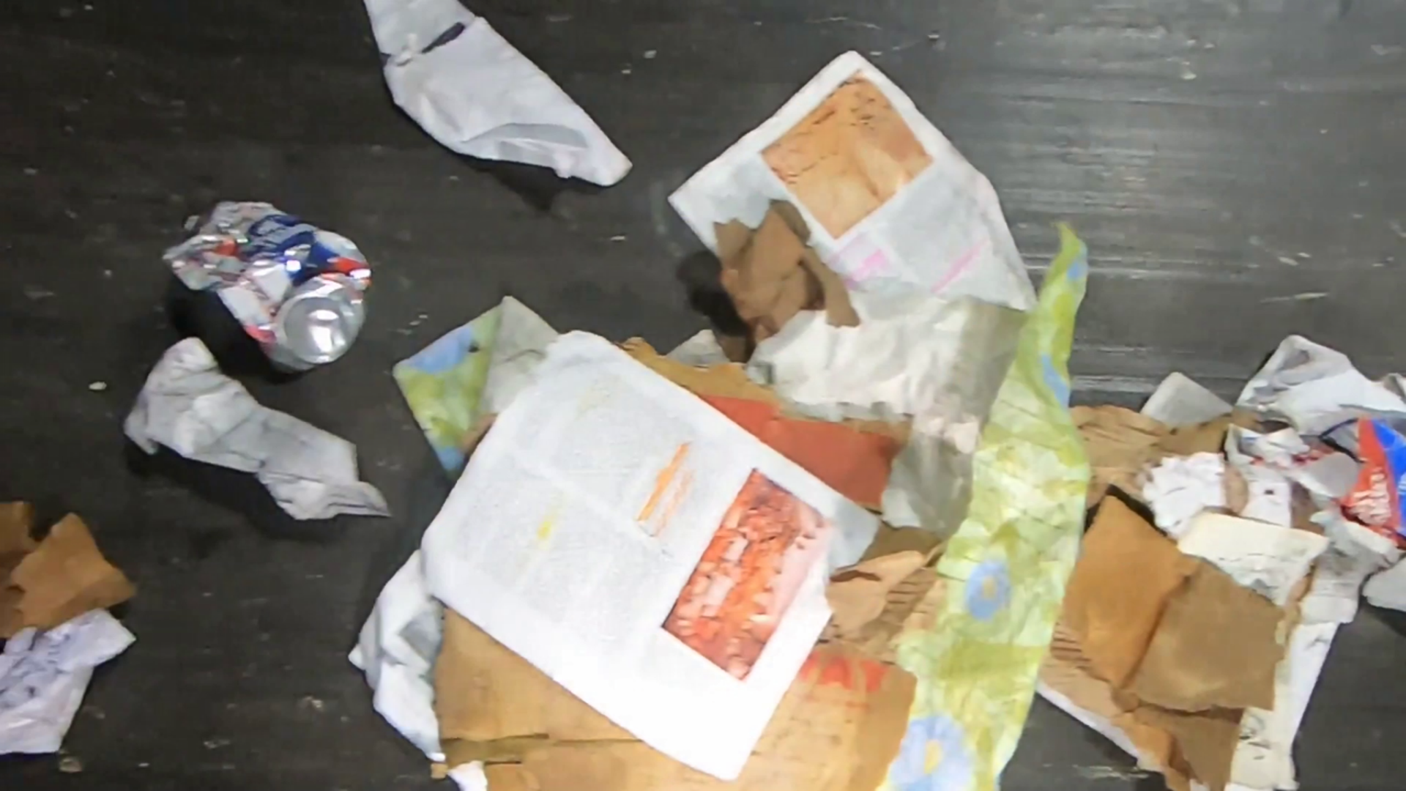

{"image_path": "/home/numansaeed/Desktop/Ali_Bhai/Qwen-VL/waste_dataset/splits_final_deblurred/eval/01_frame_004540.PNG", "question": {"text": "Examine the image closely and generate a caption for this image and describe in detail which waste materials are present . There may be broady 4 major categories of waste which includes soft plastic, hard plastic, cardboard and metal. You need to examine closely this image and generate a caption for this image based on various waste items included in these categories? For example if there is cardboard, soft plastic bag, hard platic and metal is present in the image you should generate a caption including all these and if in the image some of these waste categories are missing then you should not write about them"},

"caption": "The image shows a pile of mixed waste materials, including cardboard, soft plastic, hard plastic, and metal. The cardboard is in various sizes and shapes, and the soft plastic is crumpled and tangled. The hard plastic is also crumpled and tangled, and there is a can of soda among the waste materials. The metal waste materials are also mixed in with the other waste."}

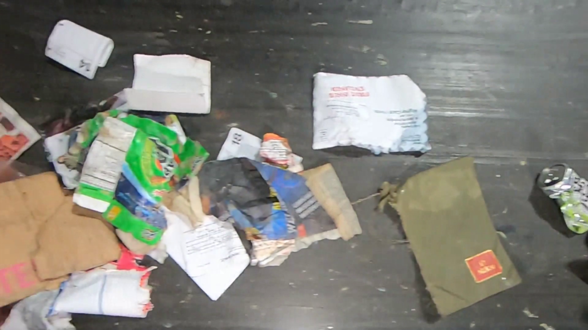
"question": {"text": "Examine the image closely and generate a caption for this image and describe in detail which waste materials are present . There may be broady 4 major categories of waste which includes soft plastic, hard plastic, cardboard and metal. You need to examine closely this image and generate a caption for this image based on various waste items included in these categories? For example if there is cardboard, soft plastic bag, hard platic and metal is present in the image you should generate a captin including all these and if in the image some of these waste categories are missing then you should not write about them"},

"caption": "The image shows a pile of various waste materials, including soft plastic, hard plastic, cardboard, and metal. The pile is located on a dark surface and appears to be quite large. The presence of these different waste materials suggests that this is a recycling facility or a waste management facility, where different types of waste are sorted and processed. It is important to properly dispose of and recycle these materials to reduce their impact on the environment."}

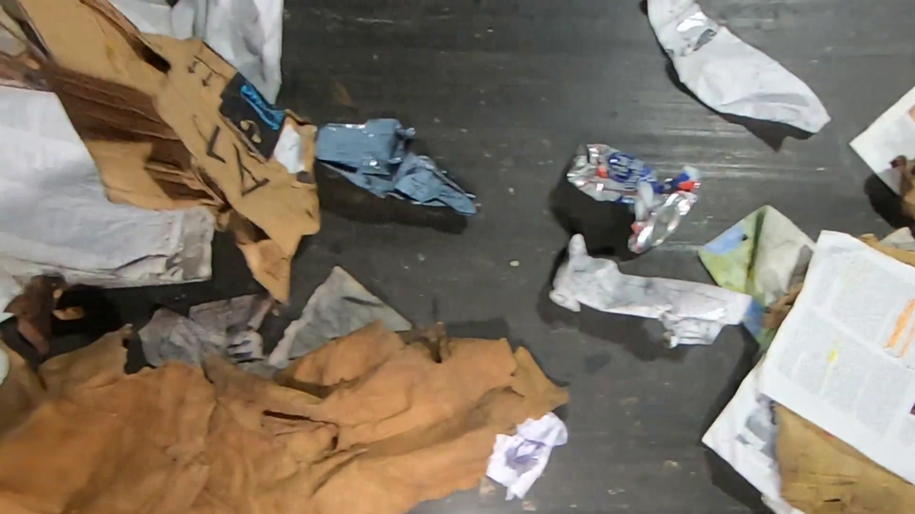

01_frame_004610.PNG", "question": {"text": "This image depicts various waste materials. Examine the image and provide detailed caption for this image describing the types and conditions of waste present."},

"caption": "The image shows a variety of waste materials scattered across a dark surface. There are several pieces of paper, including newspapers and tissue paper, in different sizes and colors. Additionally, there are several plastic bottles, one of which is partially crushed, and another is relatively intact. The presence of these waste materials indicates a lack of proper waste management in the area, which can lead to environmental pollution and health hazards."}

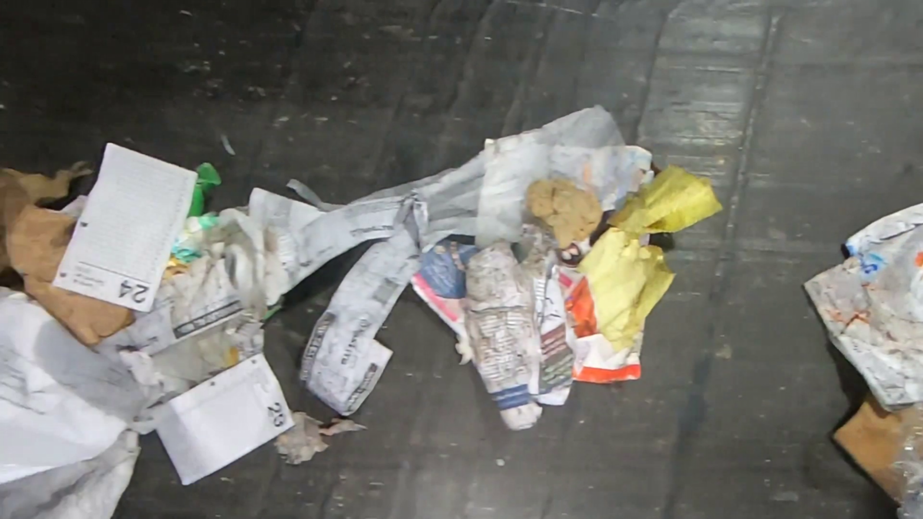

{"image_path": 02_frame_001870.PNG", "question": {"text": "This image depicts various waste materials. Examine the image and provide detailed caption for this image describing the types and conditions of waste present."},
"caption": "The image shows a pile of assorted waste materials, including plastic bags, cardboard, and newspapers. The pile is located on the ground and is filled with a variety of items. The plastic bags are crumpled and appear to be old and used. The cardboard is also crumpled and appears to be in a damaged condition. The newspapers are bunched together and have likely been discarded. Overall, the pile of waste materials gives off a sense of clutter and disorganization."}

{"image_path": 02_frame_001840.PNG", "question": {"text": "This image depicts various waste materials. Examine the image and provide detailed caption for this image describing the types and conditions of waste present."},

"caption": "The image shows a pile of assorted waste materials, including plastic bottles, paper, and cardboard. The pile is located on the ground and is filled with various types of waste. The plastic bottles are empty and clear, and the paper and cardboard items are crumpled and torn. The pile appears to be dirty and unorganized, indicating that it has not been properly managed or sorted."},

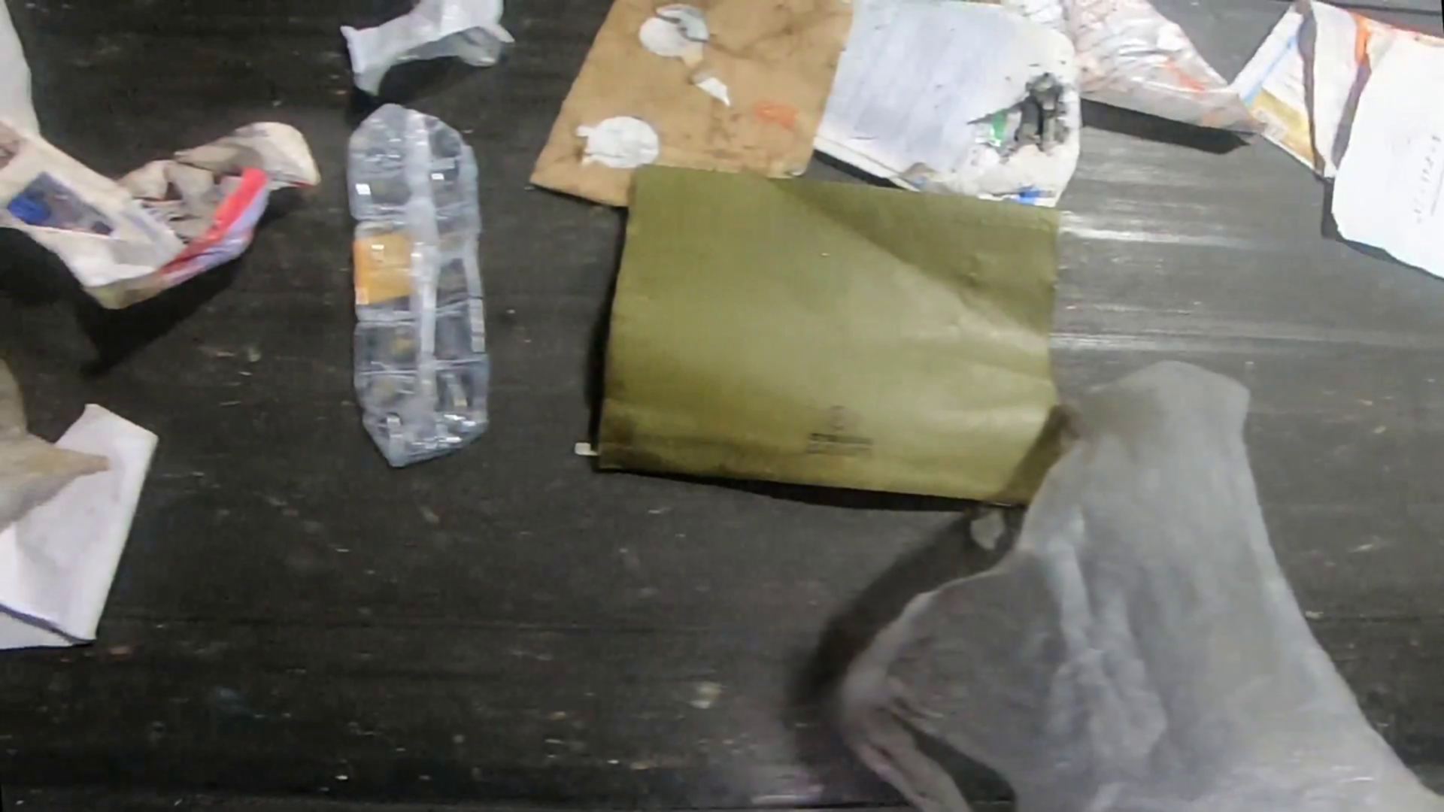

{"image_path": 09_frame_002490.PNG", "question": {"text": "This image depicts various waste materials. Examine the image and provide detailed caption for this image describing the types and conditions of waste present."},
"caption": "The image shows a variety of waste materials, including a plastic bottle, a paper bag, a cardboard box, a plastic bag, and a piece of cloth. The waste materials are in different conditions, with the plastic bottle and the paper bag being crumpled and crushed, the cardboard box and the cloth appearing somewhat intact, and the plastic bag being partially transparent."}]

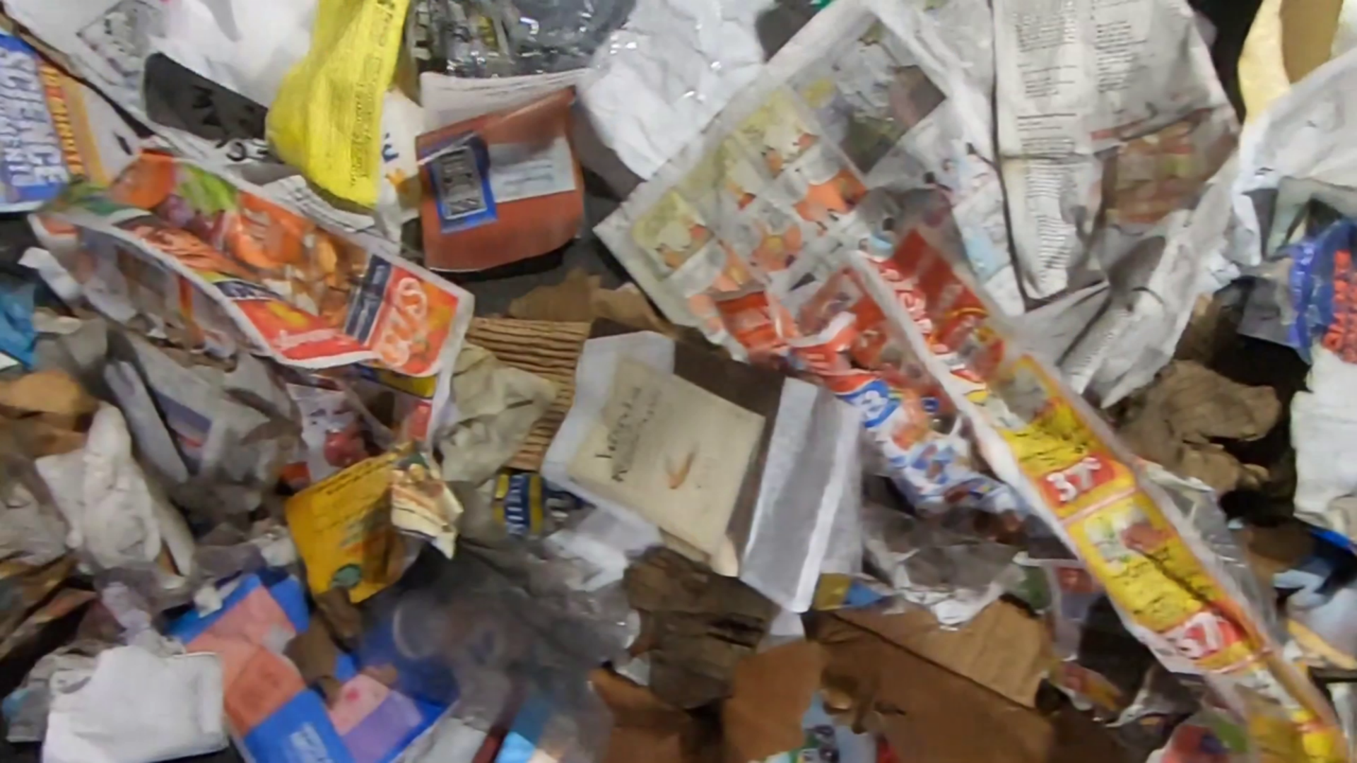

{"image_path": 05_frame_040300.PNG", "question": {"text": "This image depicts various waste materials. Examine the image and provide detailed caption for this image describing the types and conditions of waste present."},

"caption": "The image shows a pile of assorted waste materials, including a crumpled up newspaper, a juice box, a plastic bottle, and a piece of paper. The pile is located on a dark surface, and the waste materials are in various states of disarray. The juice box has a blue label and a white top, and the plastic bottle has a white label and a blue ring around the middle. The piece of paper has a white border and a black center. The newspaper has a yellow cover with red, blue, and green text. The pile of waste materials is situated on a dark surface, which could be a conveyor belt or some other type of waste management facility."},

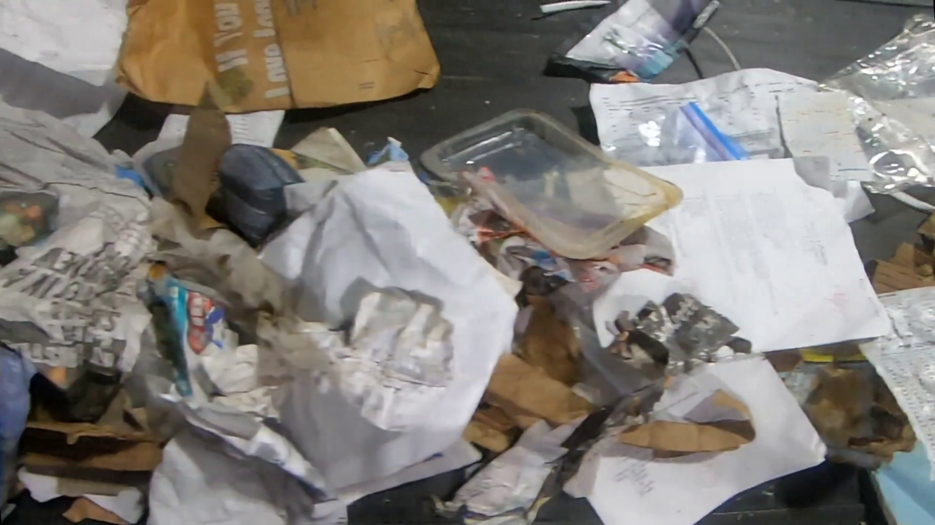
{"image_path": /10_frame_019100.PNG", "question": {"text": "This image depicts various waste materials. Examine the image and provide detailed caption for this image describing the types and conditions of waste present."},

"caption": "The image shows a pile of assorted waste materials, including paper, plastic, glass, and metal. The pile is located on a dark surface and contains a mix of different items. Some of the waste materials are crumpled and torn, while others are more intact. The pile also contains a few small pieces of paper scattered around it. The presence of plastic, glass, and metal indicates that this waste likely comes from a variety of sources, including household waste and recycling. Overall, the image depicts a messy and unorganized pile of waste that needs to be sorted and recycled or disposed of properly."},

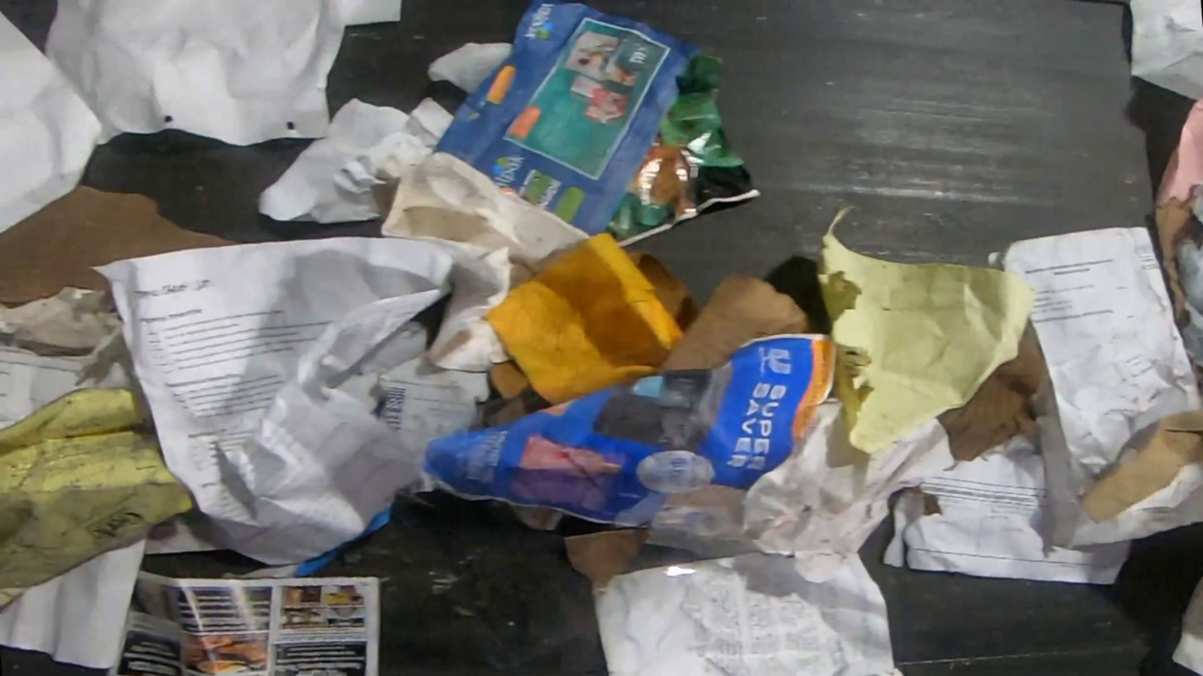
{"image_path": /07_frame_034800.PNG", "question": {"text": "This image depicts various waste materials. Examine the image and provide detailed caption for this image describing the types and conditions of waste present."},

"caption": "The image shows a variety of waste materials scattered across a dark surface. There is a crumpled up brown paper bag, a torn piece of newspaper, and a crumpled up piece of paper that has a blue and red label on it. Additionally, there is a crumpled up piece of paper that has a torn piece of paper with blue and red writing on it. The overall condition of the waste materials appears to be crumpled and torn, indicating that they have been discarded or discarded carelessly."},

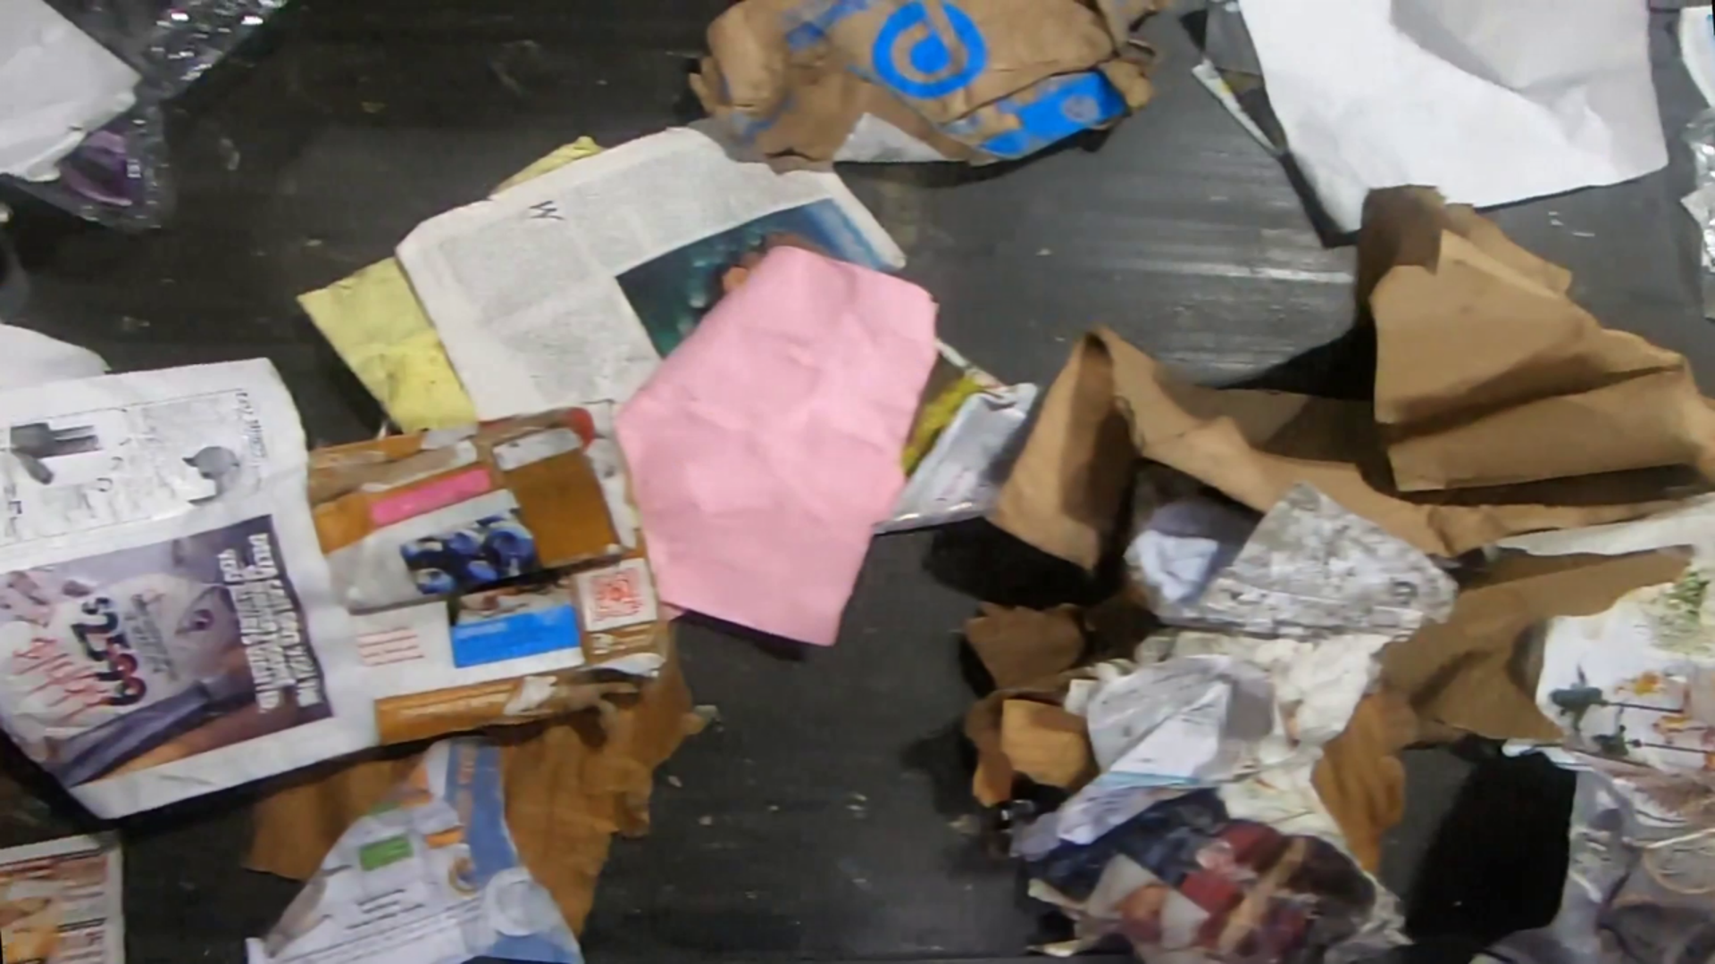

{"image_path": /10_frame_035200.PNG", "question": {"text": "This image depicts various waste materials. Examine the image and provide detailed caption for this image describing the types and conditions of waste present."},

"caption": "The image shows a pile of assorted waste materials, including paper, cardboard, and plastic. The pile is located on a dark surface and contains a variety of items such as boxes, bags, and newspapers. The condition of the waste materials varies, with some appearing crumpled and\u76b1\u8936, while others are more flattened and smooth. The plastic waste is particularly noticeable in the pile, adding to the overall cluttered appearance of the scene. This image highlights the importance of proper waste management and recycling to reduce the environmental impact of waste materials."},

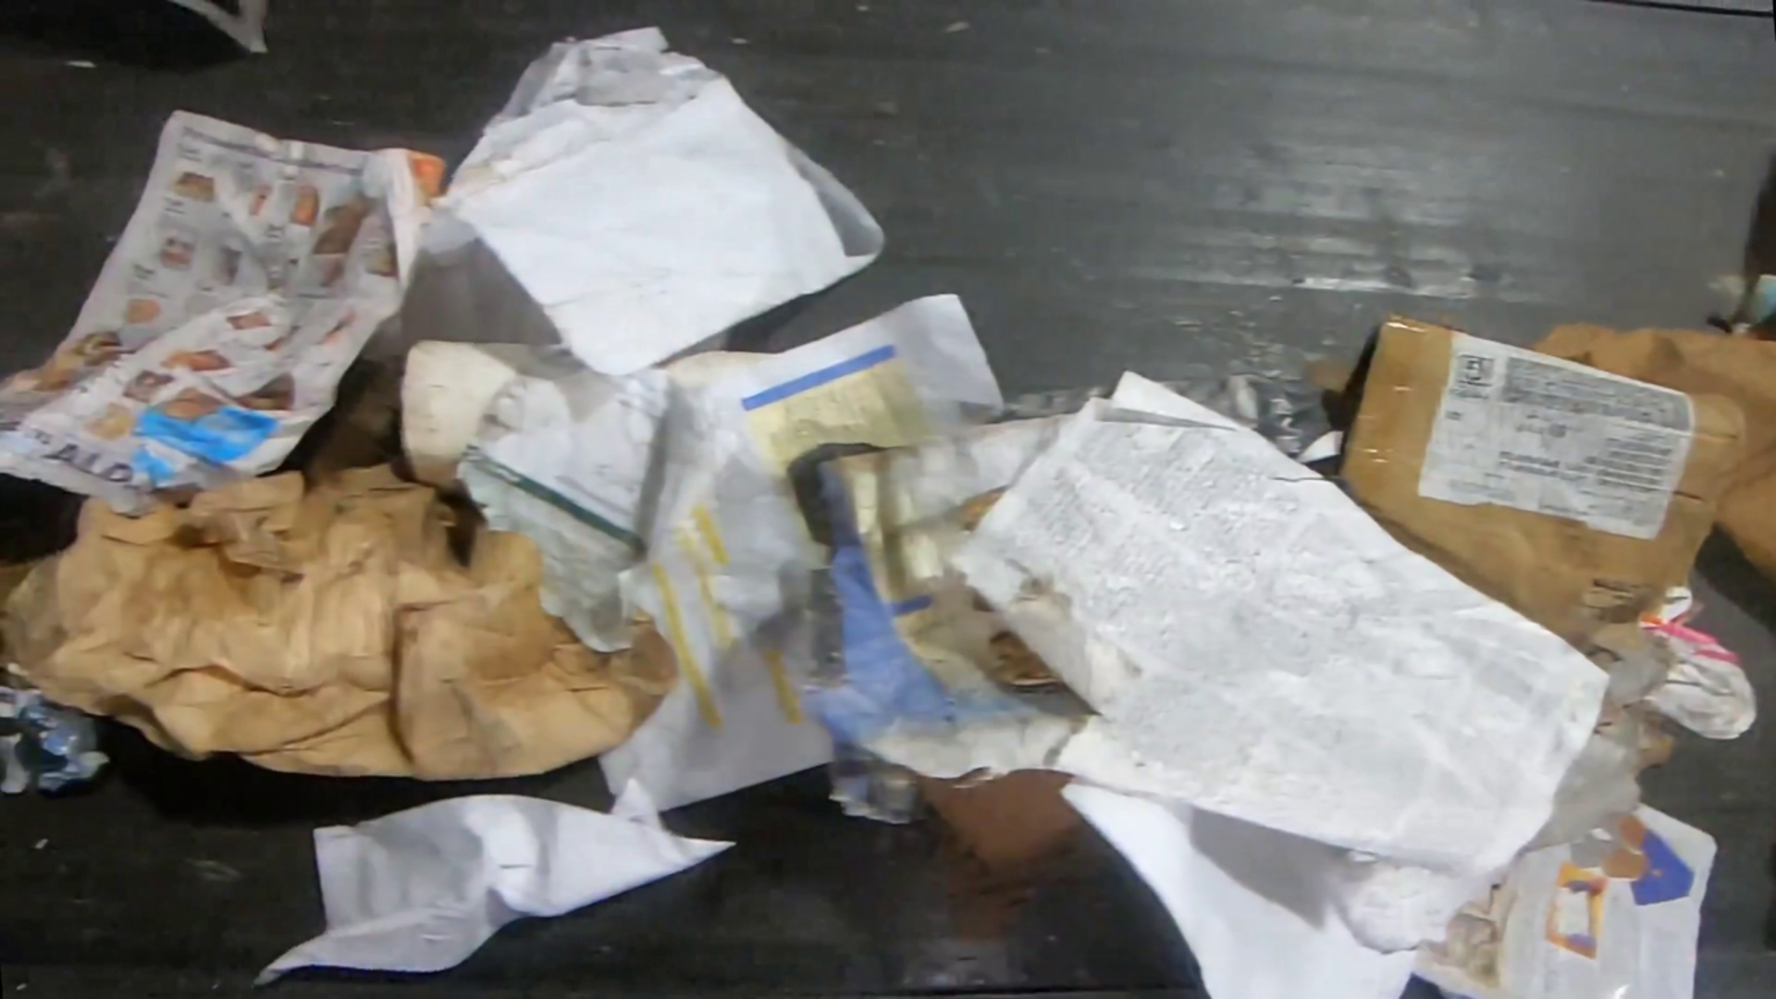

{"image_path": /09_frame_001710.PNG", "question": {"text": "This image depicts various waste materials. Examine the image and provide detailed caption for this image describing the types and conditions of waste present."},

"caption": "The image shows a variety of waste materials on a dark surface. There are several pieces of crumpled paper, a plastic bag, and a crushed cardboard box. The paper waste includes a newspaper page and some tissue paper. The crushed cardboard box is also visible. The presence of these different types of waste materials indicates a lack of proper waste management in the area."}

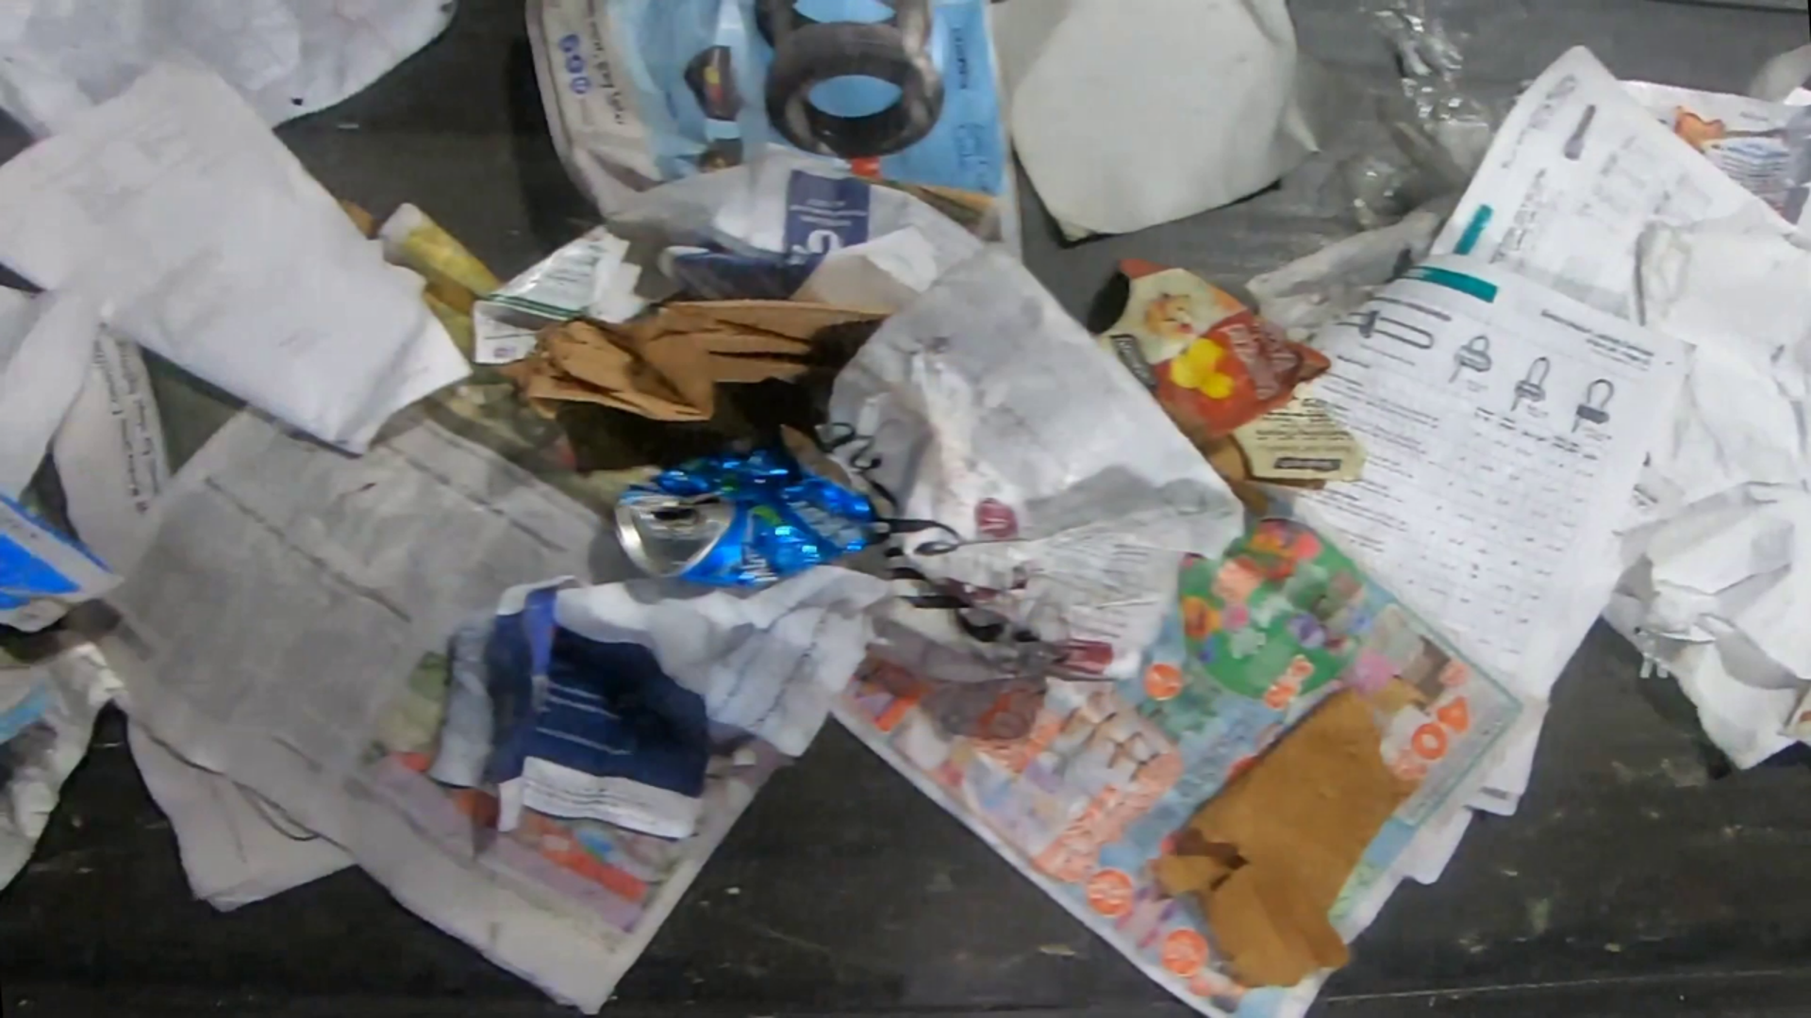

{"image_path": 11_frame_000081.PNG", "question": {"text": "This image depicts various waste materials. Examine the image and provide detailed caption for this image describing the types and conditions of waste present."},

"caption": "The image shows a pile of assorted waste materials. There are several pieces of paper, including newspapers and wrapping paper, in various colors and sizes. There are also some plastic items, such as a water bottle and a plastic bag, as well as a piece of cardboard. The pile of waste is located on a dark surface, and the overall condition of the materials appears to be crumpled and used."},

