https://www.analyticsvidhya.com/blog/2021/07/understanding-sequential-vs-functional-api-in-
keras/

First code
https://machinelearningmastery.com/tutorial-first-neural-network-python-keras/

https://stackoverflow.com/questions/43306323/keras-conv2d-and-input-channels
Input shape: (samples, channels, rows, cols)
Output shape: (samples, filters, new_rows, new_cols)

inputs = Input((3,3,3))
conv = Conv2D(filters=1,
strides=1,
padding='valid',
activation='relu',
kernel_size=2,
kernel_initializer='ones',
bias_initializer='zeros', )(inputs)
model = Model(inputs,conv)

matrix [r] - prints row at r index
matrix[ : , c] - prints column at c index
print("Array till the end")
print(arr1[3:])

https://lms.onnocenter.or.id/wiki/index.php/Keras:_Activation_Function

Identity or linear activation function
→ F(x) = x
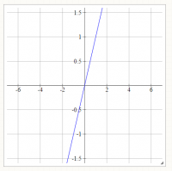
Identity Function
→ You will get the exact same curve.
→ Input maps to same output.

Binary Step
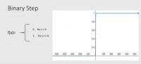
Binary Step Function
→Very useful in classifiers

Logistic or Sigmoid
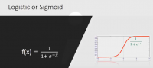
Logistic/Sigmoid Function
→ Maps any sized inputs to outputs in range [0,1].
→ Useful in neural networks.

Tanh
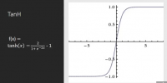
Tanh Function
→Maps input to output ranging in [-1,1].
→Similar to sigmoid function except it maps output in [-1,1] whereas sigmoid maps output to [0,1].

ArcTan
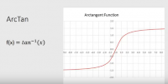
ArcTan Function
→ Maps input to output ranging between [-pi/2,pi/2].
→ Similar to sigmoid and tanh function.

Rectified Linear Unit (ReLu)

ReLu
→ It removes negative part of function.

Leaky ReLu

Leaky ReLu
→ The only difference between ReLu and Leaky ReLu is it does not completely vanishes the negative part,it just lower its magnitude.

Softmax

Softmax
→Softmax function is used to impart probabilities when you have more than one outputs you get probability distribution of outputs.
→Useful for finding most probable occurrence of output with respect to other outputs.

Set get weight
https://www.codespeedy.com/get_weights-and-set_weights-functions-in-keras-layers/

Complex value
https://github.com/Doyosae/Deep-Complex-Networks

https://keras-complex.readthedocs.io/api/api_toc.html

('Failed to import pydot. You must `pip install pydot` and install graphviz (https://graphviz.gitlab.io/download/), ', 'for `pydotprint` to work.')

install matlab in python

n linux:
First activate your environment:
conda activate
Then simply install the engine:
cd /usr/local/MATLAB/R2020b/extern/engines/python
python setup.py install

https://download.ir/%D9%85%D8%AA%D9%84%D8%A8/
2020b update

sr.movahhed@gmail.com

how install matlab lnux

https://virgool.io/@mohamad_halakoei/%D9%86%D8%B5%D8%A8-matlab-2020b-%D8%B1%D9%88%DB%8C-%D9%84%DB%8C%D9%86%D9%88%DA%A9%D8%B3-hvsjrwgnniiv

https://downloadly.ir/software/engineering-specialized/matlab-7/

MathWorks MATLAB R2016b Linux64

https://soft98.ir/software/engineering/3476-%D8%AF%D8%A7%D9%86%D9%84%D9%80%D9%80%D9%88%D8%AF-%D9%85%D8%AA%D9%84%D9%80%D8%A8.html

How install matlab for python

https://www.mathworks.com/help/matlab/matlab_external/install-the-matlab-engine-for-python.html

Install the Engine API
To install the engine API, choose one of the following. You must call this python install command in the specified folder.
- At a Windows operating system prompt (you might need administrator privileges to execute these commands) —
cd "matlabroot\extern\engines\python"
python setup.py install
- At a macOS or Linux operating system prompt (you might need administrator privileges to execute these commands) —
cd "matlabroot/extern/engines/python"
python setup.py install
- At the MATLAB command prompt —
cd (fullfile(matlabroot,'extern','engines','python'))
system('python setup.py install')

First activate your environment:
conda activate
Then simply install the engine:
cd /usr/local/MATLAB/R2020b/extern/engines/python
python setup.py install

Start MATLAB Engine
Start Python, import the module, and start the MATLAB engine:
import matlab.engine
eng = matlab.engine.start_matlab()

