SMART IRRIGATION REQUIREMENT PREDICTION USING MACHINE LEARNING

1. Abstract
This project focuses on predicting irrigation requirements using machine learning techniques based on environmental and soil-related parameters. Efficient irrigation plays a vital role in sustainable agriculture, as improper water usage can lead to water wastage and reduced crop productivity. The objective of this project is to develop a data-driven decision support system for accurate irrigation planning.
A supervised machine learning approach was adopted using an agricultural dataset containing features such as Moisture Index (MOI), temperature, and humidity. A baseline Logistic Regression model was implemented to establish a reference performance. Subsequently, a Transformer-based deep learning model was developed to capture complex feature relationships and improve prediction accuracy.
The machine learning pipeline included data preprocessing, feature scaling, model training, evaluation, and real-time inference. After ensuring stable and error-free execution, controlled hyperparameter tuning was performed on the Transformer model. The tuned model achieved an accuracy of approximately 87%, outperforming the baseline approach.
The results indicate that Transformer-based models can enhance irrigation requirement prediction and support smart irrigation systems aimed at improving water efficiency in agriculture.

2. Introduction
Agriculture plays a vital role in ensuring food security and supporting the global economy. One of the most critical factors affecting agricultural productivity is water management, particularly irrigation. In many regions, irrigation practices are still based on fixed schedules or manual judgment rather than real-time environmental conditions. Such approaches often lead to over-irrigation or under-irrigation, resulting in water wastage, reduced crop yield, and long-term environmental damage.
With increasing water scarcity and climate variability, efficient irrigation management has become an essential requirement for sustainable agriculture. Smart irrigation systems aim to optimize water usage by considering environmental and soil-related parameters such as moisture level, temperature, and humidity. By using these parameters, irrigation decisions can be made more accurately, ensuring that crops receive sufficient water without unnecessary waste.
Recent advancements in machine learning have enabled the development of data-driven models capable of analyzing complex relationships within agricultural data. Machine learning techniques can process historical and real-time data to identify patterns that are difficult to capture using traditional rule-based methods. As a result, these techniques have been widely explored for applications such as crop yield prediction, soil condition analysis, and irrigation scheduling.
Among various machine learning approaches, deep learning models have shown promising performance in handling non-linear and high-dimensional data. Transformer-based architectures, originally developed for sequence modeling tasks, have recently been adapted for a variety of prediction problems due to their ability to capture complex feature interactions. Applying such models to irrigation requirement prediction can potentially improve decision accuracy and support intelligent water management.
This project focuses on developing a machine learning-based system for predicting irrigation requirements using environmental features. A baseline machine learning model is first implemented to establish a reference performance, followed by a Transformer-based model to enhance predictive capability. The objective is to evaluate the effectiveness of advanced learning techniques in supporting smart irrigation systems and promoting sustainable agricultural practices.

3. Objectives
The main objectives of this project are as follows:
- To analyze environmental and soil-related data for predicting irrigation requirements
- To develop a baseline machine learning model for irrigation prediction
- To design and implement a Transformer-based deep learning model
- To compare the performance of the baseline and Transformer models using accuracy
- To perform controlled hyperparameter tuning to improve model performance
- To evaluate model results using both numerical metrics and visual comparison
- To implement a real-time inference mechanism for irrigation decision support

4. Literature Review
Recent advancements in machine learning have significantly influenced the development of smart irrigation systems. Researchers have increasingly focused on utilizing data-driven techniques to optimize irrigation scheduling and improve water resource management [1].
Younes et al. presented a systematic literature review on the application of machine learning techniques in smart irrigation systems [1]. Their study analyzed models such as Logistic Regression, Support Vector Machines, Random Forests, and neural networks, highlighting the importance of soil moisture and climatic variables for irrigation prediction.
Del-Coco et al. explored the integration of machine learning with Internet of Things (IoT) technologies for smart irrigation applications [2]. Their research demonstrated that sensor-based data combined with machine learning models can support automated irrigation decisions and improve water efficiency.
Roy et al. proposed an IoT-based smart irrigation system using advanced machine learning models to automate irrigation scheduling [3]. Their study showed that intelligent decision-making systems outperform traditional irrigation methods
Nsoh et al. investigated automated irrigation solutions utilizing machine learning and IoT sensors, concluding that machine learning-based systems perform better under dynamic environmental conditions [4].
Kaur developed a hybrid smart irrigation system integrating low-cost IoT sensors with machine learning techniques, emphasizing scalability and practical deployment in real-world environments [5].
Jaiswal reviewed intelligent drip irrigation systems and highlighted the growing role of machine learning and artificial intelligence in precision agriculture and sustainable irrigation practices [6]
Overall, existing literature confirms that machine learning techniques are effective for irrigation requirement prediction and water resource management. However, limited work has explored lightweight Transformer-based models for irrigation prediction using tabular environmental data. This research gap motivates the current project.

5. Methodology
This section describes the methodology followed to develop the irrigation requirement prediction system. The complete process was designed as a structured machine learning pipeline, starting from data collection and preprocessing to model training, evaluation, and real-time inference.

5.1 Dataset Description
The dataset used in this project consists of agricultural and environmental observations relevant to irrigation decision-making. The dataset includes approximately 16,000 records and contains features such as Moisture Index (MOI), temperature, and humidity. These features represent soil and atmospheric conditions that directly influence irrigation requirements. The target variable represents the irrigation requirement level, formulated as a multi-class classification problem.
Feature | Description
Moisture Index (MOI) | Soil moisture indicator
Temperature | Ambient temperature (°C)
Humidity | Relative humidity (%)
Target | Irrigation requirement level

5.2 Data Preprocessing
Prior to model training, data preprocessing steps were applied to ensure consistency and reliability. The selected features were separated from the target variable, and the dataset was divided into training and testing sets using an 80–20 split. Feature scaling was performed using a standardization technique to normalize input values, which is particularly important for deep learning models to ensure stable and efficient training.
5.3 Baseline Model
A Logistic Regression model was implemented as a baseline classifier to establish a reference performance. Logistic Regression was selected due to its simplicity and interpretability. The baseline model provides a comparative benchmark to evaluate the effectiveness of more advanced models.
5.4 Transformer-Based Model
To improve prediction performance, a Transformer-based deep learning model was developed. The model architecture consists of an embedding layer, a Transformer encoder layer, and a fully connected output layer. The Transformer model was chosen for its ability to capture complex feature interactions and learn non-linear relationships within the data. The model was trained using a cross-entropy loss function and the Adam optimization algorithm.

5.5 Model Training and Evaluation
Both models were trained using the training dataset and evaluated on the test dataset. Accuracy was used as the primary evaluation metric to measure predictive performance. To ensure reproducibility, random seeds were fixed during data splitting and model training. After training, the performance of the baseline and Transformer models was compared quantitatively.
5.6 Inference Pipeline
To simulate real-world usage, the training and inference processes were separated. The trained Transformer model and feature scaler were saved after training. A separate inference script was implemented to load the saved model and scaler, accept user-provided input values, and generate irrigation requirement predictions. This approach reflects practical deployment scenarios and avoids unnecessary retraining during prediction.

6. Results and Discussion
This section presents the experimental results obtained from the baseline machine learning model and the proposed Transformer-based model for irrigation requirement prediction.
The baseline Logistic Regression model achieved an accuracy of approximately 81% on the test dataset. This result shows that traditional machine learning techniques can capture basic relationships between environmental features and irrigation requirements, but their performance is limited due to linear modeling assumptions.
The Transformer-based model demonstrated improved predictive performance. Before hyperparameter tuning, the Transformer achieved an accuracy of approximately 84%, indicating its ability to model more complex feature interactions compared to the baseline approach.
Figure 1 presents a visual comparison of model performance, illustrating the progression from the baseline Logistic Regression model to the Transformer-based model. The visual comparison clearly highlights the effectiveness of deep learning techniques for irrigation prediction tasks.
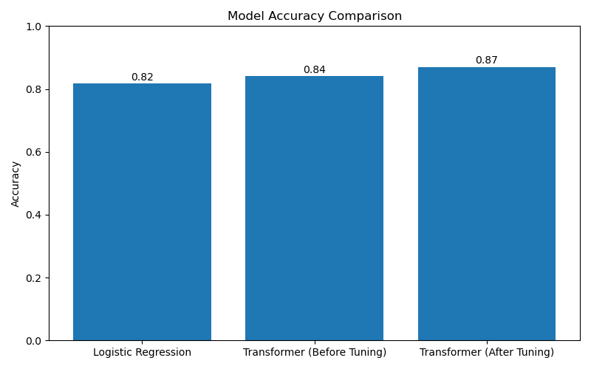
Figure 1: Accuracy comparison of the baseline Logistic Regression model, the Transformer model before hyperparameter tuning, and the Transformer model after hyperparameter tuning.

Overall, the results confirm that the Transformer-based model outperforms the baseline model and provides a strong foundation for further performance enhancement through controlled hyperparameter tuning.

7. Results After Hyperparameter Tuning
After establishing the baseline and initial Transformer model performance, controlled hyperparameter tuning was conducted to further improve prediction accuracy. The tuning process focused on adjusting a limited set of parameters, including the number of training epochs, the hidden dimension of the Transformer embedding layer, and the learning rate. These parameters were selected because they directly influence learning stability and model capacity.
As shown in Figure 1, hyperparameter tuning resulted in a noticeable improvement in model performance. The Transformer model accuracy increased from approximately 84% before tuning to approximately 87% after tuning. This improvement demonstrates that careful adjustment of hyperparameters can enhance model performance without modifying the underlying architecture.
Although further experiments with higher epochs and larger hidden dimensions yielded slightly higher accuracy, the final tuned configuration was selected to maintain a balance between performance improvement and generalization. The chosen configuration provides stable and reproducible results while minimizing the risk of overfitting.
Overall, the tuning results confirm the effectiveness of controlled hyperparameter optimization in improving deep learning model performance for irrigation requirement prediction.

8. Limitations
Despite achieving promising results, this project has several limitations. First, the dataset used in this study contains a limited number of features, primarily focusing on Moisture Index, temperature, and humidity. Additional factors such as soil type, rainfall, crop variety, and seasonal variations were not included, which may affect prediction accuracy in real-world scenarios.
Second, model performance was evaluated mainly using accuracy as the primary metric. While accuracy provides a general indication of performance, additional evaluation metrics such as precision, recall, and F1-score could offer deeper insight into model behavior, especially in the presence of class imbalance.
Third, the model was trained and tested on a single dataset, which may limit its generalization capability across different geographic regions or agricultural conditions. Further validation using diverse datasets would be required to ensure robustness.
Finally, the current implementation is designed for offline prediction and demonstration purposes. Real-time deployment would require integration with live sensor data and additional system-level considerations.

9. Conclusion and Future Work
This project demonstrated the effective use of machine learning techniques for predicting irrigation requirements based on environmental data. A complete and error-free machine learning pipeline was developed, and the performance of a baseline Logistic Regression model was compared with a Transformer-based deep learning model. The tuned Transformer model achieved an accuracy of approximately 87%, outperforming the baseline approach and highlighting the benefit of controlled hyperparameter tuning. The results indicate that machine learning can support smart irrigation systems by improving decision accuracy and water efficiency. Future work may involve incorporating additional environmental and agronomic features, using more comprehensive evaluation metrics, and deploying the model with real-time sensor data for practical applications.

10. References
[1] A. Younes et al., “The application of machine learning techniques for smart irrigation systems: A systematic literature review,” Smart Agricultural Technology, 2024.
[2] M. Del-Coco, F. Piccialli, and G. Casalino, “Machine learning for smart irrigation in agriculture,” Information, vol. 15, no. 6, 2024.
[3] U. Roy B. P., K. N. Abdul Sattar, and A. A. Elngar, “A smart irrigation system using the IoT and advanced machine learning model,” 2024.
[4] B. Nsoh et al., “Internet of Things-based automated solutions utilizing machine learning in smart irrigation,” Sensors, 2024
[5] A. Kaur, “Developing a hybrid irrigation system for smart agriculture,” Journal of Sensors, 2024.
[6] N. Jaiswal, “Smart drip irrigation systems using IoT and artificial intelligence,” Springer, 2025.

