Range of Motion (ROM) Booklet

Instructions with Pictures
on use of Goniometers
and Bubble Inclinometers
to measure ROM of major joints
and cervical spine.

Table of Contents

References

Equipment

ROM Values and Norms

Use of Bubble Inclinometer

Instruction set from Fabrication Enterprises Incorporated

Measuring ROM

Cervical Spine Flexion, Extension, Lateral Bend (side-bend), Rotation
with Goniometer
with Bubble Inclinometer

Shoulder Flexion, Extension, Internal and External Rotation, Abduction
with Goniometer

Hip Flexion, Extension, Abduction, Adduction, External and Internal Rotation
with Goniometer

Knee Flexion, Extension
with Goniometer

References
ROM References

All ROM measurements are referenced from:

Magee D. Orthopedic Physical Assessment. 4th edition. Elsevier Sciences. 2006

All the patient positions and goniometer positions are referenced

Norkin C, White D. Measurement of Joint motion. A guide to Goniometry. 3rd edition. Philadelphia. F.A. Davis Company. 2003

Other References

American Academy of Orthopaedic Surgeons. Joint Motion: Methods of Measuring and Recording. AAOS, Chicago, 1965.

Cleland, Joshua. Orthopaedic Clinical Examination: An Evidence-Based Approach for Physical Therapists. 2005. Carlstadt, NJ: Icon Learning Systems.

Dutton, Mark. Orthopaedic Examination, Evaluation and Intervention. 2004. New York: McGraw Hill.

Rothstein, Jules M., Serge H. Roy, Steven L Wolf, David A. Scalzitti. The Rehabilitation Specialist’s Handbook, 3rd ed. 2005. Philadelphia: F.A. Davis Company.

Bubble inclinometer instructions from:
Fabrication Enterprises Incorporated
PO Box 1500
White Plains, New York 10602 (USA)
tel: 914-591-9300 fax: 914-591-4083
The goniometer is a standard device for measuring angles and is relatively inexpensive. Bubble inclinometers are gaining in popularity for ease of use, but are more expensive and lack research for its validity and reliability.
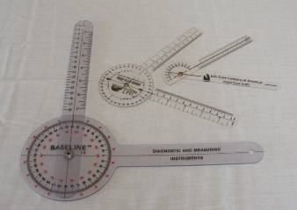

Goniometers come in various sizes for use with different joints.

Goniometer has three components. The circular or semi-circular base with degree markings is called the body. Goniometers also have two arms. The stationary arm is fixed to the body. The moving arm is moved in concert with the patient’s joint movement and points to the readings on the goniometer body .

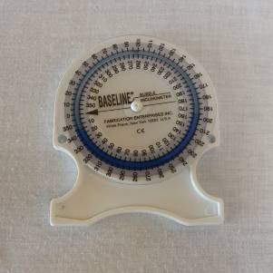
Bubble inclinometers have a circular tube partially-filled with a colored fluid that moves with motion, and is gravity dependent. It has a moveable circular dial with degree markings.

- Each measure device requires knowledge of placement and expected measurement.

- The measurement should include which device was used. Ideally, each time a patient is re-measured the same device type would be used.

- For left and right sided movements, both sides should be measured and compared.
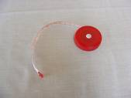
Before the use of the goniometer and the bubble inclinometer, a tape measure was used for certain range of motion measurements. It is still used for measuring torso girth, and well as diameter of limbs for left-right comparisons (for muscle wasting, edema, etc.). Use of tape measure for range of motion measurements is not included in this booklet. (Please refer to Measurement of Joint Motion by Cynthia C. Norkin for more details.)
Range of Motion Measurement Values and Norms

The ranges of motion measurements for different movements vary considerably in the literature.
Range of motion values often decline with age without detriment to a person’s quality of life or ability to do activities of daily living (ADL).
More important than which set of ROM values to use as criteria, consider the following:
- What does the ROM limitation have on the quality of the patient’s life?
- How does the ROM limitation affect general movements and ability to do tasks in the person's life (ADLs: Activities of Daily Lives)?

- How close is the patient's ROM to an expected full range of motion?
- How does a left-sided movement compare to a right-sided movement?
- What are the ROM measurements on the same patient over time, over the course of several treatments?

It is recommended that measurements be taken at initial evaluation, and after every four to six weeks of treatment. The idea is that four to six weeks are the expected tissue healing time.

Documentation

ROM provides objective, reproducible outcome measurements. Documentation of ROM can help determine the effectiveness of treatment. It can promote continuous patient care between practitioners: this means that when a patient is seeing two different practitioners or interns for the same condition, such as shoulder pain, documented ROM can help them determine the progression of treatment. Either the shoulder is getting better or worse (or no change) through treatment.

Proper ROM documentation needs to include date, joint measured, active or passive movement, types of ROM (flex, extend, etc.), testing position, equipment used, and the range measurement.

Example:
Cervical AROM (Active ROM) sitting with goni
Flexion (Flex) 0-60⁰ Extension(Ext) 0-45⁰
Left Sidebend (LS) 0-45⁰ Right Sidebend (RS) 0-45⁰
Left Rotation (LR) 0-80⁰ Right Sidebend (RS) 0-80⁰

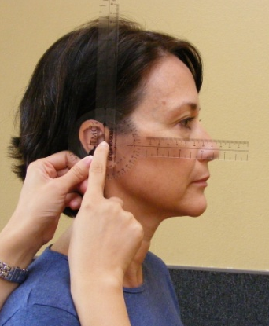
Measuring Neck Flexion with a Goniometer

1. With patient in a seated position, place the center of goniometer body over the external auditory meatus.

2. Align stationary arm perpendicular to the floor .

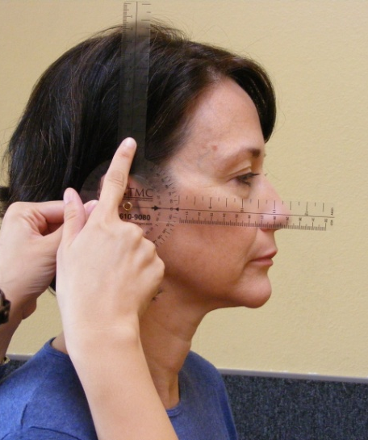

3. Align moving arm with nares. This is the
Neutral or “zero” position.

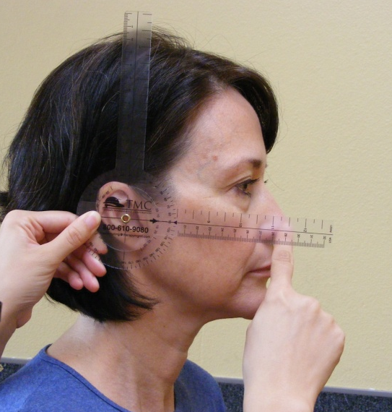

4. Keeping stationary arm in perpendicular position, have patient bend the neck forward bringing the chin as close to chest as possible. Align moving arm with the nares. Read the angle.

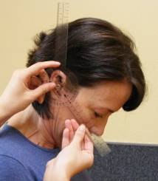

Normal ROM: 80-90⁰
Measuring Neck Extension with a Goniometer

1. With patient in a seated position, place the center of goniometer body over external auditory meatus.

2. Align stationary arm perpendicular to the floor.

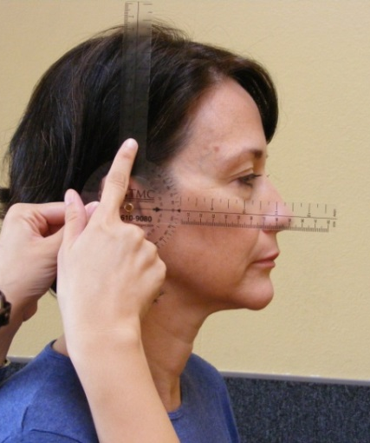

3. Align rotating arm with nares. This is the
neutral or “zero” position.
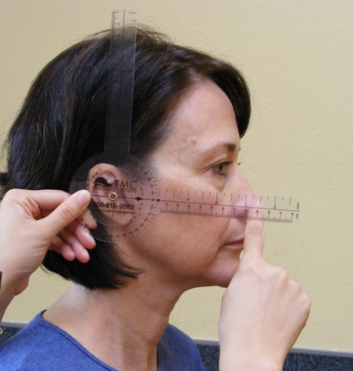

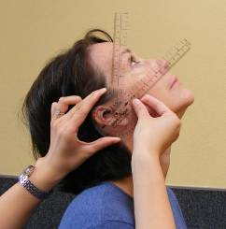
4. Keeping stationary arm in perpendicular position, have patient extend neck backward to bringing the back of head as close to upper back as possible. Align moving arm with the nares. Read the angle.

Normal ROM: 70⁰

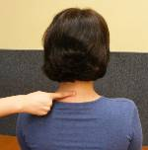
Measuring Neck Lateral Bend (Side Bend) with a Goniometer

- With patient in a seated position, locate C7 spinous process.

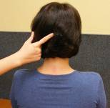

- Locate occipital protuberance.

- Place the center of goniometer body over C7 and align stationary arm with the spinous processes of the thoracic vertebrae so that the arm is perpendicular to the floor. Align the moving arm in the opposite direction going straight up over the occipital protuberance. This is the “zero” position.

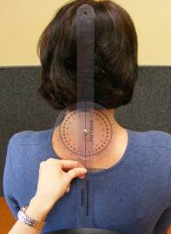
- Stabilize the shoulder opposite of the bend. Have the patient do a lateral bend by bringing the ear as close to the top of the shoulder as possible without moving either shoulder. Align the moving arm with the occipital protuberance. Read the angle.

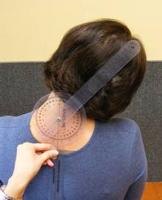

Normal ROM: 20-45⁰
Do both left and right sides and compare the readings.

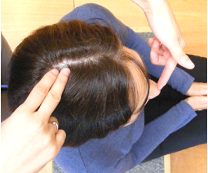
Measuring Neck Rotation with a Goniometer

- With patient in a seated position, locate the vertex (~DU20) and the tip of the nose.

- Place the center of the goniometer body over the vertex (at ~ Du20), with the stationary arm align with acromion process. The moving arm should be aligned with the tip of the nose.

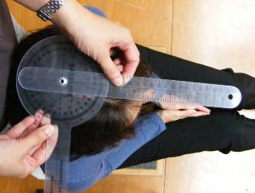

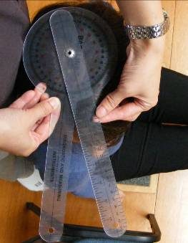

- Keep the stationary arm in the original position as the patient rotates to one side. Align the moving arm with the tip of the nose for the reading.

Normal ROM: 70-90⁰
Do both left and right sides and compare the readings.
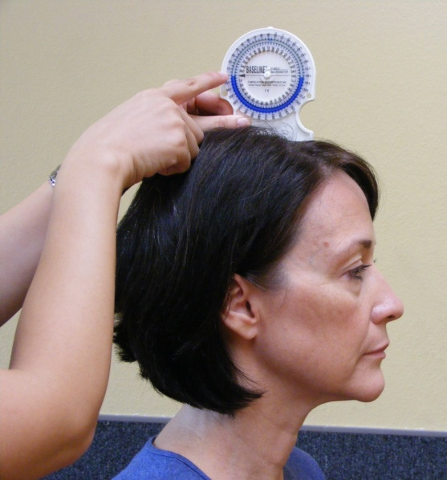
Measuring neck flexion with a bubble inclinometer

1. With patient in a seated position, place inclinometer on vertex of head. Move rotating dial so that the “0” / arrow aligns with the surface of the fluid.

2. Holding the inclinometer securely in a steady position, have patient bend the neck forward bringing the chin as close to chest as possible. Read the measure indicated by the level of the inclinometer fluid.

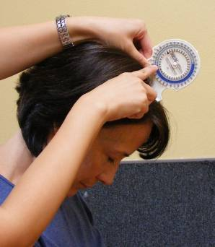
Normal ROM: 80-90⁰

Make sure the patient’s upper spine is stabilized during the flexion. A method to account for thoracic movement is to have a second inclinometer on T1 to measure any forward movement of the thorax. This measurement is subtracted from the above reading to obtain a more accurate ROM of the neck.

Measuring neck extension with a bubble inclinometer

1. With patient in a seated position, place inclinometer on vertex of head. Move rotating dial so that the “0” / arrow aligns with the surface of the fluid.

2. Holding the inclinometer securely in a steady position, have patient extend neck backward to bringing the back of head as close to upper back as possible. Read the measure indicated by the level of the inclinometer fluid.

Normal ROM: 70⁰

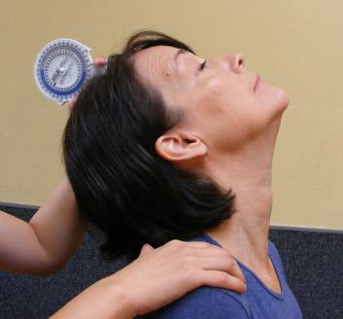

Make sure the patient’s upper spine is stabilized during the flexion. A method to account for thoracic movement is to have a second inclinometer on T1 to measure any forward movement of the thorax. This measurement is subtracted from the above reading to obtain a more accurate ROM of the neck.

Measuring neck lateral bend (side bend) with a bubble inclinometer

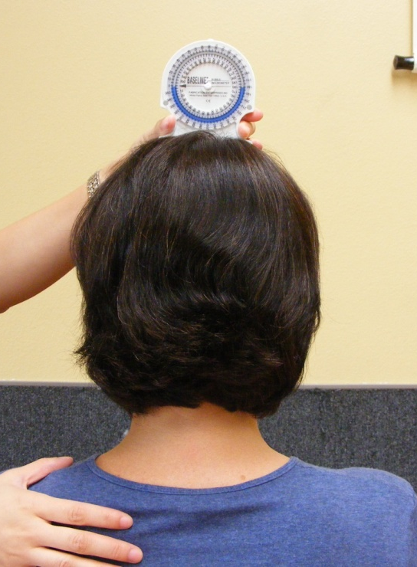
- With patient in a seated position, place inclinometer on vertex of head. Move rotating dial so that the “0” / arrow aligns with the surface of the fluid.

- Hold the inclinometer securely in a steady position and stabilize the shoulder opposite of the bend. Have the patient do a lateral bend by bringing the ear as close to the top of the shoulder as possible without moving either shoulder.

Read the measure indicated by the level of the inclinometer fluid.

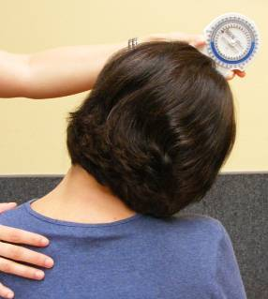
Normal ROM: 20-45⁰
Do both left and right sides and compare the readings.

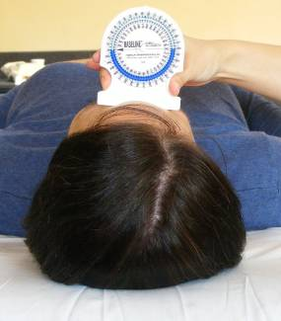
Measuring neck rotation with a bubble inclinometer

- With patient in a supine position, place inclinometer on top of the forehead. Move rotating dial so that the “0” / arrow aligns with the surface of the fluid.

- Hold the inclinometer securely in a steady position and have the patient rotate to one side.

Read the measure indicated by the level of the inclinometer fluid.

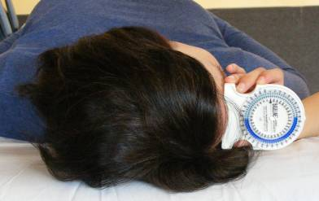
Normal ROM: 70-90⁰
Do both left and right sides and compare the readings.

Activities of Daily Living – Examples



Flexion, abduction and external rotation are important for fixing hair!

Extension and internal rotation is important hooking, unhooking bra straps, cleaning after bowel movement, and getting the wallet out of the back pocket!

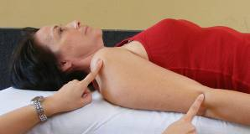
Compare left to right side movements.
Measuring Shoulder Flexion with a Goniometer

- Patient in supine position.

Locate the humeral head and the lateral epicondyle of the humerus.

- Locate the lateral mid-line of the truck.
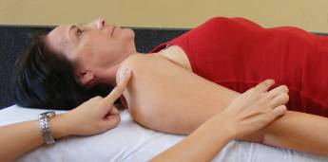

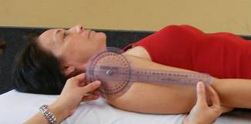

- Place the body of the goniometer over the humeral head. Align the stationary arm with the lateral mid-line of the truck.

- Have patient flex shoulder by moving arm upward and backward as far as possible.
Align moving arm with lateral epicondyle of humerus.
Read the angle.

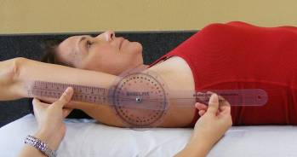

Normal ROM: 160-180⁰
Do both left and right sides and compare the readings.

Measuring Shoulder Extension with a Goniometer

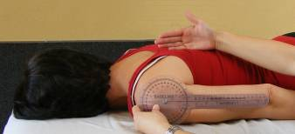
- Patient in prone position with patient’s head turned away from the testing arm.

Locate the humeral head, the lateral epicondyle of humerus, and the mid-line of truck.

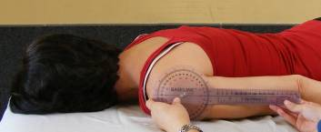
- Place the center of the goniometer body over the humeral head. Align the stationary arm with the lateral mid-line of truck.

- Have patient lift the arm backward as far as possible. Align moving arm with lateral epicondyle of humerus. Read the angle.

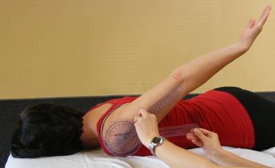

Normal ROM:
50-60⁰
Do both left and right sides and compare the readings.

Measuring Shoulder External and Internal Rotation with a Goniometer
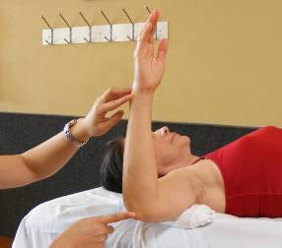
- Patient in supine position. Place a folded pillow case under the humerus to keep shoulder and elbow level. Elbow is bent at 90⁰ angle and forearm is perpendicular to floor.

Locate the olecranon process and the ulnar styloid process.

- Place center of goniometer body over olecranon process and keep stationary arm perpendicular to floor.

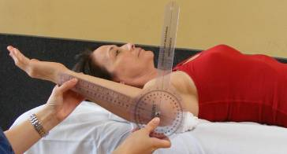

- For external rotation, have patient move the forearm upward towards the head. Align moving arm with ulnar styloid process. Read angle.

Normal ROM: 80-90⁰
Do both left and right sides and compare the readings.

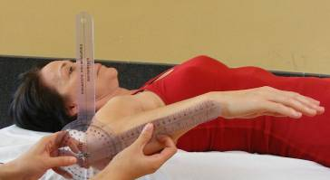

- For internal rotation, have patient move the forearm downward towards the feet. Align moving arm with ulnar styloid process. Read angle.

Normal ROM: 60-100⁰
Do both left and right sides and compare the readings.

Measuring Shoulder Abduction with a Goniometer

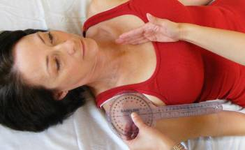
- Patient in supine position.

Locate the anterior aspect of the acromion process and the sternum.

Place the center of goniometer body over anterior aspect of acromion process and align stationary arms with sternum.

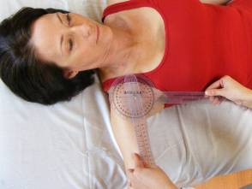
- Have patient abduct the arm, moving laterally outward.

Here the arm is abducted about half way; have patient turn the palm up and continue the movement.

- When patient has abducted as far as possible to the ear, align the moving arm with the anterior mid-line of the humerus. Read the angle.

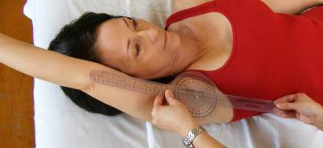

Normal ROM: 170-180⁰
Measuring Hip Flexion with a Goniometer
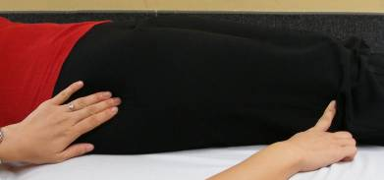
- Patient in supine position.

Locate the greater trochanter of the femur and the lateral epicondyle of femur.

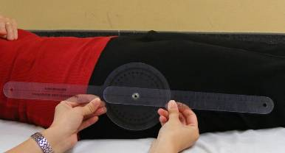

- Place the center of the goniometer body over the greater trochanter. Align the stationary arm with the lateral mid-line of the pelvis. Align the moving arm with lateral epicondyle of femur.

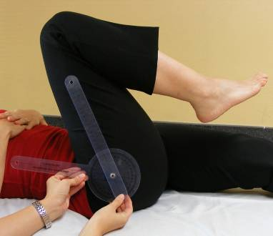
- Stabilize pelvis and have patient flex hip bringing thigh close to the trunk with knee bent. Align moving arm with lateral epicondyle of femur. Read the angle.

Normal ROM: 110-120⁰
Do both left and right sides and compare the readings.

Measuring Hip Extension with a Goniometer

- Patient in prone position.

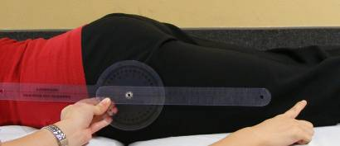
Locate the greater trochanter of the femur and the lateral epicondyle of the femur.

- Place the center of goniometer body over the greater trochanter. Align the stationary arm with the lateral mid-line of the pelvis.

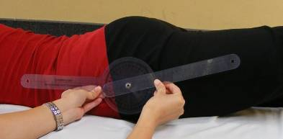

- Stabilize pelvis and have patient extend hip by lifting the leg upward. Align moving arm with lateral epicondyle of femur. Read the angle.

Normal ROM: 10-15⁰
Do both left and right sides and compare the readings.

Measuring Hip Abduction with a Goniometer

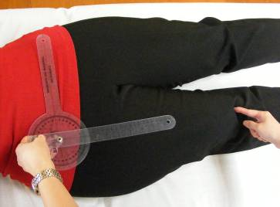
- Patient in supine position, with toes pointing up (no rotation).

Locate the anterior superior iliac spine (ASIS) on both sides and the midline of the femur.

Place the center of goniometer body over the ASIS of the side being measured and point the stationary arm to the opposite ASIS.
Align the moving arm with the with the midline of the femur, using the midline of the patella for reference.

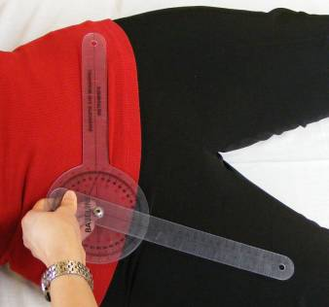
- Stabilize pelvis and have patient abduct the leg, moving laterally outward.

Read the angle.

Normal ROM: 30-50⁰
Do both left and right sides and compare the readings.

Measuring Hip Adduction with a Goniometer

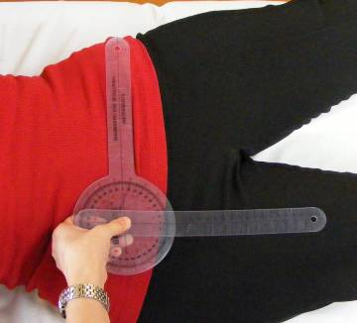
- Patient in supine position, with toes pointing up (no rotation). Have patient move the leg of the non-testing side laterally out of the way.

Locate the anterior superior iliac spine (ASIS) on both sides and the midline of the femur, using the midline of the patella for reference.

Place the center of goniometer body over the ASIS of the side being measured and point the stationary arm to the opposite ASIS.
Align the moving arm with the with the midline of the femur, using the midline of the patellar for reference.

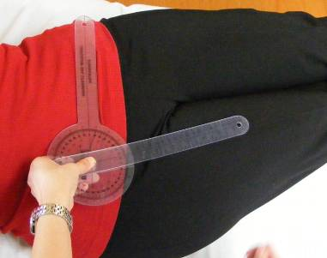

- Stabilize pelvis and have patient adduct the leg, moving it medially inward.

Read the angle.

Normal ROM: 0-30⁰
Do both left and right sides and compare the readings.

Measuring Hip External and Internal Rotation with a Goniometer

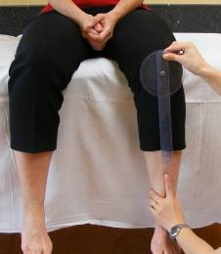
- Patient in seated position with lower legs dangling freely(short sit), perpendicular to floor.

Locate the anterior aspect of the patella and the midline of the tibia.

- Place the center of goniometer body over the center of the patella and keep stationary arm of goniometer perpendicular to floor.
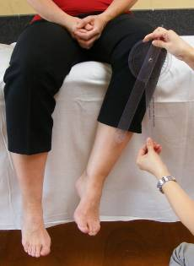

- For external rotation, stabilize distal femur head with one hand and distal fibular with another. Guide the patient to move the lower leg medially as much as he/she can without moving the hip. Stationary arm is perpendicular to the floor: align the moving arm with the midline of tibia. Read angle.

Normal ROM: 40-60
Do both left and right sides and compare the
readings.

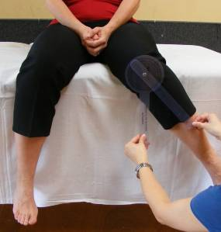

- For internal rotation, stabilize distal femur head with one hand and distal fibular with another. Guide the patient to move the lower leg laterally as much as he/she can without moving the hip. Stationary arm is perpendicular to the floor: align the moving arm with the midline of tibia. Read angle.

Normal ROM: 30-40
Do both left and right sides and compare the readings.
Measuring Knee Flexion with a Goniometer

- Patient is supine.
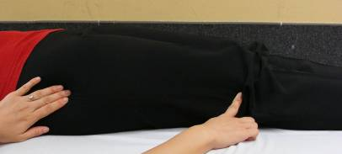
Locate greater trochanter and lateral epicondyle of the femur.

Place the center of goniometer body on lateral epicondyle of femur. Align stationary arm with midline of femur, using greater trochanter for reference.
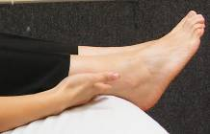

Locate the lateral maleolus.

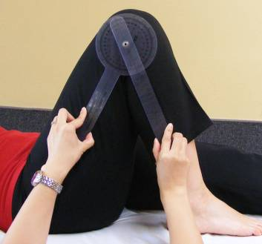
- Have patient flex knee. Align moving arm with the lateral maleolus.

Read the angle.

Normal ROM: 135⁰

