AAF Enterprise Agent Factory — Project Plan
Governed self-service AI agent platform, built on Microsoft Foundry inside a customer's Azure/Microsoft 365 tenant.
Living document owner: Ali · status: pre-build, planning complete · last updated: 2026-10-03
Contents

1. Executive concept
2. Target user experience
3. Architecture
4. Agent creation UI
5. NLP → Agent Blueprint
6. Governance gate
7. Approval model
8. Who builds what
9. MVP scope
10. Work breakdown
11. Timeline
12. Tech stack
13. Microsoft service notes
14. Research checklist
15. Open questions
16. Change log

1. Executive concept
AAF Enterprise Agent Factory is a governed self-service platform deployed inside a customer's Microsoft/Azure tenant. Authorized business users describe an AI use case in natural language, select approved data sources, tools, departmental context and access controls through a guided GUI, and submit the result for automated validation and human approval. Once approved, the platform creates and publishes the agent using Microsoft Foundry and exposes it through approved channels (Teams, Microsoft 365, or a custom app).
The product is not "access to Foundry." It's the enterprise factory built around Foundry: templates, a business-friendly creation experience, tool/data catalogs, policy enforcement, approval workflows, evaluation, identity, observability and lifecycle management.
2. Target user experience
- Create Agent — plain-language description of the business problem
- Choose department / function — HR, Finance, Procurement, IT, Security, Sales, Operations…
- Choose agent type — Knowledge Assistant, Analyst, Process Agent, Action Agent, Monitoring Agent, or template
- Select knowledge sources — approved SharePoint sites, docs, databases, knowledge bases
- Select actions/tools — Teams, Outlook, ServiceNow, SAP, CRM, security tools, APIs, MCP tools
- Define audience — named users, Entra groups, department, business unit
- Review generated Agent Blueprint — purpose, instructions, model, data, tools, permissions, risk class, guardrails
- Test in sandbox — sample prompts, business test cases
- Submit for approval — automated policy checks + human approval where required
- Publish — versioned, registered, monitored, exposed via approved channels
3. Architecture
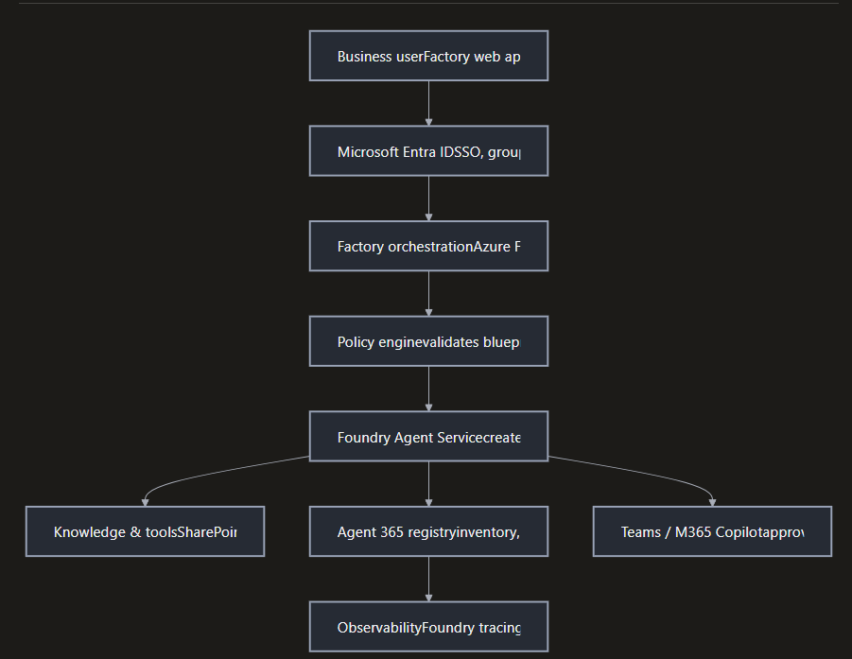

Layer | Component | Purpose
User experience | AAF Agent Factory Web App / Teams App | NL agent creation, forms, templates, test, submit, status, catalog
Identity | Microsoft Entra ID | SSO, groups, RBAC, Conditional Access, user/agent identity
Factory orchestration | Azure Functions / App Service + API Management | Validate input, assemble blueprint, call Foundry APIs, versioning, submit/publish
NLP / agent design | Foundry model + structured schema | Convert intent into a constrained Agent Blueprint
Policy engine | Functions/APIM + Azure Policy + Purview/DLP | Enforce approved models, data classes, tools, connectors, audiences
AI platform | Foundry Agent Service | Agents, models, instructions, tools, knowledge, versions, runtime, observability
Tool catalog | Azure API Center + approved MCP/API tools | Expose only approved tools to citizen builders
Data / knowledge | SharePoint, Azure Storage, Azure AI Search, SQL, Fabric | Ground agents in authorized enterprise knowledge
Security | Entra, Managed Identities, Key Vault, private networking, Defender/Purview | Least privilege, secrets, network controls, monitoring
Governance | Agent 365 + Power Platform governance where relevant | Tenant-wide inventory, approval, ownership, lifecycle
Observability | Foundry tracing/eval + Azure Monitor/App Insights + SIEM | Quality, latency, errors, usage, cost, tool activity, security telemetry
4. Agent creation UI (10 pages)
Should read as an enterprise service catalog, not an Azure admin console.
- Describe — "What would you like your agent to do?" + examples + structured outcome field
- Context — department, process, agent type, risk sensitivity, expected users
- Knowledge — searchable catalog of sources the user is entitled to select
- Actions — searchable tool catalog, permission-aware filtering
- Behaviour — tone, response format, human approval required, escalation, business hours
- Security — data classification, audience, geography, external sharing, action restrictions
- Review — generated blueprint + visual capability summary (Models + Knowledge + Tools + Users + Guardrails)
- Test — sample prompts, expected outcomes, evaluation results, red-team/security checks
- Submit — owner, business sponsor, expiry/review date, deployment channel, approval route
- Lifecycle — published version, users, usage, cost, evaluations, incidents, change history
5. NLP → Agent Blueprint
The NLP layer never lets raw user text bypass policy. It converts intent into a constrained, schema-validated blueprint — approved templates and the tool/data catalog bound what it can produce; it cannot invent connectors, permissions, or security settings.
Example request: "Create an HR agent that answers employee questions about leave policies using our HR SharePoint site and can raise a ServiceNow request when the employee needs HR support."
{
"name": "HR Leave & Support Agent",
"department": "HR",
"pattern": "knowledge_action",
"modelPolicy": "approved-general-enterprise",
"knowledgeSources": ["HR-SharePoint-Leave"],
"tools": ["ServiceNow-Create-HR-Request"],
"audience": ["All-Employees"],
"dataClassification": "HR-Sensitive",
"humanApproval": true,
"externalSharing": false,
"channels": ["Teams"],
"owner": "user@customer.com",
"reviewPeriodDays": 180
}
Internally this is machine-readable JSON; the user always sees a human-readable blueprint before submission.
6. Governance gate
Every agent passes an automated policy gate before human approval:
- Identity — is the requester authorized to create agents?
- Department — is the function allowed for this user?
- Model — approved for this data classification?
- Knowledge — sources approved and accessible to the intended audience?
- Tools — present in the approved tool catalog?
- Permissions — minimum required only?
- Data — personal, financial, health, security, or other restricted data involved?
- Actions — create, modify, delete, approve, transfer, send?
- Human-in-the-loop — required before consequential actions?
- External access — prohibited or restricted?
- Network — private connectivity required?
- Evaluation — minimum quality/safety thresholds met?
- Ownership — named business + technical owner?
- Lifecycle — expiry/review date set?
7. Approval model (risk-based)
Risk | Example | Gate
Low | Read-only knowledge agent, approved data | Automated checks; optional dept approval; publish
Medium | Business actions or sensitive internal data | Department owner + AI/security policy approval
High | Financial, HR-sensitive, security, privileged/consequential actions | Business owner + security/privacy + AI platform approval; human-in-loop
Restricted | Unapproved data, arbitrary external tools, destructive actions | Block, route to AAF/customer engineering review
8. Who builds what
Party | Responsibility
Microsoft | Foundry Agent Service, models, agent runtime, RBAC, agent identities, evaluation/observability, M365 agent governance
AAF | Factory UX, templates, business taxonomy, policy orchestration, approval workflows, tool catalog design, integrations, dashboards, managed service
Customer IT/Security | Identity groups, data ownership, security policies, approved apps/sources, risk appetite, approval authorities
Architecture principle: don't build a second AI platform. Foundry, Entra, Agent 365, Purview and Azure API Management supply the platform; AAF's IP is the factory experience, templates, policy orchestration, catalog, approval model, deployment patterns and operating model.
9. MVP scope
- One customer Azure/Microsoft tenant
- One Foundry resource, controlled project structure
- AAF web portal authenticated with Entra ID
- 5–8 agent templates
- Natural-language use-case description
- Department + agent type + knowledge + tool + audience dropdowns
- Approved tool catalog, 5–10 tools
- Automated blueprint generation
- Policy validation
- Human approval workflow
- Foundry agent creation and versioning
- Teams as first consumption channel
- Basic evaluation and monitoring
- Agent inventory + owner/review-date dashboard
10. Work breakdown
Phase 0 — Foundations
Azure tenant, CI/CD, repo skeleton
Resource group structure (dev/test/prod), Entra app registrations, GitHub repo, CI/CD pipeline deploying a hello-world Function + static site.
Phase 1 — Identity & shell UI
The Factory app skeleton
Entra ID auth (MSAL), routing through all 10 UX pages as empty forms, no real logic yet.
Phase 2 — Blueprint schema & NLP layer
Natural language → structured blueprint
Define the Agent Blueprint JSON schema, build the prompt + structured-output call constrained by templates/catalogs so it can't invent connectors or permissions.
Phase 3 — Policy engine & catalogs
The governance gate, in code
Implement the 14-point governance checklist against small catalogs of approved sources/tools; Azure API Center as the tool inventory.
Phase 4 — Foundry integration
Blueprint → real agent
Functions/App Service calling Foundry Agent Service APIs: create agent, attach knowledge, attach tools, create dev/test version.
Phase 5 — Approval workflow & publish
Human-in-the-loop, Teams
Approval UI/notifications, versioning, publish pipeline to Teams via Foundry's GA publish-to-Teams/Copilot path.
Phase 6 — Lifecycle & observability
Dashboard, monitoring
Agent inventory dashboard, Azure Monitor/App Insights wiring, basic eval hooks, owner/review-date tracking; Agent 365 once budget allows.
11. Timeline (self-paced, fast)
Phase | Fast-pace estimate | Done when…
0. Foundations | 3–5 days | Hello-world deploys via CI/CD
1. Identity & shell | 1–1.5 weeks | Login works, all 10 pages routable
2. Blueprint & NLP | 2–3 weeks | Plain-language input → valid schema-conforming blueprint
3. Policy engine & catalogs | 2 weeks | Blueprint auto-approved/rejected/flagged against a real catalog
4. Foundry integration | 2–3 weeks | Approved blueprint creates a running test agent in Foundry
5. Approval & Teams publish | 1.5–2 weeks | Human approves; agent usable in Teams
6. Lifecycle & observability | 1.5–2 weeks | Dashboard shows agents, owners, status, usage signal
Total to working MVP | ~11–15 weeks | 5–8 templates, end-to-end flow, Teams-only channel
Highest slippage risk: Phase 2 (NLP reliability) and Phase 4 (Foundry API surface). Worth a small early spike on both rather than waiting for their scheduled phase.
12. Tech stack
Layer | Pick | Why
Factory frontend | React + TypeScript on Azure Static Web Apps (free tier) | Free tier covers MVP; pairs with Functions backend
Backend/orchestration | Azure Functions + Azure API Management (Consumption) | Serverless, near-zero idle cost, matches architecture
Identity | Microsoft Entra ID + MSAL.js | Required for Foundry/Teams integration anyway
Schema validation | Pydantic (Python) | Free, enforces blueprint schema server-side
Policy engine | Hand-rolled rules module first; Azure Policy later | Don't over-engineer for MVP
AI/agent platform | Microsoft Foundry Agent Service | Core requirement, GA since March 2026
Tool catalog | Azure API Center (Free plan) | Zero cost, does the discovery job needed
Knowledge/data | SharePoint + Azure AI Search (free tier for dev) | Matches architecture; fine until real document volume
Database | Azure Cosmos DB free tier (1000 RU/s + 25GB) or Azure SQL serverless free tier | Genuinely free always-on tiers
Secrets | Azure Key Vault | Needed the moment real credentials show up
CI/CD | GitHub Actions | Free for small repos, deploys to Azure directly
Design/prototyping | Figma (free tier) | Mock the 10-page UI before coding it
Project tracking | GitHub Projects or Trello (free) | No paid tooling needed yet
Governance (post-MVP) | Agent 365 | Real line item (~$15/user/mo standalone); bring in once past solo-dev MVP
13. Microsoft service notes (researched)
Foundry Agent Service GA
Core AI/agent runtime
Reached general availability in March 2026 with end-to-end private networking, Voice Live integration, expanded MCP authentication, GA evaluations with continuous monitoring, and hosted agent deployments across six new Azure regions. In June 2026, Claude became GA inside Foundry (Messages API, prompt caching, extended thinking, tool streaming), and Foundry agents gained GA publishing straight into Microsoft 365 Copilot and Teams — so the "Teams as first channel" MVP goal is now a governed first-party pipeline rather than a custom integration.
Agent 365 GA — paid
Tenant-wide agent governance / registry
GA since May 1, 2026. Standalone pricing is $15/user/month, or bundled into Microsoft 365 E7 at $99/user/month. At GA, admins can install, publish, block, unblock, delete, and assign new owners for agents directly from the registry; it also assigns each agent its own Entra ID. This is a real budget line, not a free dev tool — worth bringing in once governance needs to be tenant-wide rather than during solo MVP development.
Azure API Center Free plan available
Tool/API catalog
Design-time API governance and centralized discovery — exactly the "tool catalog" layer the architecture needs. Has a genuine Free plan (no Microsoft support on that tier, but functionally enough for a 5–10 tool MVP catalog). Distinct from Azure API Management, which is the runtime gateway.
Azure Functions & Azure API Management
Orchestration layer
Functions (Consumption plan has a free monthly grant) hosts the blueprint-assembly and policy-check logic. APIM fronts it as a governed gateway; its Consumption tier is usage-based and cheap at MVP scale — don't reach for the Developer/Standard tiers until you need policies like rate limiting or OAuth validation at the gateway itself.
Microsoft Entra ID
Identity backbone
Handles SSO, groups, RBAC, Conditional Access, and both user and agent identity (Agent 365 assigns each agent an Entra ID). Free tier (Entra ID Free) covers basic app registration and group-based access for MVP; Conditional Access policies require P1/P2 licensing — relevant once the customer tenant needs them, not for your own dev tenant.
Microsoft Purview
Data governance, DLP, sensitivity labels
Supplies data classification and DLP enforcement the policy engine checks against (the "could this agent access personal/financial/health data" gate). Purview's AI-specific governance features (for Copilot/agent data flows) have been evolving quickly through 2025–2026 — worth a fresh docs check closer to Phase 3/6 rather than relying on older material.
Azure Key Vault
Secrets & certificates
Standard tier has a generous free-tier-equivalent pricing model (pay per operation, trivial at dev scale). Prefer Managed Identities over stored secrets wherever Functions/APIM talk to Foundry or other Azure services — avoids needing Key Vault for most internal service-to-service auth.
SharePoint / Microsoft Graph
Knowledge source
Primary enterprise knowledge source for Knowledge Assistant-type agents, accessed via Graph with permission scoping so agents only see what their audience is entitled to. Needs a real Microsoft 365 tenant (not just an Azure subscription) to test against meaningfully.
Microsoft Defender
Security monitoring
Covers runtime security signals — prompt injection, data exfiltration via tool calls, anomalous agent behavior — and integrates with Agent 365's "secure" pillar. Defender for AI / Defender for Cloud Apps coverage of agents is a fast-moving area; check current docs before Phase 6 rather than assuming older capability descriptions still hold.
Azure AI Search
Retrieval/grounding
Backs RAG-style grounding for Knowledge Assistant agents when raw SharePoint/Graph search isn't precise enough. Has a free tier (small index size, fine for MVP-scale testing) before needing Basic/Standard.
Application Insights / Azure Monitor
Observability
Captures Factory app telemetry (errors, latency, usage) separately from Foundry's own agent-level tracing/evaluation — the architecture needs both, piped into one dashboard for Phase 6. Has a free monthly data allowance generous enough for MVP telemetry volume.
Power Platform
Low-code workflow option
Optional: useful if a business workflow (e.g. the approval routing or a notification step) is better expressed as a Power Automate flow than custom code. Not core to the MVP — treat as a later convenience rather than a Phase 0–6 dependency.
14. Research checklist
Topics flagged for a closer look, with current status:
Service | Status
Foundry Agent Service | Verified current (GA, March 2026) — notes above
Agent 365 | Verified current (GA, May 2026, pricing) — notes above
Azure API Center | Verified current (Free plan exists) — notes above
Azure Functions | Stable service, general knowledge applied — light check before Phase 0 pricing tiers
Azure API Management | Stable service, general knowledge applied — check Consumption tier limits before Phase 0
Microsoft Entra ID | Stable service, general knowledge applied — check Conditional Access licensing before customer deployment
Microsoft Purview | Needs fresh check — AI/agent-specific governance features moving fast
Azure Key Vault | Stable service, general knowledge applied
SharePoint / Graph | Stable service, general knowledge applied — check Graph permission scopes before Phase 4
Microsoft Defender | Needs fresh check — Defender-for-AI/agent coverage moving fast, relevant for Phase 6
Azure AI Search | Stable service, general knowledge applied — check free-tier index limits
Application Insights | Stable service, general knowledge applied
Power Platform | Stable service, general knowledge applied — optional dependency only
15. Open questions
- Which customer tenant (if any) is the actual target for the first real deployment, vs. building against your own dev tenant only?
- Does the dev tenant have a real Microsoft 365/SharePoint presence, or does Phase 4+ need a seeded test tenant?
- Backend language choice: Node.js or Python for Azure Functions — not yet decided.
- When does Agent 365 licensing get introduced — MVP, or only once there's a paying customer tenant?
16. Change log
2026-10-03 — Initial document created from the requirements discussion: concept, architecture, UX flow, blueprint schema, governance gate, approval model, work breakdown, timeline, tech stack, and Microsoft service research.

