Software Requirements

Specification

­For

Hotwire Communication LTD.

Version 1.0

Prepared by **Mahbubul Islam**

(NOC Tech OPS)

Passdown for NOC Department

“The NOC Dept. who is making Passdown software for Hotwire Communication Ltd.”

**March 12, 2018**

Software Requirements Specification for Hotwire Communication Ltd.

**Table of Contents**

Table of Contents .......................................................................................................................... ii

Revision History ............................................................................................................................ ii

1. Introduction ..............................................................................................................................1

1.1 Purpose ........................................................................................................................... 1

1.2 Document Conventions .................................................................................................. 1

1.3 NOC .................................................................2

1.4 Project Scope ................................................................................................................. 2

1.5 References ..................................................................................................................... 2

2. Overall Description ..................................................................................................................3

2.1 Product Perspective ....................................................................................................... 3

2.2 Product Features ............................................................................................................ 3

2.3 User Classes and Characteristics ................................................................................... 4

2.4 Operating Environment ................................................................................................. 4

2.5 Design and Implementation Constraints ....................................................................... 4

2.6 User Documentation ...................................................................................................... 5

2.7 Assumptions and Dependencies ................................................................................... 5

3. System Features ......................................................................................................................5

3.1 System Feature 1 ............................................................ Error! Bookmark not defined.

3.2 System Feature 2 (and so on) ......................................... Error! Bookmark not defined.

4. External Interface Requirements ...........................................................................................5

4.1 User Interfaces ............................................................................................................. 5

4.2 Hardware Interfaces ..................................................................................................... 6

4.3 Software Interfaces ...................................................................................................... 6

4.4 Communications Interfaces .......................................................................................... 6

5. Other Nonfunctional Requirements .......................................................................................6

5.1 Performance Requirements .......................................................................................... 6

5.2 Safety Requirements .................................................................................................... 6

5.3 Security Requirements ................................................................................................. 7

5.4 Software Quality Attributes .......................................................................................... 7

6. Other Requirements ................................................................................................................7

Appendix A: Glossary.....................................................................................................7

Appendix B: Analysis Models .......................................................................................7

Appendix C: Issues List .................................................................................................7

**Revision History**

|  |  |  |  |
| --- | --- | --- | --- |
| **Name** | **Date** | **Reason For Changes Version** | **Version** |
| Mahbubul Islam | 03/09/2018 | Initial Draft | 1.0 |
| Qais Hassanzada | 03/09/2018 | Mock up design | 1.0 |
| Mahbubul Islam | 03/12/2018 | Initial design in progress | 1.0.1 |

Software Requirements Specification for Hotwire Communication Ltd.

**1. Introduction**

1.1 Purpose

To ensure that information, concerning ongoing issues, is transferred efficiently from shift to shift, the following procedures have been developed. This is a NOC Shift Turnover and Help Desk Hand-off process as well. As issues are transferred between the NOC to Help Desk, there is a transitional document developed to assist both groups. This will allow each group to continue problem resolution seamlessly.

**1.2 Document Conventions**

Shift Turnover is a form of communication between First and Second shift. Calls/Tickets that are initiated on either shift will have full informational transfer to the other shift. Executing shift turnover will be transparent to the end user. Datacenter and Network status at the time of shift turnover will be documented and transferred to the next shift.

Software Requirements Specification for Hotwire Communication LTD.

**1.3 NOC**

**1.2 Network Operations Center (NOC)**

NOC (Network Operations Center), as the facility that monitors, troubleshoots, and reports incidents that are abnormal in the environment or changes that will impact normal operations of the HW Network. The NOC also provides service desk coverage from 9:00am – 6:00pm. The NOC is manned 24x7 and runs two shifts; 9:00am to 6:00pm and 6:00 pm to 2:00am and 2:00 am to 9:00am. The transfer of operational information between shifts is called the Shift Turnover.

**1.5 Responsibility**

Provide a listing of workers that are responsible for activities in this procedure, as well as a description of their responsibilities.

| Role | Responsibilities |
| --- | --- |
| Service Desk Agent Ending Shift | Complete NOC turnover document and email to the NOC at end of shift |
| Service Desk Agent Beginning Shift | Review NOC turnover document; Ensure he/she has a good understanding of current state of the NOC and any outstanding user issues from overnight |
| NOC Personnel ending Shift | Complete End of Shift Checklist; Complete NOC turnover document |
| NOC Personnel beginning shift | Review NOC turnover document; Ensure he/she has a good understanding of current state of the NOC; |

The designated NOC Personnel will be responsible for ensuring that Shift Turnover is always completed. The shift turning over must ensure that the next shift has all of the necessary information, tools, and whatever necessary to resolve the ongoing issue or problem. The ultimate goal is to appear to the customer as though the NOC never changed shifts at all.

**2.0 NOC Shift Turnover Process**

The shift turnover process begins 30 minutes prior to the end of the shift. Follow the steps below to complete the shift turnover process

1. By 8:45, complete data Center walk through i.e. (power and temperature checks). Use Pre-turnover checklist and NOC temperature checklist below

2. Complete Solar Winds status update to document the connectivity state of the stations and remote offices.

3. Complete the NOC Turnover Document which details all actions that have occurred by Altiris ticket number; include a complete explanation of current status. NOC/Service Desk will continue problem resolution from that point.

4. Completed forms will be

a. If pm turnover, given to the NOC personnel beginning their shift at 6 pm

b. If am turnover, given to the NOC personnel beginning their shift at 7am and emailed to #helpdesk for the service desk

NOTE – Service Desk Agents are responsible for communicating outstanding issues to the NOC via the NOC turnover document at the end of their shift via email to ______________

**2.1 Pre-Turnover NOC checklist**

* Data Center Walkthrough: Walk through the entire Datacenter and ensure that appropriate devices are powered on, that there are no unwanted Error lights or alerts, and check and log temperature levels.
* List stations that have SOLARWINDS alerts and what the status of that alert is i.e. Yellow, or Red.
* List stations that have Big Brother alerts and what the status of that alert is IE Yellow, or Red.
* Complete a Data Center walkthrough every two hours and ensure that all necessary equipment is powered on and that there are no error lights.
* Check and document room temperatures periodically. These temperatures will be che4cked every 3 hours.
* Ensure that NOC/Work area is clean and in order.
* Ensure that Area is physically secure.

**2.2 Product Features**

There will be following pages that would be on the web-based NOC Passdown Application:

1. **Home Page:** This will be the landing page for any user. When the user types in the URL in

the address bar, the users will land to this page. This page will contain the following links

and functionalities

a. Header of the page: Will contain the Welcome NOC Passdown with Banner

b. Left header corner: Will contain the logo of Hotwire Communication Ltd.

c. Right navigation menu: Will contain the following Menu:

i. Home: Clicking on this will remain on the home page.

ii. Login: Clicking on this link will take to user login page.

iii. Sign Up: Clicking on this will take to the Sign-up page for user.

1. **Login:** Once the user’s login, they will have a lot of functionalities, for example Showing three tab (Menu).
2. **Sign Up Page:** Sign up page allow to sign up only employee of Hotwire Communication Ltd. And it will automatically save in MYSQL database of Linux server. It’s also protect to Robot SQL injection auto sign up protection using human 2 step verification with email link notification.
3. **Overview:**
4. **Task:**
5. **Maintenance :**
6. **Log out:** Log out will be secure logout and will disappear user name.
7. **Backend:** Back end using MYSQL Database using the SQL Query to generate HTML5 (Responsive) view visualization.

All the above functionalities will be described in detail for separate Use Cases (or Design

Documents).

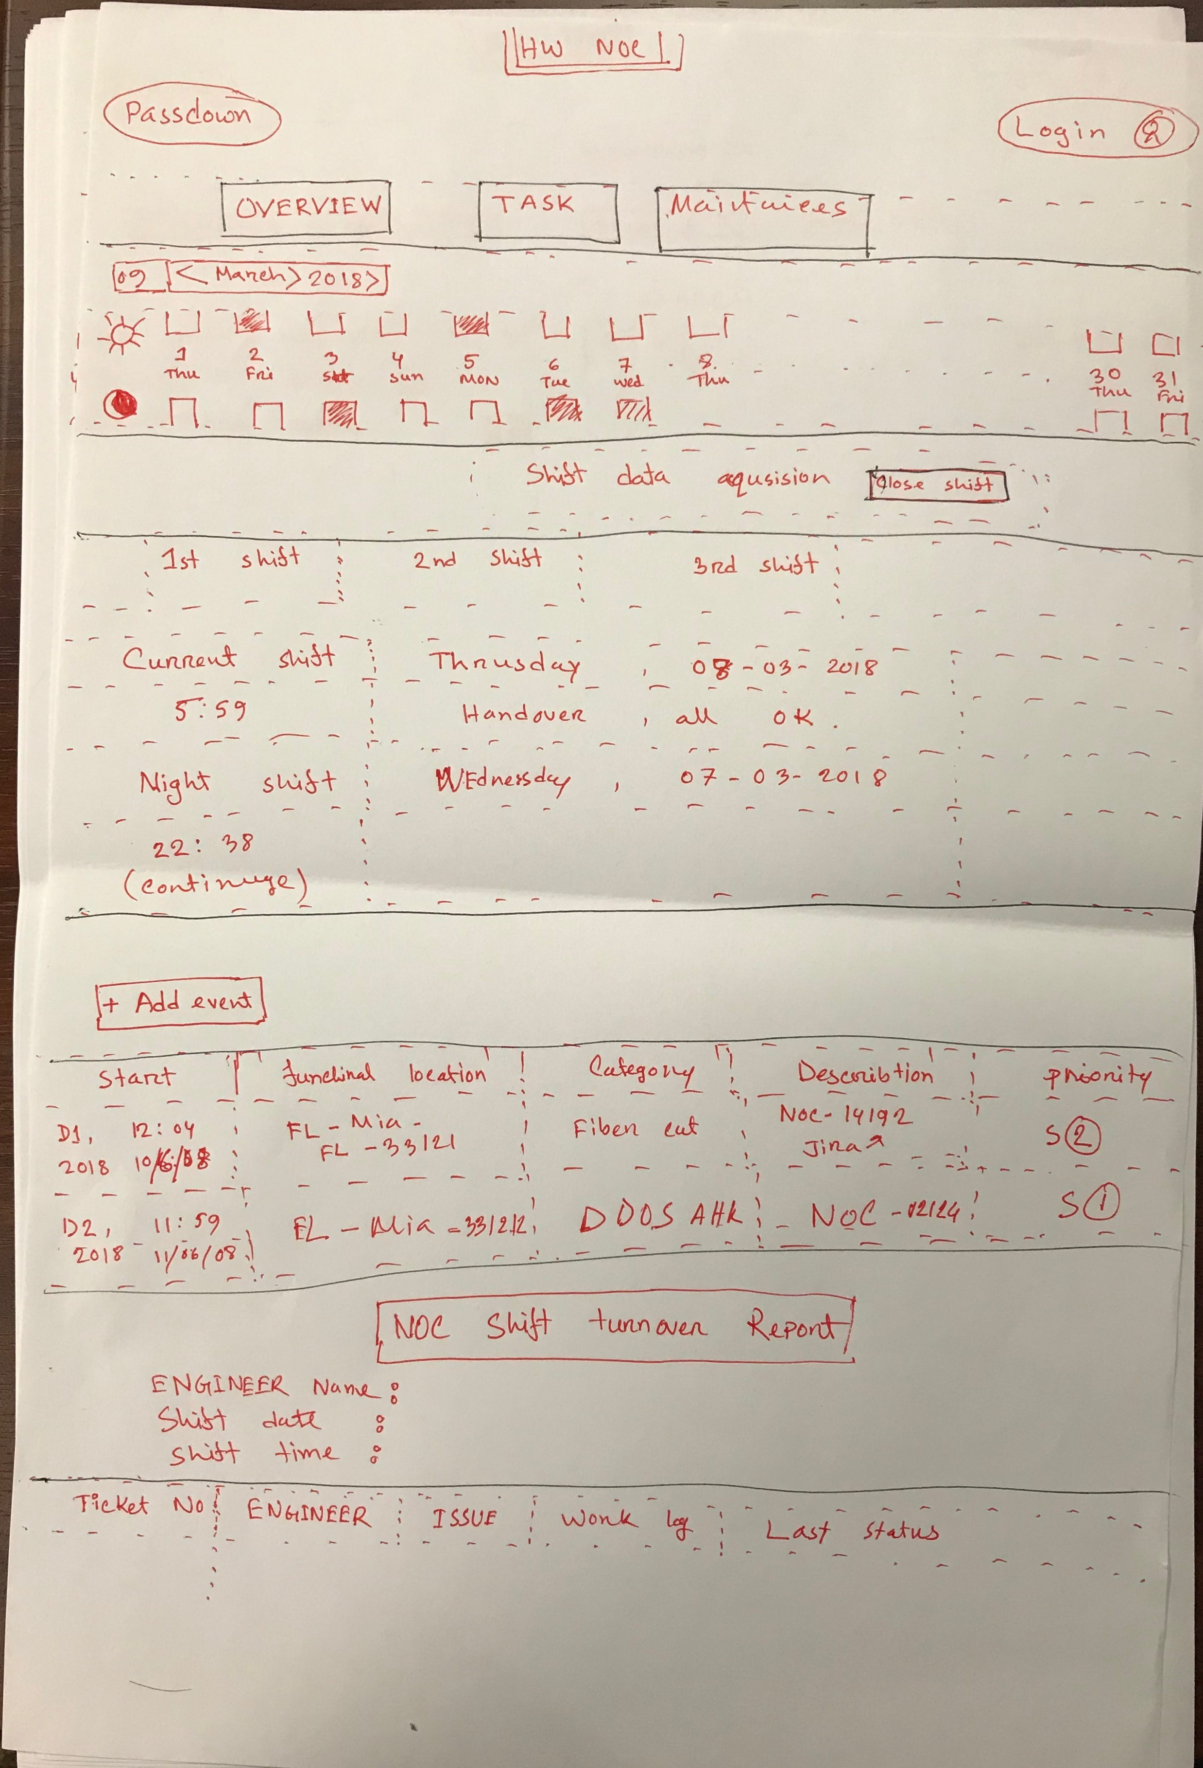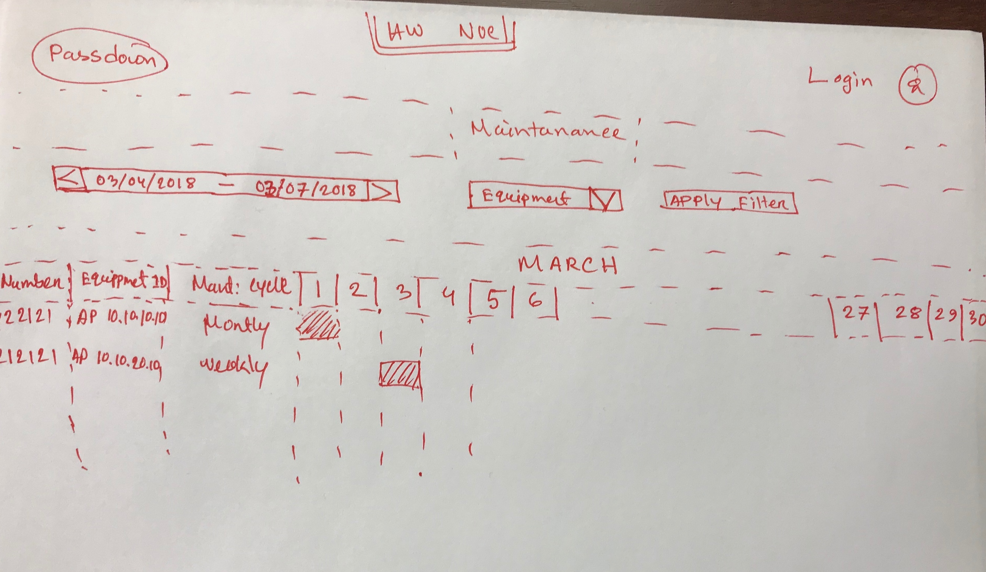

Sample : Shift turnover report

**NOC Shift Turnover Report**

Engineer Name: Shift Date:

Shift Time:

|  |  |  |  |  |
| --- | --- | --- | --- | --- |
| Ticket No. | Engineer | Issue | Work Log | Last Status |
|  |  |  |  |  |
|  |  |  |  |  |
|  |  |  |  |  |

**2.3 User Classes and Characteristics**

**2.4 Operating Environment**

**2.4 Operating Environment**

**2.4 Operating Environment**

**2.7 Assumptions and Dependencies**

**3. System Features**

**4. External Interface Requirements**

**4.1 User Interfaces**

**4.2 Hardware Interfaces**

**4.3 Software Interfaces**

**4.4 Communications Interfaces**

**5. Other Nonfunctional Requirements**

**5.1 Performance Requirements**

**5.2 Safety Requirements**

**5.2 Safety Requirements**

**5.4 Software Quality Attributes**

**6. Other Requirements**

**Appendix A: Glossary**

**Appendix B: Analysis Models**

**Appendix C: Issues List**