**Passdown** (LOGO) Logged in with : **Barbara S.**

|  |  |  |
| --- | --- | --- |
| Overview | Event | Maintenance |

**OVERVIEW Page**

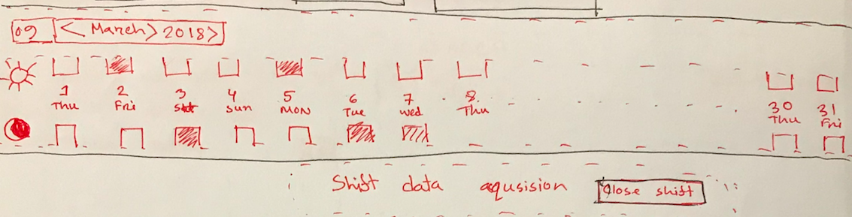

|  |  |  |  |  |  |  |  |  |
| --- | --- | --- | --- | --- | --- | --- | --- | --- |
| ShiftoverDate | ShiftiverTIme | Key / Ticket | T | Status | Jira Summary | NOC Summary | Handover | Assignee |
| 03/14/2018 | 5:59 pm | NOCOUTAGE-14660 | Data | Investing | Grove Resort and SPA | Unit 3506 | pending Chad D to head to site. | Barbara S. |  |



|  |  |  |  |  |  |  |  |  |
| --- | --- | --- | --- | --- | --- | --- | --- | --- |
| 02/14/2018 | 8:59 pm | NOCOUTAGE-14660 | Data | Investing | Grove Resort and SPA | Unit 3506 | pending Chad D to head to site. | John Millar |  |

**Passdown** (LOGO) Logged in with : **Barbara S.**

|  |  |  |
| --- | --- | --- |
| Overview | Event | Maintenance |

**Event PAGE**



|  |  |  |  |  |  |  |  |  |
| --- | --- | --- | --- | --- | --- | --- | --- | --- |
| ShiftBook | Event Time | Key / Ticket | T | Status | Jira Summary | NOC Summary | Priority | ShiftBook |
| Shift 2 | 3:59 pm | NOCOUTAGE-14660 | Data | Investing | Grove Resort and SPA | Unit 3506 | pending Chad D to head to site. | S4 | S4 |
| Shift 1 | 7:59 pm | NOCOUTAGE-14660 | iptv | Investing | Grove Resort and SPA | Unit 3506 | pending Chad D to head to site. | S3 | S3 |
| Shift 2 | 2:59 pm | NOCOUTAGE-14660 | All Service | Investing | Grove Resort and SPA | Unit 3506 | pending Chad D to head to site. | S1 | S1 |
| Shift 1 | 6:59 pm | NOCOUTAGE-14660 | Voice | Investing | Grove Resort and SPA | Unit 3506 | pending Chad D to head to site. | S1 | S1 |

**Passdown** (LOGO) Logged in with : **Barbara S.**

|  |  |  |
| --- | --- | --- |
| Overview | Event | Maintenance |

**Maintenance PAGE**

