A Mini Project Report

On

**Smart Security for Crop Cultivation**

Submitted in partial fulfilment of the

Requirements for the award of degree of

**Bachelor of Technology**

In

**Computer Science and Engineering**

By

1. **Sumanth Kumar (15H61A05C2)**

**MD. Arshiya (15H61A05G2)**

**S. Akhil Reddy (15H61A05H3)**

Under the Guidance of

**Mr K. Raghavendra Rao**

Assistant Professor



**Department of Computer Science and Engineering**

ANURAG GROUP OF INSTITUTIONS

**(Formerly CVSR College of Engineering)**

**(An Autonomous Institution, Approved by AICTE and NBA Accredited)**

**Venkatapur(V), Ghatkesar(M), Medchal Dist., T.S-500088**

**(2015-2019)**

**Department of Computer Science and Engineering**

**ANURAG GROUP OF INSTITUTIONS**

**(Formerly CVSR College of Engineering)**

**(An Autonomous Institution, Approved by AICTE and NBA Accredited)**

**Venkatapur (V), Ghatkesar (M), Medchal Dist., T.S-500088**



**CERTIFICATE**

This is to certify that the project entitled **“Smart Security for Crop Cultivation”** being submitted by **A. Sumanth Kumar** bearing the Hall Ticket number **15H61A05C2**, **MD. Arshiya** bearing the Hall Ticket number **15H61A05G2** and S. **Akhil Reddy** bearing the Hall Ticket number **15H61A05H3** in partial fulfillment of the requirements for the award of the degree of the **Bachelor of Technology** in **Computer Science and Engineering** to **Anurag Group of Institutions (Formerly CVSR College of Engineering)** is a record of bonafide work carried out by them under my guidance and supervision from June 2018 to Nov 2018.

The results presented in this project have been verified and found to be satisfactory. The results embodied in this project have not been submitted to any other University for the award of any other degree or diploma.

**Internal Guide External Examiner**

**Mr. K. Raghavendra Rao**

**(Assistant Professor)**

**Dr. G. Vishnu Murthy,**

**Professor and Head, Dept. of CSE**

**ACKNOWLEDGEMENT**

It is our privilege and pleasure to express profound sense of respect, gratitude and indebtedness to our guide Mr. K. Raghavendra Rao, Assistant Professor, Dept. of Computer Science and Engineering, Anurag Group of Institutions (Formerly CVSR College of Engineering), for his indefatigable inspiration, guidance, cogent discussion, constructive criticisms and encouragement throughout this dissertation work.

We express our sincere gratitude to Dr. G. Vishnu Murthy, Professor & Head, Department of Computer Science and Engineering, Anurag Group of Institutions (Formerly CVSR College of Engineering), for his suggestions, motivations and co-operation for the successful completion of the work.

We extend our sincere thanks to, Principal, Dr. K. S. Rao, Director, Prof. M. Bhagvanth Rao, Director, Dr. V. Vijaya Kumar, Dean, Dept. of CSE & IT, Anurag Group of Institutions (Formerly CVSR College of Engineering), Venkatapur (V), Ghatkesar (M), Medchal(Dist), for their encouragement.

A. Sumanth Kumar (15H61A05C2)

MD. Arshiya(15H61A05G2)

S. Akhil Reddy (15H61A05H3)

Dept. of Computer Science and Engineering,

Anurag Group of Institutions.

**DECLARATION**

We hereby declare that the project work entitled **“Smart Security for Crop Cultivation”** submitted to the **Anurag Group of Institutions (Formerly CVSR College of Engineering)** in partial fulfilment of the requirements for the award of the degree of **Bachelor of Technology (B.Tech)** in Computer Science and Engineering is a record of an original work done by us under the guidance of **Mr. K Raghavendra Rao, Assistant Professor** and this project work have not been submitted to any other university for the award of any other degree or diploma.

1. Sumanth Kumar(15H61A05C2)

MD. Arshiya (15H61A05G2)

S. Akhil Reddy (15H61A05H3)

Date:

**CONTENTS**

PG.NO

1. Introduction……………………………………………………………………..

Purpose

Background

Scope

Features

2. Existing System…………………………………………………………………

3. Proposed System………………………………………………………………..

4. Technologies Used………………………………………………………………

4.1-------- Software Interfaces

5. Architecture……………………………………………………………………..

5.1-------- Authorized user

5.2--------Un-Authorized user

6. Design Modules…………………………………………………………………

6.1-------- Detailed Activity diagrams

6.2-------- Use-cases

6.3-------- Software Requirement Specifications

7. Implementation………………………………………………………………….

7.1-------- IOT Technology

7.2-------- Device Construction steps

8. Sample Code……………………………………………………………………..

9. Testing……………………………………………………………………………

10. Conclusion ………………………………………………………………………

11. Bibliography……………………………………………………………………..

**ABSTRACT**

Most of the farmers are facing an issue of protecting their agricultural farms being attacked by birds and animals. Birds and animals attack the farm for their food which causes a greater loss to the farmer. We came up with a solution to overcome such issues, our approach involves in smart monitoring the farm. Smart monitoring system monitors the farm and if it detects any unusual activity then it will notify the farmer about that activity based on that rappelers can be used to keep animals and birds ward away from the farm.

INTRODUCTION

Surveillance plays a major role in many fields be it at home, hospitals, schools, public places, farmlands etc. It helps us to monitor a certain area and prevent theft and provides proof of evidence in case of occurrence of such incidents. In the case of farmlands or agricultural lands surveillance is very important to prevent unauthorized people from gaining access to the area as well as to protect the area from animals. Various methods aim only at surveillance which is mainly for human intruders, but we tend to forget that the main enemies of such farmers are the animals which destroy the crops. The problem of wild animal attacks on crop fields i.e. Crop vandalization is becoming a very common phenomenon in the state of Telangana, Himachal Pradesh, Punjab, Haryana and many other states. Wild animals like monkeys, estray animals especially cows and buffaloes, wild dogs, nilgais, bisons, elephants, deer, wild pigs and even birds like parakeets cause a lot of damage to crops either by running over them or eating them and vandalizing them completely. This leads to poor yield of crops. These animals attack on fruit orchards and destroy the flowerings and fruits. In both cases, this leads to significant financial loss to the farmers and orchard owners. The problem is so pronounced that sometimes farmers decide to leave the area barren due to these animal attacks. The main aim of this project is to provide **an effective solution to this problem**, so that the **economic losses incurred by our farmers are minimized**and they have a good crop yield.

**1.1 Purpose**

In India two- third of population is directly depending on agricultural sector for their livelihood. The animals from the wild area are continuously attacking to crop from so many years and the protection of this crop field from wild animals is the serious issue. The wild animals face an shortage of water and food due to which they move towards the agriculture area which creates great loss to the crops and annual income of farmers, It has been estimated that at minimum conservative average damage per household of  **₹6,000, 15 million families could suffer a cumulative loss of ₹ 9,000 crore** every year. This is a very huge amount to loose in a country like India. when wild animals enter in a farm there is a need for an alert system to prevent crops from damages from wild animal.

   This project aims to provide an effective solution to the problem stated above in the form of an **ELECTRONIC SURVEILLANCE SYSTEM**. This system will enable the farmers to protect their fields and orchards effectively, **without any human intervention,**by warding off the animals with **automatically and manually controlled ultrasonic animal repellent buzzers.** It will also enable them to remotely monitor their fields from any place, thus **eliminating the need of physical presence** of a person in the fields

**1.2 Background**

Various traditional techniques are used for providing security but up to date, complete security is not discovered.

1.Electric fencing around the crop

2.Building of wall around the crop fields

3.Use of local dogs for scaring away wild boars

4.Fencing around the crop

**1.3 Scope**

The main objective of this project is to provide an effective solution to this problem, so that the economic losses incurred by our farmers are minimized and they have a good crop yield. It helps to save time and money by reducing the manual work that is otherwise required if the farmers themselves had to provide protection to their farmlands with their constant manual supervision. The manual work done to keep away the animals from the crops is automated, hence such constant supervision is a thing of the past with such smart protection systems, which can identify and taking the required actions themselves without any human intervention.

1.4 Features

Our proposed system overcomes all the security problems in existing system and provides high security and efficiency. This is a perfect/optimal solution for protecting the farm from wild animals and birds. The features of our product are briefly described below:

1.4.1Effective

#### This system requires almost no human supervision, except for the task of switching the system on and off. The system can turn the buzzers on automatically and warding off the animals thus protecting the fields from any damage.

#### Requires no human supervision

It a determines the presence of animals in the fields and sounds the buzzer This system is very effective in driving off the animals from the fields and keeping them away

#### Economical

#### This system is economical as compared to many of the existing solutions like electric fences, brick walls and manual supervision of the fields. The cost of the existing solutions is very high and the cost of this system is only a fraction of their cost. Thus, it saves a lot of money of the farmer.

#### Real time monitoring

#### This system works in real time to detect the animals in the fields. The system enables the farmer to have a real time view of his fields from any place via internet and even provides manual buzzer controls if the need arises to use them. Thus, the farmer is in effective control of the system and can manually sound the buzzer if needed. The system also provides a history of the events taking place in the fields, in the form of images and textual log records.

#### Causes no harm to animals and humans

#### This system is totally harmless and doesn’t injure animals in any way. It also doesn’t cause any harm to humans. Also, this system has a very low power requirement thus reducing the hazards of electric shocks.

#### Highly flexible

#### This system, although primarily aimed at crop protection, can be used for other purposes also. It may be used as a remote monitoring system, or as a standalone system. Thus it can be installed at places like godowns, places prone to robbery, shops, offices etc.

EXISTING SYSTEM

The existing systems mainly provide the surveillance functionality. Also, these systems don’t provide protection from wild animals, especially in such an application area. They also need to take actions based on the on the type of animal that tries to enter the area, as different methods are adopted to prevent different animals from entering such restricted areas. Also the farmers resort to the other methods by erecting human puppets and effigies in their farms, which is in effective in warding off the wild animals, though is useful to some extent to ward off birds .The other commonly used methods by the farmers in order to prevent the crop vandalization by animals include building physical barriers, use of electric fences and manual surveillance and various such exhaustive and dangerous methods.

PROPOSED SYSTEM

Our proposed system overcomes all the security problems in existing farmland and provides high security and efficiency. This is a perfect/optimal solution for farm protection. It can be operated in two modes automatic and manual.

In automatic mode whenever any bird or animal enter near to the farm then our PIR sensor will detect that some living object has come near the farm then it will be notified to the farmer, and at the same time reppelers like Ultrasonic sensor, Buzzer, Light are used to ward of animals and birds away from the farm. In manual mode after notifying the farmer, the farmer can decide which repellent can be used to ward off the animals and birds through the interface provided to him where he can choose different options consisting of an option for buzzer and other for ultrasonic and Light. Farmer can choose either buzzer option to repel birds and animals or ultrasonic to repel animals.

**TECHNOLOGIES USED**

**Software Interfaces:**

We are using Raspbian Noobs and python programming language for writing the project code.

**Software Requirements:**

1. Raspbian Noobs Version 3 Model B

2. Androids OS

**Hardware Requirements:**

1. RAM: 1.GB SDRAM

2. Hard Disk: 8GB Memory

3. Processor: ARM Cortex A53

4. Sensors: 1. Ultrasonic

2. PIR Sensor

3. Buzzer

4. Led Bulb.

**ARCHITECTURE**

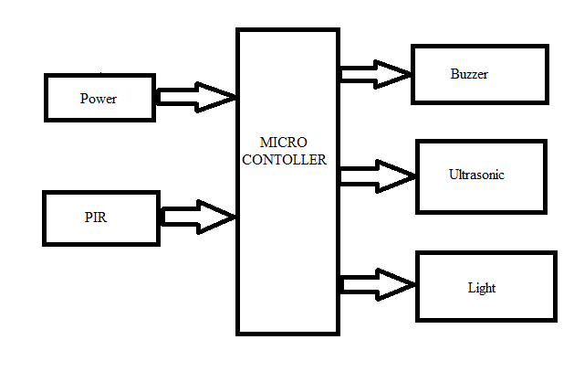

The above diagram shows the architecture of the Smart security for crop protection with its interfaces. The Raspberry pi microcontroller centrally controls all the devices connected to it. The program must be fed into the Raspberry pi board and connected to the power supply. The devices are triggered according to the flow of the code. First PIR sensor will senses if any motion has occurred or not. If any motion has occurred the data is sent to the microcontroller. From microcontroller the data is sent to the cloud and to user. The rappelers like Buzzer, Ultrasonic, Light are activated to ward off animals and birds.

**DESIGN MODULES**

**6.1 Detailed Activity diagrams :**

The below diagrams describe the architecture of the farm security with its interfaces. The Raspberry microcontroller centrally controls all the devices connected to it. The program must be fed into the Raspberry and connected to the power supply. The devices are triggered according to the flow of the code.

**A screenshot of a cell phone

Description generated with very high confidence**

**6.3 USECASES:**

**6.3.1 Automatic mode:**

**A screenshot of a cell phone

Description generated with very high confidence**

Our proposed system overcomes all the security problems in existing system and provides high security and efficiency. This is a perfect/optimal solution for saving/protecting farm from birds and animals. When the module is turned on in automatic mode and if any animal or bird comes near to the farm then our PIR sensor detects the motion of the body and sends a alerting signal to the farmer through raspberry pi interface and cloud and at the same time it will turn on the reppelers i.e. Buzzer which is used to make a buzz sound, Light to create luminous effect and Ultrasonic sensors for generating the Ultrasonic waves. Through reppelers our device can ward off animals and birds.

**6.3.2 Manual:**

**A screenshot of a cell phone

Description generated with very high confidence**

In manual mode if PIR sensor detects any motion then immediately it will be uploaded to cloud through Raspberry pi gateway and alert will be sent to the farmer then farmer can manually turn on the repellers to ward off animals and birds.

**6.5 Software Requirement Specification:**

* **SRS:**

Software Requirement Specification (SRS) is the starting point of the software developing activity. As system grew more complex it became evident that the goal of the entire system cannot be easily comprehended. Hence the need for the requirement phase arose. The software project is initiated by the client needs. The SRS is the means of translating the ideas of the minds of clients (the input) into a formal document (the output of the requirement phase).

The SRS phase consists of two basic activities:

* **Problem/Requirement Analysis:**

The process deals with understanding the problem, goal and constraints.

* **Requirement Specification:**

Here, the focus is on specifying what has been found giving analysis such as representation, specification languages and tools, and checking the specifications are addressed during this activity.

The Requirements phase terminates with the production of the validate SRS document producing the SRS document is the basic goal of this phase.

* **Document Conventions:**

We have used Times New Roman (text size 12). Bold font is used for Main headings (text size 16). Normal font is used for sub headings (text size 14).

**Font**: Times New Roman

**Main Heading:** Bold Font

**IMPLEMENTATION:**

* **IOT Technology:**

**7.1.1 Internet of Things**

The Internet of Things (IOT) is a system of interrelated computing devices, mechanical and digital machines, objects, animals or people that are provided with unique identifiers and the ability to transfer data over a network without requiring human-to-human or human-to-computer interaction.

**7.1.2 Raspberry Pi**

A picture containing electronics, circuit

Description generated with very high confidence  
The Raspberry Pi is a low cost, **credit-card sized computer** that plugs into a computer monitor or TV, and uses a standard keyboard and mouse**.** It is a capable little device that enables people of all ages to explore computing, and to learn how to program in languages like Scratch and Python**.** It’s capable ofdoing everything you’d expect a desktop computer to do, from browsing the internet and playing high-definition video, to making spreadsheets**,** word-processing, and playing games. What’s more, the Raspberry Pi  has the ability to interact with the outside world, and has been used in a wide array of digital maker projects, from music machines and parent detectors to weather stations and tweeting birdhouses with infra-red cameras. We want to see the Raspberry Pi being used by kids all over the world to learn to program and understand how computers work.

**Raspberry Pi Foundation**

The Raspberry Pi Foundation is a registered **educational charity** (registration number 1129409) based in the UK. Our Foundation’s goal is to advance the education of adults and children, particularly in the field of computers, computer science and related subjects.

**7.1.3 Applications of Raspberry pi**

The different applications of the raspberry pi model are

* Media steamer
* Tablet computer
* Home automation
* Internet radio
* Controlling robots
* Cosmic Computer
* Arcade machines
* Raspberry pi based projects

7.2 **Software development**

7.2.1 **Raspberry Pi - Environment Setup**

We can start our Raspberry Pi application development on either of the following operating systems

* Microsoft Windows XP or later version.
* Mac OS X 10.5.8 or later version with Intel chip.
* Linux including GNU C Library 2.7 or later.

Second point is that all the required tools to develop Arduino applications are freely available and can be downloaded from the Web.

**7.2 Device construction steps:**

Step 1: Solution and Module Preparing.

Step 2: Hardware Connection.

Step 3: Dump the code into Raspberry and run.

Step 4: Get the Sensor connections done.

Step 5: Make the Sensors Work and System Installation.

**7.2.1 ScreenshotsA circuit board

Description generated with very high confidence**

Raspberry pi

**A picture containing indoor

Description generated with very high confidence**

PIR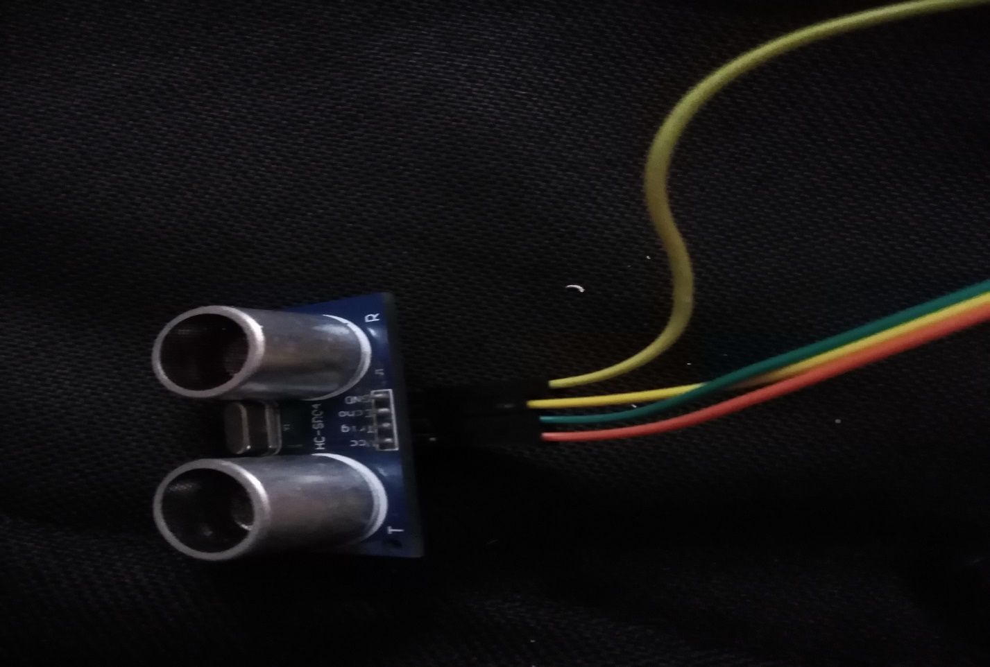

Ultrasonic Sensor

**A picture containing indoor, wall

Description generated with high confidence**

Buzzer

**A close up of a device

Description generated with high confidence**

**Final Setup**

**SAMPLE CODE:**

**Farm Security**

import RPi.GPIO as GPIO

from firebase_admin import db

import firebase_admin

from firebase_admin import credentials

from firebase_admin import auth

import time

import urllib

import urllib.request

PIN_TRIGGER = 7

PIN_ECHO = 11

cred =credentials.Certificate('farm-672f9-firebase-adminsdk-2eud9-ba87c485bd.json') # name of the downloaded json file

default_app = firebase_admin.initialize_app(cred, {'databaseURL' :'https://farm-672f9.firebaseio.com//'}) # data base url of your project

root = db.reference()

GPIO.setmode(GPIO.BOARD)

GPIO.setwarnings(False)

GPIO.setup(18,GPIO.OUT)#led

GPIO.setup(23, GPIO.IN) #PIR

GPIO.setup(24, GPIO.OUT) #BUzzer

GPIO.setup(PIN_TRIGGER, GPIO.OUT)

GPIO.setup(PIN_ECHO, GPIO.IN)

base_url = " https://api.thingspeak.com/update?api_key=56CU24ALSVDFJM77"

def ultrasonic():

GPIO.output(PIN_TRIGGER, GPIO.LOW)

print("Transmitting Ultrasonic Waves")

time.sleep(2)

print("Calculating the object distance")

GPIO.output(PIN_TRIGGER, GPIO.HIGH)

time.sleep(0.00001)

GPIO.output(PIN_TRIGGER, GPIO.LOW)

while GPIO.input(PIN_ECHO)==0:

pulse_start_time = time.time()

while GPIO.input(PIN_ECHO)==1:

pulse_end_time = time.time()

pulse_duration = pulse_end_time - pulse_start_time

distance = round(pulse_duration * 17150, 2)

print("Object is at",distance,"cm")

time.sleep(2) # to stabilize sensor

def get():

print("get");

x = str(db.reference('farm-672f9/farm-672f9/Command/Command'.format()).get())

print(x)

if(x == '"ON"'):#Led on

print("led is on")

GPIO.output(18,1)

if (x == '"OFF"'):#Led off

print("led is off")

GPIO.output(18,0)

if(x == '"BON"'):#buzzer_on

print("Buzzer on")

GPIO.output(24, True)

if(x == '"BOFF"'):#buzzer off

print("Buzzer off")

GPIO.output(24, False)

if(x == '"UON"'):#Ultrasonic on

print("Ultrasonic on")

ultrasonic()

if(x == '"UOFF"'):#ultrasonic off

print("Ultrasonic off")

if(x == '"ROFF"'):#Repellers off

print("Repellers off")

GPIO.output(24, False)

GPIO.output(18,0)

if(x == '"RON"'):#Repellers on

print("Repellers on")

GPIO.output(24, True)

GPIO.output(18,1)

if(x == '"MOFF"'):

automatic()

def manual():

print("manual")

while True:

print("testing")

if GPIO.input(23):

print("Motion Detected...")

url = base_url+"&field1=1"

print(url)

f = urllib.request.urlopen(url)

response=f.read()

print('response')

print(response)

f.close()

get()

time.sleep(1)

def automatic():

print("automatic")

while True:

x = str(db.reference('farm-672f9/farm-672f9/Command/Command'.format()).get())

if(x == '"MOFF"'):

if GPIO.input(23):

print("Motion Detected...")

url = base_url+"&field1=1"

print(url)

f = urllib.request.urlopen(url)

response=f.read()

print('response')

print(response)

f.close()

ultrasonic()

GPIO.output(24, True)#buzzer

GPIO.output(18, True)#led

time.sleep(15) #Buzzer turns on for 0.5 sec

else:

print("not detected")

GPIO.output(24, False)

GPIO.output(18, False)

time.sleep(1)

time.sleep(0.1) #loop delay, should be less than detection delay

if(x == '"MON"'):

manual()

while True:

print("testing")

x = str(db.reference('farm-672f9/farm-672f9/Command/Command'.format()).get())

if (x=='"MON"'):

manual()

if(x=='"MOFF"'):

automatic()

time.sleep(1)

A close up of a computer

Description generated with high confidence

**A screen shot of a computer

Description generated with very high confidence**

**TEST CASES:**

* **Introduction:**

The purpose of testing is to discover errors. Testing is the process of trying to discover every conceivable fault or weakness in a work product. It provides a way to check the functionality of components, sub-assemblies, assemblies and/or a finished product. It is the process of exercising software with the intent of ensuring that the software system meets its requirements and user expectations and does not fail in an unacceptable manner. There are various types of test. Each test type addresses a specific testing requirement.

* **Types of Test:**
* **Unit Testing:**

Unit testing is essentially for the verification of the code produced during the coding phase and the goal is test the internal logic of the module/program. In the Generic code project, the unit testing is done during coding phase of data entry forms whether the functions are working properly or not. In this phase all the drivers are tested they are rightly connected or not. Unit testing is usually conducted as part of a combined code and unit test phase of the software lifecycle, although it is not uncommon for coding and unit testing to be conducted as two different phases.

* **Execution Testing:**

The program is successfully loaded and executed with no execution errors. All the modules of whole application is tested. The complete performance of the project “CSE-Labs” is good.

**CONCLUSION:**

The problem of crop vandalization by wild animals has become a major social problem in current time. It requires urgent attention for this problem. Thus, this project carries a great social relevance as it aims to address this problem. This project will help farmers in protecting their orchards and fields and save them from significant financial losses and will save them from the unproductive efforts that they endure for the protection their fields. This will also help them in achieving better crop yields thus leading to their economic well-being.

**12. BIBLIOGRAPHY**

<http://www.ijariie.com/AdminUploadPdf/A_SMART_FARMLAND_USING_RASPBERRY_PI_CROP_VANDALIZATION_PREVENTION___INTRUSION_DETECTION_SYSTEM_1404.pdf>

<https://www.electroschematics.com/3864/ultrasound-and-insects/>

<https://www.researchgate.net/publication/256494027_Damage_to_agricultural_yield_due_to_farmland_birds_present_repelling_techniques_and_its_impacts_an_insight_from_the_Indian_perspective>

<http://www.entomoljournal.com/archives/?year=2018&vol=6&issue=3&part=K&ArticleId=3641>

<http://www.ijecscse.org/papers/IETE2017/13.pdf>