Faculty of Computers and Artificial Intelligence

Information Systems Department

Software Engineering-2

Spring semester 2023-2024

**Online Library System**

**Project Number: 68**

***Team Members***

|  |  |  |  |
| --- | --- | --- | --- |
|  | **Name** | **ID** | **Grade** |
| **1** | **شونيز علاء مختار** | **20210473** |  |
| **2** | **بسنت حيدر محمد احمد** | **20210226** |  |
| **3** | **علي محمد محمود محمد** | **20210584** |  |
| **4** | **محمد أحمد عبدالخالق بيومي** | **20210732** |  |
| **5** | **احمد حماده احمد فرغلي** | **20210041** |  |
| **6** | **محمد اشرف محمد فراج** | **20210744** |  |

***Grading criteria***

|  |  |  |
| --- | --- | --- |
|  | **Name** | **ID** |
| **1** | SRS (Use Case Diagram, Activity Diagram, Sequence Diagram, Class Diagram, ERD) | **10%** |
| **2** | SDD (Project detailed documentation) | **10%** |
| **3** | Validation | **15%** |
| **4** | OCL | **20%** |
| **5** | ASOP (Aspect Oriented programming) | **20%** |
| **6** | Microservices | **5%** |

***Guided By:***

***Prof. Salwa Osama***

***Assistant Prof. Omar Tark***

# ***Table of Contents***

1. ***INTRODUCTION*** 
   1. PURPOSE-------------------------------------------------------------------------------------------------------------
   2. SCOPE-----------------------------------------------------------------------------------------------------------------
2. ***OVERALL DESCRIPTION***
   1. PRODUCT PRESPECTIVE----------------------------------------------------------------------------------------
   2. SOFTWARE REQUIREMENT------------------------------------------------------------------------------------
   3. HARDWARE REQUIREMENT-----------------------------------------------------------------------------------
   4. FUNCTIONAL REQUIREMENT----------------------------------------------------------------------------------
   5. NON-FUNCTIONAL REQUIREMENTS-------------------------------------------------------------------------
   6. USERS CHARACTRISTICS----------------------------------------------------------------------------------------
3. ***UML DIGRAMES***
   1. USE-CASE DIGARM-----------------------------------------------------------------------------------------------
   2. ACTIVITY DIGRAM------------------------------------------------------------------------------------------------
   3. SEQUENCE DIGRAM----------------------------------------------------------------------------------------------
   4. CLASS DIGRAM----------------------------------------------------------------------------------------------------
   5. ER DIGRAM --------------------------------------------------------------------------------------------------------
   6. ERD DIGRAM ------------------------------------------------------------------------------------------------------
4. ***CONCLUSION***
5. ***Introduction***

Online Library System is an application that refers to library System and it is suitable to use by small and medium size library. It is used by the librarian to manage the library using a computerized system. The system was developed and designed to help the librarian record every book transaction so that problems such as file missing or record missing will not happen, in addition to generating reports about all the book shelfs statues.

Member users also can benefit from this computerized system because it helps them to register to the library system and search for books and request a book to borrow in addition to showing a list of books borrowed books.

All the previous advantages of this system have been developed for the user in highly modern technologies all for the sake of user satisfaction.

* 1. ***Purpose***

The purpose of the project is to maintain the details of books and library members.

The main purpose of this project is to maintain an easy circulation system between members and the librarians, to issue books, also to search for any book from different available books. Moreover, the user can check specific features from their home.

* 1. ***Scope***

Manually updating the library system into a web-based application so that the user can:

* Know the details of the books available and maximum limit on borrowing from their computer and through their phones.
* The system provides services like updating details of the books, insertion of new books, deletion of books, limitation on issuing books.
* Generating reports about borrowed books and available books.

1. ***Overall Description***

***2.1 Product Perspective***

The proposed Library Management System will take care of the current book detail at any point of time. The book issue, book return will update the current book details automatically so that user will get the update current book details.

***2.2 Software Requirements***

* Front-end: React Framework.
* Backend: SpringBoot Framework and MySQL Database.

***2.3 Hardware Requirements***

* 8GB Ram
* 3.2 GHz Processor
* Intel core i5
* Window 10/11

***2.4 Functional Requirements***

**R.1: Register**

▪ Description: First the user will have to register/sign up. There are two different type of users.

▪ The library manager/head: The manager must provide details about his/her name, address, phone number, role, email, and password.

▪ Member: The user must provide details about his/her name of address,

phone number, role, email, and password.

**R.2: Login**

▪ Input: Enter the role, email, and password provided in the registration stage.

▪ Output: User will be able to use the features of software restricted to his/her role.

**R.3: Manage books by user.**

**R.3.1: Search**

▪ Input: Enter the name of author's name of the books to be issued.

▪ Output: List of books related to the keyword.

**R.3.2: Borrow Book**

▪ State: Searched the book user wants to borrow.

▪ Input: click the book user wants.

▪ Output: conformation for book issue and apology for failure in issue.

▪ Processing: if selected book is available then book will be issued else error will be displayed.

**R.3.3: Return Book**

▪ Input: Return the book to the library.

▪ Output: The issued list will be updated and the returned book will be listed out.

**R.3.4: Show Borrowed Books**

▪ Description: List of books that had been borrowed before.

**R.4 Manage book by librarian**

**R.4.1 Update details of books**

**R.4.2 Add Books**

▪ Input: Enter the details of the books such as names, author, ISBN, quantity, etc.

▪ Output: confirmation of addition.

**R.4.3 Remove Books**

▪ Input: Enter the id of the book.

▪ Output: Update the list of the books available.

**R.5 Generate reports of shelf status**

***2.5 Non-Functional Requirements***

**Usability Requirement**

The system shall allow the users to access the system from the phone using any web browser. The system uses a web-based interface. There is no special training is required. The system is user friendly which makes the system easy.

• **Availability Requirement**

The system is available 100% for the user and is used 24 hours a day and 365 days a year. The system shall be operational 24 hours a day and 7 days a week.

• **Accuracy**

The system should accurately provide real time information taking into consideration various concurrency issues. The system shall provide 100% access reliability.

• **Performance Requirement**

The information is refreshed depending upon whether some updates have occurred or not in the application. The system shall respond to the member in not less than two seconds from the time of the request submittal. The system shall be allowed to take more time when doing large processing jobs. Responses to view information shall take no longer than 5 seconds to appear on the screen.

• **Reliability Requirement**

The system must be 100% reliable due to the importance of data and the damages that can be caused by incorrect or incomplete data. The system will run 7 days a week, 24 hours a day.

***2.6 Users Characteristics***

we have two levels of users.

* ***Librarian user***
* Login/logout
* Manage books (CURD)
* Generate requests about borrowed and available books.
* ***Normal user***
* Register
* Login/logout
* Search for book.
* Borrow a book.
* Return a book.
* Show list of borrowed book.

1. ***UML Diagrams***

***3.1 Use-Case Diagram***

***3.2 Activity Diagram***

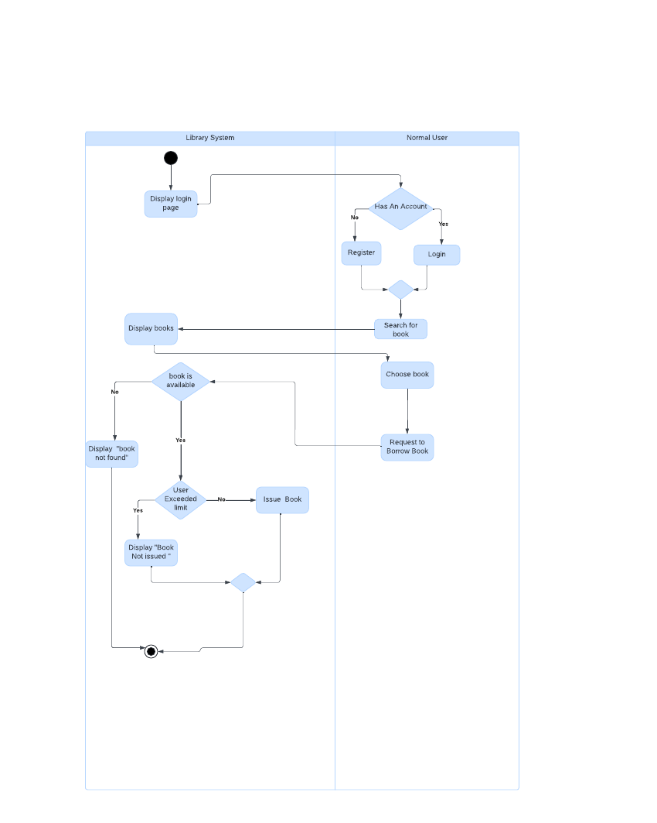

***3.3 sequence Diagram***

***For login and registration***

***For user services***

***For librarian services***

***3.4 Class Diagram***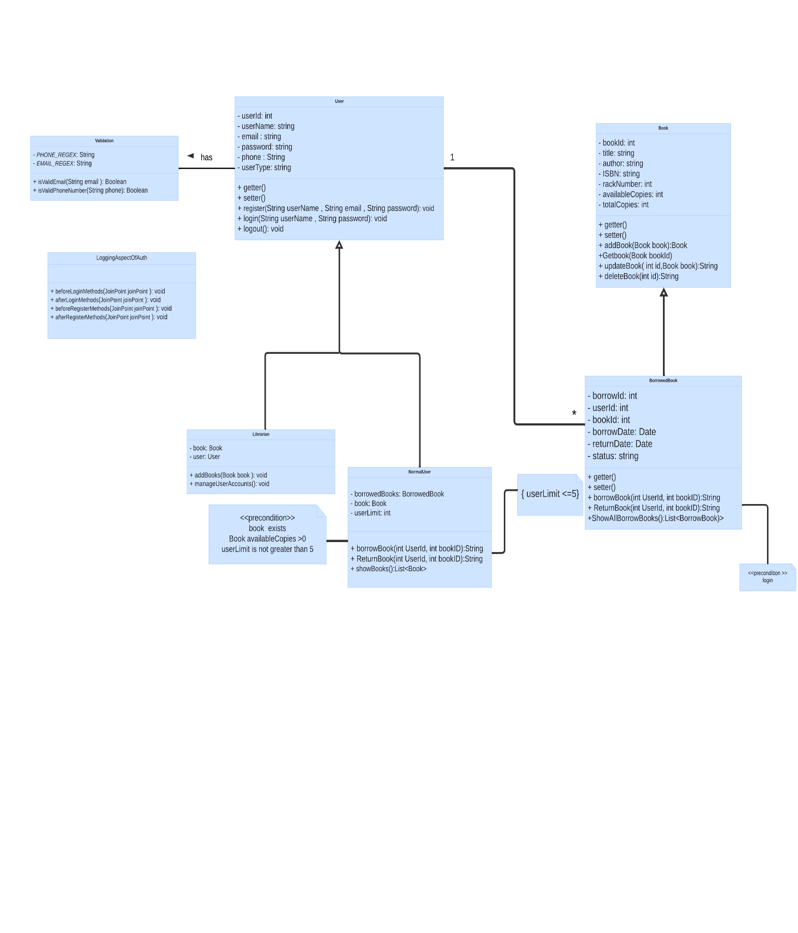

* 1. ***ER Digram***

1. ***Conclusion***

From a proper analysis of positive points and constraints on the system, it can be safely concluded that the product is a highly efficient and this application is working properly and meeting to all user requirements.in addition that it can be easily plugged in any organization that needs its services.