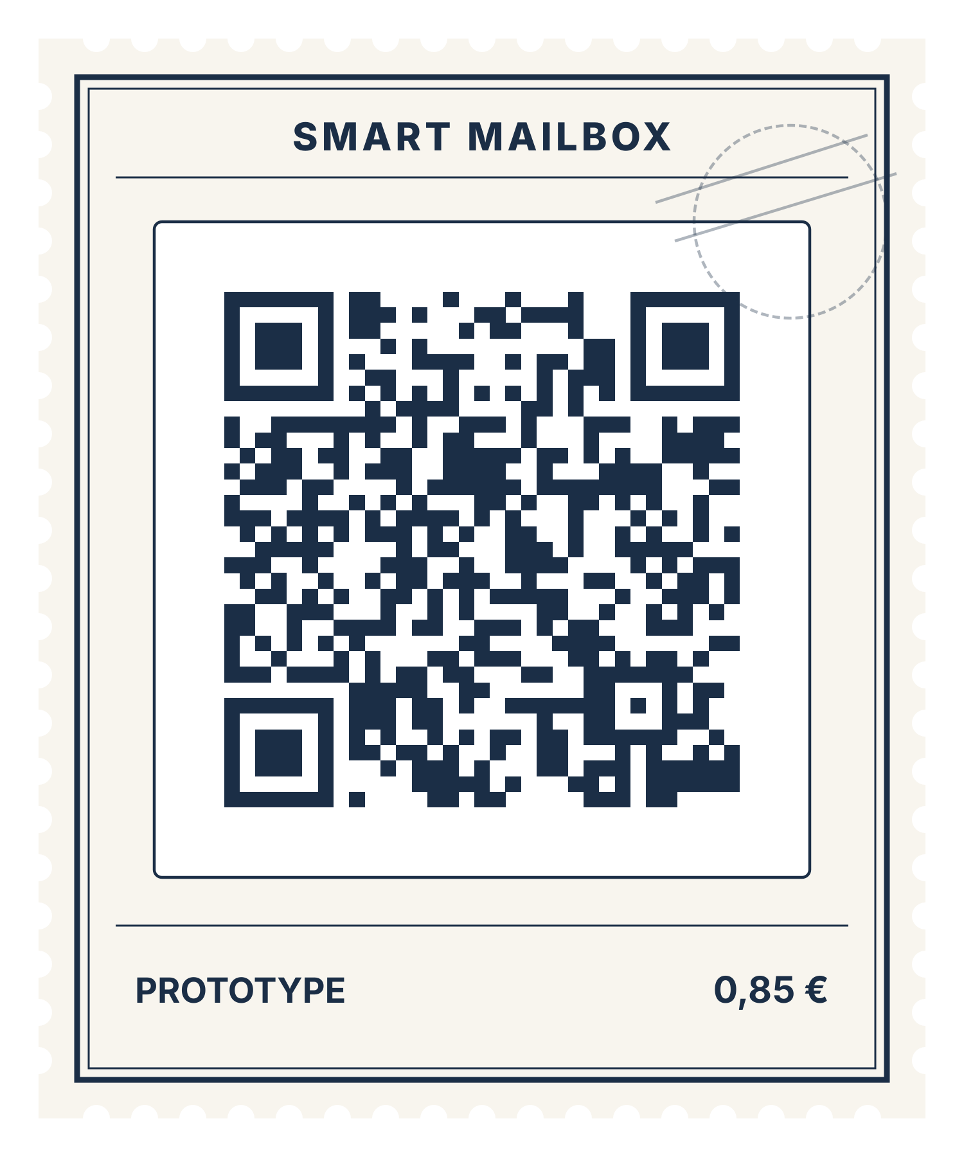
Participant Brief & Task (Caretaker)

Product / Team: Smart Mailbox
Prototype link: https://ictsmartmailbox.vercel.app/demo.html

1. What are you trying?
Smart Mailbox is a prototype of a mailbox sensor with a connected app. It is intended to help a building caretaker take in large parcels that do not fit into a mailbox, keep track of what is stored, and let the residents know without extra phone calls or notes.

2. Imagine this situation
You are the caretaker of a residential building. A courier has just delivered an oversized parcel that is too big for the mailbox, and the resident does not know about it yet. You need to keep the parcel safe in the storage room, and you want the resident to be able to collect it without having to ask you.

3. Your task
Take the oversized parcel into the building’s storage so that the resident knows it is waiting for them, and make sure the building’s records show where it is and when it was handed over.

4. Instructions for the session
- Open the prototype using the link or QR-Code provided and follow the scenario and task above.
- At the start, select the role “Caretaker” in the demo, then work through the tasks listed on the left. On a mobile device, you will find them on the “Demo controls” page. We recommend opening the demo on a laptop.
- Use the prototype as you normally would. You may think aloud about what you are doing, expecting, or finding confusing.
- We are testing the prototype, not you. Some functionality may be simulated, and encountering problems is perfectly acceptable.
- The researcher will observe without guiding you through the interface. You may request assistance or stop at any time.
- Do not enter passwords, financial details, or other sensitive personal information.

5. When you finish
Tell the researcher when you believe you have completed the task, cannot proceed, or decide to stop.
Afterward, the researcher will conduct a short interview about your experience. You may also be asked to clarify something you did during the task.
Session format: Observation (10 min) + Interview (10 min) + Final debrief (10 min)

