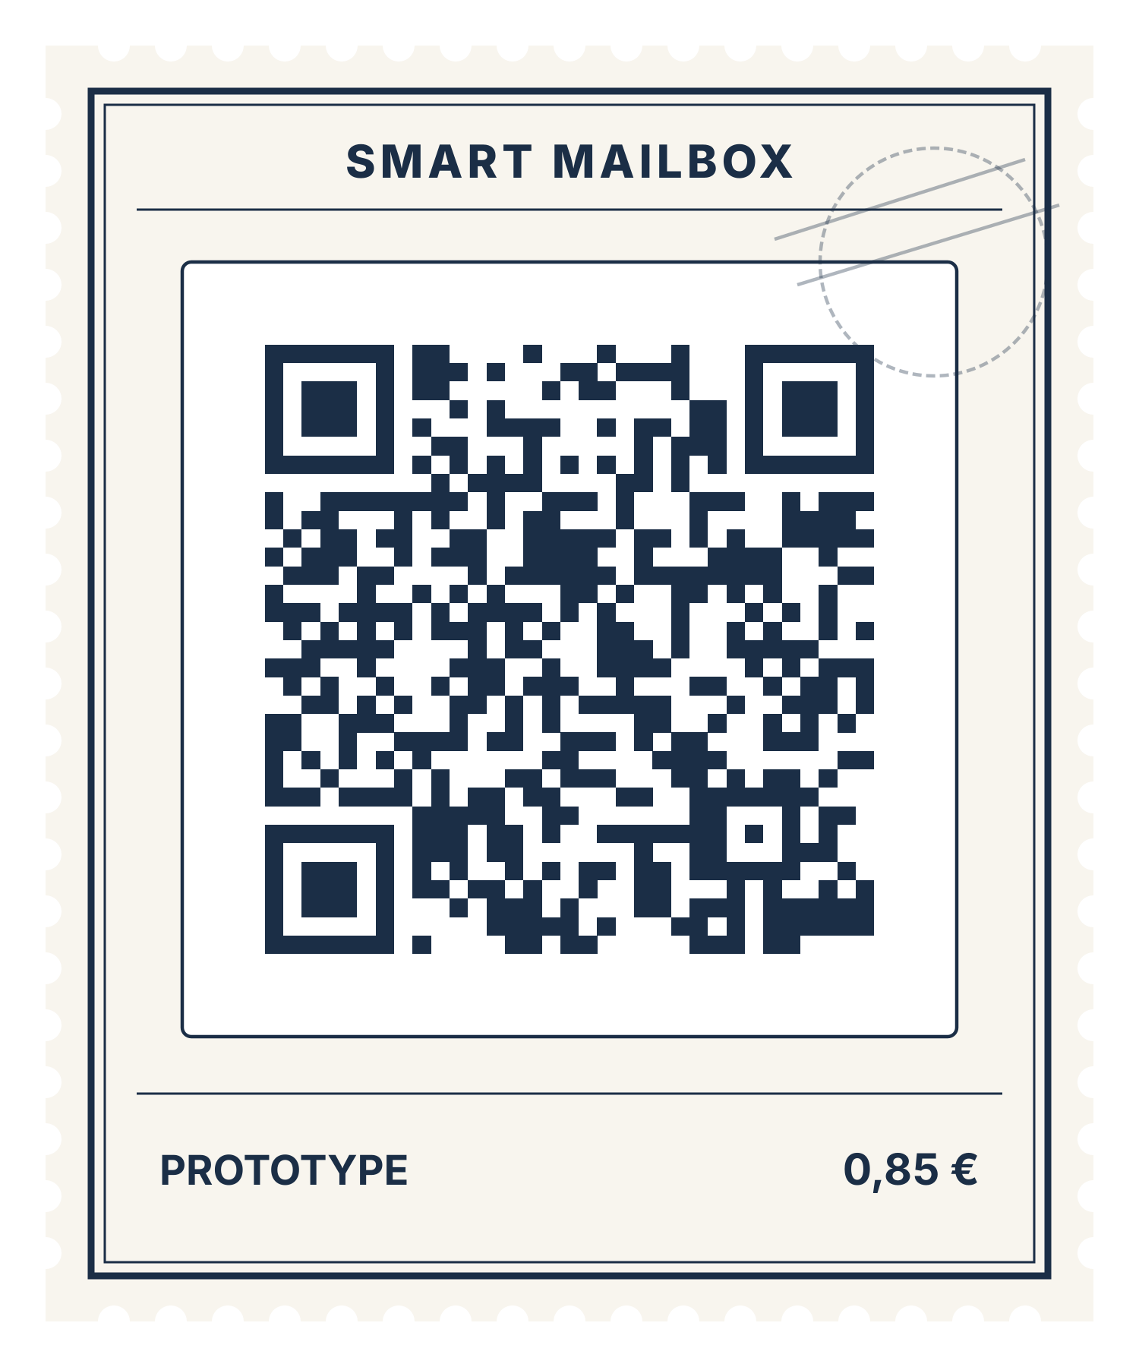
Participant Brief & Task
(Resident)

Product / Team: Smart Mailbox
Prototype link: https://ictsmartmailbox.vercel.app/demo.html

1. What are you trying?
Smart Mailbox is a prototype of a mailbox sensor with a connected app. It is intended to tell residents when mail or parcels have arrived, to let them allow someone else to reach their mailbox for a limited time, and to help a building caretaker handle large parcels.

2. Imagine this situation
You live in an apartment building and will be away from home for a few days. You expect letters and a parcel during that time, and you trust a neighbour to look after your mail. When you return, you want to be sure that nothing was lost and to know exactly what happened while you were gone.

3. Your task
Work through all five tasks listed in the demo. Together they cover the full resident journey:
- See whether mail has arrived
- Collect the mail and watch it reset
- Give a neighbour timed access
- Let the neighbour open your box
- Check what happened while you were away

4. Instructions for the session
- Open the prototype using the link or QR-Code provided and follow the scenario and task above.
- At the start, select the role “Resident” in the demo, then work through the tasks listed on the left. On a mobile device, you will find them on the “Demo controls” page.
- Best experienced on desktop: On a larger screen, simulation controls and tasks remain visible side-by-side, without needing to toggle extra menus
- Use the prototype as you normally would. You may think aloud about what you are doing, expecting, or finding confusing.
- We are testing the prototype, not you. Some functionality may be simulated, and encountering problems is perfectly acceptable.
- The researcher will observe without guiding you through the interface. You may request assistance or stop at any time.
- Do not enter passwords, financial details, or other sensitive personal information.

5. When you finish
Tell the researcher when you believe you have completed the task, cannot proceed, or decide to stop.
Afterward, the researcher will conduct a short interview about your experience. You may also be asked to clarify something you did during the task.
Session format: Observation (10 min) + Interview (10 min) + Final debrief (10 min)

