BLG337E: Principles of Computer Communications

Homework #3

Due Date: 20.12.2016, 23:00

Write a program to simulate wireless stations that transmit data on a wireless medium.

A “stations.txt” file contains the list of stations. Stations are located on a NxN grid. Each line of the file contains station’s name as a single character, row and column numbers of the station within the grid, and transmission range of the station. Figure 1 shows an example stations.txt file and 3 given stations on a 10x10 (i.e., N=10) grid.

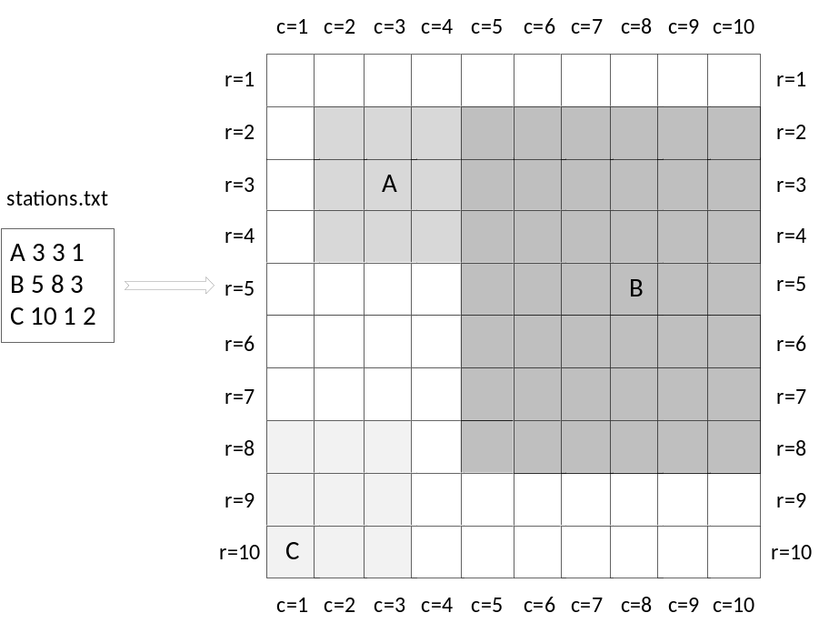
Figure 1 Stations and their ranges specified by stations.txt file

“transmissions.txt” file contains data transmission events. Each line of the file contains transmitter station’s name, receiver station’s name, and start time of transmission. Figure 2 shows an example transmissions.txt file and propagation of signals as well as the virtual time clock. The virtual clock starts from 0 and increases by 1 after all the events (if any) are processed which are scheduled for that time.
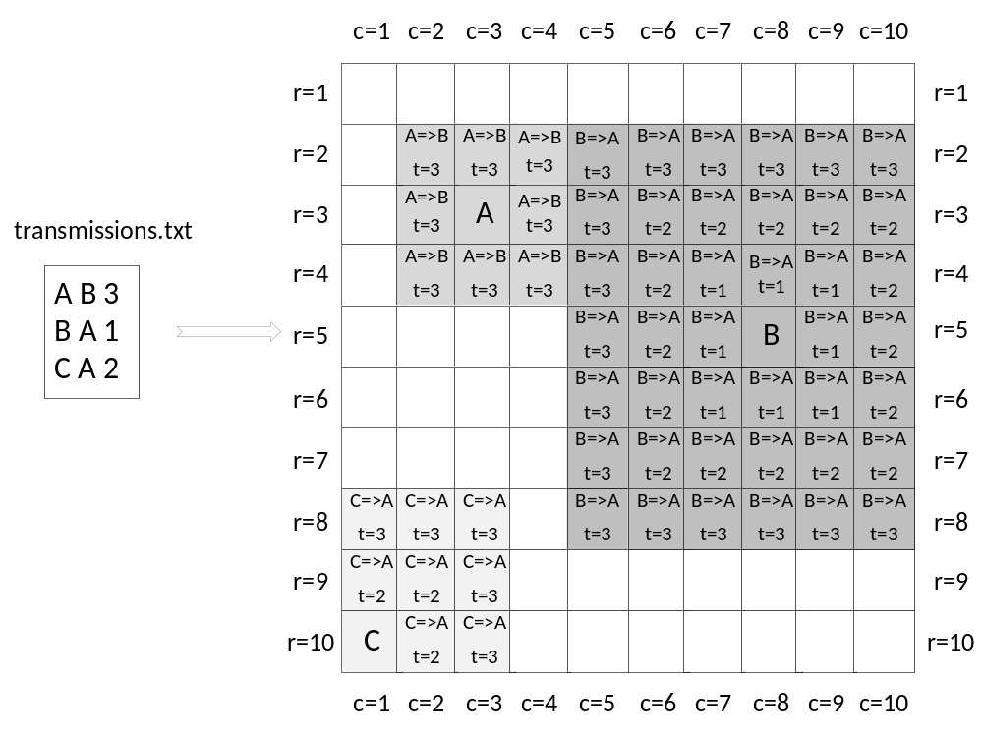
Figure 2: Transmission events specified in “transmissions.txt” file and propagation of signals

Please note:
- Transmission range of 1 unit includes all the cells surrounding the station (e.g., see station A).
- Transmission range of 2 units includes all the cells surrounding the station as well as all the cells surrounding the cells surrounding the station…etc.
- If the transmission range contains cells that are out of the grid, then they are discarded (e.g., station C has a range of 2 but its signal only propagates within its transmission range in the grid).
- Signal propagates with a speed of 1 unit/time in all directions.
- For simplicity, the example scenario shows no overlapping of either ranges or transmission events. In addition, no station is within the range of other stations. In the homework scenarios, all these cases can happen! Thus, you have to test your code for different scenarios representing different cases.

A transmission attempt can fail if:

- the receiver station is out of transmission range of the transmitting station. That is, signals can’t reach to the receiver.

- signals from two (or more) transmitting stations reach to same receiver station at the same time (i.e., a collision).

Your program must decide whether the transmission events specified in transmissions.txt are successful or not. The results must be written into “student_id.txt” file where student_id is your student number:

- On successful transmissions add a line as follows:

SUCCESS: TSN => RSN (Start time of transmission => time of arrival)

Where TSN is transmitter station’s name and RSN is receiver station’s name. Time of arrival is the time when signal reaches to the receiver.

- On out-of-range failures add a line as follows:

OOR: TSN => RSN (Start time of transmission => Time of failure)

Where TSN is transmitter station’s name and RSN is receiver station’s name. Time of failure is the time when signal reaches to sender’s transmission range.

- On collision failures (for each transmitter station that causes collision), add a line as follows:

COLLISION: TSN => RSN (Start time of transmission => Time of failure)

Where TSN is transmitter station’s name and RSN is receiver station’s name. Time of failure is the time when two (or more) signals reach to the receiver at the same time (i.e., when collision occurs).

Your program will be executed as follows:
program.exe N

where N is the dimension of the grid.

You have to submit:

- The source file which is written in c programming language and named as “student_id.c”. The source file MUST BE compilable and runnable in Linux. Please write your development environment at the start of the source file as well as your name, surname and student ID, of course within comments!

- A PDF report which is named as “student_id.pdf”.

AN EXAMPLE RUN (N = 10)

