Where SOAR fits, and the part of the problem we solve
A plain-language primer placing our project precisely in the security stack and naming the exact gap it closes.
The one-line picture
A security operation is a chain: the network produces events, sensors and a SIEM decide which events look like threats, and a response layer acts on those threats. Detection and response are two different jobs done by two different parts of the stack. Our project, the SOAR, is the response part — it acts on alerts that the detection part has already raised. It does not detect; it decides what to do and does it.
The security stack at a glance
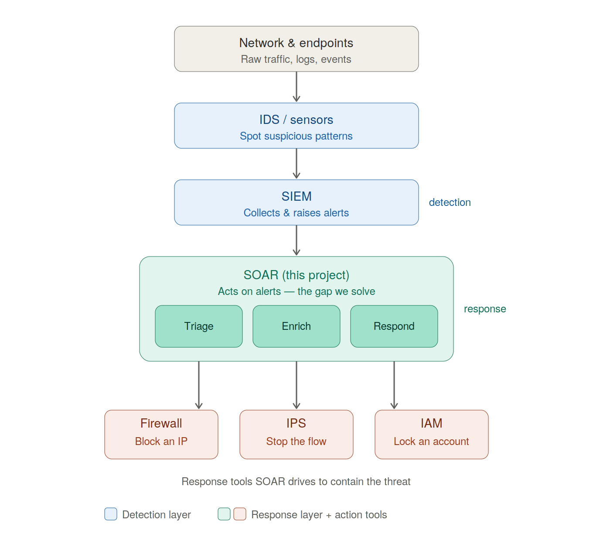
Network → IDS → SIEM (detection) → SOAR (response) → firewall / IPS / IAM (the tools it drives).
The parts of the stack, each in one line
- Network & endpoints — the company's computers, servers, and the traffic between them. Where everything happens, and where raw evidence (traffic, logs, events) comes from.
- IDS (Intrusion Detection System) / sensors — watchers on the network or on machines that spot suspicious patterns in raw traffic and flag them. Think of them as the smoke detectors.
- SIEM (Security Information and Event Management) — the central panel that collects events from across the company, applies rules to decide what's worth flagging, and raises alerts. The screen a human analyst stares at. Together, IDS and SIEM are the detection layer — their job ends at “here is an alert.”
- SOAR (Security Orchestration, Automation & Response) — our project. It picks up where detection ends: takes an alert and decides — is this real? how urgent? what should we do? — then carries out the response. It is the response layer.
The response tools SOAR drives — SOAR commands the tools that already exist rather than fighting threats directly:
- Firewall — the gate that allows or blocks network traffic. SOAR can tell it to block a malicious IP address.
- IPS (Intrusion Prevention System) — like an IDS, but it can also stop traffic in real time, not just flag it. SOAR can tell it to cut off a malicious flow.
- IAM (Identity & Access Management) — controls who can log in and what they can access. SOAR can tell it to lock a compromised user account.
The problem — and which slice is ours
The detection layer has a built-in pain: it produces far more alerts than anyone can handle, and most are false alarms. A typical security team faces thousands of alerts a day and can investigate only a fraction. The real threat hides in the pile of burnt-toast alarms. For every alert, an analyst repeats the same tedious detective work — whose machine? what's the destination? have we seen this before? is it actually dangerous? — and there are never enough analysts. Miss the wrong alert and it's a breach.
This pain splits cleanly along the same line the stack does:
- The detection problem — “are we flagging the right things, and are we missing novel attacks?” That is the IDS/SIEM’s burden. It is not our project.
- The response problem — “we have a pile of raised alerts; how do we investigate and act on them fast, consistently, and without burning out our people?” That is our slice.
Our SOAR closes the response gap. When an alert arrives, the system automatically does the analyst’s repetitive legwork and decides on an action:
- Triage — is this a real threat or a false alarm, and how urgent? (clears the burnt toast)
- Enrichment — gather the context a human would gather by hand: history of this machine, reputation of the destination, related recent alerts.
- Response — pick the right action and carry it out through the tools above — with a human approving anything destructive before it happens. That human-in-the-loop pause is the safety line: a system that can lock accounts or isolate machines on its own is far riskier than one that proposes the action and waits for a yes.
The result: false alarms get cleared automatically, clear threats get contained in seconds, and the scarce human analyst spends attention only on the genuinely ambiguous cases — with all the legwork already done.
Why an AI agent, and why this is the interesting part
Traditional SOAR runs rigid playbooks — a human writes every if-this-then-that branch in advance. That works for alerts you can fully predict and breaks on anything novel or multi-step. Our contribution is to make the response layer reason: an AI agent reads a messy alert, decides which investigation steps to run, chains them together, and explains its conclusion in plain language — handling the ambiguous cases a rigid playbook can’t, the way a junior analyst would, but instantly and at any hour. It also accumulates memory of past incidents, so it gets more useful over time.
One honest boundary worth stating plainly: because the agent sits in the response layer, it cannot catch a threat the detection layer let through silently. Detecting novel and zero-day attacks is a detection-layer problem — a natural next stage that plugs in upstream of us, not a gap in the response work itself.
In one sentence
The detection layer (IDS + SIEM) raises far more alerts than humans can handle; our SOAR is the response layer that automatically triages, investigates, and acts on those alerts — driving the firewall, IPS, and IAM to contain real threats while a human approves anything destructive — and we make that layer reason with an AI agent instead of running rigid pre-written playbooks.

