LEGALCONNECT - LAWYER APPOINTMENT SYSTEM
PROJECT PRESENTATION

TEAM MEMBERS:
• ABDUL RAHEEM - Team Leader & Full Stack Developer - Testing Engineer & Documentation
• AYAN - Backend Developer & Database Specialist
• MUHAMMAD ZULMANAN - Frontend Developer & UI Designer

COURSE: Software Engineering Diploma - Semester 2
INSTITUTION: Aptech Learning
TECHNOLOGY: PHP, MySQL, HTML, CSS, JavaScript
PROJECT DURATION: 4 Weeks
DATE: [01-Dec-2025]

TABLE OF CONTENTS
1. Executive Summary
2. Project Introduction
3. Problem Statement
4. Proposed Solution
5. Technology Stack
6. System Architecture
7. Database Design
8. Features Overview
9. Implementation Details
10. Testing Strategy
11. Challenges & Solutions
12. Learning Outcomes
13. Future Enhancements
14. Conclusion

1. EXECUTIVE SUMMARY

LegalConnect is a comprehensive web-based lawyer appointment system designed to bridge the gap between legal professionals and clients. This project demonstrates our proficiency in backend development using PHP and MySQL, combined with frontend technologies learned in previous semester.

Key Achievements:
✅ Complete CRUD Operations
✅ Secure User Authentication
✅ Responsive Web Design
✅ Database Management
✅ Role-based Access Control

2. PROJECT INTRODUCTION:
Project Title: Lawyer Appointment System
Project Type: Web Application
Purpose: Digital platform for lawyer-client appointments
Scope: User management, appointment scheduling, search functionality

Core Functionality:
• User Registration & Authentication
• Lawyer Search & Filtering
• Appointment Booking System
• Profile Management
• Admin Dashboard

3. PROBLEM STATEMENT

Current Challenges in Traditional System:
FOR CLIENTS:
❌ Difficulty finding specialized lawyers
❌ No transparency in availability
❌ Time-consuming appointment process
❌ Lack of lawyer information

FOR LAWYERS:
❌ Manual appointment management
❌ Difficulty in client acquisition
❌ No digital profile management
❌ Scheduling conflicts

4. PROPOSED SOLUTION

LegalConnect provides:

Digital Platform Features:
✅ Online lawyer directory
✅ Advanced search & filtering
✅ Real-time appointment booking
✅ Profile management system
✅ Admin oversight

User Benefits:
• Time-saving for both parties
• Better lawyer discovery
• Digital record keeping
• Professional interface

5. TECHNOLOGY STACK
FRONTEND TECHNOLOGIES:
• HTML5 - Page structure and semantics
• CSS3 - Styling and responsive design
• JavaScript - Client-side interactivity

BACKEND TECHNOLOGIES:
• PHP 7.4+ - Server-side processing
• MySQL 5.7+ - Database management
• XAMPP - Development environment

SECURITY FEATURES:
• Password hashing
• SQL injection prevention
• Session management
• Input validation

6. SYSTEM ARCHITECTURE
Three-Tier Architecture:
PRESENTATION LAYER (Client Side):
• Web browsers
• HTML/CSS/JavaScript
• User interface

BUSINESS LOGIC LAYER (Server Side):
• PHP scripts
• Form processing
• Data validation
• Session management

DATA LAYER (Database):
• MySQL database
• Tables: users, lawyer_details, appointments
• CRUD operations

7. DATABASE DESIGN

DATABASE: lawyers_appointment

TABLES STRUCTURE:

USERS TABLE:
Field | Type | Null | Key | Default | Extra
Id | Int(11) | NO | PRI | NULL | Auto_increment
Username | Varchar(50) | NO | UNI | NUL
Email | Varchar(50) | NO | UNI | NUL
Password | Varchar(50) | NO |  | NUL
User_type | Enum(…..) | NO |  | NULL
Created_at | timestamp | YES |  | NOW

LAWYER_DETAILS TABLE:
Field | Type | Null | Key | Default | Extra
Id | Int(11) | NO | PRI | NULL | Auto_increment
User_id | Varchar(50) | NO | UNI | NUL
Email | Varchar(50) | NO | UNI | NUL
specialization | Varchar(50) | NO |  | NUL
location | Enum(…..) | NO |  | NULL
Experience | timestamp | YES |  | NOW
Working_hours | Varchar(70) | YES |  | NULL
services | Text | YES |  | NULL
Image_path | Text | YES |  | NULL

APPOINTMENTS TABLE:
Field | Type | Null | Key | Default | Extra
Id | Int(11) | NO | PRI | NULL | Auto_increment
User_id | Varchar(50) | NO | FK | NUL
Customer_id | Varchar(50) | NO | FK | NUL
Lawyer_id | Varchar(50) | NO |  | NUL
Appointment_date | date | NO |  | NULL
Appointment_time | time | YES |  | NOW
Case_deatils | text | YES |  | NULL
Services | Enum(..) | YES |  | NULL
Image_path | timestamp | YES |  | NULL

8. FEATURES OVERVIEW

CUSTOMER FEATURES:
Registration & Login System
Advanced Lawyer Search
- Search by location
- Filter by specialization
- Real-time results
Lawyer Profile Viewing
- Complete professional details
- Experience and services
- Availability information
Appointment Booking
- Date and time selection
- Case details submission
- Status tracking
Responsive Design
- Mobile-friendly interface
- Cross-browser compatibility

LAWYER FEATURES:
Profile Management
- Professional information
- Specialization details
- Service offerings
- Working hours
Appointment Management
- View all appointments
- Confirm/cancel requests
- Track appointment history
Availability Setting
- Define working hours
- Service customization

ADMIN FEATURES:
User Management
- View all users
- Manage user accounts
- Delete users if needed
System Analytics
- User statistics
- Appointment overview
- Platform insights
Platform Control
- Monitor all activities
- Generate reports
- System configuration

9. IMPLEMENTATION DETAILS

KEY PHP CODE SNIPPETS:

DATABASE CONNECTION:
<?php
$host = 'localhost';
$user = 'root';
$password = '';
$dbname = 'lawyers_appointment';

$conn = new mysqli($host, $user, $password, $dbname);
if ($conn->connect_error) {
die("Connection failed: " . $conn->connect_error);
}
?>

USER REGISTRATION:
<?php
$password_hash = password_hash($_POST['password'], PASSWORD_DEFAULT);
$sql = "INSERT INTO users (username, email, password, user_type) VALUES (?, ?, ?, ?)";
$stmt = $conn->prepare($sql);
$stmt->bind_param("ssss", $username, $email, $password_hash, $user_type);
$stmt->execute();
?>

USER LOGIN:
<?php
session_start();
$user = $result->fetch_assoc();
if (password_verify($password, $user['password'])) {
$_SESSION['user_id'] = $user['id'];
$_SESSION['user_type'] = $user['user_type'];
$_SESSION['username'] = $user['username'];
}
?>

APPOINTMENT BOOKING:
<?php
$sql = "INSERT INTO appointments (customer_id, lawyer_id, appointment_date, appointment_time, case_details) VALUES (?, ?, ?, ?, ?)";
$stmt = $conn->prepare($sql);
$stmt->bind_param("iisss", $customer_id, $lawyer_id, $date, $time, $case_details);
$stmt->execute();
?>

10. TESTING STRATEGY

TESTING APPROACH:
• Unit Testing - Individual components
• Integration Testing - Module interactions
• System Testing - Complete system validation
• User Acceptance Testing - Client requirements

AUTHENTICATION TESTING:
✅ Valid user registration
✅ Successful login/logout
✅ Invalid credential handling
✅ Session management

FUNCTIONAL TESTING:
✅ Lawyer search functionality
✅ Appointment booking process
✅ Profile management
✅ Admin panel access

SECURITY TESTING:
✅ SQL injection prevention
✅ Password encryption
✅ Input validation
✅ Access control

11. CHALLENGES & SOLUTIONS

CHALLENGE 1: SQL Injection Prevention
PROBLEM: User input could manipulate database queries
SOLUTION: Implemented prepared statements
IMPACT: Enhanced security and data integrity

CHALLENGE 2: Password Security
PROBLEM: Storing passwords securely
SOLUTION: Used password_hash() function
IMPACT: Industry-standard password protection

CHALLENGE 3: Session Management
PROBLEM: Maintaining user state across pages
SOLUTION: PHP session variables
IMPACT: Seamless user experience

CHALLENGE 4: Role-based Access
PROBLEM: Different functionality for different users
SOLUTION: User type checking and redirection
IMPACT: Proper access control

12. LEARNING OUTCOMES
TECHNICAL SKILLS ACQUIRED:
• PHP programming and syntax
• MySQL database design and management
• Form handling and validation
• Session management techniques
• Security implementation
• Error handling and debugging

SOFT SKILLS DEVELOPED:
• Team collaboration and coordination
• Problem-solving approach
• Time management
• Project planning
• Documentation skills

PROJECT MANAGEMENT:
• Requirement analysis
• Task distribution
• Progress tracking
• Quality assurance
• Delivery management

13. FUTURE ENHANCEMENTS
SHORT-TERM IMPROVEMENTS:
• Email notification system
• Calendar integration
• Advanced search filters
• Rating and review system

MEDIUM-TERM ENHANCEMENTS:
• Payment gateway integration
• Mobile application
• Document upload feature
• Video consultation

LONG-TERM VISION:
• AI-based lawyer recommendations
• Multi-language support
• API development
• International expansion

14. CONCLUSION
PROJECT SUCCESS METRICS:
✅ All functional requirements implemented
✅ Secure and robust system architecture
✅ User-friendly interface design
✅ Comprehensive documentation
✅ Successful testing and validation

TECHNICAL ACHIEVEMENTS:
• Complete CRUD operations
• Secure authentication system
• Responsive web design
• Efficient database management
• Professional code structure

BUSINESS VALUE:
• Digital transformation of legal appointments
• Time and cost savings for users
• Professional platform for lawyers
• Scalable and maintainable system

FINAL STATUS: PROJECT SUCCESSFULLY COMPLETED

The LegalConnect Lawyer Appointment System demonstrates our team's ability to design, develop, and deploy a complete web application using modern technologies and best practices.

APPENDICES:
A. INSTALLATION GUIDE
B. USER MANUAL
C. SOURCE CODE STRUCTURE
D. DATABASE SCHEMA
E. TEST CASES

TEAM CONTRIBUTIONS:
ABDUL RAHEEM:
• Project planning and management
• System architecture design
• Integration of all modules
• Final deployment
• Test case development
• Functional testing
• Documentation preparation
• Quality assurance

AYAN:
• Database design and implementation
• Backend logic development
• Security implementation
• Performance optimization

MUHAMMAD ZULMANAN:
• UI/UX design
• Frontend development
• Responsive design implementation
• User interface testing

ACKNOWLEDGEMENT
We would like to express our gratitude to our instructor at Aptech Learning for guidance and support throughout this project. This project has been a valuable learning experience in backend development and team collaboration.

[Team Signature]
ABDUL RAHEEM
MUHAMMAD AYYAN AKHLAQ
MUHAMMAD ZULMANAN

[Date - 01-Dec-2025]

For admin-login
EMAIL admin@legalconnect.com
Password Admin@123

15.ScreenShorts:

Homhe page
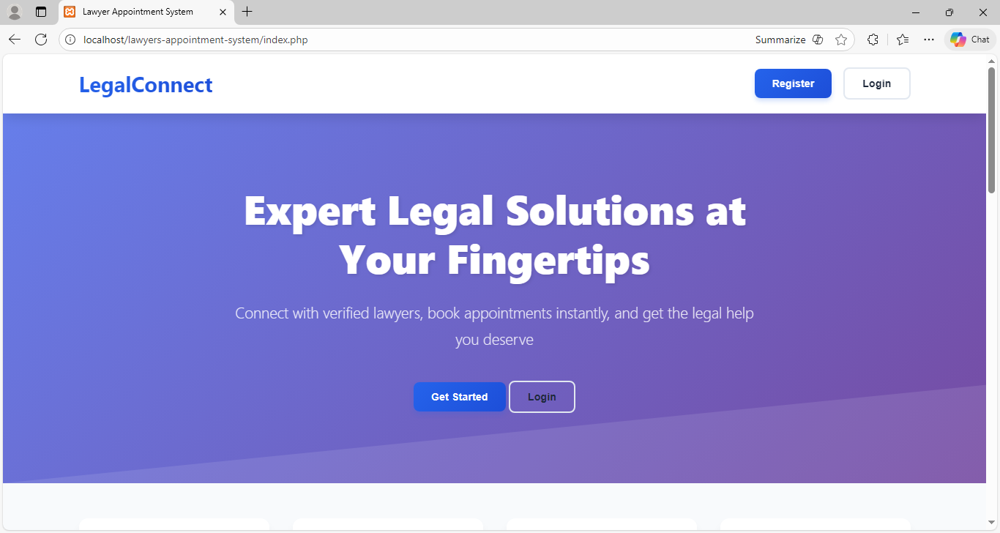
Home page
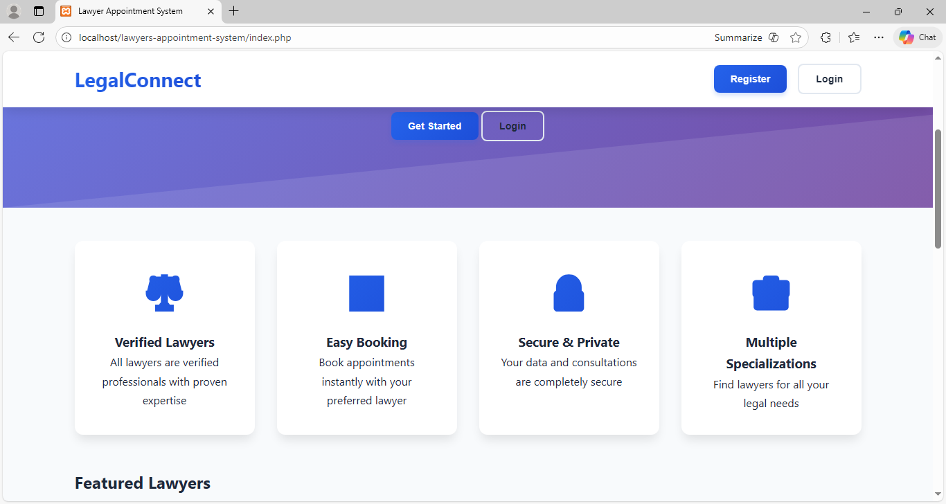

Registration Form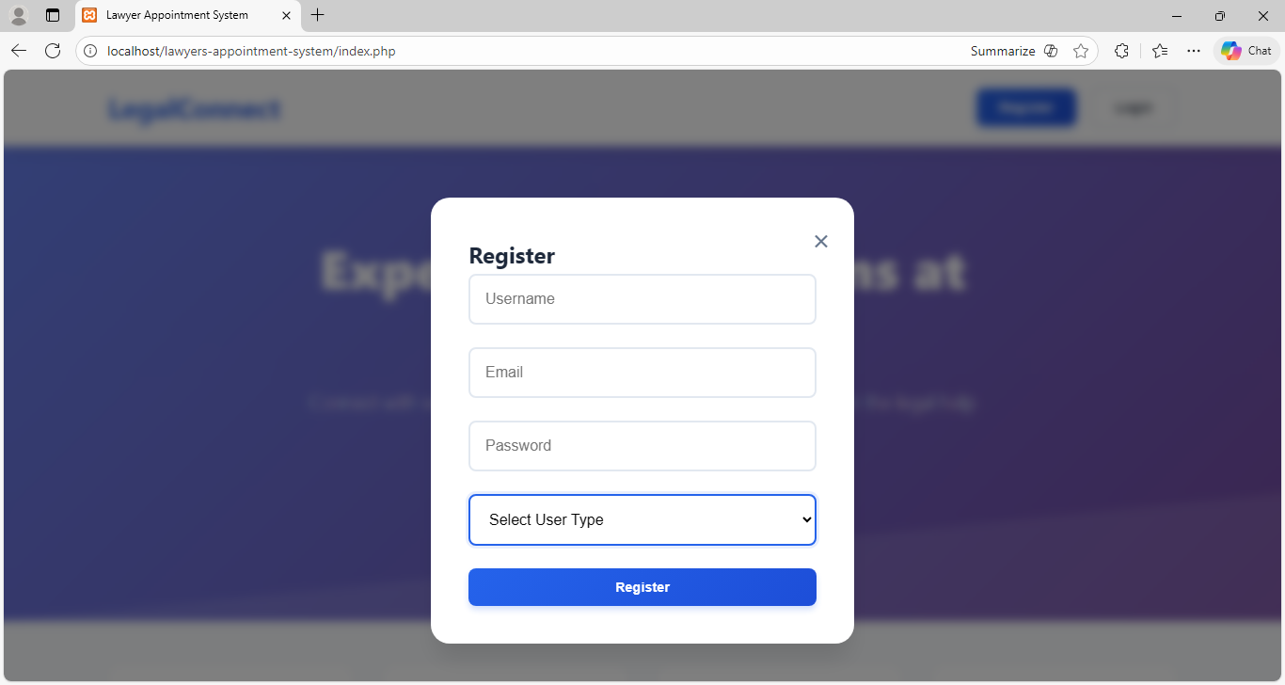
Login form
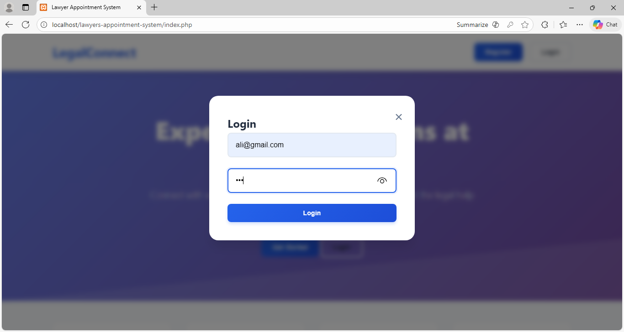
Lawyer Dashboard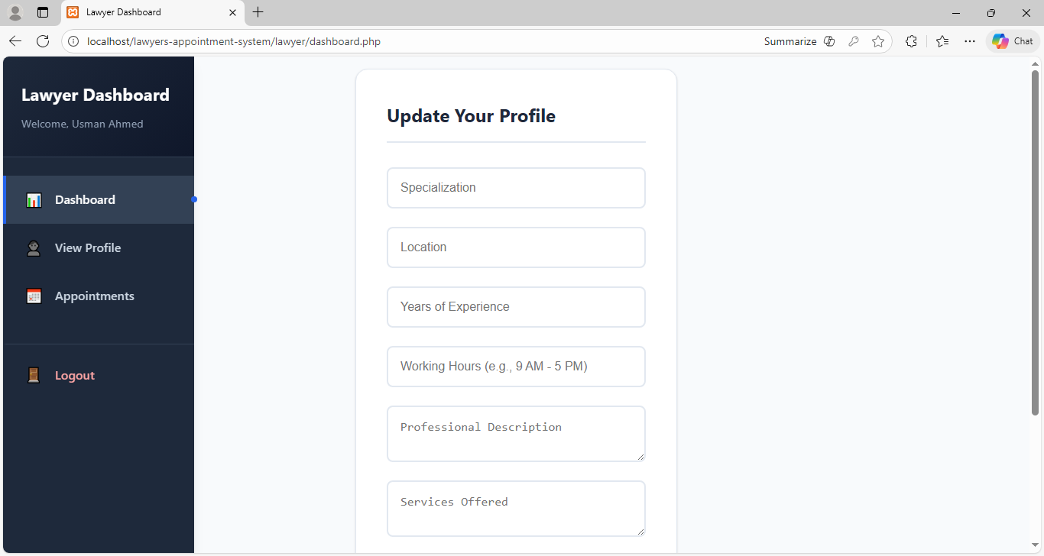
Cards of lawyers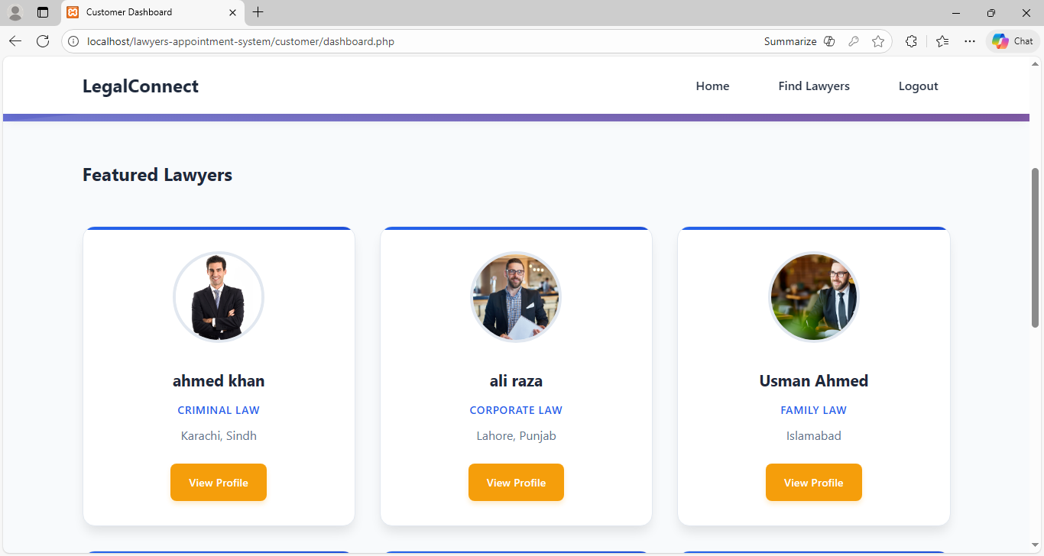
Search bar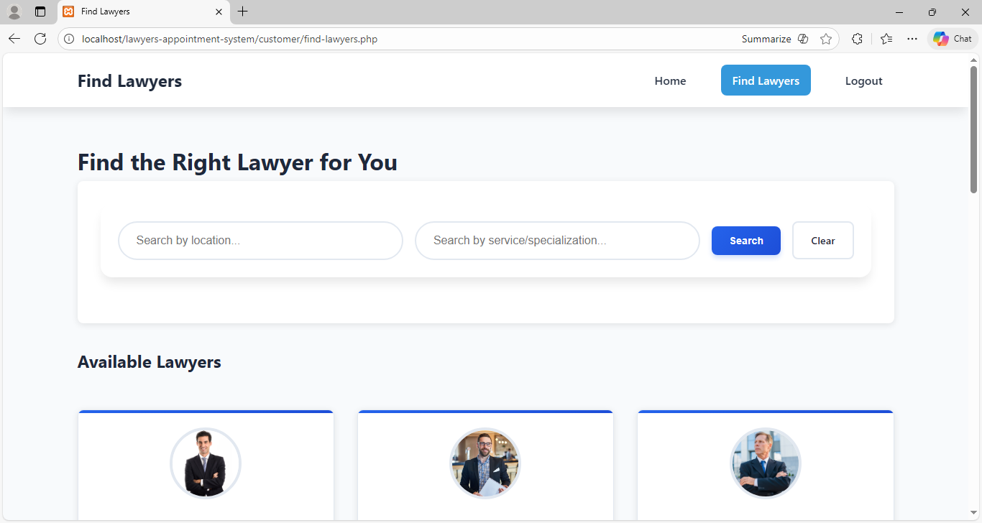
Lawyer profile for customers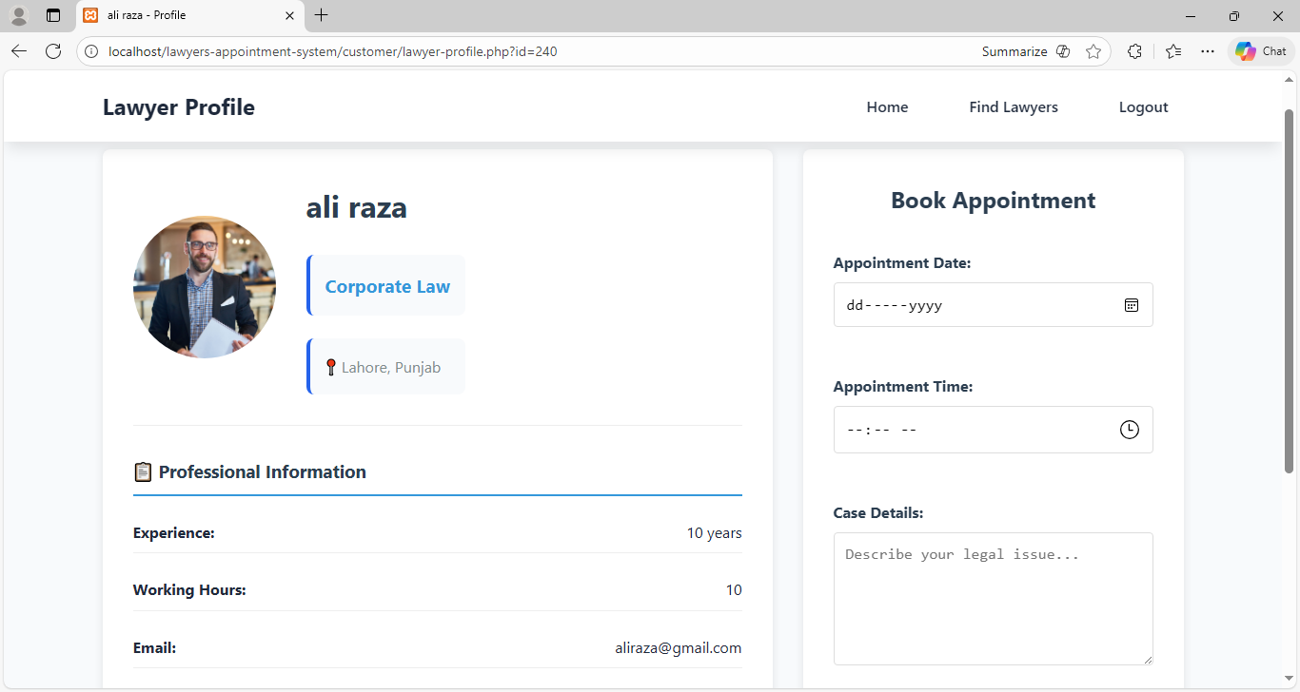
Customers Search lawyer with location & services + specialization 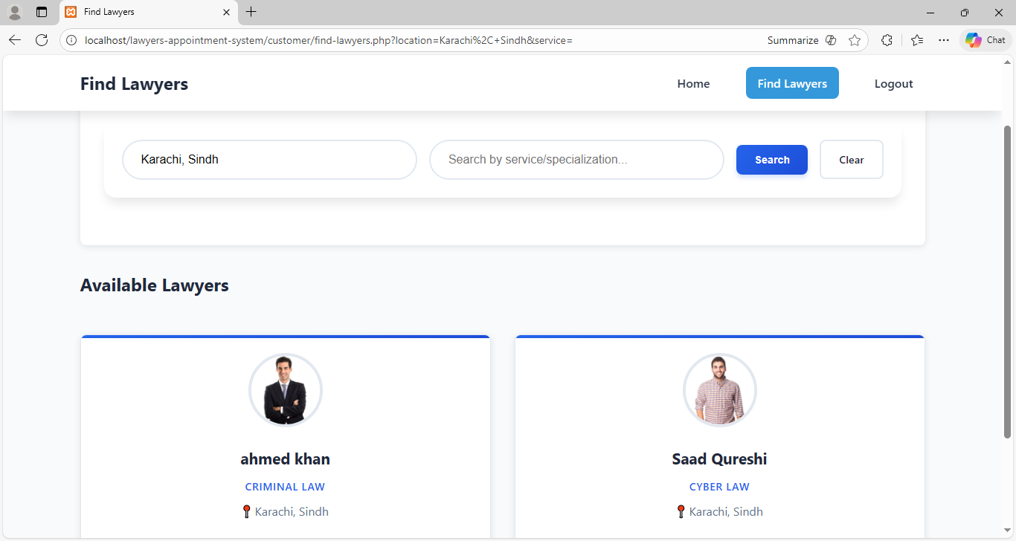
Admin Login form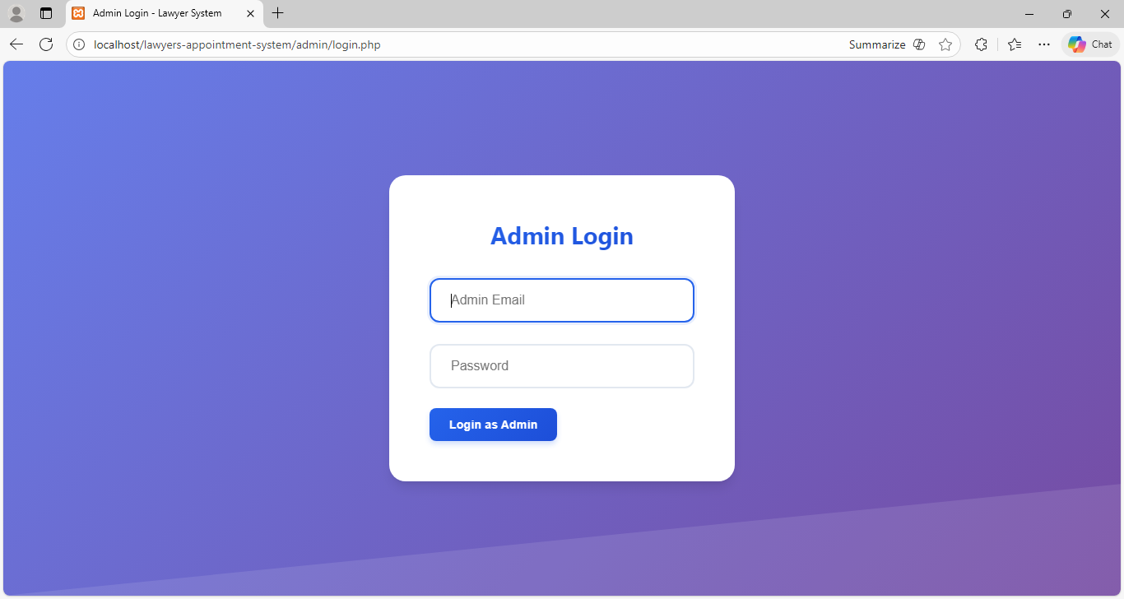
Admin dashboard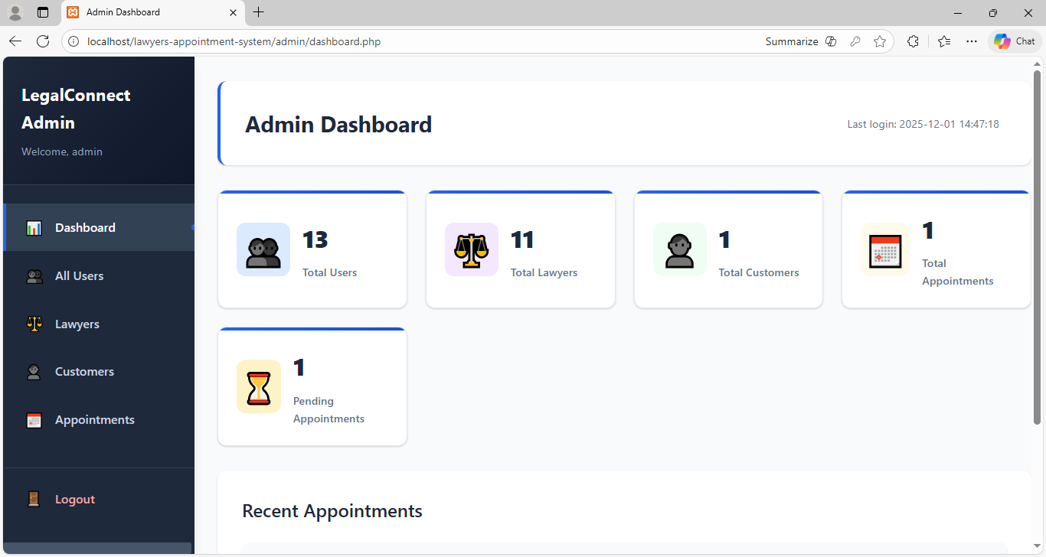
All Users Management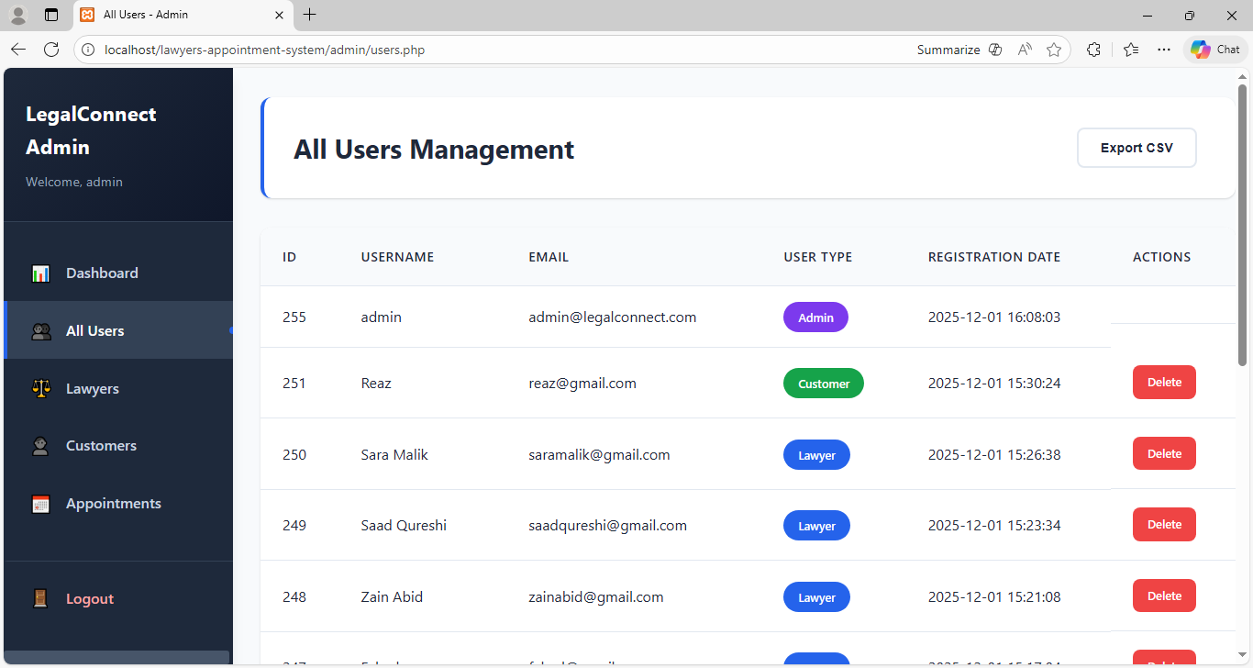
Customer Management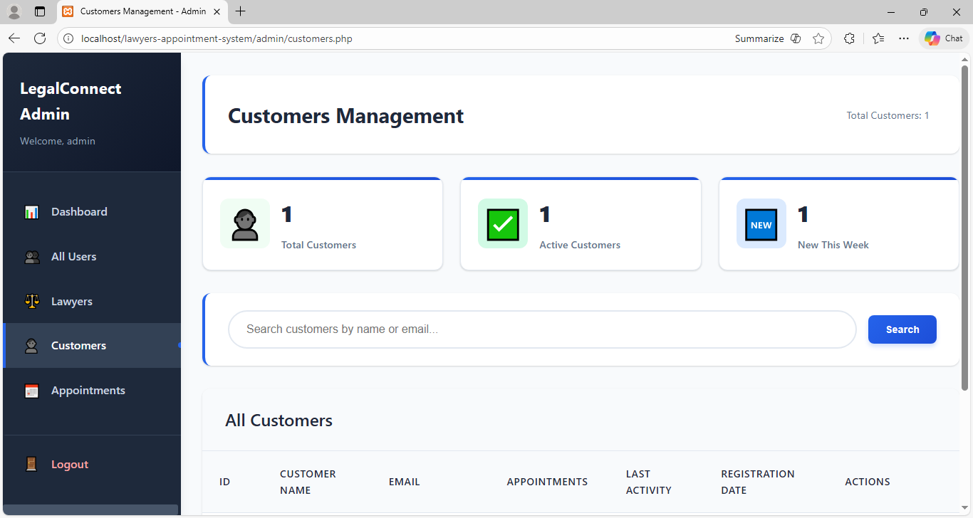
All Appointment Management