Student Portfolio Website (Day 2)

Student Name:
Muhammad Arqum Ali Khokhar

Roll Number:
(Write your roll number)

Course:
Web Development

Instructor:
(Teacher's Name)

Submission Date:
08 July 2026

<!DOCTYPE html>
<html lang="en">
<head>
<meta charset="UTF-8">
<meta name="viewport" content="width=device-width, initial-scale=1.0">
<title>Student Portfolio | Muhammad Arqum Ali Khokhar</title>
</head>

<body>

<!-- ================= HEADER ================= -->

<header id="home">
<h1>Muhammad Arqum Ali Khokhar</h1>
<p>Aspiring Article Writer | Student | Future Web Developer</p>
<hr>
</header>

<!-- ================= NAVIGATION ================= -->

<nav>
<h2>Navigation</h2>

<ul>
<li><a href="#home">Home</a></li>
<li><a href="#about">About Me</a></li>
<li><a href="#skills">Skills</a></li>
<li><a href="#education">Education</a></li>
<li><a href="#courses">Courses</a></li>
<li><a href="#hobbies">Hobbies</a></li>
<li><a href="#contact">Contact</a></li>
<li><a href="#social">Social Media</a></li>
</ul>

<hr>
</nav>

<main>

<!-- ================= HERO SECTION ================= -->

<section>

<h2>Welcome to My Student Portfolio</h2>

<p>
Hello! Welcome to my personal portfolio website.
I am Muhammad Arqum Ali Khokhar, a passionate student who enjoys
learning web development, content writing, and modern technology.
</p>

<p>
This portfolio highlights my education, skills, hobbies,
and career goals.
</p>

</section>

<hr>

<!-- ================= ABOUT ================= -->

<section id="about">

<h2>About Me</h2>

<img src="images/profile.jpg"
alt="Profile picture of Muhammad Arqum Ali Khokhar"
width="220">

<p>
My name is Muhammad Arqum Ali Khokhar. I enjoy learning new
technologies and creating useful projects. I have a strong
interest in HTML, content writing, artificial intelligence,
and web development.
</p>

<p>
My goal is to become a skilled software developer and
professional technical content writer while continuously
improving my knowledge and practical experience.
</p>

</section>

<hr>

<!-- ================= SKILLS ================= -->

<section id="skills">

<h2>Skills</h2>

<h3>Technical Skills</h3>

<ul>
<li>HTML5</li>
<li>Content Writing</li>
<li>Internet Research</li>
<li>Microsoft Word</li>
<li>Basic Computer Skills</li>
</ul>

<h3>Professional Skills</h3>

<ol>
<li>Communication</li>
<li>Problem Solving</li>
<li>Time Management</li>
<li>Critical Thinking</li>
<li>Teamwork</li>
</ol>

</section>

<hr>

<!-- ================= EDUCATION ================= -->

<section id="education">

<h2>Education</h2>

<table border="1">

<tr>
<th>Qualification</th>
<th>Institution</th>
<th>Year</th>
</tr>

<tr>
<td>Matriculation</td>
<td>Your School Name</td>
<td>2022</td>
</tr>

<tr>
<td>Intermediate</td>
<td>Your College Name</td>
<td>2024</td>
</tr>

<tr>
<td>Bachelor's Degree</td>
<td>Your University Name</td>
<td>Present</td>
</tr>

</table>

</section>

<hr>

<!-- ================= COURSES ================= -->

<section id="courses">

<h2>Current Semester Courses</h2>

<ol>

<li>Web Development</li>

<li>Programming Fundamentals</li>

<li>Database Systems</li>

<li>Object-Oriented Programming</li>

<li>English Composition</li>

</ol>

</section>

<hr>

<!-- ================= HOBBIES ================= -->

<section id="hobbies">

<h2>Hobbies</h2>

<ul>

<li>Reading
<ul>
<li>Technology Books</li>
<li>Programming Blogs</li>
</ul>
</li>

<li>Writing
<ul>
<li>Articles</li>
<li>Research</li>
</ul>
</li>

<li>Sports
<ul>
<li>Cricket</li>
<li>Football</li>
</ul>
</li>

</ul>

</section>

<hr>

<!-- ================= CONTACT ================= -->

<section id="contact">

<h2>Contact Information</h2>

<p><strong>Name:</strong> Muhammad Arqum Ali Khokhar</p>

<p><strong>Email:</strong>
<a href="mailto:yourname@email.com">
yourname@email.com
</a>
</p>

<p><strong>Phone:</strong><br>
+92-300-1234567
</p>

<p><strong>Address:</strong><br>
Punjab, Pakistan
</p>

</section>

<hr>

<!-- ================= SOCIAL MEDIA ================= -->

<section id="social">

<h2>Social Media Links</h2>

<ul>

<li>
<a href="https://github.com/yourusername" target="_blank">
GitHub
</a>
</li>

<li>
<a href="https://www.linkedin.com/in/yourusername" target="_blank">
LinkedIn
</a>
</li>

<li>
<a href="https://www.facebook.com/" target="_blank">
Facebook
</a>
</li>

</ul>

</section>

</main>

<hr>

<!-- ================= FOOTER ================= -->

<footer>

<p>&copy; 2026 Muhammad Arqum Ali Khokhar</p>

<p>
Thank you for visiting my Student Portfolio Website.
</p>

</footer>

</body>
</html>

Muhammad Arqum Ali Khokhar
Aspiring Article Writer | Student | Future Web Developer

Navigation
- Home
- About Me
- Skills
- Education
- Courses
- Hobbies
- Contact
- Social Media

Welcome to My Student Portfolio
Hello! Welcome to my personal portfolio website. I am Muhammad Arqum Ali Khokhar, a passionate student who enjoys learning web development, content writing, and modern technology.
This portfolio highlights my education, skills, hobbies, and career goals.

About Me
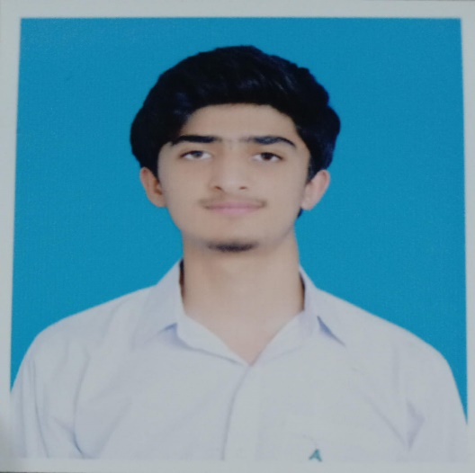
My name is Muhammad Arqum Ali Khokhar. I enjoy learning new technologies and creating useful projects. I have a strong interest in HTML, content writing, artificial intelligence, and web development.
My goal is to become a skilled software developer and professional technical content writer while continuously improving my knowledge and practical experience.

Skills

Technical Skills
- HTML5
- Content Writing
- Internet Research
- Microsoft Word
- Basic Computer Skills

Professional Skills
- Communication
- Problem Solving
- Time Management
- Critical Thinking
- Teamwork

Education
Qualification | Institution | Year
Matriculation | Your School Name | 2022
Intermediate | Your College Name | 2024
Bachelor's Degree | Your University Name | Present

Current Semester Courses
- Web Development
- Programming Fundamentals
- Database Systems
- Object-Oriented Programming
- English Composition

Hobbies
- Reading
  - Technology Books
  - Programming Blogs
- Writing
  - Articles
  - Research
- Sports
  - Cricket
  - Football

Contact Information
Name: Muhammad Arqum Ali Khokhar
Email: yourname@email.com
Phone:
+92-300-1234567
Address:
Punjab, Pakistan

Social Media Links
- GitHub
- LinkedIn
- Facebook

© 2026 Muhammad Arqum Ali Khokhar
Thank you for visiting my Student Portfolio Website.

