HireGuard
Alberta Employment Contract Risk Management
Product Requirements Document — Version 4.0

Course | ENTI 633 L01 — Generative AI and Prompting, Spring 2026
Instructor | Dr. Mohammad Keyhani, Haskayne School of Business
Document status | Build specification — supersedes v1.0, v2.0, v3.0 for class purposes
Date | May 13, 2026
Version history | v1.0 ClauseCompass (generic scope) → v2.0 HireGuard (Alberta vision) → v3.0 Class build → v4.0 This document (updated scope, architecture, personas, features)

1. Executive Summary
HireGuard is an AI-powered Alberta employment contract risk management platform for established small-to-medium Alberta employers (typically 50–250 employees). It analyzes employment agreements — individually and as a portfolio — to flag clauses that violate the Alberta Employment Standards Code (ESC), are likely unenforceable under Alberta common law, or expose the employer to wrongful dismissal, human rights, privacy, or operational risk.

The product solves a specific, expensive problem: Alberta employers are using AI tools to draft and review their employment contracts, but those tools hallucinate legal citations, miss Alberta-specific rules, and cannot compare documents against each other. HireGuard is not a replacement for employment counsel. It is a structured, citation-backed triage layer that helps employers know which contracts to prioritize, what questions to ask their Alberta employment lawyer, and how to approach existing employees who are on contracts that need updating.

The core differentiator
Every other tool either sells you a template (LawDepot), gives you a vague AI summary (ChatGPT/Claude/Gemini), or charges $400/hr for a lawyer. HireGuard is the only tool that combines (a) verified Alberta-specific rule coverage with CanLII-sourced citations, (b) a three-layer AI architecture that separates extraction, validation, and scoring to eliminate hallucination risk, (c) portfolio-level cross-document consistency analysis, and (d) a leadership-ready output specifically designed to brief a CFO, COO, or employment lawyer — not replace them.

2. Problem Statement

2.1 The expensive reality of bad employment contracts
Small and mid-size Alberta employers regularly issue employment contracts that are non-compliant, unenforceable, or both. The most common and most costly failure modes:

- Termination clauses that fail at the worst moment. Under the Machtinger line of cases (reinforced by Waksdale), if a termination clause fails to meet ESC minimums in any foreseeable scenario, the entire clause is void. For a $90K employee with 8 years of service, that converts a 6-week statutory obligation into 8–12+ months of pay in lieu of notice.
- Probation clauses that misstate the law. "You can be terminated at any time during the 6-month probation" — wrong. ESC notice obligations apply after 90 days regardless of contractual probation length.
- Restrictive covenants that do not survive challenge. Non-competes are presumptively unenforceable in Alberta. Employers rely on them, then learn at exactly the wrong moment that they are worthless.
- Statutory minimums understated. Overtime, vacation, vacation pay, and holiday pay get drafted incorrectly, creating ESC complaints and back-pay orders across the entire hourly workforce.
- Cross-document conflicts. An NDA specifying 3 years of confidentiality and an employment agreement specifying 2 years hand a departing employee’s lawyer a ready-made argument. Alberta courts construe ambiguity in the employee’s favour.

2.2 Why existing tools don’t solve it
Alberta employers are already using AI. The problem is that raw AI chat tools — GPT-4o, Claude, Gemini — when asked to review an employment contract, produce outputs that are vague, inconsistent, and often actively wrong:

Tool | What you get | The problem
ChatGPT / Gemini (raw) | Vague summary. "Two weeks notice may be low." No citation. | Frequently hallucinate statutes and cases that do not exist in Alberta. No severity rating. No fix.
Raw Claude | Better summary but still no Alberta-specific structure or case law. | No scoring framework. No cross-document view. No suggested revision.
LawDepot / Cleardocs | A new template. | Tells you nothing about the contract you already issued to your 12 employees.
Employment lawyer | Authoritative and complete. | CA$400–450/hr. Not scalable for every offer letter. Average SME defers until an issue surfaces.
HireGuard | Alberta-specific risk scores, real citations, cross-document conflicts, before/after revision language, leadership summary. | None — this is the gap HireGuard fills.

3. Target Users & Personas

3.1 Primary persona — “Operator Olivia”
Role | Office manager / HR generalist at a 50-person Calgary professional services firm
Context | Handles HR alongside ops. Manages 3 contract templates. Issued ~20 new contracts in the last year. No in-house counsel.
Pain | Has no idea whether her FT salaried template — pulled from a Word doc the founder created in 2019 — would survive an ESC review or a wrongful-dismissal claim. Uses an Edmonton employment lawyer at $425/hr for big issues but doesn't run every offer letter past them.
Goal | Audit the portfolio once. Get a written report she can hand to the COO showing what to fix and what the exposure looks like. Then run each new hire's offer through HireGuard.

3.2 Secondary persona — “COO Cameron”
Role | COO of a 60-person Calgary construction services company, scaling to ~100 by year-end
Context | Trying to understand the company's employment liability exposure before a refinancing. CFO flagged employment contracts as a diligence risk. Has 6 different contract templates across salaried, hourly, and executive tracks.
Pain | Needs a number — what is the company's maximum employment liability right now? And which contracts does he prioritize with their employment lawyer?
Goal | A leadership-ready report with an estimated exposure figure and a prioritized action list. Bring the top three contracts to the employment lawyer for redrafting.

3.3 Tertiary persona — “Consultant Cassie”
Fractional HR consultant serving 8 small Alberta employer clients. Reviews contracts as part of annual HR audits. Needs multi-client portfolio management and branded export capability to deliver to clients.

Who this is NOT for
Employees reviewing their own offers. In-house legal teams at large Alberta companies (they have Ironclad / LinkSquares). Federally regulated employers (banks, airlines, telecom — governed by the Canada Labour Code, not the Alberta ESC). Unionized workplaces.

4. Product Overview

4.1 What the product does
HireGuard has two primary views. The portfolio landing page shows all of an employer's agreements ranked by risk, cross-document conflicts flagged, and a leadership summary with estimated financial exposure. The document deep-dive shows the detailed analysis for a single contract: risk scores across six Alberta-law categories, a side-by-side comparison of what raw AI tools said versus what HireGuard's structured analysis found, specific red flags with Alberta citations sourced from CanLII, before-and-after revision language, and prioritized next steps.

4.2 Portfolio & Risk Overview — Screen 1
SCREENSHOT: PORTFOLIO LANDING PAGE
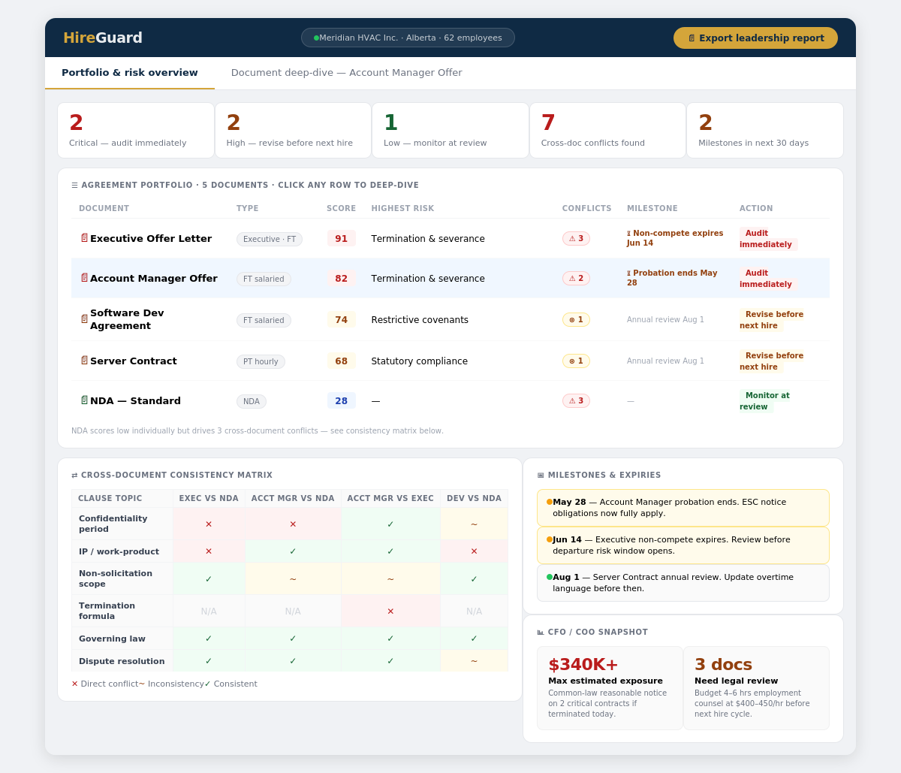

The portfolio view is the landing screen. Every agreement the employer has uploaded is ranked by overall risk score from highest to lowest. The five summary cards at the top give an immediate picture: how many contracts are critical, how many cross-document conflicts exist, and how many milestones are coming up in the next 30 days. The cross-document consistency matrix shows which pairs of documents conflict on which clause topics — a feature that no raw AI chat tool can replicate. The CFO/COO snapshot in the bottom right converts risk scores into an estimated dollar exposure figure for leadership conversations.

4.3 Document Deep-dive — Screen 2
SCREENSHOT: DOCUMENT DEEP-DIVE — ACCOUNT MANAGER OFFER LETTER
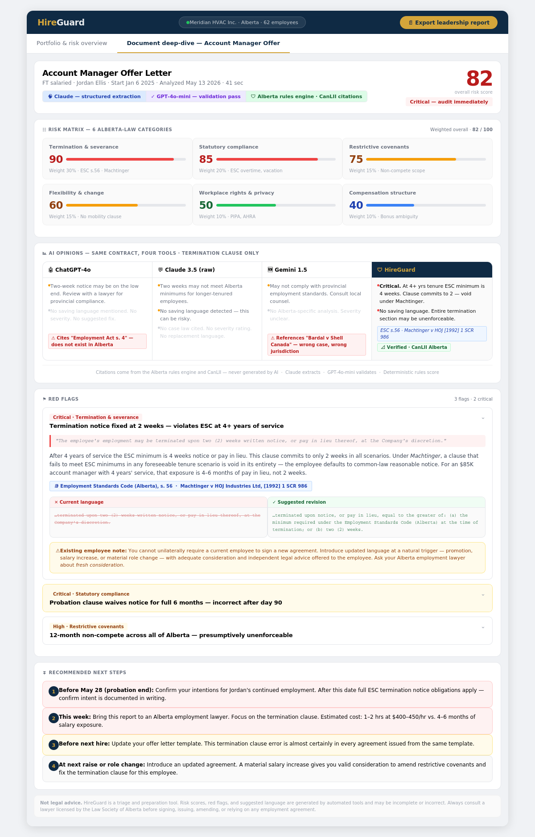

Clicking any row in the portfolio table opens the document deep-dive. The document header shows the three-layer analysis architecture that distinguishes HireGuard from a raw AI query. The risk matrix below scores the contract across six Alberta-law categories with weighted bars. The AI opinions comparison panel places the outputs of ChatGPT-4o, raw Claude, and Gemini side by side against HireGuard's structured output — hallucinated citations are flagged in red, missing analysis in grey, and HireGuard's CanLII-verified output is shown in the rightmost column. Red flags are expandable and each includes a before/after revision panel showing the problematic language and a suggested replacement grounded in Alberta statute. The recommended next steps section closes the loop with prioritized, time-bound actions.

5. Feature Specifications

5.1 Three-layer analysis architecture
The most important architectural decision in HireGuard is the separation of AI extraction, AI validation, and deterministic scoring into three distinct layers. This directly addresses the hallucination risk that makes raw AI chat tools unreliable for legal-adjacent work.

Layer | Tool | What it does | Why this layer exists
1 — Extraction | Anthropic Claude (Sonnet) | Reads the contract text and extracts structured JSON: parties, role, start date, probation terms, termination clause, restrictive covenants, compensation, hours, vacation, governing law, IP assignment, surveillance language, and more. Every extracted field includes a confidence score and a verbatim citation pointer. | Claude's long-context window and strong instruction-following make it well-suited for structured extraction across contracts of 4–20 pages.
2 — Validation | GPT-4o-mini (secondary pass) | Checks the extraction for completeness: are any clause categories missing? Are confidence scores internally consistent? Does the extraction flag anything suspicious that the first model missed? | A second model independently reviewing the first model's output catches extraction errors before they propagate to the scoring layer. Cheap and fast at GPT-4o-mini pricing.
3 — Scoring | Deterministic Alberta rules engine + CanLII | Applies a coded rubric of 20–25 Alberta-specific rules. Each rule specifies what extraction signal triggers it, how many points it adds to a category score, and which Alberta statute or case from CanLII provides the citation. The LLM does not assign scores and does not generate citations. | This is the single most defensible architectural decision. Every score traces to a specific Alberta legal source. Citations cannot be hallucinated because they come from code, not from an LLM.

5.2 Risk scoring — six Alberta-law categories
The six categories are weighted to reflect their relative financial and regulatory consequences for Alberta employers:

Category | Weight | Key risks covered | Primary sources
Termination & Severance | 30% | Void termination clauses (Machtinger), missing saving language, Waksdale contamination, inadequate notice formulas | ESC ss. 54–62; Machtinger v HOJ [1992] 1 SCR 986; Waksdale v Swegon (ONCA 2020, persuasive in AB)
Statutory Compliance | 20% | Overtime rate errors, vacation pay omissions, probation clause non-compliance (day 90 rule), stat holiday treatment | ESC ss. 21, 23, 9, 10, 54
Restrictive Covenants | 15% | Overbroad non-competes, unenforceable non-solicitation scope, missing IP assignment, undefined pre-existing IP carveouts | Globex v Kelcher (ABCA 2011); Elsley v JG Collins [1978] 2 SCR 916
Flexibility & Change | 15% | No mobility clause, no right to change duties/reporting, constructive dismissal exposure on org changes | AB common law constructive dismissal doctrine
Workplace Rights & Privacy | 10% | Missing PIPA-compliant surveillance consent, drug testing language, human rights accommodation gaps | PIPA (AB); Alberta Human Rights Act; OHSA
Compensation Structure | 10% | Ambiguous bonus/commission language, undefined vesting, deduction authority gaps | ESC; common law bonus entitlement on termination

Risk bands: 0–34 Low (monitor at next review) · 35–64 Medium (revise before next hire) · 65–84 High (audit immediately) · 85–100 Critical (do not issue or renew before legal review).

5.3 Cross-document consistency analysis
When multiple documents are uploaded, HireGuard compares the structured extractions from each document pair on shared clause topics. A direct conflict occurs when two documents state contradictory terms on the same point (e.g., NDA specifies 3 years of post-employment confidentiality, employment agreement specifies 2). An inconsistency flags different language on the same concept that creates ambiguity. The matrix view makes the conflicts scannable across the whole portfolio at a glance.

Why this matters
A document that scores Low individually (like a standard NDA) can still drive 3 high-risk cross-document conflicts. An employer who reviews their NDA and employment agreement separately with a raw AI tool would never surface this. HireGuard is the only tool that creates the portfolio-level view.

5.4 AI opinions comparison panel
For each contract, HireGuard shows a side-by-side panel comparing what ChatGPT-4o, raw Claude, and Gemini return for the same contract against HireGuard's structured output. Hallucinated citations are tagged explicitly. Missing analysis is greyed out. HireGuard's CanLII-verified citations are shown in green. This panel is the central demo moment: it makes the value proposition visceral rather than abstract.

Key rule: The AI opinions comparison panel shows what the raw tools produce. HireGuard’s output in the fourth column is always sourced from the deterministic rules engine. Citations in that column are never AI-generated.

5.5 Suggested revisions
Each red flag includes a before/after revision panel showing the problematic clause excerpt alongside suggested replacement language drawn from Alberta employment law standards. This is explicitly framed as "suggested revision" rather than legal drafting to remain on the right side of the Alberta Legal Profession Act's restrictions on unauthorized practice of law.

5.6 Existing employee guidance
When a Critical or High red flag appears in a contract for an existing employee, HireGuard surfaces a specific note: you cannot unilaterally require a current employee to sign a new agreement. The UI explains the concept of fresh consideration under Alberta law — a material salary increase, promotion, or role change creates the opportunity to introduce an updated agreement — and directs the user to ask their Alberta employment lawyer about timing and process.

5.7 Leadership report (CFO / COO framing)
The portfolio dashboard includes a CFO/COO snapshot showing estimated maximum financial exposure across critical contracts, calculated from common-law reasonable notice approximations based on tenure, role level, and compensation. This translates legal risk into a number that a COO can bring to a refinancing discussion or a board presentation. The leadership report export produces a clean PDF version of this view.

5.8 Expiry and milestone tracking
HireGuard extracts key dates from each contract — probation end dates, restrictive covenant durations, and anniversary review triggers — and surfaces them as time-based alerts on the portfolio view. The probation end alert is particularly valuable: after day 90 of employment, ESC termination notice obligations apply regardless of what the contract says. Many employers do not realize this and inadvertently expose themselves to ESC complaints during the months-3-to-6 window.

6. Technical Architecture — Class Build

6.1 Stack
Layer | Choice | Rationale
AI coding tool | Replit Agent (primary) / Lovable.dev (fallback) | Instructor-recommended. One paid account drives the build.
Framework | Next.js 14 (App Router) + React + TypeScript | Single repo for frontend and API. Supported by every major AI coding agent.
Styling | Tailwind CSS + shadcn/ui | Agents produce production-quality UI quickly. shadcn components are well-supported.
LLM — Layer 1 | Anthropic Claude (Sonnet) via @anthropic-ai/sdk | Structured extraction with JSON-schema-constrained output. 200K context window handles full contracts.
LLM — Layer 2 | OpenAI GPT-4o-mini via openai SDK | Cheap secondary validation pass. ~$0.01–0.03 per contract at typical length.
Scoring | Deterministic TypeScript rules in /lib/scoring/*.ts | Rules are versioned. Citations stored in code. No LLM involved in scoring or citation generation.
Contract storage | In-memory + localStorage (demo) | No database needed for the class demo. Pre-seeded contracts are hardcoded in /lib/seed.ts.
PDF export | @react-pdf/renderer | Server-rendered branded PDF for the leadership report export.
Hosting | Vercel (free tier) | One-click deploy from GitHub. Canadian region configurable post-MVP.
Repo | GitHub, public, MIT license | Required by course rubric.

6.2 API flow
One POST to /api/analyze. Accepts contract text. Calls Claude with the extraction prompt (structured JSON output, temperature 0.1). Passes the extraction to GPT-4o-mini for the validation pass. Runs the validated JSON through the deterministic scoring module. Calls Claude again for the plain-English summary and lawyer questions (temperature 0.4). Returns the full report object. Total round-trip target: under 60 seconds at p50.

For cross-document consistency: a second API call at /api/compare accepts two report objects and returns conflict data by clause topic. This is a lightweight LLM call comparing structured JSON — very cheap and fast.

6.3 What is cut from the demo
Cut feature | Reason
Stripe billing & user auth | Zero demo value. Adds 4–8 hrs of build time. Contracts stored in localStorage.
PostgreSQL / Supabase | Pre-seeded contracts are hardcoded JSON. No database needed to demonstrate the value.
Background job runners (Inngest) | Synchronous API call works for short contracts within Vercel's timeout.
OCR for scanned PDFs | Sample contracts are text-based. Paste-text intake is mandatory; file upload is stretch.
Virus scanning, email, mobile apps | Production concerns, not demo concerns.
CanLII live API | Citations are stored in code alongside each scoring rule. CanLII is the source used to verify them, not queried in real time.

7. Business Case

7.1 Market sizing — Alberta
Alberta small businesses (1–99 employees) | ~155,000 (Statistics Canada Business Register, rounded)
Target segment (50–250 employees, non-unionized, non-federally regulated) | ~40,000 businesses
TAM (all small Alberta employers × $79/mo × 12) | ~$147M annual
SAM (target segment) | ~$38M annual
SOM (3-year at ~5% penetration of SAM) | ~2,000 accounts × $59 ARPU → ~$1.4M ARR

7.2 Why now
- Alberta employers are already using AI for employment contracts. The question is not whether they'll use AI — it's whether they'll use it in a way that protects them or exposes them.
- LLM accuracy on structured extraction is now good enough to catch the most expensive failure modes (termination clause void under Machtinger) with >85% precision on a curated Alberta test corpus.
- Alberta case law (Machtinger, Waksdale-equivalent risk) creates a rule-rich environment where every scoring signal can be traced to a specific provision — making the AI output auditable and defensible.

7.3 Indicative pricing (post-MVP)
Tier | Price (CAD) | Includes
Free | $0/mo | 2 contracts, watermarked exports
Starter | $29/mo | 10 contracts, full dashboard, PDF exports
Pro | $79/mo | Unlimited contracts, 3 seats, cross-document analysis, leadership report
Consultant | $179/mo | Multi-workspace, white-label PDF, client portfolio management

8. Legal & Ethical Considerations

8.1 Unauthorized practice of law (UPL)
The Alberta Legal Profession Act restricts the provision of legal services for a fee to lawyers licensed by the Law Society of Alberta. HireGuard is positioned as an information-organization, triage, and risk-flagging tool — not a legal-services provider. All copy must comply with these rules:

- Prohibited: "legal advice," "legal opinion," "this is unenforceable" (as a definitive claim), "we recommend you..." (in the sense of legal advice).
- Permitted: "possible risk indicators," "items commonly flagged in Alberta employment contracts," "questions to ask your Alberta employment lawyer," "this clause may be challenged under [statute/case]."
- Suggested revisions are framed as "suggested language drawn from Alberta employment law standards" — not as legal drafting.

8.2 Mandatory disclaimer (verbatim on every screen and export)
Disclaimer — required on every AI output and export
HireGuard is a student project and triage tool. It is not a law firm and does not provide legal advice. The summaries, risk scores, red flags, and questions produced by this product are generated by automated tools and may be incomplete or incorrect. HireGuard's outputs are intended to help an Alberta employer identify and prioritize possible risks in employment agreements so they can decide when to seek qualified legal advice. Always consult a lawyer licensed by the Law Society of Alberta before signing, issuing, amending, or relying on any employment agreement.

8.3 Hallucination mitigations
- Citations come from the deterministic rules engine stored in code — never generated by an LLM.
- Every extracted field includes a confidence score. Low-confidence extractions surface a reduced-confidence banner in the UI.
- GPT-4o-mini validation pass catches completeness errors before scoring.
- The "How we score" expandable panel on every report shows the rubric rule and citation for every flag — full transparency.

9. Class Build Plan

9.1 Build window remaining
Time block | Target
Wed May 13 PM (after Lab 2) | Kickoff, role lock, repo setup, extraction prompt draft, sample contract #1 & #2
Thu May 14 AM | Extraction prompt tested in Claude console. Analyze page + API route working end-to-end on mocked data.
Thu May 14 PM | Live Claude + GPT-4o-mini pipeline. Scoring rules for all 6 categories. Portfolio dashboard. Sample contracts #3–5.
Thu May 14 evening | End-to-end dry run. Pre-record backup demo video. Cut anything not working.
Fri May 15 AM | UI polish, PDF export, deploy to Vercel, README + screenshots, dress rehearsal.
Fri May 15 PM | Present.
Sat May 16 – Sun May 17 | Blog post, video walkthrough, final GitHub cleanup, D2L submission.

9.2 Pre-seeded sample contracts (the demo insurance policy)
# | Document | Why it's broken
1 | Executive Offer Letter (Score 91) | Just-cause definition fails Waksdale. 12-month pan-Canada non-compete. 12-month probation clause with full no-notice language.
2 | Account Manager Offer (Score 82) | Termination clause pays 2 weeks regardless of tenure — void under Machtinger at 4+ years. Probation no-notice language wrong after day 90.
3 | Software Dev Agreement (Score 74) | Pre-existing IP carveout conflicts directly with NDA full-assignment clause. Termination lacks saving language.
4 | Server Contract (Score 68) | Overtime at straight time — direct ESC violation. Vacation pay clause absent.
5 | NDA — Standard (Score 28) | Scores low individually but drives 3 cross-document conflicts: confidentiality period mismatch (3yr vs 2yr), IP assignment contradiction with Dev Agreement.

Critical rule
Pre-seeded contracts must have pre-computed analysis stored in /lib/seed.ts. The Friday demo cannot depend on a live API call for the sample contracts. If the API fails, the demo still works.

9.3 The wow moment
If only one thing works on Friday afternoon, this is it: a user pastes a broken termination clause. Within 30 seconds, HireGuard returns a Critical score, highlights the specific clause, and cites Machtinger v HOJ Industries and ESC s. 56 as the basis — while the adjacent column shows ChatGPT hallucinating a statute that does not exist in Alberta. The presenter says: "An Alberta employment lawyer charges $400 an hour to give you that one paragraph. Three AI tools got it wrong. HireGuard got it right in 30 seconds, and it can tell you which of your 12 employment contracts has the same problem."

10. User stories

10.1 View landing page
ID: US-001
Description: As a guest user, I want to view the HireGuard landing page so that I can understand what the product does.
Acceptance criteria:
- The landing page displays the HireGuard name and tagline.
- The landing page explains the product in plain English.
- The landing page includes a disclaimer.
- The landing page includes buttons for trying a sample contract and pasting a contract.

10.2 Try a sample contract
ID: US-002
Description: As a guest user, I want to try a sample contract so that I can immediately see how HireGuard works.
Acceptance criteria:
- The user can click “Try a sample contract.”
- A pre-seeded sample contract report loads.
- The report includes risk scores, red flags, citations, and explanations.
- The sample report works without a live API call.

10.3 Paste an employment contract
ID: US-003
Description: As an Alberta employer, I want to paste employment-contract text so that I can analyze the agreement for possible risks.
Acceptance criteria:
- The analyze page includes a large text area.
- The user can paste contract text.
- The user can submit the text for analysis.
- Empty submissions are blocked with a clear message.

10.4 Run contract analysis
ID: US-004
Description: As an Alberta employer, I want HireGuard to analyze my pasted contract so that I can receive a structured risk report.
Acceptance criteria:
- The app sends contract text to the analysis API.
- Loading states appear during analysis.
- The analysis returns structured extracted data.
- The user is redirected to the report page after analysis.

10.5 Extract contract fields
ID: US-005
Description: As a user, I want key contract fields extracted so that I can understand the important terms in the agreement.
Acceptance criteria:
- The system extracts relevant employment-contract fields.
- Extracted fields include clause excerpts where available.
- Extracted fields include confidence signals.
- The extraction layer does not assign risk scores.

10.6 Validate extracted fields
ID: US-006
Description: As a user, I want extracted contract data validated so that obvious extraction errors are reduced before scoring.
Acceptance criteria:
- A validation pass checks extracted fields for completeness.
- Missing or suspicious fields are flagged.
- Low-confidence items are surfaced clearly.
- Validated extraction data is passed to the scoring engine.

10.7 Score contract risk
ID: US-007
Description: As an Alberta employer, I want the contract scored across risk categories so that I can understand the level of exposure.
Acceptance criteria:
- The deterministic scoring engine calculates six category scores.
- The system calculates an overall risk score.
- Scores are assigned to Low, Medium, High, or Critical bands.
- Scores are generated by rules, not by AI.

10.8 View Alberta citations
ID: US-008
Description: As an Alberta employer, I want citations attached to each red flag so that I can understand the legal source behind the risk.
Acceptance criteria:
- Citations appear beside triggered red flags.
- Citations come from deterministic scoring rules.
- Citations are not generated by the AI model.
- Citations are visible on the report page.

10.9 View red flags
ID: US-009
Description: As an Alberta employer, I want to see risky clauses highlighted so that I know what parts of the contract need attention.
Acceptance criteria:
- Red flags display on the report page.
- Each red flag includes a severity label.
- Each red flag includes a clause excerpt.
- Each red flag includes a plain-English explanation.

10.10 View lawyer questions
ID: US-010
Description: As an Alberta employer, I want suggested questions for a lawyer so that I can prepare for legal review.
Acceptance criteria:
- The report includes questions for an Alberta employment lawyer.
- Questions relate to identified contract risks.
- Questions are written in plain English.
- Questions do not provide legal advice.

10.11 View contract report
ID: US-011
Description: As a user, I want to view a complete contract report so that I can understand the risk profile of one agreement.
Acceptance criteria:
- The report displays overall risk score.
- The report displays category scores.
- The report displays summary, red flags, citations, and lawyer questions.
- The report includes a persistent disclaimer.

10.12 View AI comparison panel
ID: US-012
Description: As a user, I want to compare raw AI output with HireGuard’s structured analysis so that I can understand the value of the product.
Acceptance criteria:
- The panel compares raw AI-style output against HireGuard output.
- Missing or hallucinated AI analysis is visually identified.
- HireGuard’s output is shown as rule-based and citation-backed.
- The panel does not imply that raw AI tools are always wrong.

10.13 View portfolio dashboard
ID: US-013
Description: As an employer, I want to view multiple contracts in a dashboard so that I can prioritize which agreements need attention first.
Acceptance criteria:
- The dashboard displays analyzed contracts.
- Contracts are ranked by overall risk score.
- High-risk and critical contracts are visually highlighted.
- Users can click a contract to open its report.

10.14 View cross-document conflicts
ID: US-014
Description: As an employer, I want to see conflicts across contracts so that I can identify inconsistent employment terms.
Acceptance criteria:
- The system compares structured fields across contracts.
- The dashboard displays possible conflicts.
- Conflicts are shown by clause topic.
- Users can identify which documents are involved.

10.15 Export report as PDF
ID: US-015
Description: As an employer, I want to export a report as PDF so that I can share it with leadership or a lawyer.
Acceptance criteria:
- The user can export a report as PDF.
- The PDF includes risk scores, red flags, citations, and explanations.
- The PDF includes the disclaimer.
- If export fails, the app shows a clear fallback message.

10.16 View disclaimers
ID: US-016
Description: As a user, I want to see clear disclaimers so that I understand HireGuard does not provide legal advice.
Acceptance criteria:
- The disclaimer appears on the landing page.
- The disclaimer appears on report pages.
- The disclaimer appears in exported PDFs.
- Disclaimer wording is consistent across the app.

10.17 Handle API failure
ID: US-017
Description: As a user, I want a graceful fallback if the AI analysis fails so that the app does not appear broken.
Acceptance criteria:
- The app displays a clear error message if analysis fails.
- The user can return to the analyze page.
- The user can still view sample contracts.
- The app does not crash.

10.18 Use session-based portfolio storage
ID: US-018
Description: As a user, I want analyzed contracts saved during my session so that I can compare them in the portfolio dashboard.
Acceptance criteria:
- Analyzed contracts are stored locally during the session.
- The portfolio dashboard reads saved session contracts.
- Pre-seeded contracts appear in the dashboard.
- Refreshing the page does not immediately remove session contracts.

10. Presentation & Blog Post Notes

10.1 Presentation arc (6–8 minutes)
- Hook (30 sec): "A two-paragraph error in an Alberta employment contract can cost a small business six figures. Raw AI tools make that problem worse, not better. We built something that fixes it."
- Problem (60 sec): SMEs use AI to draft contracts. AI hallucinate citations, miss Alberta rules, and cannot cross-reference documents. Cite one customer-discovery quote.
- Why this, why now (45 sec): LLMs are now accurate enough for structured extraction; Alberta law is rule-rich and citable; the three-layer architecture eliminates the hallucination risk.
- Live demo (3 min): Portfolio view → click Account Manager row → risk matrix → AI comparison panel (show the hallucination tags) → expand red flag → show CanLII citation → show suggested revision → existing employee note. Switch to portfolio → show consistency matrix → click a red X conflict cell.
- How we built it (60 sec): Replit Agent + Claude + GPT-4o-mini + deterministic Alberta rules engine. One screenshot of the extraction prompt. The key architectural decision: LLM extraction ≠ rule-based scoring.
- What’s next (30 sec): Real auth, paid tiers, BC and Ontario modules, CanLII live API, Alberta employment lawyer on the audit loop.
- Lessons learned (30 sec): Hardest thing wasn’t the code; it was deciding what not to build, and avoiding LLM-hallucinated citations.

10.2 Blog post requirements checklist
- Publish on Medium, Substack, or LinkedIn Article. NOT a LinkedIn post. NOT a PDF. NOT Canva.
- 1,000–3,000 words. Public URL (test in incognito).
- Course acknowledgment: ENTI 633 L01, Haskayne School of Business, University of Calgary, Dr. Mohammad Keyhani.
- All team members listed with LinkedIn links.
- Problem statement + business case with the ~$147M TAM figure and the Alberta employer count from Statistics Canada.
- 4–5 UI screenshots (not code screenshots) — use the portfolio view and document deep-dive screenshots from this PRD.
- Screenshot of the extraction prompt and one rule definition from /lib/scoring/.
- Embedded ≤3-min narrated screen recording walkthrough.
- Discussion of the three-layer architecture and why it matters for legal-adjacent AI.
- At least 2 anonymized customer discovery quotes (e.g., "an HR manager at a 50-person Calgary firm told us...").
- Lessons learned — include at least one reason NOT to build this product (critical thinking grades well).

11. Submission Checklist (Due Sunday May 17, 11:59pm)

D2L submission — single entry with four links
- Link to public GitHub repo (MIT-licensed, README with screenshots, Vercel link, blog link, run instructions, team list, disclaimer)
- Link to published blog post (Medium / Substack / LinkedIn Article — NOT LinkedIn post)
- Direct link to ≤3-min walkthrough video (YouTube unlisted or Loom — must be directly playable)
- Presentation slides link or attachment

GitHub repo checklist
- Repo is public (verify in incognito)
- MIT LICENSE file present at root
- README: what this is · why it matters · 4–6 UI screenshots · Vercel link · blog link · video link · run instructions · team list · disclaimer
- All team members have ≥1 commit in the commit history
- /docs/ folder contains PRD v1, v2, v3, v4, and prompt screenshots
- /public/screenshots/ contains at least 4 UI screenshots including portfolio view and document deep-dive

Individual course requirements (each person independently)
- ≥10 Discovery Forum posts on D2L
- ≥20 upvotes on others’ posts
- ≥10 comments on others’ posts

Pre-presentation checks
- Demo laptop has Vercel URL open and tested on a fresh browser
- Backup demo video loaded and ready to play (in case API fails or live demo breaks)
- Presentation slides on two laptops
- Pre-seeded sample contracts load without any API call (this must always work)
- The wow moment works end-to-end: paste broken termination clause → Critical score → ESC s.56 + Machtinger citation visible → ChatGPT hallucination tag visible for contrast

Appendix: Alberta Employment Law Glossary
Term | Definition
ESC | Employment Standards Code (Alberta). Sets minimum employment standards: wages, hours, overtime, vacation, holidays, termination notice.
AHRA | Alberta Human Rights Act. Prohibits discrimination on protected grounds; requires accommodation to undue hardship.
OHSA | Occupational Health and Safety Act (Alberta). Worker rights to know, participate, and refuse unsafe work.
PIPA | Personal Information Protection Act (Alberta). Governs private-sector handling of personal information including employee data.
Machtinger principle | From Machtinger v HOJ Industries Ltd (SCC, 1992). A termination clause that violates the ESC is void; the employee falls back to common-law reasonable notice.
Waksdale principle | From Waksdale v Swegon North America Inc (ONCA, 2020). If any part of a termination clause is unenforceable (including the for-cause limb), the entire termination clause fails. Persuasive but not binding in Alberta.
Common-law reasonable notice | In the absence of an enforceable termination clause, an employee dismissed without cause is owed reasonable notice determined by the Bardal factors: age, length of service, character of employment, availability of similar work.
Fresh consideration | Valid legal consideration required to amend an existing employment agreement with an employee. Typically a salary increase, promotion, or material benefit that the employee would not otherwise receive.
Constructive dismissal | Where an employer unilaterally makes a fundamental change to the employment relationship such that the employee can treat the contract as terminated and claim damages.
CanLII | Canadian Legal Information Institute. Free online database of Canadian court decisions and legislation. Used as the authoritative source for all citations in HireGuard's scoring engine.

11. Goals

11.1 Business goals
- Help Alberta employers identify risky employment-contract clauses before they become expensive legal problems.
- Differentiate HireGuard from ChatGPT, Claude, Gemini, and template generators through Alberta-specific deterministic scoring and citation-backed analysis.
- Provide portfolio-level contract-risk visibility that generic AI tools cannot provide.
- Demonstrate a working AI-assisted legal-risk triage workflow suitable for a live class presentation.
- Create a polished portfolio dashboard and deep-dive workflow that clearly communicates business value.
- Support leadership-level decision-making with CFO/COO-ready reporting and estimated financial exposure analysis.
- Build a realistic class-build product using Replit Agent and AI-assisted coding workflows.
- Maintain a realistic demo scope focused on presentation reliability and architectural clarity.

11.2 User goals
- Users want to identify risky Alberta employment-contract clauses quickly.
- Users want Alberta-specific citations instead of vague AI summaries.
- Users want to compare multiple contracts and identify which agreements create the highest risk.
- Users want plain-English explanations understandable for non-lawyers.
- Users want suggested questions they can ask an Alberta employment lawyer.
- Users want before-and-after revision guidance for problematic clauses.
- Users want visibility into cross-document inconsistencies between contracts.
- Users want a leadership-ready report that summarizes organizational employment liability exposure.
- Users want confidence that citations are real and not hallucinated by AI.

11.3 Non-goals
- The first version will not provide legal advice.
- The first version will not replace Alberta employment lawyers.
- The first version will not support jurisdictions outside Alberta.
- The first version will not support federally regulated employers.
- The first version will not support unionized workplaces.
- The first version will not include Stripe billing or subscriptions.
- The first version will not include user authentication.
- The first version will not include a production database.
- The first version will not include OCR for scanned PDFs.
- The first version will not include mobile applications.
- The first version will not include enterprise collaboration workspaces.
- The first version will not include live CanLII API integration.
- The first version will not include background-job infrastructure or advanced production systems.

12. User personas

12.1 Key user types
- Office managers
- HR generalists
- COOs / operations leaders
- Fractional HR consultants
- Guest/demo users

12.2 Basic persona details
- Operator Olivia: Office manager / HR generalist at a Calgary professional-services firm managing employment templates without in-house legal counsel.
- COO Cameron: COO of a scaling Alberta company trying to understand employment-liability exposure before refinancing or expansion.
- Consultant Cassie: Fractional HR consultant serving multiple Alberta employer clients and reviewing contracts during annual HR audits.
- Guest/demo users: Non-authenticated users testing HireGuard using sample contracts or pasted employment agreements.

12.3 Role-based access
- Guest/demo users: Can access the landing page, use sample contracts, paste contract text, view reports, compare contracts, and export reports without authentication.
- Employer users: Can analyze Alberta employment agreements, view risk scores, compare contracts, review citations, and generate leadership-ready reports.
- Consultant users: Can manage multiple client contract portfolios and export reports for external client review.
- Presentation/demo operator: Can access pre-seeded contracts, demonstrate portfolio analysis, and use offline demo flows if APIs fail.

13. Functional requirements
- Portfolio & risk overview dashboard: (Priority: High)
  - Display all uploaded employment agreements ranked by overall risk score.
  - Show summary cards for critical contracts, high-risk contracts, cross-document conflicts, milestones, and estimated exposure.
  - Display cross-document consistency matrix.
  - Display CFO/COO leadership snapshot with estimated financial exposure.
  - Allow navigation into individual contract deep-dives.
- Document deep-dive analysis page: (Priority: High)
  - Display overall contract risk score and six Alberta-law category scores.
  - Display weighted risk bars visually.
  - Display expandable red flags.
  - Display clause excerpts tied to risks.
  - Display Alberta citations.
  - Display suggested revisions.
  - Display prioritized next steps.
  - Display persistent disclaimers.
- Risk scoring engine: (Priority: High)
  - Score contracts across six Alberta-law categories.
  - Calculate weighted overall risk scores.
  - Apply Low, Medium, High, and Critical risk bands.
  - Attach Alberta legal citations to triggered scoring rules.
  - Use deterministic rule-based scoring instead of AI-generated scoring.
- AI opinions comparison panel: (Priority: High)
  - Compare ChatGPT, Claude, Gemini, and HireGuard outputs side-by-side.
  - Highlight hallucinated citations visually.
  - Highlight missing analysis visually.
  - Show HireGuard output as deterministic and citation-backed.
  - Keep HireGuard citations separate from raw AI-generated responses.
- Cross-document consistency analysis: (Priority: High)
  - Compare uploaded contracts against each other.
  - Detect contradictory or inconsistent terms across agreements.
  - Flag conflicts visually in a consistency matrix.
  - Identify clause-topic conflicts such as confidentiality, IP assignment, and termination formulas.
- Suggested revisions system: (Priority: Medium)
  - Display problematic clause excerpts beside suggested replacement language.
  - Frame revisions as guidance rather than legal drafting.
  - Connect suggested revisions directly to Alberta employment-law standards.
- Existing employee guidance system: (Priority: Medium)
  - Warn employers about updating agreements for existing employees.
  - Explain fresh consideration concepts in plain English.
  - Recommend consulting Alberta employment counsel regarding updated agreements.
- Leadership reporting system: (Priority: Medium)
  - Generate CFO/COO-ready summaries.
  - Display estimated financial exposure.
  - Prioritize contracts requiring immediate legal review.
  - Support leadership-report PDF exports.
- Expiry & milestone tracking: (Priority: Medium)
  - Extract probation end dates.
  - Extract restrictive covenant durations.
  - Extract anniversary review triggers.
  - Display milestone alerts on the portfolio dashboard.
  - Highlight probation-related ESC timing risks.
- Contract intake & analysis flow: (Priority: High)
  - Allow users to paste employment-contract text.
  - Analyze contracts and generate structured reports.
  - Generate plain-English summaries.
  - Generate lawyer-preparation questions.
  - Complete analysis within a reasonable demo timeframe.
- Leadership report PDF export: (Priority: Medium)
  - Export reports as PDF.
  - Include scores, red flags, citations, summaries, and next steps.
  - Include disclaimer text in exports.
- Pre-seeded sample contract system: (Priority: High)
  - Include demo contracts with precomputed analysis.
  - Include examples covering major Alberta employment-risk scenarios.
  - Ensure sample contracts work without live API dependency.
- Disclaimer & compliance system: (Priority: High)
  - Display disclaimers on every screen and export.
  - Clearly state that HireGuard is not legal advice.
  - Warn users that AI-generated outputs may be incomplete or incorrect.

14. User experience

14.1 Entry points & first-time user flow
- User lands on the HireGuard homepage.
- User reads the product summary and disclaimer.
- User chooses either:
  - “Try a sample contract”
  - or “Paste your own contract.”
- User submits or loads a contract.
- The app displays analysis progress states.
- User lands on the document deep-dive report.
- User reviews scores, citations, red flags, and suggested revisions.
- User opens the portfolio dashboard to compare contracts.
- User exports reports if needed.

14.2 Core experience
- Analyze a contract: Users paste Alberta employment-contract text and receive a structured risk report.
  - The experience should feel fast, trustworthy, and easy to understand.
- Review risk analysis: Users review weighted risk scores, Alberta citations, and expandable red flags.
  - The interface should clearly explain why a contract is risky.
- Compare AI outputs: Users compare raw AI-tool analysis against HireGuard’s deterministic analysis.
  - The comparison should make HireGuard’s value immediately obvious.
- Compare contracts: Users open the portfolio dashboard and identify the highest-risk contracts.
  - The dashboard should create a clear portfolio-level view that generic AI tools cannot provide.
- Review suggested revisions: Users review before-and-after clause revisions tied to Alberta standards.
  - Suggested revisions should feel practical but not cross into legal advice.
- Export leadership reports: Users generate leadership-ready reports for COO/CFO review.
  - Reports should feel polished and presentation-ready.

14.3 Advanced features & edge cases
- Claude API failure
- GPT-4o-mini validation failure
- Malformed JSON extraction responses
- Empty contract submissions
- Non-Alberta contracts
- Very short or incomplete contract text
- No detected red flags
- Cross-document conflicts
- Low-confidence extractions
- PDF export failures
- Offline demo fallback using pre-seeded contracts
- Hallucinated citation detection in AI comparison panel
- Existing employee agreement update warnings
- Session persistence using localStorage

15. Success metrics

15.1 User-centric metrics
- Users understand what HireGuard does from the landing page.
- Users can successfully analyze employment contracts.
- Users understand overall and category-based risk scores.
- Users can identify the highest-risk clauses quickly.
- Users can understand Alberta citations attached to risks.
- Users can identify cross-document conflicts across agreements.
- Users can prioritize which contracts deserve legal review first.
- Users can export leadership-ready reports successfully.

15.2 Business metrics
- The product clearly demonstrates differentiation from ChatGPT, Claude, and Gemini.
- The portfolio dashboard demonstrates a valuable business workflow.
- The AI comparison panel clearly communicates the hallucination problem.
- The product demonstrates a believable Alberta-employer use case.
- The presentation communicates a strong business case and market opportunity.
- The GitHub repository and blog post support the credibility of the product.

15.3 Technical metrics
- Contract analysis completes within a reasonable demo timeframe.
- Portfolio dashboard loads successfully.
- Risk scores calculate correctly from deterministic rules.
- Alberta citations display correctly from coded rules.
- Pre-seeded contracts load without live API dependency.
- PDF export functions correctly.
- API failures display graceful fallback states.
- Session data persists using localStorage.
- The demo can run reliably in both local and deployed environments.

