Config.json

getComponent.js

renderWithLayout.js

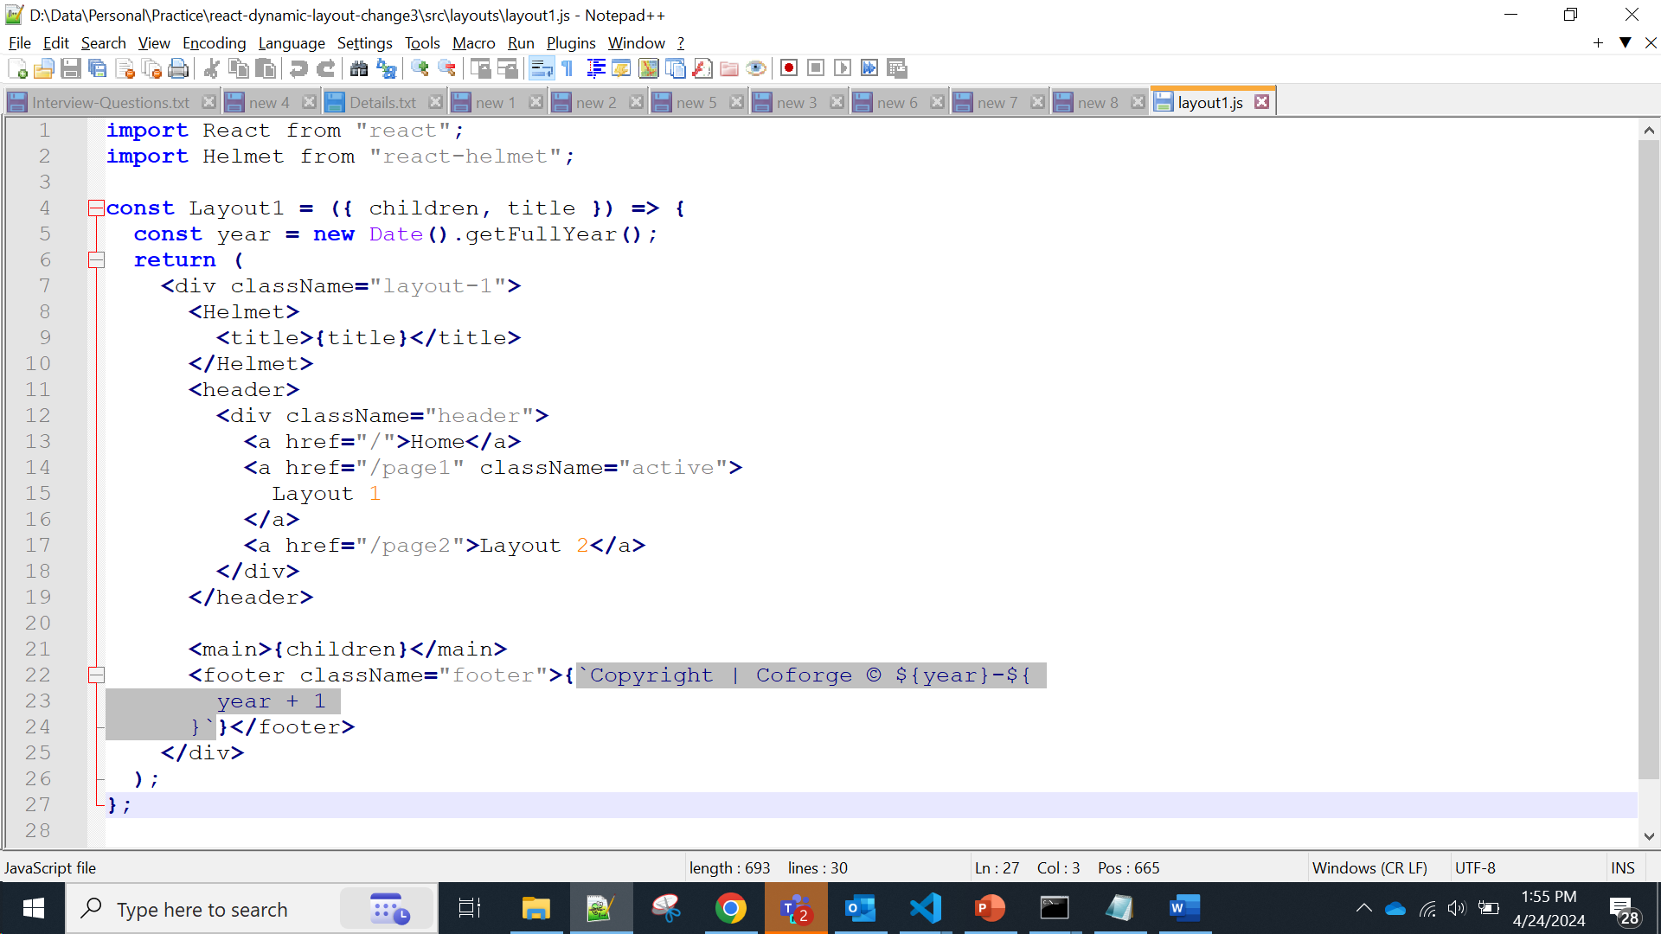

Layout1.js

Layout2.js

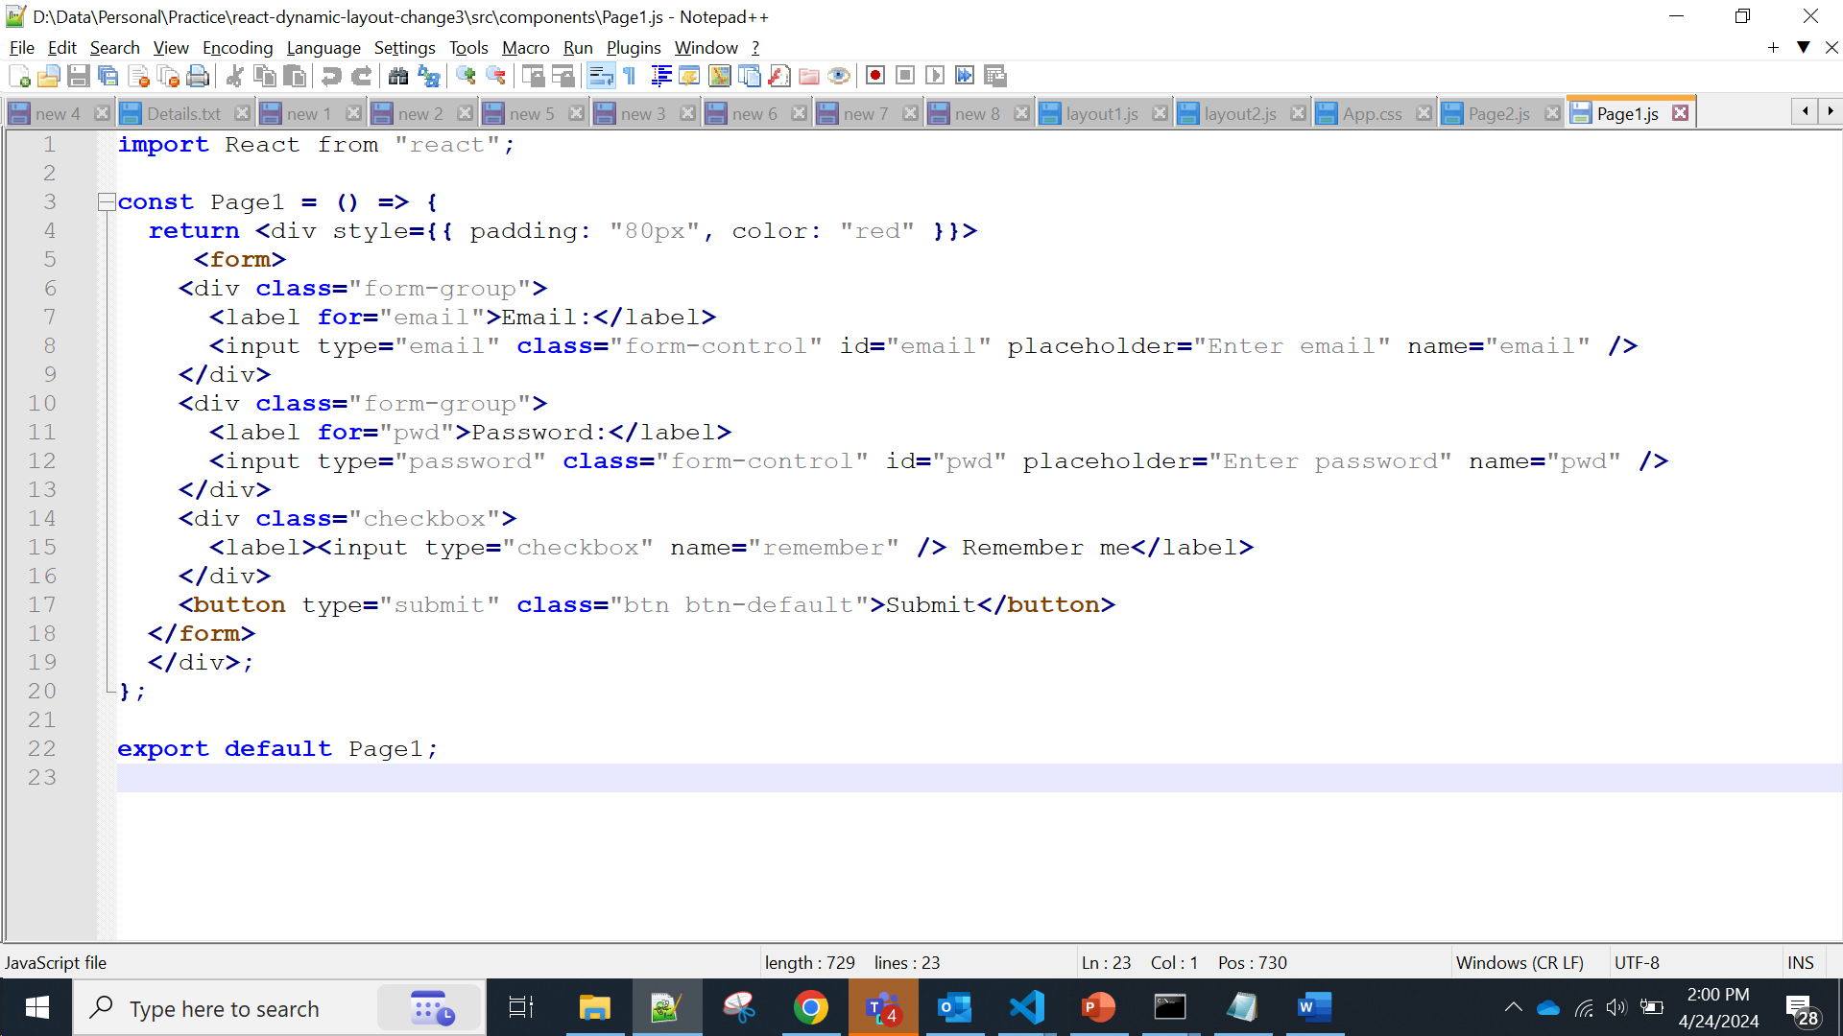

Page1.js

Page2.js