1- Enable allshore module. Better way to install that module is using drush

drush en -y allshore_auto

Since it has dependencies eck and features.

2- Now adding entity, go to admin/structure/entity-type/vehicle/car/add
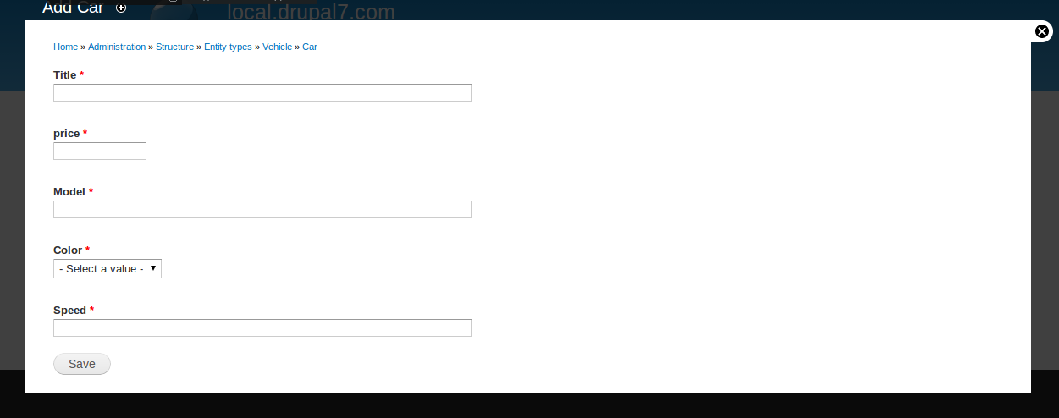

3- Crud functions as delete,edit. Go to admin/structure/entity-type/vehicle/car
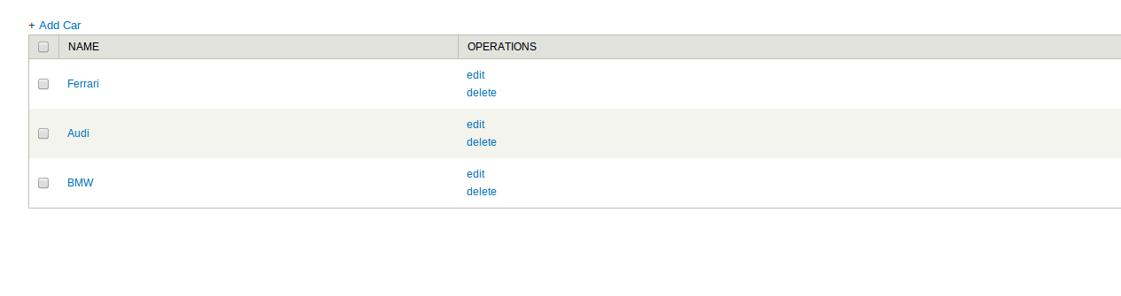
4- All listing with theme functions(table) and sortables. Go to car/listall for the path. Added screen shot with speed as sortable in desc
