**LAB # 11**

**OBJECT:** Microsoft Machine Learning.

**Task # 01:**

Choose a data set of your choice or chose UCI Bike Rental Datasets and performs the machine learning on it in such a way that your results will give give you maximum accuracy.

**OUTPUTs:**

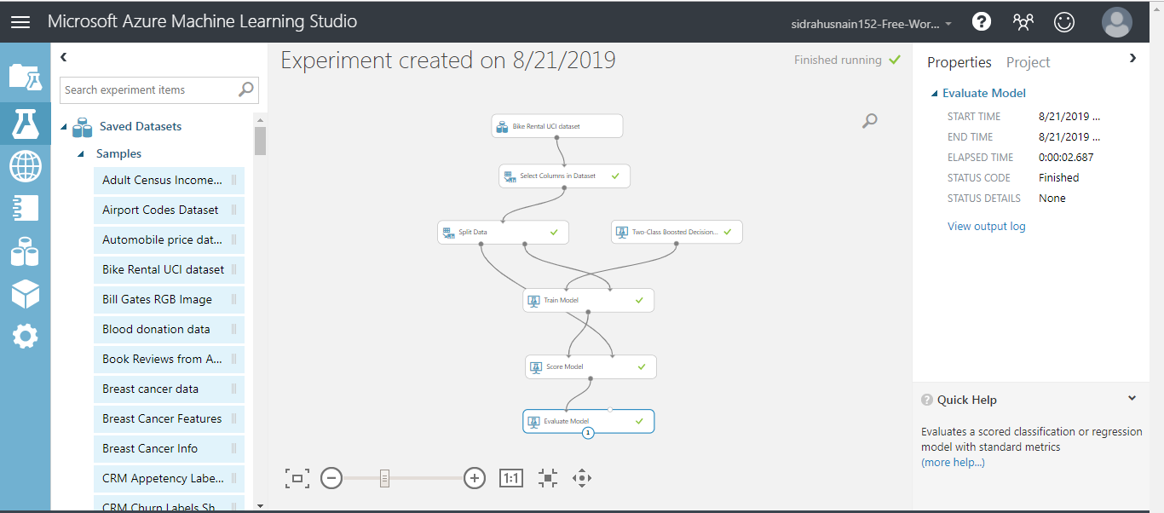

**Evaluate Model**

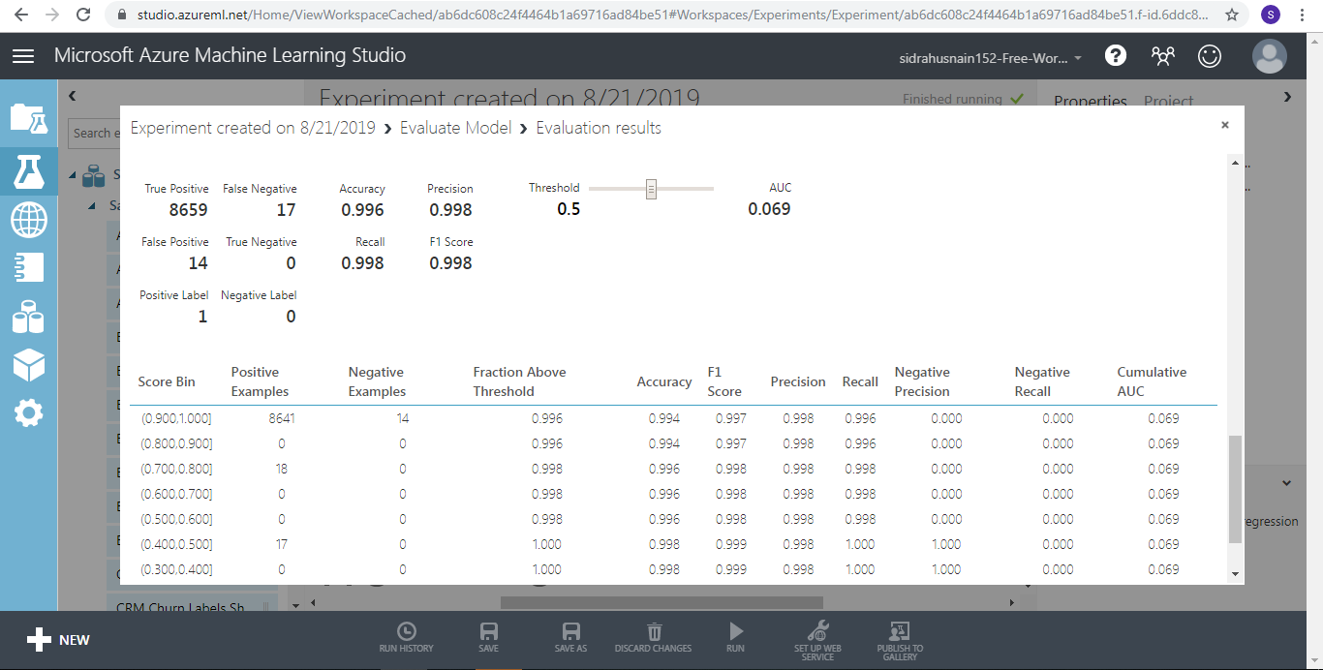

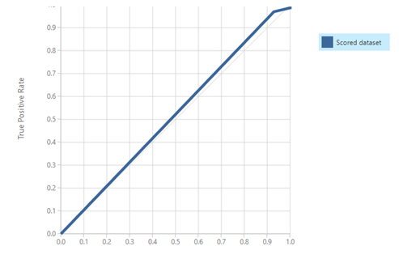

**Score Model**

