LAB NO:08

**Task # 01: Create an XML document structuring information for a store. (shopping store of your choice)**

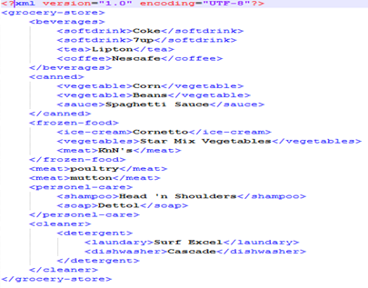

**Task # 02: Create DTD for store XML Document. And validate on** [**http://www.w3schools.com/xml/xml_validator.asp**](http://www.w3schools.com/xml/xml_validator.asp)

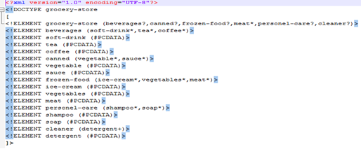

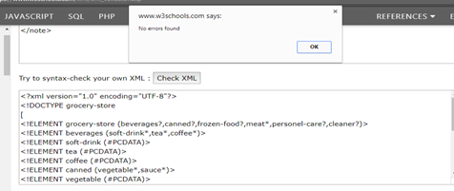

**Task #03: Write XML Schema for the following XML document and then validate the XML document along with its schema on the following website:**

**XML**

<?xml version="1.0" encoding="UTF-8"?>

<note>

<to>Alina</to>

<from>Ansari</from>

<heading>Reminder</heading>

<body>hello friend!</body>

</note>

**DTD**

<!DOCTYPE note  
[  
<!ELEMENT note (to,from,heading,body)>  
<!ELEMENT to (#PCDATA)>  
<!ELEMENT from (#PCDATA)>  
<!ELEMENT heading (#PCDATA)>  
<!ELEMENT body (#PCDATA)>  
]>

**SCHEMA**

<xs:element name="note">  
  
<xs:complexType>  
  <xs:sequence>  
    <xs:element name="to" type="xs:string"/>  
    <xs:element name="from" type="xs:string"/>  
    <xs:element name="heading" type="xs:string"/>  
    <xs:element name="body" type="xs:string"/>  
  </xs:sequence>  
</xs:complexType>  
  
</xs:element>

**XML VALIDATION**

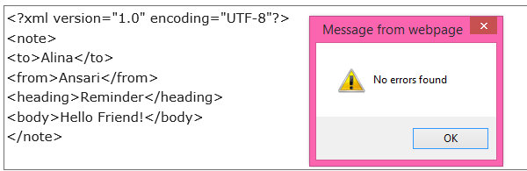

**DTD VALIDATION**

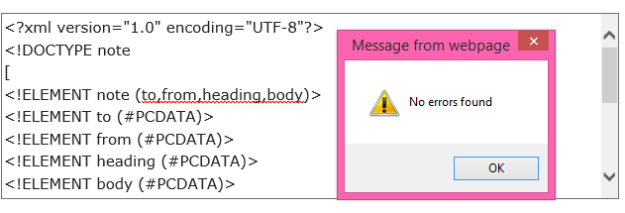

**SCHEMA VALIDATION**

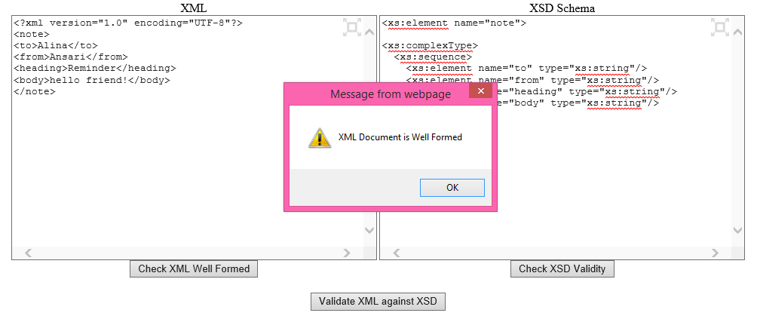

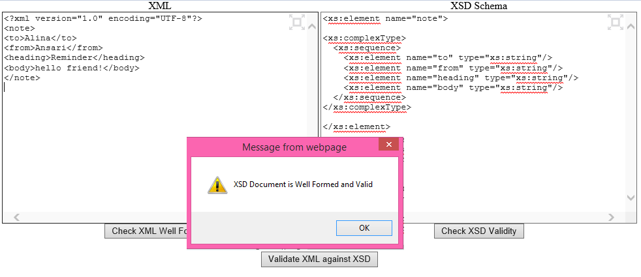

**Task # 04: Write an XML instance for following schema and then parse that document in Java using either DOM or SAX API.**

<?xml version=“1.0” ?>

<xs:schema xmlns:xs=“http://www.w3.org/2001/XMLSchema”>

<xs:element name="employee“ type="employeetype"/>

<xs:complexType name=" employeetype ">  
 <xs:sequence>  
 <xs:element name="firstname“ type="xs:string"/>  
 <xs:element name="lastname" type="xs:string"/>  
 <xs:element name=“location” type=“ xs:string”/>

</xs:sequence>  
 </xs:complexType>

<xs:complexType name=“name”>

<xs:sequence>

<xs:element name=“name” type=“ xs:string”/>

<xs:element name=“name” type=“ xs:string”/>

<xs:element name=“location” type=“ xs:string”/>

</xs:sequence>

</xs:complexType>

</xs:schema>

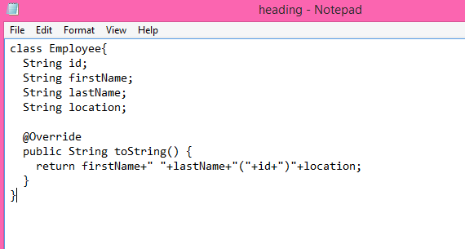

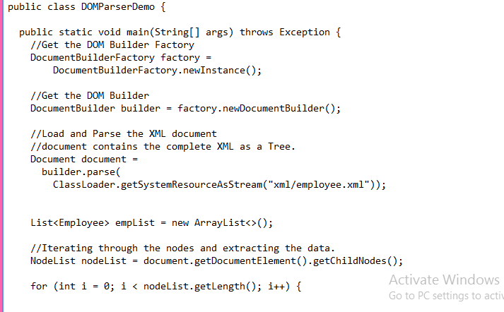

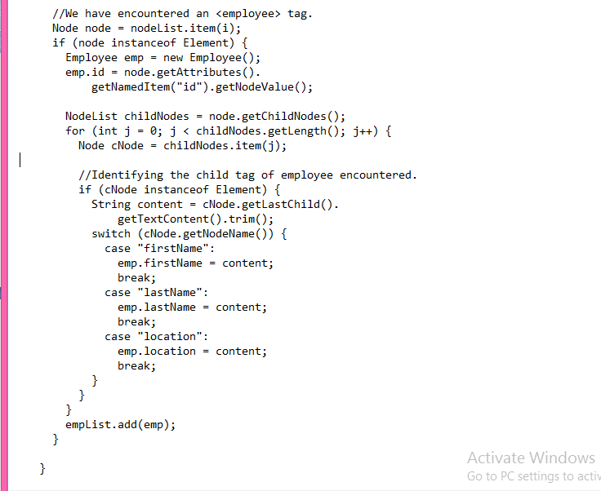

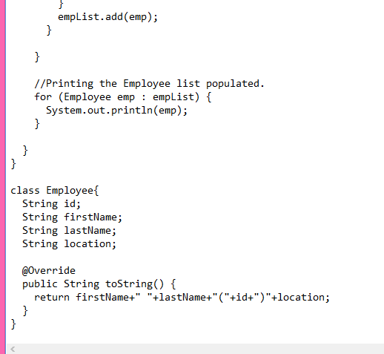

**OUTPUT**

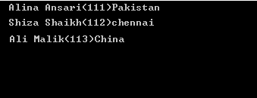

**TEXT FILE:**

