Charles Sturt University

Assessment item 1

Collatz Sequence

**_____________________________________________________________________________________**____________________________________________________________

Student ID: 11706271

Student Name: Alina Maksumova

Lecturer Name: Dr Thair Al-Dala'in

Subject Name: Programming Principles

Subject Code: ITC558

Sydney 2020

*! Assumption: User will not enter “1” as it does not make sense for the Collatz Sequence*

**Task 1**

1. Flow Chart in PDF format:



1. Flow Chart in JPEG format:

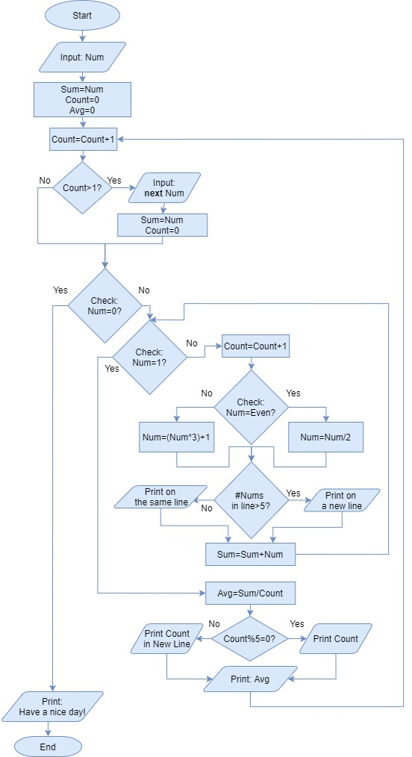

**Task 2**

1. Code source – Python:



1. Code in DOCX format:

#Ask user for input

num = int(input("Enter positive number or '0' to terminate program: "))

#Define some necessary values

count = 0

sum = num

avg = 0

zero = 0

#Start infinite loop

while(True):

count+=1

if count>1:

num = int(input("Enter next number or '0' to terminate program: "))

count=zero

sum=num

#Check first entered number

if num==0:

print("\nHave a nice day!")

break

#Program ends if first number is 0

else:

print(" ", num, end="\t")

#Start loop for first number until the result = 1

while num!=1:

count+=1

#Check and set condition for even number

if num%2==0:

num=num//2

#Check and set condition for odd number

elif num%2!=0:

num=(num*3)+1

#Set only 5 numbers per line

if (count+1)%5==0:

print(num)

else:

print(" ", num, end="\t")

sum+=num

avg=sum/count

#Display results

if (count+1)%5==0:

print("It took ",count, "iterations to arrive to 1")

else:

print("\nIt took ",count, "iterations to arrive to 1")

print("Average number is: ",format(avg, '.2f'), end="\n")

print()#Go to the beginning of loop

1. Results Screenshot:

