Charles Sturt University

**Assessment item 2**

**Data Analysis**

_____________________________________________________________________________________**____________________________________________________________**

Student ID: 11706271

Student Name: Alina Maksumova

Lecturer Name: Dr Thair Al-Dala'in

Subject Name: Programming Principles

Subject Code: ITC558

Sydney 2020

Contents

**Task 1** 3

Flowchart: Step 2-6 3

**Task 2** 4

Testing 4

**Task 3** 24

Source Code 24

Text Code 24

# **Task 1**

## Flowchart: Step 2-6

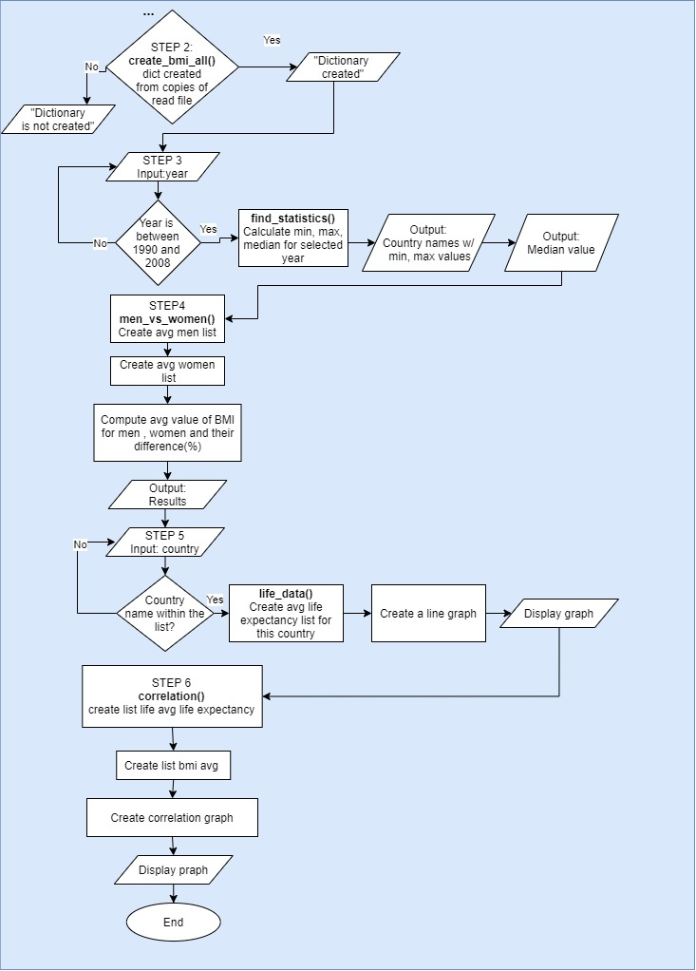

# **Task 2**

## Testing

| **Test Data Table** | | | |
| --- | --- | --- | --- |
| **Test data type** | **Test data** | **The reason it was selected** | **The output expected due to the use of the test data** |
| 1. Normal | Year: 1998  Country:  Uzbekistan | To test program operation for selected year and country | Successful completion from step 1 to step 6 and 2 graphs |

**Output:**

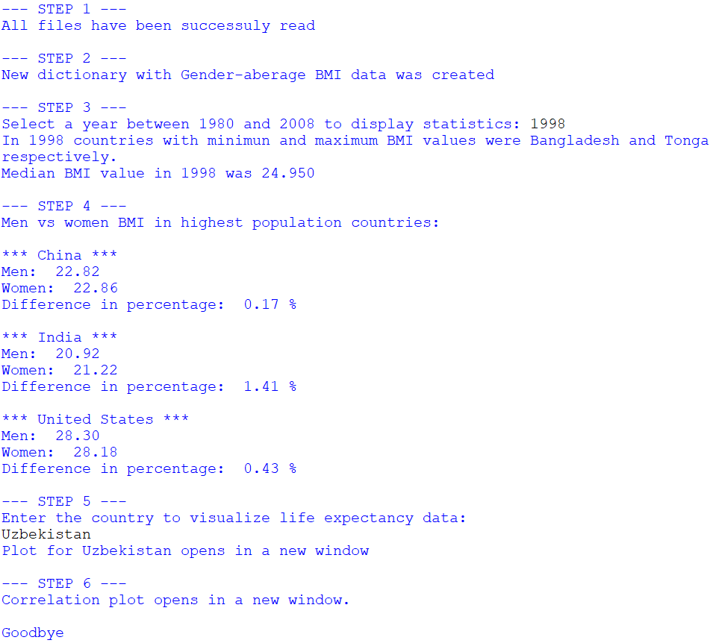

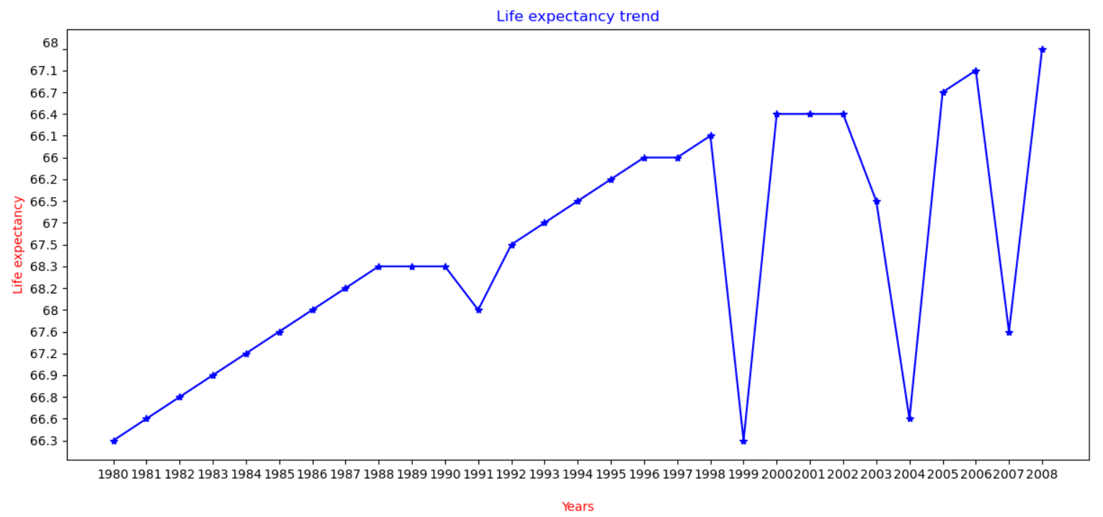

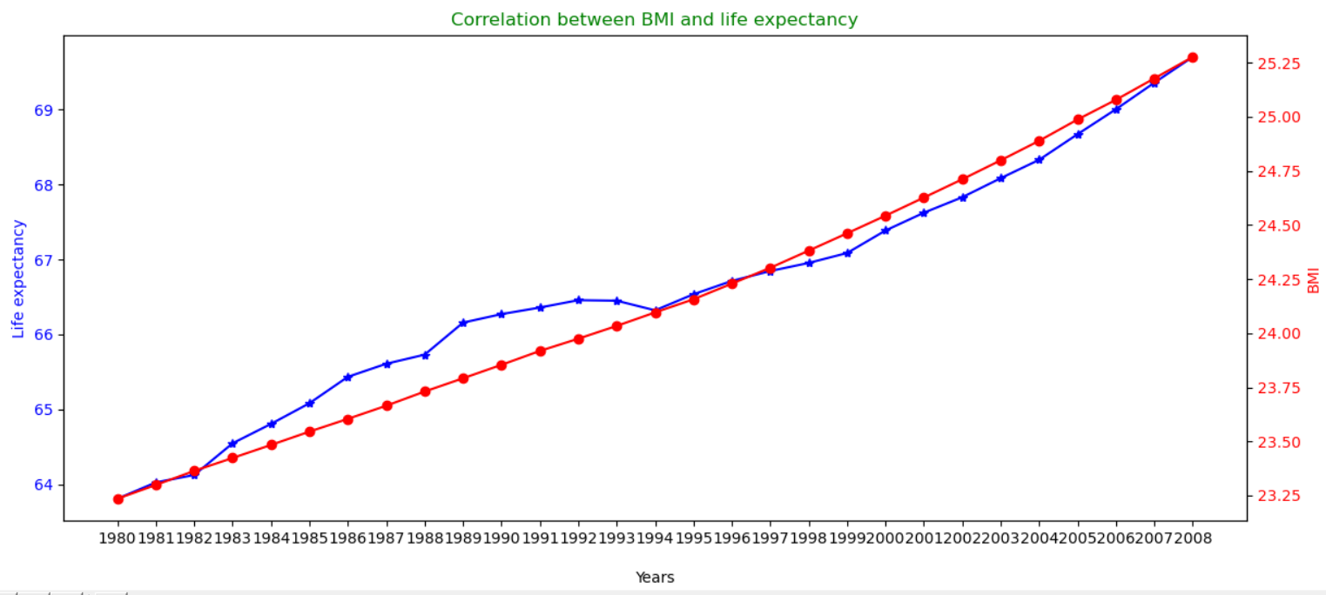

| **Test Data Table** | | | |
| --- | --- | --- | --- |
| **Test data type** | **Test data** | **The reason it was selected** | **The output expected due to the use of the test data** |
| 1. Normal | Year: 2008  Country:  Albania | To test program operation for last year and new country | Successful completion from step 1 to step 6 and 2 graphs |

**Output:**

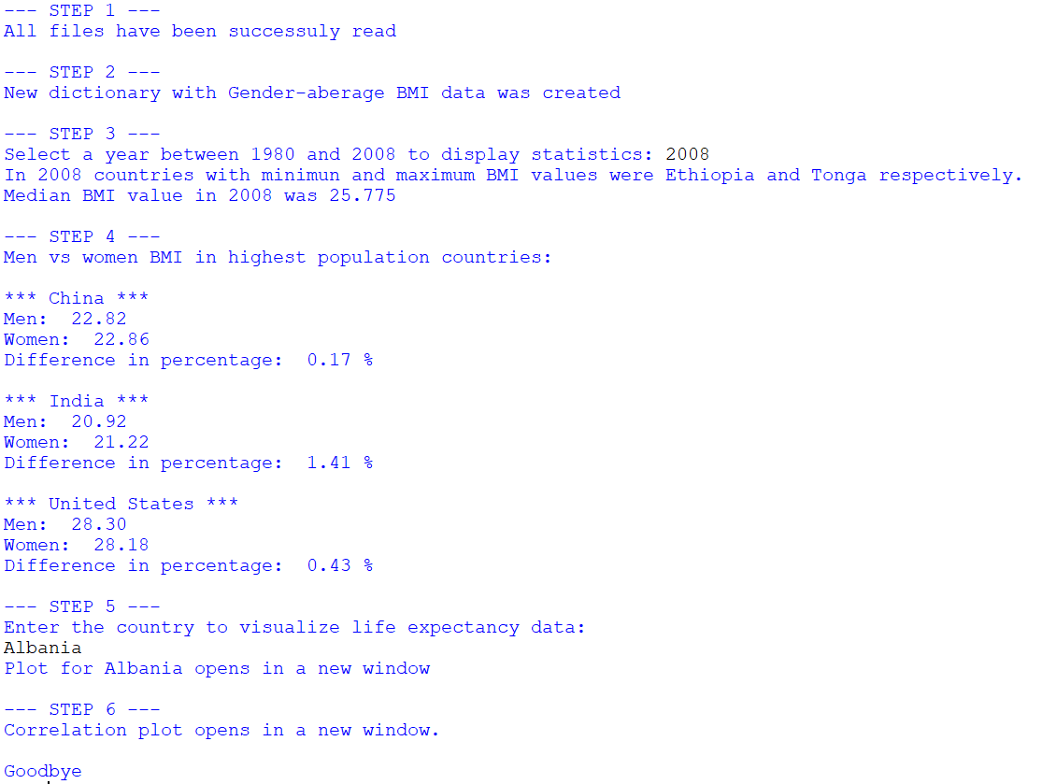

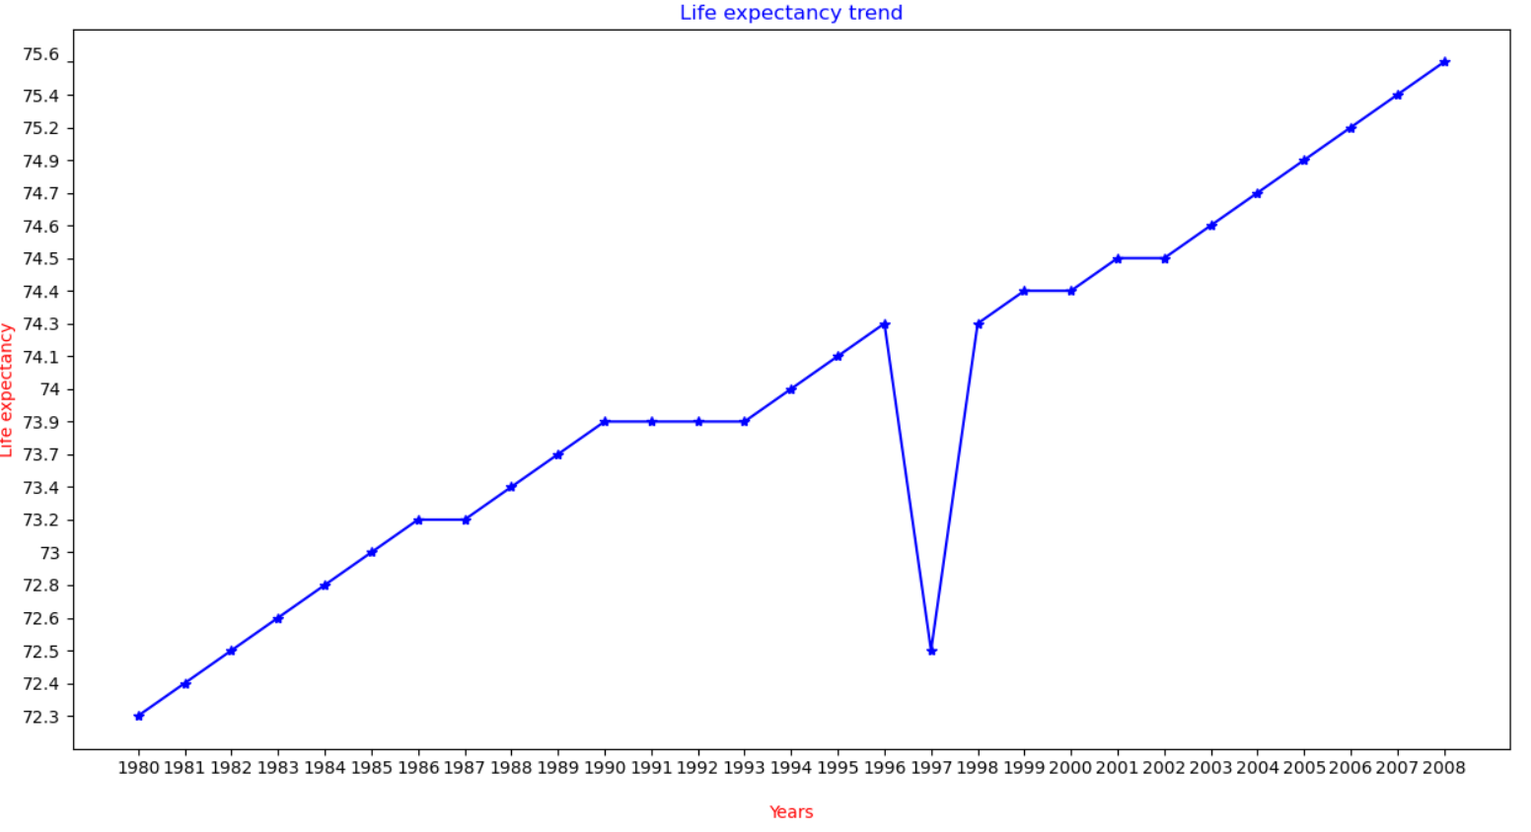



| **Test Data Table** | | | |
| --- | --- | --- | --- |
| **Test data type** | **Test data** | **The reason it was selected** | **The output expected due to the use of the test data** |
| 1. Normal | Year: 1986  Country:  ZimBabWe | To test program operation for selected year and country typed with lower and upper cases | Successful completion from step 1 to step 6 and 2 graphs |

**Output:**

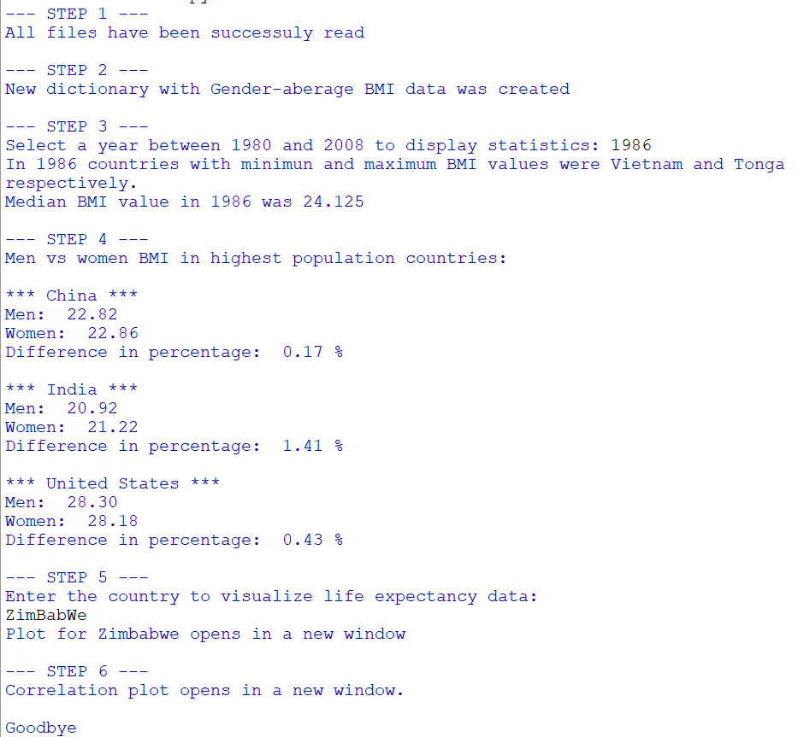

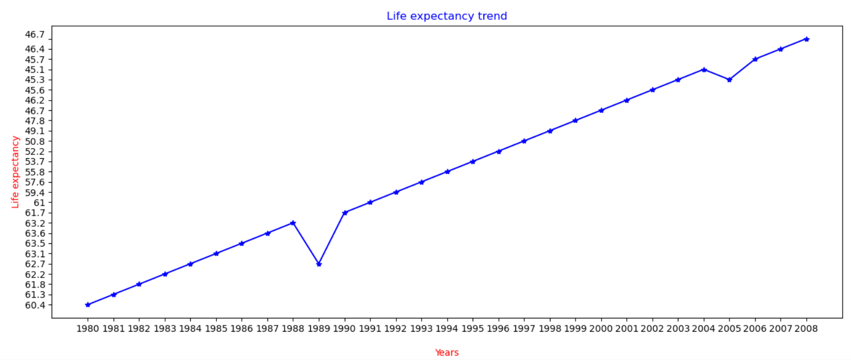

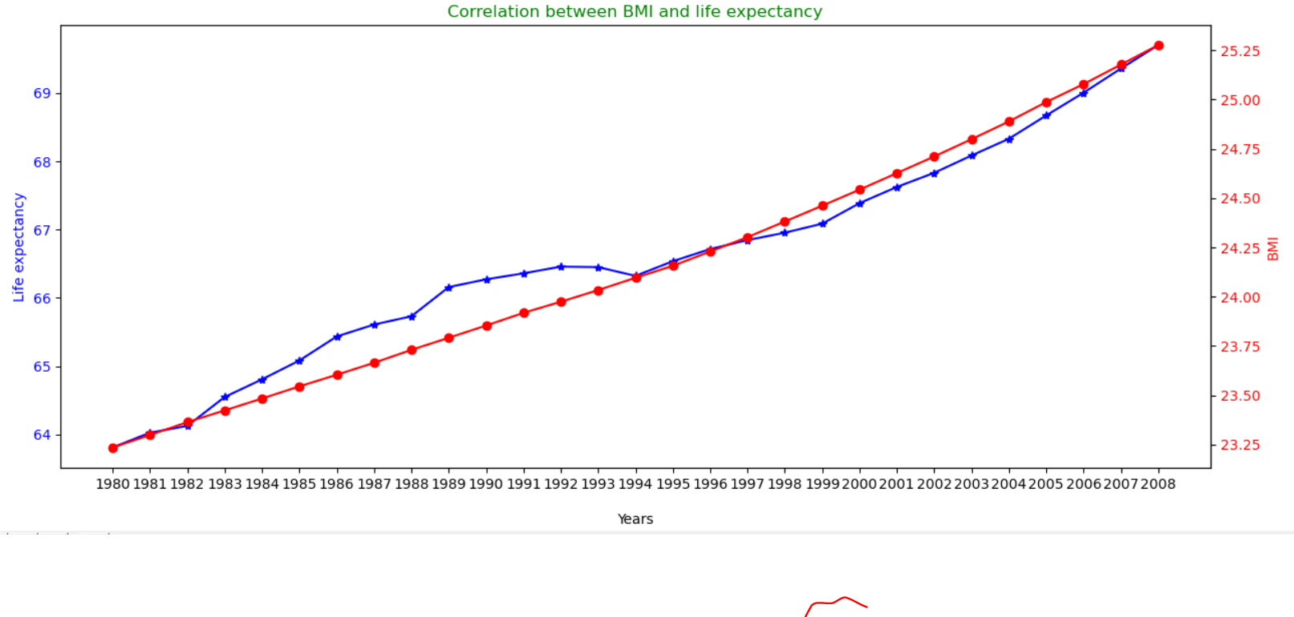

| **Test Data Table** | | | |
| --- | --- | --- | --- |
| **Test data type** | **Test data** | **The reason it was selected** | **The output expected due to the use of the test data** |
| 1. Normal | Year: 1980  Country:  ausTRALia | To test program operation for the first year and country typed with lower and upper cases | Successful completion from step 1 to step 6 and 2 graphs |

**Output:**

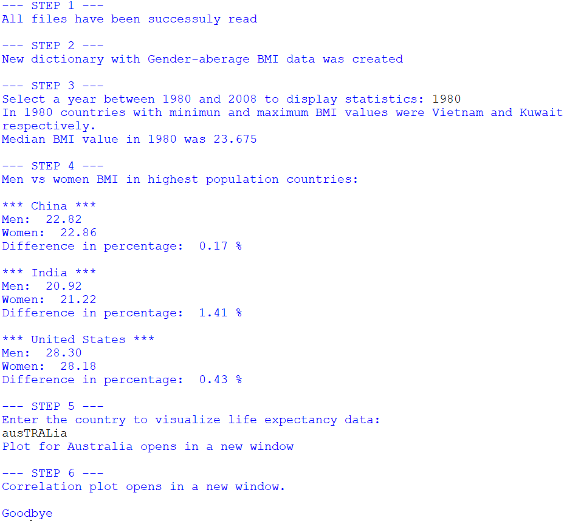

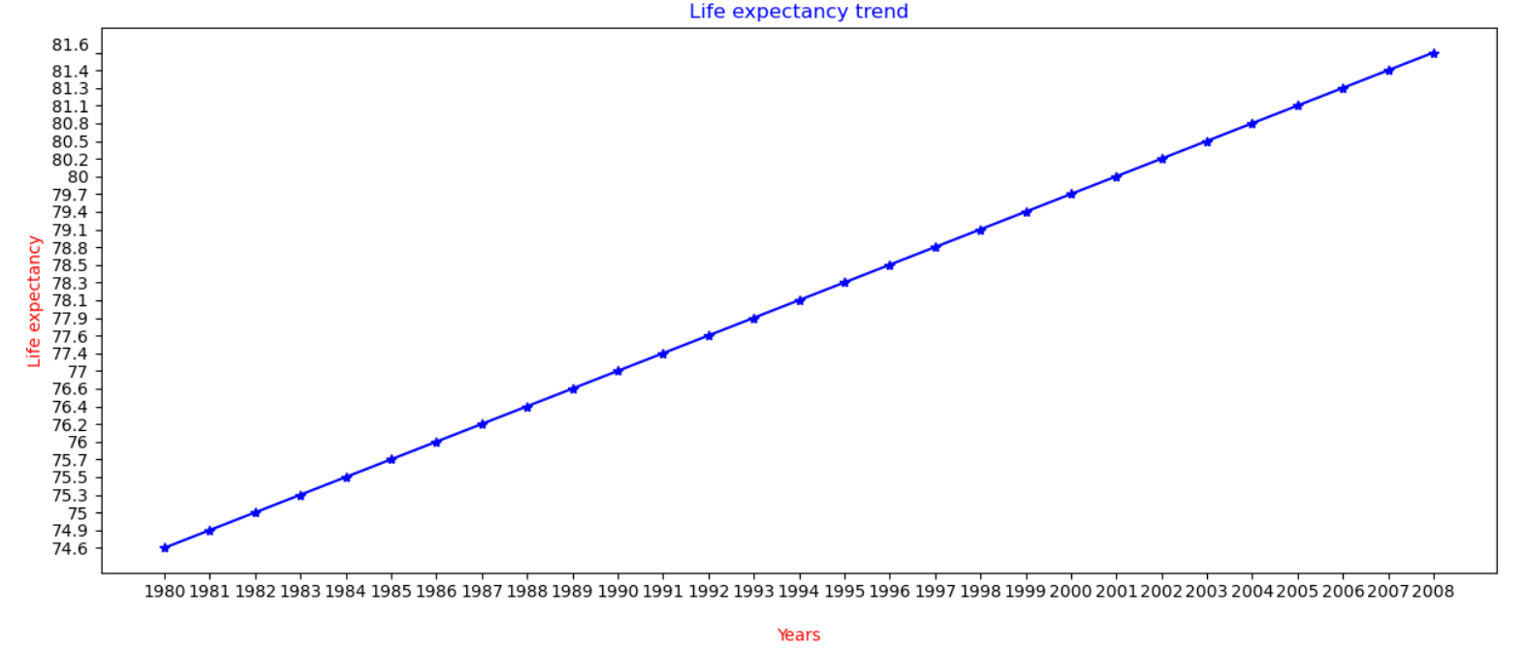



| **Test Data Table** | | | |
| --- | --- | --- | --- |
| **Test data type** | **Test data** | **The reason it was selected** | **The output expected due to the use of the test data** |
| 5) Normal | Year: 2003  Country:  tonga | To test program operation for selected year and country typed with lower cases only | Successful completion from step 1 to step 6 and 2 graphs |

**Output:**

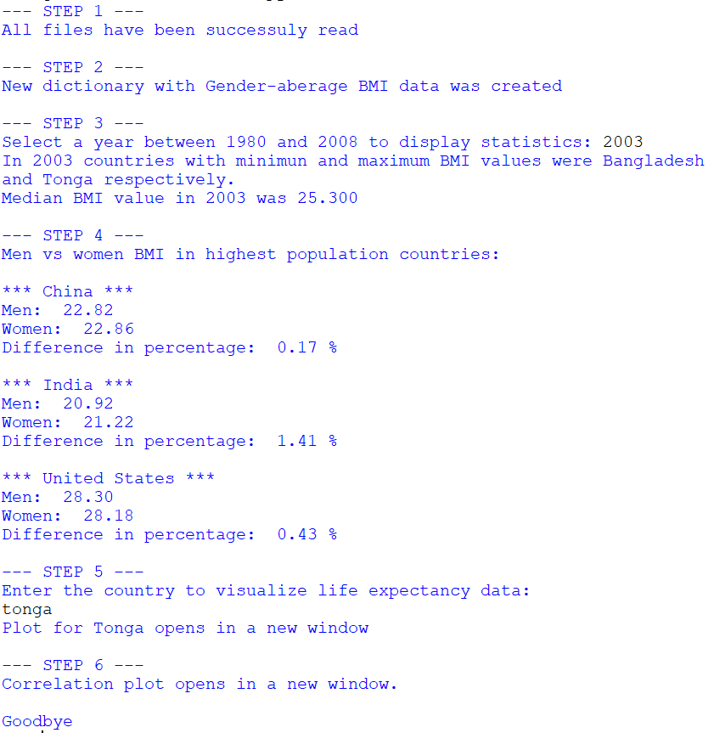

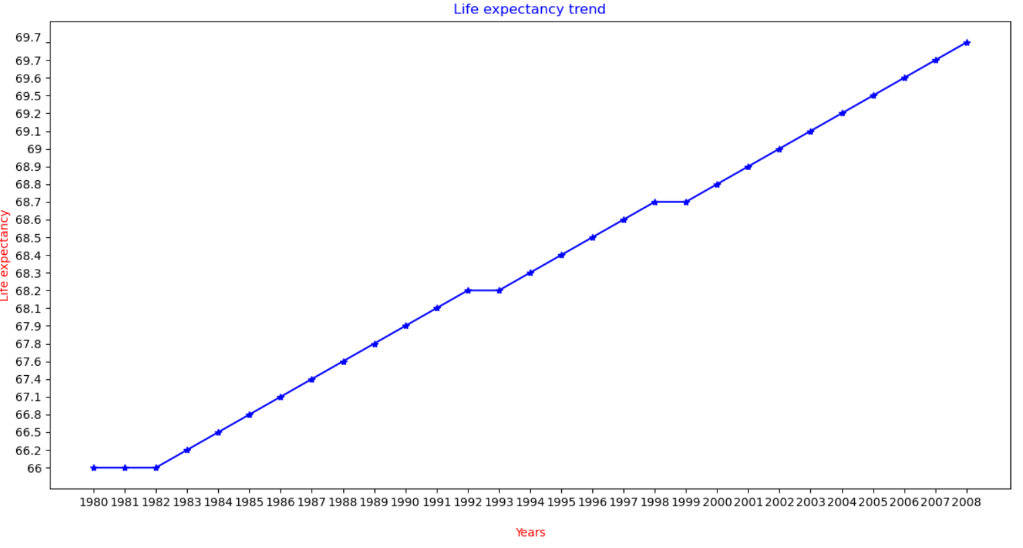



| **Test Data Table** | | | |
| --- | --- | --- | --- |
| **Test data type** | **Test data** | **The reason it was selected** | **The output expected due to the use of the test data** |
| 6) Normal | Year: 1999  Country:  JAPAN | To test program operation for selected year and country typed with upper cases only | Successful completion from step 1 to step 6 and 2 graphs |

**Output:**

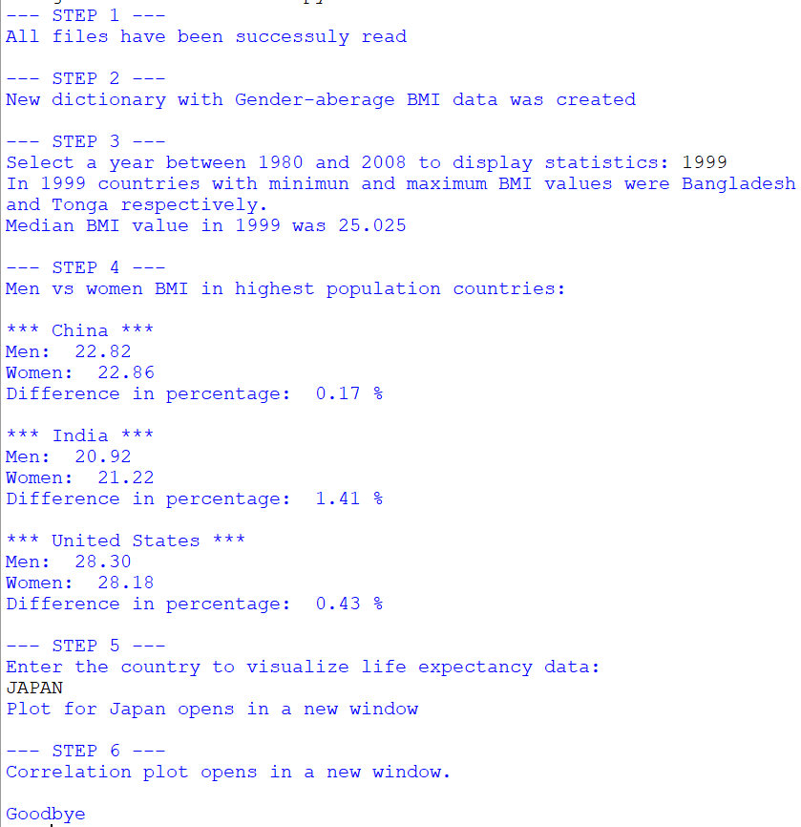

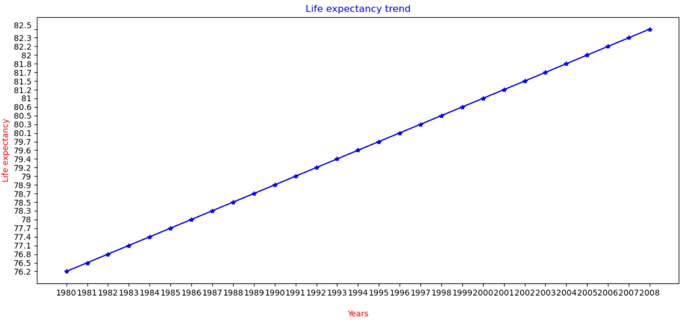



| **Test Data Table** | | | |
| --- | --- | --- | --- |
| **Test data type** | **Test data** | **The reason it was selected** | **The output expected due to the use of the test data** |
| 1. Abnormal | Year1: 2015  Year2: 2019  Year3: 2007  Country:  CostA rIcA | To test program operation for year, which is greater than expected for range; and country typed with upper and lower cases | Exception will be raised in Step 3, there should appear error message. After that, new input should be required |

**Output:**

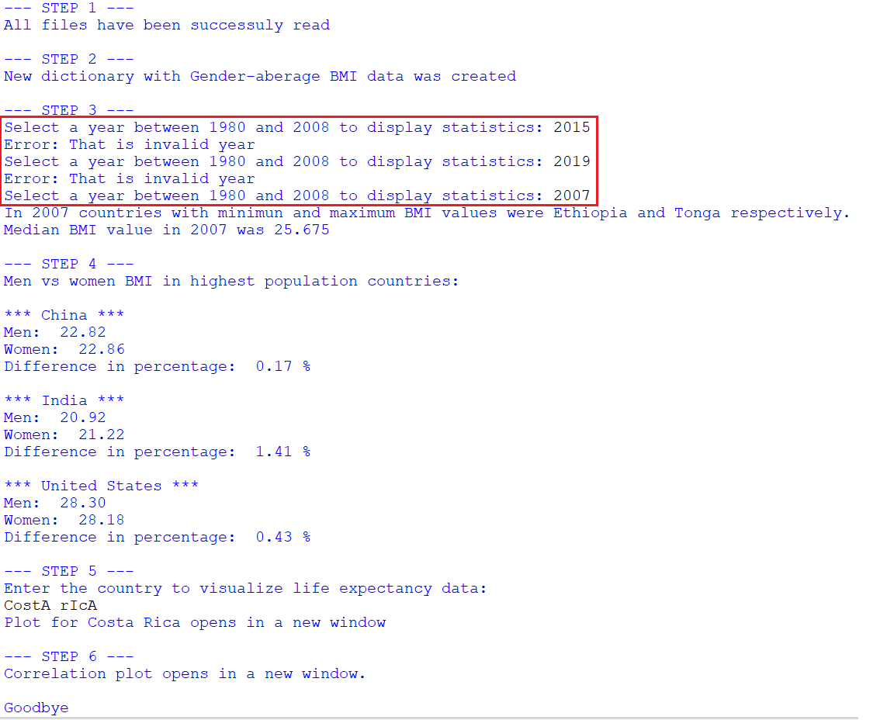

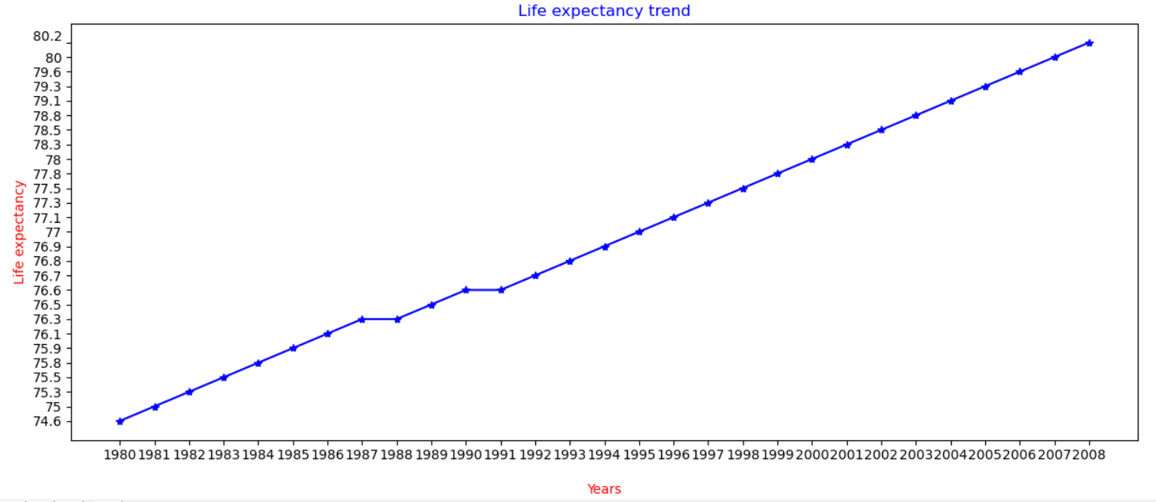



| **Test Data Table** | | | |
| --- | --- | --- | --- |
| **Test data type** | **Test data** | **The reason it was selected** | **The output expected due to the use of the test data** |
| 1. Abnormal | Year: 2002  Country1:  Las Vegas  Country2:  eArTh  Country3:  Maldives | To test program operation for selected year and input of invalid country names typed with upper and lower cases | Exception will be raised in Step 5, there should appear error message. After that, new input should be required |

**Output:**

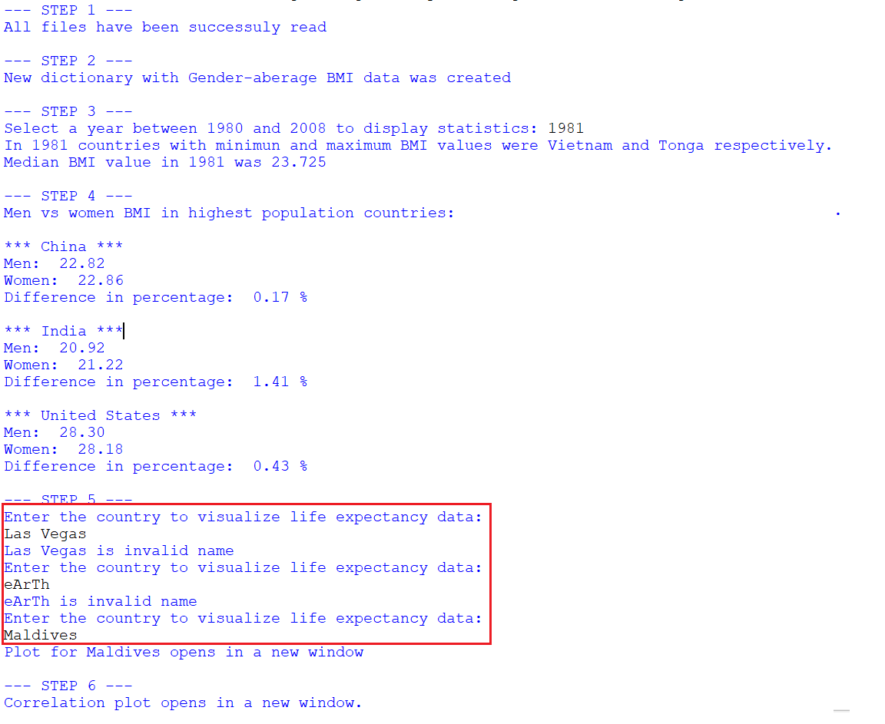

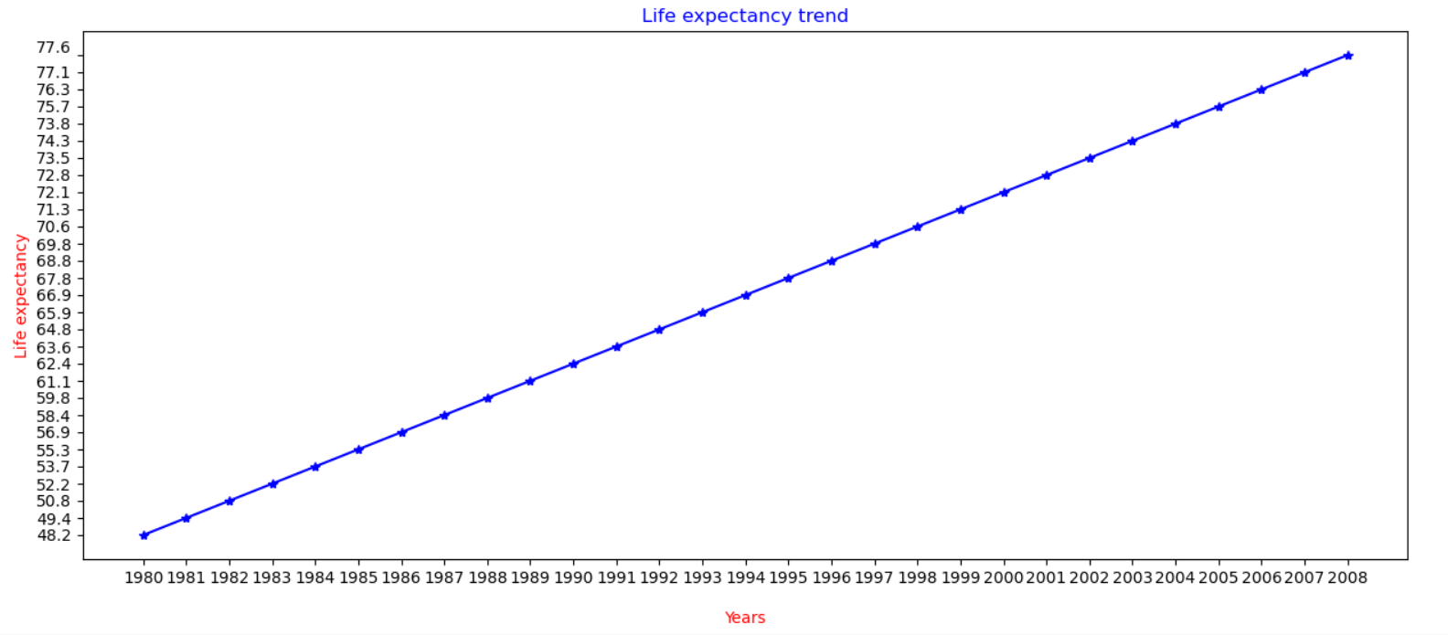



| **Test Data Table** | | | |
| --- | --- | --- | --- |
| **Test data type** | **Test data** | **The reason it was selected** | **The output expected due to the use of the test data** |
| 1. Abnormal | Year1: twenty sixteen  Year2:  1972  Year3:  2001  Country1:  RussiA | To test program operation for year typed by letters, then year greater than range and selected country | Exception will be raised in Step 3, there should appear error message. After that, new input should be required |

**Output:**

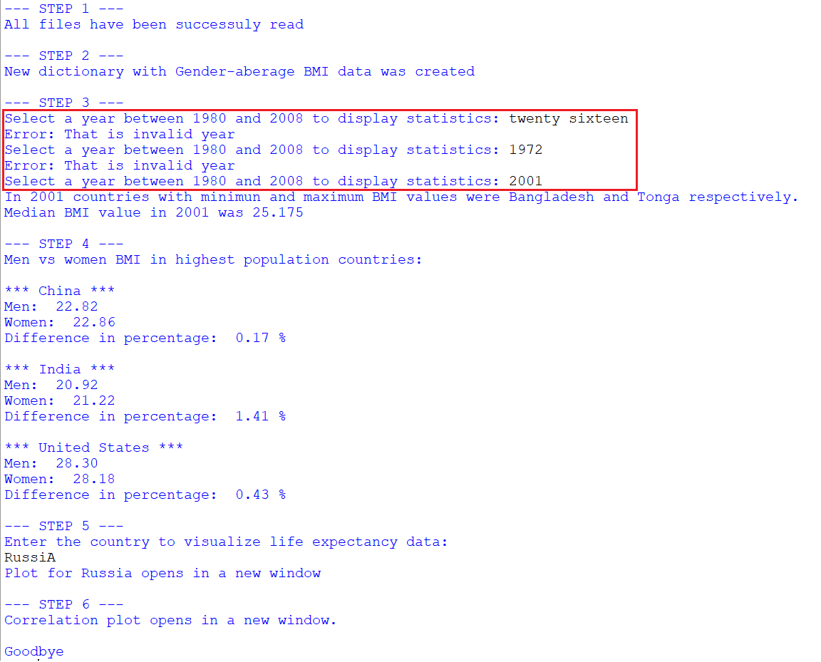

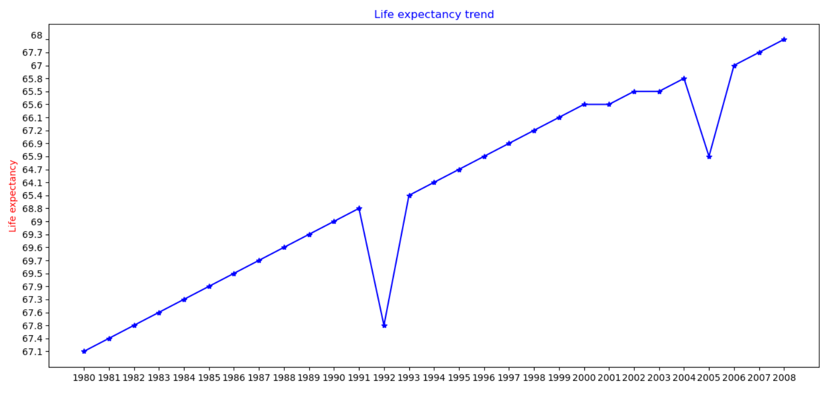



| **Test Data Table** | | | |
| --- | --- | --- | --- |
| **Test data type** | **Test data** | **The reason it was selected** | **The output expected due to the use of the test data** |
| 1. Abnormal | Year1: 19 92  Year2: 1 9 9 2  Year3: 1992  Country1:  PanAma | To test program operation for year typed by with white spaces and selected country | Exception will be raised in Step 3, there should appear error message. After that, new input should be required |

**Output:**

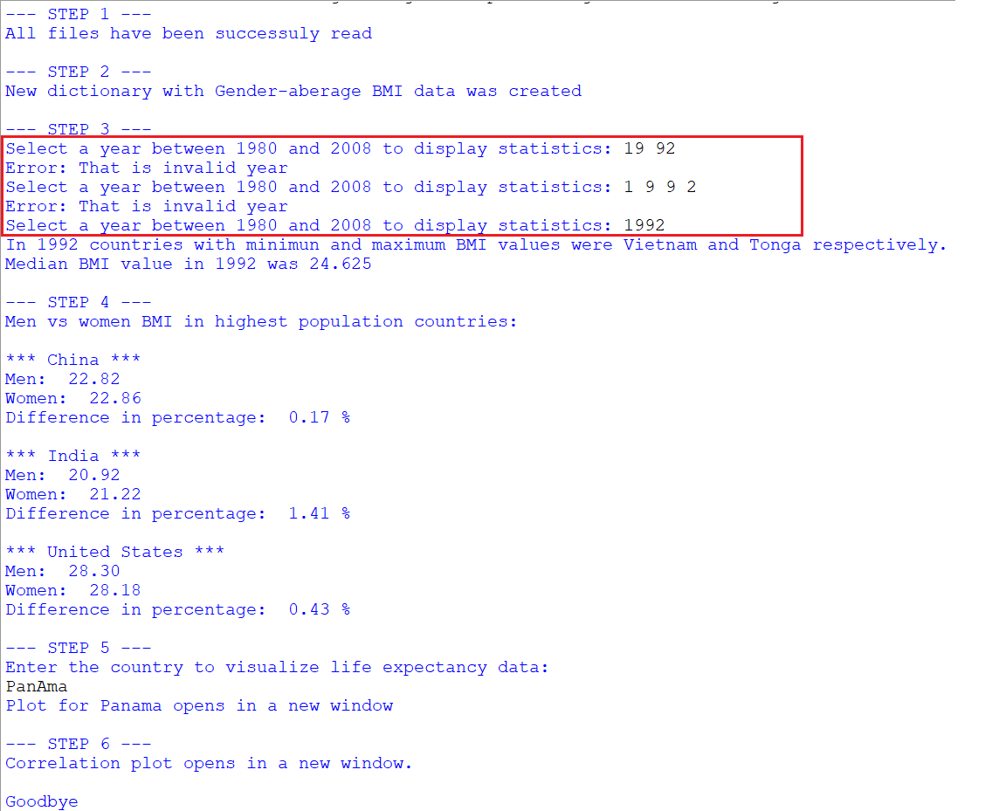

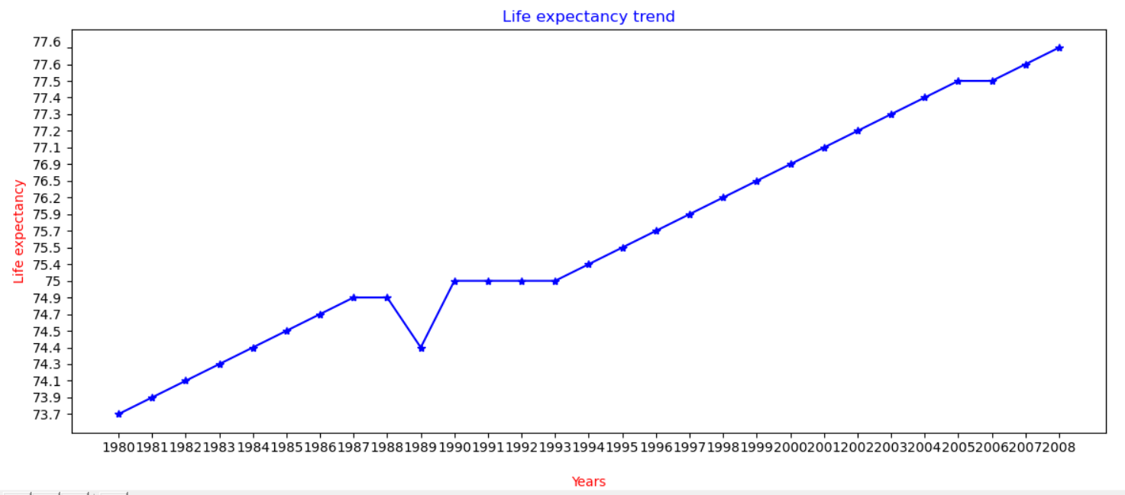



# **Task 3**

## Source Code



## Text Code

# import matplolib for graph

import matplotlib.pyplot as plt

#start main function

def main():

#step1

#call function to read files

print ("--- STEP 1 ---")

try:

women_dic = read_file_dic("bmi_women.csv")

men_dic = read_file_dic("bmi_men.csv")

life_list = read_file_list("life.csv")

print ("All files have been successuly read", '\n')

except:

print("Error occured while reading some of the files")

#step2

#create bmi_all dictionary

print ("--- STEP 2 ---")

try:

create_bmi_all()

print("New dictionary with Gender-aberage BMI data was created",'\n')

except:

print("Error occured while creating gender-average dictionary")

#step3

#compute statistics

print ("--- STEP 3 ---")

val = 0

#set loop to countinue till valid input is taken

while val ==0:

try:

#take input

year = int(input("Select a year between 1980 and 2008 to display statistics: "))

#call function

find_statistics(year)

val =1 #finish loop

#except for invalid value of input

except ValueError:

print("Error: That is invalid year")

val=0 #continue loop

#step4

#statistics of BMI men vs women

print ("--- STEP 4 ---")

print("Men vs women BMI in highest population countries:", '\n')

men_vs_women()

#step5

#plot of life expectancy

print ("--- STEP 5 ---")

v=0

while v==0:

try:

country = input("Enter the country to visualize life expectancy data: \n")

life_data(country.lower())

v=1

except:

print(country, "is invalid name")

v=0

#step6

#plot of corralation between BMI and Life expectancy

print ("--- STEP 6 ---")

print("Correlation plot opens in a new window.", '\n')

correlation()

print ("Goodbye")

#define function to read file and create dictionary

def read_file_dic(file_path):

#call try/except statement

try:

#open file for reading

file_obj = open (file_path, "r")

except IOError:

#print IOerror message in case of wrong input

print("Err: File was not found")

#declare empty dictionary for data

data_dic = {}

#declare empty dictionary for header

header_dic = {}

#declare empty list for data

list = []

#declare empty list for header

header_list = []

#define counter

counter = 0

#start for loop for a number of lines

for line in file_obj:

#increase counter by one for each iteration

counter +=1

#condition for header

if counter ==1:

#seperate lines

values = line.rstrip('\n')

#split values with comma

values = line.split(',')

#identify value with 0 index as a key

key = values[0]

#identify values, starting with index 1, as set of data for header

header_list = values[1::]

header_float = [int(i) for i in header_list]

header_dic[key] = header_float

#condition for the rest of data

else:

#seperate lines

values = line.rstrip('\n')

#split values with comma

values = line.split(',')

#identify value with 0 index as a key

key = values[0]

#identify values, starting with index 1, as set of data for list

list = values[1::]

data_float = [float(i) for i in list]

data_dic[key] = data_float

#close file

file_obj.close()

#return results of dicitionary

return header_dic, data_dic

#define function to read file and create 2d list

def read_file_list (file_path):

try:

#open file for reading

file_obj = open (file_path, "r")

except IOError:

#print error message in case of wrong input

print("Err: File was not found")

##create emply lists for data and headers

new_list = []

new_list_header = []

#set counter

counter = 0

#start loop for each line of a file

for line in file_obj:

#increase counter by one for each iteration

counter +=1

#condition for header

if counter ==1:

values = line.strip('\n')

values = line.split(',')

new_list_header = values[:]

#condition for the rest of data

else:

#attach every line as a new set of values to a list

new_list.append(line.split(','))

#close file

file_obj.close()

#return results of 2dlist

return new_list_header, new_list

#define function to create average bmi_all dictionary

def create_bmi_all():

#reference dictionaries

bmi_men_header,bmi_men_data=read_file_dic("bmi_men.csv")

bmi_women_header,bmi_women_data=read_file_dic("bmi_women.csv")

#create bmi_all dictionary

bmi_all={}

bmi_list=[]

#check for same key in men`s an women`s list

for key in list(set(bmi_men_data)|set(bmi_women_data)):

#get the keys if matched

if bmi_men_data.get(key) and bmi_women_data.get(key):

i=bmi_men_data.get(key)

j=bmi_women_data.get(key)

#create zipped list of men`s and women`s data

combined_list=zip(i,j)

#create a list of combined keys and average values

bmi_list=[round((x+y)/2,2) for (x,y) in combined_list]

#set key

bmi_all[key]=bmi_list

bmi_all_header = bmi_men_header

return bmi_all_header, bmi_all

#define function to find statistics of spesific year

def find_statistics(year):

#reference dictionary

bmi_all_header, bmi_all = create_bmi_all()

list = []

list = bmi_all_header['country']

#find index of entered year

year_index = list.index(year)

all_list = []

year_list = []

counter = 0

total = 0

min_value = 100

max_value = 0

counter_min = 0

counter_max = 0

c = 0

for line in bmi_all:

counter+=1

all_list = bmi_all[line]

#choose index of spesific year

value = all_list[year_index]

#create a list of values at that index

year_list.append(value)

#find minimum value

if min_value >= value:

min_value = value

counter_min = counter

#find maximum value

if max_value < value:

max_value =value

counter_max = counter

for key in bmi_all.keys():

c+=1

#find key of minimum value

if c == counter_min:

country_min = key

#find key of maximum value

if c== counter_max:

country_max = key

#find median value

year_list.sort()

l = len(year_list)

#for even number of values

if l%2 == 0:

med1 = year_list[l//2]

med2 = year_list[l//2-1]

med_value = (med1+med2)/2

#for odd number of values

else:

med_value = year_list[l//2]

#print output

print("In", year, "countries with minimun and maximum BMI values were", country_min, "and", country_max, "respectively.")

print ("Median BMI value in", year, "was", format(med_value, ".3f"), '\n')

#define function to compute men vs women ststistics of BMI

def men_vs_women():

#reference dictionaries

bmi_men_header,bmi_men_data=read_file_dic("bmi_men.csv")

bmi_women_header,bmi_women_data=read_file_dic("bmi_women.csv")

counter = 0

men_list = []

#create empty lists for 3 countries

china_list = []

india_list = []

us_list = []

##find values for men`s dictionary

for key in bmi_men_data.keys():

#find country China in dictionaty

if key=='China':

china_list = bmi_men_data[key]

l = len(china_list)

#get values for lat 5 years

val1 = china_list[l-1]

val2 = china_list[l-2]

val3 = china_list[l-3]

val4 = china_list[l-4]

val5 = china_list[l-5]

china_avg_men = (val1+val2+val3+val4+val5)/ 5

#find country India in dictionaty

if key == 'India':

india_list = bmi_men_data[key]

l = len(india_list)

#get values for lat 5 years

val1 = india_list[l-1]

val2 = india_list[l-2]

val3 = india_list[l-3]

val4 = india_list[l-4]

val5 = india_list[l-5]

india_avg_men = (val1+val2+val3+val4+val5)/ 5

#find country United States in dictionaty

if key == 'United States':

us_list = bmi_men_data[key]

l = len(us_list)

#get values for lat 5 years

val1 = us_list[l-1]

val2 = us_list[l-2]

val3 = us_list[l-3]

val4 = us_list[l-4]

val5 = us_list[l-5]

us_avg_men = (val1+val2+val3+val4+val5)/ 5

##find values for women`s dictionary

for key in bmi_women_data.keys():

#find country China in dictionaty

if key=='China':

china_list = bmi_women_data[key]

l = len(china_list)

#get values for lat 5 years

val1 = china_list[l-1]

val2 = china_list[l-2]

val3 = china_list[l-3]

val4 = china_list[l-4]

val5 = china_list[l-5]

china_avg_women = (val1+val2+val3+val4+val5)/ 5

#find country India in dictionaty

if key == 'India':

india_list = bmi_women_data[key]

l = len(india_list)

#get values for lat 5 years

val1 = india_list[l-1]

val2 = india_list[l-2]

val3 = india_list[l-3]

val4 = india_list[l-4]

val5 = india_list[l-5]

india_avg_women = (val1+val2+val3+val4+val5)/ 5

#find country United States in dictionaty

if key == 'United States':

us_list = bmi_women_data[key]

l = len(us_list)

#get values for lat 5 years

val1 = us_list[l-1]

val2 = us_list[l-2]

val3 = us_list[l-3]

val4 = us_list[l-4]

val5 = us_list[l-5]

us_avg_women = (val1+val2+val3+val4+val5)/ 5

#compute percentage difference for China

if china_avg_men == china_avg_women:

china_diff = 100

if china_avg_men != china_avg_women:

china_diff = (abs(china_avg_men - china_avg_women)/china_avg_women)*100

#compute percentage difference for India

if india_avg_men == india_avg_women:

india_diff = 100

if india_avg_men != india_avg_women:

india_diff = (abs(india_avg_men - india_avg_women)/india_avg_women)*100

#compute percentage difference for US

if us_avg_men == us_avg_women:

us_diff = 100

if us_avg_men != us_avg_women:

us_diff = (abs(us_avg_men - us_avg_women)/us_avg_women)*100

#print out results

print("*** China ***")

print("Men: ", format(china_avg_men, '.2f'))

print("Women: ", format(china_avg_women, '.2f'))

print("Difference in percentage: ", format(china_diff, '.2f'), "%", '\n')

print("*** India ***")

print("Men: ", format(india_avg_men, '.2f'))

print("Women: ", format(india_avg_women, '.2f'))

print("Difference in percentage: ", format(india_diff, '.2f'), "%", '\n')

print("*** United States ***")

print("Men: ", format(us_avg_men, '.2f'))

print("Women: ", format(us_avg_women, '.2f'))

print("Difference in percentage: ", format(us_diff, '.2f'), "%", '\n')

#define function to draw life expectancy plot

def life_data(country):

#reference list

life_header, life_list = read_file_list("life.csv")

#get country name from user and set it for lower letters

for line in life_list:

name = line[0]

name.lower()

#check if user`s input equals to country w/ lower letters within the list

if country==name.lower():

#get the list out of line

country_list = line

print("Plot for", line[0], "opens in a new window", '\n')

##draw life expectancy plot

#set x,y

plt.plot(life_header[1::], country_list[1::], 'b*-')

#name x axes

plt.xlabel("Years", color = 'red')

#name y axes

plt.ylabel("Life expectancy", color = 'red')

#name the graph

plt.title("Life expectancy trend", color='blue')

#display graph

plt.show()

#define function to draw correlation plot

def correlation():

#reference values

bmi_all_header, bmi_all = create_bmi_all()

life_header, life_list = read_file_list("life.csv")

## create a list of average values for life expectancy

#set lists`s values as float numbers

lst = [[float(x) for x in line[1::]]for line in life_list]

#compute total for each year

totals = [ sum(i) for i in zip(*lst) ]

#find average for each year

avg_life = []

for num in totals:

avg_life.append(num/len(life_list))

## create a list of average values for BMI

b_list = []

bmi_list = []

#compute total for each year

for line in bmi_all:

b_list = bmi_all[line]

bmi_list.append(b_list)

total = [ sum(j) for j in zip(*bmi_list) ]

#find average for each year

avg_bmi = []

for k in total:

avg_bmi.append(k/len(bmi_list))

##draw correlation plot

#set axes x, y1, y2

x_data = life_header[1::]

y1_data = avg_life

y2_data = avg_bmi

#create x and y1

fig = plt.figure()

ax1 = fig.add_subplot()

ax1.set_xlabel('Years')

ax1.plot(x_data, y1_data,'b*-')

ax1.tick_params(axis='y', labelcolor='blue')

ax1.set_ylabel('Life expectancy', color='blue')

#create a second axes that shares the same x-axis

ax2 = ax1.twinx()

ax2.plot(x_data, y2_data, 'ro-')

ax2.tick_params(axis='y', labelcolor='red')

ax2.set_ylabel('BMI', color='red')

#set name for graph

plt.title("Correlation between BMI and life expectancy", color='green')

#display the graph

plt.show()

#call main function

main()