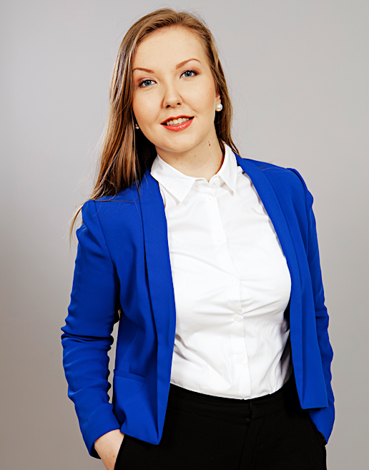
Alina Saaranto
October 2017, Hong Kong

+358 40 5084817
alina.saaranto@aalto.fi
https://fi.linkedin.com/in/alinasaaranto

”

EXPERIENCE
Data Analyst, Helsinki, Finland 4—8/2017, (5 months)
RELEX Solutions | Europe’s fastest growing provider of integrated retail & supply chain planning solutions
- Analyst and Project Manager tasks for client and sales projects from Finland and abroad
- Built quantitative reports using Excel (VLOOKUP, IF Statements) and RELEX Software (Sales forecasts, stock predictions, KPIs reporting)
- Improved clients’ ability to use software, solved hectic situations (data missing, adapter problems, software updates) resulting to superior customer feedback

IPR Analyst Intern, Helsinki, Finland 5—12/2016, (8 months)
Outotec Oyj | Global leader in minerals and metals processing technology
- Intellectual Property Rights (IPR) management, communicated worldwide, operative database management
- Appraised to be most efficient intern ever, kept our mailbox near zero, previously +100 unread emails
- Additional responsibilities: An archiving project (Excel) to boost our team’s daily work and a literature review (LaTeX) to advance my studies

Data Research Assistant, Helsinki, Finland (Espoo) 6—8/2015, (3 months)
Aalto University | Leading Finnish university where science and art meets technology and business
- Data analysis and statistical tests with R and Excel, also data visualization using tools such as ggplot2
- Carried out my Bachelor’s thesis which was appraised with the best grade

SKILLS

Tools: Excel, Word, PowerPoint
Technical: R, Matlab, RELEX, SAS, Scala, Vensim Simulation, HTML, GitHub, Mathematica, Maple
Languages: Finnish (native), English, Swedish

EDUCATION
Aalto University, Master of Science, Finland (present)
- Major: Strategy and Venturing | Minor: Statistics and Decision Making
- Exchange: The University of Hong Kong (Full Academic Year, 2017—present)
- Scholarship: Active student volunteering and academic record (Aalto Student Union)

Aalto University, Bachelor of Science (with Distinction GPA 4.2/5.00), 2016
- Major: Mathematics and Systems Science | Minor: Industrial Engineering and Management
- Scholarship: Excellent Academic record of Mathematics (Prof E. J. Nyström)

POSITIONS OF TRUST

Manager positions, Guild of Physics | Society for the Engineering Physics and Mathematics students
Event Manager, Board Member, 2016
- Organized around 20 events with 10 student team for +50 student members and alumnus, created new traditions, which are now repeated by my follower
Tutor Manager, 2015
- Coordinated and managed 30 tutors to support freshmen during their first year, during the year restructured our budgeting for tutors and succeed to increase it with 100%
Physicist Spex Dancer, Tutor person, Event Assistant, 2014

Volunteering, Slush | World’s leading startup event led by students in Finland
- Guided investors and startups during their stay, solved security issues during the events, networked with entrepreneurial-minded people from all around the world
- Communicated in English and worked with a team for long hours towards common purpose

REFERENCE
Ph.D. Pauliina Ilmonen, pauliina.ilmonen@aalto.fi, +358 41 543 7053
- Worked as her research assistant while working at Aalto University.

