**Interactive Redesign Project**

**Alina Faisal (alinafai)**

**Feedback I received:**

**VISUALIZATION 1: Stacked Bars**

The first visualization is fairly standard which makes it easy to interpret. Titles and axes labels make it clear what data is being shown and how the calculations are done. Coloring being consistent helps with cohesiveness throughout the four charts. I particularly appreciate that the four colors have similar values but differ is hue.

As for improvements, I think there could be more data shown. Racial breakdown by borough is not the most insightful since there is so much variation and segregation within each borough. However, the data that is presented is done so accurately and honestly. One interactive addition could be allowing the viewer to shift the x axis to allow for better comparison between races along the same baseline. It is not easy to compare bar lengths when they are not aligned.

**VISUALIZATION 2: Scatter (worked on improving this)**

The second visualization is visually interesting and takes advantage of several visual channels to allow for multivariate presentation. The hue channel is used very well and shows a clear correlation between poverty and academic performance. The red/blue distinction is easily distinguishable. The circle size channel, however, is more subtle. The difference between circles indicating 2000 and 100 students are not particularly obvious with so many points crowding the visual. This channel could be removed or left in if the variable of number of students is not deemed to be critical to understanding the chart. It could be more insightful to include another variable as a x axis or to focus more on the other visual channels.

**VISUALIZATION 3: Dual Plot**

I appreciate the color scale choices. The consistency is great between the ethnicities color labels and the veridas color scale works well to include both hue and value in a linear scale. First, I am not sure why these two charts are placed together. Besides showing data divided by race, I do not see a significant connection.

For the left chart, one major issue I have is that the different satisfaction metrics are cut off. This greatly hurts both interpretability and visual enjoyment. Secondly, it seems slightly dishonest to show such a variation in color when the values range between 86-88%. Finally, I think there could be more clear visual channels to use. For example, you could have used simple factorized bar chart to show results across the three metrics.

For the right chart, it could be useful to give an explanation of the graduation rate metric used and why it ranges between -100,100%. Additionally, the excess white space between the boxes makes them difficult to compare.

**VISUALIZATION 4: Map (worked on improving this)**

The map-based visual is great and I wish I had thought to use Tableau to create a geospatial visual for this project. The calculation and display of segregation rate is great and the colors are easy to distinguish. However, for the free/reduced lunch circles, I think both the calculation and visual encoding could have been done differently. The density dots are difficult to distinguish quickly and it is not clear how the gradient goes between NY, CA, SD. For the metric, I think the percent of students on free or reduced lunch would have been more interesting since this metric mostly correlates to population.

**Visualization I**

**Initial First/old Visualization:**

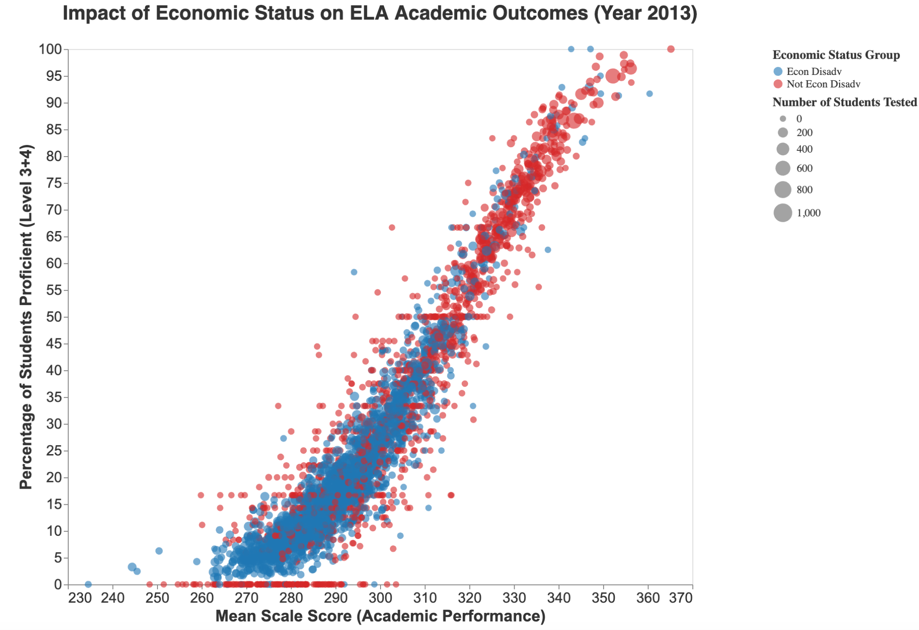

**New Improved Second Visualization:**

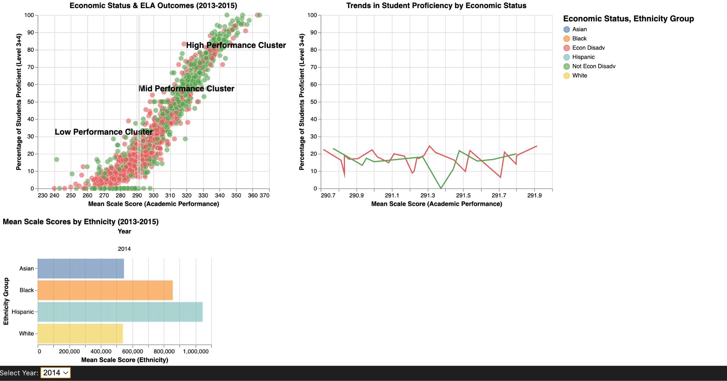

**What the starting point was**

**Explanation of the old visualization:** The old/initial visualization displayed students’ academic performance (mean scale score) against their proficiency level (percentage of students scoring at Level 3 or 4), with data points color-coded based on economic disadvantage status. The size of the points represented the number of students tested. While the visualization effectively captured the trend that students from economically disadvantaged backgrounds (blue) tended to have lower performance compared to their non-disadvantaged peers (red), it lacked deeper insights into clusters, trends across multiple years, and the impact of other demographic factors such as ethnicity.

**Explanation of the new visualization:** The starting point for the new visualization was the original scatter plot, which depicted the relationship between economic status and English Language Arts (ELA) academic outcomes for the year 2013. This initial visualization mapped students’ mean scale scores (academic performance) against the percentage of students proficient (scoring at Level 3 or 4), using color to differentiate between economically disadvantaged (blue) and non-disadvantaged students (red). Additionally, the size of the data points represented the number of students tested. While the original plot effectively conveyed the general trend that economic disadvantage correlates with lower academic performance, it lacked deeper segmentation, trend analysis over time, and consideration of other demographic factors such as race and ethnicity.

The new visualization builds upon this foundation by integrating performance clustering, trend analysis, and an ethnicity-based breakdown, providing a more structured and multi-dimensional analysis. These enhancements allow for a clearer interpretation of disparities and patterns in student performance beyond just economic status, offering a richer and more actionable understanding of the data.

First, the new scatter plot now categorizes students into distinct performance clusters—low, mid, and high performance—by grouping data points with similar mean scale scores and proficiency percentages. This clustering makes it easier to identify and analyze patterns within different performance brackets rather than interpreting a dense scatter of individual data points. In the original visualization, the separation between economic status groups was evident but not explicitly structured. By introducing these clusters, the new visualization provides a clearer understanding of how economic disadvantage correlates with academic success across different levels of achievement.

Second, a line graph has been added to highlight trends in student proficiency based on economic status over a narrower performance range, offering a more detailed comparison of the two groups. The trend line graph refines the comparison between economically disadvantaged and non-disadvantaged students over a narrower performance range. Unlike the previous scatter plot, which presented all data points in a single space, the line graph isolates key performance ranges and examines the percentage of students achieving proficiency within those bands. This approach helps reveal fluctuations and disparities in proficiency rates that might not have been as apparent in the original visualization. By focusing on this subset of data, it becomes easier to detect whether students from different economic backgrounds achieve proficiency at similar rates or if gaps persist across score ranges.

Lastly, a bar chart presents mean scale scores broken down by ethnicity, adding a new dimension to the analysis by showcasing racial disparities in academic performance. These enhancements provide a more comprehensive and structured view of the data, making it easier to identify patterns and disparities beyond just economic status. This additional layer of analysis introduces another crucial variable—race/ethnicity—highlighting how different racial groups perform in standardized academic assessments. In the original visualization, economic status was the primary factor considered, but by integrating ethnicity, the updated version enables a more intersectional analysis of academic disparities

**What We Were Trying to Achieve**

The old scatter plot aimed to illustrate the impact of economic status on English Language Arts (ELA) academic outcomes for the year 2013. The primary goal was to visualize the correlation between students’ mean scale scores (academic performance) and their proficiency levels (percentage of students scoring at Level 3 or 4) while distinguishing between economically disadvantaged and non-disadvantaged students. By color-coding these two groups and varying the size of the points based on the number of students tested, the visualization sought to highlight disparities in performance. However, while it successfully captured the broad trend that economically disadvantaged students tended to perform worse, it lacked additional context, such as longitudinal trends, performance clusters, and ethnic disparities in academic achievement.

The new visualization was designed to go beyond a single-factor analysis and offer a more nuanced perspective on student performance by incorporating multiple layers of insight. Specifically, the goals were to:

1. Identify Distinct Performance Clusters: I introduced low, mid, and high-performance clusters in the scatter plot to categorize students and make it easier to analyze performance trends rather than looking at an overwhelming number of data points.
2. Highlight Proficiency Trends Over Time: I added a line graph to show trends in student proficiency for economically disadvantaged vs. non-disadvantaged students, allowing for a more refined comparison across a smaller performance range. So when we hover over the scatter plot, it gives the line chart for that section.
3. Incorporat Ethnicity as a Key Factor: I integrated a bar chart that breaks down mean scale scores by ethnicity to reveal potential racial disparities in academic performance.

**The type(s) of interactivity you considered or explored**

The old scatter plot was a static visualization with no interactivity, making it difficult for users to explore specific subsets of the data or identify trends within particular performance bands. While the point size conveyed the number of students tested, the lack of filtering, zooming, or dynamic comparisons made it challenging to extract detailed insights beyond the broad correlation between economic status and performance.

For the enhanced visualization, I considered adding several interactive features to improve user engagement and data exploration:

1. Added Hovering Tooltips: This would allow users to see specific details about individual data points, such as the exact percentage of students proficient, mean scale scores, and the number of students in a given group.
2. Filtering by Economic Status and Ethnicity: Enabling users to isolate specific economic and ethnic groups to better understand disparities within and across categories.
3. Added Zoom and Selection Features: Will allow users to zoom in on a particular performance range or select clusters to analyze trends within specific academic performance brackets.
4. Time-Based Comparisons: The bar chart introduces a time-series perspective (2013–2015), and an interactive slider could help users compare trends across different years.
5. Also the year component when clicked changes all the charts/visualizations for that specific year.

The addition of clustered insights, trend analysis, and demographic breakdowns significantly improves interpretability.

**How well your final design meets your goals**

Old Visualization:

The original scatter plot partially met the goal of illustrating economic disparities in student performance but had several limitations:

* Lacked performance segmentation, making it difficult to see clear distinctions between different achievement levels.
* Did not account for ethnicity, missing an opportunity to explore racial disparities in student performance.
* Had no temporal component, preventing an analysis of trends over time.
* Lacked interactivity, making it difficult to focus on specific data subsets.

Improved Visualization:

The new visualization significantly improves upon the original by offering a more structured, multi-dimensional, and insightful approach to the data.

* Introduces performance clusters (low, mid, high), making the scatter plot more interpretable.
* Includes a trend line graph (provides deeper insights) to explore proficiency changes over a narrower score range, enhancing comparisons between economic groups.
* Incorporates ethnicity as a key factor, allowing for a more intersectional analysis of disparities.
* Adds a time component, expanding the analysis to multiple years (2013–2015).
* Improves readability, clarity and actionability, making the findings more accessible to educators and policymakers.

The improved visualization successfully meets the goal of making student performance disparities more interpretable and actionable. It goes beyond the original by integrating economic status, ethnicity, and trend analysis into a cohesive and structured visualization.

**Visualization II**

**Initial First/old Visualization:**

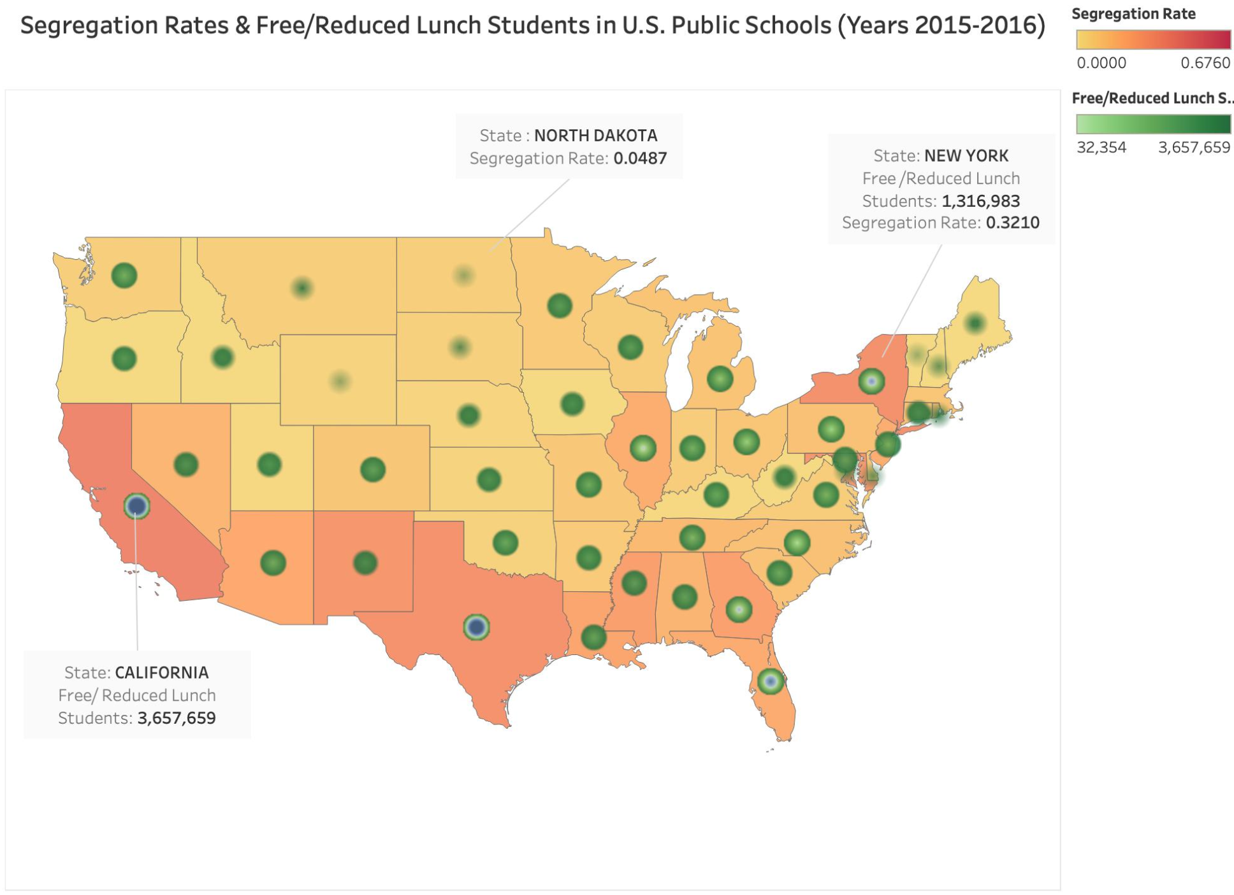

**New Improved Second Visualization:**

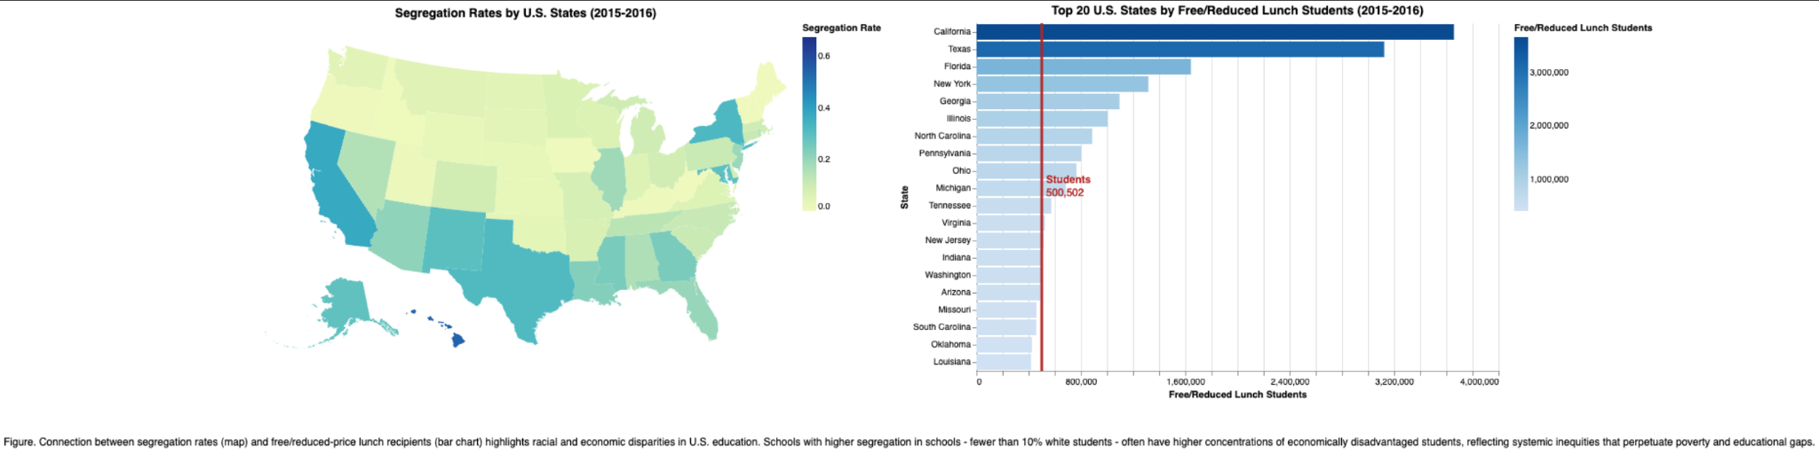

**Figure**. Connection between segregation rates (map) and free/reduced-price lunch recipients (bar chart) highlights racial and economic disparities in U.S. education. Schools with higher segregation in schools - fewer than 10% white students according to the details in the dataset- often have higher concentrations of economically disadvantaged students, reflecting systemic inequities that perpetuate poverty and educational gaps.

**What the starting point was**

**Explanation of the old visualization:** The old visualization combined two datasets—segregation rates and free/reduced lunch students—onto a single U.S. map using a heatmap background (segregation rate) and overlaid green circle markers (free/reduced lunch students). While it effectively displayed both datasets in one view, the overlapping elements made it visually cluttered. Additionally, the legend placement and color choices made interpretation slightly challenging.

**Explanation of the new visualization:** The improved visualization significantly enhances the data storytelling by introducing a Geographic Component (U.S. Segregation Map) which is a choropleth map added to show segregation rates by U.S. states (2015-2016). This provides regional context, highlighting disparities at a broader scale. The color gradient represents higher or lower segregation rates, helping to visually communicate regional differences. I have also added a Bar Chart for Socioeconomic Disparities which displays the top 20 U.S. states by free/reduced-price lunch recipients (2015-2016). This directly connects economic disadvantage to school meal program participation, reinforcing the relationship between economic status and student performance. Moreover, I added a reference line in the bar chart to highlight a specific threshold (for example, the average free/reduced lunch students are 500,502 but if you select some other state it will give you the number of free/reduced lunch students in that state), making the disparities clearer. The color gradient in the bar chart matches the map, ensuring visual consistency in representing economic disadvantage. The darker blue states on the choropleth map indicate higher segregation rates (fewer white students in schools) and the lighter green states have lower segregation rates, meaning schools have more racial integration. The bar chart on the right shows the top 20 U.S. states ranked by the number of students receiving free/reduced-price lunch. California, Texas, and Florida have the largest numbers of students receiving this assistance, indicating higher concentrations of low-income students in those states.

The starting point of the new and improved visualization was the initial version, which consisted of two separate charts:

1. A Choropleth Map displaying segregation rates across U.S. states (2015-2016) using a color gradient (lighter shades for lower segregation, darker shades for higher segregation).
2. A Horizontal Bar Chart ranking the top 20 states by the number of students receiving free/reduced-price lunch programs (an indicator of economic disadvantage). The bar lengths represented student

**What We Were Trying to Achieve**

The goal of this visualization was to:

1. Support Comparisons

* To understand the relationship between economic status and academic proficiency at the student level.
* To compare segregation rates and economic disadvantage in different U.S. states.
* To show how educational disparities manifest in both academic performance (first vis) and systemic structures (second vis).

1. Highlight Correlations and Trends

* The first visualization aimed to show the direct correlation between economic status and academic proficiency using Mean Scale Score vs. Percentage of Proficient Students (Level 3+4).
* The second visualization expanded this by linking segregation rates with economic disadvantage at a systemic level through a map + bar chart combo.

**With the new visualization, our primary objectives were:**

**1. Improved Clarity & Readability**

* In the old visualization, the combination of two datasets (segregation rate & free/reduced lunch students) on a single map resulted in overlapping elements, making it difficult to decipher patterns.
* The new visualization separates the two datasets: A choropleth map solely for segregation rates, using a gradient color scale (green to blue) to represent different values. A bar chart for free/reduced lunch student counts, allowing for easy ranking and comparison across states. This separation eliminates visual clutter and makes each dataset clearer and more interpretable.

**2. Enhanced Comparative Analysis**

* The old visualization made it hard to compare segregation rates across states because of the overlapping markers representing free/reduced lunch students.
* The new version: Uses a choropleth gradient scale so that states with similar segregation rates are visually grouped. It introduces a bar chart where states are ranked based on free/reduced lunch student populations, making comparisons more intuitive. It includes a threshold marker (500,502 students) in the bar chart to provide a meaningful reference point for understanding student population distribution. These changes allow viewers to quickly identify outliers, trends, and relationships between segregation rates and student populations.

**3. Structured and Insightful Data Representation**

* The previous visualization lacked a structured format for the free/reduced lunch data, as the size of the circles was difficult to compare at a glance.
* The new version provides: A ranked list of states based on student population. A clear segregation rate scale, ensuring that users don’t need to decode both variables simultaneously. It improved color contrast to enhance visual perception of differences across states.

**The type(s) of interactivity you considered or explored**

* Dropdown Selection (second visualization): Users could filter by year (2013-2015) to observe changes in proficiency trends over time.
* Zooming and Brushing: This allowed users to focus on specific ranges of Mean Scale Scores to see how proficiency varies among economically disadvantaged vs. advantaged students. Users can hover over a state on the map to see its exact segregation rate instead of relying on color interpretation. Similarly, hovering over a bar in the bar chart highlights that state’s free/reduced lunch student count.
* Clickable Filters: Clicking on a state in the segregation map could filter the bar chart to show lunch recipients for that state. This could help users compare segregation rate vs. economic disadvantage at the state level. Users could filter the bar chart based on region (e.g., Northeast, Midwest, South, West) to focus on specific areas. The segregation Rate Range (e.g., 0.0 - 0.2, 0.2 - 0.4, etc.) can also be filtered to examine only high- or low-segregation states. The top 20 States to dynamically display a subset of states with the highest or lowest student populations have been filtered too.
* Threshold Indicator (Second Visualization): The red reference line on the bar chart (e.g 500,502 students) was added to contextualize states’ free/reduced lunch populations relative to a meaningful benchmark. The red reference line changes when we change the state by clicking on it in the bar chart.
* State Comparison Feature: Clicking on a state in the map could highlight its corresponding bar in the bar chart, making direct comparisons easier.

**How well your final design meets your goals**

**1. Readability & Clarity**

**The new design improved**:

* The separation of variables into distinct visualizations removes confusion.
* Better color choices (green-to-blue gradient for segregation rates, blue for the bar chart) enhance clarity too.
* Eliminates overlapping elements from the old version which makes it easier to extract insights and eliminates visual clutter, ensuring that each element contributes meaningfully to the user’s understanding.
* Provides clear and separate visualizations for two different but related datasets, avoiding the confusion present in the old version.

**2. Comparative Analysis**

**Stronger comparisons**:

* The bar chart provides direct rankings of states based on free/reduced lunch student counts.
* The choropleth map in the improved version enables quick pattern recognition of segregation across states.
* The threshold marker also (e,g average 500,502 free/reduced lunch students) provides a meaningful benchmark.

**3. Interactivity & Engagement**

**More interactive potential**:

* The improved visualization was designed interactively with hovering, filtering, sorting, and comparison options in mind. The structured layout combined with interactivity makes this visualization a powerful tool for data-driven storytelling.

**4. Insights and Contribution:**

* The improved visualization separates key variables (segregation rates & free/reduced lunch students), making it easier to analyze patterns.
* It also adds interactive elements, such as clickable tooltips and filtering, which allow users to explore specific details dynamically rather than relying on a one-size-fits-all static view.
* It provides ranking and thresholds, such as the 500,502-student reference line, which adds meaningful context and allows users to benchmark states against each other. Also it enables direct comparisons between segregation rates and student populations, something that was less intuitive in the old version due to overlapping elements.

**5.** **Aesthetics and Attention to Detail**

* The segregation rate map uses a sequential gradient (green to blue), making it easy to interpret without requiring deep color differentiation.
* The bar chart maintains a consistent blue gradient, reinforcing its purpose as a ranking tool.
* All elements are well-aligned and visually consistent, ensuring an organized and professional presentation.