MATLAB Project: Badminton

By: Alina Fatima

Roll Number: 2018-10-0252

*The pictures of the texture were taken from Google Images and the sound was also taken from the Internet. The idea of making a cone from the cylinder command was taken from the Internet and was also used to make shuttle. This all was with permission of TA.*

Watch the file WatchMe and WatchMe1 to see videos.

***Summary:*** This is a program that implements the game of Badminton. The user has the control of the badminton racquet with the help of a mouse or red marker. There is a computer player playing against the user. If any of the players miss the shuttlecock, a point will be given to the other player. The player to score five points first will be the winner of the game.

***Usage:*** Start the program by running Runme.m. Click on the ‘Start Badminton!’ button and the court for the game will be set.

***Options***: The game as was specified above can be played in two ways:

1. With red marker 2) With Mouse Control

With a red marker, the user has to hold a marker in his/her hand and move it as he/she wants to move the racquet.

With the mouse control, the mouse movement will determine the movement of racquet.

***Features:***

If one player reaches the score of five points first, then a message box appears which has a message according to the user i.e. player 1. If he wins, a congratulatory message appears otherwise a ‘Try it again’ message appears.

With the red marker, the user is shown his/her input by previewing the winvideo window.

I added sound in the GUI but could not do in the game because the game becomes slow with sound.

***Theory:***

The shuttle’s motion is implemented with the help of the projectile motion in physics. The negative acceleration to signify gravity has been kept -5. There have been three elements in the variables shuttle_pos, shuttle_vel, shuttle_acc to signify the three dimensions of the game and of the shuttle motion. Each component of the above mentioned variables is dealt separately.

In computer vision, the centroid of the red marker is computed and the racquet moves accordingly.

***Programming:***

***Structure:***

The main files are ***Badminton.m*** or ***BadmintonWithComputerVision.m***

It runs through the GUI created in **RunMe**. Then there are nine m-scripts that are linked to the main files. Firstly, the***BadmintonCour****t* has all the graphics of Badminton Court.

The file ***Equipment*** has the code to create the equipment such as two racquets and a shuttle. Both these files use the following functions:

1. Plate: Plate makes a three-dimensional rectangular surface with the applied texture.
2. Mycylinder: This function constructs a cylinder that is used in making racquet and poles of the net.
3. Makeshuttle: This function makes the shuttle.
4. Makeracquet1: This function constructs a racquet for player 1 with the initial positions and texture. This also uses another function mycylinder created by myself.
5. Makeracquet2: This function constructs a racquet for player 2 with the initial positions and texture. This also uses another function mycylinder created by myself.
6. check_rachit: This functions checks whether the racquet hit the shuttle or not.

The file ***ShuttleInitialisations*** initialises the variables for shuttle motion and sets the initial conditions for the shuttle. The ***ShuttleMotion*** executes the motion for the shuttle. The file ***Cambackgroundsetup*** has the code for camera viewing and all the variables which are to be initialised before. The ***ComputerPlayer*** has the code for the artificial intelligence of player 2.

The ***Foul*** and ***WinningCondition*** files, as the names suggest have the codes for the foul and for winning condition.

The ***ComputerVision*** file is only in BadmintonWithComputerVision.

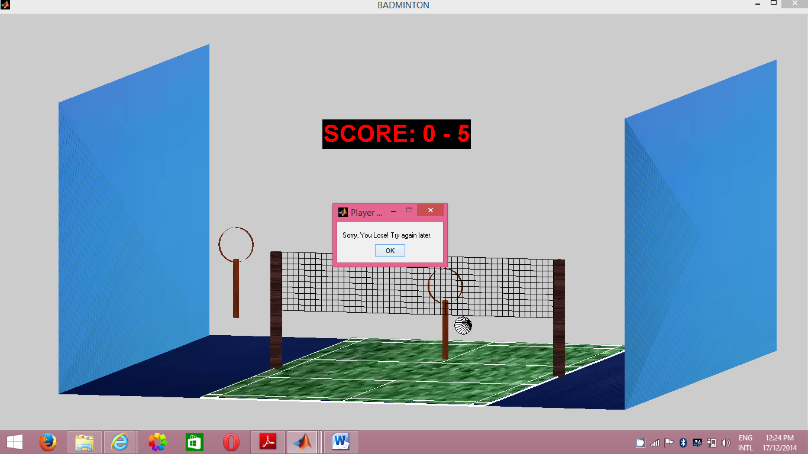

***Problems:***

I tried to make computer vision accurately but was unable to do it due to the limitation of time.