# Prerequisite:

Derby installed

Tomcat server

Iam jar

# Comment utilizer

Run the application on tomcat.

Enter login : admin

Password : admin

Run the application for the first time and execute only once the script in **init_db.sql** in case you cannot log in.

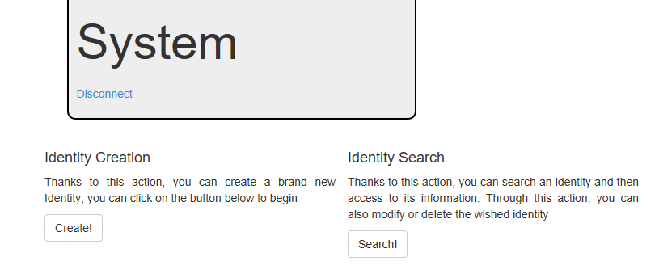

**Create an identity:**

Know issues the input of the users are not really check for now

Search for that identity given a criteria

Modify identity search:

Know issues the search does not handle properly hibernate mapped

Entities

Delete:

Select a search item and click on delete

Knows issues: Code not really refactor and cleaned up