GasDaju
Gas Daju is a mobile platform that connects LPG customers and dealers, making it easier for customers to find and order gas while helping dealers manage their inventory and orders efficiently.
What is your app about?
This application connects the customers and dealers in Nepal. Customer can see the nearby dealers around them , select their preferred gas brand and cylinder type, place orders and track order status. Dealers can trace their available stock, receive customer orders, manage their order status and accept and reject the booking which makes the booking process mor convenient for both customers and dealers.
This application is ideally no bigger than 100mb for both android and IOS
ASO of compitetors
1.Cylin
Subtitle: None
Tagline: None
Reviews: None
Feature:
Target Audience: Households and LPG dealers in Nepal
Key Features: Ordering, dealer matching, delivery, tracking, notifications
Language: English and Nepali
Social Proof: Rewards, ratings, and customer reviews
Visuals: App icon, screenshots, and promotional content
User Engagement: Order history and delivery notifications
Overall ASO: Focuses on relevant LPG-related keywords and clearly communicates the app's value to its target users.
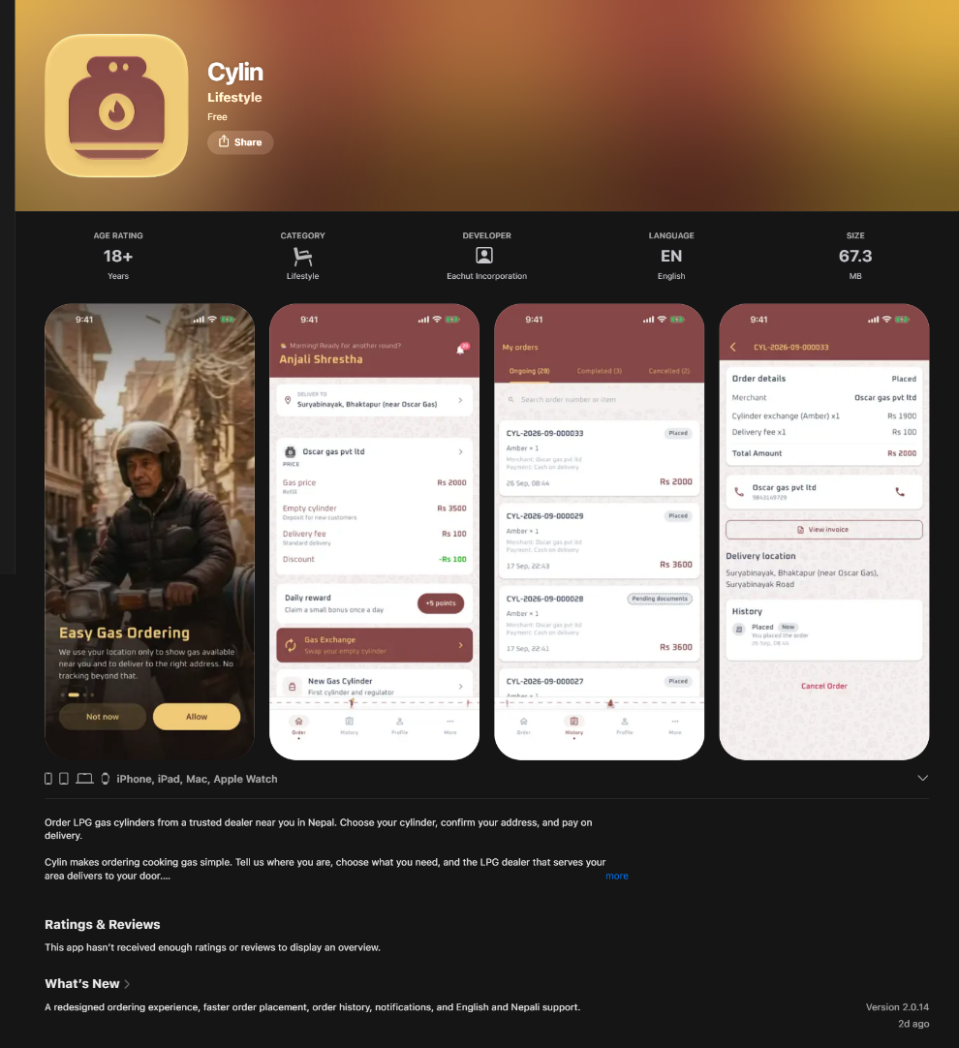

2. SajiloGas:
Subtitle: None
Tagline: LPG Booking App
Review: No reviews and rating
Description:
Target Audience: Home users, LPG agencies, and delivery personnel
Key Features: Booking, home delivery, status tracking, booking history, account management
Location Targeting: Specifically targets Nepal
User Benefits: Saves time, avoids queues and phone calls, and simplifies gas booking
Language: English
Social Proof: Uses terms such as “trusted,” “secure,” and “reliable” to build confidence
Visual Presentation: Uses emojis, headings, and bullet points to make the description easy to scan
Overall ASO: Strong use of relevant LPG and Nepal-related keywords while clearly communicating the app's benefits and target users.
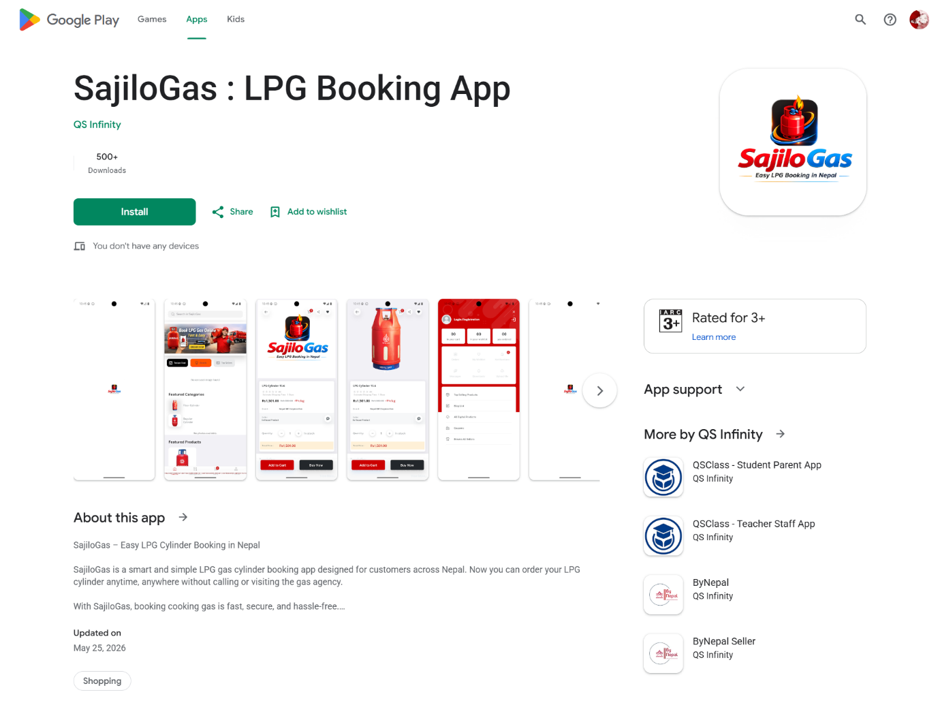
3. GasDei
Subtitle: None
Tagline: None
Review: Nonw
Description:
Main Purpose: LPG ordering and doorstep delivery
Key Features: Gas ordering, cylinder exchange, delivery, online/cash payment
Cylinder Options: Multiple sizes including 12 kg, 35 kg, and 45 kg
Commercial Focus: Supports both residential and restaurant customers
User Benefits: Convenience, time saving, and avoiding queues
Description: Clearly explains the app's purpose, features, and benefits
Overall ASO: Strong use of LPG-related keywords and clearly targets both household and commercial users, making it highly relevant to Gas Daju's B2C + B2B concept.
Coders_12780abc_@

