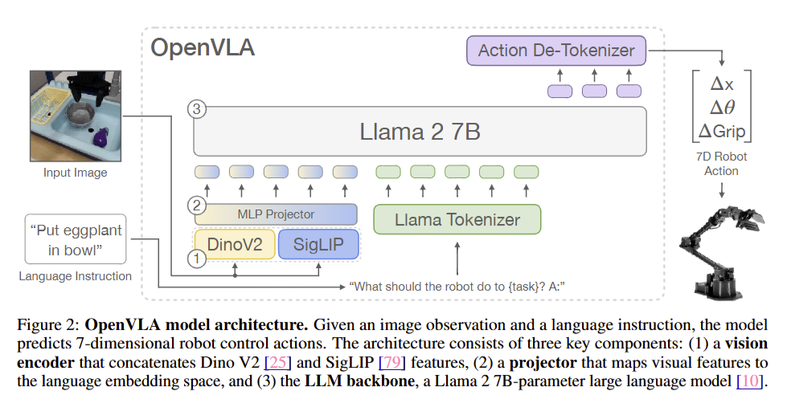

The goal of this experiment is to see where in OpenVLA information is compressed. By measuring TDNV across transformer layers, we can track how the model progressively encodes and transforms task information throughout its architecture (from your and Jiachen's paper, "From Compression to Expression: A Layerwise Analysis of In-Context Learning").
Model: openvla-7b-finetuned-libero-spatial
Analyzed hidden states at the last token “▁”, which predicts the first action token.
I used these metrics from the paper:
Within-task variance:
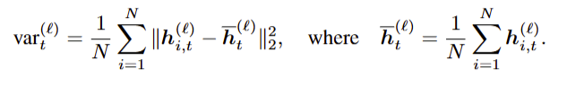
Between-task distance:
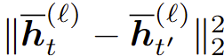

TDNV:
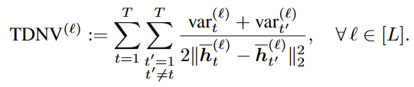

I ran 2 experiments using TDNV, one grouping by instruction and one grouping by image.

These are the 10 images used. They vary the object positions on the table.
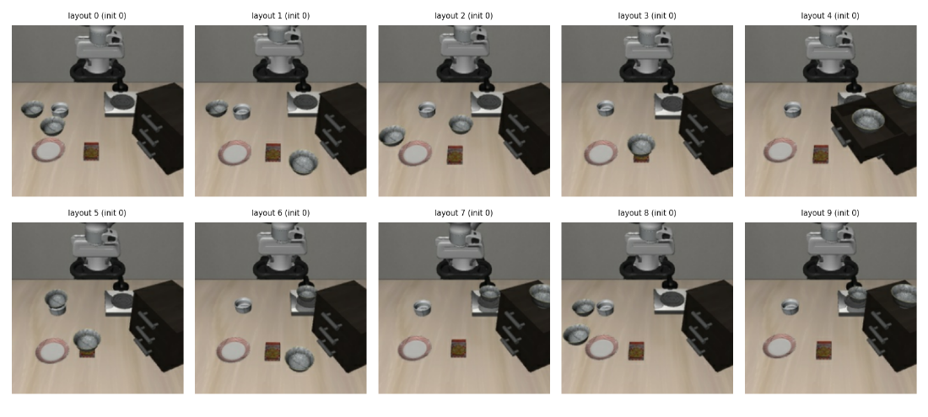
Instructions used:
Generic set tasks (10 different tasks that make sense in every layout)

pick up the black bowl and place it on the plate
stack the two black bowls
turn on the stove
open the middle drawer of the wooden cabinet
open the bottom drawer of the wooden cabinet
open the bottom drawer and put the black bowl inside
push the plate to the front of the stove
move the plate next to the cookie box
push the cookie box to the front of the stove
pick up the plate and place it next to the ramekin

These differ in the task itself: the verb, the target object and the goal.

I gave the model every combination of image and instruction, so I got 100 input pairs for OpenVLA. For each input, I recorded the internal state of OpenVLA at every layer at the last token. Here is an example of the input sequence:
“<s> [img 1] [img 2] … [img 256] In: What action should the robot take to {task}?
Out: ▁”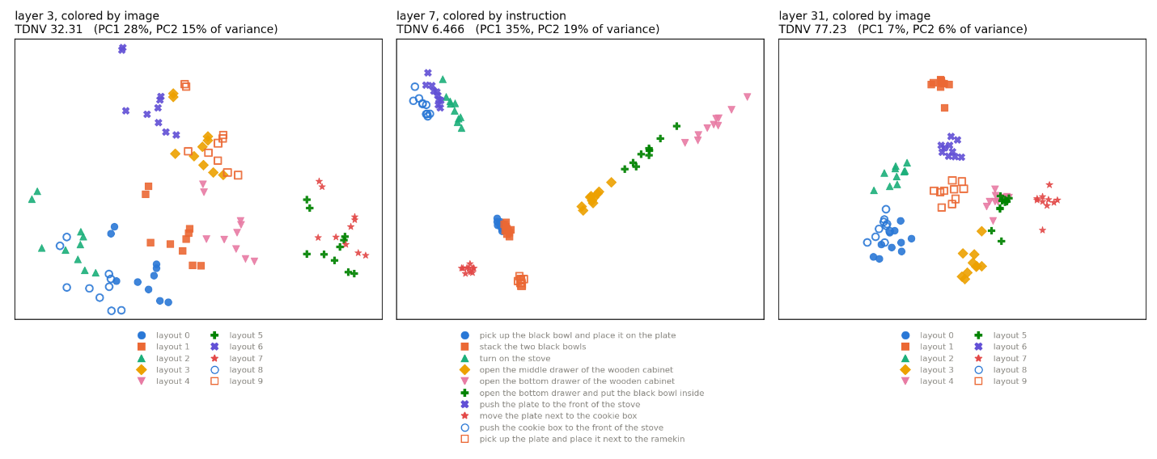
In figure above and the 2 figures below, I used PCA to show the point groups in embedding space, reduced to 2 dimensions so we can see them intuitively.
In the first experiment, I measured TDNV by separating by image: 10 groups of points in embedding space, each group was for 1 image, 10 instructions. 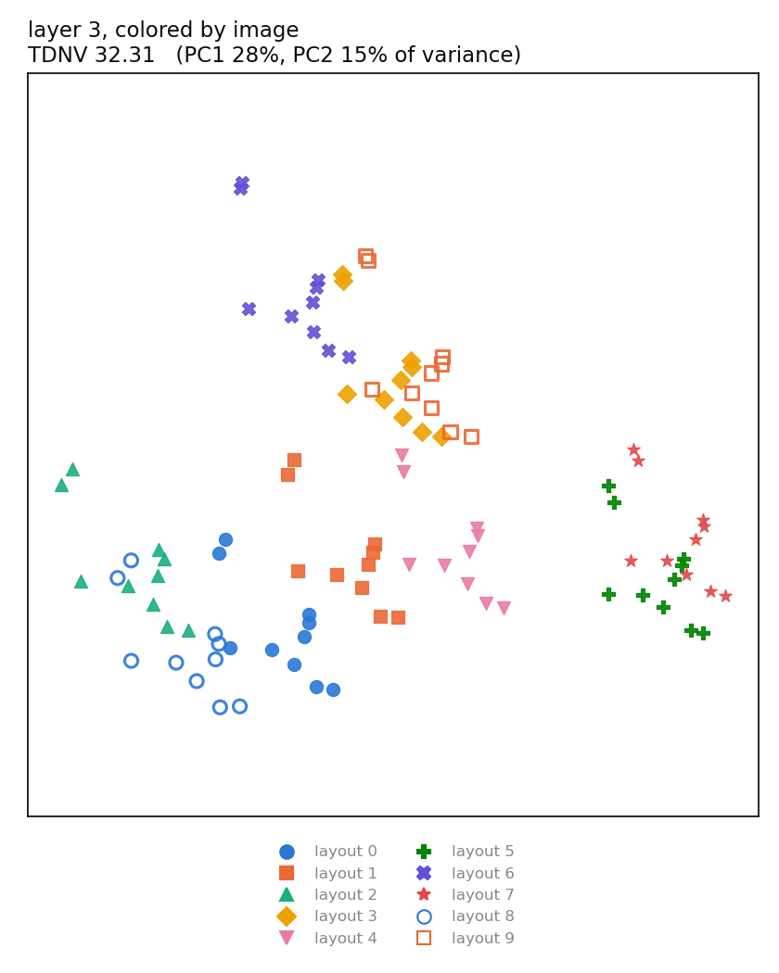

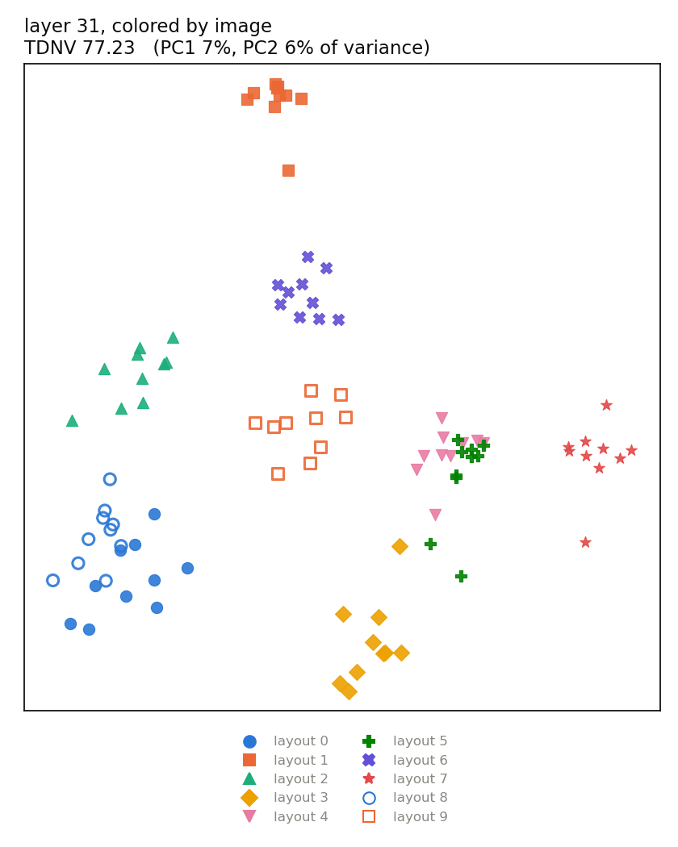In the second experiment, I measured TDNV by separating by instruction: 10 groups of points in embedding space, each group was for 1 instruction, 10 images.

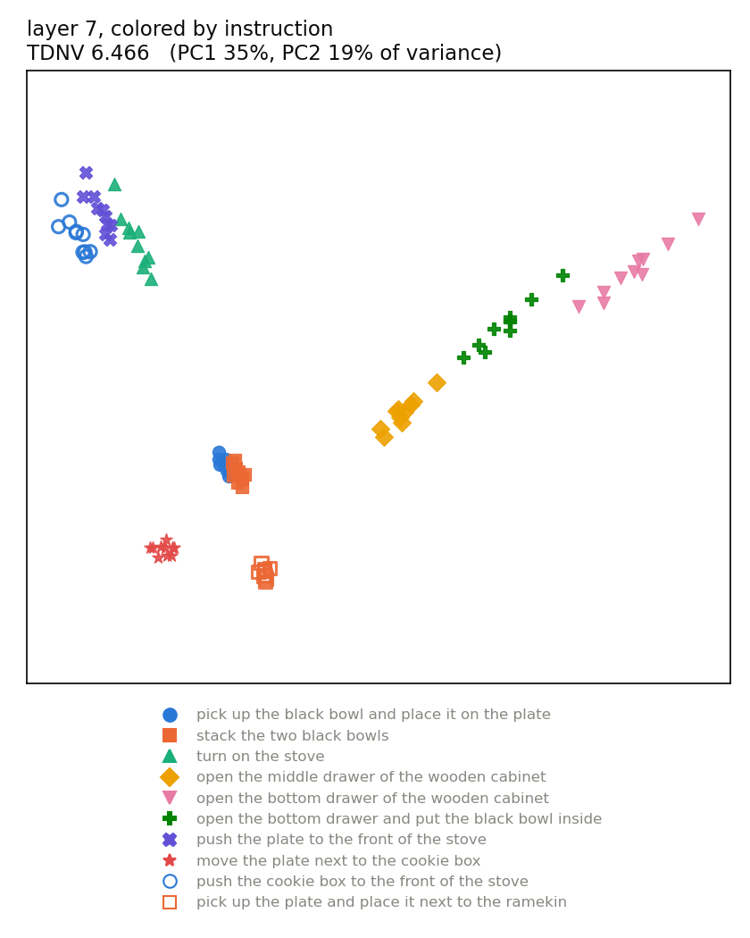
Lower TDNV -> tight, separated groups of points

Results:
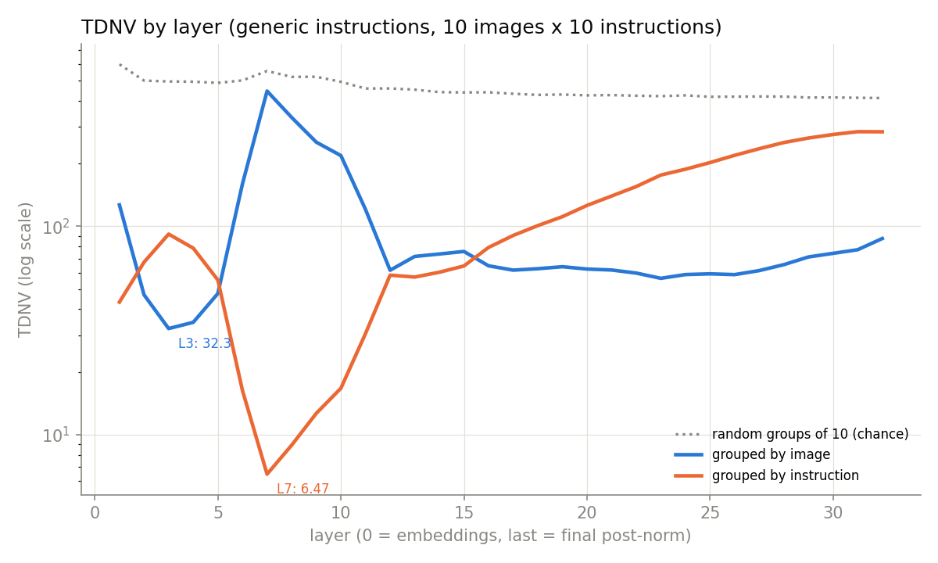
“Random groups of 10” : Take the same 100 points and deal them into 10 random groups of 10. Each group now mixes every image and every instruction, so it's as spread out as the whole cloud. Its center is the average of 10 random points, which lands near the middle of the cloud, so all 10 centers sit close together. Wide groups with nearby centers give a high TDNV: about 400–600 for groups of 10. I included this so we can show a baseline. Grouped by image is 15× below chance at L3; grouped by instruction is 86× below chance at L7.
Experiment 1: Group by image
- Loosely organized around the image at early layers and late layers, with the lowest TDNV of 32.3 at layer 3
Experiment 2: Group by instruction
- Strongly organized by the instruction at layer 7 with TDNV 6.47
the instruction curve follows the same compression-then-expression shape, falling to its minimum at L7 and rising after. One difference to point out is that the paper's minimum comes mid-network (about L17), while OpenVLA’s comes early (L7 of 32).
Looking at the layer 7, colored by instruction figure, we see that instructions that refer to “black bowls” are close together, instructions that refer to the “drawer” look like they fall on a direction/line, instructions that mention the “stove” are close, and instructions that mention “plate” are close. A possible explanation for these results is that I used openvla-7b-finetuned-libero-spatial. LIBERO-Spatial tests spatial reasoning: whether a policy can pick out the correct object when identical copies of it sit in different places, using only a spatial description in the instruction. Therefore, the positions of objects may be encoded strongly into this model.

Looking at layer 31, colored by image, layouts 0 and 8 are very close, and we see that those layouts are similar in their images regarding bowl positions.
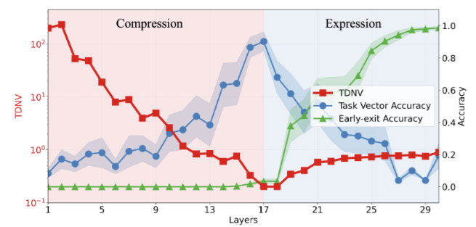

Next steps:
I only tested this on the first frame of those 10 different layouts. I could design another experiment where I use many steps and see if there are differences in the hidden states as time passes. As the robot moves, the image changes but the instruction doesn't. We could see whether the L7 instruction grouping holds across the episode, or whether the image grouping takes over.
I could test different models like the base OpenVLA, OpenVLA-OFT, OpenVLA finetuned LIBERO Goal, π0.5, etc. This my "possible explanation" on the layer 7 slide. If the arrangement by meaning at L7 (stove together, drawers on a line) comes from spatial fine-tuning, a model fine-tuned on LIBERO-Goal should arrange the instructions differently.

