Cyclistic Bike-Share Analysis
How Do Annual Members and Casual Riders Use Cyclistic Differently?
Prepared for: Lily Moreno, Director of Marketing
Google Data Analytics Capstone Case Study
Data: 12 months of Divvy/Cyclistic trip data (Aug 2025 – Jul 2026)

1. Ask

Business Task
Cyclistic's finance team has found that annual members are far more profitable than casual riders. The Director of Marketing, Lily Moreno, believes that converting casual riders into annual members is the key to future growth. This analysis identifies how annual members and casual riders use Cyclistic bikes differently, in order to inform a marketing strategy aimed at converting casual riders into members.

Key Question
How do annual members and casual riders use Cyclistic bikes differently?

Stakeholders
- Lily Moreno – Director of Marketing
- Cyclistic Marketing Analytics Team
- Cyclistic Executive Team – must approve the final recommendations

2. Prepare
This analysis uses Cyclistic's own historical trip data (the public Divvy dataset, made available under license by Motivate International Inc.), covering 12 consecutive months of ride activity.

Data Source & Structure
- 12 monthly CSV files, one per month, from Aug 2025 through Jul 2026
- Each row represents a single ride, with ride ID, bike type, start/end time, start/end station, and rider type (member or casual)

Credibility & Limitations (ROCCC)
- Reliable & Original: published directly by Cyclistic's operator
- Comprehensive: covers a full year, capturing seasonal variation
- Current: most recent 12 months available at time of analysis
- Cited: licensed and publicly documented data source
- Limitation: rider demographic data (age, income, purpose of trip) is not included, so conclusions are based on behavioral patterns only, not stated rider motivations

3. Process
Data was combined and cleaned using SQL (DuckDB) to ensure accuracy before analysis.

Cleaning Steps
- Combined all 12 monthly files into a single dataset of 6,037,968 rides
- Removed 35 duplicate ride IDs
- Removed 29 rides with zero or negative duration (data entry errors)
- Verified no missing values in ride ID, start time, end time, or rider type
- Added calculated fields: ride length (minutes), day of week, and month
Final cleaned dataset: 6,037,904 rides.

4. Analyze
Four consistent, independent patterns emerged that distinguish casual riders from annual members.

4.1 Ride Length
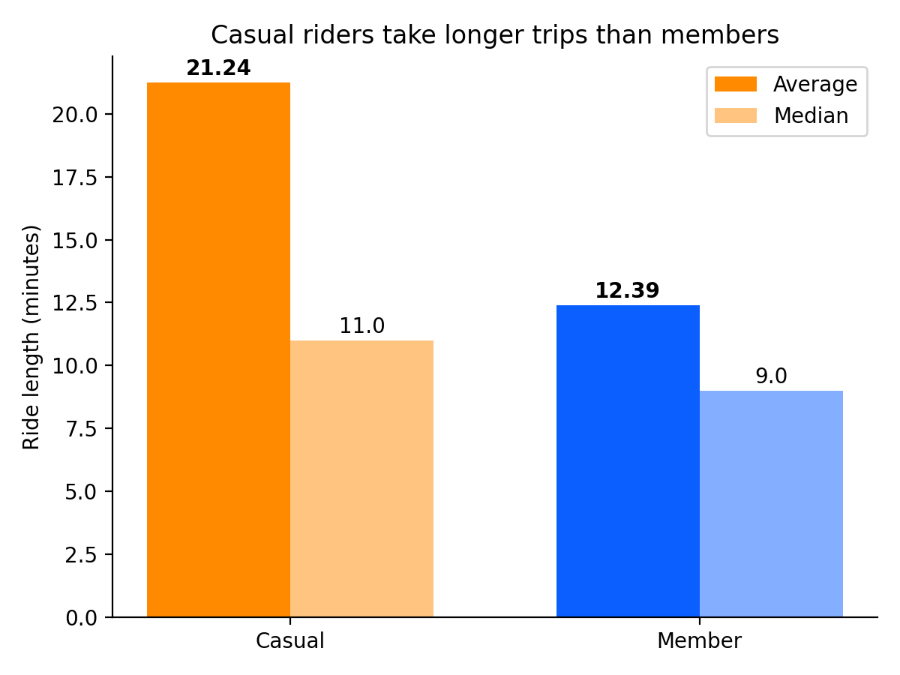
Rider Type | Avg. Length (min) | Median Length (min) | Total Rides
Casual | 21.24 | 11.0 | 2,151,032
Member | 12.39 | 9.0 | 3,886,872

Casual riders take trips that are, on average, 71% longer than members. The gap between the average and median for casual riders (21.2 vs. 11.0 minutes) indicates a subset of very long leisure rides pulling up the average — consistent with recreational use rather than point-to-point travel.

4.2 Day of Week
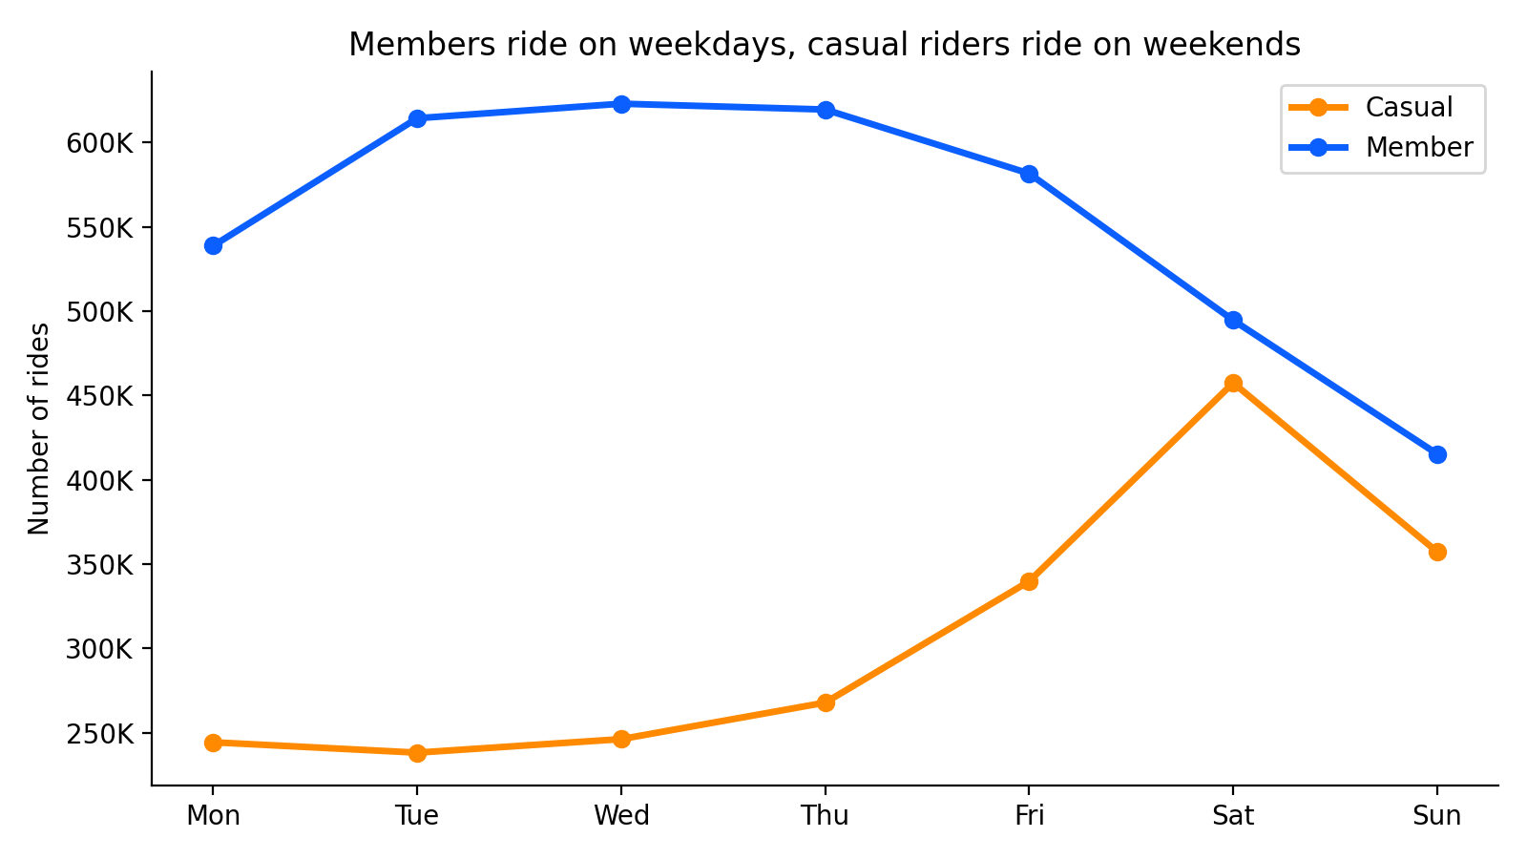
Member ridership is high and stable Monday through Friday (581K–623K rides/day) and drops off on weekends — a clear commuting pattern. Casual ridership is the mirror image: relatively flat and low on weekdays, then spikes sharply on Saturday (457,395 rides) and Sunday (357,284 rides). Casual rides are also longest on weekends (23.9 and 24.9 minutes), reinforcing a leisure-trip pattern.

4.3 Seasonality
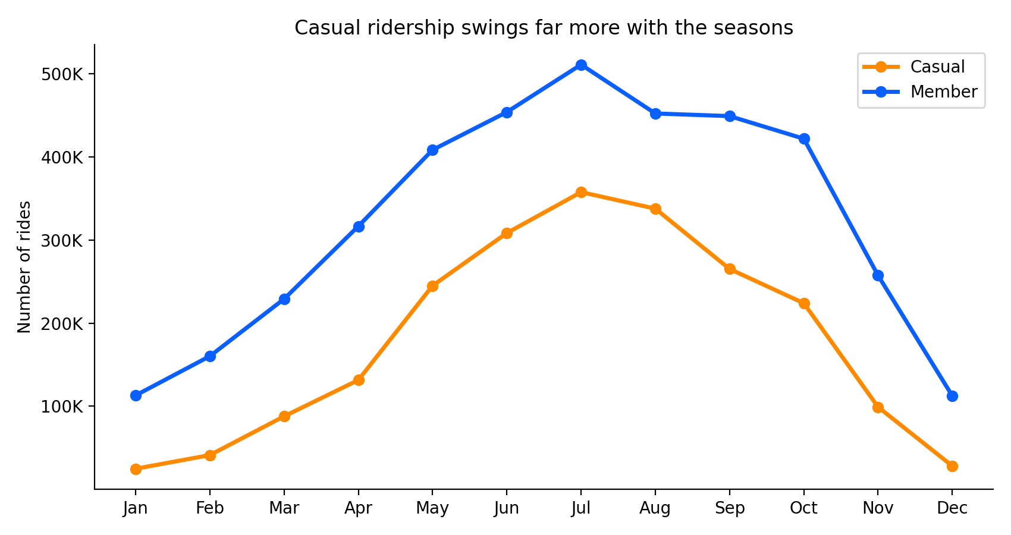
Both rider types ride more in warmer months, but casual ridership is dramatically more seasonal. Casual rides swing from a low of 24,740 in January to a peak of 357,769 in July — a nearly 14x difference. Member ridership varies far less across the year (a 4.5x difference between its January low and July peak), staying meaningfully active even in winter. This suggests casual riders use Cyclistic primarily as a warm-weather recreational activity, while members rely on it as year-round transportation.

4.4 Station Usage
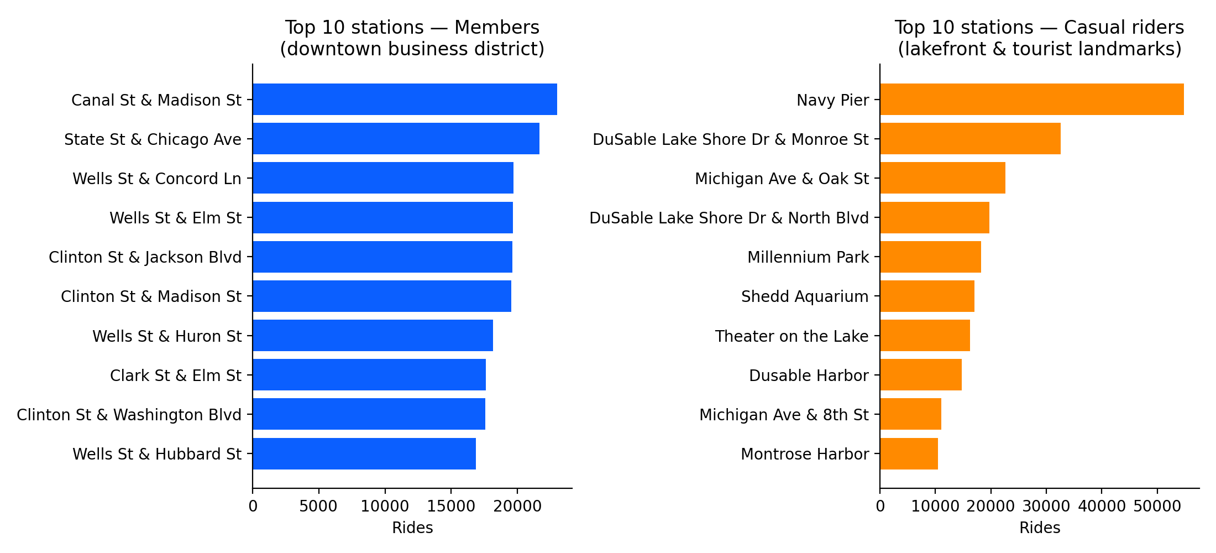
The single clearest geographic signal in the data: members' top stations sit in Chicago's downtown business district (Canal St & Madison St, Clinton St & Jackson Blvd, etc.) — consistent with commuting to and from work. Casual riders' top stations cluster almost entirely along the lakefront and around tourist landmarks: Navy Pier alone accounts for 54,838 rides, more than the next two stations combined, followed by the DuSable Lake Shore Dr corridor, Michigan Ave, Millennium Park, and Shedd Aquarium.

4.5 Bike Type
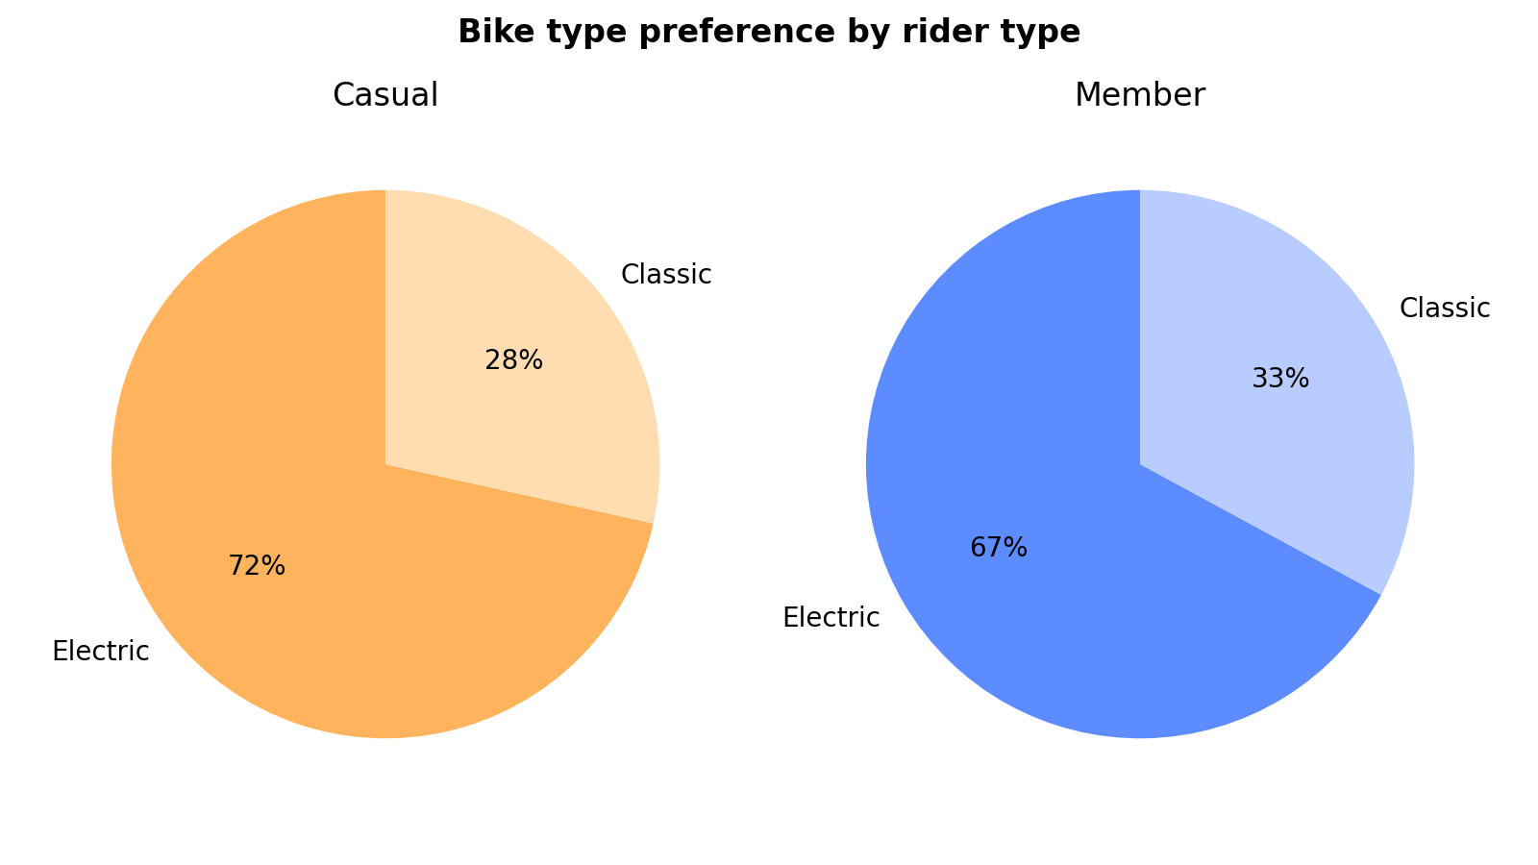
Both groups prefer electric bikes over classic bikes at a similar ratio (roughly 7:3), so bike type preference does not meaningfully distinguish the two groups — unlike the other four factors above.

5. Share — Key Findings Summary
Dimension | Annual Members | Casual Riders
Ride length | Short (avg. 12.4 min) | Long (avg. 21.2 min)
Day-of-week pattern | Weekday-heavy, flat (commuting) | Weekend-heavy, spikes Sat/Sun (leisure)
Seasonality | Relatively stable year-round | Extreme summer spike, near-zero in winter
Top locations | Downtown business district | Lakefront & tourist landmarks
Bike type | Slight electric-bike preference | Slight electric-bike preference

Together, these four independent signals tell one consistent story: annual members use Cyclistic as reliable, everyday transportation — primarily for weekday commuting in the downtown core. Casual riders use Cyclistic recreationally — for longer, weekend, warm-weather trips concentrated around the city's lakefront and tourist attractions.

6. Act — Recommendations
Based on these findings, the following three recommendations are proposed to convert casual riders into annual members:

1. Launch a “Weekend Rider” membership tier or promotion
Since casual usage is concentrated on Saturdays and Sundays, offer a discounted membership tier (or a limited-time free-trial weekend) that lets casual riders experience membership pricing on the days they already ride most. This lowers the barrier to conversion by meeting riders where their current behavior already is, rather than asking them to change it.

2. Target marketing at lakefront and tourist-landmark stations
Place station-side signage, QR-code sign-up prompts, and app notifications at the top casual stations identified above — especially Navy Pier, the DuSable Lake Shore Dr corridor, Millennium Park, and Shedd Aquarium. Because these riders are already physically present at the point of highest engagement, this is the most efficient place to capture conversion intent.

3. Run a summer-to-winter “lock in your rate” campaign
Casual ridership nearly disappears in winter, suggesting these riders don't yet see Cyclistic as a year-round option. A summer campaign that lets riders lock in a discounted annual rate before winter (e.g., “Join in July, save all year”) targets riders during their peak engagement window and reframes membership as a way to save money rather than a new commitment.

Suggested Next Steps
- A/B test the weekend membership tier with a subset of high-frequency casual riders before a full rollout
- Pair station-side marketing with a follow-up analysis of conversion rate by station
- Explore rider survey data (if available) to validate that leisure/tourism is the primary casual-rider motivation

