**SITUATION APOLLO 13**

You are the chief engineer for moon mission Apollo 13. Half way through the journey a flow valve in the service module malfunctioned and two of four oxygen tanks exploded, damaging vital components including power reserve. This forced the crew to abandon the mission and return to earth. The crew has only 13 amps of continuous power available. For re-entry to Earth's surface, vital components must be loaded. Your task as a chief engineer at Houston is to arrive at a safe step by step procedure which will enable the crew to return safely. The procedure is to be sent via a weak communication uplink which should remain on at all times. To save precious bandwidth, the procedure should have only minimum syntax.

**DETAILS OF MODULES THAT SURVIVED EXPLOSION**

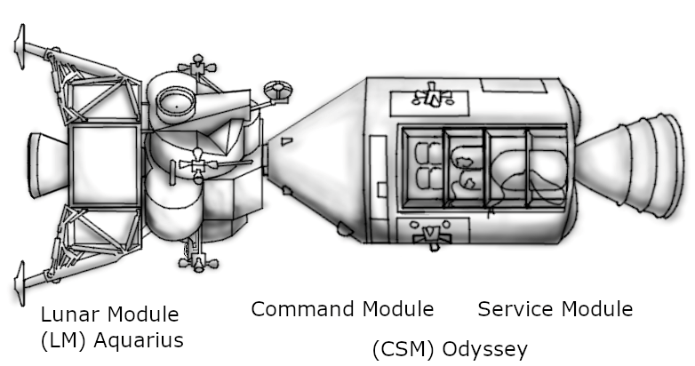The vehicle has two modules (LM and CM) each with its own sub modules.

|  |  |  |  |  |  |
| --- | --- | --- | --- | --- | --- |
| **Sl. No** | **Lunar Module** | | **Command Module** | | **Description** |
| **Sub modules** | **Current Demand** | **Sub modules** | **Current Demand** |
| 1 | Comm. System | **5A** | Comm. System | **6A** | Responsible for communication with earth station (Must not be disabled) |
| 2 | Thrusters | **3A** | Thrusters | **4A** | Responsible for navigating through space (After the usage of thrusters, the continuous power available reduced to 10 amps permanently) |
| 3 | Gyroscope | **4A** | Parachutes | **4A** | Gyroscope – To Calibrate navigation computer |
| Parachute-For safe landing. (Must be enabled as the final step.) |
| 4 | Dock Release | **4A** | Navigation Computer | **4A** | Enabling Dock Release separates Lunar module from the Command module. This module gets automatically disabled after use. |
| Navigation computer-controls both thrusters and gyroscope. |

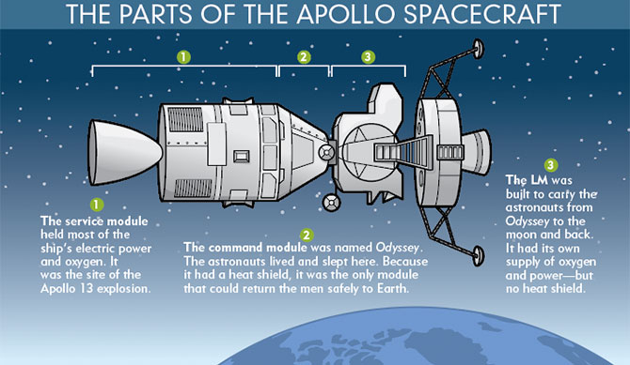

**CONSTRAINTS**

* Initially the Lunar communication module alone is enabled.
* A maximum of 13 steps in the procedure.
* Maximum power usage should not exceed 13 amps.
* At least one of the communication modules should be active at a given time.
* Enabling of thrusters is mandatory for re-entry pitch alignment.
* Gyroscope must be used for calibrating orientation before enabling the thrusters.
* Navigation computer controls the thrusters and the gyroscope. It must be active for turning on and off both thrusters and gyroscope.
* After the thruster is used and disabled, the continuous usage limit decreases from 13 amps to 10 amps (permanently).
* Before using parachutes, the dock release must be activated to abandon lunar module. However, dock release can’t be used when other lunar modules are in use.
* Once Lunar module is disabled, no lunar sub-modules can be loaded.
* Parachute must be enabled only at the end.

**PROCEDURE SYNTAX**

* A statement consists of 3 letters.
* First letter is either E or D. (i.e., To Enable or To Disable)
* Second letter is either L or C. (L for Lunar module, C for Command module)
* Last letter is a digit which represents the serial number of sub modules.
* For example: -
  + EL1- Enable Lunar Communication module
  + DL1- Disable Lunar Communication module.
  + EC4- Enable navigation computer. (In Command module)