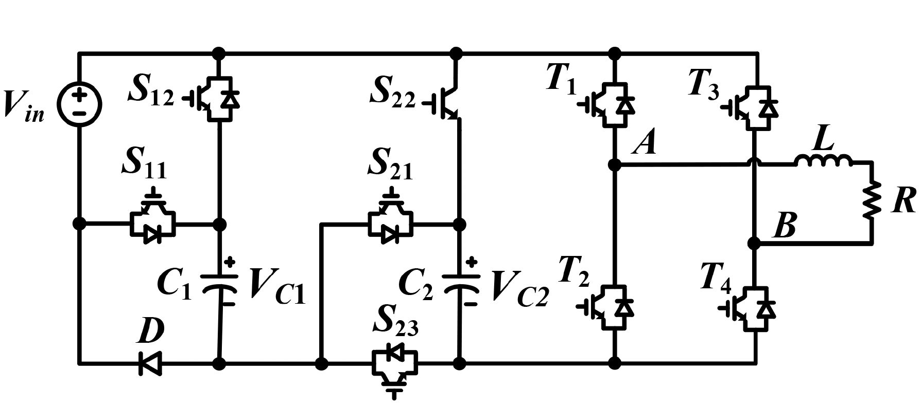

**Proposed System**

Fig. shows the proposed SC nine-level inverter topology. The proposed inverter consists of a single DC source, two SC cells connected in parallel with the H-bridge circuit and a load. The first SC cell is a combination of one capacitor, one diode, and two switches (C1-*D*-*S11*-*S12*), and the second SC cell includes one capacitor, and three switches (*C2*-*S*21-*S*22-*S*23).

**Working**

* Capacitor *C*1 is charged while connected in parallel with the input source through *S*12.
* It is discharged in series with the input source through *S*11.
* Capacitor *C*2 is charged in parallel from the input source and capacitor *C*1 through *S*22 and *S*23.
* It is discharged in series with capacitor *C*1 and the input source through *S*21.
* C1 is thus charged to Vin and C2 is charged to 2Vin.

Four Levels of voltage (in addition to a zero level) are therefore obtained by the following combinations:-

* Vin ­– Source and C1 in parallel.
* 2Vin – Source and C1 in series which is then parallel with C2.
* 3Vin – Source and C1 in parallel which is then series with C2.
* 4Vin – Source, C1 and C2 all in series.

These four levels of voltage can be reversed in polarity at the output by the H-Bridge. Therefore there are 9 different voltage levels (4*2 + 1) available at the output of the inverter. The switching states are controlled by Phase disposition PWM (PD-PWM).