CometChat React
UI Architecture, Workflow and Code Logic
A technical guide to the frontend of the CometChat chat app: how it is structured, how data moves through it, and how each file works.
Project | commetchat (React + Vite)
Location | C:\Users\kshit\howl\commetchat
Scope | UI layer only: everything under src/
Stack | React 19.3, Vite 8.3, CometChat JavaScript SDK 4.2.1
UI status | Core text chat complete. About 35% of a full chat UI (see section 7).
Date | 27 October 2026

Contents
1. Introduction 4
1.1 Purpose 4
1.2 Scope 4
1.3 Technology stack 4
1.4 Key terms 4
2. Architecture 5
2.1 Layered architecture 5
2.2 Design principles 5
2.3 Folder structure 6
2.4 Component tree 6
2.5 State ownership 7
3. Screens and layout 8
3.1 Choosing the screen 8
3.2 Main screen 8
3.3 Responsive behaviour 9
3.4 Theming 9
4. Workflows 10
4.1 Startup and session restore 10
4.2 Login and logout 10
4.3 Opening a chat 10
4.4 Sending a message 11
4.5 Receiving a message and other live events 11
4.6 Typing indicators 12
4.7 Delivery and read receipts 12
4.8 Presence 12
4.9 Loading older messages 12
4.10 Walkthrough in screenshots 13
5. Code logic, file by file 14
5.1 services/cometchat.js 14
5.2 context/AuthContext.jsx 15
5.3 hooks/useConversations.js 15
5.4 hooks/useMessages.js 15
5.5 components/ChatLayout.jsx 16
5.6 components/ChatWindow.jsx 16
5.7 components/MessageList.jsx 16
5.8 components/MessageComposer.jsx 17
5.9 Smaller components and utilities 17
5.10 services/demo/mockCometChat.js (demo mode) 17
6. Error handling and edge cases 18
7. Current status and remaining UI work 18
7.1 Remaining features 18
8. Running and extending the UI 19
8.1 Commands 19
8.2 Adding a new message type (example: images) 19
8.3 Rules to keep when extending 19
Appendix A. SDK calls used by the UI 19

1. Introduction

1.1 Purpose
This document explains how the user interface of the CometChat React app is built. It is written for developers who will maintain or extend the UI. After reading it you should be able to find where any behaviour lives, follow a message from the keyboard to the other person's screen, and add a new feature without breaking the existing structure.

1.2 Scope
- In scope: every file under src/: components, hooks, context, the service layer and the offline demo backend.
- Out of scope: CometChat's own servers, and the production token server, which has not been built yet.

1.3 Technology stack
Technology | Version | Role in the UI
React | 19.3 | Components, hooks and rendering
Vite | 8.3 | Dev server (npm run dev, npm run demo) and production build
CometChat JS SDK | 4.2.1 | Login, messages, typing, receipts and presence over HTTPS + WebSocket
Plain CSS | - | One stylesheet (src/index.css) with CSS variables for light and dark themes
Browser APIs | - | localStorage, sessionStorage and BroadcastChannel (demo mode only)

1.4 Key terms
Term | Meaning
Chat target | Who you are talking to: { type: "user" | "group", id, name, avatar, status }. Built by toChatTarget() so the UI never handles raw SDK objects.
Chat key | A string that identifies one chat: user:<uid> or group:<guid>.
Listener | A set of callbacks registered with the SDK under a unique ID. The SDK calls them when a live event arrives.
Conversation | One row in the sidebar: a chat target plus its last message and unread count.
Receipt | Proof that a message was delivered to, or read by, the other person. Drives the ticks.
Presence | Whether a user is online or offline. Drives the green dot.
Demo mode | Running the UI against mockCometChat.js, an offline fake of the SDK, with npm run demo.

2. Architecture

2.1 Layered architecture
The UI is split into layers. Each layer only talks to the one below it, and live events travel back up through SDK listeners.
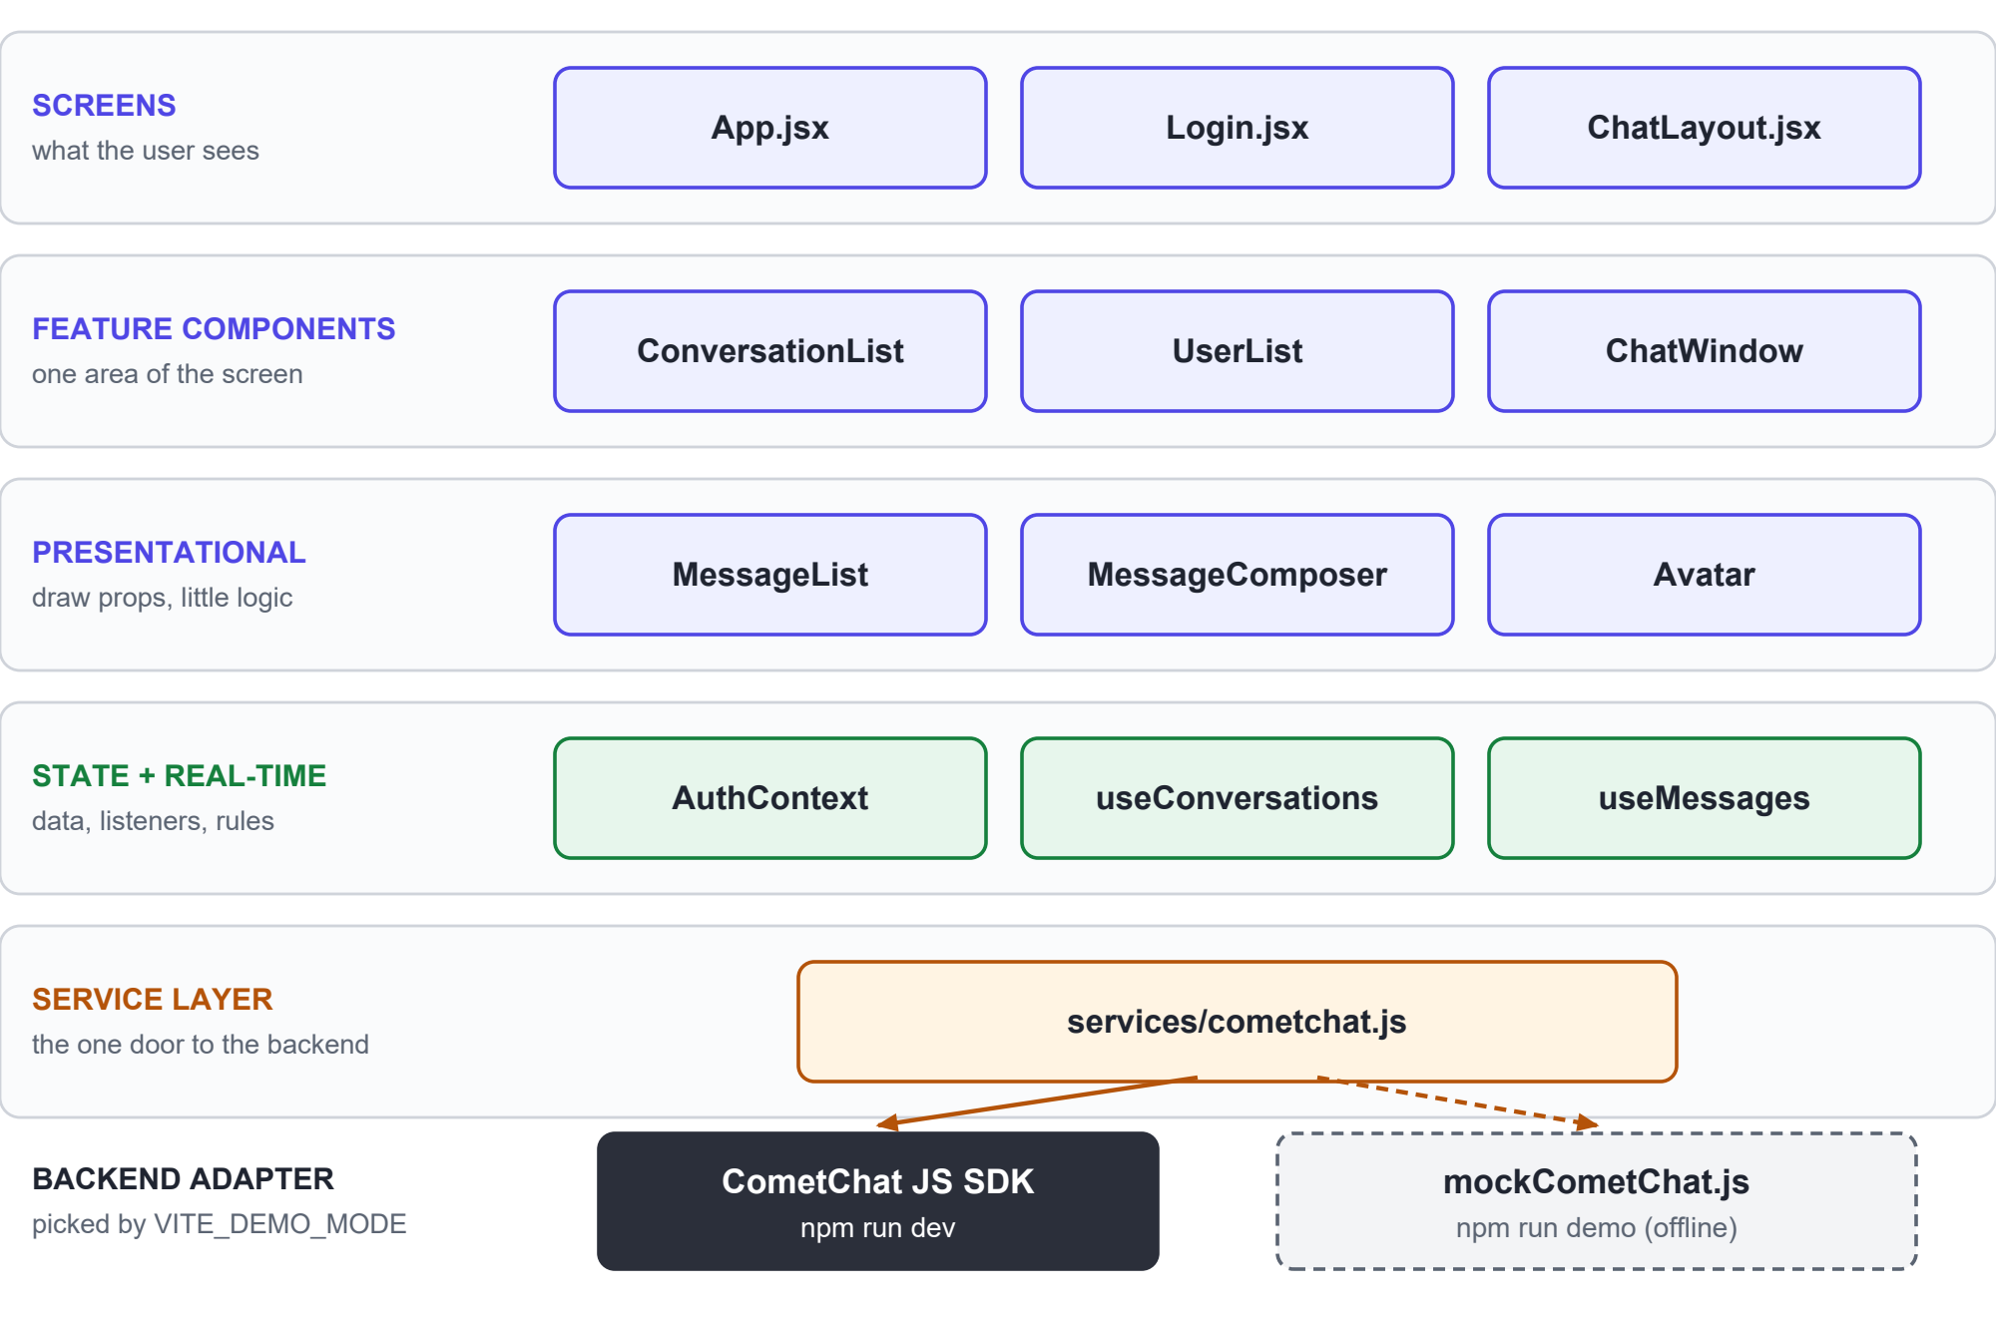
Figure 1. UI layers, from what the user sees down to the backend adapter.
Layer | Files | Responsibility | Rule
Screens | App, Login, ChatLayout | Decide which screen and which panels are visible | No direct SDK calls
Feature components | ConversationList, UserList, ChatWindow | One area of the screen each | Get data from a hook or props
Presentational | MessageList, MessageComposer, Avatar | Draw what they are given; local UI state only | No data fetching (UserList is the one exception)
State + real-time | AuthContext, useConversations, useMessages | Hold chat data, register listeners, apply business rules | Only layer that registers listeners
Service layer | services/cometchat.js | Setup, login, fetch, send, helpers; picks the backend | Only file that imports the SDK

2.2 Design principles
- One door to the backend. Only services/cometchat.js imports the SDK. Swapping the real SDK for the demo backend is a one-line decision there.
- Hooks own state, components draw it. Chat data and listeners live in hooks. Components stay small and easy to restyle.
- State lives as low as possible. There is no Redux or global store. Each piece of state belongs to the lowest component that needs it (section 2.5).
- Fresh state per chat. ChatWindow is rendered with key={activeKey}, so React builds a new instance for every chat and nothing leaks between chats.
- Every listener is cleaned up. Each addMessageListener has a matching removeMessageListener in the effect cleanup. Without it, messages would appear twice.

2.3 Folder structure
src/
|-- main.jsx React root, wraps <App> in <AuthProvider>
|-- App.jsx Chooses the screen from auth status
|-- index.css All styles, light/dark theme, mobile layout
|-- context/
| `-- AuthContext.jsx init, session restore, signIn, signOut
|-- hooks/
| |-- useConversations.js Sidebar list, unread counts, presence
| `-- useMessages.js Open chat: history, live messages, receipts, typing
|-- components/
| |-- Login.jsx UID form + sample users
| |-- ChatLayout.jsx Sidebar (Chats/Users tabs) + main pane
| |-- ConversationList.jsx Chats tab
| |-- UserList.jsx Users tab
| |-- ChatWindow.jsx Header + MessageList + MessageComposer
| |-- MessageList.jsx Bubbles, ticks, scroll handling, "Load older"
| |-- MessageComposer.jsx Text box, Enter to send, typing indicator
| `-- Avatar.jsx Picture or initials + online dot
|-- services/
| |-- cometchat.js The one door to the backend
| `-- demo/mockCometChat.js Offline fake of the SDK (demo mode)
`-- utils/
`-- format.js Timestamp formatting

2.4 Component tree
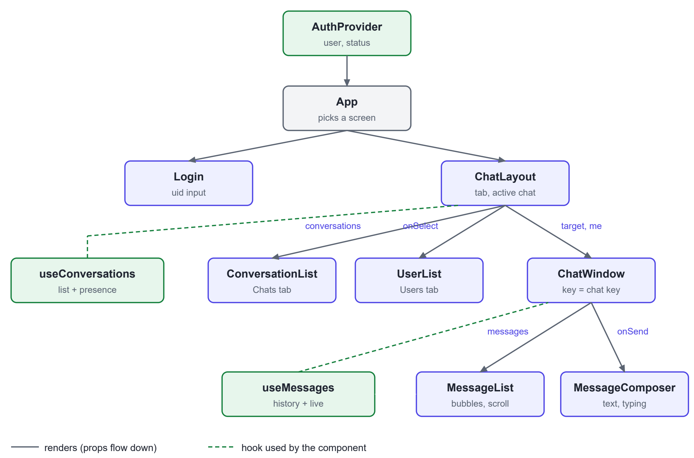
Figure 2. Component tree. Solid arrows render children and pass props; dashed lines show which component uses which hook.
Data moves in three directions:
- Down through props: ChatLayout passes conversations to ConversationList; ChatWindow passes messages to MessageList.
- Up through callbacks: onSelect(target) opens a chat; onSend(text) and onMessageSent(message) report a sent message so the sidebar can move that chat to the top.
- Sideways through listeners: both hooks subscribe to the SDK independently, so the sidebar and the open chat update themselves when an event arrives.

2.5 State ownership
State | Owner | Lifetime
Logged-in user, init status, error | AuthContext | Whole app
Selected tab, open chat | ChatLayout | While logged in
Conversation list, unread counts, presence | useConversations | While logged in
Messages, has-more flag, receipts, typing names | useMessages | One open chat (reset per chat)
Composer text, typing flag and timer, send error | MessageComposer | One open chat
Scroll anchors, loading-older flag | MessageList (refs + state) | One open chat
User list | UserList | While the Users tab is visible

3. Screens and layout

3.1 Choosing the screen
App.jsx reads status and user from useAuth() and renders exactly one screen.
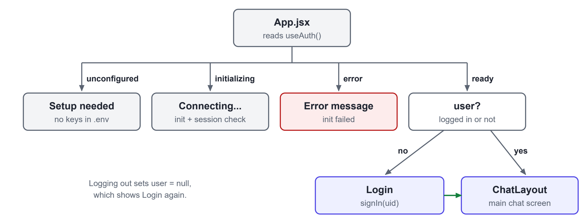
Figure 3. Screen selection in App.jsx.
Status | Shown when | Screen
unconfigured | No App ID, Region or Auth Key in .env, and not in demo mode | Setup instructions
initializing | CometChat.init() and the session check are running | "Connecting to CometChat..."
error | init() failed | Error message
ready + no user | Init done, nobody logged in | Login
ready + user | Logged in (or session restored after a refresh) | ChatLayout

3.2 Main screen
The main screen has a 320 px sidebar and a flexible chat pane. The sidebar header shows the current user and a Log out link; below it are the Chats and Users tabs and the active list. The chat pane shows the header (name, online status or typing), the message list and the composer.
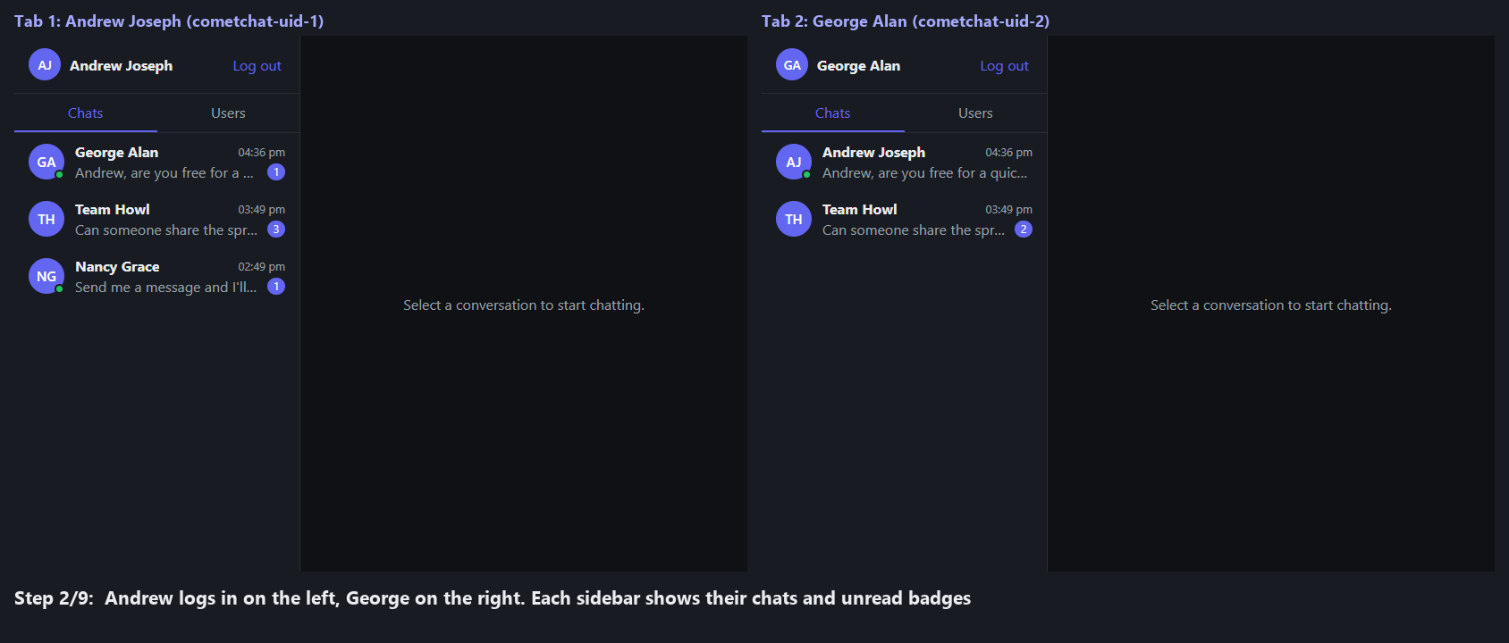
Figure 4. Two users logged in (demo mode). Each sidebar shows conversations with last message, time, unread badge and online dot.

3.3 Responsive behaviour
Below 720 px wide, the layout switches to one panel at a time. ChatLayout adds the class has-active when a chat is open, and the CSS uses it to decide which panel to hide:
@media (max-width: 720px) {
.layout { grid-template-columns: 1fr; }
.layout.has-active .sidebar { display: none; } /* chat open: hide list */
.layout:not(.has-active) .main { display: none; } /* no chat: hide chat pane */
.back { display: inline-block; } /* show the Back button */
}

3.4 Theming
All colours are CSS variables on :root. A prefers-color-scheme: dark block redefines them, so the whole app follows the operating system theme with no JavaScript.
Variable | Used for
--bg, --surface, --border | Page background, panels, dividers
--text, --muted | Main and secondary text
--accent, --accent-text | Buttons, my bubbles, active tab, badges
--bubble-other | Bubbles from other people
--online, --read, --error | Online dot, blue read ticks, error text

4. Workflows

4.1 Startup and session restore
1. index.html loads main.jsx, which renders <AuthProvider><App/></AuthProvider> inside StrictMode.
2. If the app is not configured and not in demo mode, AuthProvider sets status unconfigured and stops.
3. Otherwise it calls initCometChat(). The promise is memoised, so StrictMode's double effect does not initialise twice.
4. It calls getLoggedInUser(). The SDK keeps the session, so a page refresh returns the same user.
5. Status becomes ready. App shows Login if there is no user, otherwise ChatLayout.

4.2 Login and logout
1. The user types a UID or clicks a sample user. Login calls signIn(uid) from the context.
2. signIn calls CometChat.login(uid, AUTH_KEY) and stores the returned user. App re-renders and shows ChatLayout.
3. On failure, Login shows the error message and re-enables the form.
4. Log out calls signOut(), which calls CometChat.logout() and sets the user to null. App shows Login again, and every hook unmounts and removes its listeners.

4.3 Opening a chat
Clicking a row calls openChat(target) in ChatLayout, which sets the active chat and clears its unread badge. ChatWindow mounts with a new key, and useMessages runs the lifecycle below.
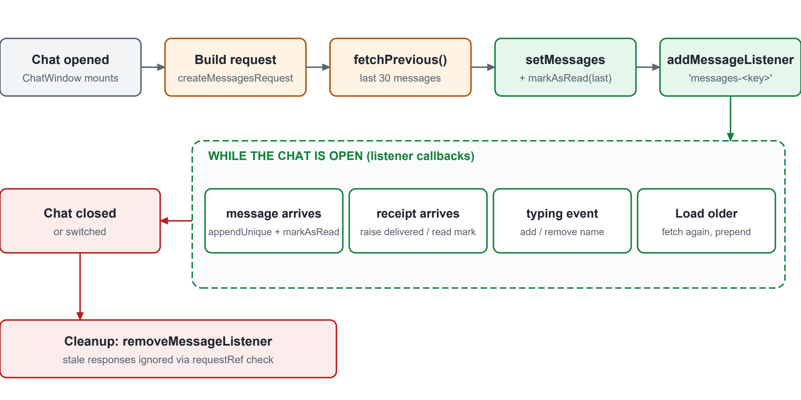
Figure 5. Lifecycle of useMessages for one open chat.

4.4 Sending a message
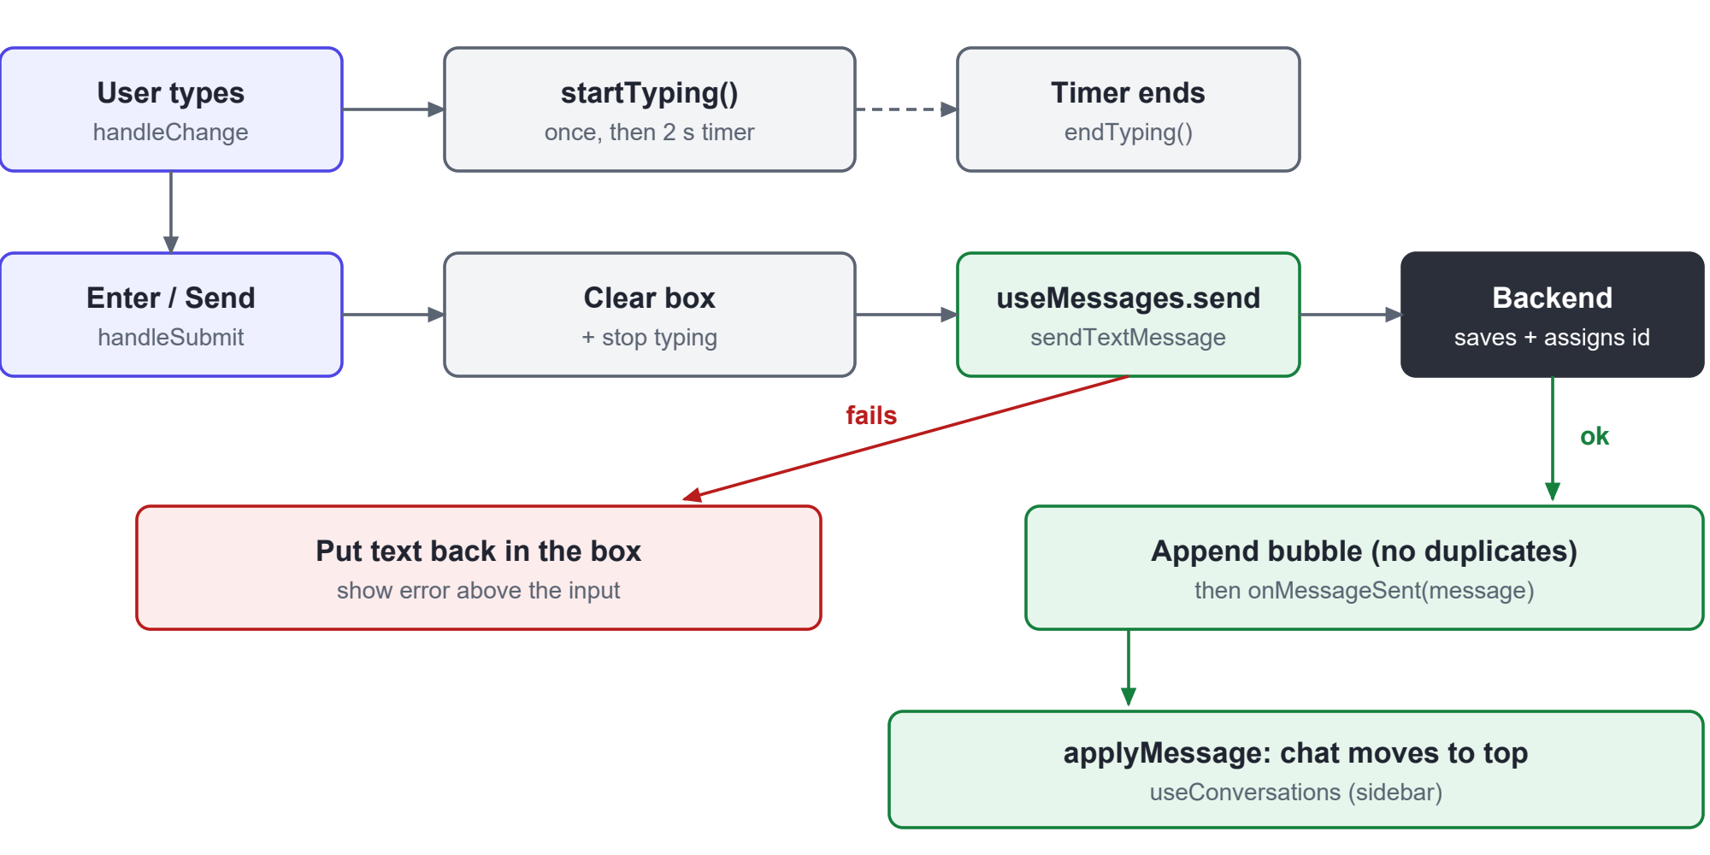
Figure 6. Send workflow, including the failure path.
1. Each keystroke calls handleChange. The first one sends startTyping; every keystroke restarts a 2-second timer that sends endTyping.
2. Enter (without Shift) or the Send button calls handleSubmit. Empty or whitespace-only text is ignored.
3. The box is cleared immediately and typing is stopped, so the UI feels instant.
4. onSend(text) runs useMessages.send, which calls sendTextMessage(target, text).
5. On success the returned message (now with an ID and timestamp) is appended. appendUnique prevents a duplicate if the same message also arrives through a listener.
6. ChatWindow then calls onMessageSent(message), which is applyMessage in useConversations. The chat moves to the top of the sidebar with the new preview.
7. On failure the text is put back in the box and the error is shown above it, so nothing is lost.

4.5 Receiving a message and other live events
Every live event arrives through a listener and is turned into a state update in one of the two hooks.
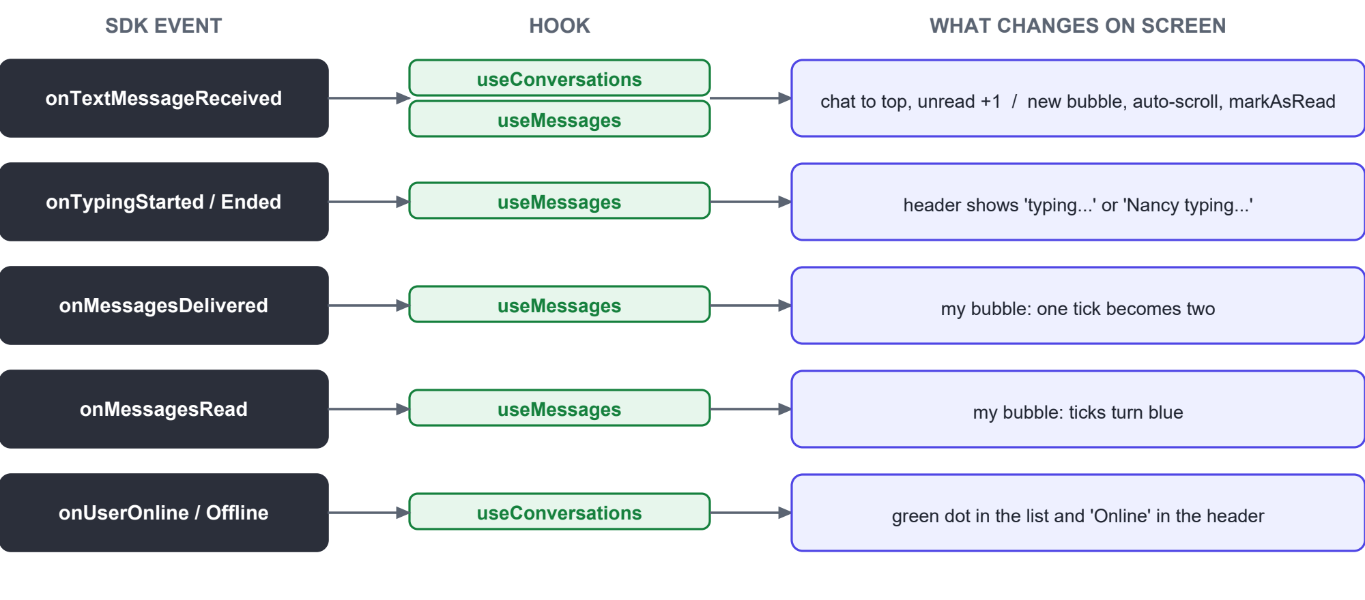
Figure 7. How each SDK event changes the screen.
When a new message arrives, both hooks react independently:
- useConversations works out the chat key. If that chat is not open it raises the unread count and calls markAsDelivered. Either way the chat moves to the top. If the chat is not in the list yet (a brand-new conversation) it re-fetches the whole list.
- useMessages ignores the message unless its chat key matches the open chat. If it matches, the message is appended and markAsRead is called, which turns the sender's ticks blue.

4.6 Typing indicators
- Outgoing: MessageComposer sends startTyping once per burst and endTyping after 2 seconds of no keystrokes, on send, or when the chat closes.
- Incoming: useMessages keeps a map of uid -> name for people typing in this chat. ChatWindow shows "typing..." in a 1:1 chat or "Nancy, John typing..." in a group.

4.7 Delivery and read receipts
Receipts are tracked as high-water marks instead of per-message flags. useMessages stores the highest message ID the other person has received and read. A message I sent is then:
read if message.getReadAt() or id <= receipts.read
delivered if message.getDeliveredAt() or id <= receipts.delivered
sent otherwise
One receipt therefore updates every older message at once. Ticks are shown in 1:1 chats only; group receipts are not implemented yet.

4.8 Presence
useConversations registers a user listener. onUserOnline and onUserOffline update the status of the matching conversation's target. ChatLayout prefers that live copy of the target when it renders ChatWindow, so the header's "Online" label stays current too.

4.9 Loading older messages
When the first page is full (30 messages), the list shows "Load older messages". Clicking it calls fetchPrevious() on the same request object, which continues from where it stopped, and prepends the result. MessageList keeps the reader's position (section 5.7).

4.10 Walkthrough in screenshots
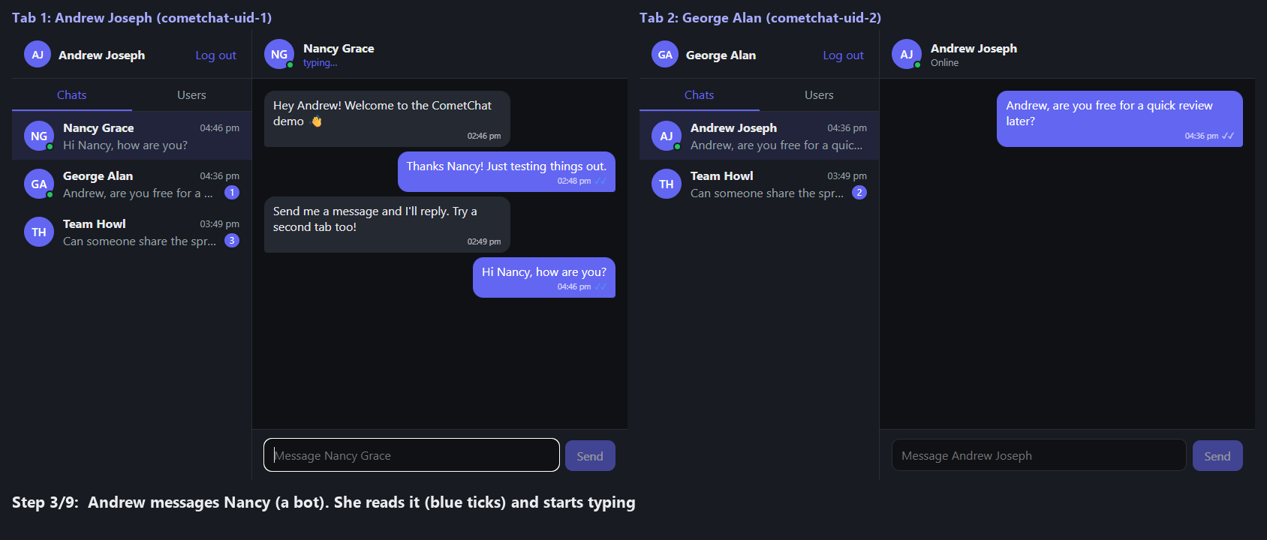
Figure 8. Andrew messages Nancy (a bot). Ticks turn blue and "typing..." appears.
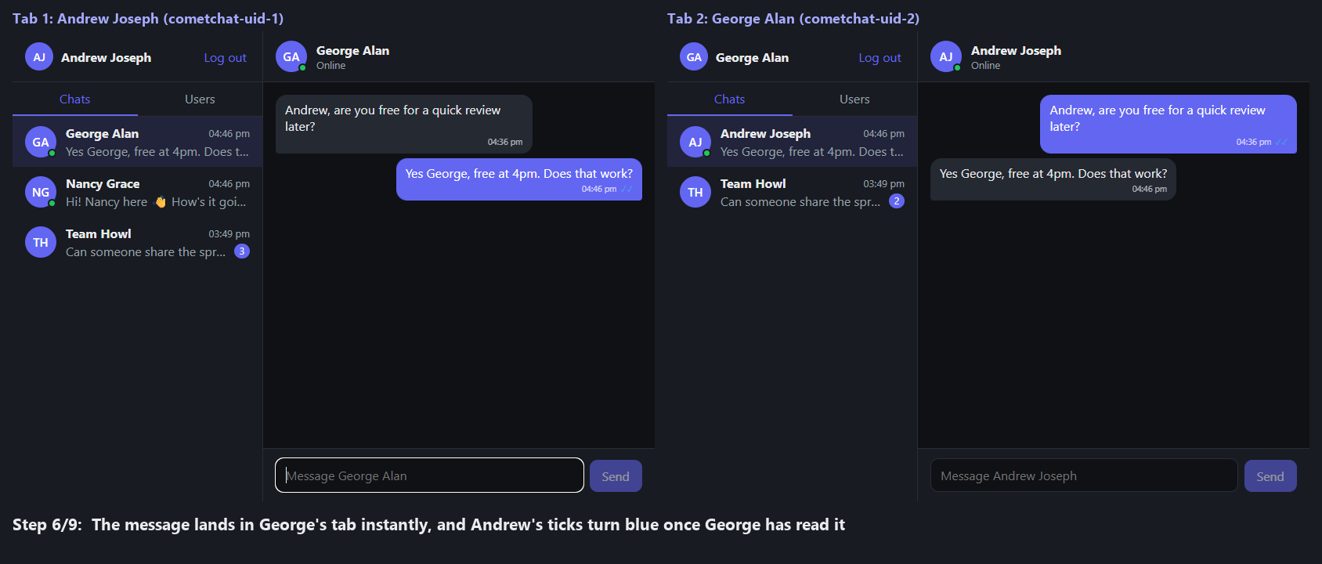
Figure 9. A message between two real tabs arrives instantly; the sender's ticks turn blue once it is read.
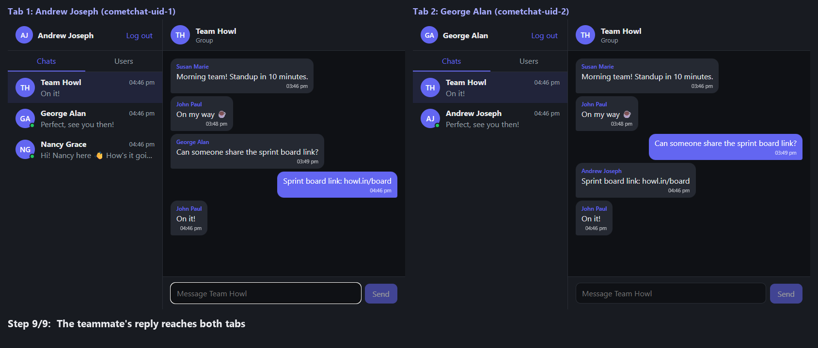
Figure 10. Group chat: both tabs see each message, with sender names on other people's bubbles.

5. Code logic, file by file

5.1 services/cometchat.js
The single entry point to the backend. Everything else imports from here.

Backend switch
export const isDemo = import.meta.env.VITE_DEMO_MODE === "true";
const CometChat = isDemo ? MockCometChat : SdkCometChat;
export const isConfigured = isDemo || Boolean(APP_ID && REGION && AUTH_KEY);
npm run demo loads .env.demo, which sets VITE_DEMO_MODE=true. Because the mock exposes the same function and class names as the SDK, no hook or component knows which backend is running.

Memoised init
let initPromise = null;
export function initCometChat() {
if (!initPromise) {
const settings = new CometChat.AppSettingsBuilder()
.subscribePresenceForAllUsers().setRegion(REGION)
.autoEstablishSocketConnection(true).build();
initPromise = CometChat.init(APP_ID, settings);
}
return initPromise;
}

Chat targets and keys
export function toChatTarget(entity) {
if (entity instanceof CometChat.Group) {
return { type: "group", id: entity.getGuid(), name: entity.getName(), avatar: entity.getIcon() };
}
return { type: "user", id: entity.getUid(), name: entity.getName(),
avatar: entity.getAvatar(), status: entity.getStatus() };
}
export const targetKey = (target) => `${target.type}:${target.id}`;
export function targetKeyFromMessage(message, myUid) {
if (message.getReceiverType() === "group") return `group:${message.getReceiverId()}`;
const senderUid = message.getSender().getUid();
const otherUid = senderUid === myUid ? message.getReceiverId() : senderUid;
return `user:${otherUid}`;
}
targetKeyFromMessage is the routing rule for the whole UI. In a 1:1 chat the "other person" is the sender if someone else sent it, or the receiver if I sent it. Both hooks use it to decide which chat an event belongs to.

Other helpers
Function | What it does
fetchConversations(limit) | Fetches conversations and maps each to { key, target, lastMessage, unread }
fetchUsers(limit) | Fetches users as chat targets
createMessagesRequest(target) | Builds a request for 30 messages of category "message", by UID or GUID
sendTextMessage(target, text) | Creates a TextMessage and sends it
setTyping(target, isTyping) | Sends startTyping or endTyping
previewText(message) | Text for previews: deleted, group update, the text, or [image]-style labels

5.2 context/AuthContext.jsx
Provides user, status, error, signIn and signOut to the whole tree.
useEffect(() => {
if (!isConfigured) return;
let cancelled = false;
(async () => {
try {
await initCometChat();
const existing = await getLoggedInUser(); // restores the session
if (cancelled) return;
setUser(existing);
setStatus("ready");
} catch (e) {
if (cancelled) return;
setError(e);
setStatus("error");
}
})();
return () => { cancelled = true; };
}, []);
The cancelled flag stops a late response from updating an unmounted provider.

5.3 hooks/useConversations.js
Keeps the sidebar live. Its listeners are registered once per login, so they read the latest values through refs instead of stale closure variables:
const activeKeyRef = useRef(activeKey);
const conversationsRef = useRef(conversations);
activeKeyRef.current = activeKey; // updated on every render
conversationsRef.current = conversations;

applyMessage
const applyMessage = useCallback((message, { countAsUnread = false } = {}) => {
const key = targetKeyFromMessage(message, me.getUid());
if (!conversationsRef.current.some((c) => c.key === key)) {
refresh(); // first message in a brand-new chat
return;
}
setConversations((prev) => {
const current = prev.find((c) => c.key === key);
const updated = { ...current, lastMessage: message,
unread: countAsUnread ? current.unread + 1 : current.unread };
return [updated, ...prev.filter((c) => c.key !== key)]; // move to top
});
}, [me, refresh]);

Listeners
- Message listener conversation-list: for each incoming message, works out whether its chat is the open one. If not, it calls markAsDelivered and counts it as unread. It then calls applyMessage.
- User listener: onUserOnline and onUserOffline set target.status on the matching conversation.
- markRead(key) sets a conversation's unread count to 0 when it is opened.

5.4 hooks/useMessages.js
Everything about the open chat. The effect re-runs only when the chat key changes.

Ignoring stale responses
const request = createMessagesRequest(target);
requestRef.current = request;
request.fetchPrevious().then((list) => {
if (requestRef.current !== request) return; // user switched chats meanwhile
setMessages(list);
setHasMore(list.length === MESSAGE_PAGE_SIZE);
...
});
If the user switches chats before the fetch returns, the old response is dropped, so one chat's messages never appear in another.

No duplicates
const appendUnique = (list, message) =>
list.some((m) => m.getId() === message.getId()) ? list : [...list, message];

Receipts and typing
- onMessagesDelivered and onMessagesRead only count if the receipt is for a 1:1 chat and came from the person this chat is with. They raise the stored mark only if the new ID is higher.
- onTypingStarted and onTypingEnded add or remove uid -> name in the typing map, after checking that the indicator belongs to this chat.
- statusOf(message) turns the marks into read, delivered or sent for MessageList.
- The effect cleanup calls removeMessageListener(messages-<key>).

5.5 components/ChatLayout.jsx
const activeKey = active ? targetKey(active) : null;
const { conversations, ... , applyMessage, markRead } = useConversations(me, activeKey);
// Prefer the conversation's copy of the target so presence stays live.
const activeTarget = conversations.find((c) => c.key === activeKey)?.target ?? active;
openChat(target) sets the active chat and clears its unread count. ChatWindow is rendered with key={activeKey} and receives applyMessage as onMessageSent.

5.6 components/ChatWindow.jsx
Connects useMessages to the header, MessageList and MessageComposer. The header subtitle is chosen in this order: typing names (if anyone is typing), then "Group" for groups, then "Online" or "Offline" for users.

5.7 components/MessageList.jsx
The scroll rule runs in useLayoutEffect, before the browser paints, so there is no visible jump:
useLayoutEffect(() => {
const el = scrollRef.current;
if (heightBeforeLoadRef.current !== null) { // older page was prepended
el.scrollTop += el.scrollHeight - heightBeforeLoadRef.current;
heightBeforeLoadRef.current = null;
return;
}
const lastId = messages[messages.length - 1]?.getId();
if (lastId !== lastIdRef.current) { // new message at the bottom
el.scrollTop = el.scrollHeight;
lastIdRef.current = lastId;
}
}, [messages]);
- Before loading older messages it records scrollHeight; afterwards it shifts scrollTop by the height added, so the reader stays on the same message.
- Bubbles are right-aligned and purple when the sender is me. Group bubbles from others show the sender name.
- Ticks: one tick for sent, two for delivered, two blue for read (1:1 chats only).

5.8 components/MessageComposer.jsx
function handleChange(e) {
setText(e.target.value);
if (!typingRef.current) { // first keystroke of a burst
typingRef.current = true;
setTyping(target, true);
}
clearTimeout(timerRef.current);
timerRef.current = setTimeout(stopTyping, TYPING_TIMEOUT_MS); // 2000 ms
}
- Enter sends; Shift+Enter inserts a new line.
- On a failed send the text is restored and the error is shown.
- An effect cleanup calls stopTyping when the chat changes or the composer unmounts.

5.9 Smaller components and utilities
File | Logic
Login.jsx | Controlled UID input plus five sample-user buttons. Shows a demo-mode note when isDemo.
ConversationList.jsx | Renders loading, error and empty states, then one row per conversation with preview, time and unread badge.
UserList.jsx | Fetches users on mount, filters out the current user, renders rows with online status.
Avatar.jsx | Shows the image if there is one, otherwise up to two initials. Adds a green dot when online.
utils/format.js | Converts CometChat timestamps (seconds) to a time for today or a short date otherwise.
App.jsx / main.jsx | Screen selection (section 3.1) and the React root.

5.10 services/demo/mockCometChat.js (demo mode)
An offline fake of the SDK with the same names (init, login, sendMessage, request builders, listener classes, RECEIVER_TYPE and so on), so the UI runs unchanged.
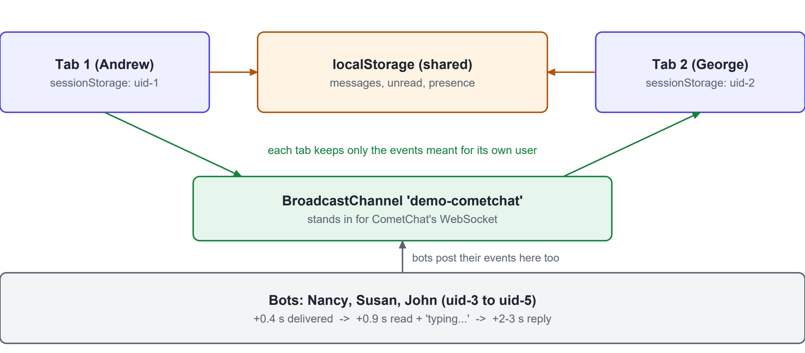
Figure 11. How demo mode works across browser tabs.
- Storage: messages, unread markers and presence heartbeats live in localStorage, which every tab shares. The logged-in user is in sessionStorage, so each tab can be a different user.
- Live events: emit() posts each event on a BroadcastChannel and also handles it locally, because a BroadcastChannel does not deliver to the tab that sent it. handleEvent() drops events that are not meant for this tab's user.
- Bots: messages to Nancy, Susan or John (or to the group) trigger delivered and read receipts, a typing indicator and a canned reply over about 2 to 3 seconds.
- Seed data: on first run it creates a few chats and a Team Howl group so the lists are not empty.

6. Error handling and edge cases
Situation | How the UI handles it
Missing .env keys | Setup screen instead of a crash
init() fails | Error screen with the SDK message
Wrong UID at login | Error under the form; form re-enabled
Send fails | Text restored to the box, error shown above it
Switching chats during a fetch | Stale response ignored through requestRef
Same message from send() and a listener | appendUnique keeps one copy
Message for a chat not in the sidebar | Conversation list re-fetched
Listener left behind after unmount | Every effect removes its listener in cleanup
StrictMode double effects | initCometChat memoised; AuthContext uses a cancelled flag
Older messages loaded | Scroll position preserved
Fetch errors in lists or messages | Inline error text in the list or chat area

7. Current status and remaining UI work
Estimated against a full chat UI such as CometChat's own UI Kit. The percentages are judgement, not measurement.
Area | Done | Notes
Core 1:1 text chat | ~95% | Complete apart from small polish
Group chat | ~40% | Messaging works; no group receipts or group management
Rich messages (media, emoji) | 0% | Non-text messages show as [image]-style labels
Message actions (reply, edit, delete, reactions) | 0%
Lists, search and details panels | ~30% | First 30 chats and 50 users only; no search
Polish and reliability | ~50% | No date separators, connection banner or tests
Overall UI | ~35%

7.1 Remaining features
# | Feature | Size | Where it goes
1 | Date separators and a "new messages" divider | S | MessageList
2 | Search, and loading more chats/users on scroll | S | ConversationList, UserList, service
3 | Emoji picker | S | MessageComposer
4 | Images and files: send, preview, download | M | Composer, MessageList, service (MediaMessage)
5 | Reply, edit, delete, copy | M | Bubble menu in MessageList, useMessages
6 | Reactions | M | MessageList, useMessages
7 | Group read receipts | S | useMessages (onMessagesReadByAll)
8 | Create/join group, members, group details | L | New components + group APIs
9 | User details panel, block/unblock | M | New side panel
10 | Delete or mute a conversation | S | ConversationList
11 | Threads | M | New thread panel
12 | @mentions and link previews | M | Composer, MessageList
13 | Connection banner ("Reconnecting...") | S | ChatLayout + connection listener
14 | Browser notifications and sound | S | useConversations
15 | Loading skeletons and accessibility pass | S | All components
16 | Automated tests | M | New test setup
17 | Voice and video calls (optional) | L | CometChat Calls SDK

Suggested order: quick wins (1, 2, 3, 7, 13), then real-chat essentials (4, 5, 6), then groups and profiles (8, 9, 10), then the rest. The production token server is backend work and is not counted here.

8. Running and extending the UI

8.1 Commands
Command | What it does
npm install | Installs dependencies
npm run demo | Runs the UI against the offline demo backend; no keys needed
npm run dev | Runs against real CometChat; needs .env with App ID, Region and Auth Key
npm run build | Production build into dist/

8.2 Adding a new message type (example: images)
1. Add sendMediaMessage(target, file) to services/cometchat.js and the matching function to the mock.
2. Add a sendFile function to useMessages that appends the returned message, like send.
3. Add an attach button to MessageComposer.
4. Render the image in MessageList when message.getType() === "image", and update previewText.
5. The listeners already route media messages (onMediaMessageReceived), so no listener changes are needed.

8.3 Rules to keep when extending
- Call the SDK only from services/cometchat.js, and add the same function to the demo mock.
- Put new chat state and listeners in a hook, not in a component.
- Give every listener a unique ID and remove it in the effect cleanup.
- Route events by chat key with targetKeyFromMessage.

Appendix A. SDK calls used by the UI
SDK call | Called from | Purpose
CometChat.init | services (initCometChat) | Connect to the CometChat app
getLoggedinUser | AuthContext | Restore the session
login / logout | AuthContext | Sign in and out
ConversationsRequestBuilder | services (fetchConversations) | Sidebar list
UsersRequestBuilder | services (fetchUsers) | Users tab
MessagesRequestBuilder | services (createMessagesRequest) | History, paged backwards
sendMessage | services (sendTextMessage) | Send a text message
startTyping / endTyping | services (setTyping) | Typing indicator
markAsRead / markAsDelivered | useMessages, useConversations | Receipts
add/removeMessageListener | useMessages, useConversations | Live messages, receipts, typing
add/removeUserListener | useConversations | Presence

